**2.Jenkins-Dockers Using Web Application**

**STEP 1: Push files to GitHub Repository**

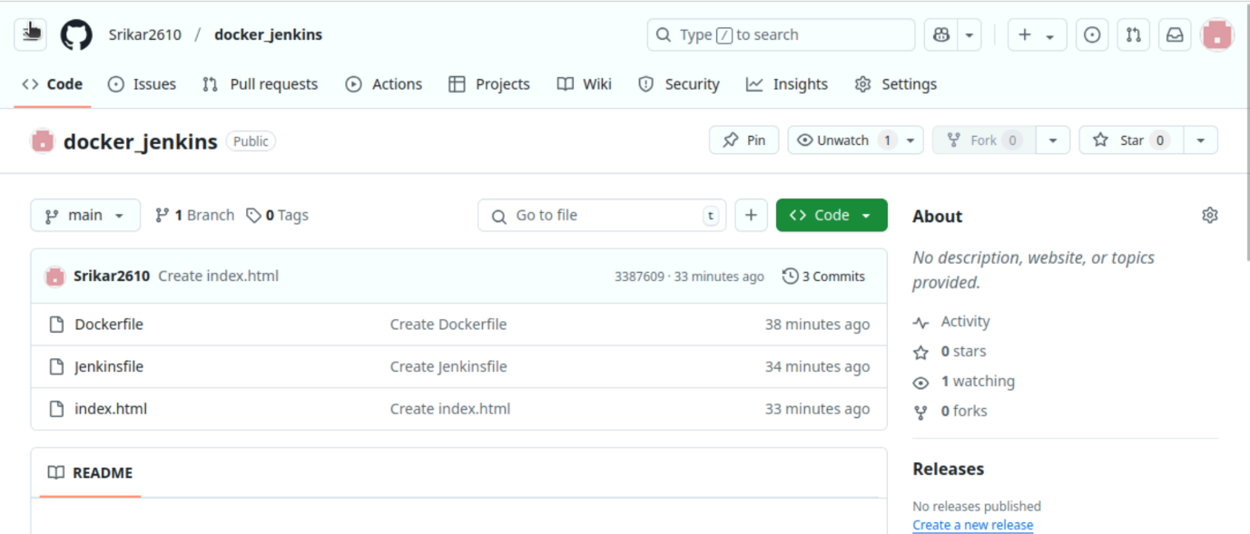

**Step 2: Create a Pipeline**

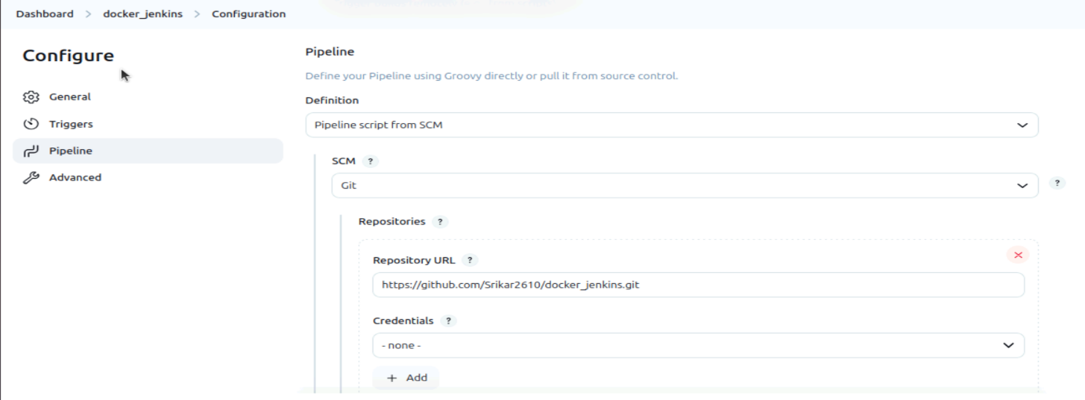

**Step 3: Build the Pipeline**

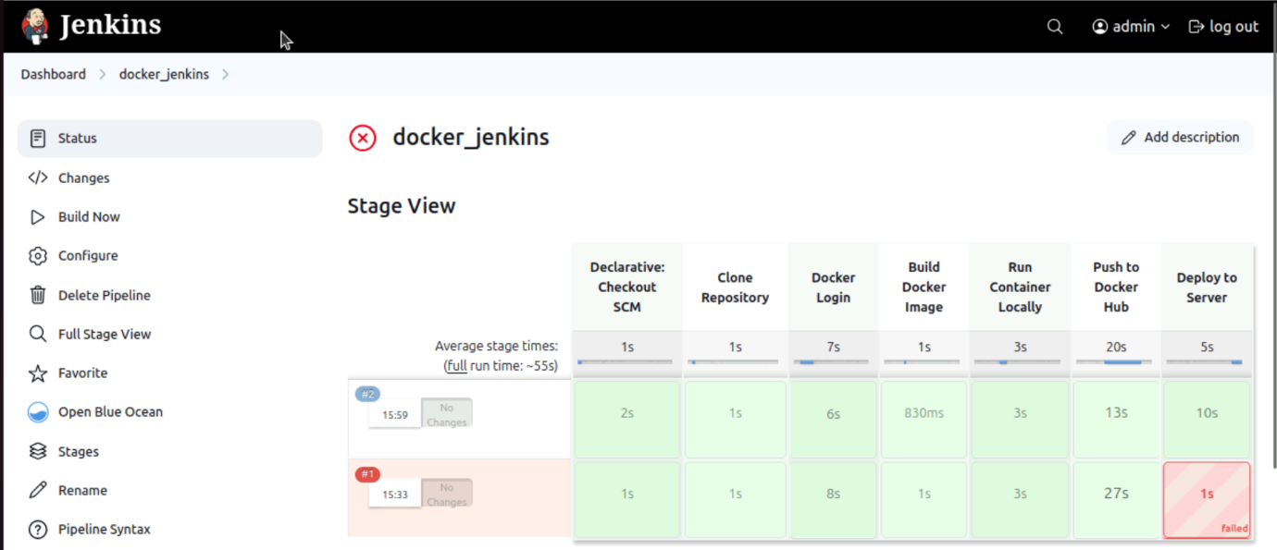

**Step 4: my-jenkins-app image is build in Docker repository**

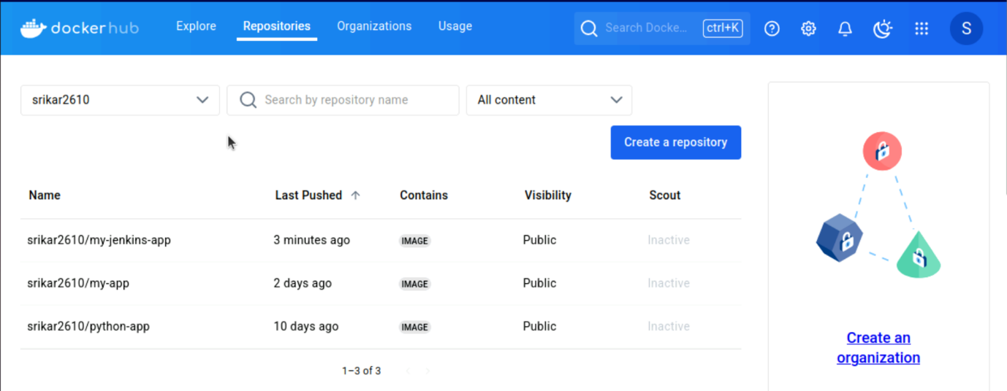

**OUTPUT**

