**Docker project 3**

**Dockerized CI/CD pipeline using Jenkins, Dockers, Kubernetes**

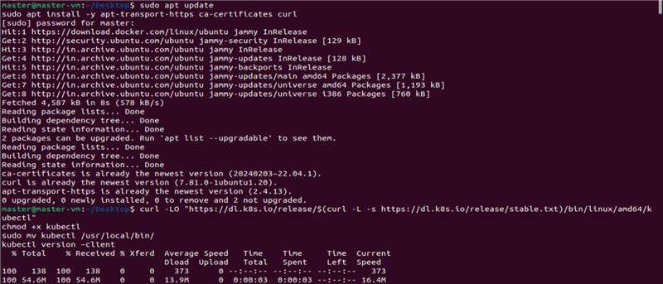

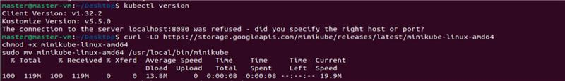

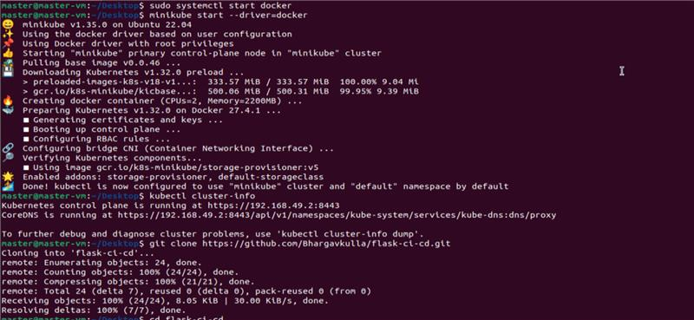

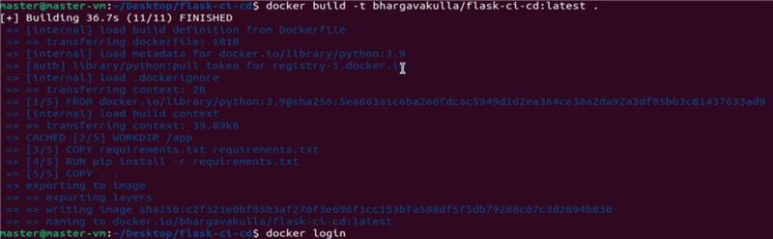

**OUTPUT**

