Hurtownie danych  
Laboratorium Czw 11:15  
  
Lista 2  
  
Kajetan Pynka 254495

**Zad 1.1**

SELECT SOH.SalesPersonID "pracID", SOD.ProductID "prodID", P.Name "Nazwa produktu", Year(SOH.OrderDate) "Rok",

    COUNT(SOD.OrderQty) "Liczba" FROM Sales.SalesOrderHeader SOH

    JOIN Sales.SalesOrderDetail SOD ON SOH.SalesOrderID=SOD.SalesOrderID

    JOIN Production.Product P ON P.ProductID=SOD.ProductID

    GROUP BY SOH.SalesPersonID, SOD.ProductID, P.Name, Year(SOH.OrderDate);

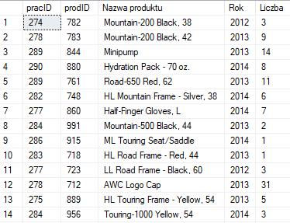

**Zad 1.1a**

SELECT * FROM (

    SELECT SOH.SalesPersonID "pracID", SOD.ProductID "prodID", P.Name "Nazwa produktu", Year(SOH.OrderDate) "Rok",

        SOD.OrderQty "Liczba" FROM Sales.SalesOrderHeader SOH

        JOIN Sales.SalesOrderDetail SOD ON SOH.SalesOrderID=SOD.SalesOrderID

        JOIN Production.Product P ON P.ProductID=SOD.ProductID) S

    PIVOT(COUNT(Liczba) FOR S.Rok IN ([2011], [2012], [2013], [2014])) AS X;

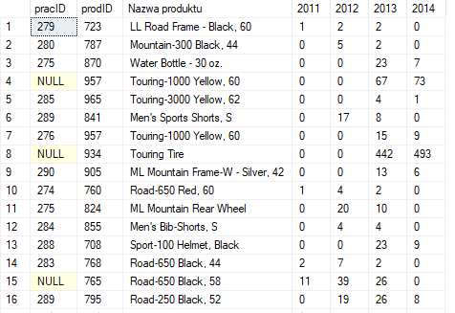

**Zad 1.1b**

SELECT * FROM (

SELECT SOH.SalesPersonID "pracID", Year(SOH.OrderDate) "Rok", P.ProductID "NrProd",

    SOD.OrderQty FROM Sales.SalesOrderHeader SOH

    JOIN Sales.SalesOrderDetail SOD ON SOH.SalesOrderID=SOD.SalesOrderID

    JOIN Production.Product P ON P.ProductID=SOD.ProductID

    WHERE P.ProductID IN (SELECT ProductID FROM (SELECT DISTINCT TOP 5 SOD.ProductID, MAX(SOD.OrderQty) "Liczba"

        FROM Sales.SalesOrderDetail SOD

        GROUP BY SOD.ProductID

        ORDER BY 2 DESC) AS Subquery)) S

    PIVOT(COUNT(OrderQty) FOR S.NrProd IN ([863], [869], [867], [864], [709])) X

    ORDER BY 2;

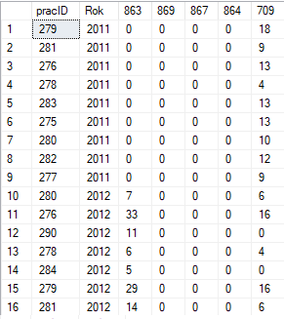

**Zad 1.2**

SELECT YEAR(SOH.OrderDate) "Rok", MONTH(SOH.OrderDate) "Miesiac", COUNT(DISTINCT SOH.CustomerID) "Rozni klienci"

    FROM Sales.SalesOrderHeader SOH

    GROUP BY YEAR(SOH.OrderDate), MONTH(SOH.OrderDate)

    ORDER BY 1, 2;

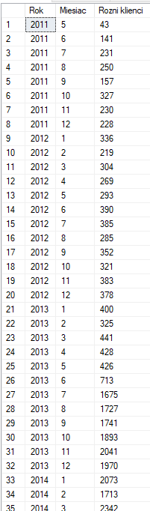

**Zad 1.2b**

SELECT * FROM (

    SELECT DISTINCT YEAR(OrderDate) "Rok", MONTH(OrderDate) "Miesiac", CustomerID "Rozni klienci"

        FROM Sales.SalesOrderHeader

    ) S PIVOT(COUNT([Rozni klienci])

    FOR S.[Miesiac] IN ([1], [2], [3], [4], [5], [6], [7], [8], [9], [10], [11], [12])) X

    ORDER BY 1;

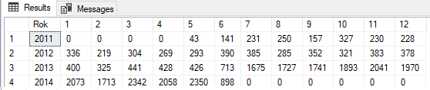

**Zad 1.3**

SELECT * FROM (

    SELECT Per.FirstName + ' ' + Per.LastName "Imie i nazwisko", YEAR(SOH.OrderDate) "Rok", SOH.SalesOrderID

        FROM Sales.SalesOrderHeader SOH

        JOIN Sales.SalesPerson SP ON SOH.SalesPersonID=SP.BusinessEntityID

        JOIN Person.Person Per ON Per.BusinessEntityID=SP.BusinessEntityID

    ) S PIVOT(COUNT(SalesOrderID) FOR S.Rok IN ([2011], [2012], [2013], [2014])) X;

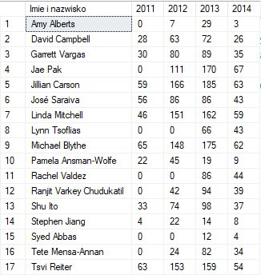

**Zad 1.4**

SELECT YEAR(SOH.OrderDate) "Rok", MONTH(SOH.OrderDate) "Miesiąc", DAY(SOH.OrderDate) "Dzień",

    SUM(SOH.TotalDue) "Suma", COUNT(DISTINCT SOD.ProductID) "Liczba różnych produktów"

    FROM Sales.SalesOrderHeader SOH

    JOIN Sales.SalesOrderDetail SOD ON SOH.SalesOrderID=SOD.SalesOrderID

    GROUP BY YEAR(SOH.OrderDate), MONTH(SOH.OrderDate), DAY(SOH.OrderDate)

    ORDER BY 1, 2, 3;

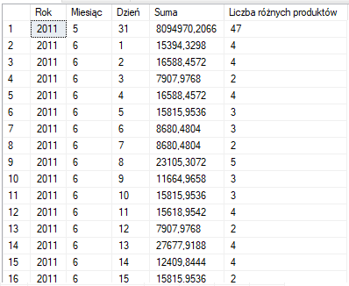

**Zad 1.5**

SELECT CASE

        WHEN MONTH(SOH.OrderDate)=1 THEN 'Styczeń'

        WHEN MONTH(SOH.OrderDate)=2 THEN 'Luty'

        WHEN MONTH(SOH.OrderDate)=3 THEN 'Marzec'

        WHEN MONTH(SOH.OrderDate)=4 THEN 'Kwiecień'

        WHEN MONTH(SOH.OrderDate)=5 THEN 'Maj'

        WHEN MONTH(SOH.OrderDate)=6 THEN 'Czerwiec'

        WHEN MONTH(SOH.OrderDate)=7 THEN 'Lipiec'

        WHEN MONTH(SOH.OrderDate)=8 THEN 'Sierpień'

        WHEN MONTH(SOH.OrderDate)=9 THEN 'Wrzesień'

        WHEN MONTH(SOH.OrderDate)=10 THEN 'Październik'

        WHEN MONTH(SOH.OrderDate)=11 THEN 'Listopad'

        WHEN MONTH(SOH.OrderDate)=12 THEN 'Grudzień'

    END "Miesiąc", SUM(SOH.SubTotal) "Suma",

    COUNT(DISTINCT SOD.ProductID) "Liczba różnych produktów"

    FROM Sales.SalesOrderHeader SOH

    JOIN Sales.SalesOrderDetail SOD ON SOH.SalesOrderID=SOD.SalesOrderID

    GROUP BY MONTH(SOH.OrderDate) ORDER BY MONTH(SOH.OrderDate);

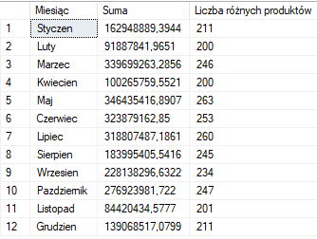

**Zad 1.5b**

SELECT CASE

        WHEN DATEPART(WEEKDAY, SOH.OrderDate)=1 THEN 'Niedziela'

        WHEN DATEPART(WEEKDAY, SOH.OrderDate)=2 THEN 'Poniedziałek'

        WHEN DATEPART(WEEKDAY, SOH.OrderDate)=3 THEN 'Wtorek'

        WHEN DATEPART(WEEKDAY, SOH.OrderDate)=4 THEN 'Środa'

        WHEN DATEPART(WEEKDAY, SOH.OrderDate)=5 THEN 'Czwartek'

        WHEN DATEPART(WEEKDAY, SOH.OrderDate)=6 THEN 'Piątek'

        WHEN DATEPART(WEEKDAY, SOH.OrderDate)=7 THEN 'Sobota'

    END "Dzień tygodnia", SUM(SOH.SubTotal) "Suma",

    COUNT(DISTINCT SOD.ProductID) "Liczba różnych produktów"

    FROM Sales.SalesOrderHeader SOH

    JOIN Sales.SalesOrderDetail SOD ON SOH.SalesOrderID=SOD.SalesOrderID

    GROUP BY DATEPART(WEEKDAY, SOH.OrderDate) ORDER BY CASE

        WHEN DATEPART(WEEKDAY, SOH.OrderDate)=1 THEN 7

        WHEN DATEPART(WEEKDAY, SOH.OrderDate)=2 THEN 1

        WHEN DATEPART(WEEKDAY, SOH.OrderDate)=3 THEN 2

        WHEN DATEPART(WEEKDAY, SOH.OrderDate)=4 THEN 3

        WHEN DATEPART(WEEKDAY, SOH.OrderDate)=5 THEN 4

        WHEN DATEPART(WEEKDAY, SOH.OrderDate)=6 THEN 5

        WHEN DATEPART(WEEKDAY, SOH.OrderDate)=7 THEN 6

    END;

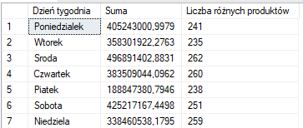

**Zad 1.6**

SELECT * FROM (

SELECT PER.FirstName "Imie", PER.LastName "Nazwisko", COUNT(DISTINCT SOH.SalesOrderID) "Liczba",

    SUM(DISTINCT SOH.TotalDue) "Kwota", CASE

        WHEN (SELECT TOP 1 COUNT(DISTINCT SOH_2.SalesOrderID)

                FROM Sales.Customer C_2

                JOIN Sales.SalesOrderHeader SOH_2 ON SOH_2.CustomerID=C_2.CustomerID

                WHERE C_2.CustomerID=C.CustomerID

                GROUP BY YEAR(SOH_2.DueDate)

                ORDER BY COUNT(DISTINCT SOH_2.SalesOrderID)

            ) >= 2 AND (SELECT COUNT(*) FROM (SELECT COUNT(DISTINCT SOH_2.SalesOrderID) "test123"

                FROM Sales.Customer C_2

                JOIN Sales.SalesOrderHeader SOH_2 ON SOH_2.CustomerID=C_2.CustomerID

                WHERE C_2.CustomerID=C.CustomerID

                GROUP BY YEAR(SOH_2.DueDate)) something)=4

            AND (SELECT TOP 1 COUNT(DISTINCT SOH_2.SalesOrderID) FROM Sales.SalesOrderHeader SOH_2

                    WHERE SOH_2.CustomerID=C.CustomerID AND

                        SOH_2.TotalDue > 1.5 * (SELECT AVG(SOH_3.TotalDue) FROM Sales.SalesOrderHeader SOH_3)

                    GROUP BY YEAR(SOH_2.DueDate) ORDER BY 1) >=  2

            THEN 'Platynowa'

        WHEN (SELECT COUNT(DISTINCT SOH_2.SalesOrderID) FROM Sales.SalesOrderHeader SOH_2

                    WHERE SOH_2.CustomerID=C.CustomerID AND SOH_2.TotalDue > 1.5 *

                        (SELECT AVG(SOH_3.TotalDue) FROM Sales.SalesOrderHeader SOH_3)) >= 2

            THEN 'Z�ota'

        WHEN COUNT(DISTINCT SOH.SalesOrderID) >= 5 THEN 'Srebrna'

    END "Karta" FROM Sales.Customer C

    JOIN Sales.SalesOrderHeader SOH ON SOH.CustomerID=C.CustomerID

    JOIN Person.Person PER ON PER.BusinessEntityID=C.PersonID

    JOIN Sales.SalesOrderDetail SOD ON SOD.SalesOrderID=SOH.SalesOrderID

    GROUP BY PER.FirstName, PER.LastName, C.CustomerID) MAIN

    WHERE Karta IS NOT NULL

    ORDER BY 2, 1;

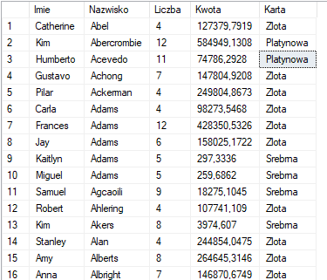

**Zad 2.1.1**

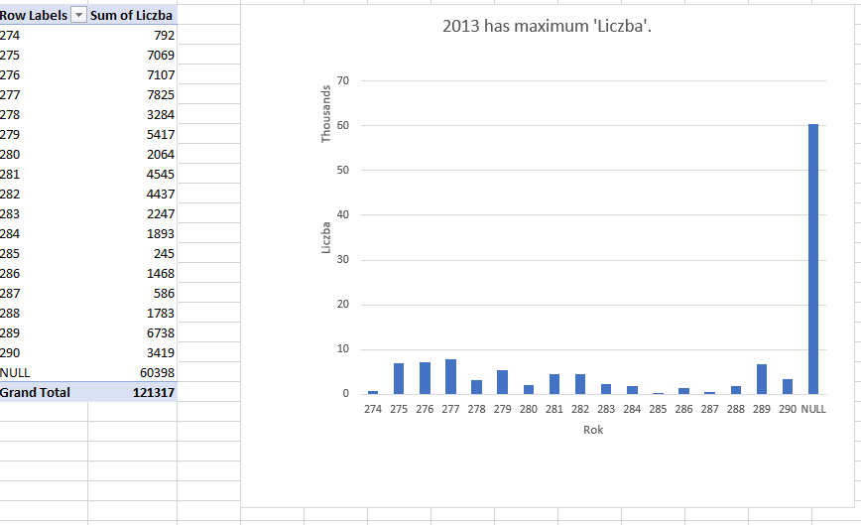

**Zad 2.1.1a**

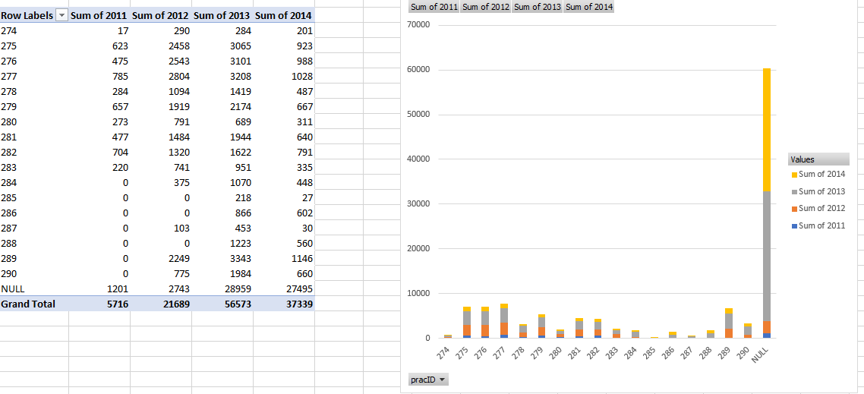

**Zad 2.1.1b**

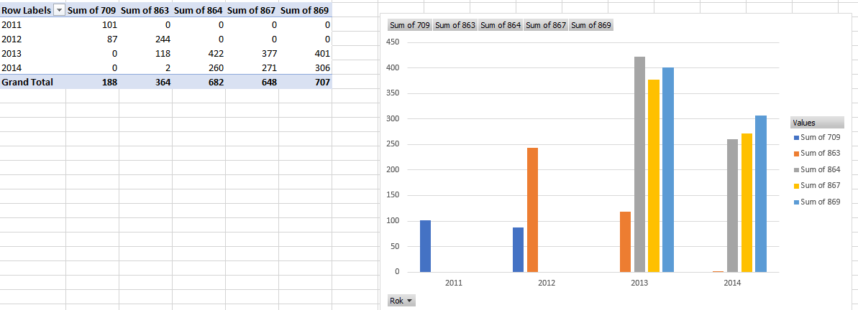

**Zad 2.1.2**

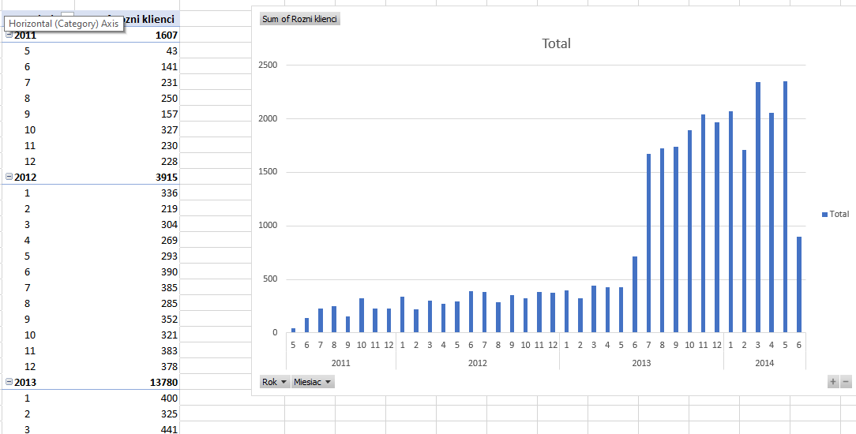

**Zad 2.1.2b**

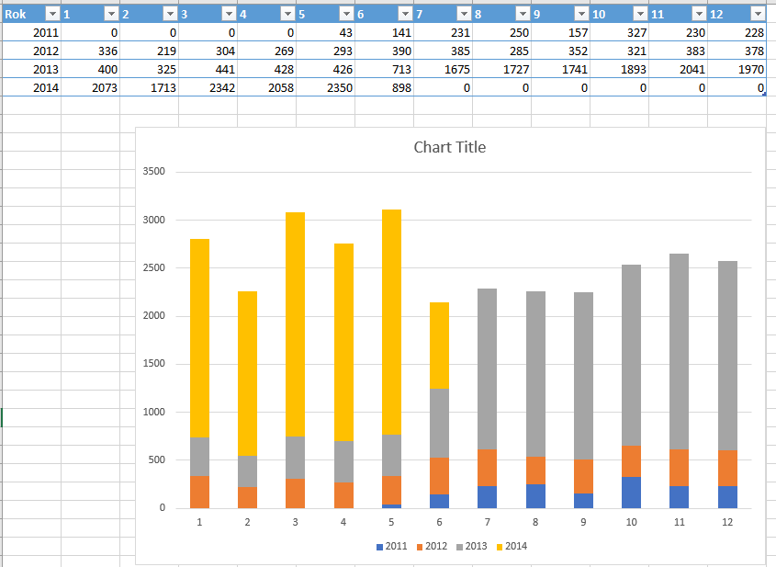

**Zad 2.1.3**

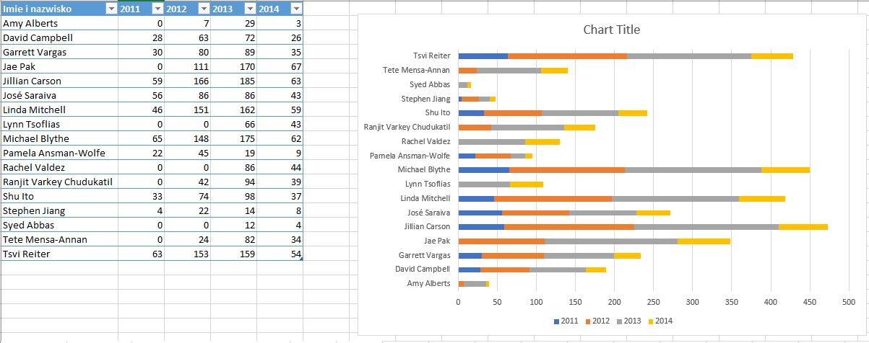

**Zad 2.1.4**

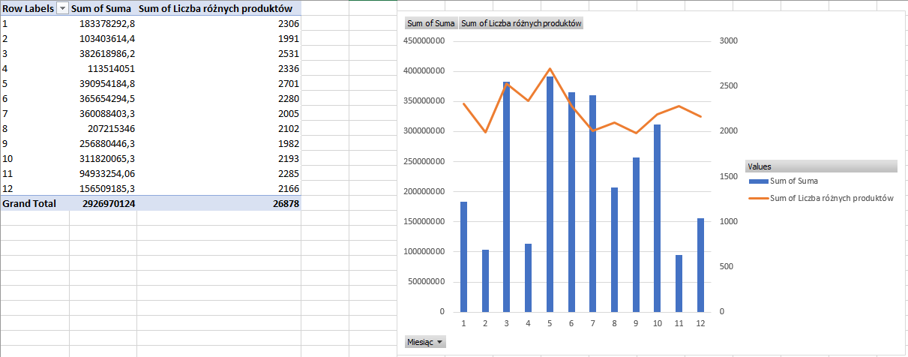

**Zad 2.1.5**

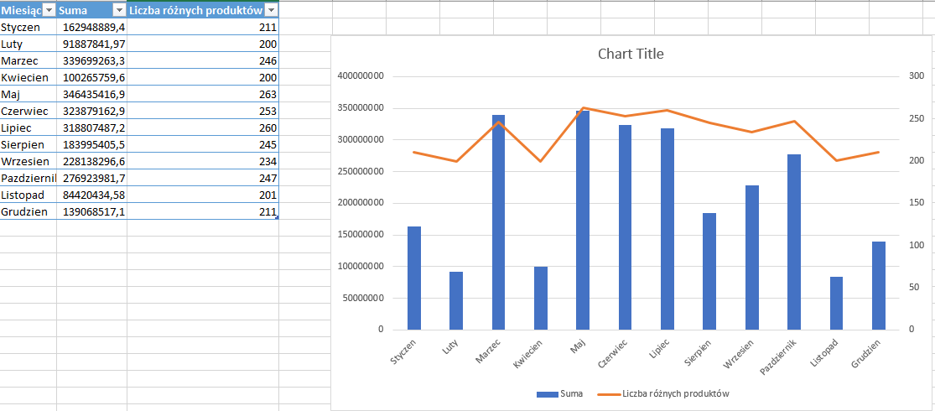

**Zad 2.1.5b**

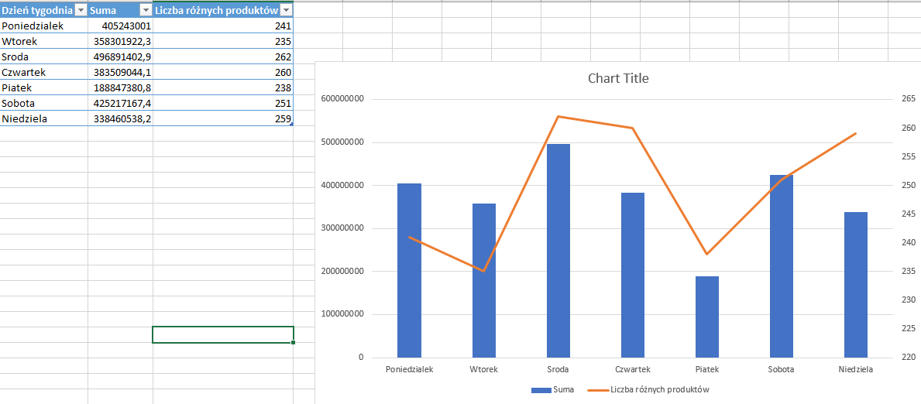

**Zad 2.1.6**

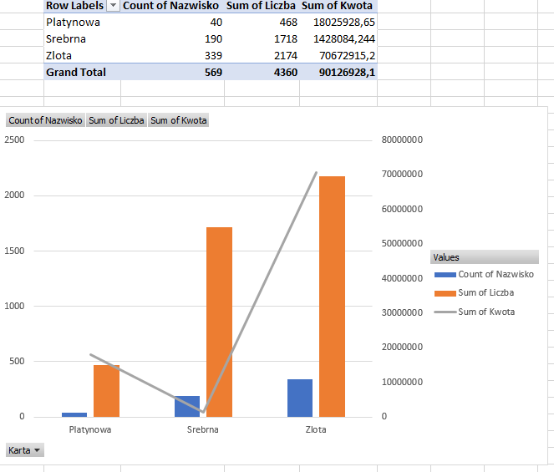

**Zad 2.2.1**

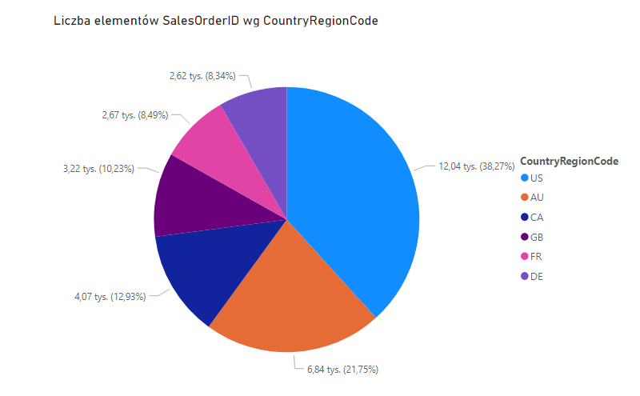

**Zad 2.2.2**

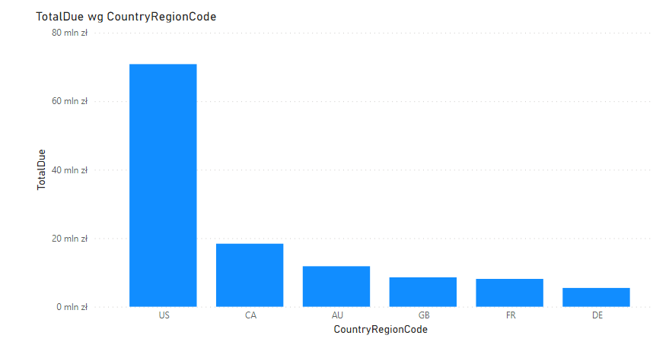

**Zad 2.2.3**

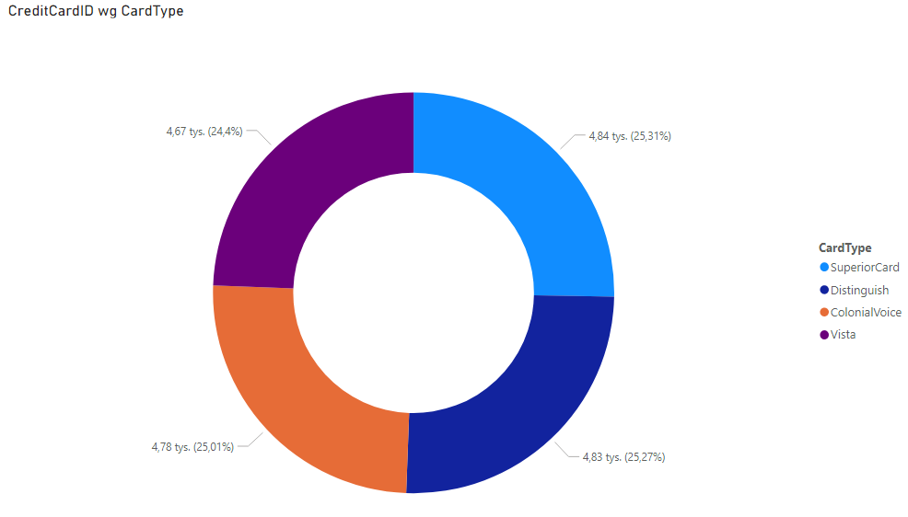

**Zad 2.2.4**

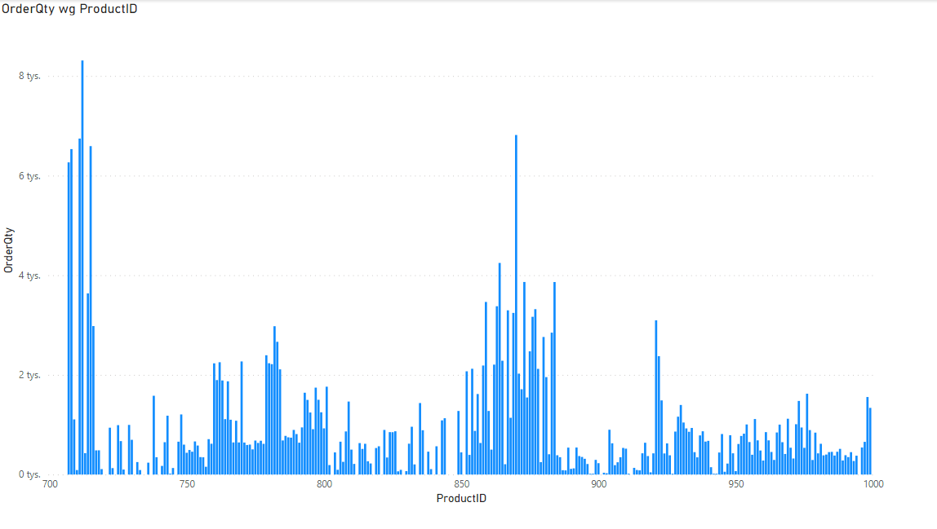

**Zad 2.2.5**

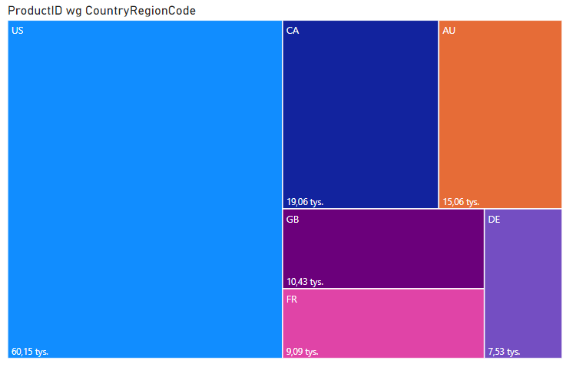

**Zad 3.1**

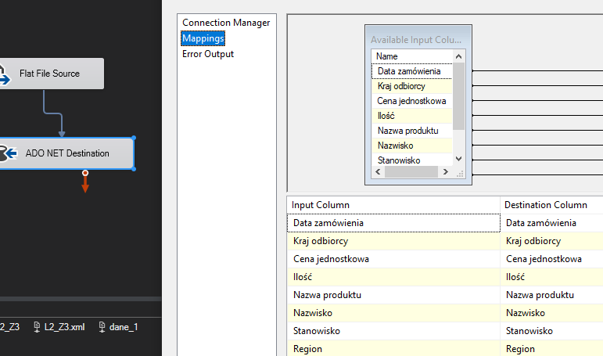

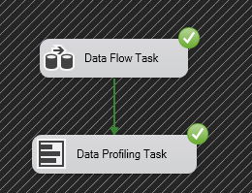

**Zad 3.2**

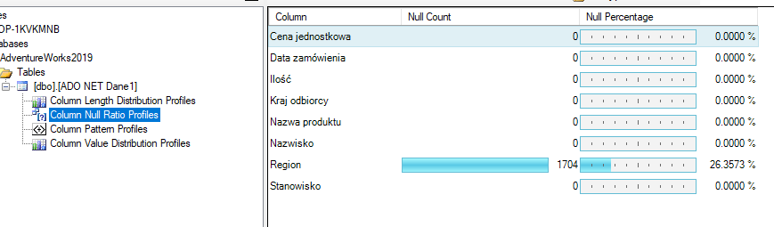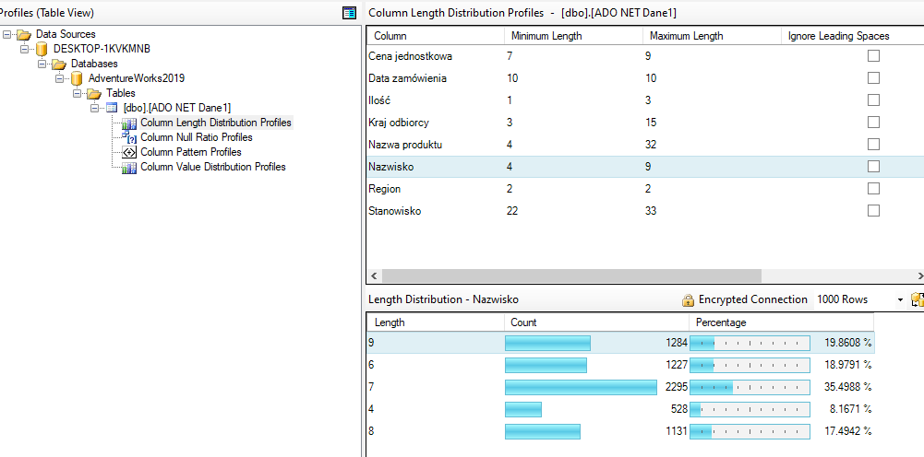

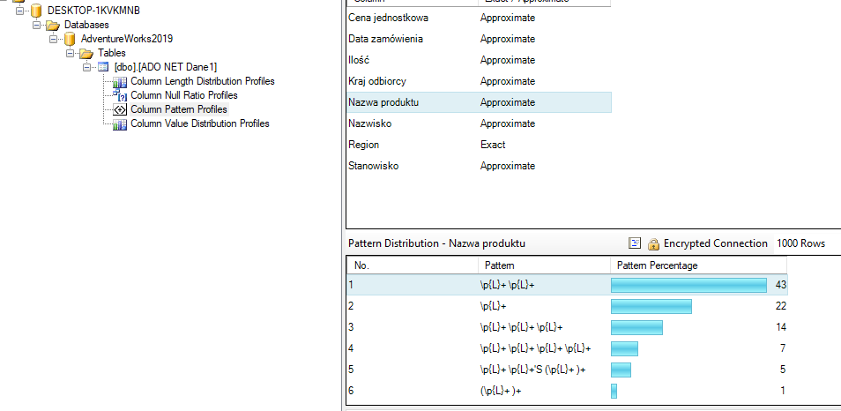

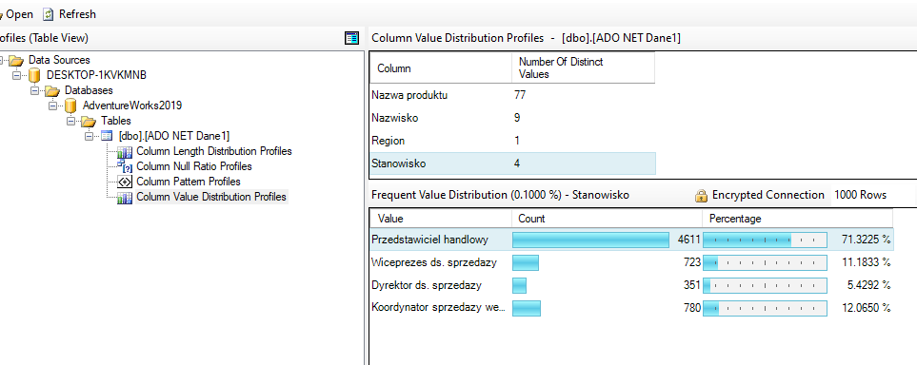

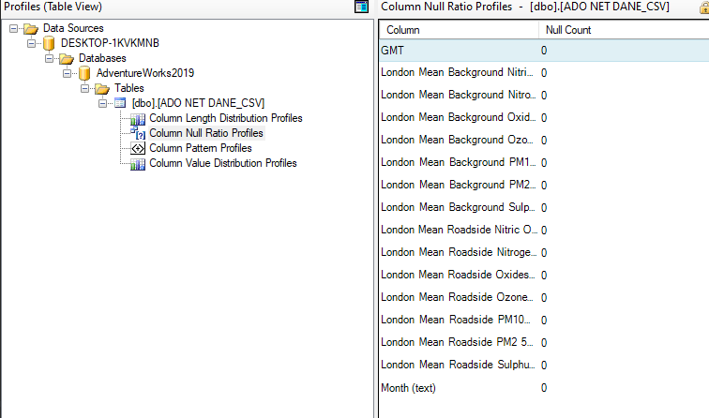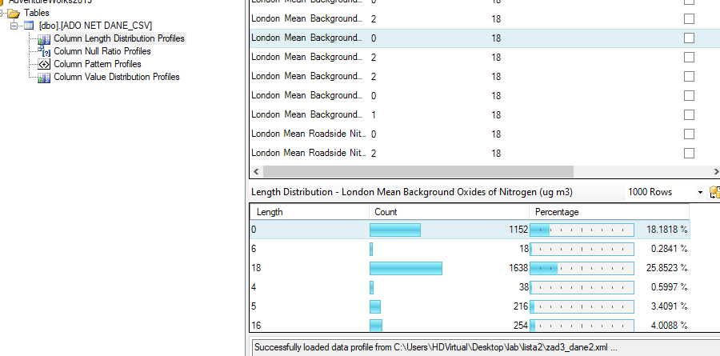

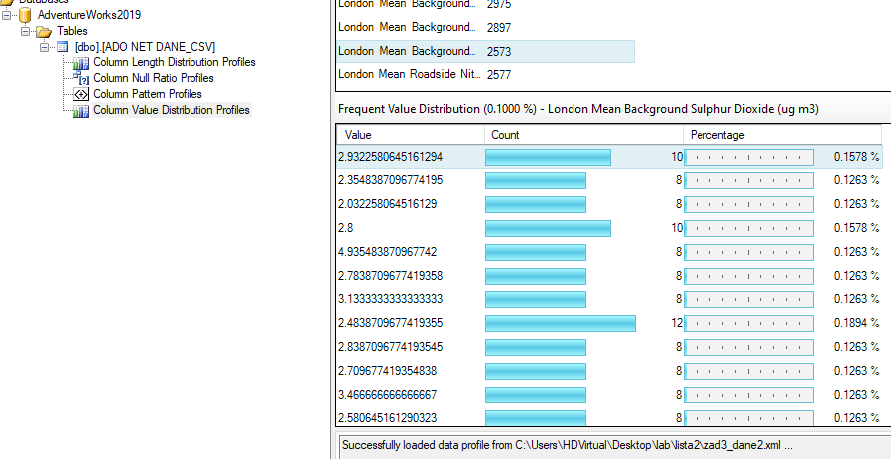

**Wnioski:**

* Polecenia ‘CASE’ oraz ‘PIVOT’ w ramach SQL’a pozwalają na uzyskanie tabel przestawnych, które w bardzo czytelny sposób przedstawiają zależności między danymi w naszej hurtowni
* Narzędzia takie jak PowerBI, Tableu czy też Excel zapewniają możliwość wygenerowania wielu rodzajów wykresów. Pozwala to przedstawić pewne trendy zachodzące wśród danych w bardzo obrazowy i przejrzysty sposób
* SQL Server Integration Services (SSIS) pozwala wyprofilować nasze źródło danych pod wieloma względami. Zapewnia to unikalne spojrzenie na strukturę naszych danych i pozwala przemyśleć czy aktualna architektura na pewno jest sensowna (np. ze względu na procentowo duży udział wartości NULL w ramach jakiejś kolumny LUB ze względu na procentowy udział długości danych)