
ALfaconverter
User Guide

February
Kybele



Initial Setup
In the application directory there is a file called “AlfaConverter.exe.config” whose content allows you to configure some basic parametersThe most important are:
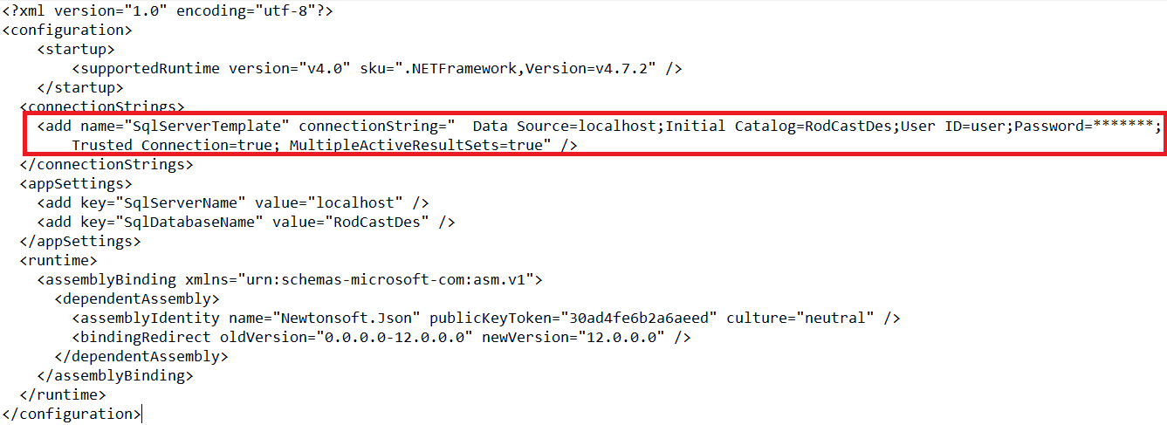
Figure 1: Important fields for AlfaConverter configuration
configuration/connectionStrings
Contains a database connection string with name “SqlServerTemplate”, which is used by the application to connect to an SQL Server (DataSource field), a database (Initial Catalog field) and to enter the user credentials for the connection (User Id and Password field).
configuration/appSettings
They contain key-value type configurations. There are two:
- SqlServerName: Name of the server to which it connects by default at startup.
- SqlDatabaseName: Name of the database to which it connects by default at startup.

Alfaconverter use
When you open the desktop application, it initially connects to the server database configured in the App.config file. For example, see the following figure:
Figure 2: Initial opening of the application
Because in the connection process you perform an analysis of the database in search of the tables and their columns, it may take a while to finish displaying the result in the left panel. This result can be seen below:
Figure 3: Initial load of the tables of the configured database
In this state, the user can modify the name of the server, in which case the drop-down list of databases is updated with the new listing. The user can also select another database if desired:
Figure 4: Displaying the BD list
When selecting a different database, the list of tables in the left pane is updated as can be seen below:
Figure 5:Selection of another database
The left panel allows an agile exploration of the database through its tables. Display a table shows your list of columns:
Figure 6:Showing list of columns in tables
In the previous figure it can be seen that in addition to the list of columns, additional information is also shown differentiated by a color code:
- Green: Column type.
- Grey: Indicates if the field can be NULL.
- Red: Indicate to which table a foreign key points.
- Orange: Indicates the list of tables that point to the current table field.

SQL to JSON conversion
Being easy to obtain important information from the Country table, this table will be processed to JSON detailing the fields it has:
- It has three fields: pais, nombre and CodigoId. You can also quickly see their types and if they can be NUL.
- The field Pais.CodigoId points to the Codigo.CodigoId.
- The field Pais.paisid is referred to by the Cliente.paisid.
Next, the user can select one or more tables:
Figure 7:Selecting an SQL table
By clicking on the process icon (Gear):
Figure 8:"Process" button in the AlfaConverter tool
The application performs an analysis of the selected table and generates an equivalent JSON in the right panel:
Figure 9:Conversion of an SQL table to JSON
As can be seen in Figure 8, the JSON that has been generated explains the SQL relationships originating in the Client table:
- As Cliente.paisid is a foreign key to the Pais table, in the JSON structure it translates into a field called “Pais” which in turn contains fields according to its table.
- As Pais.CodigoId is a foreign key to the Codigo table, in the JSON structure it translates into a field called "Codigo" within the "Pais" field which in turn contains fields according to its table.
- As Pais.paisid is referred to by the Cliente table, a “Cliente” field is created (note the automation of the plural), which is of the array type. As the "Cliente" object has already been defined at a higher level, to avoid infinite loops, this branch of the JSON structure is stopped here.
- The same thing happens with the “Pais” field that is autogenerated in the plural within the “Codigo” field. As the “Pais” structure has been generated at higher levels, the definition of the branch is also stopped here to avoid the infinite loop.
- SQL types are converted to NoSQL types:
  - Integer translates to Integer.
  - Varchar translates to String.

Conversion of several SQL tables to JSON
It is also possible to generate a JSON from multiple tables as seen in the following image:
Figure 10:Conversion of two SQL tables to JSON structure
In this case, the structure for the Pais table is generated following the relationships taking that table as a starting point. By jointly generating Cliente and Pais, it is easy to realize the action of infinite loop protection:
- The “Pais” field slows its definition in the “Clientes” field because it was already defined at a higher level.
- However, when the “Pais” structure is defined in parallel, the “Clientes” structure is defined.

Import SQL script
In addition to being able to access an existing database, the application has the possibility to import an SQL script with DDL statements using the import button as shown in the following image:
Figure 11:"Import" button of the AlfaConverter tool

Figure 12:Importing a SQL script into AlfaConverter
If the import was successful, the application will display a message similar to the one below as a notification to the user:
Figure 13:Notification message by AlfaConverter tool
After which, it is possible to select the new database as one more:
Figure 14:Viewing a new imported data database

