The project VLDB is divided into the following folders:

- Metamodel: contains the metamodel ASD.

- Transformations: contains the ATL transformations to generate a annotated model (ServiceAnnotation.atl) and the generator contracts (ContractGeneration.atl).

- Launchers: contains two folders.

* ContractGeneration: contains the launcher to generate test examples of ContractGeneration.
* ServiceAnnotation: contains the launcher to generate test examples of ServiceAnnotation.

- Models: This folder is divided into three other folders.

* Original: contains the examples in the paper being prepared (POCliente, POClientEvolution, POService and POServiceEvolution) expressed in ASD models.
* Annotated: contains the result of the generation of the services annotated.
* POClientAnnotated: is generated from the model POClient (Source) and POClientEvolution (Target).
* POClienteEvolutionAnnotated: is generated from the model POClientEvolucion (Source) and POClient (Target).
* POServiceAnnotated:is generated from the model POService (Source) and POServiceEvolution (Target).
* POServiceEvolutionAnnotated: is generated from the model POServiceEvolution (Source) and POService (Target).
* Contract: contains the result of the generation contracts.
  + ContractPOClient_POClientEvolution: ContractPOClient_POClientEvolution is generated from models POClientEvolutionAnnotated (Provider) POClientAnnotated (Client).

To use the launcher to try other model input should do the following:

Example to change the configuration of the launcher that generates generating contracts.

Select the file GenerateContractModel.launch that is inside VLDB/Launchers/ContractGeneration and clicking the right mouse button get the following menu:

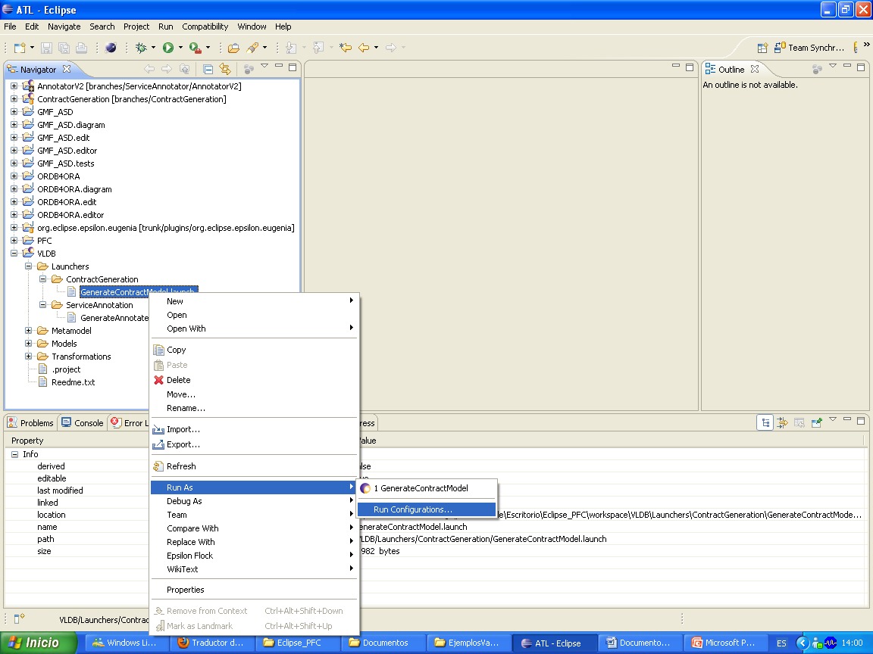

Select "Run As" and then "Run Configurations ...".

Once this is done open other the window:

  
To change the Provider model should be press the button "Workspace" and select one of the listed models that are generated in VLDB / Models / Annotated.

The same is done to choose the model client.

Finally change the name of the output model:

/ VLDB / Models / Contract / ContractPOClient_POClientEvolution.xmi / VLDB / Models / Contract / newoutmodel.xmi

Click on "Apply" then "Run" and the model output will be generated with the new name in the folder / VLDB / Models / Contract.

The same should be done to change the configuration of the launcher that generates annotated models except the input models are in / VLDB / Models / Original and models are saved in the folder / VLDB / Models / Annotated.

The name of launcher that generates annotated models is “GenerateAnnotatedModel.launch” and is in this folder: VLDB/Launchers/ServiceAnnotation.