Задание 1. Даны два неотрицательных числа a и b. Найти их среднее

геометрическое, т. е. квадратный корень из их произведения:√(a · b).

XAML

<Window x:Class="V10.MainWindow"

xmlns="http://schemas.microsoft.com/winfx/2006/xaml/presentation"

xmlns:x="http://schemas.microsoft.com/winfx/2006/xaml"

xmlns:d="http://schemas.microsoft.com/expression/blend/2008"

xmlns:mc="http://schemas.openxmlformats.org/markup-compatibility/2006"

xmlns:local="clr-namespace:V10"

mc:Ignorable="d"

Title="MainWindow" WindowStyle="ToolWindow" Height="450" Width="800" ResizeMode="NoResize">

<Grid>

<Grid.RowDefinitions>

<RowDefinition></RowDefinition>

<RowDefinition></RowDefinition>

<RowDefinition></RowDefinition>

<RowDefinition></RowDefinition>

<RowDefinition></RowDefinition>

</Grid.RowDefinitions>

<Grid.ColumnDefinitions>

<ColumnDefinition></ColumnDefinition>

<ColumnDefinition></ColumnDefinition>

<ColumnDefinition></ColumnDefinition>

</Grid.ColumnDefinitions>

<Label Content="Задание 1" FontSize="32" VerticalAlignment="Center" HorizontalAlignment="Center" Grid.ColumnSpan="3"></Label>

<Label Content="a" FontSize="32" VerticalAlignment="Center" HorizontalAlignment="Center" Grid.Row="1"></Label>

<TextBox Background="LightGray" Width="200" FontSize="32" x:Name="NumberA" Grid.Row="1" Grid.Column="1" VerticalAlignment="Center" HorizontalAlignment="Center"/>

<Label Content="b" FontSize="32" VerticalAlignment="Center" HorizontalAlignment="Center" Grid.Row="2"></Label>

<TextBox Background="LightGray" Width="200" FontSize="32" x:Name="NumberB" Grid.Row="2" Grid.Column="1" VerticalAlignment="Center" HorizontalAlignment="Center"/>

<Label Content="Ответ:" FontSize="32" VerticalAlignment="Center" HorizontalAlignment="Center" Grid.Row="3"></Label>

<Label x:Name="NAnswer" FontSize="32" VerticalAlignment="Center" HorizontalAlignment="Center" Grid.Row="3" Grid.Column="1" Grid.ColumnSpan="2"></Label>

<Button x:Name="BtnOk" Grid.Row="4" Grid.Column="1" Content="OK" FontSize="32" Background="#FF2211" Click="BtnOk_Click"></Button>

</Grid>

</Window>

CS

using System;

using System.Collections.Generic;

using System.Linq;

using System.Text;

using System.Threading.Tasks;

using System.Windows;

using System.Windows.Controls;

using System.Windows.Data;

using System.Windows.Documents;

using System.Windows.Input;

using System.Windows.Media;

using System.Windows.Media.Imaging;

using System.Windows.Navigation;

using System.Windows.Shapes;

namespace V10

{

/// <summary>

/// Логика взаимодействия для MainWindow.xaml

/// </summary>

public partial class MainWindow : Window

{

public MainWindow()

{

InitializeComponent();

}

private void BtnOk_Click(object sender, RoutedEventArgs e)

{

double a = Convert.ToDouble(NumberA.Text);

if (a < 0)

{

NumberA.Text = "A !< 0";

}

double b = Convert.ToDouble(NumberB.Text);

if (b < 0)

{

NumberA.Text = "B !< 0";

}

if (a >= 0 && b >= 0)

{

double c = Math.Sqrt(a * b);

NAnswer.Content = c;

}

}

}

}

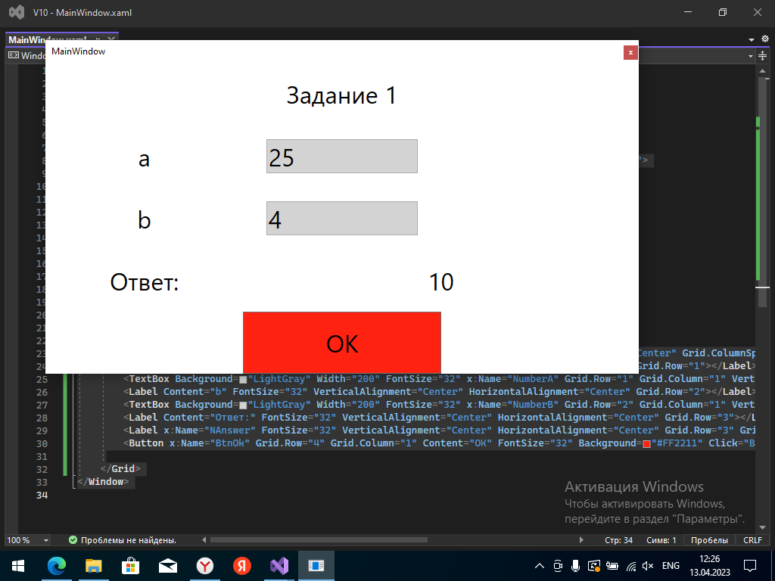

Задание 2. Даны координаты трех вершин треугольника: (x1, y1), (x2, y2), (x3, y3).

Найти его периметр и площадь, используя формулу для расстояния между двумя

точками на плоскости.

√((x2 − x1

)

2 + (y2 − y1

)

2)

Для нахождения площади треугольника со сторонами a, b, c использовать

формулу Герона:

S =√(p · (p − a) · (p − b) · (p − c)),

где p = (a + b + c)/2 — полупериметр.

XAML

<Window x:Class="V10.MainWindow"

xmlns="http://schemas.microsoft.com/winfx/2006/xaml/presentation"

xmlns:x="http://schemas.microsoft.com/winfx/2006/xaml"

xmlns:d="http://schemas.microsoft.com/expression/blend/2008"

xmlns:mc="http://schemas.openxmlformats.org/markup-compatibility/2006"

xmlns:local="clr-namespace:V10"

mc:Ignorable="d"

Title="MainWindow" WindowStyle="ToolWindow" Height="500" Width="800" ResizeMode="NoResize">

<Grid>

<Grid.RowDefinitions>

<RowDefinition></RowDefinition>

<RowDefinition></RowDefinition>

<RowDefinition></RowDefinition>

<RowDefinition></RowDefinition>

<RowDefinition></RowDefinition>

<RowDefinition></RowDefinition>

<RowDefinition></RowDefinition>

<RowDefinition></RowDefinition>

<RowDefinition></RowDefinition>

<RowDefinition></RowDefinition>

<RowDefinition></RowDefinition>

</Grid.RowDefinitions>

<Grid.ColumnDefinitions>

<ColumnDefinition></ColumnDefinition>

<ColumnDefinition></ColumnDefinition>

<ColumnDefinition></ColumnDefinition>

</Grid.ColumnDefinitions>

<Label Content="Задание 2" FontSize="20" VerticalAlignment="Center" HorizontalAlignment="Center" Grid.ColumnSpan="3"></Label>

<Label Content="x1" FontSize="20" VerticalAlignment="Center" HorizontalAlignment="Center" Grid.Row="1"></Label>

<TextBox Grid.ColumnSpan="2" Background="LightGray" Width="500" FontSize="20" x:Name="NumberX1" Grid.Row="1" Grid.Column="1" VerticalAlignment="Center" HorizontalAlignment="Center"/>

<Label Content="x2" FontSize="20" VerticalAlignment="Center" HorizontalAlignment="Center" Grid.Row="2"></Label>

<TextBox Grid.ColumnSpan="2" Background="LightGray" Width="500" FontSize="20" x:Name="NumberX2" Grid.Row="2" Grid.Column="1" VerticalAlignment="Center" HorizontalAlignment="Center"/>

<Label Content="x3" FontSize="20" VerticalAlignment="Center" HorizontalAlignment="Center" Grid.Row="3"></Label>

<TextBox Grid.ColumnSpan="2" Background="LightGray" Width="500" FontSize="20" x:Name="NumberX3" Grid.Row="3" Grid.Column="1" VerticalAlignment="Center" HorizontalAlignment="Center"/>

<Label Content="y1" FontSize="20" VerticalAlignment="Center" HorizontalAlignment="Center" Grid.Row="4"></Label>

<TextBox Grid.ColumnSpan="2" Background="LightGray" Width="500" FontSize="20" x:Name="NumberY1" Grid.Row="4" Grid.Column="1" VerticalAlignment="Center" HorizontalAlignment="Center"/>

<Label Content="y2" FontSize="20" VerticalAlignment="Center" HorizontalAlignment="Center" Grid.Row="5"></Label>

<TextBox Grid.ColumnSpan="2" Background="LightGray" Width="500" FontSize="20" x:Name="NumberY2" Grid.Row="5" Grid.Column="1" VerticalAlignment="Center" HorizontalAlignment="Center"/>

<Label Content="y3" FontSize="20" VerticalAlignment="Center" HorizontalAlignment="Center" Grid.Row="6"></Label>

<TextBox Grid.ColumnSpan="2" Background="LightGray" Width="500" FontSize="20" x:Name="NumberY3" Grid.Row="6" Grid.Column="1" VerticalAlignment="Center" HorizontalAlignment="Center"/>

<Label Content="Ответ:" FontSize="20" VerticalAlignment="Center" HorizontalAlignment="Center" Grid.Row="7"></Label>

<Label x:Name="NAnswer" FontSize="20" Grid.RowSpan="2" VerticalAlignment="Center" HorizontalAlignment="Center" Grid.Row="7" Grid.Column="1" Grid.ColumnSpan="2"></Label>

<Button x:Name="BtnOk" Grid.Row="11" Grid.Column="1" Content="OK" FontSize="20" Background="#FF2211" Click="BtnOk_Click"></Button>

</Grid>

</Window>

CS

using System;

using System.Collections.Generic;

using System.Linq;

using System.Text;

using System.Threading.Tasks;

using System.Windows;

using System.Windows.Controls;

using System.Windows.Data;

using System.Windows.Documents;

using System.Windows.Input;

using System.Windows.Media;

using System.Windows.Media.Imaging;

using System.Windows.Navigation;

using System.Windows.Shapes;

using static System.Math;

namespace V10

{

/// <summary>

/// Логика взаимодействия для MainWindow.xaml

/// </summary>

public partial class MainWindow : Window

{

public MainWindow()

{

InitializeComponent();

}

private void BtnOk_Click(object sender, RoutedEventArgs e)

{

double x1 = Convert.ToDouble(NumberX1.Text);

double x2 = Convert.ToDouble(NumberX2.Text);

double x3 = Convert.ToDouble(NumberX3.Text);

double y1 = Convert.ToDouble(NumberY1.Text);

double y2 = Convert.ToDouble(NumberY2.Text);

double y3 = Convert.ToDouble(NumberY3.Text);

double a = Sqrt(Pow(x2 - x1,2)+Pow(y2 - y1,2));

double b = Sqrt(Pow(x3 - x2,2)+Pow(y3 - y2,2));

double c = Sqrt(Pow(x1 - x3,2)+Pow(y1 - y3,2));

double p = (a + b + c) / 2;

double S = Sqrt(p * (p - a) * (p - b) * (p - c));

double P = a + b + c;

NAnswer.Content = $"S = {S} \nP = {P}";

}

}

}

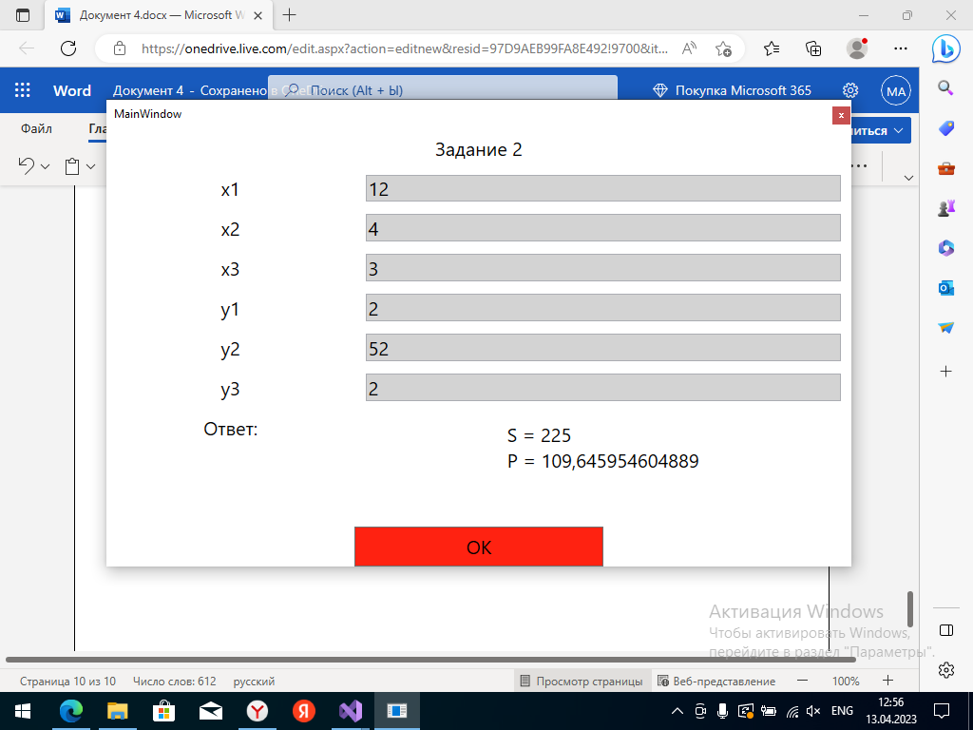

Задание 3.Дано значение угла α в радианах (0 ≤ α < 2·π). Определить значение

этого же угла в градусах, учитывая, что 180° = π радианов. В качестве значения π

использовать 3.14.

XAML

<Window x:Class="V10.MainWindow"

xmlns="http://schemas.microsoft.com/winfx/2006/xaml/presentation"

xmlns:x="http://schemas.microsoft.com/winfx/2006/xaml"

xmlns:d="http://schemas.microsoft.com/expression/blend/2008"

xmlns:mc="http://schemas.openxmlformats.org/markup-compatibility/2006"

xmlns:local="clr-namespace:V10"

mc:Ignorable="d"

Title="MainWindow" WindowStyle="ToolWindow" Height="400" Width="800" ResizeMode="NoResize">

<Grid>

<Grid.RowDefinitions>

<RowDefinition></RowDefinition>

<RowDefinition></RowDefinition>

<RowDefinition></RowDefinition>

<RowDefinition></RowDefinition>

<RowDefinition></RowDefinition>

</Grid.RowDefinitions>

<Grid.ColumnDefinitions>

<ColumnDefinition></ColumnDefinition>

<ColumnDefinition></ColumnDefinition>

<ColumnDefinition></ColumnDefinition>

</Grid.ColumnDefinitions>

<Label Content="Задание 3" FontSize="20" VerticalAlignment="Center" HorizontalAlignment="Center" Grid.ColumnSpan="3"></Label>

<Label Content="a" FontSize="20" VerticalAlignment="Center" HorizontalAlignment="Center" Grid.Row="1"></Label>

<TextBox Grid.ColumnSpan="2" Background="LightGray" Width="500" FontSize="20" x:Name="NumberA" Grid.Row="1" Grid.Column="1" VerticalAlignment="Center" HorizontalAlignment="Center"/>

<Label Content="Ответ:" FontSize="20" VerticalAlignment="Center" HorizontalAlignment="Center" Grid.Row="3"></Label>

<Label x:Name="NAnswer" FontSize="20" VerticalAlignment="Center" HorizontalAlignment="Center" Grid.Row="3" Grid.Column="1" Grid.ColumnSpan="2"></Label>

<Button x:Name="BtnOk" Grid.Row="11" Grid.Column="1" Content="OK" FontSize="20" Background="#FF2211" Click="BtnOk_Click"></Button>

</Grid>

</Window>

CS

using System;

using System.Collections.Generic;

using System.Linq;

using System.Text;

using System.Threading.Tasks;

using System.Windows;

using System.Windows.Controls;

using System.Windows.Data;

using System.Windows.Documents;

using System.Windows.Input;

using System.Windows.Media;

using System.Windows.Media.Imaging;

using System.Windows.Navigation;

using System.Windows.Shapes;

using static System.Math;

namespace V10

{

/// <summary>

/// Логика взаимодействия для MainWindow.xaml

/// </summary>

public partial class MainWindow : Window

{

public MainWindow()

{

InitializeComponent();

}

private void BtnOk_Click(object sender, RoutedEventArgs e)

{

double a = Convert.ToDouble(NumberA.Text);

if(a >= 0 && a < 2 * 3.14)

{

double b = a * 180;

NAnswer.Content = b;

}

else

{

NAnswer.Content = "a !>= 0 || a !< 2 * 3.14";

}

}

}

}

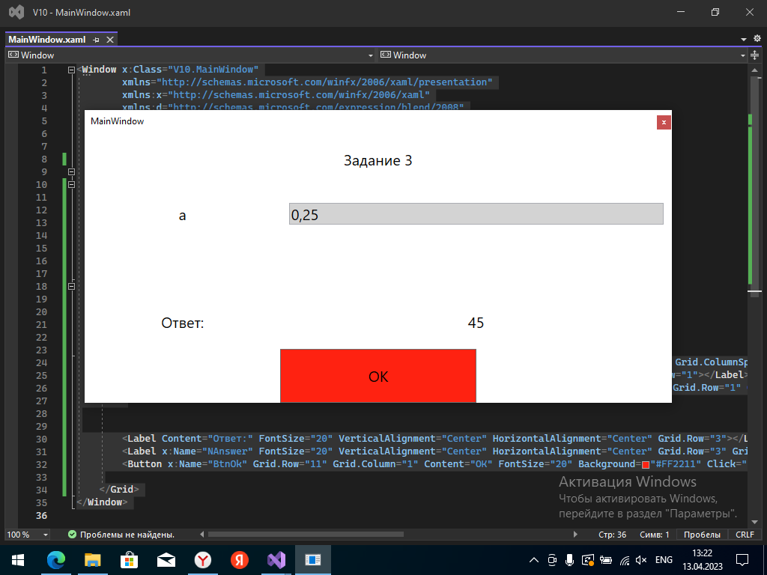

Задание 4.

Найти значение выражения. Исходные данные необходимо подобрать

самостоятельно, исходя из допустимой области значений исследуемой функции.

D =

L + sin lλ

2 + cos λ

2 + λ − 10λ

, где L = 1 + 24.86 ∙ 10−2

XAML

<Window x:Class="V10.MainWindow"

xmlns="http://schemas.microsoft.com/winfx/2006/xaml/presentation"

xmlns:x="http://schemas.microsoft.com/winfx/2006/xaml"

xmlns:d="http://schemas.microsoft.com/expression/blend/2008"

xmlns:mc="http://schemas.openxmlformats.org/markup-compatibility/2006"

xmlns:local="clr-namespace:V10"

mc:Ignorable="d"

Title="MainWindow" WindowStyle="ToolWindow" Height="400" Width="800" ResizeMode="NoResize">

<Grid>

<Grid.RowDefinitions>

<RowDefinition></RowDefinition>

<RowDefinition></RowDefinition>

<RowDefinition></RowDefinition>

<RowDefinition></RowDefinition>

<RowDefinition></RowDefinition>

</Grid.RowDefinitions>

<Grid.ColumnDefinitions>

<ColumnDefinition></ColumnDefinition>

<ColumnDefinition></ColumnDefinition>

<ColumnDefinition></ColumnDefinition>

</Grid.ColumnDefinitions>

<Label Content="Задание 4" FontSize="20" VerticalAlignment="Center" HorizontalAlignment="Center" Grid.ColumnSpan="3"></Label>

<Label Content="Lya" FontSize="20" VerticalAlignment="Center" HorizontalAlignment="Center" Grid.Row="1"></Label>

<TextBox Grid.ColumnSpan="2" Background="LightGray" Width="500" FontSize="20" x:Name="NumberLya" Grid.Row="1" Grid.Column="1" VerticalAlignment="Center" HorizontalAlignment="Center"/>

<Label Content="l" FontSize="20" VerticalAlignment="Center" HorizontalAlignment="Center" Grid.Row="2"></Label>

<TextBox Grid.ColumnSpan="2" Background="LightGray" Width="500" FontSize="20" x:Name="Numberl" Grid.Row="2" Grid.Column="1" VerticalAlignment="Center" HorizontalAlignment="Center"/>

<Label Content="D =" FontSize="20" VerticalAlignment="Center" HorizontalAlignment="Center" Grid.Row="3"></Label>

<Label x:Name="NAnswer" FontSize="20" VerticalAlignment="Center" HorizontalAlignment="Center" Grid.Row="3" Grid.Column="1" Grid.ColumnSpan="2"></Label>

<Button x:Name="BtnOk" Grid.Row="11" Grid.Column="1" Content="OK" FontSize="20" Background="#FF2211" Click="BtnOk_Click"></Button>

</Grid>

</Window>

CS

using System;

using System.Collections.Generic;

using System.Linq;

using System.Text;

using System.Threading.Tasks;

using System.Windows;

using System.Windows.Controls;

using System.Windows.Data;

using System.Windows.Documents;

using System.Windows.Input;

using System.Windows.Media;

using System.Windows.Media.Imaging;

using System.Windows.Navigation;

using System.Windows.Shapes;

using static System.Math;

namespace V10

{

/// <summary>

/// Логика взаимодействия для MainWindow.xaml

/// </summary>

public partial class MainWindow : Window

{

public MainWindow()

{

InitializeComponent();

}

private void BtnOk_Click(object sender, RoutedEventArgs e)

{

double Lya = Convert.ToDouble(NumberLya.Text);

double l = Convert.ToDouble(Numberl.Text);

double L = 1 + 24.86 * Pow(10, -2);

double D = (L + Sin(l * Lya)) / (2 + Cos(Pow(Lya, 2))) + Lya - Pow(10, Lya);

NAnswer.Content = D;

}

}

}

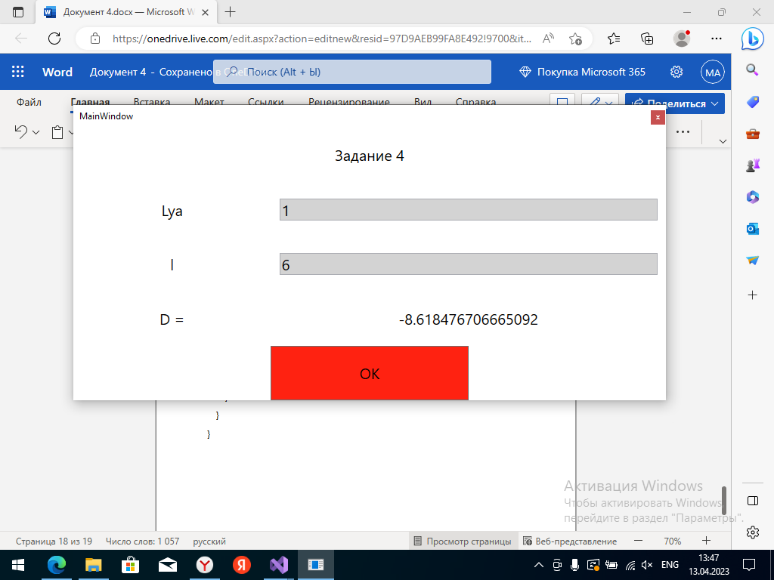

Задание *

Если выполнили все задания практической работы No1

Найти решение системы линейных уравнений вида

A1·x + B1·y = C1,A2·x + B2·y = C2,

заданной своими коэффициентами A1, B1, C1, A2, B2, C2, если известно, что

данная система имеет единственное решение.

Воспользоваться формулами

x = (C1·B2 − C2·B1)/D, y = (A1·C2 − A2·C1)/D, где D = A1·B2 − A2·B1.

<Window x:Class="WpfApp24.MainWindow"

xmlns="http://schemas.microsoft.com/winfx/2006/xaml/presentation"

xmlns:x="http://schemas.microsoft.com/winfx/2006/xaml"

xmlns:d="http://schemas.microsoft.com/expression/blend/2008"

xmlns:mc="http://schemas.openxmlformats.org/markup-compatibility/2006"

xmlns:local="clr-namespace:WpfApp24"

mc:Ignorable="d"

Title="MainWindow" Height="450" Width="800">

<Grid>

<Grid.RowDefinitions>

<RowDefinition ></RowDefinition>

<RowDefinition ></RowDefinition>

<RowDefinition ></RowDefinition>

<RowDefinition ></RowDefinition>

<RowDefinition ></RowDefinition>

<RowDefinition ></RowDefinition>

<RowDefinition ></RowDefinition>

<RowDefinition ></RowDefinition>

<RowDefinition ></RowDefinition>

</Grid.RowDefinitions>

<Grid.ColumnDefinitions>

<ColumnDefinition></ColumnDefinition>

<ColumnDefinition></ColumnDefinition>

<ColumnDefinition></ColumnDefinition>

</Grid.ColumnDefinitions>

<Label HorizontalAlignment="Center" FontSize="30" VerticalAlignment="Center">A1= </Label>

<Label HorizontalAlignment="Center" FontSize="30" VerticalAlignment="Center" Grid.Row="1">B1= </Label>

<Label HorizontalAlignment="Center" FontSize="30" VerticalAlignment="Center" Grid.Row="2">C1= </Label>

<Label HorizontalAlignment="Center" FontSize="30" VerticalAlignment="Center" Grid.Row="3">A2= </Label>

<Label HorizontalAlignment="Center" FontSize="30" VerticalAlignment="Center" Grid.Row="4">B2= </Label>

<Label HorizontalAlignment="Center" FontSize="30" VerticalAlignment="Center" Grid.Row="5">C2= </Label>

<Label FontSize="30" VerticalAlignment="Center" Grid.ColumnSpan="2" Grid.Row="6" x:Name="Otvx">x = </Label>

<Label FontSize="30" VerticalAlignment="Center" Grid.ColumnSpan="2" Grid.Row="7" x:Name="Otvy">y= </Label>

<Label HorizontalAlignment="Center" FontSize="30" VerticalAlignment="Center" Grid.Column="1" Grid.Row="0"></Label>

<Label HorizontalAlignment="Center" FontSize="30" VerticalAlignment="Center" Grid.Column="1" Grid.Row="1"></Label>

<Label HorizontalAlignment="Center" FontSize="30" VerticalAlignment="Center" Grid.Column="1" Grid.Row="2"></Label>

<Label HorizontalAlignment="Center" FontSize="30" VerticalAlignment="Center" Grid.Column="1" Grid.Row="3"></Label>

<Label HorizontalAlignment="Center" FontSize="30" VerticalAlignment="Center" Grid.Column="1" Grid.Row="4"></Label>

<Label HorizontalAlignment="Center" FontSize="30" VerticalAlignment="Center" Grid.Column="1" Grid.Row="5"></Label>

<Button x:Name="OK" Grid.Column="1" Grid.Row="8" Click="OK_Click" Content="OK" FontSize="30" ></Button>

<TextBox Grid.Column="1" Grid.Row="0" HorizontalContentAlignment="Center" VerticalContentAlignment="Center" FontSize="30" x:Name="polA1"></TextBox>

<TextBox Grid.Column="1" Grid.Row="1" HorizontalContentAlignment="Center" VerticalContentAlignment="Center" FontSize="30" x:Name="polB1"></TextBox>

<TextBox Grid.Column="1" Grid.Row="2" HorizontalContentAlignment="Center" VerticalContentAlignment="Center" FontSize="30" x:Name="polC1"></TextBox>

<TextBox Grid.Column="1" Grid.Row="3" HorizontalContentAlignment="Center" VerticalContentAlignment="Center" FontSize="30" x:Name="polA2"></TextBox>

<TextBox Grid.Column="1" Grid.Row="4" HorizontalContentAlignment="Center" VerticalContentAlignment="Center" FontSize="30" x:Name="polB2"></TextBox>

<TextBox Grid.Column="1" Grid.Row="5" HorizontalContentAlignment="Center" VerticalContentAlignment="Center" FontSize="30" x:Name="polC2"></TextBox>

</Grid>

</Window>

CS

int A1 = Convert.ToInt32(polA1.Text);

int B1 = Convert.ToInt32(polB1.Text);

int C1 = Convert.ToInt32(polC1.Text);

int A2 = Convert.ToInt32(polA2.Text);

int B2 = Convert.ToInt32(polB2.Text);

int C2 = Convert.ToInt32(polC2.Text);

int D = (A1 * B2) - (B1 * A2);

double x =(double) (C1 * B2 - C2 * B1) / D;

double y =(double) (A1 * C2 - A2 * C1) / D;

Otvx.Content = $" x = {x}";

Otvy.Content = $" y = {y}";

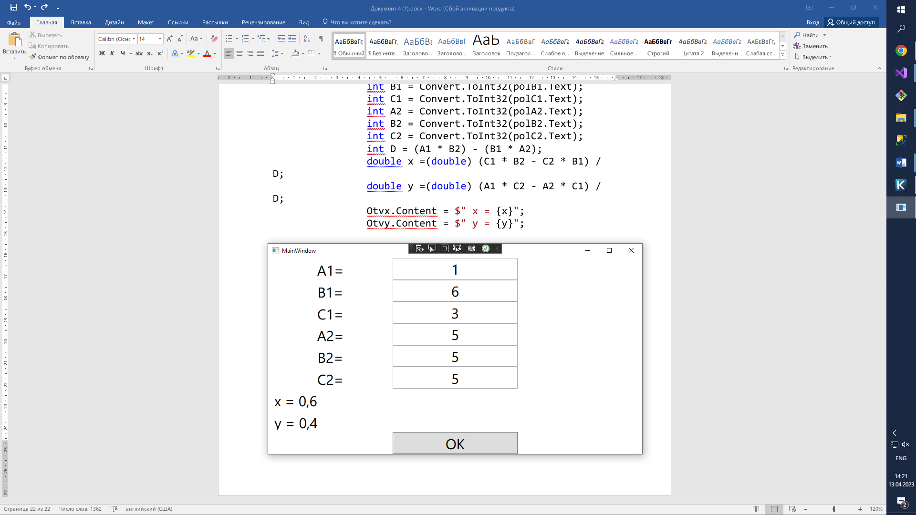

* Задание 1.Даны целые положительные числа A, B, C. На прямоугольнике

размера A × B размещено максимально возможное количество квадратов со стороной

C (без наложений). Найти количество квадратов, размещенных на прямоугольнике, а

также площадь незанятой части прямоугольника.

<Window x:Class="WpfApp26.MainWindow"

xmlns="http://schemas.microsoft.com/winfx/2006/xaml/presentation"

xmlns:x="http://schemas.microsoft.com/winfx/2006/xaml"

xmlns:d="http://schemas.microsoft.com/expression/blend/2008"

xmlns:mc="http://schemas.openxmlformats.org/markup-compatibility/2006"

xmlns:local="clr-namespace:WpfApp26"

mc:Ignorable="d"

Title="MainWindow" Height="450" Width="800">

<Grid>

<Grid.RowDefinitions>

<RowDefinition ></RowDefinition>

<RowDefinition ></RowDefinition>

<RowDefinition ></RowDefinition>

<RowDefinition ></RowDefinition>

<RowDefinition ></RowDefinition>

</Grid.RowDefinitions>

<Grid.ColumnDefinitions>

<ColumnDefinition></ColumnDefinition>

<ColumnDefinition></ColumnDefinition>

<ColumnDefinition></ColumnDefinition>

</Grid.ColumnDefinitions>

<Label HorizontalAlignment="Center" FontSize="30" VerticalAlignment="Center">A = </Label>

<Label HorizontalAlignment="Center" Grid.Row="1" FontSize="30" VerticalAlignment="Center">B= </Label>

<Label HorizontalAlignment="Center" Grid.Row="2" FontSize="30" VerticalAlignment="Center">C= </Label>

<Label FontSize="30" VerticalAlignment="Center" Grid.ColumnSpan="2" Grid.Row="3" x:Name="Otv">Ответ:</Label>

<Label HorizontalAlignment="Center" FontSize="30" VerticalAlignment="Center" Grid.Column="1"></Label>

<Button x:Name="OK" Grid.Column="1" Grid.Row="4" Click="OK_Click" Content="OK" FontSize="30" ></Button>

<TextBox Grid.Column="1" HorizontalContentAlignment="Center" VerticalContentAlignment="Center" FontSize="30" x:Name="polA"></TextBox>

<TextBox Grid.Column="1" Grid.Row="1" HorizontalContentAlignment="Center" VerticalContentAlignment="Center" FontSize="30" x:Name="polB"></TextBox>

<TextBox Grid.Column="1" Grid.Row="2" HorizontalContentAlignment="Center" VerticalContentAlignment="Center" FontSize="30" x:Name="polC"></TextBox>

</Grid>

</Window>

CS

int A = Convert.ToInt32(polA.Text);

int B = Convert.ToInt32(polB.Text);

int C = Convert.ToInt32(polC.Text);

int ObS = A * B;

int malS = C * C;

int pyst = ObS % malS;

int pol = ObS / malS;

Otv.Content = $"Ответ: {pyst} Pol: {pol}";

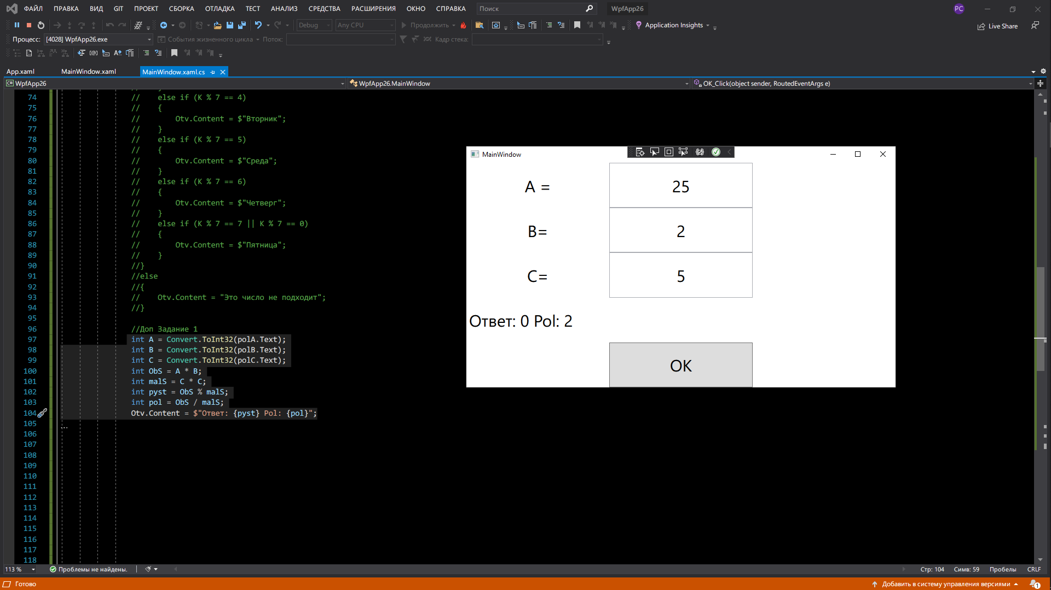

* Задание 2. Дан номер некоторого года (целое положительное число).

Определить соответствующий ему номер столетия, учитывая, что, к примеру, началом

20 столетия был 1901 год.

<Window x:Class="WpfApp26.MainWindow"

xmlns="http://schemas.microsoft.com/winfx/2006/xaml/presentation"

xmlns:x="http://schemas.microsoft.com/winfx/2006/xaml"

xmlns:d="http://schemas.microsoft.com/expression/blend/2008"

xmlns:mc="http://schemas.openxmlformats.org/markup-compatibility/2006"

xmlns:local="clr-namespace:WpfApp26"

mc:Ignorable="d"

Title="MainWindow" Height="450" Width="800">

<Grid>

<Grid.RowDefinitions>

<RowDefinition ></RowDefinition>

<RowDefinition ></RowDefinition>

<RowDefinition ></RowDefinition>

<RowDefinition ></RowDefinition>

</Grid.RowDefinitions>

<Grid.ColumnDefinitions>

<ColumnDefinition></ColumnDefinition>

<ColumnDefinition></ColumnDefinition>

<ColumnDefinition></ColumnDefinition>

</Grid.ColumnDefinitions>

<Label HorizontalAlignment="Center" FontSize="30" VerticalAlignment="Center">Год</Label>

<Label FontSize="30" VerticalAlignment="Center" Grid.ColumnSpan="2" Grid.Row="2" x:Name="Otv">Ответ:</Label>

<Label HorizontalAlignment="Center" FontSize="30" VerticalAlignment="Center" Grid.Column="1"></Label>

<Button x:Name="OK" Grid.Column="1" Grid.Row="3" Click="OK_Click" Content="OK" FontSize="30" ></Button>

<TextBox Grid.Column="1" HorizontalContentAlignment="Center" VerticalContentAlignment="Center" FontSize="30" x:Name="polA"></TextBox>

</Grid>

</Window>

CS

int god = Convert.ToInt32(polA.Text);

if (god > 0)

{

god = god / 100;

Otv.Content = $"{god+1} Столетия";

}

else

{

Otv.Content = "Число меньше нуля";

}

