ASSESSING HIGH LEVEL DATA REPRESENTATION FOR HDM-4

By

PHILIP KYEYUNE KAZIBWE

A dissertation submitted to the University of Birmingham for the degree of Master of Science in Road Management and Engineering

August 2016

University of Birmingham
College of Engineering and Physical Sciences
School of Engineering
Edgbaston Birmingham B15 2TT

Abstract
Economic decision making is at the kernel of highway management. The decisions deal with resource allocation to the most beneficial projects. Computer programs are vital tools in this decision making process. Computers are able to store and process the huge amounts of data that may be required to get a clearer picture before making a decision. These computer programs rely on models which mimic the behaviour of the real road over the course of its lifespan in the virtual world. One such model is the Highway Development and Management Model (HDM-4) (Archondo-Callao, 2008a)
The Highway Development and Management Model (HDM-4) is a popular appraisal tool for road projects (Stannard and Snaith, [no date]). However, adoption of HDM-4 is hindered by the large data requirements to set up and run analyses. High level data representations are a possible solution to these challenges. This project assessed high level data representations for the HDM-4 Model as implemented in HDM-Sentry, a new software aimed at increasing accessibility of the HDM-4 Models. HDM-Sentry is a ‘simplified HDM-4 data-preparation and analysis tool’ developed as a simpler and improved user interface to the HDM-4 model. It relies on simpler high level data descriptors to enable the user to set up and run an analysis in four simple steps.
Four main inputs to HDM-Sentry were considered in this project; Traffic Volume, Traffic Growth, Initial road Condition and Geometry. A full factorial experiment design was used to run analyses at all the various levels of the four inputs. Analyses were done for all the maintenance alternatives for gravel surfaced and bituminous surfaced roads. The NPV and average IRI outputs from the analyses were used in an ANOVA sensitivity analysis.
The results show that the NPV for gravel roads is significantly influenced by the traffic volume while the NPV for bituminous roads is influenced by both the initial condition and the traffic volume. The condition was found to be the main input affecting the average IRI for bituminous roads.
The ranges of the two identified major inputs were compared to road information from an actual road network using data from the Uganda National Road Authority (UNRA). The range of the inputs was observed not to cover the full input space from this network. Further work is recommended to improve the responsiveness of the high level descriptors to conditions that may be encountered in practice.

Acknowledgments
This dissertation is the end result of years of work by the many people who have encouraged me, guided me, advised me and kept me on the safe path despite my best efforts to wander off. It is impossible to thank them all without writing a whole book (Which I intend to do one day). The following is therefore not a complete list of all the people that ultimately have had an influence on this work.
I thank my supervisor Dr. Eric Stannard and the team at HDM-Global for giving me the exciting opportunity to work with their software and all the support they provided during the course of this project. I thank Dr. Micheal Burrow my personal tutor and the course convener for the guidance throughout the course of my studies at the University of Birmingham. The journey of discovery has been more interesting with the signals he provided at each fork in the road.
I thank the Commonwealth Scholarship Commission and the University of Birmingham whose financial assistance made my studies at the School of Engineering possible.
Special thanks to my friends Mr. Otokurubu (Toku) Iboroma and Mr. Justice Ohemeng for the company and assistance in the course of the academic year and specifically for the help during the writing of this dissertation. Thanks to Hao Tian for the assistance in using HDM-4 and the manuals.
Finally, I thank my family for the support they gave me in this year away from home and for every time they have supported me and encouraged me to continue when I was ready to give up.

Table of Contents
1 INTRODUCTION 1
1.1 Background 1
1.2 Utility of high level data representations 1
1.3 Aims and Objectives 2
2 LITERATURE REVIEW 4
2.1 The Highway Development and Management (HDM-4) Model 4
2.1.1 Development of HDM-4 4
2.1.2 The HDM-4 Model 4
2.2 Highway Development and Management Simplified Entry (HDM-Sentry) 5
2.3 Sensitivity Analysis of Computer Models 8
2.3.1 One at a Time Sensitivity Analysis (OAT) 8
2.3.2 Global Sensitivity Analysis methods 8
2.3.3 Factorial Experiments 9
2.3.4 Analysis of variance (ANOVA) in factorial experiments 10
2.3.5 Sensitivity Analyses of HDM-4 Model 10
3 METHODOLOGY 12
3.1 Introduction 12
3.2 Automation of HDM-Sentry Analysis 12
3.3 Experiment Design 12
3.4 Experiment Runs 14
3.5 Analysis Procedure 15
3.6 Comparison of most significant descriptors with real network values 15
4 RESULTS 16
4.1 Introduction 16
4.2 Actual Data Inputs in The HDM-4 Workspace from Each High Level Descriptor 16
4.3 NPV and IRI Results 17
4.4 Results of ANOVA Sensitivity Analysis 14
5 ANALYSIS AND DISCUSSION 16
5.1 Introduction 16
5.2 Gravel Surface Results 16
5.3 Bituminous Surface Results 17
5.4 Comparison of descriptors to UNRA road Network 17
5.5 Limitations 18
6 CONCLUSIONS 20
REFERENCES 21
Appendix A: Results of ANOVA ANALYSIS 23
Appendix B: Python Scripts Used in Analysis 32
B1: CreateInput.py 32
B2: HDMSentryAuto 32
B3: ResultsExtractor 35

List of Figures
Figure 1: NPV and IRI for Regravelling (Blue) and Upgrading (Green) for gravel road 17
Figure 2: NPV and IRI for Reconstruction (Blue) and Minimum maintenance (Green) of Surface Dressing 17
Figure 3: NPV and IRI for Overlay (Blue) and Resealing (Green) of Surface Dressing 18
Figure 4: NPV and IRI for Overlay (Green) and Resealing (Blue) of Asphalt Concrete 18
Figure 5: NPV and IRI for Reconstruction (Blue) and Minimum maintenance (Green) of Asphalt Road 14
Figure 6: Input levels of each parameter in simulation runs 16
Figure 8: ANOVA results for NPV (Upgrading of a gravel road to bituminous standard) 22
Figure 9: ANOVA results for IRI (Upgrading of a gravel road to bituminous standard) 22
Figure 10: ANOVA results for IRI (Regravelling of a gravel road) 23
Figure 11: ANOVA results for NPV (Regravelling of a gravel road) 23
Figure 12: ANOVA results for IRI (Overlay of a surface dressed road) 24
Figure 13: ANOVA results for NPV (Overlay of a surface dressed road) 24
Figure 14: ANOVA results for IRI (Reseal of a surface dressed road) 25
Figure 15: ANOVA analysis for NPV (Reseal of a surface dressed road) 25
Figure 16: ANOVA analysis for IRI (Minimum maintenance of a surface dressed road) 26
Figure 17: ANOVA results for IRI (Reconstruction of a surface dressed road) 26
Figure 18: ANOVA results for NPV (Reconstruction of a surface dressed road) 27
Figure 19: ANOVA results for IRI (Overlay of an asphalt concrete road) 27
Figure 20 ANOVA results for NPV (Overlay of an asphalt concrete road) 28
Figure 21: ANOVA results for IRI (Reseal of an asphalt concrete road) 28
Figure 22: ANOVA results for NPV (Reseal of an asphalt concrete road) 29
Figure 23: ANOVA results for IRI (Minimum maintenance of an asphalt concrete road) 29
Figure 24: ANOVA results for IRI (Reconstruction of an asphalt concrete road) 30
Figure 25: ANOVA results for NPV (Reconstruction of an asphalt concrete road) 30

List of Tables
Table 1: Development of HDM-4 (Kerali, Odoki and Stannard, 2000) 3
Table 2: Variables in HDM-Sentry (Source: (Thomas Buckland, [no date])) 6
Table 3: Full factorial experiment for three factors 8
Table 4: surface classes and maintenance alternatives considered in the experiment 12
Table 5 Input variables and their experiment codes 12
Table 6 Part of the experiment input matrix 13
Table 7: Surface class and maintenance alternatives considered in each trial run 13
Table 8: Actual HDM-4 inputs for Traffic Growth 15
Table 9: Actual HDM-4 inputs for Traffic Volume 15
Table 10: Actual HDM-4 Inputs for Geometry 15
Table 11: Actual HDM-4 Inputs for Condition 16
Table 12: Summary of ANOVA sensitivity analysis results 15
Table 13: Actual vehicle figures for traffic volume levels 17
Table 14: Comparison of ranges for condition parameters 18

INTRODUCTION

Background
Economic decision making is at the kernel of highway management. These decisions deal with efficient allocation of resources to the most beneficial projects. Computer programs are vital tools in this decision making process. Computers are able to store and process the huge amounts of data that may be required to get a clearer picture before making a decision. These computer programs rely on models which mimic the behaviour of the real road over the course of its lifespan in the virtual world. One such model is the Highway Development and Management Model (HDM-4) (Archondo-Callao, 2008a)
HDM-4 is a computer analysis program used by road management professionals in the economic appraisal of road projects (Kerali et al, 1998). This program has been used in appraisal at the project, programme and strategic network level with success around the world (Kerali, 2001).
Economic appraisal using HDM-4 requires collecting and processing of large amounts of data which makes it an expensive endeavour. The expense arises from the time required by specialised professionals to collect process and analyse the data. This expense limits the number of options that may be considered in the appraisal as above a certain number of options, expenses in terms of time and cost outweigh the potential benefits of considering all options available.
In addition to the problem of expense, the complexity of the data entry process is a barrier to the use of the model (Stannard and Snaith, [no date] ). Many potential users are unable to use the model because they lack the specialised skills required to process the data from the field and enter it into the model. Unfortunately, many times the high level decision makers in the industry are not specialists in the field of road asset management. With the current complex data entry process for the models these key players are unable to use the software to make quick decisions without having to resort to the services of another professional.
To address these challenges, it is necessary for research into methods of reducing the amount of time spent at the data entry phase without affecting the output. This would involve development of simplified entry for the HDM-4 Models. HDM-Sentry (for simplified-entry) is a new program being developed which seeks to enable the user to use simpler data entry for quick analysis (Thomas Buckland, [no date])). This aim of the tool is to simplify the data entry process without adversely affecting the accuracy or validity of the results from the analysis tool.
In analyses using HDMSentry, low level data required by the model is replaced with high level data descriptors. The high level descriptors for the main types of data required by the model enable the data entry process to be simplified and shortened. Selection of these high level descriptors requires in depth analysis to ensure their use does not affect the validity of the outputs of the model in relation to the problem being considered. The proposed high level data descriptors were tested in this project to assess their suitability.

Utility of high level data representations
The large amount of data entry required to make a full HDM-4 run is a big barrier to the widespread adoption of the tool (Stannard and Snaith, [no date]). Many agencies miss out on the potential benefits of using the tool due to a lack of detailed data or a shortage in specialised skills for setting up the analysis. In addition to this, the intricacies in making a full HDM-4 analysis have turned away many non-technical decision makers in the sector with the result that many view the use of the software as a specialised esoteric tool accessible only to the few qualified professionals. The steep learning curve in learning the application of HDM-4 to road project appraisal is also a barrier which is directly linked to the complexities on the data entry and analysis set up (Stannard and Snaith, [no date]).
All these challenges call for the development of simpler methods of data entry and analysis set up for the HDM-4 models. This will increase the accessibility of the tool to the decision makers in the roads industry around the world. One method of simplifying the data entry process is through abstraction or construction of simpler data representatives to the underlying model. These high level descriptors should simplify the process of the user setting up and running an analysis.
These high level descriptors and simplified entry has four main advantages. They enable the user to set up and conduct a quick analysis without having to go through the laborious setting up of the full HDM-4 workspace. This is useful in situations where the decision makers want to consider different options early before zeroing in the few best alternatives and examining those in more detail.
Secondly, the high level descriptors would enable the use of the HDM-4 model in situations where there is inadequate data. The lack of quality data is often a barrier to the use of the model for appraisal of projects. With well-designed high level descriptors, it is possible for the appraisers to use approximations and conduct an analysis instead of giving up on the notion of using the tool altogether.
A simplified entry system for the HDM-4 models will also lower the skills barrier slightly to allow professionals who are conversant with road appraisal methods but may not have a lot of skills with the HDM-4 tool to use it. This has two advantages; there is an increase in the accessibility to the software and the user gets an introduction to the use of the tools. Finally, the simplified entry can be used as a training tool to increase skills in the use of the HDM models for road appraisal (Stannard and Snaith, [no date]).
For all these advantages to be realised, it is necessary to carefully develop the high level descriptors to ensure that the analyses done using them are comparable to the analyses using the full HDM-4 software. This project aims to assess the use of high level data representations for HDM-4.

Aims and Objectives
The main aim of this study was to evaluate descriptors for a high level representation of a typical section in HDM4 and assess the effects of the selected descriptors on the outputs of the HDM-4 model. In particular, the study aimed to meet the following objectives:
- To assess the representative data descriptors for a typical section run in HDM-Sentry;
- Conduct a sensitivity analysis of the economic and deterioration model outputs to the data inputs for HDM-Sentry;
- Identify the significant high level inputs to HDM-Sentry;
- Investigate variations in the output across the input space;
- To investigate the applicability of the data descriptors in real world situations.

LITERATURE REVIEW

The Highway Development and Management (HDM-4) Model

Development of HDM-4
The Highway Development and Management Model (HDM-4) has been used worldwide as a decision support tool for road asset managers since the release of version 1 in 2000 (Kerali, Odoki and Stannard, 2000). This version of HDM-4 was based on the Highway Design and Maintenance Standards Model (HDM-III) which had been developed by the World Bank. The improved version was the result of the International Study of Highway Development and Management (ISOHDM) and aimed at making the software more capable and user friendly. (Kerali, Odoki and Stannard, 2000) show how this improvement in the model fits into the evolution of the software from its beginnings as the Highway Cost Model (HCM) produced at the Massachusetts Institute of Technology (MIT) in 1972. Since then, a second version (HDM-4 Version 2) has been developed and released. The model is constantly evolving to meet the users’ requirements and also take advantage of advances in computers.
Table 1: Development of HDM-4 (Kerali, Odoki and Stannard, 2000)
Model | Year | New features
Highway Cost Model | 1968 | Road work costs  Vehicle operating costs (VOC)
Highway Design and Maintenance Model (HDM) | 1979
Highway Design and Maintenance Model 3 (HDM-III) | 1987
Highway Design and Maintenance Model 3 (HDM-PC) | 1989 | Microcomputer version of HDM Model
HDM-Q | 1994 | Considering effects of traffic congestion in HDM-III program
HDM Manager | 1994 | Menu driven user interface for HDM-III
Highway Development and Management Tool (HDM-4) | 2000 | Traffic congestion models  Cold climate effects considered  Increased range of pavement types  Road Safety  Environmental Effects
Highway Development and Management Tool (HDM-4) Version 2 | 2005 | Sensitivity analysis, Budget scenario analysis, multi-criteria analysis (MCA), social benefits  Improved interoperability on different computer systems

The HDM-4 Model
HDM-4 analysis is accomplished by simulating the behaviour of the road over its life cycle based on the data entered by the user (Morosiuk, Riley and Toole, 2006). Specifically, the model simulates the deterioration of the road, the intervention works, road user effects and environmental effects over the road’s lifetime.
Using the results of the simulations, the model predicts road user costs (RUC) and road agency costs (RAC) which are then used to calculate economic appraisal indicators. The costs from the model are determined by estimation of quantities of physical items and multiplying them with their unit costs (Morosiuk, Riley and Toole, 2006). The road user costs are derived from the user defined vehicle fleets and traffic levels while the road agency costs over the lifetime of the road will depend on the user defined maintenance / development strategy, the environment, and the initial condition of the road. All these factors are utilised in the model to finally compute economic indicator factors like internal rate of return (IRR), net present value (NPV), and cost benefit ratios (BCR). From this process, HDM-4 is able to assist decision making using economic efficiency indicators, multi-year works programmes, and strategic road maintenance/ development plans.
HDM-4 analysis is done using the following four sets of models (Morosiuk, Riley and Toole, 2006):
- Road Deterioration (RD)
- Works Effects (WE)
- Road User Effects (RUE)
- Social and Environmental Effects (SEE)
The results of the whole analysis depend on the results from each of the models. The results of each model in turn depend on the user inputs and the internal calibration of the model. Each of the models has different data requirements for its running. The models require inputs related to the vehicle fleet, road characteristics, works activities, and environmental and social figures HDM-4.
The amount of data that is required to run an analysis in HDM-4 increases the gradient of the learning curve for application of the models. (Archondo-Callao, 2008b) identified collection of network data as one of the biggest challenges to use of HDM-4 at strategic level. This was based on HDM-4 Version 2.04 and not the current version 2.10 which has some improvements. However, setting up an analysis still requires a lot of data. For non-specialist users, including many of the top decision makers, this is often a barrier. One of the other challenges identified by (Archondo-Callao, 2008b) was the commitment of decision makers to the use of HDM-4 in making strategic decisions. Notably, this was in organisations that had already invested in the software. Although the data intensive nature of HDM-4 was not explicitly identified as the cause of this, it is plausible that the inaccessibility contributes to its low adoption by top decision makers for strategic decision making.

Highway Development and Management Simplified Entry (HDM-Sentry)
HDM-Sentry is a ‘simplified HDM-4 data-preparation and analysis tool’ that was developed as a simpler and improved user interface to the HDM-4 model (Stannard and Snaith, [no date]). The tool works by providing template guidance to the user for the entry of the data required by the underlying HDM-4 software (Thomas Buckland, [no date])). The data entered by the HDM-Sentry user is in the form of high level descriptors. HDM-Sentry converts these descriptors into a full HDM-4 workspace for analysis. After HDM-4 has run the analysis the results are sent back and presented to the user in by HDM-Sentry. The version of HDM-Sentry software used in this project is limited to the project analysis of one or more road sections.
The entry of data for analysis in HDM-Sentry is significantly simplified compared to the data entry process in HDM-4. A full analysis for a project can be prepared in four steps (Thomas Buckland, [no date]):
- Analysis Step: The user enters the details of the analysis including the analysis name, analysis period, discount rate and reporting currency;
- Traffic and environment Step: The user chooses the vehicle fleet, traffic growth and climate zone for the analysis;
- Road section Step: The user enters the section name, road class, road geometry, condition, length, traffic volume and surface class;
- Maintenance Alternatives Step: The user enters a maximum of two maintenance alternatives to be analysed.
The whole process of entering the data is completed in four screens (Thomas Buckland, [no date]). The user has a maximum of 15 data input values with relatively understandable non-technical names. Of these, only the analysis name, discount rate, section name and length are typed manually by the user. The rest are chosen from a pre-populated drop-down menu with the choices shown in Table 2.

Table 2: Variables in HDM-Sentry (Source: (Thomas Buckland, [no date]))
Menu | Variables
Traffic Growth | None
 | Low
 | Medium
 | High
Climate Zone | Arid Temperate
 | Arid Tropical
 | Arid Sub Tropical
 | Semi-arid Tropical
 | Semi-arid Sub Tropical
 | Semi-arid Temperate
 | Humid Tropical
 | Humid Sub Tropical
 | Humid Temperate
Road Class | Primary or Trunk
 | Secondary or main
 | Tertiary or Local
Road Geometry | Straight and Level
 | Mostly straight and gently undulating
 | Bendy and generally level
 | Bendy and gently undulating
 | Bendy and severely undulating
 | Winding and gently undulating
 | Winding and severely undulating
Condition | New
 | Good
 | Fair
 | Poor
 | Bad
Traffic Volume | Low Traffic
 | Medium Traffic
 | High Traffic
Surface Class | Surface Dressing
 | Asphaltic Concrete
 | Gravel
 | Earth
Maintenance Alternatives
Unsealed | Regravelling
 | Upgrade
 | Minimum Maintenance
Sealed | Reseal
 | Overlay
 | Reconstruction
 | Minimum Maintenance

These variables are used by HDM-Sentry to create an input space for HDM-4 and analysed. The output from the model is then passed back to HDM-Sentry and presented to the user in the HDM-Sentry results screen (Thomas Buckland, [no date]).
The HDM-Sentry workflow and data requirements can be seen to be significantly simpler and faster in comparison to HDM-4. Additionally, since the software depends on HDM-4 for the analysis, the results from using the two will be similar for similar input values. The difference between analyses by HDM-4 and those by HDM-Sentry will depend on how the high level descriptors in the software will be used to generate the HDM-4 workspace. It is therefore necessary to assess the output in relation to the varying input descriptors. The assessment enables identification of the inputs which have the greatest impact on the output.

Sensitivity Analysis of Computer Models
Application of computer models in simulation requires an understanding of how the model outputs vary with the inputs. This is achieved by sensitivity analysis which is testing the response of the outputs to changes in inputs. Different methods have been developed to improve the effectiveness of the analysis. Local analysis methods rely on changing one variable at a time and observing the effect of the change on the output of the computer models Global sensitivity analysis methods on the other hand change all the variables simultaneously and analyse not only the impacts of each input alone but also the impacts of the interactions between the inputs (Kucherenko, 2009, Saltelli et al., 2010, Sobol′, 2001, Sobol', 1990). (Borgonovo and Plischke, 2016) review the advances in the field of sensitivity analysis and compare the different methods developed to date.

One at a Time Sensitivity Analysis (OAT)
OAT or ceteris paribus sensitivity analysis is a popular quick method of testing the input of a model. It is intuitive and gives a good indication of the effects of a parameter on the output of the model at the points which are chosen for the test. This method has been applied in the sensitivity analysis of the HDM models (Mrawira and Haas, 1996, Bennett and Paterson, 2000). The OAT method is preferred in the sensitivity analysis of the HDM-4 models due to the large number of factors to be considered (Bennett and Paterson, 2000).
Since the analysis is done for given values and changing one factor at time, there is a danger of missing interactions between the inputs of the factors or, in the case of non-linear models, missing effects at points of the input space which are not tested (Saltelli and Annoni, 2010). (Mrawira et al., 1999, Mrawira, 1997) explored the use of global sensitivity analysis methods on the HDM-III models as an alternative to the OAT method. These methods are described in the section below.

Global Sensitivity Analysis methods
Global sensitivity measures depend on analysis of the outputs of the model in relation to the inputs by using statistical methods to measure the impact of changes in the inputs over the whole input space. These methods of analysis take into account the distribution functions of the input parameters and how they affect the output of the model. These methods offer greater insight in the interactions of parameters at the cost of more computation. Various variations of global sensitivity methods for different computer models have been developed and are being applied (Homma and Saltelli, 1996, Sobol′, 2001, Kucherenko, 2009).
(Mrawira et al., 1999) demonstrated the advantages of global sensitivity analysis in the analysis of HDM-III. Latin hypercube sampling was used in combination with statistical approximating functions to fully explore the input space of the models. The study found that use of the global sensitivity analysis methods enables investigation of interactions of the factors which would cannot be discerned using the traditional OAT. However, sensitivity analyses of HDM-4 models have still largely been done using local sensitivity analysis methods.

Factorial Experiments
Factorial experiments are used to explore the response of a model to different levels of the input factors (Montgomery and Runger, 2010). This type of experiment is useful in computer models where the input can be categorised into discrete levels. For each run of the experiment one input is changed from one level to another and this is done for each input such that at the end of the experiment outputs are obtained for all combinations of the input levels (Loucks et al., 2005).
For an experiment with three factors (A, B, C) each with two levels (a₁, a₂, b₁, b₂, c₁, c₂) the full factor experiment would be as shown in Table 3
Table 3: Full factorial experiment for three factors
 | Inputs
Runs | A | B | C | Output
1 | a₁ | b₁ | c₁ | y₁
2 | a₁ | b₁ | c₂ | y₂
3 | a₁ | b₂ | c₁ | y₃
4 | a₁ | b₂ | c₂ | y₄
5 | a₂ | b₁ | c₁ | y₅
6 | a₂ | b₁ | c₂ | y₆
7 | a₂ | b₂ | c₁ | y₇
8 | a₂ | b₂ | c₂ | y₈

This design of experiment permits analysis of the response of the output to each individual input and their interactions using different statistical methods.
For this experiment the effects of input C can be estimated as the average of the effect of changing this input while the other parameters were kept constant (Loucks et al., 2005).

$δ\left(y | C\right)=\frac{\left(y_{2}-y_{1}\right)+\left(y_{4}-y_{3}\right)+\left(y_{6}-y_{5}\right)+\left(y_{2}-y_{1}\right)}{4}$ (2.1)

Where
$δ\left(y | C\right)$: an estimate of the effect that input C has on the output y
The effects of the other factors can be estimated using similar equations. The interactions between the inputs are estimated using interaction equations. The interaction between input C and B can be estimated by considering the difference between the effect of changing C when B is at its highest level and the effect of changing B at the lowest level of C.
$δ\left(y | C,B\right)=\frac{\left(y_{8}-y_{7}\right)+\left(y_{4}-y_{3}\right)-\left(y_{6}-y_{5}\right)+\left(y_{8}-y_{7}\right)}{4}$ (2.2)

$δ\left(y | C,B\right)$: estimate of the interaction effects of B and C
Another statistical method used in the analysis of results of factorial experiments is the analysis of variance method (ANOVA).

Analysis of variance (ANOVA) in factorial experiments
The ANOVA method is a useful tool in measuring the impact of discrete input variables on the output. This method is popular in the design of experiments for optimisation of industrial processes (Oliaei et al., 2016, Montgomery and Runger, 2010). The method has however also been demonstrated to be useful in sensitivity analysis with results that are similar to other global sensitivity analysis methods (Ginot et al., 2006). ANOVA analyses enable investigation of higher order interactions of model inputs. (Borgonovo and Plischke, 2016) identify ANOVA as being at the basis of high dimensional scientific modelling and being instrumental in sensitivity analysis. (Montgomery and Runger, 2010) gives a detailed derivation of the ANOVA identity.
The core principle in ANOVA analysis is partitioning the observed variance in in an output of a model to the influences of the different inputs and any errors or unexplained variations (Montgomery and Runger, 2010). In sensitivity analyses, the test can therefore be used to partition the variance in the model’s output to the influence of each of the parameters. The contribution of each input factor is calculated using the sum of squares of that input compared to the total sum of squares of all the inputs and their interactions (Ginot et al., 2006). For the factorial experiment shown in Table 3, the ANOVA sensitivity can be shown as equations (2.3)

$S_{iA}\%=\frac{{SS}_{A}}{{SS}_{Tot}} ×100; S_{iAB}=\frac{{SS}_{AB}}{{SS}_{Tot}}×100; S_{iABC}=\frac{{SS}_{ABC}}{{SS}_{Tot}}×100$ (2.3)

Where
${SS}_{x}$: The ANOVA sum of squares of x
${SS}_{Tot}$: The total sum of the sums of squares
$S_{iA}$: The sensitivity of index of A;
$S_{iAB}$: The sensitivity index of the AB interactions; and
$S_{iABC}:$The sensitivity index of ABC interactions in the model
The discrete levels of data entry in HDM Sentry are well suited to analysis by factorial experiments together with ANOVA analysis.

Sensitivity Analyses of HDM-4 Model
Sensitivity analysis work has been done on the HDM models by a number of researchers. Local sensitivity analyses were done for the road user effects, road deterioration and works effects by (Bennett and Paterson, 2000). This analysis of the model sensitivity was based on impact elasticity values. Impact elasticity is the ratio of the percentage change in the input to the percentage change in the outputs. The study considered the sensitivity of the WE, and RD models. However, the economic outputs were not considered in the study. Impact elasticity was also applied in assessing the HDM-III model in relation to Tanzanian conditions (Mrawira and Haas, 1996).
Global sensitivity analysis of the HDM-4 model has been done in the past to determine the important input parameters. (Mrawira et al., 1999) assessed the sensitivity of net present value (NPV) to link characterisation factors. The study found that the NPV was most affected by the rutting progression parameter. More importantly, the study established methods that can be applied in the sensitivity analysis of deterministic computer models in engineering like HDM-4. The Gaussian stochastic methods that were used enable a global sensitivity analysis of the model inputs.

METHODOLOGY

Introduction
This study aimed to assess the high level data descriptors used in HDM-Sentry by conducting a sensitivity analysis of the NPV and international roughness index (IRI) outputs to the Traffic Growth (Tg), Condition (Co), Traffic Volume (Tv), Geometry (Ge), Surface Class and Maintenance alternatives. This was done using a full factorial experimental design and analysis of variance methods (Montgomery and Runger, 2010). The experiments in this project considered primary / trunk roads in a humid tropical environment. The variables related to road class and climate zone were therefore kept constant throughout the experiments. The length of the section considered was 30km.
The four variables chosen for inclusion in the factorial experiment are open to variability when entered by different users. For example, perception of high traffic may vary from user to user. However, every user would be able to correctly enter the surface class of the road (a gravel road is a gravel road). The surface conditions and maintenance alternatives were therefore not included in the factorial experiment. Instead, factorial experiments were done for each combination of these two variables. This section describes how the computer runs were arranged, including the software scripts developed for the automation of HDM-Sentry, and the procedure followed in analysing the results using ANOVA methods. This project was done using HDM Sentry 1.0.0.0 and HDM-4 (Version 2.10.00). The automation scripts were written in Python 2.7 (Van Rossum, 2007).

Automation of HDM-Sentry Analysis
HDM-Sentry is a Microsoft windows based application. The application does not have component object model (COM) technology therefore automation was only possible by scripts simulating human input using the dropdown menus and input boxes. The automation of the analysis was done using three scripts.
- Creating the input: The first script was CreateInput.py (Appendix B1). This generated the inputs for a full factorial experimental run for the four parameters and stored them in an input text file. The file was formatted to have the run name and the level for each of the input parameters for that particular run.
- Running HDM-Sentry: The second script was HDMSentryAuto.py (Appendix B2). This read the input file generated in the step above and used the inputs to set up the HDM-Sentry software for a run with the inputs at the required levels. The results of each HDM-Sentry run are automatically stored on the computers local drive.
- Extracting the results: The third script was ResultsExtractor.py (Appendix B3). This script read the results of each analysis which was completed by the HDM-Sentry and stored them in comma separated value (CSV) format for processing.

Experiment Design
The experiment was set up to test the responses of NPV and IRI to the changes in the four (4) chosen variables. A complete experiment trial was done for each of the surface classes and the maintenance alternatives for that particular surface type. The different surface classes and their maintenance alternatives considered are shown in Table 4.
Table 4: surface classes and maintenance alternatives considered in the experiment
Surface Class | Maintenance Alternative
Gravel | Minimum maintenance (U)
 | Regravelling
 | Upgrading
Surface Dressing | Minimum maintenance
 | Reseal
 | Overlay
 | Reconstruction
Asphalt concrete | Minimum maintenance (B)
 | Reseal
 | Overlay
 | Reconstruction
The different levels of the variables in the software were given number codes as shown in Table 5

Table 5 Input variables and their experiment codes
Menu | Variables | Code
Traffic Growth | None | 1
 | Low | 2
 | Medium | 3
 | High | 4
Condition | New | 0
 | Good | 1
 | Fair | 2
 | Bad | 3
 | Poor | 4
Traffic Volume | Low Traffic | 0
 | Medium Traffic | 1
 | High Traffic | 2
Road Geometry | Straight and Level | 0
 | Mostly straight and gently undulating | 1
 | Bendy and generally level | 2
 | Bendy and gently undulating | 3
 | Bendy and severely undulating | 4
 | Winding and gently undulating | 5
 | Winding and severely undulating | 6
Each full simulation of the experiment considered the full combinations of the factors. The total number of runs for the full simulation was 420 (1 factor with 4 levels, one factor with 5 levels, one factor with 3 levels and one factor with 7 levels: 4¹×5¹×3¹×7¹ = 420).
The total input space was generated to give a full factorial experiment. A part of the input matrix for the experiment shown in Table 6
Table 6 Part of the experiment input matrix
Run No. | INPUT PARAMETERS
 | Tg | Co | Tv | Ge
T2Run1 | 1 | 0 | 0 | 0
T2Run2 | 1 | 0 | 0 | 1
T2Run3 | 1 | 0 | 0 | 2
. | . | . | . | .
. | . | . | . | .
T2Run150 | 2 | 2 | 0 | 2
T2Run151 | 2 | 2 | 0 | 3
T2Run152 | 2 | 2 | 0 | 4
T2Run250 | 3 | 1 | 2 | 4
. | . | . | . | .
. | . | . | . | .
T2Run350 | 4 | 1 | 1 | 6
T2Run351 | 4 | 1 | 2 | 0
T2Run419 | 4 | 4 | 2 | 5
T2Run420 | 4 | 4 | 2 | 6

Experiment Runs
Using the input matrix for the four input values, HDM-Sentry was run using the HDM Sentry automation script for each of the surface class and maintenance alternative. This required a total of 2520 runs (420 runs for each of the 6 test cases). The script was set up to name each analysis in HDM Sentry as trial number followed by run number. For example, the first analysis run of trial two is named ‘T2Run1’. The results from each run of HDM Sentry were labelled with this analysis name.
The trial numbers with the surface classes and maintenance alternative considered are shown in Table 7.
Table 7: Surface class and maintenance alternatives considered in each trial run
Trial Number | Surface Class | Maintenance Alternative | No. of Runs
T2 | Gravel | Minimum maintenance (U) | 420
 |  | Upgrade
T3 | Gravel | Upgrade | 420
 |  | Regravel
T4 | Surface Dressing | Reseal | 420
 |  | Overlay
T5 | Surface Dressing | Reconstruction | 420
 |  | Minimum maintenance (B)
T6 | Asphalt Concrete | Reseal | 420
 |  | Overlay
T7 | Asphalt Concrete | Reconstruction | 420
 |  | Minimum maintenance (B)
The results for NPV and IRI of each analysis were extracted from the HDM-4 database and stored in a results database for further analysis.

Analysis Procedure
The results from the test procedure as described in the test section above were analysed using the analysis of variance method (ANOVA) (Montgomery and Runger, 2010). MATLAB was used to conduct an N-way ANOVA test on the outputs of the test runs.
The software calculated the sum of squares values for each of the four input variables, the six second order interactions and the four third order interactions.

Comparison of most significant descriptors with real network values
The values and levels of the most sensitive descriptors were compared to data from the road network in Uganda. The values for the Uganda road network were from the Uganda National Roads Authority.

RESULTS

Introduction
This chapter summarises the results of the HDM-Sentry analysis. First the results of checking the high level descriptors are presented in terms of the actual inputs generated in the HDM-4 workspace. Secondly, the results of NPV and average IRI (ave_iri) were plotted against the run number. These results are presented in the second section of this chapter in the form of graphs. In the third section of the chapter, a summary of the results from the ANOVA sensitivity analysis is given in tabular form.

Actual Data Inputs in The HDM-4 Workspace from Each High Level Descriptor
Table 8: Actual HDM-4 inputs for Traffic Growth
Traffic Growth
Code | 1 | 2 | 3 | 4
HDM-Sentry Descriptor | None | Low | Medium | High
Actual Traffic Growth | 0% | 1% | 3% | 5%

Table 9: Actual HDM-4 inputs for Traffic Volume
Traffic Volume
CODE |  | 0 | 1 | 2
HDM-Sentry Descriptor |  | Low | Medium | High
Actual AADT Gravel |  | 60 | 139 | 641
Actual AADT Bituminous |  | 600 | 2400 | 6000

Table 10: Actual HDM-4 Inputs for Geometry
Geometry
CODE | 0 | 1 | 2 | 3 | 4 | 5 | 6
HDM-Sentry Descriptor | Straight and Level | Mostly straight and gently undulating | Bendy and generaly level | Bendy and generally undulating | Bendy and severely undulating | Winding and gently undulating | Winding and severly undulating
Actual HDM-4 Geometry INPUT
Rise+Fall (m/km) | 1 | 10 | 3 | 15 | 25 | 20 | 40
No of rises and falls (no./km) | 1 | 2 | 2 | 2 | 3 | 3 | 4
Superelevation (%) | 2 | 2 | 2 | 3 | 5 | 5 | 7
Avg Horiz curvature (deg/km) | 3 | 15 | 50 | 75 | 150 | 300 | 500
adral (m/s2) | 0.1 | 0.1 | 0.1 | 0.1 | 0.1 | 0.1 | 0.1
Speed limit (km/h) | 110 | 100 | 100 | 80 | 70 | 60 | 50
Speed limit enforcement | 1.1 | 1.1 | 1.1 | 1.1 | 1.1 | 1.1 | 1.1
Altitude (m) | 1000 | 1000 | 1000 | 1000 | 1000 | 1000 | 1000
Table 11: Actual HDM-4 Inputs for Condition
Condition
Code |  | 0 | 1 | 2 | 3 | 4
HDM-Sentry Descriptor |  | New | Good | Fair | Poor | Bad
Gravel (end of 2015) | Gravel thichness | 100 | 100 | 50 | 25 | 0
 | Roughness | 4 | 4 | 6 | 8 | 10
Bituminous Surface Dressing (End of 2015) | Roughness (IRI m/km) | 2 | 2 | 4 | 6 | 8
 | All structural cracks (%) | 0 | 0 | 5 | 15 | 25
 | Wide structural cracks (%) | 0 | 0 | 0 | 10 | 19
 | Thermal cracks (%) | 0 | 0 | 0 | 0 | 0
 | Ravelled area (%) | 0 | 1 | 10 | 20 | 30
 | Number of potholes (no./km) | 0 | 0 | 0 | 5 | 50
 | Edge break area (m2/km) | 0 | 0 | 10 | 100 | 300
 | Mean rut depth (mm) | 0 | 2 | 5 | 15 | 25
 | Rut depth standard deviation (mm) | 0 | 0 | 0 | 0 | 0
 | Texture Depth (mm) | 1.5 | 1.5 | 0.7 | 0.3 | 0.3
 | Skid resistance (SCRIM 50km/h) | 0.5 | 0.5 | 0.4 | 0.3 | 0.3
 | Drainage | Excellent | Good | Fair | Poor | Very Poor
Bituminous Asphalt Concrete (End of 2015) | Roughness (IRI m/km) | 2 | 2 | 4 | 6 | 8
 | All structural cracks (%) | 0 | 0 | 5 | 15 | 25
 | Wide structural cracks (%) | 0 | 0 | 0 | 10 | 19
 | Thermal cracks (%) | 0 | 0 | 0 | 0 | 0
 | Ravelled area (%) | 0 | 1 | 10 | 20 | 30
 | Number of potholes (no./km) | 0 | 0 | 0 | 5 | 50
 | Edge break area (m2/km) | 0 | 0 | 10 | 100 | 300
 | Mean rut depth (mm) | 0 | 2 | 5 | 15 | 25
 | Rut depth standard deviation (mm) | 0 | 0 | 0 | 0 | 0
 | Texture Depth (mm) | 1.5 | 1.5 | 0.5 | 0.3 | 0.3
 | Skid resistance (SCRIM 50km/h) | 0.5 | 0.5 | 0.4 | 0.3 | 0.3
 | Drainage | Excellent | Good | Fair | Poor | Very Poor

NPV and IRI Results
The NPV and average IRI figures from all the analysis runs are shown in the following section. Four graphs of the results for NPV and IRI are presented in Figures 1 to 5. The results are presented in the order of the trial runs. First the results from the trial runs on a gravel surfaced road, second the results on a road with surface dressing, and finally the results for a road with asphalt concrete.
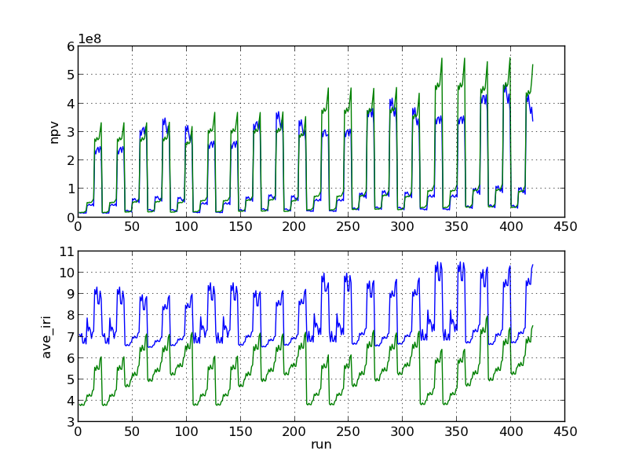
Figure 1: NPV and IRI for Regravelling (Blue) and Upgrading (Green) for gravel road
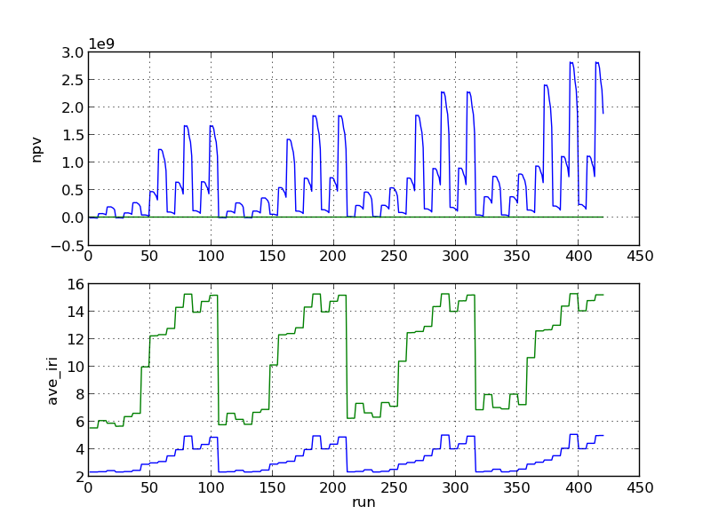
Figure 2: NPV and IRI for Reconstruction (Blue) and Minimum maintenance (Green) of Surface Dressing
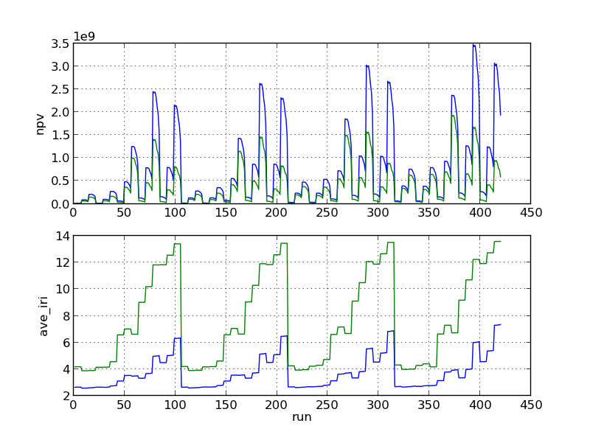
Figure 3: NPV and IRI for Overlay (Blue) and Resealing (Green) of Surface Dressing

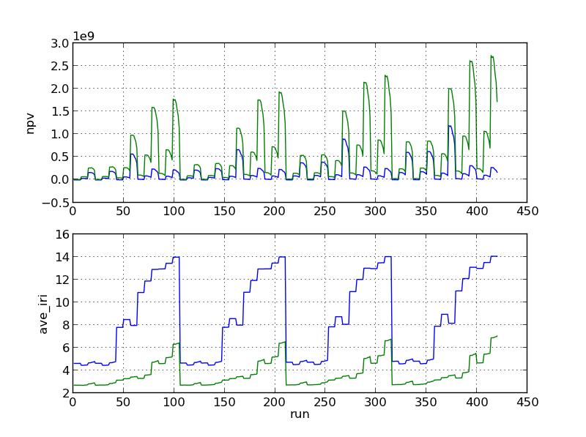
Figure 4: NPV and IRI for Overlay (Green) and Resealing (Blue) of Asphalt Concrete

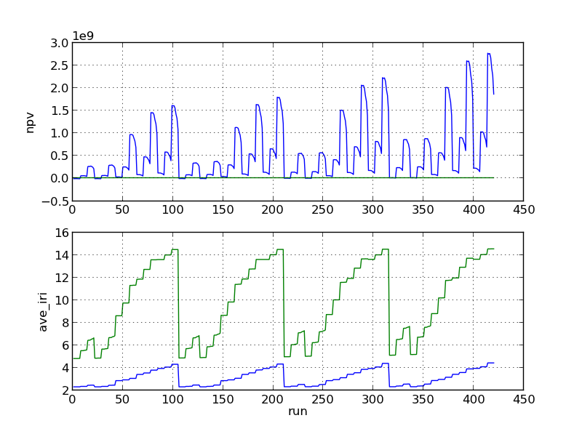
Figure 5: NPV and IRI for Reconstruction (Blue) and Minimum maintenance (Green) of Asphalt Road

The results show the variation of NPV and average IRI over all the runs conducted. The results varied according to the increase in the different inputs. The shape of the results curves was considered to show the influence of the different inputs. There were noticeable differences between the reactions of the outputs from one surface type to another. There was a particularly marked distinction between the response graphs for the unpaved (gravel) surface and the bituminous surfaces (surface dressing and asphalt). While the unpaved surface graphs showed multiple peaks in recurring after every 20 runs, the bituminous surface graphs showed peaks recurring after every 100 runs.
Comparing the results with the variation of the input parameters over all the runs enables identification of the effects of each input on the two output parameters. This is discussed in detail in the next chapter. The following subsection contains a summary of the ANOVA sensitivity analysis done on the NPV and average IRI from the HDM-Sentry analyses.

Results of ANOVA Sensitivity Analysis
For unpaved surface roads, under both the maintenance alternatives considered (regravelling and upgrading), the traffic volume was the dominant parameter according to the ANOVA analysis. Bituminous surfaced roads showed a different response. For both the asphalt and surface dressing roads the results showed that the NPV was highly sensitive to traffic volume, condition and the combination of the two parameters. The average IRI was most sensitive to the condition. A summary of the results of the ANOVA analysis is given in Table 12 and screenshots of the full results from MATLAB are given in Appendix A.

Table 12: Summary of ANOVA sensitivity analysis results
Trial No. |  | Surface Class | Maintenance Alternative | Inputs | C  NPV | C  IRI
T6 |  | Asphalt Concrete | Reseal | TG | 5% | 0%
 |  |  |  | Co | 9% | 98%
 |  |  |  | Tv | 54% | 1%
 |  |  |  | Ge | 1% | 0%
 |  |  |  | Co + Tv | 19% | 1%
 |  |  | Overlay | TG | 4% | 0%
 |  |  |  | Co | 24% | 80%
 |  |  |  | Tv | 52% | 11%
 |  |  |  | Ge | 1% | 0%
 |  |  |  | Co + Tv | 13% | 9%
T7 |  | Asphalt Concrete | Reconstruction | TG | 5% | 0%
 |  |  |  | Co | 21% | 96%
 |  |  |  | Tv | 54% | 3%
 |  |  |  | Ge | 1% | 0%
 |  |  |  | Co + Tv | 13% | 0%
 |  |  | Minimum maintenance (B) | TG |  | 0%
 |  |  |  | Co |  | 94%
 |  |  |  | Tv |  | 5%
 |  |  |  | Ge |  | 0%
 |  |  |  | Co + Tv |  | 1%

ANALYSIS AND DISCUSSION

Introduction
The results of NPV and average IRI from the HDM-Sentry analyses were graphed and an ANOVA sensitivity analysis conducted on them as described in the previous chapter. This chapter discusses results in relation to the original aims of the project. The results for the three classes of road surface are discussed in the order; gravel, surface dressing, and asphalt. For each of the surface classes the results from the analysis are considered in terms of which parameters were found to be most influential and possible reasons are given for the factors influence.

Gravel Surface Results
The results for the gravel surface roads show that the NPV and average IRI are most sensitive to the traffic volume. In Figure 1 the graphs for NPV and average IRI have a repeating pattern with peaks after every 21 runs. This matches with the variation of the traffic volume inputs as shown as the subplot for traffic volume (Tv) in Figure 6.
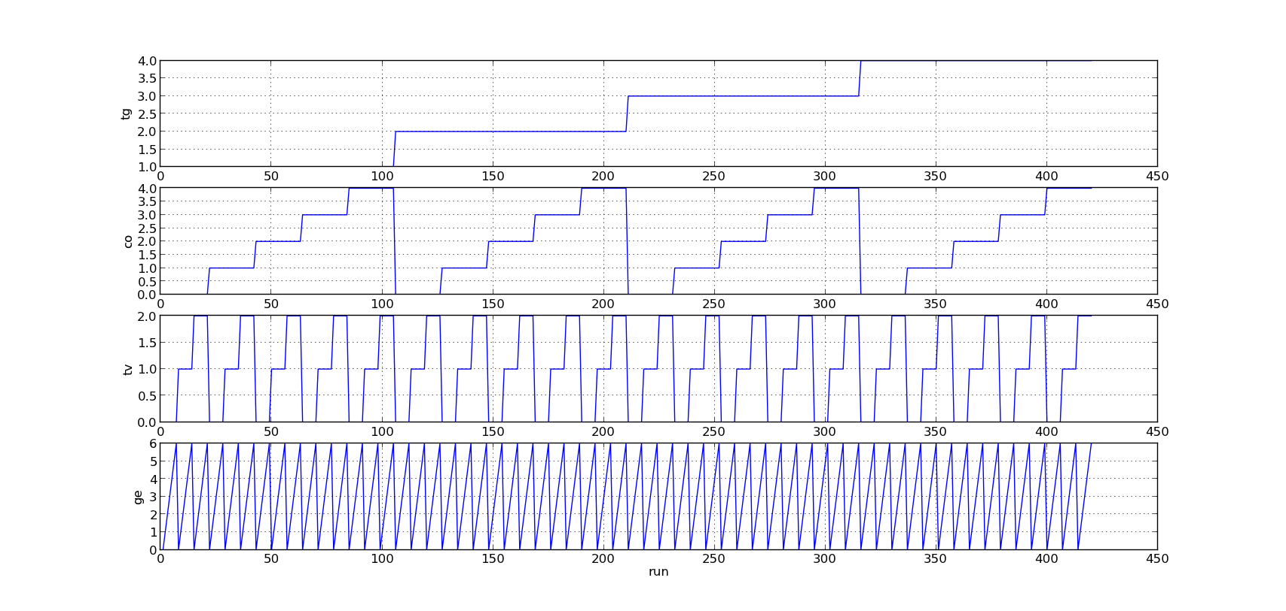
Figure 6: Input levels of each parameter in simulation runs
The general level of the peaks does not change significantly over the entire 420 runs. The major variations in this case can therefore be attributed to the traffic volume input. This is supported by the results of the ANOVA analysis which show traffic volume as the dominant input parameter for NPV (91%) and average IRI (60%). However, the response of the IRI for the ‘upgrade’ alternative was observed to also be sensitive to the initial condition. This may be due to the fact that the ‘upgrade’ alternative involves changing the road surface class from unpaved to bituminous. The traffic levels on an unpaved road in the model are more important in determining the average roughness than the original pavement condition.
The difference between the peak values of the NPV and the next values is very large compared to the difference between the next two levels. This significant shift may be attributed to the large difference between the actual traffic figures attached to the descriptors. Table 13 shows the actual figures of traffic for the low, medium and high traffic levels in HDM-4.

Table 13: Actual vehicle figures for traffic volume levels
Traffic Volume Level | Gravel Surface | % Change | Bituminous Surface | % Change
0 | 60 |  | 600
1 | 139 | 131 | 2400 | 300
2 | 641 | 361 | 6000 | 150
Such a large discontinuity in the NPV figures is undesirable for two reasons. If, like is the case here, it is due to a corresponding large step in the underlying definition of the descriptor, there is a significant chance that users will have data points that lie within the range between the two values. This would lead to uncertainty in deciding which descriptor to use during the analysis. Secondly, when the collected data is near the boundary, there is a possibility of wrongly selecting the wrong descriptor. In such a situation the results would end up being significantly misleading and affecting the quality of the appraisal using HDM-Sentry. The results of the quick HDM-Sentry analysis would be significantly different from the results of an appraisal using the full HDM-4 suite. This would affect the reliability of HDM-Sentry results. Introducing intermediate steps between the traffic volume levels are a possible solution to this.

Bituminous Surface Results
The results show the NPV output is very sensitive to Traffic Volume (Tv) and initial condition (Co) of the road. Traffic volume is the dominating input. The interaction of the two parameters also has significant impact on the NPV output. The magnitude of the NPV values for the bituminous surfaced roads are significantly higher than the NPV results from the gravel surface roads.
The average IRI results also showed high sensitivity to the condition and the traffic volume. The sensitivity however varied according to the maintenance alternative. For the resealing, reconstruction and minimum maintenance alternatives, the analysis shows the dominant input affecting average IRI was the condition. In the overlay alternative, the impact of traffic volume on the average IRI values was significantly increased. Interactions between the two parameters (condition and traffic volume) were also significant.
There was a significant range between the peak NPV values (occurring at high traffic volume runs) and the next level of NPV results for the medium traffic volume levels. This was similar to the results for gravel surfaces but even more pronounced. This could be due to the differences in the traffic volumes assigned to the two surface classes as shown in Table 13. The traffic volumes for the bituminous surfaces are higher and the ranges between the different levels also much larger. This large range between successive levels of the descriptors poses similar potential problems to the user as described in the section above on gravel roads.

Comparison of descriptors to UNRA road Network
The two key parameters, condition and traffic volume were compared to actual values from the Uganda National Roads Authority (UNRA) database collected in 2014. For the unsealed sections, the traffic volumes in the database varied from AADT of 4 to highs of 5617. A total of 31 road sections had AADT above 1000. An appraisal of these projects using the traffic volumes in the Table 13 would underestimate the traffic levels. The same was observed for the traffic levels of bituminous roads. The traffic levels ranged from AADT of 14 to 21,634. A total of eight roads had traffic volumes over 9000. The upper level of the Tv descriptor in Table 13 is 6000. This descriptor would not be representative for the high traffic volume sections on the network.
The ranges of values for the condition of bituminous surface roads is shown in Table 14.
Table 14: Comparison of ranges for condition parameters
 | UNRA Range | HDM-Sentry Range
IRI | 2-14 | 2-8
All structural cracks (%) | 0-40 | 0-25
wide structural cracks (%) | 0-30 | 0-19
thermal cracks (%) | 0 | 0
ravelled area (%) | 0-40 | 0-30
potholes per km | 0-245 | 0-50
edge break area (m²/km) | 0-1260 | 0-300
mean rut depth (mm) | 0-25 | 0-25
rut depth standard deviation (mm) | 0-12.5 | 0
texture depth (mm) | 0.7-1 | 0.3-1.5
skid resistance | 0.45-0.5 | 0.3-0.5
drainage condition | fair | Very poor - excellent
The ranges of conditions on the UNRA network for the potholes per km and edge break area are grossly outside the HDM-Sentry bounds. Other parameters like the cracking and ravelling parameters are slightly outside the bounds. The worst condition descriptor in the HDM-Sentry may therefore not be able to adequately represent these sections. It may be necessary to introduce another level of descriptor for the condition to represent sections which are in very poor condition. It was noted that all the road sections on the network had drainage marked as fair. This is for a total of over 2000km of paved roads in the UNRA network. Further investigation of the effect of drainage condition on the HDM-Sentry output may be necessary.
The results identify the two dominant parameters for NPV and average IRI as the traffic volume and the condition of the pavement. The results also showed significant jumps in the output of NPV for the analyses. This needs to be addressed to minimise the danger of over or underestimation during conducting appraisals. A comparison with the actual ranges from a road network has given indication that the ranges of descriptors may not cover the very high traffic road sections and road sections in very poor conditions. Further investigation is necessary to identify ranges that cover these situations.

Limitations
This analysis was conducted on the inputs of HDM-Sentry and is therefore a sensitivity analysis of the high level inputs. These inputs are two levels of abstraction above the actual inputs into the HDM-4 economic analysis model. For example, the input of the traffic volume has an upper limit of an AADT of 6000. This limit has been shown to be lower than traffic levels that may be encountered in practice like the UNRA network in section 5.4 above. The same may be true for the other input parameters. It is possible that the model characteristics is not linear and the responses in the unexplored regions of the input space vary from the characteristics shown here. Further investigations may be necessary to ascertain the response of the outputs to inputs in these regions.
This investigation was limited to two output variables of the HDM-4 model used in the appraisal of projects. Further investigations of the other outputs like the benefit cost ratios (BCR), road agency costs and road user costs may be necessary to determine the characteristics of these outputs in relation to the high level descriptors.

CONCLUSIONS
This project describes a sensitivity analysis of four high level descriptors as inputs to HDM-4. The work demonstrates the application of a full factorial experiment design in the sensitivity analysis of high level descriptors used in HDM-Sentry. The use of automation methods enabled the exploration of the full input space in relation to the chosen inputs.
The sensitivity analysis shows that for project appraisal of a road section using HDM-Sentry, the Traffic volume is the dominant input factor in relation to NPV. The road condition was also found to be a significant contributor to the NPV and average IRI for projects on bituminous surfaced roads. The effect of the condition on NPV was observed to depend on the maintenance alternative considered. The interaction of the condition and traffic volume inputs was observed to be significant to the NPV for bituminous surfaced roads.
One characteristic of interest in the results is the large differences in levels of outputs which can affect the reliability of the HDM-Sentry appraisals in practice. The cause of these ‘jumps’ was identified as the large differences in the levels chosen for the traffic volume input parameter. The responses could be improved by increasing the levels of descriptors to ensure the input space is better covered. This can be explored further.
The comparison of the main inputs with a range of inputs from an actual network revealed that the selected input ranges may not cover all the possible inputs especially for cases where the traffic volumes are high and the initial conditions are very poor. More investigations may be required to fine tune the descriptors to cover the whole range of possible inputs for different case uses.
The high sensitivity of the outputs to the traffic volume and condition inputs suggests that emphasis should be placed on the two parameters to increase the reliability of the results of HDM-Sentry when compared to the results of a full HDM-4 analysis.

REFERENCES
Archondo-Callao, R., 2008. Applying the HDM-4 model to strategic planning of road works (No. TP-20).
Bennett, C. and Paterson, W. (2000) 'HDM-4, volume 5: Guide to calibration and adaptation', International Study of Highway Development and Management Tools (ISOHDM), World Road Association (PIARC), Paris, .
Borgonovo, E. and Plischke, E. (2016) 'Sensitivity analysis: A review of recent advances', European Journal of Operational Research, 248(3), pp. 869-887. doi: http://dx.doi.org/10.1016/j.ejor.2015.06.032.
Ginot, V., Gaba, S., Beaudouin, R., Aries, F. and Monod, H. (2006) 'Combined use of local and ANOVA-based global sensitivity analyses for the investigation of a stochastic dynamic model: Application to the case study of an individual-based model of a fish population', Ecological Modelling, 193(3–4), pp. 479-491. doi: http://dx.doi.org/10.1016/j.ecolmodel.2005.08.025.
Homma, T. and Saltelli, A. (1996) 'Importance measures in global sensitivity analysis of nonlinear models', Reliability Engineering & System Safety, 52(1), pp. 1-17. doi: http://dx.doi.org/10.1016/0951-8320(96)00002-6.
Kerali, H.G., Odoki, J. and Stannard, E. (2000) 'Overview of HDM-4', The World Road Association (PIARC), .
Kucherenko, S. (2009) 'Derivative based global sensitivity measures and their link with global sensitivity indices', Mathematics and Computers in Simulation, 79(10), pp. 3009-3017.
Loucks, D.P., Van Beek, E., Stedinger, J.R., Dijkman, J.P. and Villars, M.T. (2005) Water resources systems planning and management: an introduction to methods, models and applications. Paris: Unesco.
Montgomery, D.C. and Runger, G.C. (2010) Applied statistics and probability for engineers. John Wiley & Sons.
Morosiuk, G., Riley, M. and Toole, T. (2006) 'Applications Guide', .
Mrawira, D. and Haas, R. (1996) 'Toward adapting HDM-III model to local conditions: Lessons from a case study in Tanzania', Transportation Research Record: Journal of the Transportation Research Board, (1524), pp. 58-66.
Mrawira, D., Welch, W., Schonlau, M. and Haas, R. (1999) 'Sensitivity Analysis of Computer Models: World Bank HDM-III Model', Journal of Transportation Engineering, 125(5), pp. 421-428. doi: 10.1061/(ASCE)0733-947X(1999)125:5(421).
Mrawira, M.D.M. (1997) Streamlining the World Bank's Highway Design and Maintenance Standards model ( HDM- III) for network- level application National Library of Canada = Bibliothèque nationale du Canada.
Oliaei, E., Heidari, B.S., Davachi, S.M., Bahrami, M., Davoodi, S., Hejazi, I. and Seyfi, J. (2016) 'Warpage and Shrinkage Optimization of Injection-Molded Plastic Spoon Parts for Biodegradable Polymers Using Taguchi, ANOVA and Artificial Neural Network Methods', Journal of Materials Science & Technology, 32(8), pp. 710-720. doi: http://dx.doi.org/10.1016/j.jmst.2016.05.010.
Saltelli, A. and Annoni, P. (2010) 'How to avoid a perfunctory sensitivity analysis', Environmental Modelling & Software, 25(12), pp. 1508-1517. doi: http://dx.doi.org/10.1016/j.envsoft.2010.04.012.
Saltelli, A., Annoni, P., Azzini, I., Campolongo, F., Ratto, M. and Tarantola, S. (2010) 'Variance based sensitivity analysis of model output. Design and estimator for the total sensitivity index', Computer Physics Communications, 181(2), pp. 259-270. doi: http://dx.doi.org/10.1016/j.cpc.2009.09.018.
Sobol', I.M. (1990) 'On sensitivity estimation for nonlinear mathematical models', Matematicheskoe Modelirovanie, 2(1), pp. 112-118.
Sobol′, I.M. (2001) 'Global sensitivity indices for nonlinear mathematical models and their Monte Carlo estimates', Mathematics and Computers in Simulation, 55(1–3), pp. 271-280. doi: http://dx.doi.org/10.1016/S0378-4754(00)00270-6.
Stannard, E. and Snaith, M. 'Development of a Simplified HDM-4 User-Interface: HDMSentry', (unpublished).
Thomas Buckland, G.M. HDM-Sentry User Guide (unpublished).
Van Rossum, G., 2007, June. Python Programming Language. In USENIX Annual Technical Conference (Vol. 41).

Appendix A: Results of ANOVA ANALYSIS

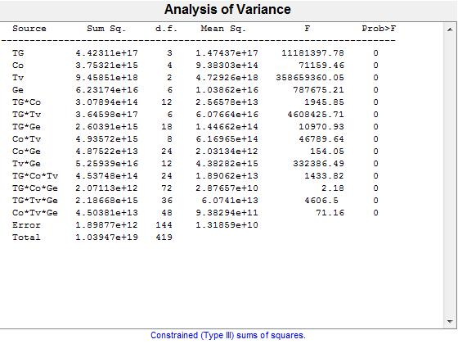
Figure 8: ANOVA results for NPV (Upgrading of a gravel road to bituminous standard)

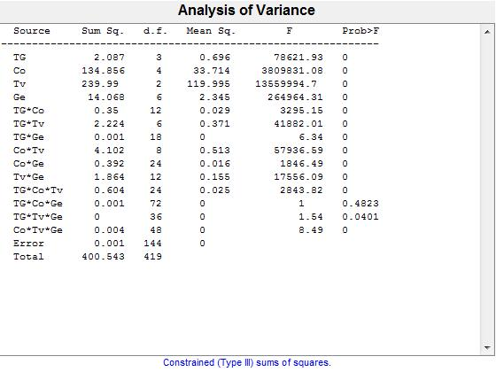
Figure 9: ANOVA results for IRI (Upgrading of a gravel road to bituminous standard)

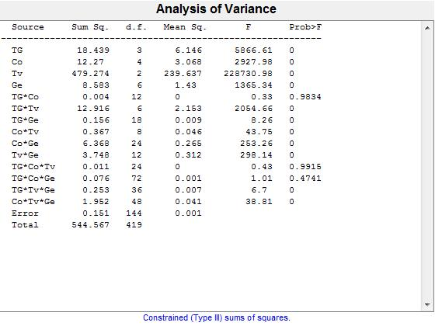
Figure 10: ANOVA results for IRI (Regravelling of a gravel road)

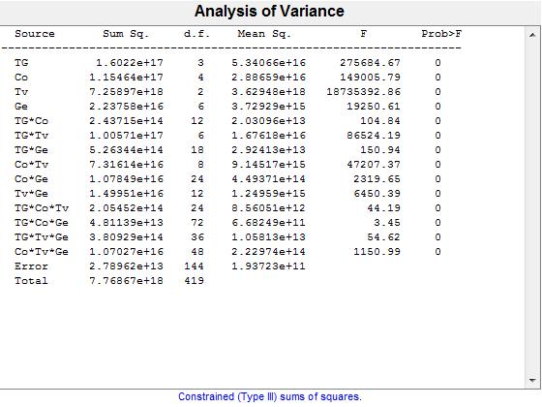
Figure 11: ANOVA results for NPV (Regravelling of a gravel road)
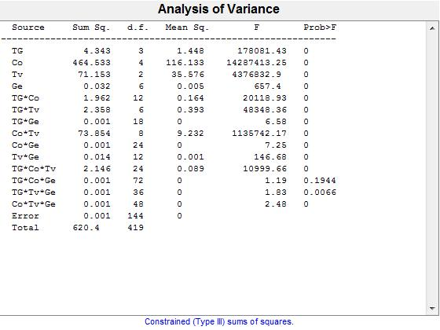
Figure 12: ANOVA results for IRI (Overlay of a surface dressed road)

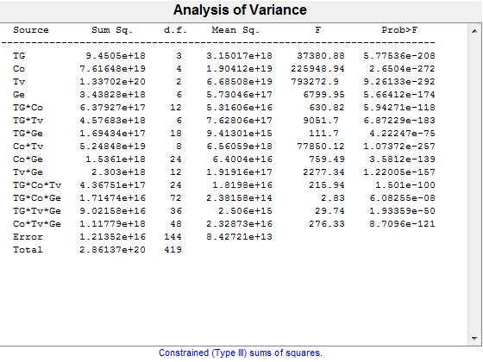
Figure 13: ANOVA results for NPV (Overlay of a surface dressed road)
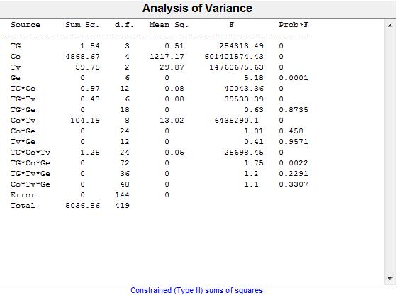
Figure 14: ANOVA results for IRI (Reseal of a surface dressed road)

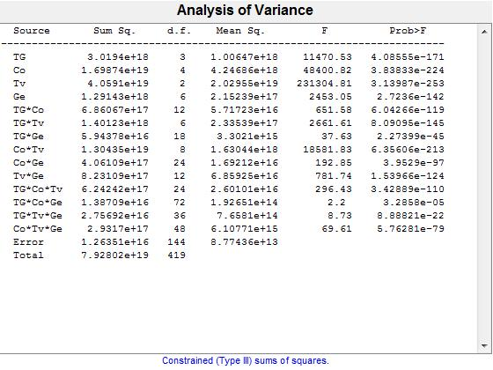
Figure 15: ANOVA analysis for NPV (Reseal of a surface dressed road)
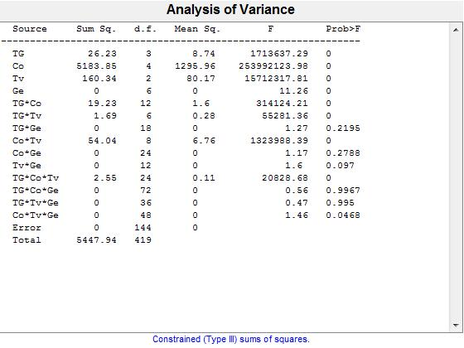
Figure 16: ANOVA analysis for IRI (Minimum maintenance of a surface dressed road)

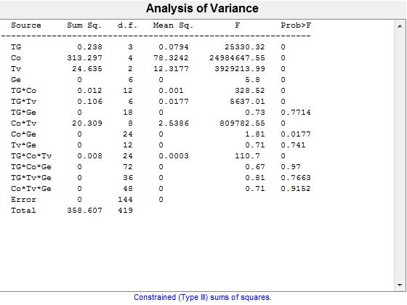
Figure 17: ANOVA results for IRI (Reconstruction of a surface dressed road)
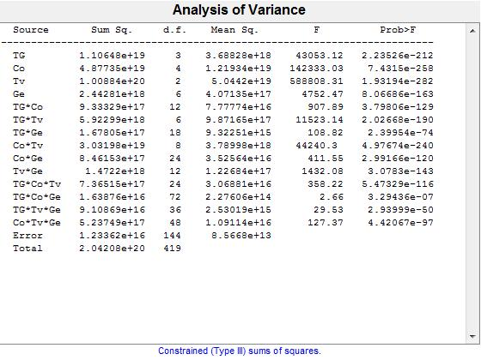
Figure 18: ANOVA results for NPV (Reconstruction of a surface dressed road)

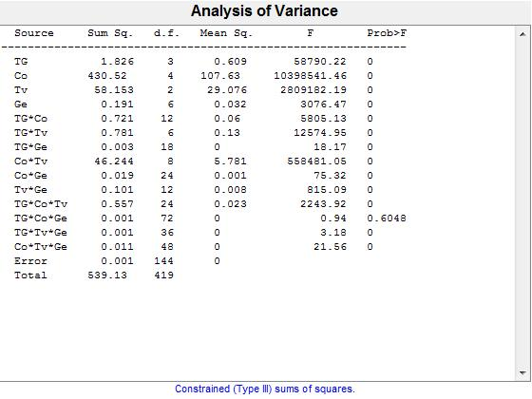
Figure 19: ANOVA results for IRI (Overlay of an asphalt concrete road)
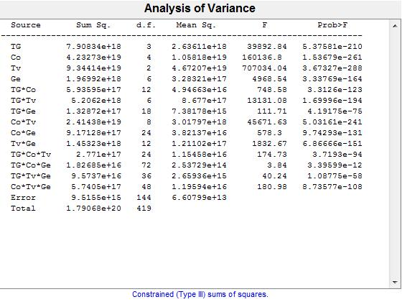
Figure 20 ANOVA results for NPV (Overlay of an asphalt concrete road)

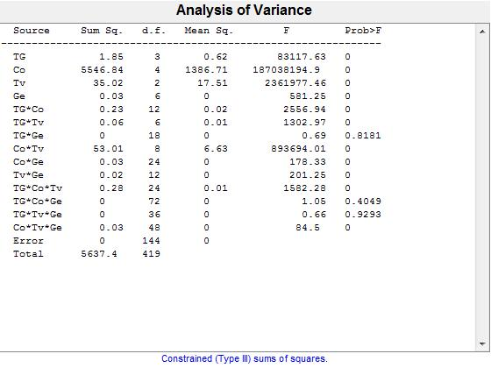
Figure 21: ANOVA results for IRI (Reseal of an asphalt concrete road)
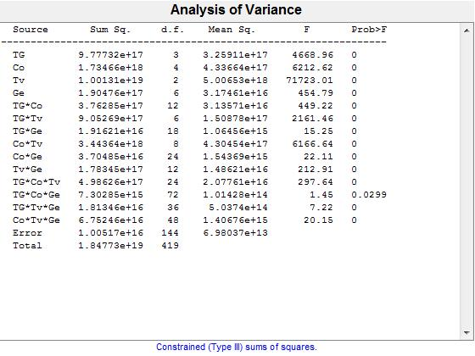
Figure 22: ANOVA results for NPV (Reseal of an asphalt concrete road)

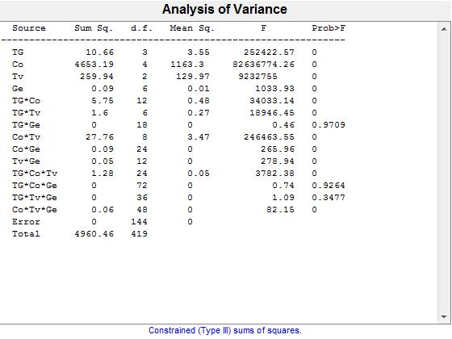
Figure 23: ANOVA results for IRI (Minimum maintenance of an asphalt concrete road)
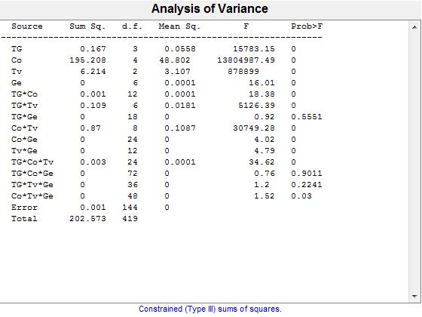
Figure 24: ANOVA results for IRI (Reconstruction of an asphalt concrete road)

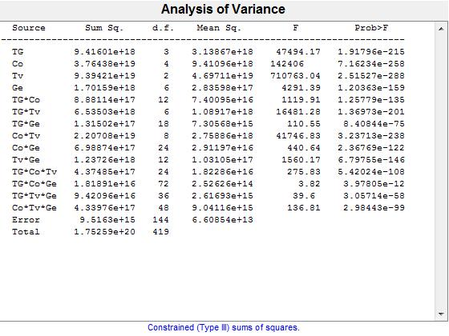
Figure 25: ANOVA results for NPV (Reconstruction of an asphalt concrete road)

Appendix B: Python Scripts Used in Analysis

B1: CreateInput.py

- import itertools

- # Order is [ [Traffic_Growth, Condition, Traffic_volume, Geometry]]
- input_list = [[1,2,3,4],[0,1,2,3,4],[0,1,2],[0,1,2,3,4,5,6]]
- inputs = list(itertools.product(*input_list))
- fh = open('C:\Users\Documents\Msc. RoadMgtAndEng\Academics\IndividualProject\Analysis\Scripts\\input7.txt', 'w')
- run_number = 1
- for item in inputs:
- output = "T7Run%s," %run_number +str(item[0])+","+str(item[1])+","+str(item[2])+","+str(item[3])+"\n"
- run_number += 1
- fh.write(output)
- fh.close()

B2: HDMSentryAuto

- import pywinauto
- import time
- import fileinput

- # Reads input parameters from input2.txt and creates HDMSENTY analysis.

- global dlg, app

- def move_cursor(cur_moves):
- global dlg
- moves = cur_moves
- while cur_moves != 0:
- dlg.TypeKeys('{TAB}')
- cur_moves -= 1

- def click_element(clicks):
- num_clicks = clicks
- while num_clicks != 0:
- dlg.TypeKeys('{ENTER}')
- num_clicks -= 1
- def chng_dropdown(item_pos):
- num_clicks = item_pos
- while num_clicks !=0:
- dlg.TypeKeys('{DOWN}')
- num_clicks -= 1
- #time.sleep(1)
- def fill_text(text):
- dlg.TypeKeys(text)

- def analysis_run(name, traffic_growth, condition, traffic_volume, geometry):
- global app, dlg
- app = pywinauto.application.Application().start('"C:\Program Files (x86)\HDM-Sentry\HDMSentry.exe"')
- #time.sleep(10)
- dlg = app.top_window_()
- dlg.MoveWindow(0,0) # Moves the window to top left hand corner so that in case we need to use the mouse we know where the window is
- move_cursor(3)
- click_element(1)
- move_cursor(2)
- fill_text(str(name)) # Run name
- move_cursor(3)
- chng_dropdown(1)
- time.sleep(1)
- move_cursor(2)
- click_element(1)
- move_cursor(2)
- click_element(1)
- #move_cursor(2)
- chng_dropdown(1) # Setting vehicle fleet
- move_cursor(1)
- chng_dropdown(7) # Setting climate zone
- move_cursor(1)
- chng_dropdown(int(traffic_growth)) # Setting Traffic Growth
- move_cursor(2)
- click_element(1)
- move_cursor(2)
- fill_text('Trial') # Section name
- move_cursor(1)
- chng_dropdown(int(traffic_volume)) # Setting Traffic Volume
- move_cursor(2)
- chng_dropdown(int(geometry)) # Setting the geometry
- move_cursor(1)
- chng_dropdown(2) # Setting Surface Class (0: Surface dressing 1: Asphaltic concrete 2: gravel 3: earth)
- move_cursor(1)
- chng_dropdown(int(condition)) # Setting condition
- move_cursor(1)
- fill_text('30')
- move_cursor(2)
- click_element(1)
- move_cursor(5)
- chng_dropdown(1) # Setting Alternative 1
- move_cursor(1)
- # Alternative 2 (For Unpaved surface: 1: Regravelling 2: Upgrading) (For Bituminous: 1: Reseal 2: Overlay 3: #Reconstruction 4: Minimum maintenance)
- chng_dropdown(2) move_cursor(3)
- click_element(1)

- input_file = 'C:\Users\Kyeyune.PKAZIBWE-LAP\Documents\Msc. RoadMgtAndEng\Academics\IndividualProject\Analysis\Scripts\\input3rerun2.txt'
- print " Using: %s as input file" % input_file
- for line in fileinput.input(input_file):
- srt = line
- params = line.split(',')
- analysis_run(params[0],int(params[1]),int(params[2]),int(params[3]),int(params[4]))
- print '%s' %(params[0]) + "Done"
- time.sleep(30)
- dlg.TypeKeys('%{F4}')
- time.sleep(5)

B3: ResultsExtractor

- import csv, pyodbc
- import fileinput
- # Gets the results (NPV, IRR and IRI) of HDM SENTRY runs and Outputs them in results2.csv file
- # Includes a test for which analyses were done and record of which analyses failed in failedruns.txt
- has_top_row = False # Variable to check if the output file has been created and a top row inserted

- def dbase_extract(run_num):
- global has_top_row

- opfile = 'C:\Users\Kyeyune.PKAZIBWE-LAP\Documents\Msc. RoadMgtAndEng\Academics\IndividualProject\Analysis\Scripts\\results7.csv'

- # Set up the constants
- DRIVER = '{Microsoft Access Driver (*.mdb)}'; PWD = 'pw'

- # Go to the data outputfile for run_num
- database = 'C:\Users\Kyeyune.PKAZIBWE-LAP\Documents\HDMSentry\%s\WS\RunData\RunData.mdb' %run_num;
- # connect to db
- con = pyodbc.connect('DRIVER={};DBQ={};PWD={}'.format(DRIVER,database,PWD))
- cur = con.cursor()

- # run a query and get the results

- SQL = 'SELECT Options.OPT_DESC,OptionEconomics.NPV,OptionEconomics.IRR,SectOptData.IRIAV FROM Options,OptionEconomics,SectOptData WHERE OptionEconomics.OPT_ID = Options.OPT_ID and SectOptData.OPT_ID = Options.OPT_ID'
- rows = cur.execute(SQL).fetchall()
- SQL = 'SELECT HDM4RunData.DESC FROM HDM4RunData';
- run = cur.execute(SQL).fetchall()
- cur.close()
- con.close()
- named_rows = []
- # Create a list of tuples in named_rows. Each tuple contains a row of data to be written in the output file

- for row in rows:
- row = list(row)
- row.insert(0,run[0][0])
- row = tuple(row)
- named_rows.append(row)

- # write the top row of the csv

- if has_top_row == False:
- with open(opfile, 'wb') as output:
- csv_writer = csv.writer(output)
- toprow = ['Run Title','Alternative','NPV','IRR','AVE_IRI']
- csv_writer.writerow(toprow)
- has_top_row = True
- with open(opfile, 'ab') as output:
- csv_writer = csv.writer(output) # default field-delimiter is ","
- csv_writer.writerows(named_rows)

- # Open a file to store data on the runs which failed (Did not result in a database being written)

- dmp = open('C:\Users\Kyeyune.PKAZIBWE-LAP\Documents\Msc. RoadMgtAndEng\Academics\IndividualProject\Analysis\Scripts\\failedruns7.txt', 'wb')

- for line in fileinput.input('C:\Users\Kyeyune.PKAZIBWE-LAP\Documents\Msc. RoadMgtAndEng\Academics\IndividualProject\Analysis\Scripts\\input7.txt'):
- params = line.split(',')
- try:
- dbase_extract(params[0])
- print '%s' %(params[0]) + "Done"
- except:
- print '%s' %(params[0]) + "Broken"
- dmp.write('%s' %(params[0]) + "Broken" + "\r\n")
- dmp.close(

