**Lab03: Pointers**

1. Write declaration statements for the following:
   1. The variable pointed to by **yAddr** is an integer.

int *yAddr;

* 1. The variable pointed to by **chAddr** is a character.

char *chAddr;

* 1. The variable pointed to by **amt** is a double-precision variable.

double *amt;

* 1. **datePtr** is a pointer to an integer

int *datePtr;

* 1. **ptChr** is a pointer to a character.

char *ptChr;

1. What is printed by the following code fragment?

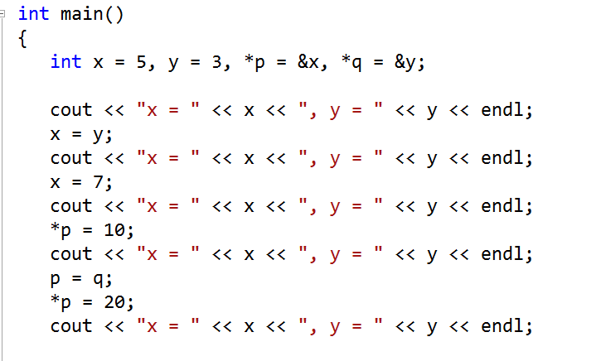

X = 5, y = 3

X = 3, y = 3

X = 7, y = 3

X = 10, y = 3

X = 10, y = 20

3. Given the declarations:

int x, y, *p, *q;

indicate what each of the following code fragments will print.

1. p = &x;

x = 5;

cout << *p << endl;

5

1. p = &x;

*p = 8;

cout << *p << " " << x << endl;

8 8



p = &x;

q = &y;

x = 100;

y = 200;

q = p;

cout << x << " " << y << endl;

cout << *p << " " << *q << endl;

100 200

100 100

p = &x;

q = &y;

x = 100;

y = 200;

*q = *p;

cout << x << " " << y << endl;

cout << *p << " " << *q << endl;

100 200

100 100

x = 5;

y = 10;

p = q = &y;

cout << *p << " " << *q << endl;

*p = 100;

*q = 1;

cout << x << " " << y << endl;

10 10

5 1

(f)

x = 5;

y = 10;

p = q = &x;

*p = *q = y;

cout << x << " " << y << endl;

10 10

~~~~~~~~~~~~~~~~~~~~~~~~~~~~~~~