Burn down chart

“Burn down chart is common, a useful tool used in sprint meetings to assess how much work has been completed on an assignment. The charts are a highly useful tool used to monitor completed work and work that still needs to be done during designated time frames. However, as useful as they are, burndown charts have their limitations. They cannot, for example, clearly or effectively measure work that is still in progress; they only measure what has already been completed. Scrum projects can use [release burn down](https://www.mountaingoatsoftware.com/agile/scrum/scrum-tools/release-burndown) charts to track their progress. The [Scrum Master](https://adaptmethodology.com/what-is-scrum-master/) is responsible for updating the release burn down at the end of each sprint exercise. On this chart, the horizontal axis shows each sprint while the remaining work is shown on the vertical axis. Teams can use any method they choose to show the remaining amount of work including story points, team days, and ideal days.” (Luis Gonçalves, 2021)

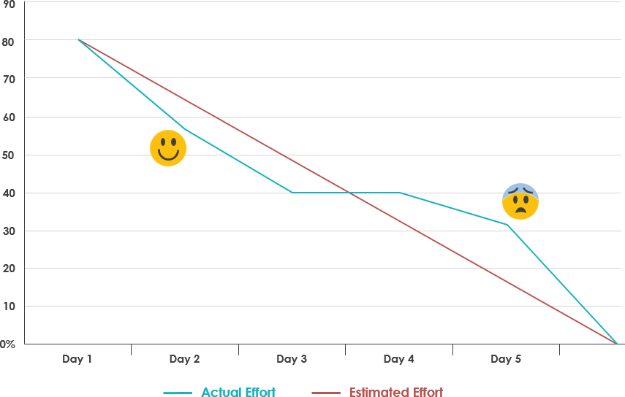

Burndown chart and emotion (https://www.visual-paradigm.com/scrum/scrum-burndown-chart/)

The sprint is 2 weeks, assume that team will work for 5 days in a week.The team consists of four members working 8 hours per day. However, rarely the case that all team members is 100% productive, the scrum master estimate that the average productivity percentage is 80%. Draw a burndown chart based on the given scenario and the information given in Table 1.

|  |  |
| --- | --- |
| Duration (work days) | 10 days |
| Team members | 4 |
| Working hrs per member | 8 |
| Total working hrs per day | 32 |
| Total working hrs | 320 |
| Productive working hrs | 320 * 60% = 256 hrs |
| Productivity per day | 256 / 10 = 25.6 hrs |

Table 1: Progress of the team

|  |  |  |  |  |  |  |  |  |  |
| --- | --- | --- | --- | --- | --- | --- | --- | --- | --- |
| Day of Sprint | D1 | D2 | D3 | D4 | Total  Effort | Total burn | Estimation (-25.6) | Target (-32) | Actual  (-Total effort) |
| 1 | 12 | 12 | 12 | 12 | 48 | 48 | 230.4 | 288 | 320-48=272 |
| 2 | 8 | 8 | 8 | 8 | 32 | 80 | 204.8 | 256 | 272-32 =240 |
| 3 | 8 | 8 | 0 | 8 | 24 | 104 | 179.2 | 224 | 216 |
| 4 | 8 | 8 | 8 | 8 | 32 | 136 | 153.6 | 192 | 184 |
| 5 | 0 | 8 | 8 | 8 | 24 | 160 | 128 | 160 | 160 |
| 6 | 8 | 8 | 8 | 0 | 24 | 184 | 102.4 | 128 | 136 |
| 7 | 8 | 8 | 8 | 8 | 32 | 216 | 76.8 | 96 | 104 |
| 8 | 12 | 12 | 12 | 12 | 48 | 264 | 51.6 | 64 | 56 |
| 9 | 8 | 8 | 8 | 8 | 32 | 296 | 25.6 | 32 | 24 |
| 10 | 8 | 0 | 8 | 8 | 24 | 320 | 0 | 0 | 0 |

|  |  |
| --- | --- |
| Actual burn | Available effort left |
|  | 256 |
| 25.6 | 230.4 |
| 25.6 | 204.8 |
| 25.6 | 179.2 |
| 25.6 | 153.6 |
| 25.6 | 128 |
| 25.6 | 102.4 |
| 25.6 | 76.8 |
| 25.6 | 51.6 |
| 25.6 | 25.6 |
| 25.6 | 0 |

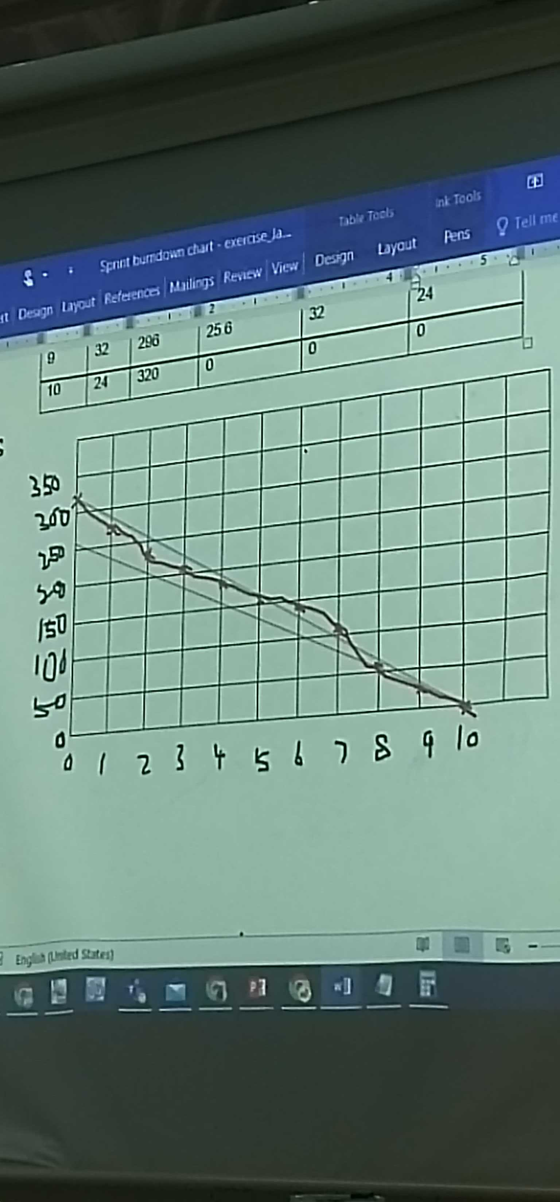

Reference:

<https://asana.com/resources/burndown-chart>

<https://www.tutorialspoint.com/scrum/scrum_burn_down_charts.htm>

<https://adaptmethodology.com/burndown-chart-ultimate-guide/>

<http://www.agilenutshell.com/burndown>

<https://www.mountaingoatsoftware.com/agile/scrum/scrum-tools/release-burndown>

<https://www.visual-paradigm.com/scrum/scrum-burndown-chart/>