Question 1

Use the Control flow graph given below to answer part a and b:

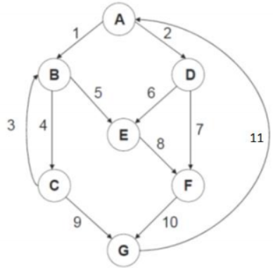

1. Determine the Cyclomatic complexity of the CFG given above.

**6**

b. Determine the possible independent paths that exist in the above CFG.

**A-B-C-G-A**

**A-B-(C-B)-C-G-A**

**A-B-E-F-G-A**

**A-B-(C-B)-E-F-G-A**

**A-D-E-F-G-A**

**A-D-F-G-A**

Question 2

Based on the if-else statement below

|  |
| --- |
| If((A > 0 && A <-100) || (A >= 800 && A <900) ) {  B = 1;  } else {  B = 0;  } |

1. Draw CFG (control flow graph).
2. Determine the cyclomatic complexity.
3. List all independent paths.

Question 3

|  |  |
| --- | --- |
|  | int find-maximum(int i,int j, int k){ |
| 1 | int max; |
| 2 | if(i>j) |
| 3 | if(i>k) |
| 4 | max=i; |
| 5 | else |
|  | max=k; |
| 6 | else if(j >k) |
| 7 | max= j; |
| 8 | else  max=k; |
| 9 | return max; |
|  | } |

1. Draw the control flow graph for the function named find_maximum that select the largest number.
2. From the control flow graph determine the cyclomatic complexity.
3. List all independent paths.

