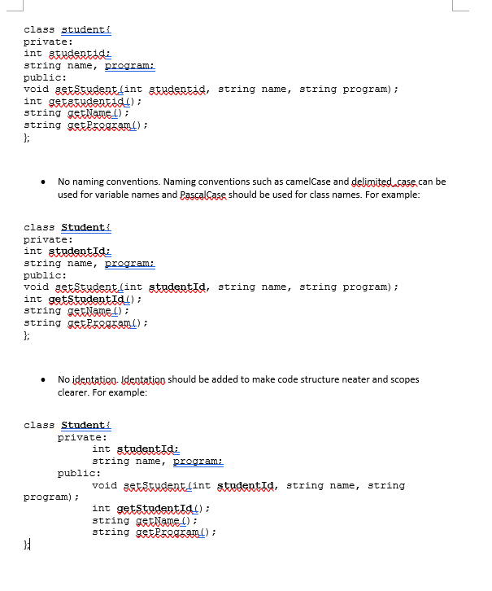



void setStuID (int studentid);

void setStuName (string name);

void setStuProgram (string program);

// for better cohesion, this should be split into three different methods