## CET3013N: - Fragment Communication (Master & Detail View)

**Week 6 Part 1 Exercises: Fragment Communication**

###### Objectives – What this lesson is trying to achieve.

You are trying to learn communication of fragments

### Task 1. Creating Fragments

1. Create a new empty project and call it **Week 6** **Master Detail Fragment**. You can leave all the settings at their defaults as usual.
2. Delete the default TextView in *activity_main.xml*. Place a **frameLayout** as place holder of fragment in activity_main.xml. Do not forget to infer the layout.

<**FrameLayout  
 android:id="@+id/frameLayout"  
 android:layout_width="match_parent"  
 android:layout_height="match_parent"  
 android:layout_marginTop="8dp"  
 app:layout_constraintBottom_toBottomOf="parent"  
 app:layout_constraintLeft_toLeftOf="parent"  
 app:layout_constraintRight_toRightOf="parent"  
 app:layout_constraintTop_toTopOf="parent"** />

1. Create a new class called **MasterFragment**. Extends the class to the **ListFragment**. This class does not have any layout but itself served as a ListView component.

**public class MasterFragment: ListFragment() {**

**}**

1. Create an array to store a set of country names in **MasterFragment** class.

**var countries = *arrayOf*("China", "France","Germany",**

**"India", "Russia", "United Kingdom",**

**"United States")**

1. Create the public interface as follows:

**public interface OnMasterSelectedListener {  
 fun onItemSelected(countryName: String?)  
}**

1. Create a variable called mOnMasterSelectedListener as **onMasterSelectedListener** type. Initialise the object with null value.
2. Implement a method called **setOnMasterSelectedListener** as a setter method for the mOnMasterSelectedListener variable.
3. Override the **onViewCreated** method and write the following code:

**override fun onViewCreated(view: View, savedInstanceState: Bundle?) {  
 super.onViewCreated(view, savedInstanceState)  
 val countryAdapter: ListAdapter = ArrayAdapter(  
 requireActivity(),R.layout.*simple_list_item_1*,**

**countries)  
  
 *listAdapter* = countryAdapter  
  
 *listView*.*choiceMode* = ListView.*CHOICE_MODE_SINGLE  
  
 listView*.*onItemClickListener* =  
 OnItemClickListener { parent, view, position, id ->  
 if (mOnMasterSelectedListener != null) {**

**mOnMasterSelectedListener!!.onItemSelected((view as TextView).*text*.toString())  
 }  
 }  
}**

1. Create a blank fragment called **DetailFragment**.

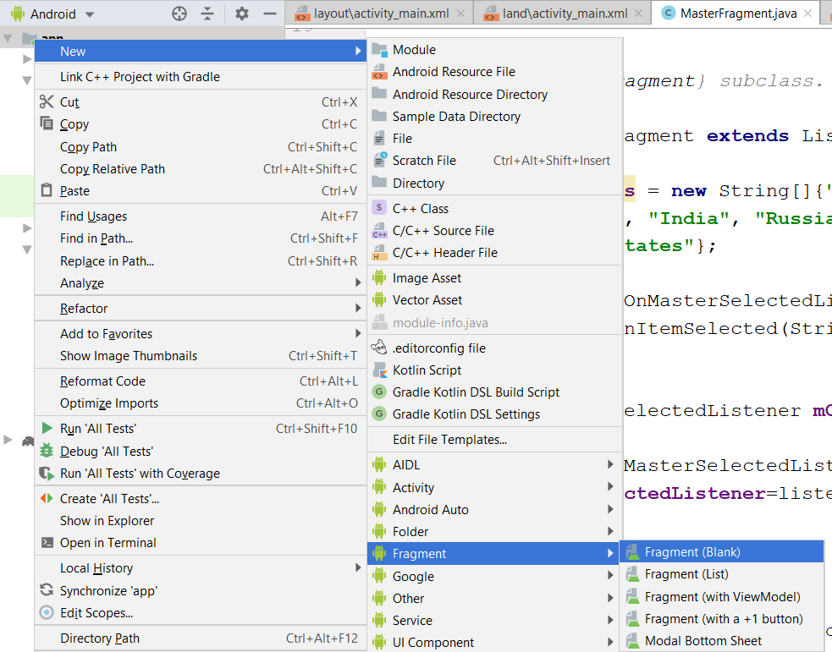

1. Add a **TextView** in fragment_detail.xml layout file. Assign it an **id** called **textViewCountryName**.

***<?*xml version="1.0" encoding="utf-8"*?>*<FrameLayout xmlns:android="http://schemas.android.com/apk/res/android"  
 xmlns:tools="http://schemas.android.com/tools"  
 android:layout_width="match_parent"  
 android:layout_height="match_parent"  
 tools:context=".DetailFragment">  
  
 <TextView  
 android:id="@+id/textViewCountryName"  
 android:layout_width="wrap_content"  
 android:layout_height="wrap_content"  
 android:gravity="center_horizontal|center_vertical" />  
  
</FrameLayout>**

1. Open the **DetailFragment.java** class. Set the binding object for this fragment class. Remember to enable the view binding in the gradle module file. Override the **onCreateView** method and return back the **binding.root** object.

1. Add in a constant value in the companion object as follows:

**public var KEY_COUNTRY_NAME = "KEY_COUNTRY_NAME"**

1. Override the **onViewCreated** method in **DetailFragment** class.

**override fun onViewCreated(view: View, savedInstanceState: Bundle?) {  
 super.onViewCreated(view, savedInstanceState)  
 val bundle = *arguments* if (bundle != null && bundle.containsKey(KEY_COUNTRY_NAME)) {  
 showSelectedCountry(bundle.getString(KEY_COUNTRY_NAME))  
 }  
}**

Do not worry about the bundle object. It will be assigned in the **MainActivity** class.

1. Implement the **showSelectedCountry** method as follows to update the detail Textview.

**fun showSelectedCountry(countryName: String?) {  
 val countryText = binding.textViewCountryName  
 countryText.*text* = countryName  
}**

1. Create a landscape variation mode for **activity_main.xml** layout file.

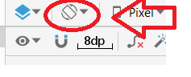

1. Change the default layout to **LinearLayout**. Assign two FrameLayouts in landscape activity_main.xml file.

*<?***xml version="1.0" encoding="utf-8"***?>*<**LinearLayout xmlns:android="http://schemas.android.com/apk/res/android"  
 xmlns:app="http://schemas.android.com/apk/res-auto"  
 xmlns:tools="http://schemas.android.com/tools"  
 android:layout_width="match_parent"  
 android:layout_height="match_parent"  
 tools:context=".MainActivity"**>  
  
  
 <**FrameLayout  
 android:id="@+id/frameLayoutMaster"  
 android:layout_width="0dp"  
 android:layout_height="match_parent"  
 android:layout_weight="1"** />  
  
 <**FrameLayout  
 android:id="@+id/frameLayoutDetail"  
 android:layout_width="0dp"  
 android:layout_height="match_parent"  
 android:layout_weight="1"** />  
  
</**LinearLayout**>

So the layout will split to the 2 sections to represent master and detail view.

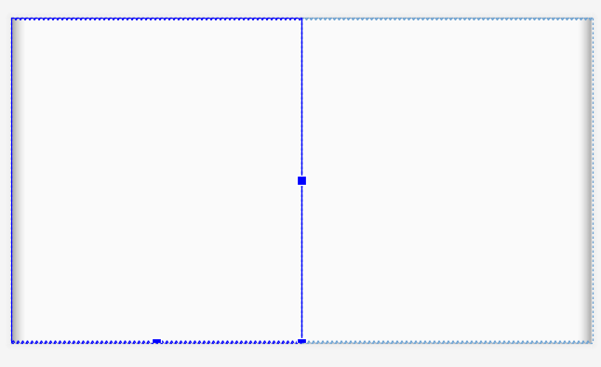

1. Switch to the MainActivity.java class. Create the following instance variables:

**class MainActivity : AppCompatActivity() {  
 var mDualPane = false  
 private var frameLayout: FrameLayout? = null  
 private lateinit var binding:ActivityMainBinding;**

**}**

1. Initialise the view binding object for the **MainActivity** class.
2. Write the following code in the **onCreate** method right after the **setContentView** method.

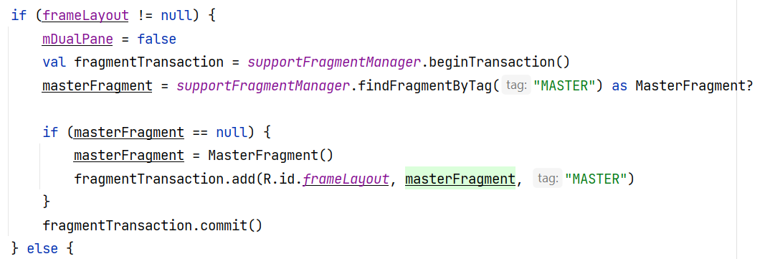

1. Provide the code in the else block to support the landscape mode of the fragment.

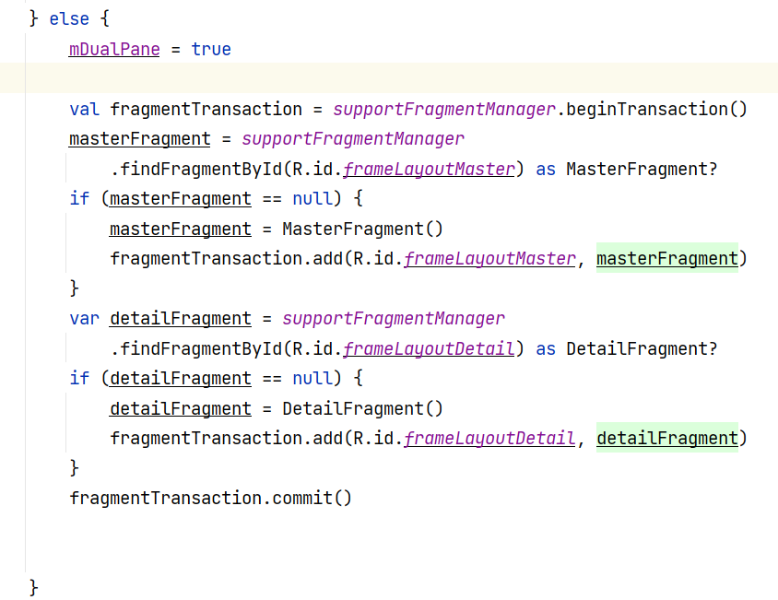

1. Create a method called **sendCountryName** in MainActivity.java. This method is used to show the country details either in portrait or landscape mode. The **bundle** object is created under single pane layout and assign to the fragment using **arguments** attribute.

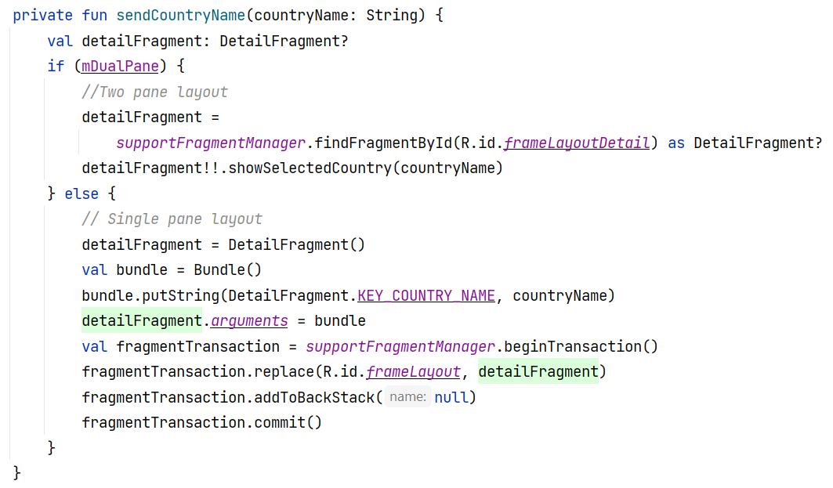

1. Implement the **OnMasterSelectedListener** listener in the **MainActivity**. Switch to the **MainActivity.java**. Place the following inside the onCreate method after the else block.

**masterFragment!!.setOnMasterSelectedListener(  
 object : MasterFragment.OnMasterSelectedListener {  
 override fun onItemSelected(countryName: String?) {  
 if (countryName != null) {  
 sendCountryName(countryName)  
 }  
 }  
 })**

1. Execute your program code with the real device or any emulator.

