

School of Engineering, Computing and Built Environment
Department of Computing
DIPLOMA IN COMPUTER STUDIES
[DMT22114 MOBILE TECHNOLOGY]

[LECTURER: LAI KIM KIM]

Assignment : [1]

[Basic Android Application: Bill Calculation Part 2]

STUDENT NO | NAME | Marks

DUE DATE | : | [04/04/2022]
TOTAL MARKS | : | [100 MARKS / 20%]

Assignment 2 Specification (Group Assignment- 2 to 3 students)

In this assignment, you will further enhance the previous assignment (bill calculator) with the following features:

- Design a class called Bill to capture the bill details such as the amount, percentage, category, bill date and split number.

- Add in a Spinner view in the interface to capture the bill category. For example:

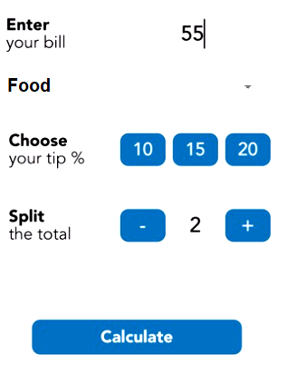
Include a new button to save the bill details into an ArrayList with the Bill object type.

- Provide a new field to capture the date of the bill by using the DatePickerDialog.

- Add in a menu for the app. Include two menu items. You may add an additional icon to the menu items or show them in the toolbar.

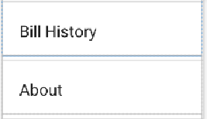

- The Bill History option will display another new screen (Activity) and display all the previous saved bill records with a ListView. The design of the ListView is up to each group preference (You may create a customised layout for the ListView). Users may view the bill detail by tapping or clicking on the list item (move to another activity or display with AlertDialog). Users may delete the bill item individually or truncate all the records.

- The About option will briefly display the app details (app name, version, programmer details).

- Provide a Splash screen each time user start launching the app. Show a simple animation in the Splash screen (for example moving an image or rotating the text). Use the CountDownTimer object with 10 seconds duration then move to the MainActivity.

Additional Features
If you have 2 to 3 members in the group, pick one of the following feature. If 4, then you all have to implement all the following features.
- Save all the bill details to the file and reload the records for the next program execution.
- Sort the bill in ListView based on the bill amount (ascending or descending order)

Submission
You are required to produce the following report & final product:

- Report
  - Title page. Include the names and ID's of all students in your group.
  - A simple user manual to explain the functionalities of the prototype.
  - A list of bugs/weaknesses and/or strengths in your system
  - References.

- Individual Evaluation Report
- A review (200-300 words). This review should include:

- Discuss how the course affected you, reflecting on what you have achieved. Please include in your report what went well; any design/implementation problems encountered and how you solved them. In addition, you should explain the development processes in details such as how you connect the source data adapter to the ListView.

- Print out all the source code under Java extension (e.g. MainActivity.java)

- Attach the Group Member Work Contribution Form (found in the next page)

- Mobile Apps (Manifest file, Source File and Resource Files): submitted electronically, via the Open Learning, in the form of a single .zip file of your Android Studio project folder (NOT any other form of archive). This should be named with your group name.

- Create a brief screencast recording (including screen and sound) demonstrating the key functionalities of the system. This can be created using any suitable software (eg Camtasia, Jing or other online software) and hosted securely on the cloud. Submit the relevant URL in the text file for evaluation purpose.

Marking Scheme

Fitness for purpose & Functionality | 40%
Build quality & Usability | 40%
Program code structure | 10%
Report | 10%

Group members work contribution form
In percentage, please indicate the work contribution of each member. This should be agreed by all group members. The total of all members work must add to 100%
You must submit this form in your final report. Put your initials in the signature columns. This copy must be signed by all members.

Group/Team Name:________________________________________________

Team member name | Student ID | Individual overall work contribution (%) | Signature
Student:
Student:
Student:
Total 100%

Marking Rubric for Assignment
The assignment will be marked based on the following criteria. Include this sheet as the last page of your submission.

Criteria | Very Poor | Poor | Good | Expert | Allocated Marks
Fitness of Purposes & Functionality  - Event handling  - Output in multiline textview  - Validation | (0-15)  Little or no attempt to implement the feature correctly | (16-23)  A partial implementation of the feature, but some aspects are incorrect and not particularly well coded. May give rise to run-time errors. | (24-32)  A mostly complete implementation of the feature which works correctly, although the coding could be clearer. | (33-40)  A complete implementation of the feature, clearly coded.
Build Quality & Usability  - Layouts  - Model  - Data structure usage | (0-15)  Poor build quality provided according to the Android and general coding standard. Weak in system feddbacks and no input validation. | (16-23)  Fair build quality provided according to the Android and general coding standard. Ambigous in system feedbakcs and minor implementation in input validation | (24-32)  Good build quality provided according to the Android and general coding standard. Good system feedback given with appropriate input validation | (33-40)  Excellent build quality provided according to the Android and coding standard. Provide very clear feedbacks and excellent in input validation.
Program code structure (using classes, methos, code indentation & commenting) | (0-3)  Weak or no program structure and commenting code provided | (4-5)  Poor/Average program structure and commenting code provided | (6-8)  Good program structure and commenting code provided | (9-10)  Excellent program structure and commenting code provided
Report | (0-3)  Little or no evaluation is offered of the work undertaken | (4-5)  Some attempt at an evaluation of the work undertaken. However, the extent or quality is inadequate. | (6-8)  A complete evaluation of the work undertaken. Some outstanding features but not wholly outstanding. | (9-10)  A outstanding evaluation of the work undertaken

