# 

Asian Institute of Technology

School of Engineering and Technology

Department of ICT

Computer Science and Information Management

Data Science and AI Program

[AT 82 - DSAI] Business Intelligence and Analytics (BI&A)

Assignment 1

by

Kyi Thin Nu (st124087)

# Tables of Contents

Tables of Contents 2

**Task 1: Comparison 3**

Similarities 3

Differences: 4

**Task 2 6**

2.1 Analysis 7

Overall Attrition Rate 7

2.2. Dashboard for Demographic Analysis 7

2.3 Dashboard for Performance, Tenure and Satisfaction Analysis 9

Performance Analysis: 9

Tenure Analysis: 10

Satisfaction Analysis: 10

2.4 Dashboard for Managerial Analysis 10

2.5 Conclusion 11

# 

# Task 1: Comparison

Compare and contrast two well-known BI tools, Power BI and Tableau to investigate similarities and differences of key features. Which one of the two do you prefer? Also justify your choice.

[Analytics tools](https://sprinkledata.com/blogs/data-analytics-tools) are the lifeblood of any data-driven organization that enables companies to collect, analyze, and interpret vast amounts of data, helping them for better decision making and derive better business development. In this assignment, I'll compare and contrast between the two most used BI tools: Tableau vs Power BI to investigate similarities and differences of key features.

## Similarities

Some main similarities of Tableau can Power BI are as follows:

| **Factors** | **Tableau and Power BI** |
| --- | --- |
| Data Sources and Connectivity | offer extensive data connectivity options, allowing users to connect to various data sources such as databases, cloud services, spreadsheets, and more. |
| Visualization Capabilities: | Both tools provide a wide range of visualization options, including charts, graphs, maps, and tables. Users can create interactive and dynamic dashboards for data exploration and analysis. |
| Certifications | Provide professional certifications that are recognized worldwide |
| Supported Programming Languages | Common popular programming languages such as R, Python, and SQL are supported.  (Some programming languages may be different). |
| Drag and Drop Interfaces | Drag and Drop functionality is more user friendly by making it easy for users to create and customize visualizations without the need for extensive coding or technical expertise. |
| Data Preparation | Both tools include data preparation capabilities, enabling users to clean, transform, and shape data before creating visualizations. This helps in ensuring that the data is in the right format for analysis. |
| Cross Platform Compatibility | Power BI and Tableau are compatible with various platforms, allowing users to access and view dashboards across different devices, including desktops, tablets, and mobile devices. |

## Differences:

The main difference between Tableau and Power BI is the way they handle data. Tableau is best for data exploration and visualizing complex data sets, while Power BI is best for creating interactive dashboards and data analysis. Here are some differences listed:

| Factors | Tableau | Power BI |
| --- | --- | --- |
| Costing | Expensive flexible pricing plans are provided | Multiple cost-effective plans are provided including a free version with limited features. |
| Learning Curve | Platform can be tough for the beginners. | Learning curve can be low if the user familiar with others microsoft applications except that the complex calculations in which the learning curve is steep |
| Visualization Options | It supports basic and advanced level visualizations for high level reporting | It has various advanced level visualization for complex reporting |
| Sharing dashboards with end users | Limited sharing options are provided | Many options for sharing dashboard are provided |
| User Experiences for using Drag and Drop feature | Drag and Drop functionality that support for more user friendly | The workflow for creating dashboard is more simpler |
| Ease of Integration | Integration with other third party apps | Easy integration with Microsoft applications like Excel, Azure, and SQL Server. |
| Limitations on supported OS | MacOS is support | MacOS is not supported |
| Performance | It is optimized for speed, allowing for high-performance analytics and data exploration.  It offers advanced features such as in-memory query processing, analytics acceleration, and query optimization which allows for faster data analysis. | The performance of Power BI is highly dependent on the size and complexity of the data set. With large and complex data sets, the performance can be slow, particularly when users are trying to produce interactive visuals and reports. However, with smaller and simpler data sets, Power BI can be very fast and efficient.  It offers in-memory caching to improve query response times. |
| Advanced Analytics | Having strong visualization capabilities, might require additional tools for advanced analytics. | Power BI is known for its integration with Azure Machine Learning and other advanced analytics capabilities. |
| Community and Support | Tableau has a strong community of data enthusiasts | Power BI benefits from its association with the broader Microsoft community |

Ultimately, the choice between Power BI and Tableau depends on factors such as cost, existing technology stack, user preferences, and the specific requirements of the organization.

Choosing Power BI for its cost-effectiveness and strong user community support is a sound decision.

Power BI is widely used and has gained popularity for its user-friendly interface, integration with other Microsoft products, and flexible pricing options. Here are some benefits:

* Cost-Effective Options
* Integration with Microsoft Ecosystem:
* Active User Community
* Microsoft Support
* Ease of Use

By choosing Power BI, I’ll be joining a large and active user community, which can be advantageous for getting assistance, sharing insights, and staying informed about updates and best practices. Additionally, the cost-effective pricing options make it accessible to a broad range of organizations.

# Task 2

HR Analytics on Employee Attrition and Performance Using Data Visualization

The data set is in CSV format which has 1470 rows and 35 columns. Each row represents an employee. This dataset includes important attributes like:

* Age
* Attrition
* Daily Rate
* Education
* Employee Number
* Gender
* Hourly Rate
* Job Role
* Monthly Income
* Total working year
* Years at company
* Years in current role

Dashboard Design Report: HR Employee Attrition and Performance Analysis

The goal of this dashboard is to leverage descriptive analytics to provide insights into HR employee attrition and performance. By employing Tableau, we aim to present a comprehensive view of demographic analyses related to attrition, empowering users to make informed decisions and take targeted actions.

## 2.1 Analysis

### Overall Attrition Rate

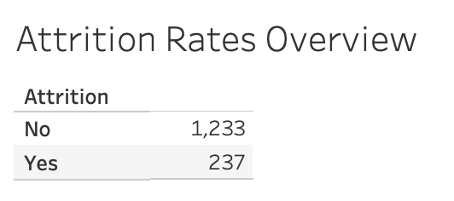

From this, I would like to remind the user that there is a class imbalance problem.

* Attrition Counts:
  + No: 1233 instances
  + Yes: 237 instances
* Attrition Proportions:
  + No: 0.838776 (Approximately 83.88%
  + Yes: 0.161224 (Approximately 16.12%)

The majority class (No attrition) constitutes around 83.88% of the dataset, while the minority class (Yes attrition) makes up approximately 16.12%. In imbalanced datasets like this, where one class is significantly more prevalent than the other, it's important to be mindful of potential challenges.

The ratio of Male and Female for this dataset is 60:40.

Here is the analysis of attrition based on gender.

| Female | Attrition Count | Attrition Proportion | Percentage |
| --- | --- | --- | --- |
| No | 501 | 0.85 | 85% |
| Yes | 87 | 0.15 | 15% |

| Male | Attrition Count | Attrition Proportion | Percentage |
| --- | --- | --- | --- |
| No | 732 | 0.83 | 83% |
| Yes | 150 | 0.17 | 17% |

## 2.2. Dashboard for Demographic Analysis

I would like to design dashboards that provide attrition analysis based on the employees’ demographic data.

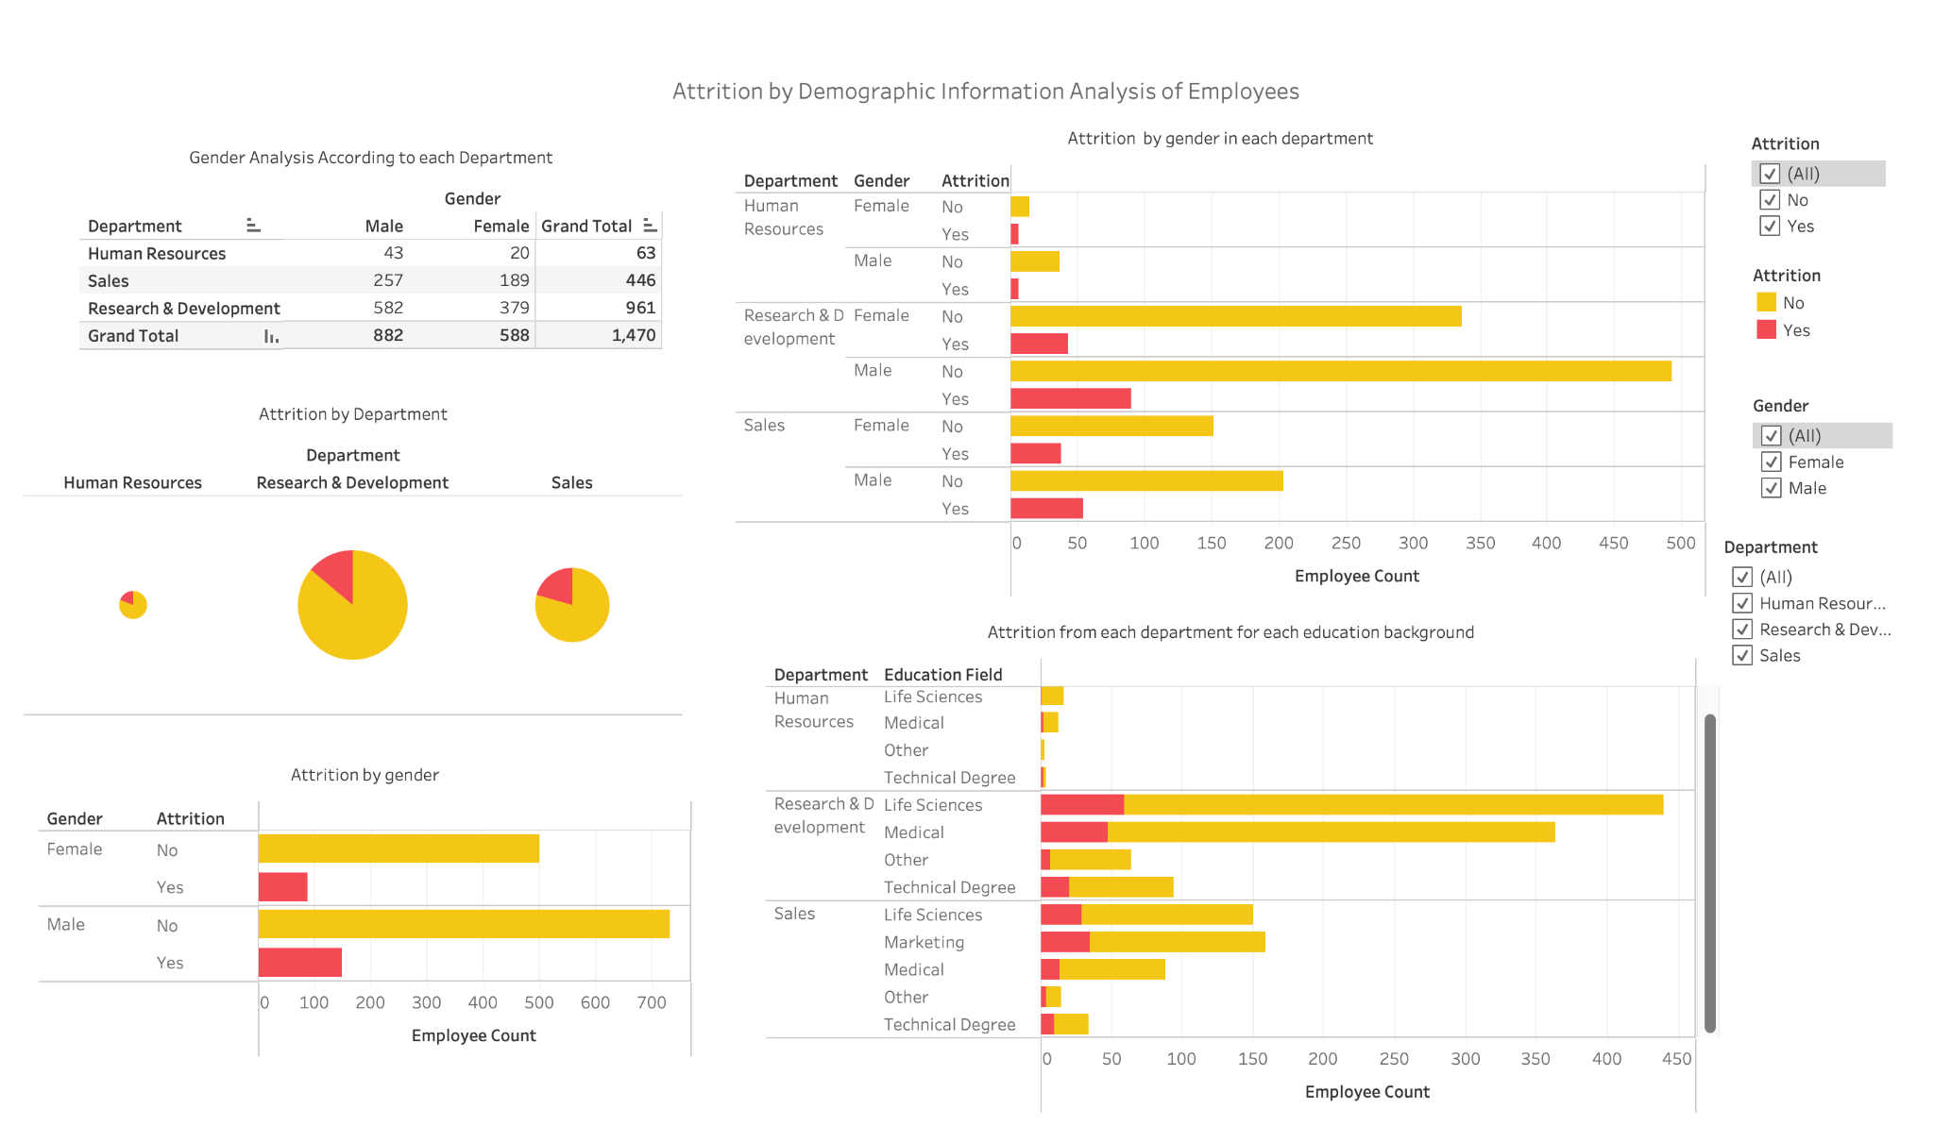

### Dashboard 1: Demographic Analysis:

* Gender Distribution in Each Department:
  + Design Rationale: Adds granularity by considering gender-specific attrition patterns.
  + Interpretation: Enables users to discern if attrition rates vary between genders within specific departments, highlighting potential gender-related dynamics.
* Attrition Rate for Each Gender in Each Department:
  + Design Rationale: A stack bar chart is used to track attrition rates over time. Separate lines for each gender facilitate easy comparison.
  + Interpretation: Users can identify patterns and trends in attrition rates for different genders within specific departments.
* Attrition Rate for Each Department:
  + Design Rationale: A pie chart provides a clear comparison of attrition rates across departments.
  + Interpretation: Users can pinpoint departments with higher attrition rates, prompting further investigation into potential issues.
* Attrition by Gender:
  + Design Rationale: A fundamental element, table is used, showcasing overall attrition rates in each department.
  + Interpretation: Identifies departments with higher or lower attrition, guiding targeted retention efforts.
* Attrition from Each Department for Each Educational Background:
  + Design Rationale: A stacked bar chart is used to display attrition numbers based on education background and department.
  + Interpretation: Users can identify which educational backgrounds are more susceptible to attrition in each department.

Dashboard 1 provides a deep dive into the demographic dimensions of attrition, empowering stakeholders to uncover patterns related to gender, department, educational background, and their intersections. The visualizations foster a comprehensive understanding, allowing for the formulation of targeted strategies to enhance employee retention in specific demographic contexts.

### Dashboard 2: Demographic Analysis

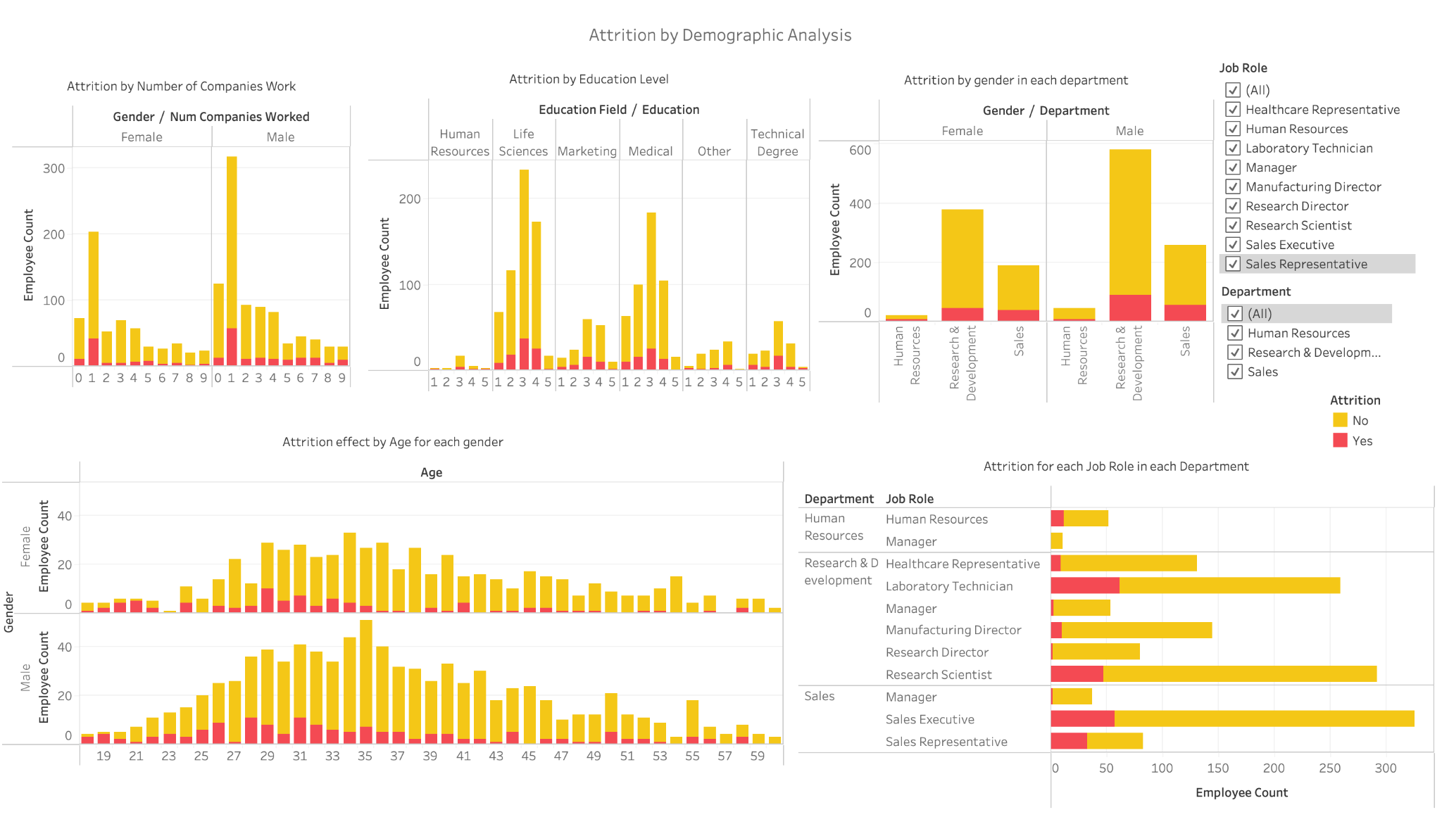

* Attrition by Number of Companies Work:
  + Visualization Type: Column Chart
  + Design Rationale: Displays the count of attrition based on the number of companies an employee has worked for.
  + Interpretation: Easily compares attrition rates for individuals with different work histories.
* Attrition by Education Level:
  + Visualization Type: Column Chart
  + Design Rationale: Represents attrition across different education levels using vertical bars.
  + Interpretation: Provides a quick overview of attrition distribution based on education backgrounds.
* Attrition by Gender in Each Department:
  + Visualization Type: Bar Chart
  + Design Rationale: Compares attrition between genders within each department.
  + Interpretation: Identifies gender-specific attrition patterns in different departments.
* Attrition Effect by Age for Each Gender:
  + Visualization Type: Column Chart
  + Design Rationale: Illustrates the impact of age on attrition, separately for each gender.
  + Interpretation: Examines whether age influences attrition differently for males and females.
* Attrition for Each Job Role in Each Department:
  + Visualization Type: Bar Chart
  + Design Rationale: Displays attrition rates for various job roles within each department.
  + Interpretation: Highlights specific job roles and departments with higher attrition rates.

Dashboard 2 provides a comprehensive analysis of demographic factors influencing attrition. The chosen visualizations offer clear comparisons and insights into the impact of the number of companies worked for, education levels, gender dynamics within departments, age-related attrition trends, and the attrition landscape across different job roles and departments. This detailed exploration enables stakeholders to tailor retention strategies based on specific demographic dimensions.

## 2.3 Dashboard for Performance, Tenure and Satisfaction Analysis

This analysis aims to provide a holistic analysis of factors influencing employee performance, tenure, and satisfaction within the organization. Through a series of carefully selected visualizations, it seeks to offer actionable insights into the impact of overtime, work-life balance concerning marital status, performance ratings, total working years, years at the company, and satisfaction with the work environment and job. The primary objective is to empower stakeholders with a comprehensive understanding of these dimensions to drive informed decision-making and implement targeted strategies for improving overall employee well-being and organizational performance.

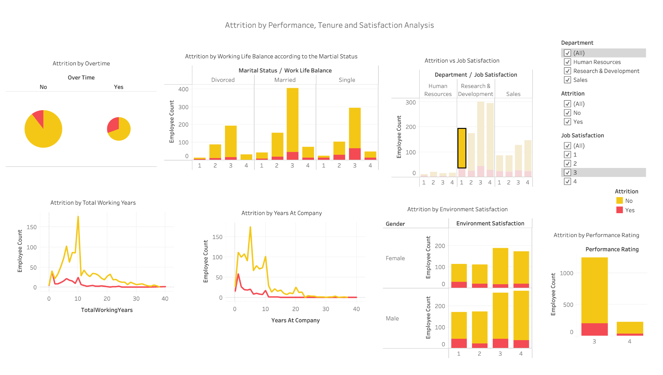

### Performance Analysis:

1. Attrition by Overtime: Pie Chart
   * Design Rationale: Pie chart for a quick overview of the proportion of attrition linked to overtime.
   * Interpretation: Easily identifies the impact of overtime on attrition, assisting in workload management strategies.
2. Attrition by Working Life Balance According to Marital Status: Bar Chart
   * Design Rationale: Bar chart to compare attrition concerning marital status and work-life balance.
   * Interpretation: Reveals correlations between marital status, work-life balance, and attrition, aiding in targeted interventions.
3. Attrition by Performance Ratings: Bar Chart
   * Design Rationale: Bar chart for visualizing attrition across different performance ratings.
   * Interpretation: Highlights attrition patterns based on performance ratings, guiding strategies for performance improvement.

### Tenure Analysis:

1. Attrition by Total Working Years: Line Chart
   * Design Rationale: Line chart to show the trend of attrition concerning total working years.
   * Interpretation: Illustrates if there's a trend in attrition based on total working years, facilitating long-term retention planning.
2. Attrition by Years at Company: Line Chart
   * Design Rationale: Line chart to depict attrition trends over the years at the company.
   * Interpretation: Identifies how the duration of employment correlates with attrition, aiding in retention strategies.

### Satisfaction Analysis:

1. Attrition by Environment Satisfaction: Bar Chart
   * Design Rationale: Bar chart to represent attrition based on different levels of environment satisfaction.
   * Interpretation: Provides insights into how employee satisfaction with the work environment influences attrition, guiding workplace improvement efforts.
2. Attrition by Job Satisfaction: Bar Chart
   * Design Rationale: Bar chart for visualizing attrition concerning job satisfaction.
   * Interpretation: Highlights the impact of job satisfaction on attrition, supporting strategies for improving employee contentment.

## 2.4 Dashboard for Managerial Analysis

The "Managerial Analysis" dashboard delves into the relationship between attrition and the duration of employees' experiences, both with their current manager and overall tenure at the company.

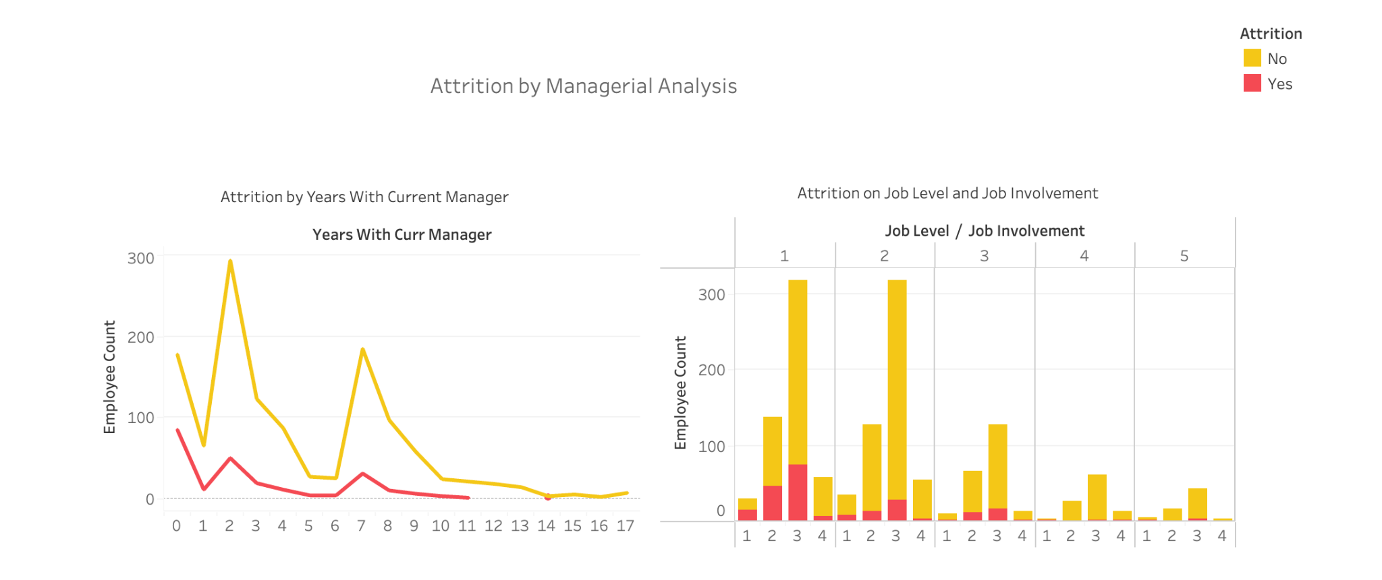

Components:

* Attrition vs Years with Current Manager:
  + Design Rationale: Explores the correlation between the duration of working with the current manager and attrition.
  + Interpretation: Users can identify if longer or shorter durations with the current manager are associated with attrition, guiding manager-employee relationship strategies.
* Attrition by Job Level and Job Involvement:
  + Design Rationale: The bar chart is chosen to visually represent the attrition rates across different job levels and job involvement categories. This design allows for easy comparison and identification of patterns.
  + Interpretation: The bar chart provides a clear snapshot of the attrition landscape concerning job levels and job involvement. Each bar represents a specific category, and the length of the bar corresponds to the attrition rate.

## 2.5 Conclusion

The designed dashboards aim to provide a comprehensive view of employee attrition, focusing on demographic analysis, performance, tenure, and satisfaction. The choice of visualization elements is driven by the need for clarity, comparison, and trend identification. Here's a summary of the dashboard's strengths and contributions:

* Demographic Analysis Dashboards:
  + Granularity: The use of gender, education background, and other factors adds granularity for a more detailed understanding.
  + Comparison Ease: Different chart types facilitate easy comparison of attrition rates within departments and across categories.
  + Identifying Patterns: Users can quickly identify patterns, such as gender-based attrition variations or the impact of education background on attrition.
* Performance, Tenure, and Satisfaction Analysis Dashboards:
  + Visual Clarity: Clear and concise visualizations, including pie charts, bar charts, and line charts, enhance the clarity of information.
  + Trend Analysis: Line charts for tenure-related metrics enable trend analysis over time, helping in forecasting and strategic planning.
  + Holistic Insights: The combined analysis of performance, tenure, and satisfaction provides a holistic view of factors influencing attrition.
* Overall Impact:
  + Decision Support: The dashboards serve as decision support tools, enabling HR professionals and organizational leaders to make informed decisions.
  + Actionable Insights: Identification of specific areas of concern allows for the formulation of targeted retention strategies and interventions.
  + User-Friendly: The design prioritizes user-friendliness, ensuring that stakeholders can easily interpret and derive insights from the presented data.

In conclusion, the dashboard design aligns with the goal of leveraging descriptive analytics for HR employee attrition analysis. It empowers users with actionable insights, fostering a data-driven approach to talent management and organizational decision-making.