Studio 1A and 1B

Name and Student Id: Kaikun Song 33414564

Self-Evaluation {To be highlighted by Student only}:

|  |  |  |  |  |  |
| --- | --- | --- | --- | --- | --- |
| Need Help | Work in Progress | Pass | Credit | Distinction | High Distinction |

Task 1A

{Answers}

Five different IDEs:

1.IntelliJ IDEA

2.Visual Studio Code

3.Eclipse

4.PyCharm

5.Xcode

{Screenshots}

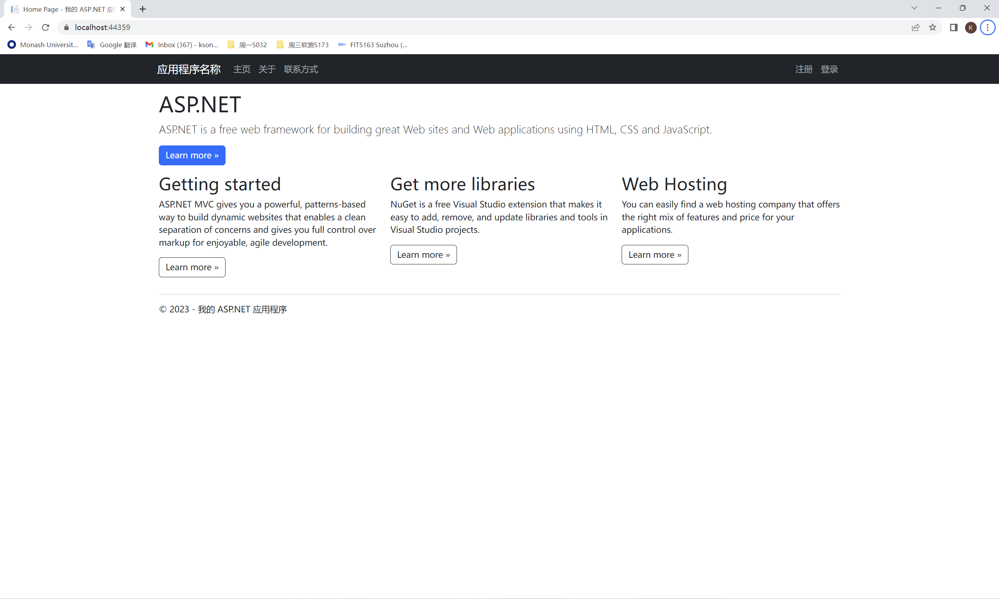

Fig1.Community Edition IDE IIS localhost screenshot

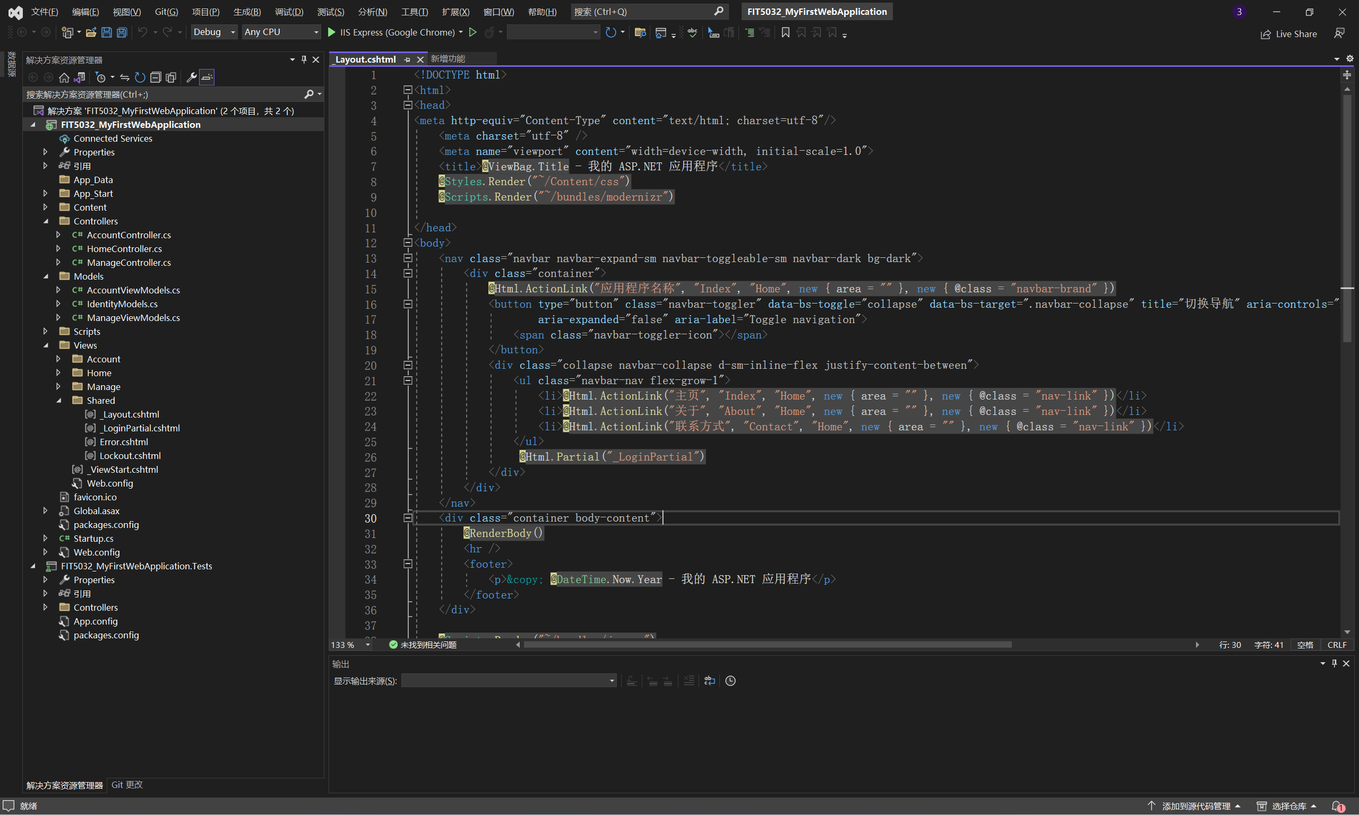

Fig2. Visual Studio Community Edition screenshot

Features:

1.Code Editor: Visual Studio Community Edition provides a highly customizable and feature-rich code editor. It supports syntax highlighting, code completion, and IntelliSense.

2.Project and Solution Management: The IDE allows you to organize your code into projects and solutions.

3.Integrated Source Control: Visual Studio Community Edition seamlessly integrates with popular version control systems such as Git and Team Foundation Version Control (TFVC). You can perform source code management tasks directly from the IDE, including committing changes, branching, merging, and viewing commit history.

4.Testing and Debugging: Visual Studio Community Edition includes comprehensive testing and debugging tools. It supports various testing frameworks for unit testing, integration testing, and performance testing.

{Link to code repository}

/

{References}

/

{URLs}

/

Task 1B

{Answers}

{Screenshots}

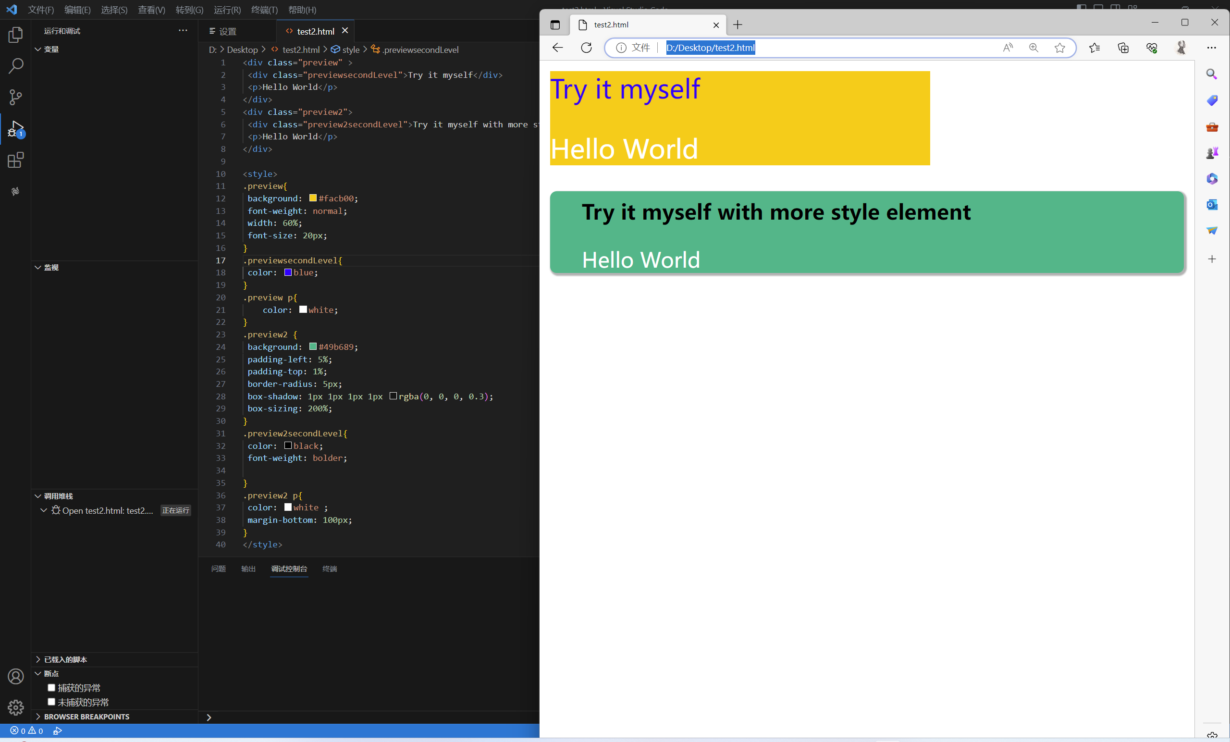

Fig3. Test CSS example screenshot

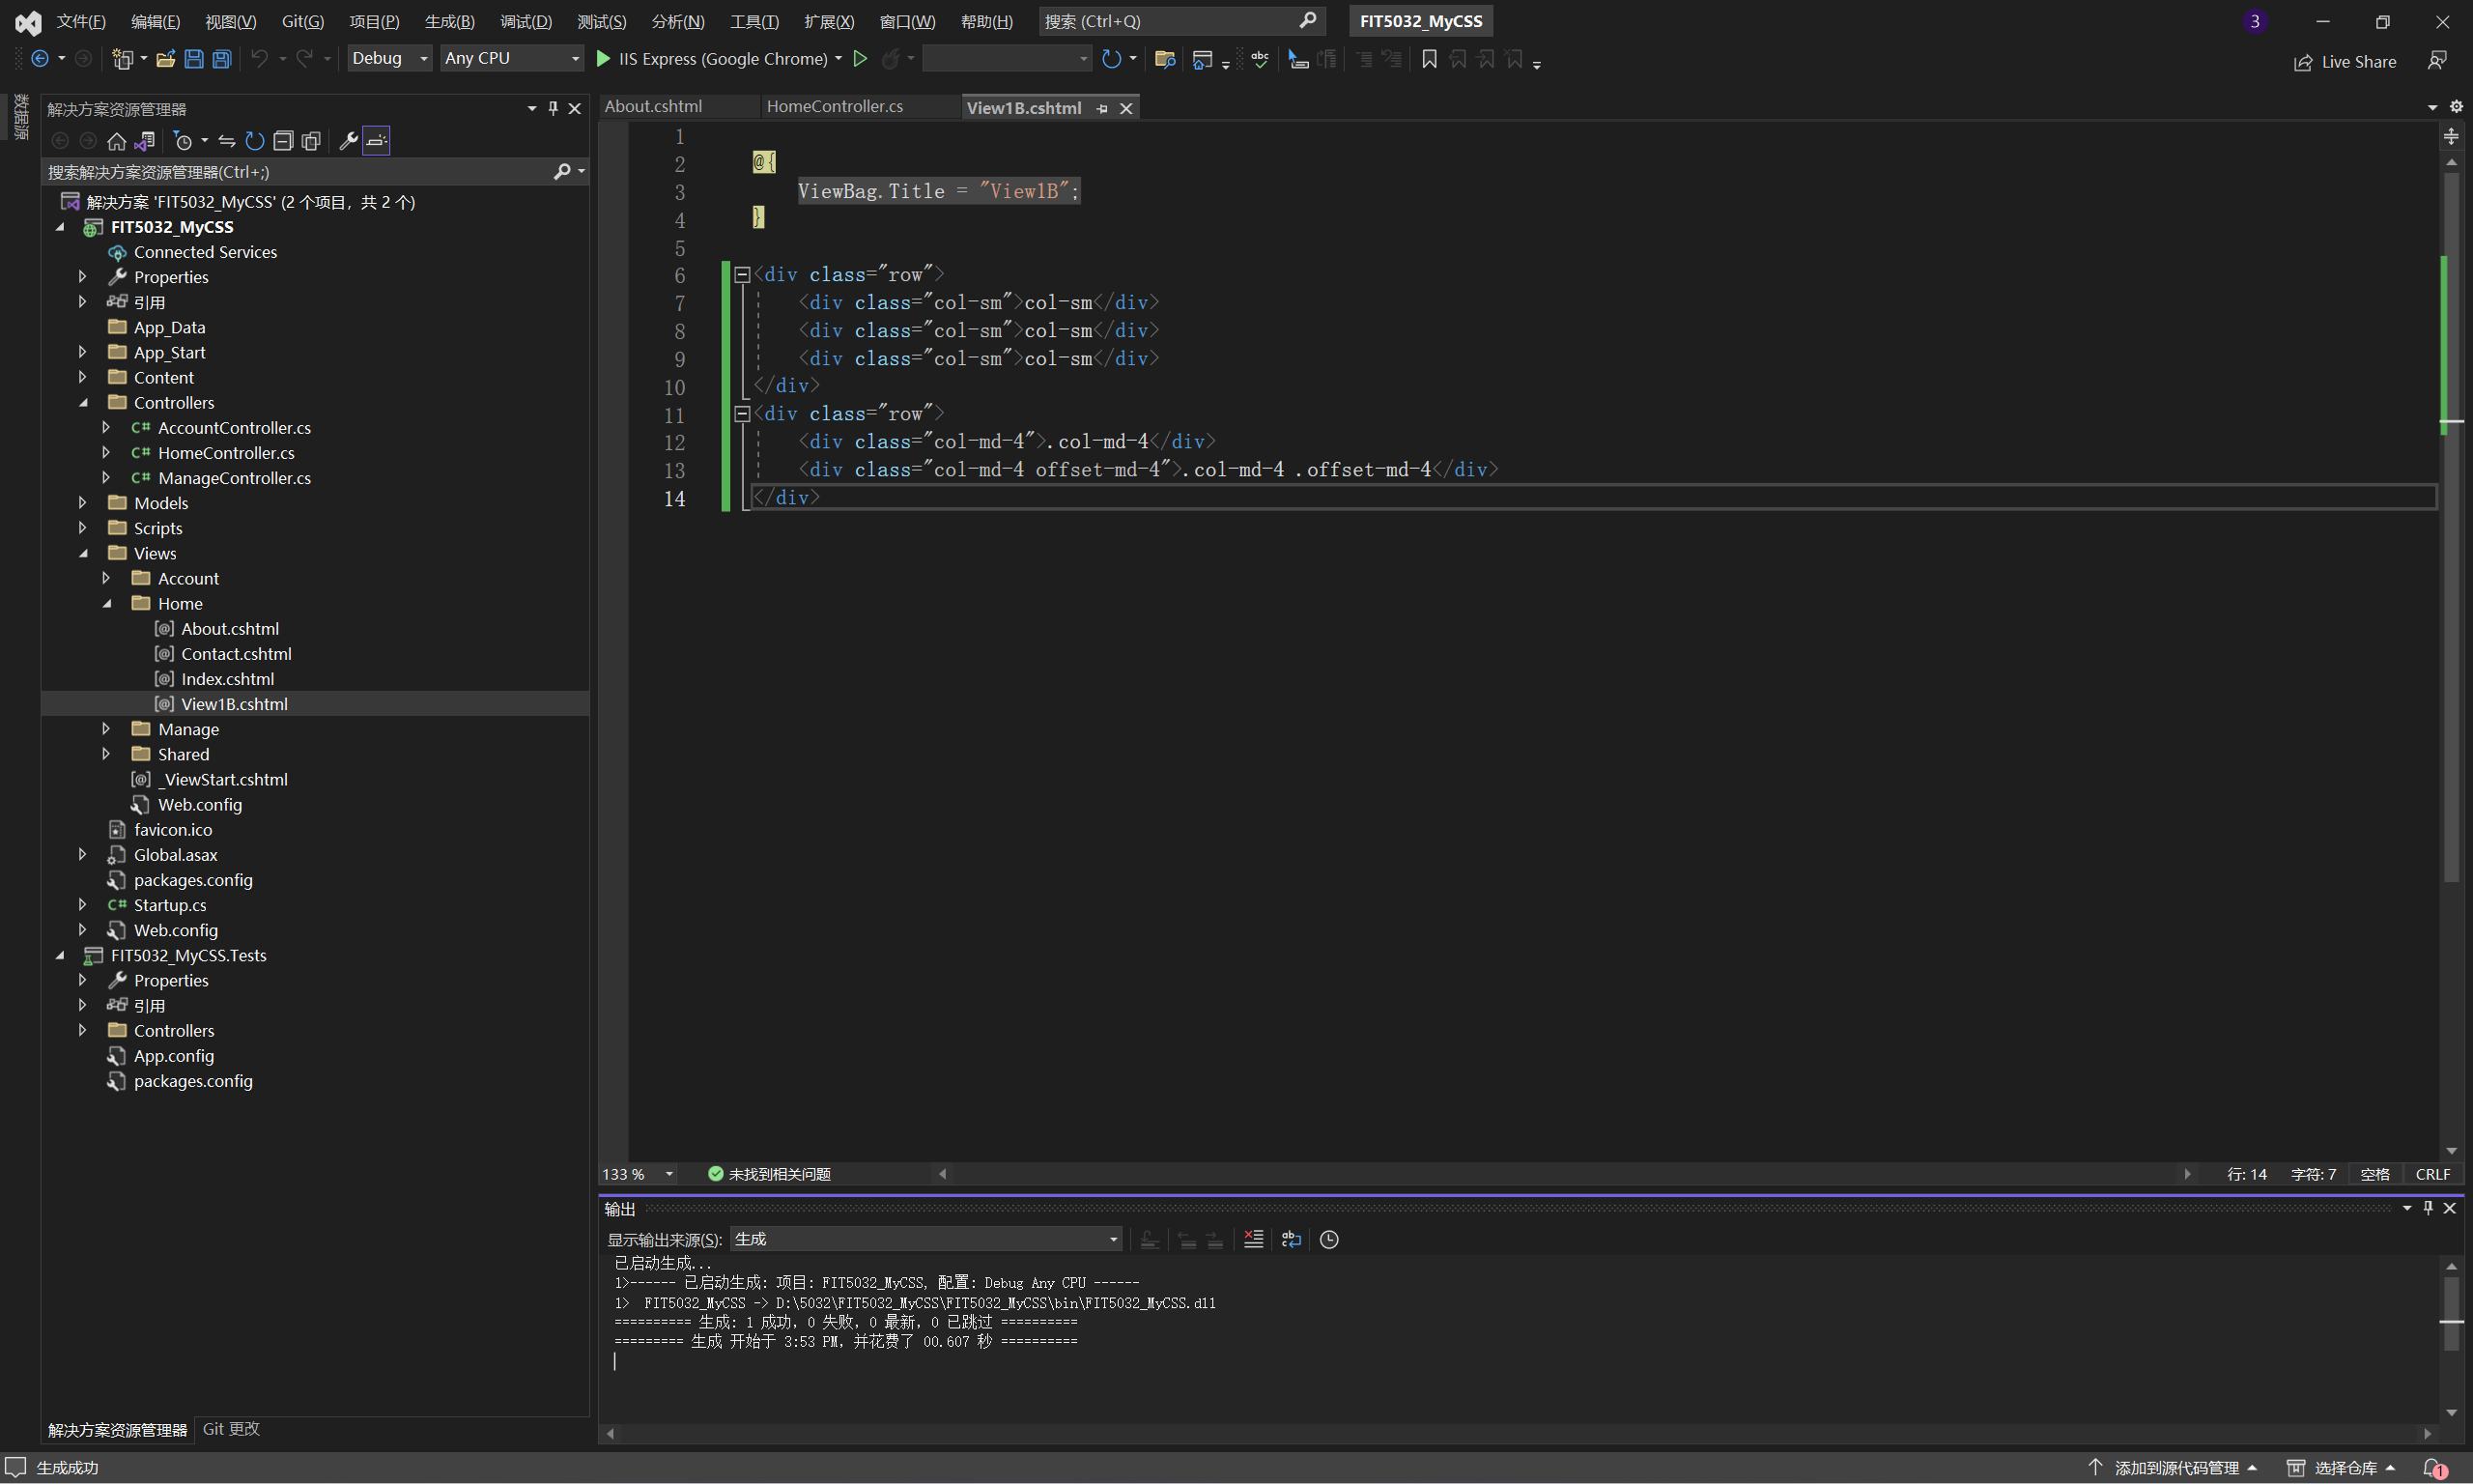

Fig4.1 Code screenshot

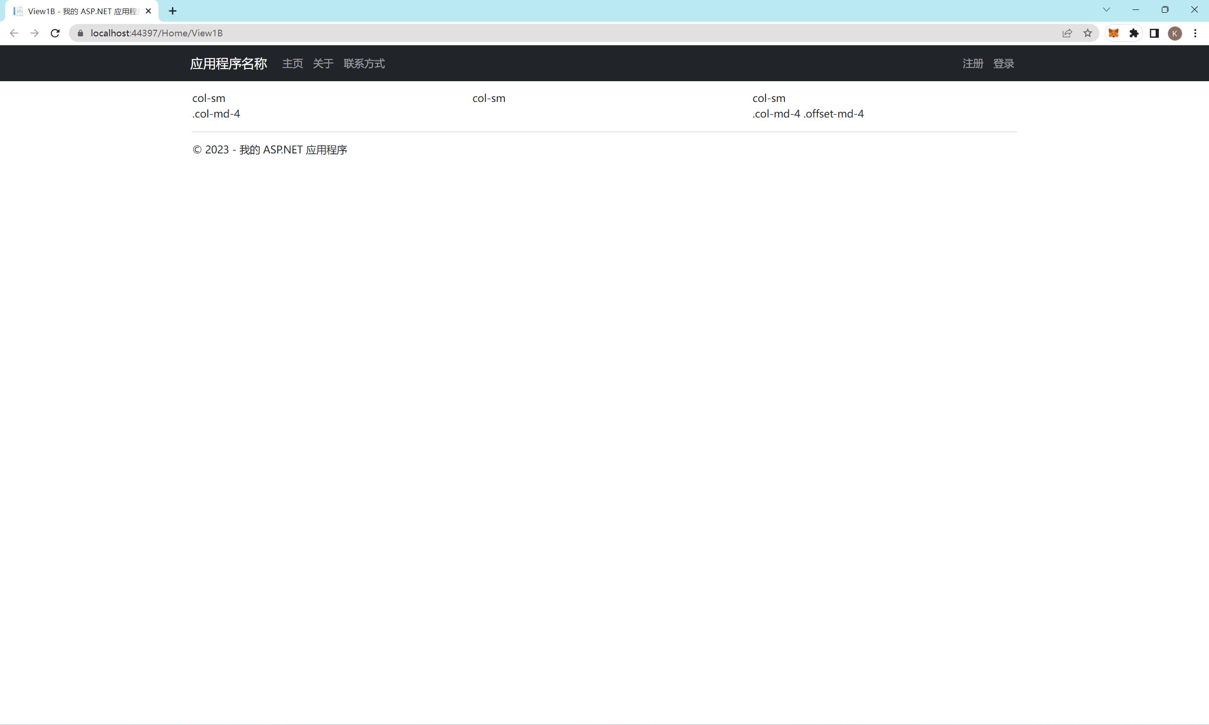

Fig4.2 Bootstrap screenshot

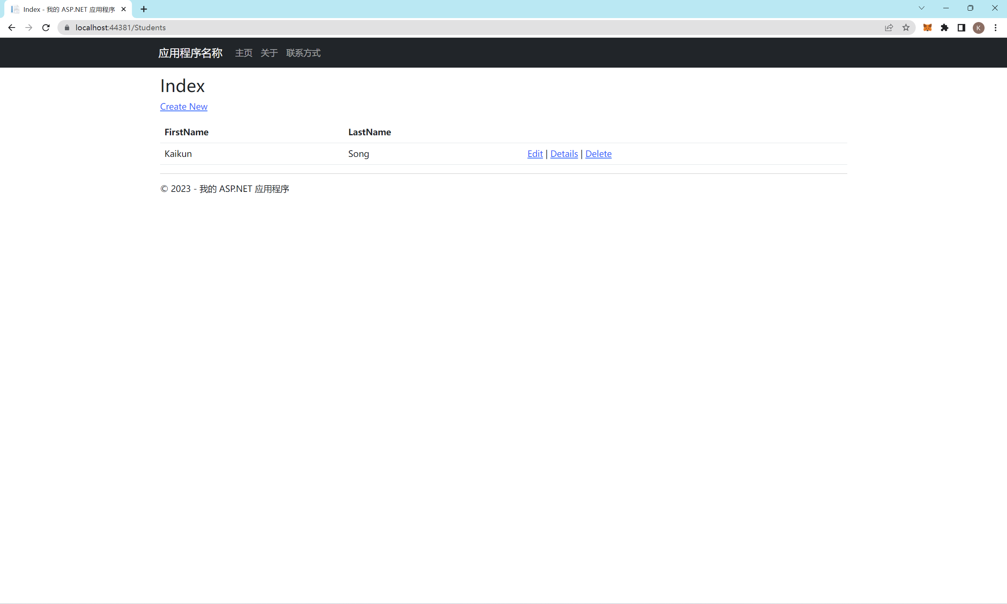

Fig5 Database schema and code screenshot

{Link to code repository}

{References}

{URLs}