Data Mining for Business Analytics
Exercise 4: Graph analysis

Task 4.1 (3p)

Compute PageRank for each node in the following graph assuming
- no taxation
- β = 0.8

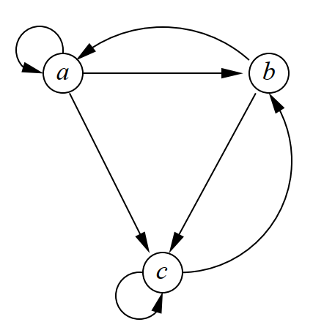

You may verify the “a)” results using the code in Task 4.2 (copy, edit for this purpose and run the code block 4.2.1 [6] and [7].)

Task 4.2 (11 p)

In this task you will first analyze a simple ‘toy’ graph and then perform pagerank and cluster analysis on a larger graph obtained as a subset of a network data set available from the Stanford web page: https://snap.stanford.edu/data/egonets-Facebook.html .

The code examples below make use of the iGraph library. Go first to the CSC pyspark environment as in previous exercises. You can now download the Ex4_data.zip file from Moodle (section Exercise 4 dataset), unzip it and load to your CSC pyspark. In addition to data, the file contains also a jupyter notebook. Open the Ex4.ipynb notebook. All the subtasks with the instructions on reporting. Start running the code boxes and follow the instructions.

Please return your exercise in pdf format to Moodle with your name, student number and the title of the exercise clearly visible on the first page.

