Appendix A1 Signup page with Please fill out this field massage  
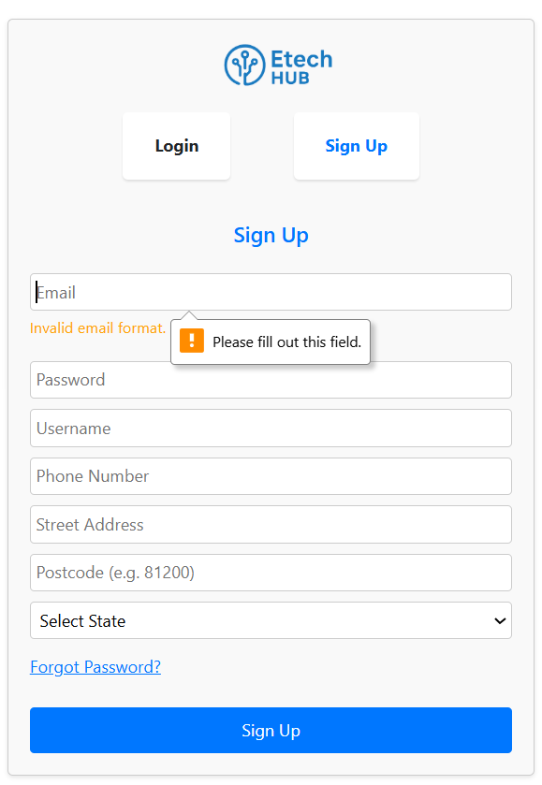  
  
Appendix A2 Login page show massage please use a different email  
  
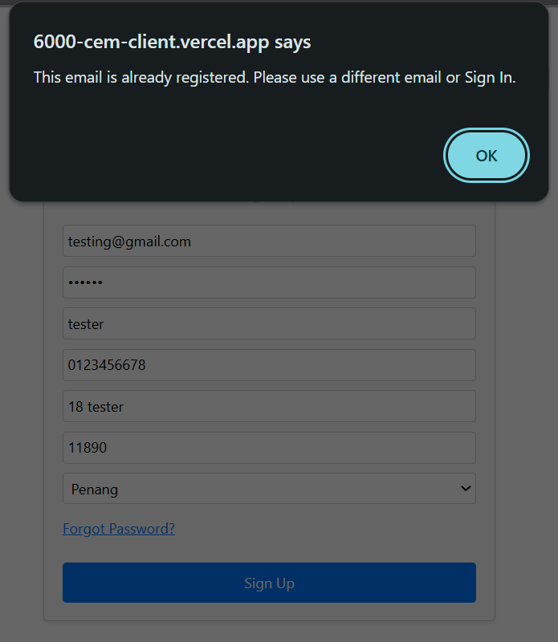

Appendix A3 Login page show massage please include an @ in the email address 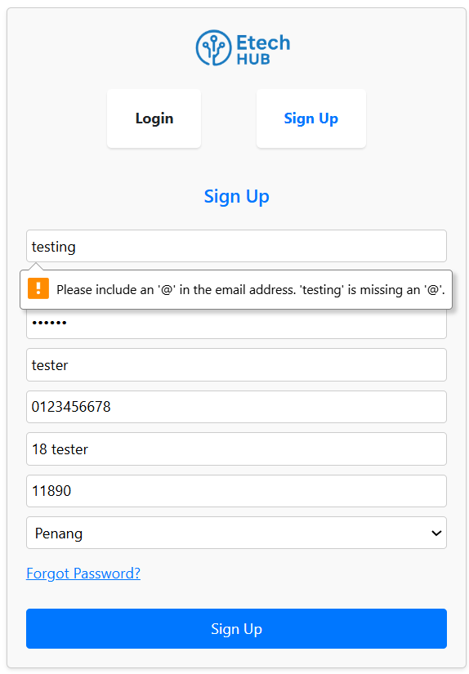  
  
Appendix A4 Login page show massage Password must be at least 6 characters.  
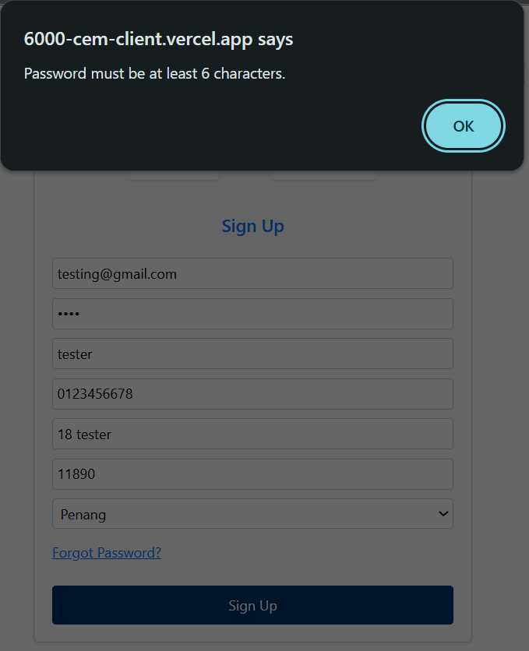

Appendix A5 Login page show massage Phone number must be 10 or 11 digits  
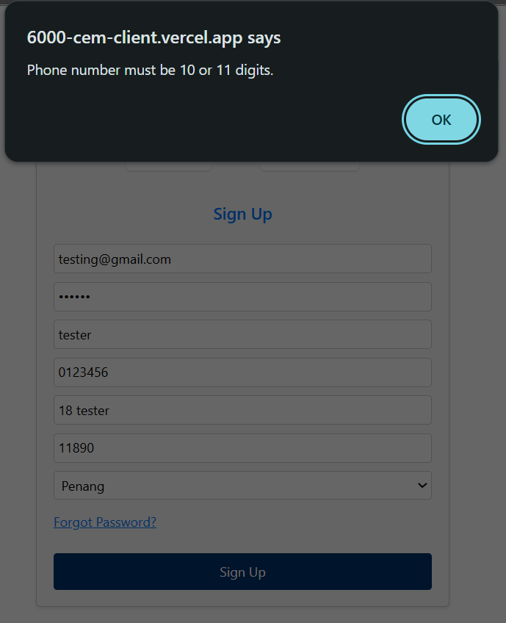

Appendix A6 Login page show massage Please enter a valid address

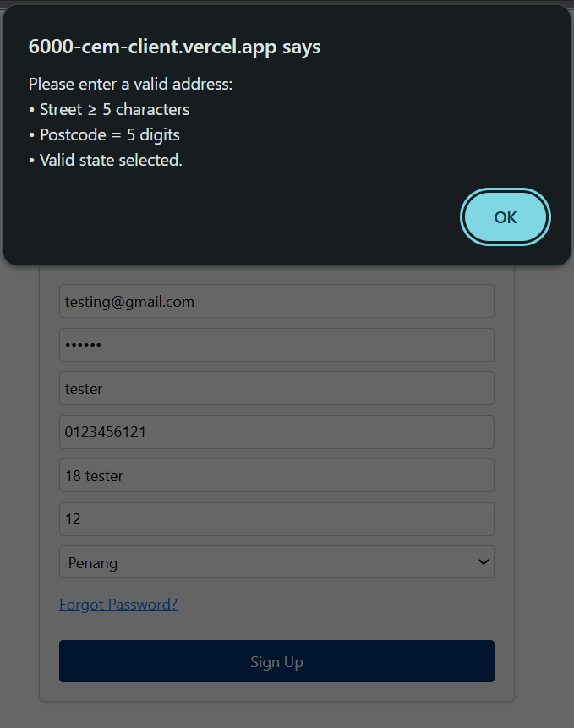

Appendix A7 The Sign Up button responds correctly when clicked, successfully triggering the registration process.

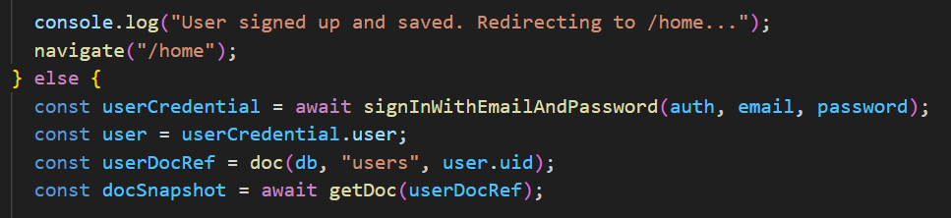

Appendix A8 Login Page show massage Please fill out this field  
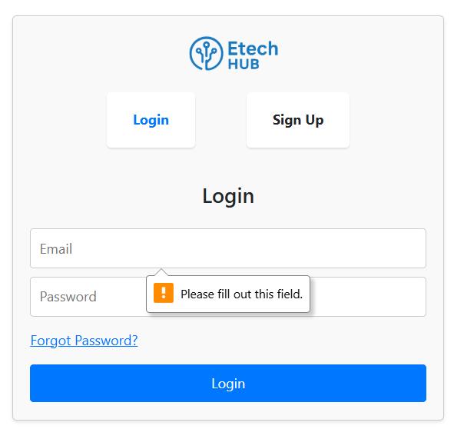

Appendix A9 Login Page show massage invalid login credentials  
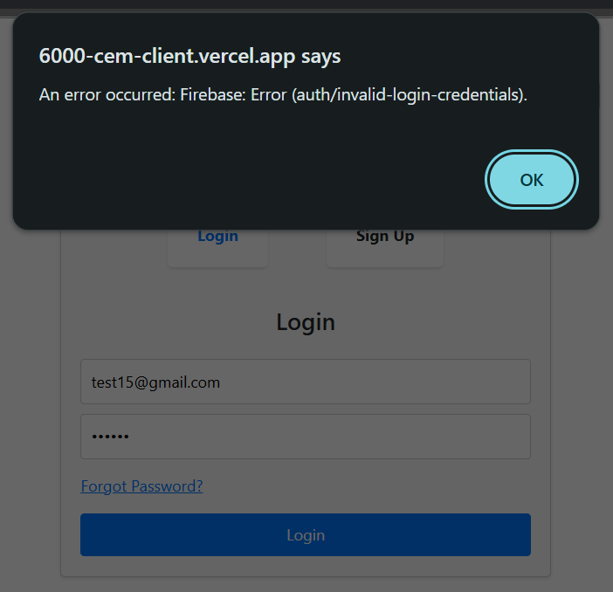

Appendix A10 Login Page show massage Password must be atleast 6 characters  
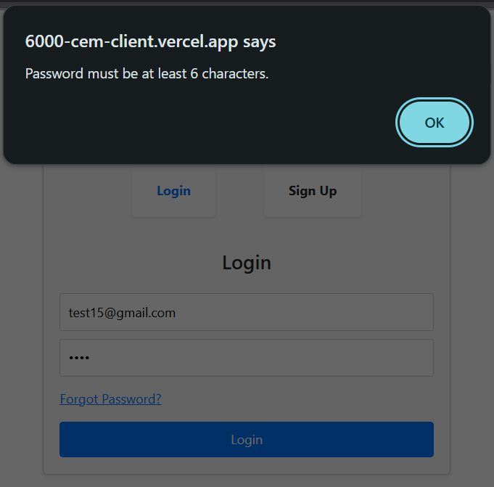

Appendix A11 Password reset page show massage auth/invalid-email  
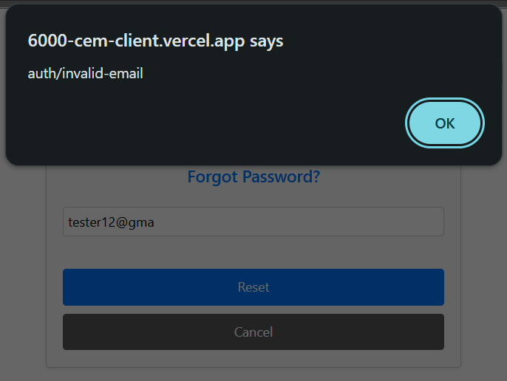

Appendix A12 Reset password page show massage check your email

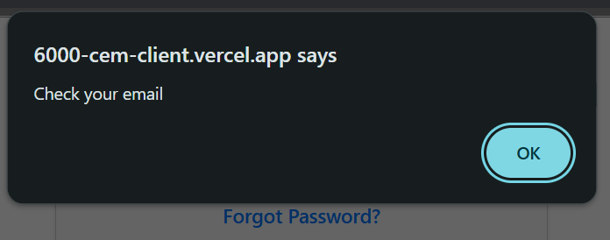

Appendix A13 Reset password page show massage the password must be atleast 6 characters long  
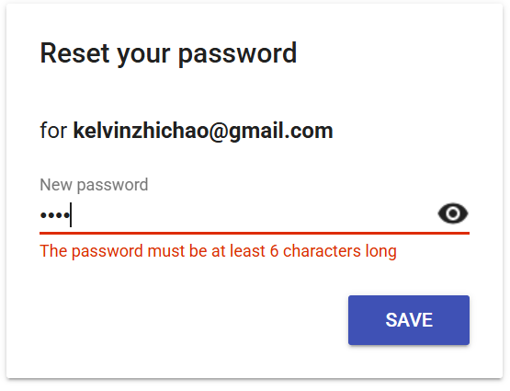

Appendix A14 Reset password page show massage try ressetting your password again  
  
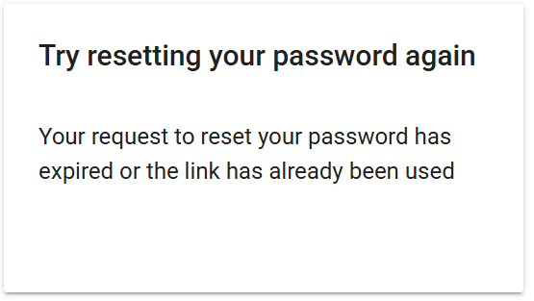

Appendix A15 Homepage loads without errors and delays  
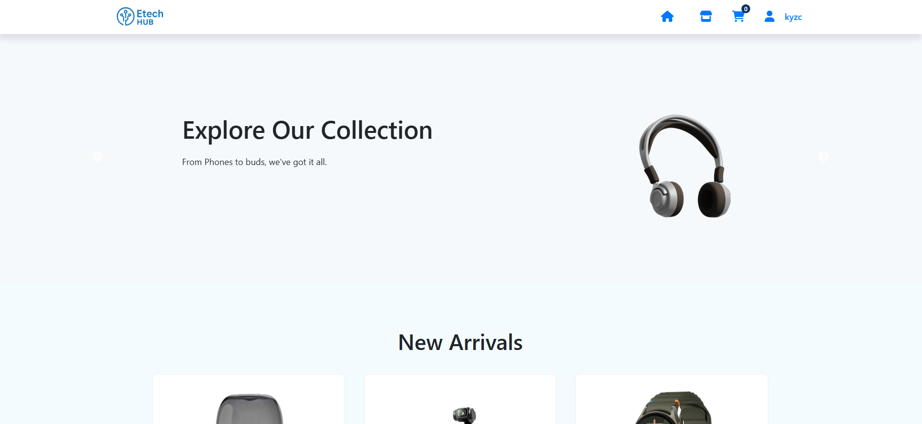  
  
Appendix A16 Navigation bar are clickable and route correctly  
  
  
Appendix A17 Homepage New arrivals product displayed correctly  
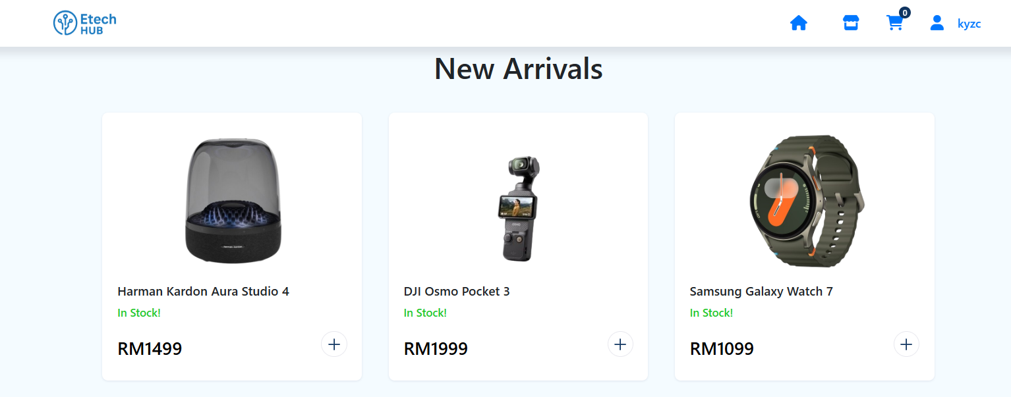  
  
Appendix A18 Show product details page   
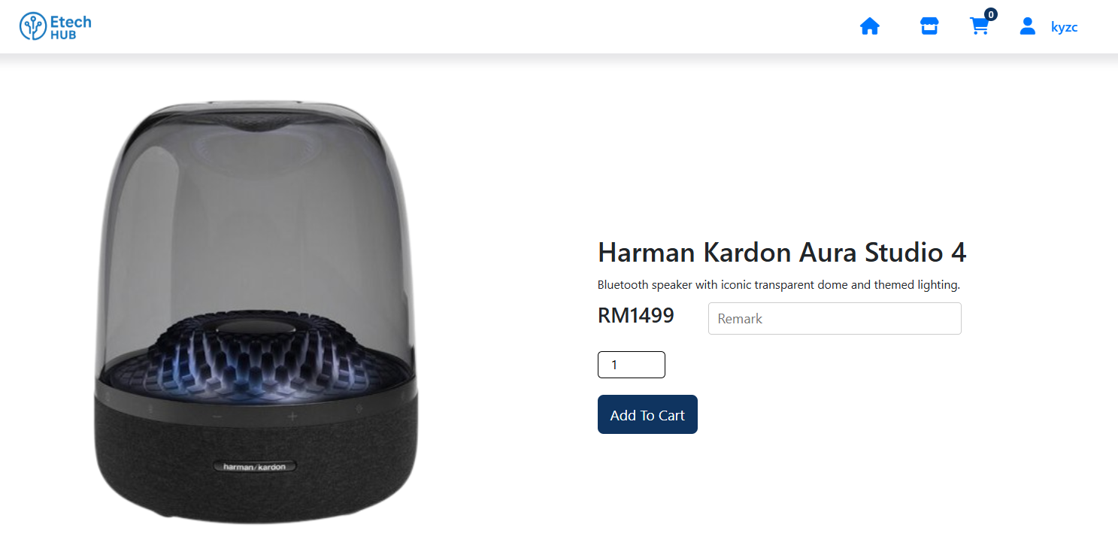

Appendix A19 Show Home page navigation bar is still remain in place when page reached bottom  
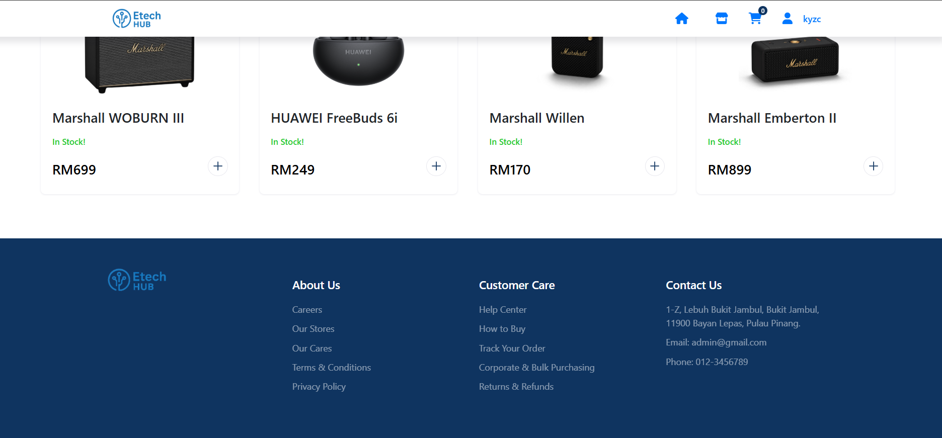  
  
Appendix A20 Show Home page footer  


Appendix A21 Show home page with welcome banner   
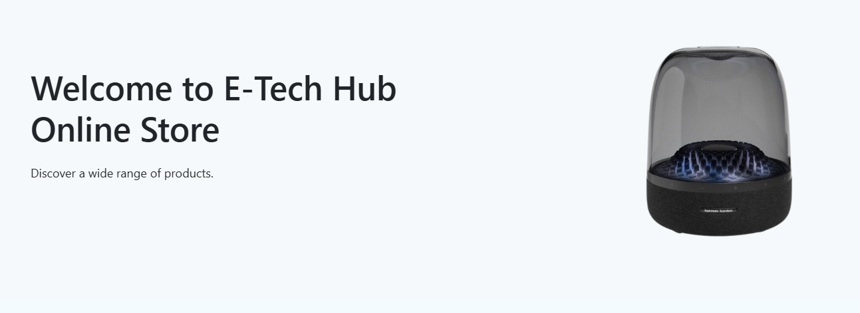  
  
Appendix A22 Show when navigation cart icon reflect correct number of items  
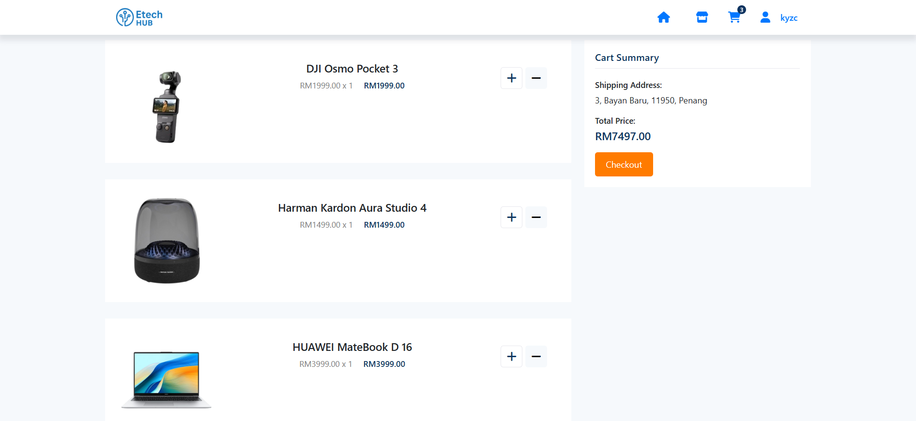

Appendix A23 Navigation bar show username   


Appendix A24 Show code snip of Sign Out  
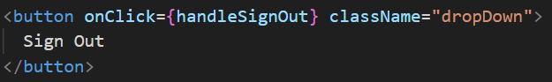

Appendix A2

Appendix A2

Appendix A2

Appendix A2

Appendix A2

Appendix A2