User Manual

# Provided Elements

The refitted toy car set includes:

1. The refitted car with the mouse and battery holder attached

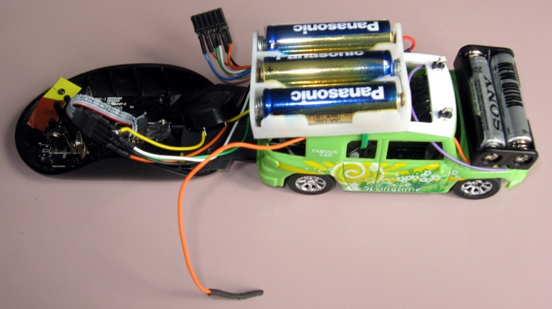

1. The power regulation circuit

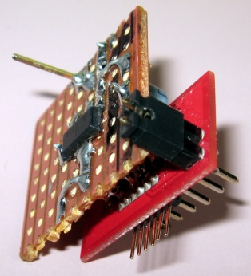

1. Car Serial Wireless

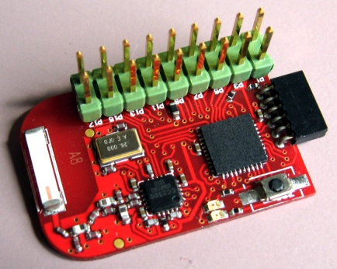

1. PC Serial Wireless

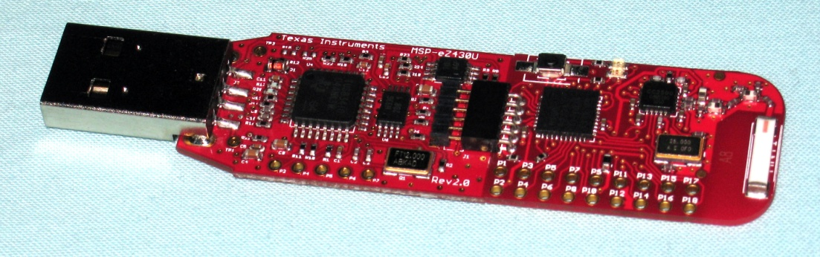

# CarV2.jpgToy car

## Battery

The toy car has two set of battery. The top holder contains 3 AA batteries that power the car original circuit. Those 3 batteries supply the car motor and steering coils. The second set powers the embedded system. The set is composed of the front battery holder and the bottom battery holder from the car. Two AAA batteries are placed in the front holder and **1 AAA is placed in the bottom holder**. The battery in the bottom holder is placed in the slot way from the holder screw.

**WARNING:** Care should be taken when placing the batteries into the holders.

## ConnectionsCarConnector.jpg

The car has two loose connectors. The connector shown here is the embedded system connector and connects to the *Power Regulation Circuit*. The following signals are present:

* UART Tx : Blue
* VCC (3.3V) : Red
* TST : Green
* RST : White
* GND : Black
* UART Rx : Orange

**WARNING:** Care should be taken when connecting this connector

The second connector is the loose black-ended orange wire. This wire is connection to the embedded system battery set. It provides a nominal voltage of 4.5V to the *Power Regulation Circuit.*

# RegV2.jpgPower Regulation Circuit

The power regulation circuit generates a stable voltage for the embedded system from the embedded system battery set. The black-ended orange wire from the car connects to the single pin on the top.

The power regulation circuit interface the *Car Serial Wireless* with the embedded system. The *Car Serial Wireless* connects to

The circuit connects to the car embedded system connector with

Labels are present to correctly connect the circuit.

**WARNING:** Care should be taken when connecting the circuit to the car connector.  
Failure to connect the circuit correctly may result in the embedded system being damaged.

# Serial WirelesReg+RF_V2.jpgs

The toy car communicates with the computer via a serial link. The serial settings are 9600 baud, 8 bit data, 1 bit stop, no parity bit.

The serial link can be achieved wirelessly by Texas Instrument RF2500 which simulates a serial link proxy.

The *car serial wireless* connects to the *power regulator circuit* as shown above. The *car serial wireless* circuit enables the serial link once the switch is pressed. Then the *PC serial wireless* is able to connect and exchange serial commands.

The *PC Serial Wireless* is shown below. When plugged, the dongle waits for the connection to be enabled by the car circuit. This state is indicated by 2 blinking LED. Once the connection is established the LEDs indicate transmission and reception of data.

If the car wireless circuit is reset. The connection must be reinitiated by reconnecting the dongle to the computer and enabling the link for the car circuit.

