User Manual

# Provided Elements

The refitted toy car set includes:

1. The refitted car with the mouse and battery holder attached
2. The power regulation circuit
3. Car Serial Wireless ( Optional )
4. 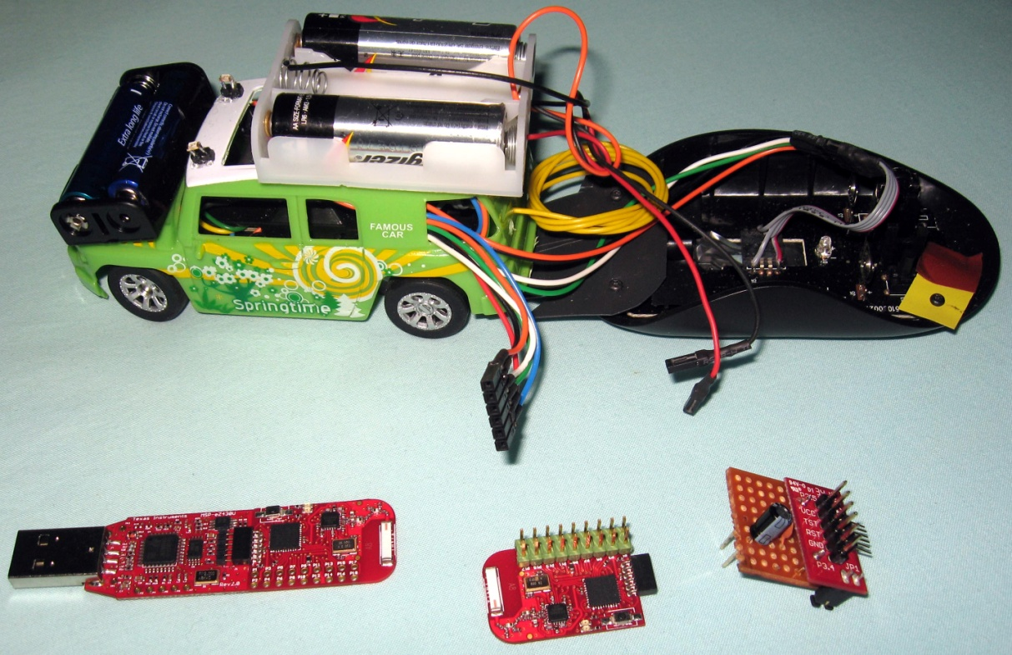PC Serial Wireless ( Optional )

# Toy car

Figure 1 Refitted Toy Car Elements

## Connections

The toy car, noted 1, has 2 connections noted 1a and 1b (see Fig. 1). 2 is the power regulation circuit with the battery input, 3 is the MPS430 associated with the wireless link to its counterpart plug in to the PC which is noted 4.

The 1a is the battery connection supplying a nominal voltage of 6V. This connection plugs onto *the* battery input of *the power regulation circuit.* The connection 1b is composed of the car power supply, the micro-controller programming link and the serial lines. This connection plugs into the *power regulation circuit* car output. **Care should be used to plug this connector correctly in order to avoid any damage to the car/circuit.** Red wire connects to VCC, Black wire to GND, White wire to RST, Green wire to TST and The orange and blue wires are serial Rx, Tx respectively.

## Battery

The toy car has two battery holders:

* one on the hood holding two AAA batteries
* the second is on top of the car holding two AA batteries.

**WARNING:** The battery holder on top of the car only holds two batteries. No battery should be placed in the middle slot.

# Power Regulation Circuit

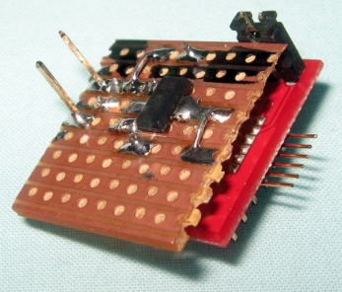The power regulation circuit has a battery input and a car output. The car output is a 6 pin header with labels VCC, TST, RST, and GND. The battery input is shown in Fig 2. The pin labelled 2, close to the black mark, is the ground. The black wire from the battery should be connected to it. The pin labelled 3 is the battery high potential (Battery +). The red wire from the battery should be connected to it.

Figure 2 Battery Input

**WARNING:** The battery connection 1a shown in Fig. 1 should be correctly connected to the *power regulation circuit*. Failure to do so will result in damage of the circuit and the car.

The *power regulation circuit* has a ground jumper, labelled 1 in Fig. 2. Removing the jumper disable power to any device connected to the *power regulation circuit* by removing the ground of the output. In this case, the 3.3V regulator is still connected to the battery.

# Serial Wireless Option

The refitted toy car set has a serial wireless option which allows remote communication. The serial wireless option has 2 elements, one goes on the car and the other is connected to the computer.

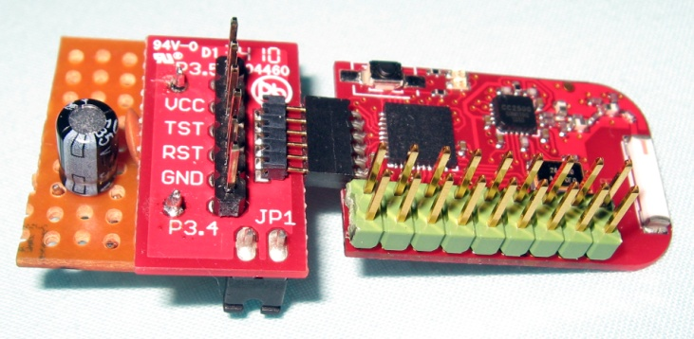The car element connects as shown in Figure 3. The PCB of the elements must be on the same plane as the *power regulation circuit* red PCB for it to be correctly connected.

Figure 3 Car Element Connection

The PC element, Figure 4, plugs into a computer USB port. The received data is read with the serial port associated with the key usually: *MSP430 Application UART.* The serial settings are 9600 baud, 8 bit data, 1 bit stop, no parity bit.

The LEDs on the elements indicate communication when blinking. Both LED on the PC element may flash together indicating that the element waits for the Car Element to be ready.

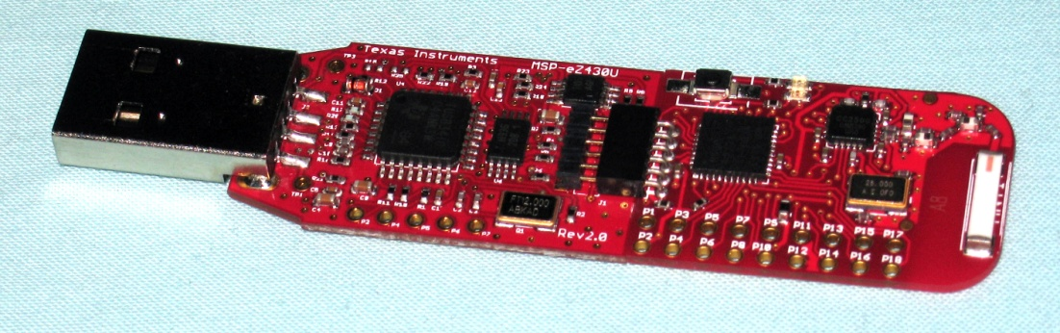

Figure 4 PC Element