Jackson State University
CSC 323 Algorithm Design and Analysis, Fall 2020
Instructor: Dr. Natarajan Meghanathan
Exam 4 (Take Home)
Maximum Points: 100 Due on: Nov. 21st, 11.59 PM

Q1: 20 pts) For the graph assigned to you, find the following using the approximation heuristics discussed in class.

(a-6) Maximal Independent Set (b-2) Minimal Vertex Cover (c-6) Maximal Clique (d-6) Minimum Connected Dominating Set

Show all the work for each.
Wilson, Kyla

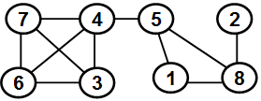

(a-6)

Maximal Independent = {1, 2, 3}

(b-2)
Minimal Vertex Cover = {4, 5, 6, 7, 8}

(c-6)
Maximal Clique = Cannot solve, too many edges for my graph so it is confusing…

(d-6)
Minimum Connected Dominating Set =

Q2: 18 pts) You are assigned the edge weight matrix for a complete graph. Determine an approximation to the minimum weight tour using the (i-6) Nearest neighbor heuristic (ii-8) Twice around the tree heuristic.

Also, show one attempt of reducing the tour weight using the 2-change heuristic for the tour obtained with each of the two heuristics.

Show all the work as well as clearly indicate the tour and its weight before and after the attempt of using the 2-change heuristic in each case

Wilson, Kyla
Initial pick(v1)

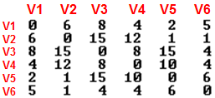

Iteration 1(0 + 2 =2): v1 – v5
Iteration 2(2 + 1 = 3): v1 – v5 – v2

Iteration 3(3+ 1 = 4): v1 – v5 – v2 – v6


Iteration 4(4 + 4=8): v1 – v5 – v2 – v6 – v3

Iteration 5(8 + 8): v1 – v5 – v2 – v6 -v3 -v4



Final tour = v1 – v5 – v2 – v6 -v3 -v4– v1
Weight = 16 + 0

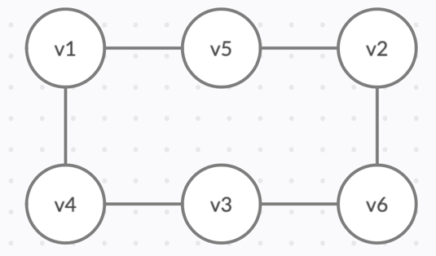

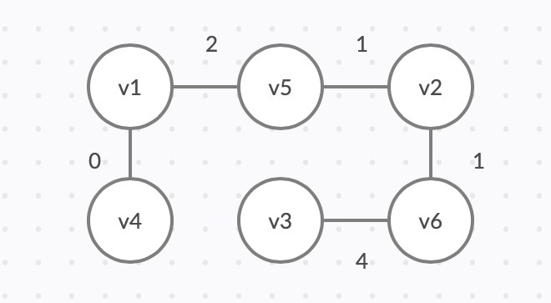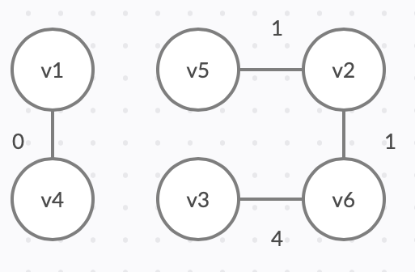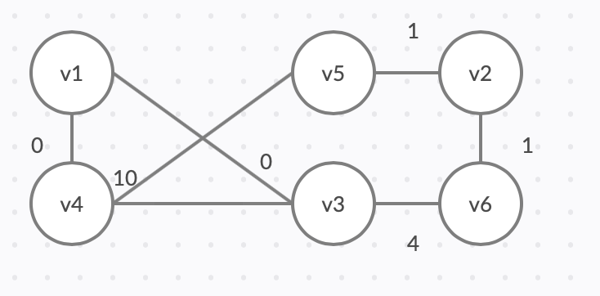

Q3: 12 pts) For the edge weight matrix assigned to you for a directed graph, determine the shortest path weights between any two vertices of the graph using the Floyd-Warshall algorithm.

Show clearly the distance matrix and the predecessor matrix for each iteration.

Also, extract a path of length two or above between any two vertices of your choice. Clearly show the path extraction steps, as shown in the slides.

Wilson, Kyla
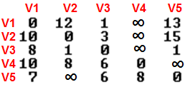

Q4: 12 pts) For the edge weight matrix assigned to you for a directed graph, determine the shortest path weights from vertex V1 to every other vertex using the Bellman-Ford algorithm.

Show clearly the table (with the distance estimate and predecessor) for each iteration, as discussed in the slides.

Also, extract the shortest paths from V1 to every other vertex in the graph, as shown in the slides. Clearly show the path extraction steps.

Wilson, Kyla

Q5: 8 pts) Run the Dijkstra's shortest path algorithm on the graph assigned to you, starting from Vertex 1, and determine the shortest path tree rooted from Vertex 1 to the rest of the vertices. If any edge does not have weight assigned, assume the weight of that edge to be 5. Show your work for each iteration in the skeletal graphs (see next page). For each skeletal graph, indicate the vertices and all the edges that are selected as part of the particular iteration as well as carried over from the previous iterations. Show all the steps.

Wilson, Kyla
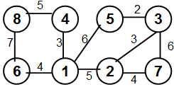

Skeletal Graphs (Iterations)

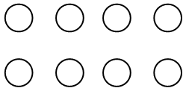
Given Graph Initialization

Iteration 1 Iteration 2

Iteration 3 Iteration 4

Iteration 5 Iteration 6

Iteration 7 Shortest Path Tree

Sum of the Weights of the Shortest Path Tree: _________
Q6: 10 pts) For the graph assigned to you, use the Breadth First Search algorithm-based approach to determine the BWC of the two vertices listed with respect to the pair y and z: i.e., BWC(X; Y and Z).

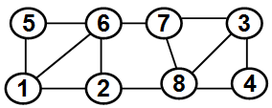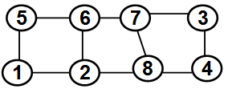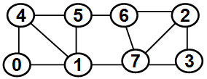
Allen, Kenneth Amos, Tara Atkins, Nayaa

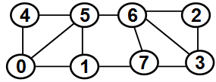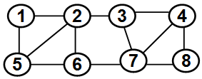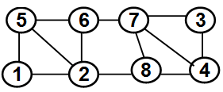
Dixon, Kobe Foster, Angel Harmon, Kenjeffery

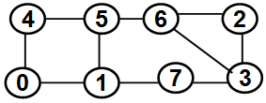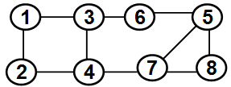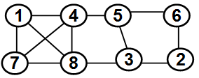
Holliman, Qaylin Irving, Atayliya Rankin, Simeon

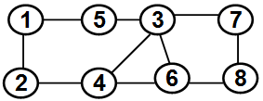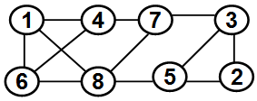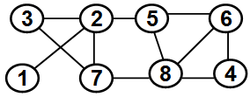
Redmond, Brandon Thomas, DiQuonte Thompson, Da Johne

Williams, Opeoluwa Wilson, Kyla

Student | X | Y and Z |  | X | Y and Z
Allen, Kenneth | 7 | 1 and 3 |  | 5 | 1 and 3
Amos, Tara | 7 | 5 and 8 |  | 3 | 5 and 8
Atkins, Nayaa | 7 | 2 and 4 |  | 0 | 2 and 4
Dixon, Kobe | 6 | 0 and 2 |  | 3 | 0 and 2
Foster, Angel | 3 | 1 and 8 |  | 4 | 1 and 8
Harmon, Kenjeffery | 7 | 1 and 3 |  | 4 | 1 and 3
Holliman, Qaylin | 7 | 0 and 3 |  | 2 | 0 and 3
Irving, Atayliya | 7 | 1 and 8 |  | 5 | 1 and 8
Rankin, Simeon | 8 | 1 and 2 |  | 7 | 1 and 2
Redmond, Brandon | 6 | 1 and 8 |  | 4 | 1 and 8
Thomas, DiQuonte | 7 | 1 and 3 |  | 2 | 1 and 3
Thompson, Da Johne | 8 | 1 and 4 |  | 3 | 1 and 4
Williams, Opeoluwa | 4 | 0 and 6 |  | 3 | 0 and 6
Wilson, Kyla | 2 | 4 and 5 |  | 8 | 4 and 5

Q7: 10 pts) Run the Ford-Fulkerson algorithm on the graph assigned to you and determine the maximum flow possible between the source (s) and destination (d) as well as determine the minimum cut of edges (set of edges with the minimum sum of the edge weights) to disconnect the source and destination. Show all the work (including the use of the residual graphs in each iteration).

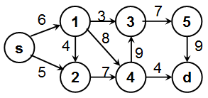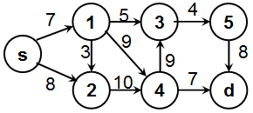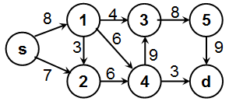
Allen, Kenneth Amos, Tara Atkins, Nayaa

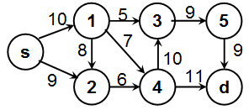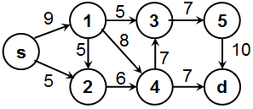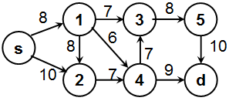
Dixon, Kobe Foster, Angel Harmon, Kenjeffery

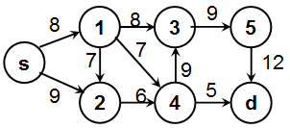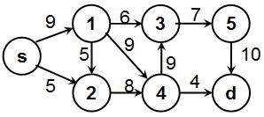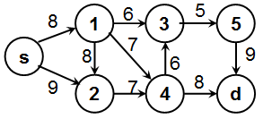
Holliman, Qaylin Irving, Atayliya Rankin, Simeon

Redmond, Brandon Thomas, DiQuonte Thompson, Da Johne

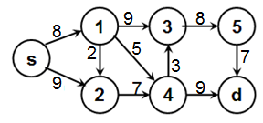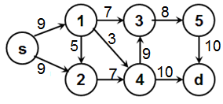
Williams, Opeoluwa Wilson, Kyla

Q8: 10 pts) Use the Ford-Fulkerson algorithm to determine the maximum bipartite matching of the edges in the graph assigned to you. Show all the work.

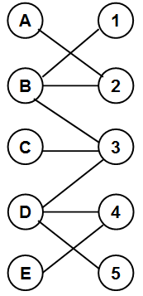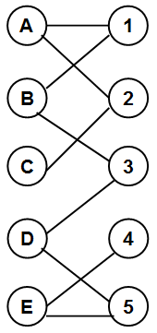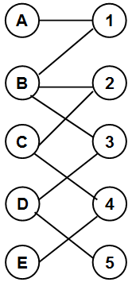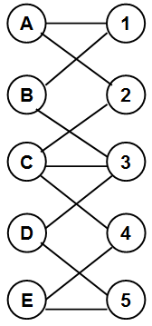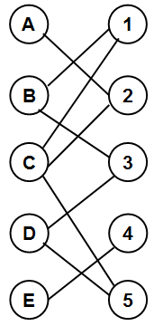
Allen, Kenneth Amos, Tara Atkins, Nayaa Dixon, Kobe Foster, Angel

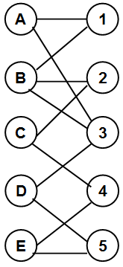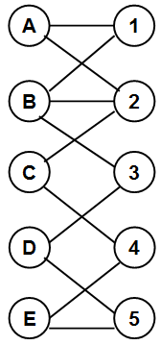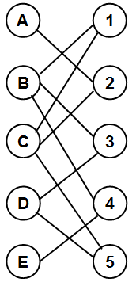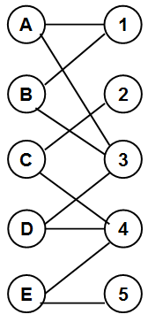
Harmon, Kenjeffery Holliman, Qaylin Irving, Atayliya Rankin, Simeon Redmond, Brandon

Thomas, DiQuonte Thompson, DaJohne Williams, Opeoluwa Wilson, Kyla

Q9: 10 pts) Consider a group of 25 people identified with ids 0 to 24. There are two people (ids: 8 and 20) in this group who are infected with an epidemic. We seek to employ group testing to minimize the number of test kits used and still be able to individually identify and isolate the infected people. We would like to use a binary search approach for "group testing" to identify the two infected people.

(a - 4 pts) Draw a binary search tree that will illustrate the isolation of the two infected people from the groups of the people (tested with only one test kit) who are not infected.
(b - 6 pts) Determine the following:
Efficiency of the group testing approach
# Tests per cleared person
Spread Size Index.

