Bothell

DEPARTMENT OF COMPUTING AND SOFTWARE SYSTEMS

STUDENT WORK PUBLICATION PERMISSION FORM

To the Student: The University of Washington Bothell, Division of Computing and Software Systems would like your permission to publish some of your student work from CSS452: Game Engine Development. Publication would consist of posting student work (including source codes written by students) on publicly accessible internet sites and/or including examples of such work in scholarly publications or presentations. Please provide the information requested below and indicate whether you are willing to grant the Department this permission. GRANTING PERMISSION TO PUBLISH YOUR STUDENT WORK IS NOT A COURSE REQUIRMENT.

Name ______Linda (Kyla) NeSmith________________

Address __7542 NE 202nd PL__________________

__Kenmore, WA 98028________________

__________________________________

Quarter/Year __Winter 2019__

Please check one:

☑ I grant permission to the University of Washington to release and/or publication of coursework, including computer source codes, submitted by me in this class. I understand that publication may consist of posting this work on one or more public access internet websites and/or publishing examples of the work in scholarly publications or presentations.

 I do not consent to the University’s release or publication of my student work in this class.

____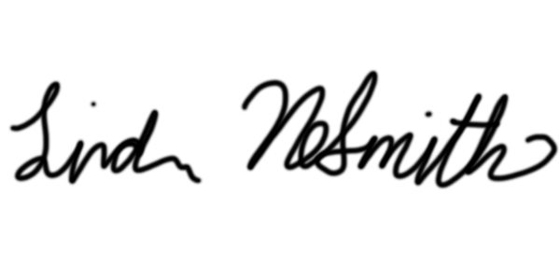_____ __03/18/2019_
Student Signature Date

