Ch2

**Pegboard Analogy**

More pixels would give a sharper images. This is represented by the pegboard showing a musical note analogy. Increasing the pixels is increasing the sampling. Each of these sample points is called picture element (pixel) for short.

**Pixel Dimensions**

Refer to an images width and height in pixels. 10 x 10 has a resolution of 100 pixels

**A natural scene**

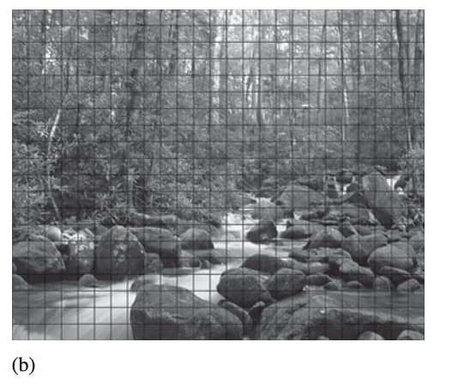

If you want to represent this scene with a 25 x 20 (b) resolution you would take the average of all the neighboring pixels to find the value of the solid color for each pixel. 25 x 20 (c) sampling size is just a demo size no realistic pictures would have these dimensions. A good image is going to be thousands or millions of pixels.

Now we take a sampling size of 100 x 80 (d). Then we take the average color value of each neighboring pixel to get one solid color for each pixel. The bigger the sampling size the better quality the image is (e). 100 x 80 dimensions is still just for demo not realistic to have an image with this resolution.

**Sampling rate**

Refers to how frequent you take a sample

For an image, sampling frequency refers to how close neighboring samples are in a 2-D image plane.

**Resolution**

Is the detail you can get from the image

“Higher resolution means more pixels” – Essa

6mb image ~ 2000 x 3000 px

Therefor increasing the sampling rate increases the image resolution

Which increases the file size

*Sampling points means pixels*

**Pixel is not a square block**

It does not have a physical dimension associated with it. In reality there is no certain shapes for the pixels. For concept we are considering them as a square.

**Colors**

**Quantization Step**

To encode an infinite number of colors and shades with a finite list.

Quantizing the sampled image involves mapping the color of each pixel to a discrete and precise value.

Instead of using the average color from the pixels neighbors, we will use 4 distinct green colors. We want to map the color of each pixel into one of the 4 colors (a). Each color is represented by a number 100, 150, 200, 250.

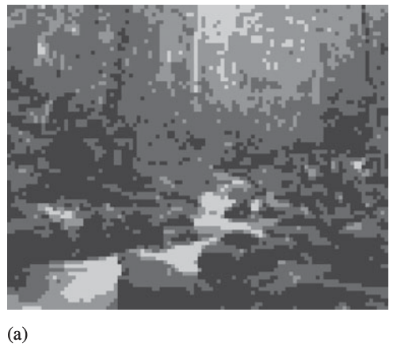

**Quantized with 8 colors**

**Bit depth**

The number of colors used for quantization is related to the color depth or bit depth of the digital image.

A bit depth of n allows 2n different colors.

A 2-bit digital image allows 22 (4) colors in the image

A 8-bit digital image allows 28 (256) colors in the image

The most common bit depth is 24 which allows 777,216 colors.

Ch2 continued….

Digital Image

An image is two dimensional fuction f(x,y), where x and y are spatial coordinates, and the amplitude of f at any pair of coordinates (x,y) is called the intensity of the image at that level.

Digital images are composed of a finite number of elements called pixel each of which has a particular location and value.

To normalize the data set you divide by the max. If 8 bit then the range of each value is 0 – 255 so to normalize the data set you divide each value by 255.

Image Types

* grayscale image G(x,y)
* RGB colored image Rgb(x,y,3)
* 3 represents 3 channels with each channel has 8 bits therefore 24 bits for each pixel represents 224 (16M) colors
* RGB video sequence v(x,y,3,t)
* T represents time
* Multi-spectral image s(x,y,b)
* B represents number of channels where b > 3
* If B > 20 then image is considered hyper-spectral image
* 3D image m(x,y,z)

**Color Models**

Used to describe colors numerically, usually in terms of varying amounts of primary colors.

Common color models:

1. RGB main focus of this class
2. CMYK (cyan, magenta, yellow, kyan) printing ink
3. HSB painting
4. CIE and their varients photoshop and other comp. software

**Additive Color System**

**RGB Color Model**

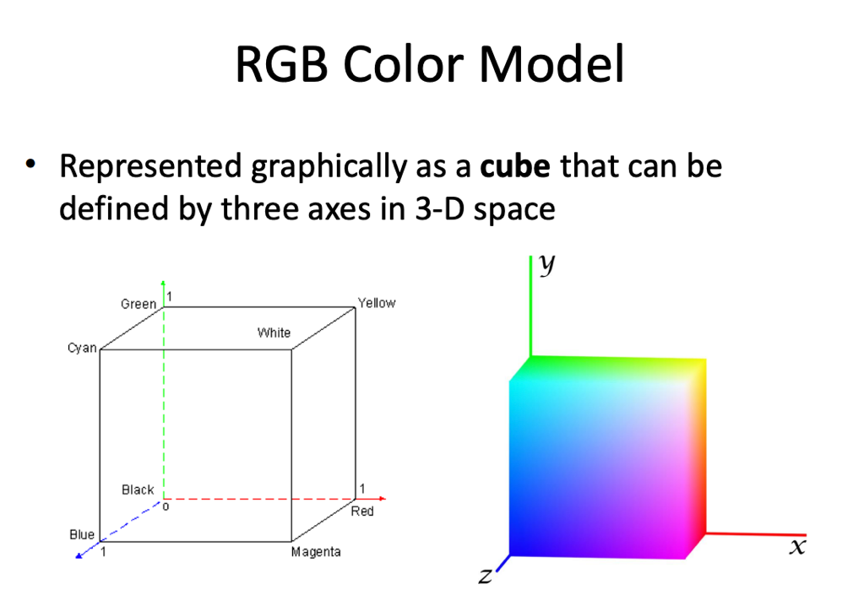

**File Size and Compression**

Suppose 6MB digital camera produces 3K x 2K pixels in 24 bit color depth.

How many pixels?

3k x 2k = 6M pixels

How many bits?

6M x 24 bits = 144M bits

How many bytes?

144M / 8 bits = 18M bytes

**Strat to reduce file size**

* Reduce Pixel dimensions
* Capture image at lower resolution
* Resample (Resize) the current image to a lower pixel dimension.

Now suppose 6MB digital camera produces 1.5K x 1K pixels in 24 bit color depth.

How many pixels?

1.5K x 1K = 1.5M pixels

How many bits?

1.5M x 24 bits = 36M bits which is ¼ the size of the original size