Habit Tracker App – Project Report

1. Create a Git Repository
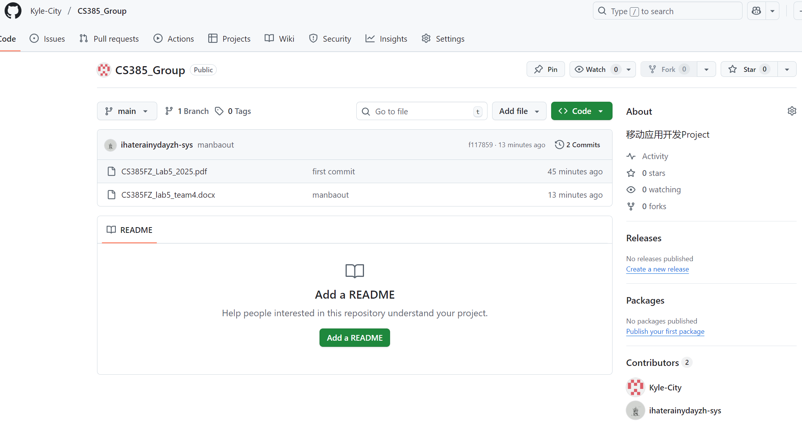
2. Project Requirements and Technology Selection
1.1 Project Overview
The Habit Tracker is a mobile application designed to help users build consistent habits and improve self-discipline. Users can create personalized habits, mark them as completed each day, and view their progress through statistics such as streaks and total completions.
The application is developed using React Native with Expo for the frontend and a backend service to store user and habit data. The project fully satisfies the module requirements, including frontend, backend, database usage, and user authentication.

1.2 Functional Requirements
1.2.1. User Management
- User registration
- User login
- Persistent authentication using tokens or Firebase Authentication
1.2.2. Habit Management
- Create habits (name, target frequency, optional icon or color)
- Edit existing habits
- Delete habits
1.2.3. Daily Check-in
- Mark a habit as “completed” for the day
- View which habits have been completed today
- View historical check-in records for each habit
1.2.4. Data Display
- Display all habits on the home screen
- Show statistics for each habit (streak, total completions, etc.)
- Optional: calendar-style habit completion view
1.2.5. Frontend-Backend Interaction
- Fetch habit data and check-in data from the backend
- Submit new habits and check-ins to the backend
1.3 Non-Functional Requirements
1.3.1. Performance
- UI response time within 0.5–1 second
- API response time < 500 ms
- Smooth data synchronization
1.3.2. Usability
- Clean and intuitive UI
- At least four functional screens: Login, Register, Home, Habit Detail/Statistics
1.3.3. Security
- Passwords stored securely (hashed)
- Token-based or Firebase authentication
- Backend input validation
1.3.4. Maintainability
- Component-based frontend structure
- RESTful backend API design
- Continuous and meaningful GitHub commits
1.3.5. Persistence
- Backend database to store user and habit data (SQL or NoSQL)
1.4 Technology Selection
Frontend
- React Native with Expo for cross-platform mobile development
- Expo Router / React Navigation for screen navigation
- Axios / fetch API for backend communication
- AsyncStorage for local storage
Backend – Two Possible Options
Option A: Firebase
- Firebase Authentication
- Firestore Database
- Firebase Storage (optional)
Option B: Node.js + Express + MongoDB
- Express RESTful API
- MongoDB / Mongoose database
- JWT authentication
Version Control
- GitHub for full code hosting
3. Team Member Responsibilities
3.1 Member Responsibilities
Zhong Chang_832304215 – Frontend Developer
Member B – Backend Developer & Tester
Jincheng Xie_832304227 – UI/UX Designer & Frontend Developer
3.2 Me Responsibilities
Jincheng Xie_832304227 – UI/UX Designer & Frontend Developer
① UI/UX design work
- Develop app visual specifications (main and secondary colors, fonts, component styles) to ensure uniform style;
- Draw prototypes and visuals of the whole process page (login, registration, homepage, habit management, statistics page, etc.);
- Design interaction logic and micro-feedback (page jumps, clock-in animations, loading status, etc.);
- Deliver design resources (cutting drawings, design files) and cooperate with the front-end restoration and landing.
② Front-end development work
- Develop core pages and reusable UI components based on React Native + Expo.
- Implement form interaction (habit creation/editing), page navigation and data display logic.
- Connect to the back-end API to complete data pull and submission (habits, clock-in records, etc.);
- Optimize page adaptation and interaction fluency to ensure UI resiliency and user experience.
4. Implementation Plan
Week 1: Requirements & Design
- Define requirements
- Create wireframes
- Design database
- Set up GitHub
Week 2: Basic Development
- Implement login/register frontend
- Implement authentication backend
- Test connectivity
Week 3: Core Features
- Build habit-related screens
- Implement CRUD APIs
- UI refinement
- Functional testing
Week 4: Finalization & Submission
- Full testing and bug fixing
- Complete documentation and demo video
- Finalize UI and stability improvements
- Prepare submission package

