E.g. Given x R, m, n, p I⁺, and the matrices below:

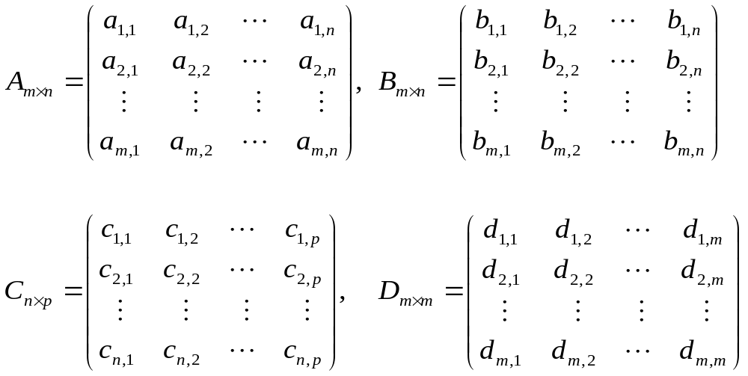

Fig. 4-1. Matrix computations.

- Translate a coordinate system to v₀

- Translate a point v by Δv

- Rotate a coordinate system θ degree (CCW)

- Rotate a point v about (0, 0) θ degree (CCW)

- Scale a point v referring to (0, 0) by α_{x} and α_{y}

Fig. 4-2. Basic transformations in Cartesian coordinates.

- Translate a coordinate system to v₀

- Translate a point v by Δv

- Rotate a coordinate system θ degree (CCW)

- Rotate a point v about (0, 0) θ degree (CCW)

- Scale a point v referring to (0, 0) by α_{x} and α_{y}

Fig. 4-3. Basic transformations matrices in homogeneous coordinates.

E.g. Rotate a vertex v about an arbitrary point v₀ θ degree.

Y
v'

v
θ

X
v₀
(0, 0)

Fig. 4-4. Non-basic transformations (1).

E.g. Scale a vertex v referring to an arbitrary point v₀ with the scaling factor α_{L} along a line L that passes v₀ and has a slope m.

Y
v'

v

v₀
X
L
(0, 0)

Fig. 4-5. Non-basic transformations (2).

