DQN tweaking DQN_MountainCar_PyTorch/main.py
Seed: 21
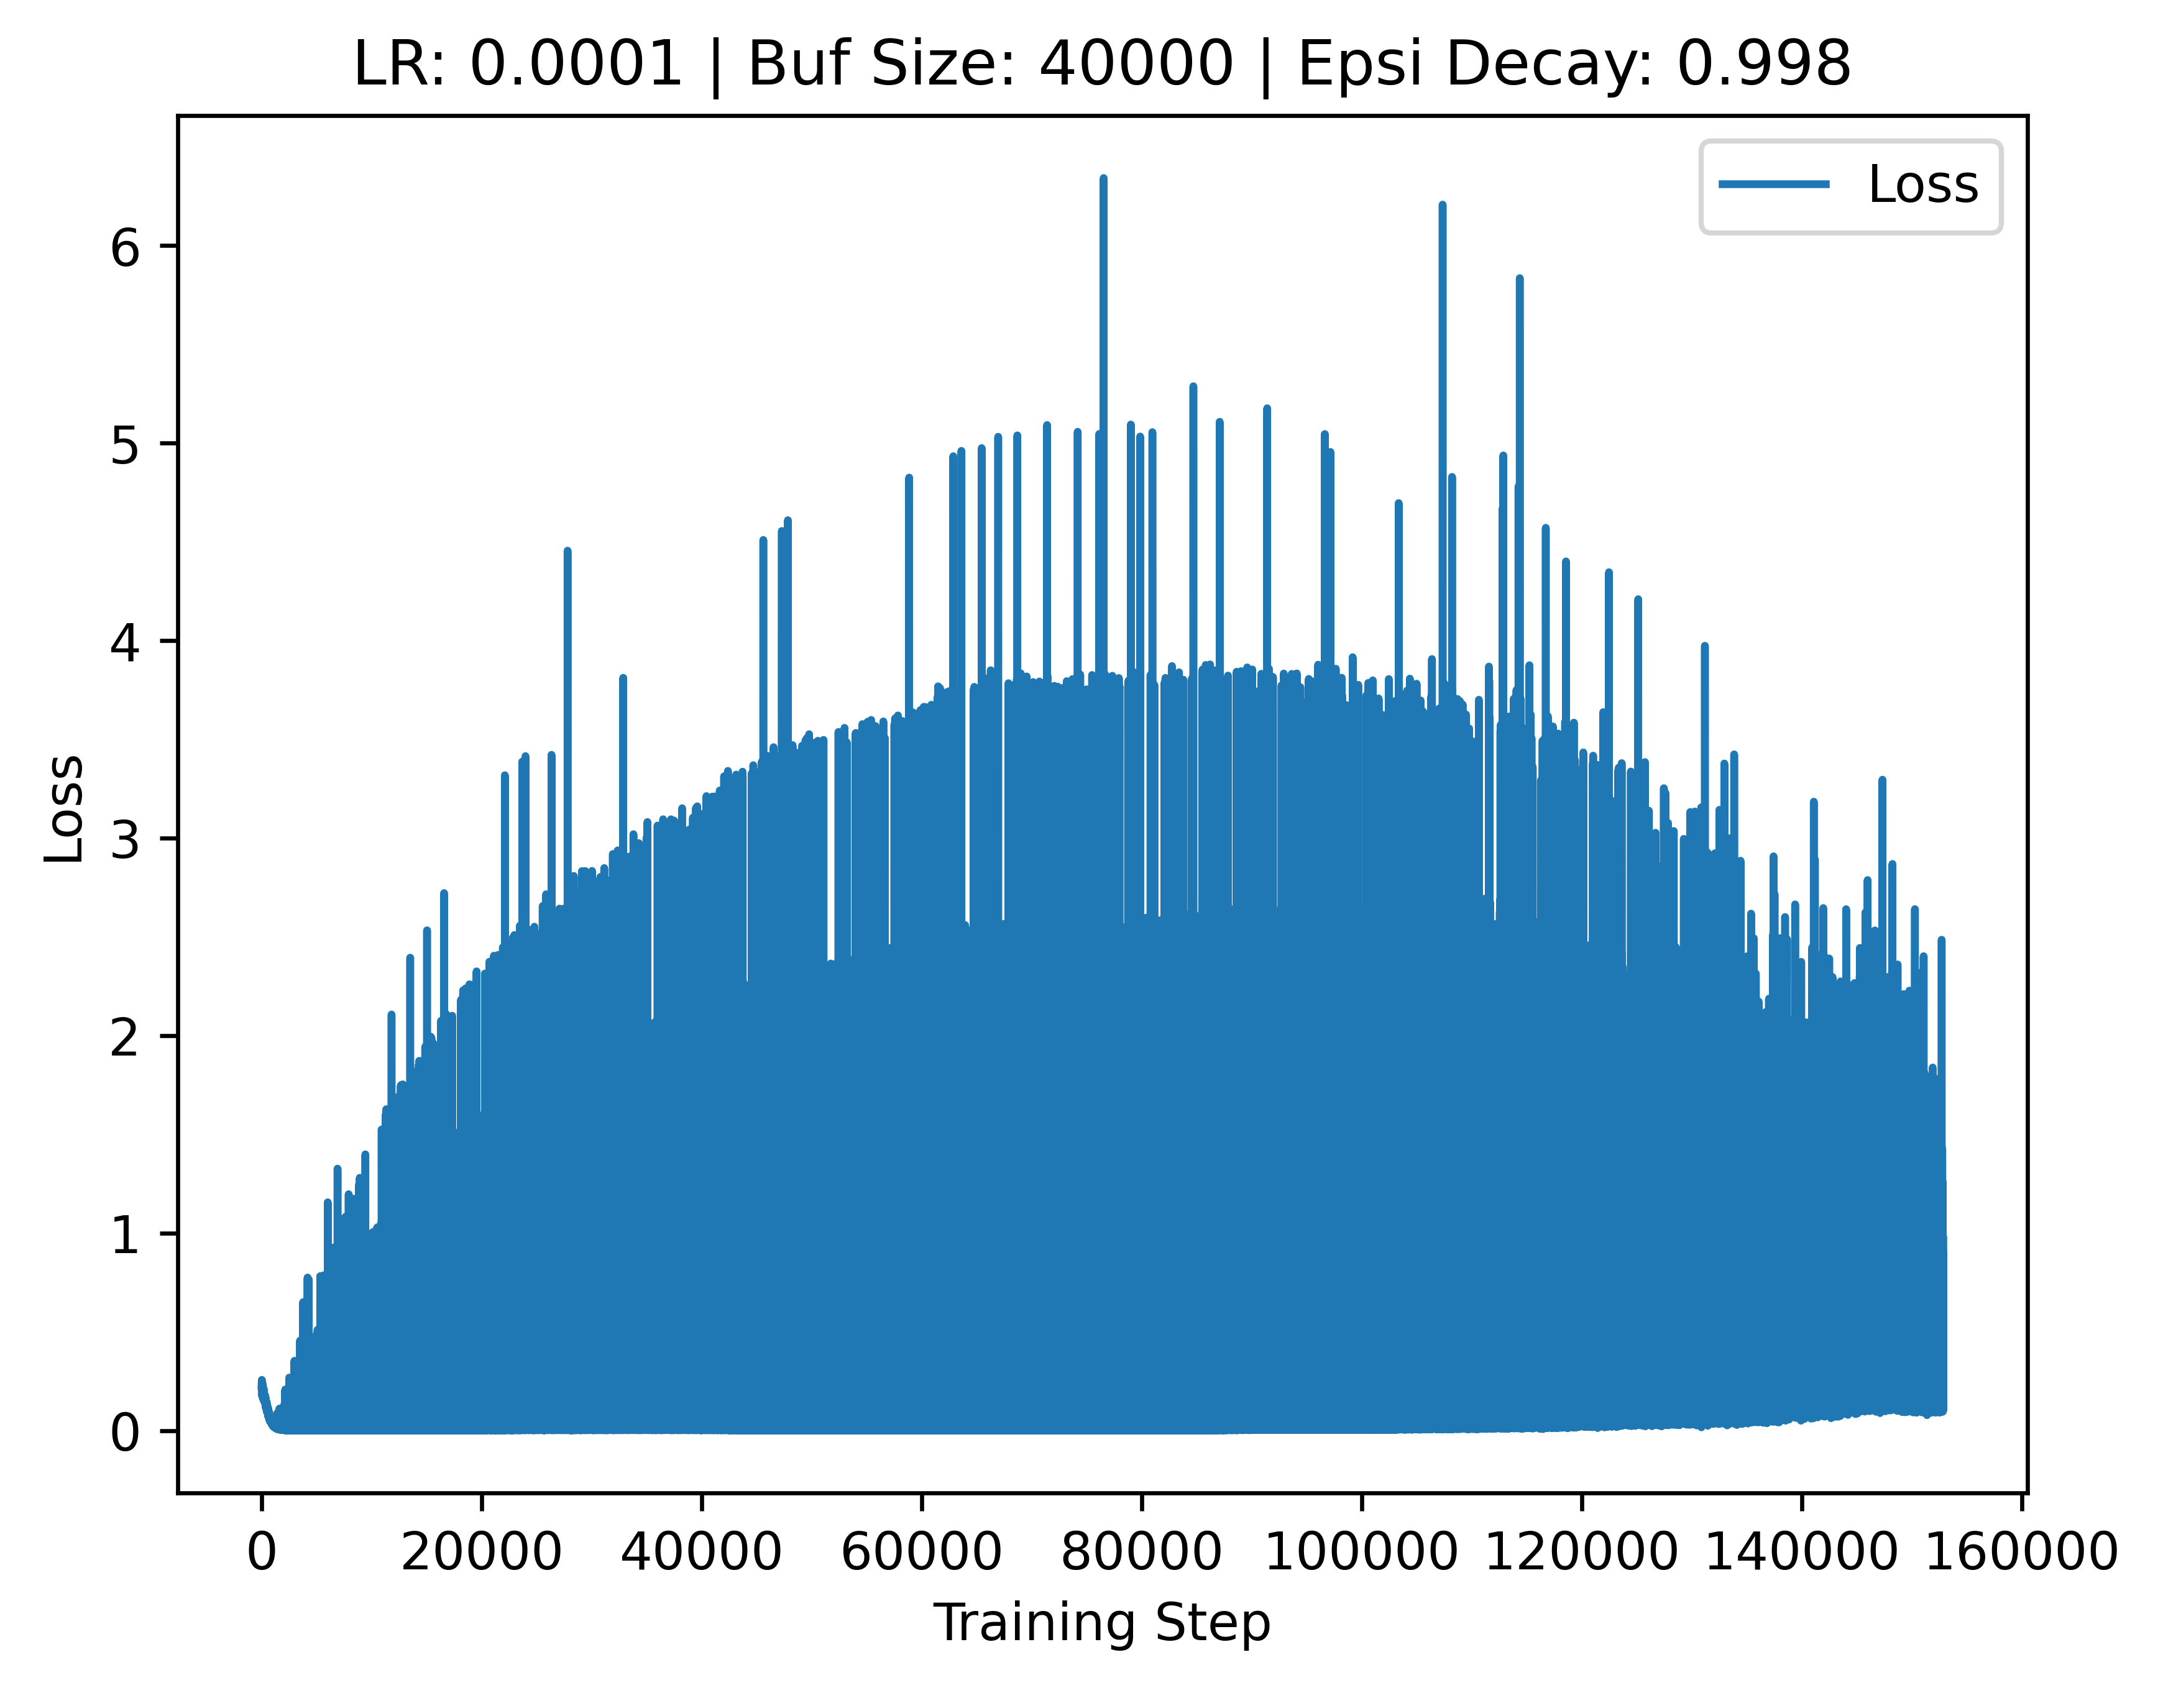
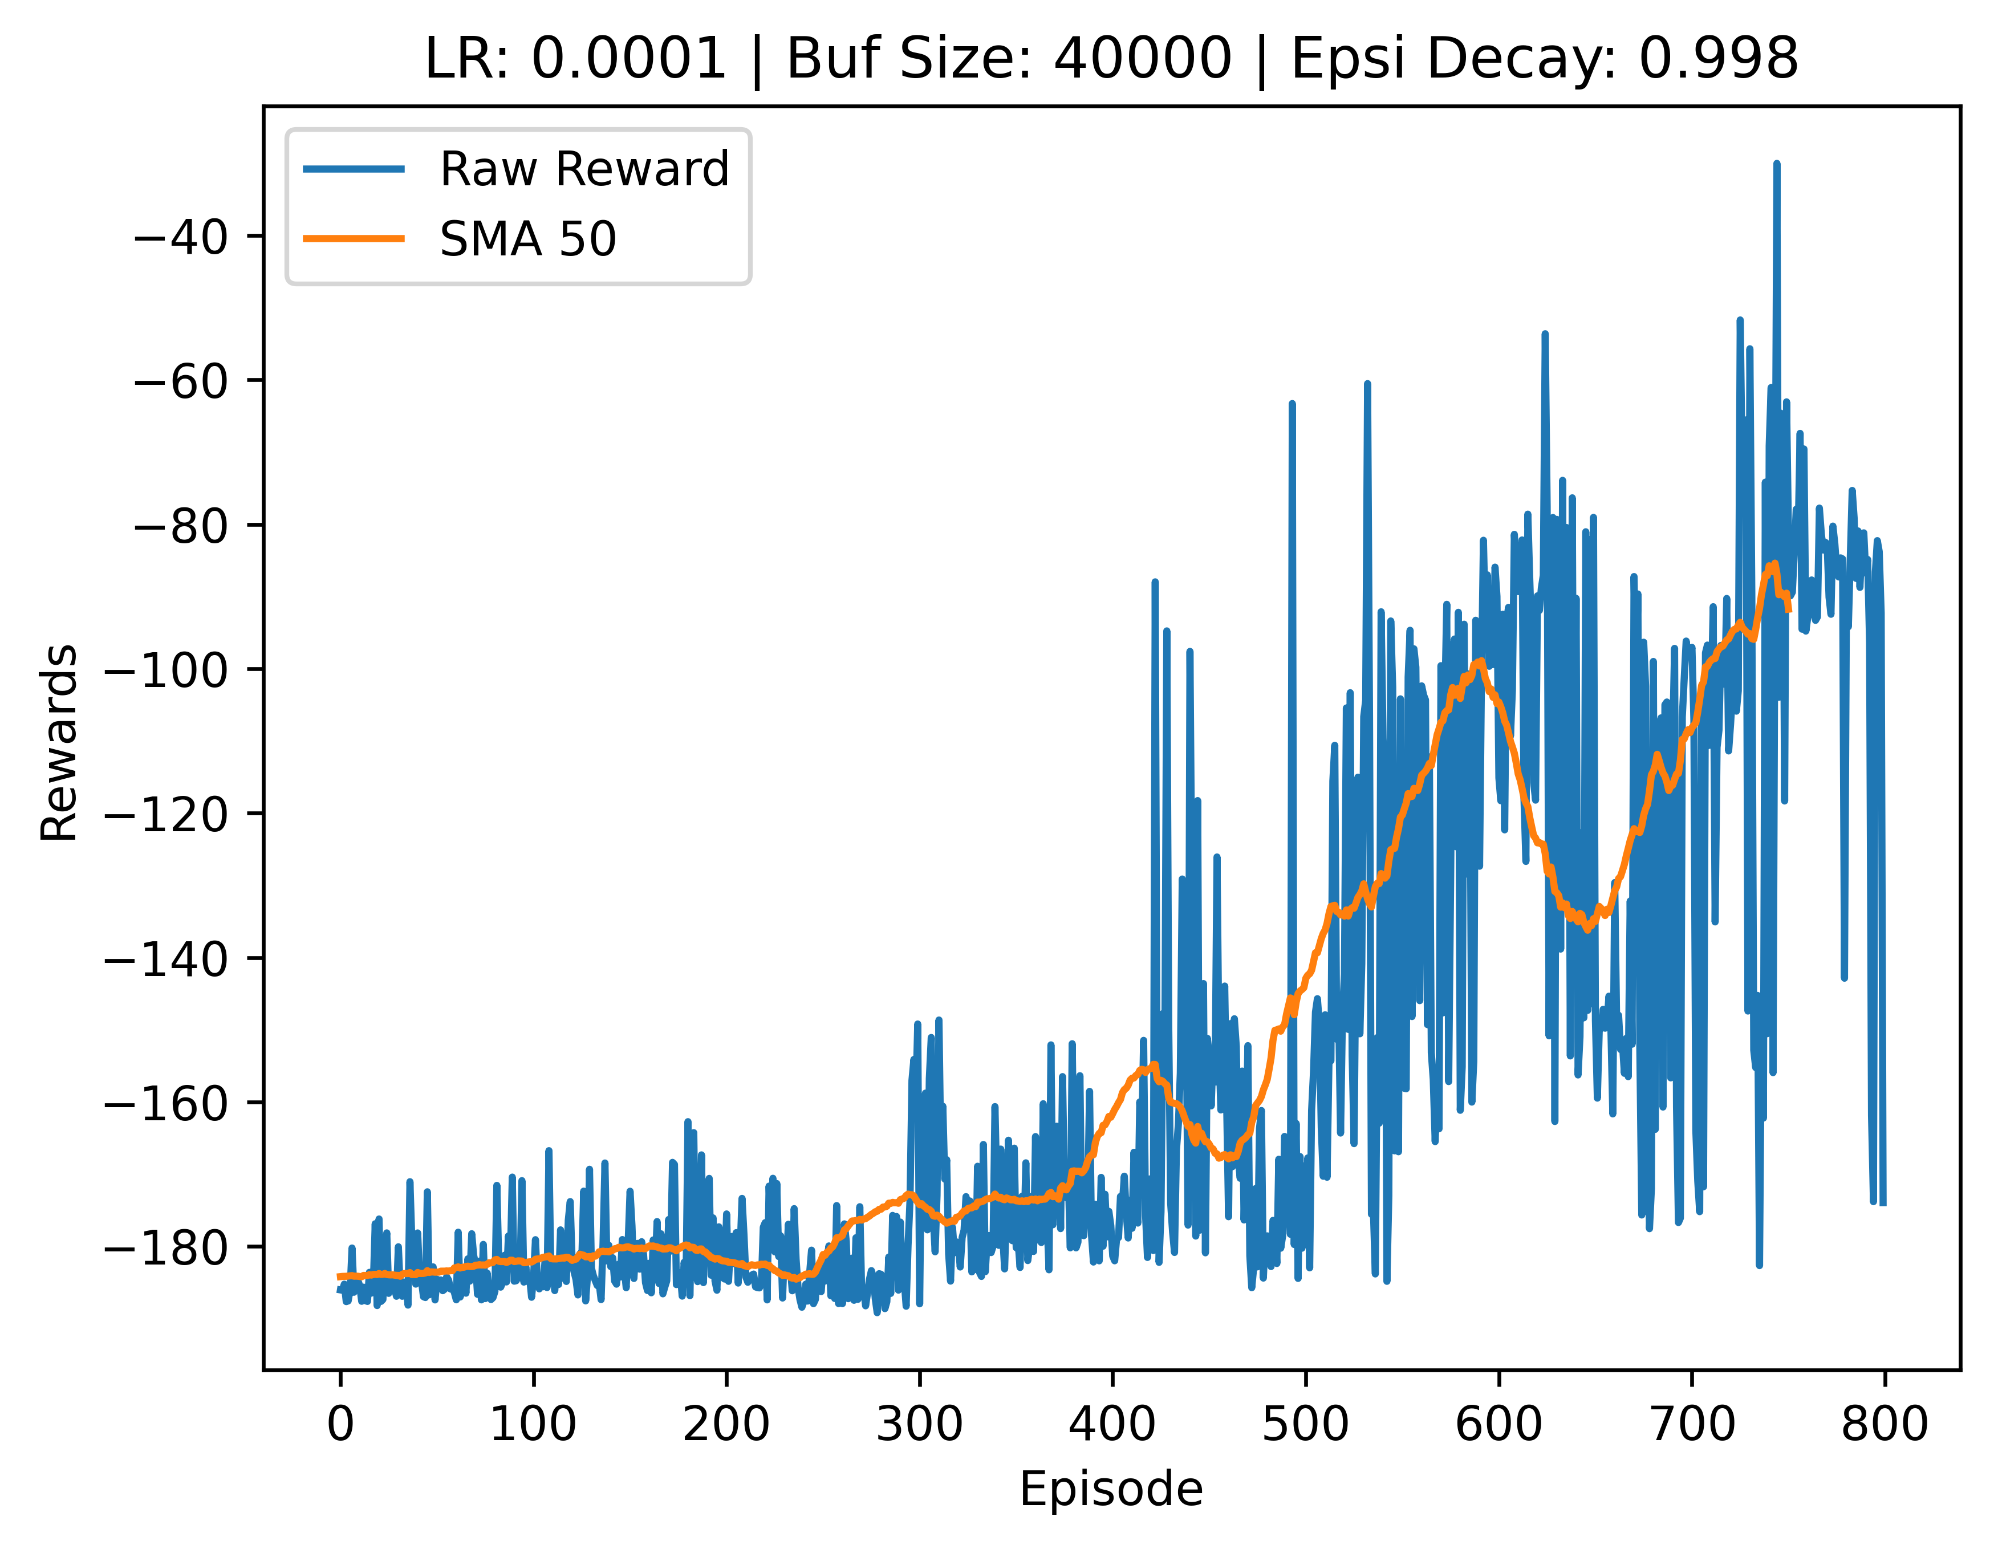
V1:
Reward
modified_reward -= 0.5
if position > 0.48:
modified_reward += 10.0
elif position > 0.40:
modified_reward += 4.0
elif position > 0.30:
modified_reward += 1.0
Network
self.fc1 = nn.Linear(state_dim, 25)
self.fc2 = nn.Linear(25, 20)
self.fc3 = nn.Linear(20, action_dim)

V2:
Reward: V1
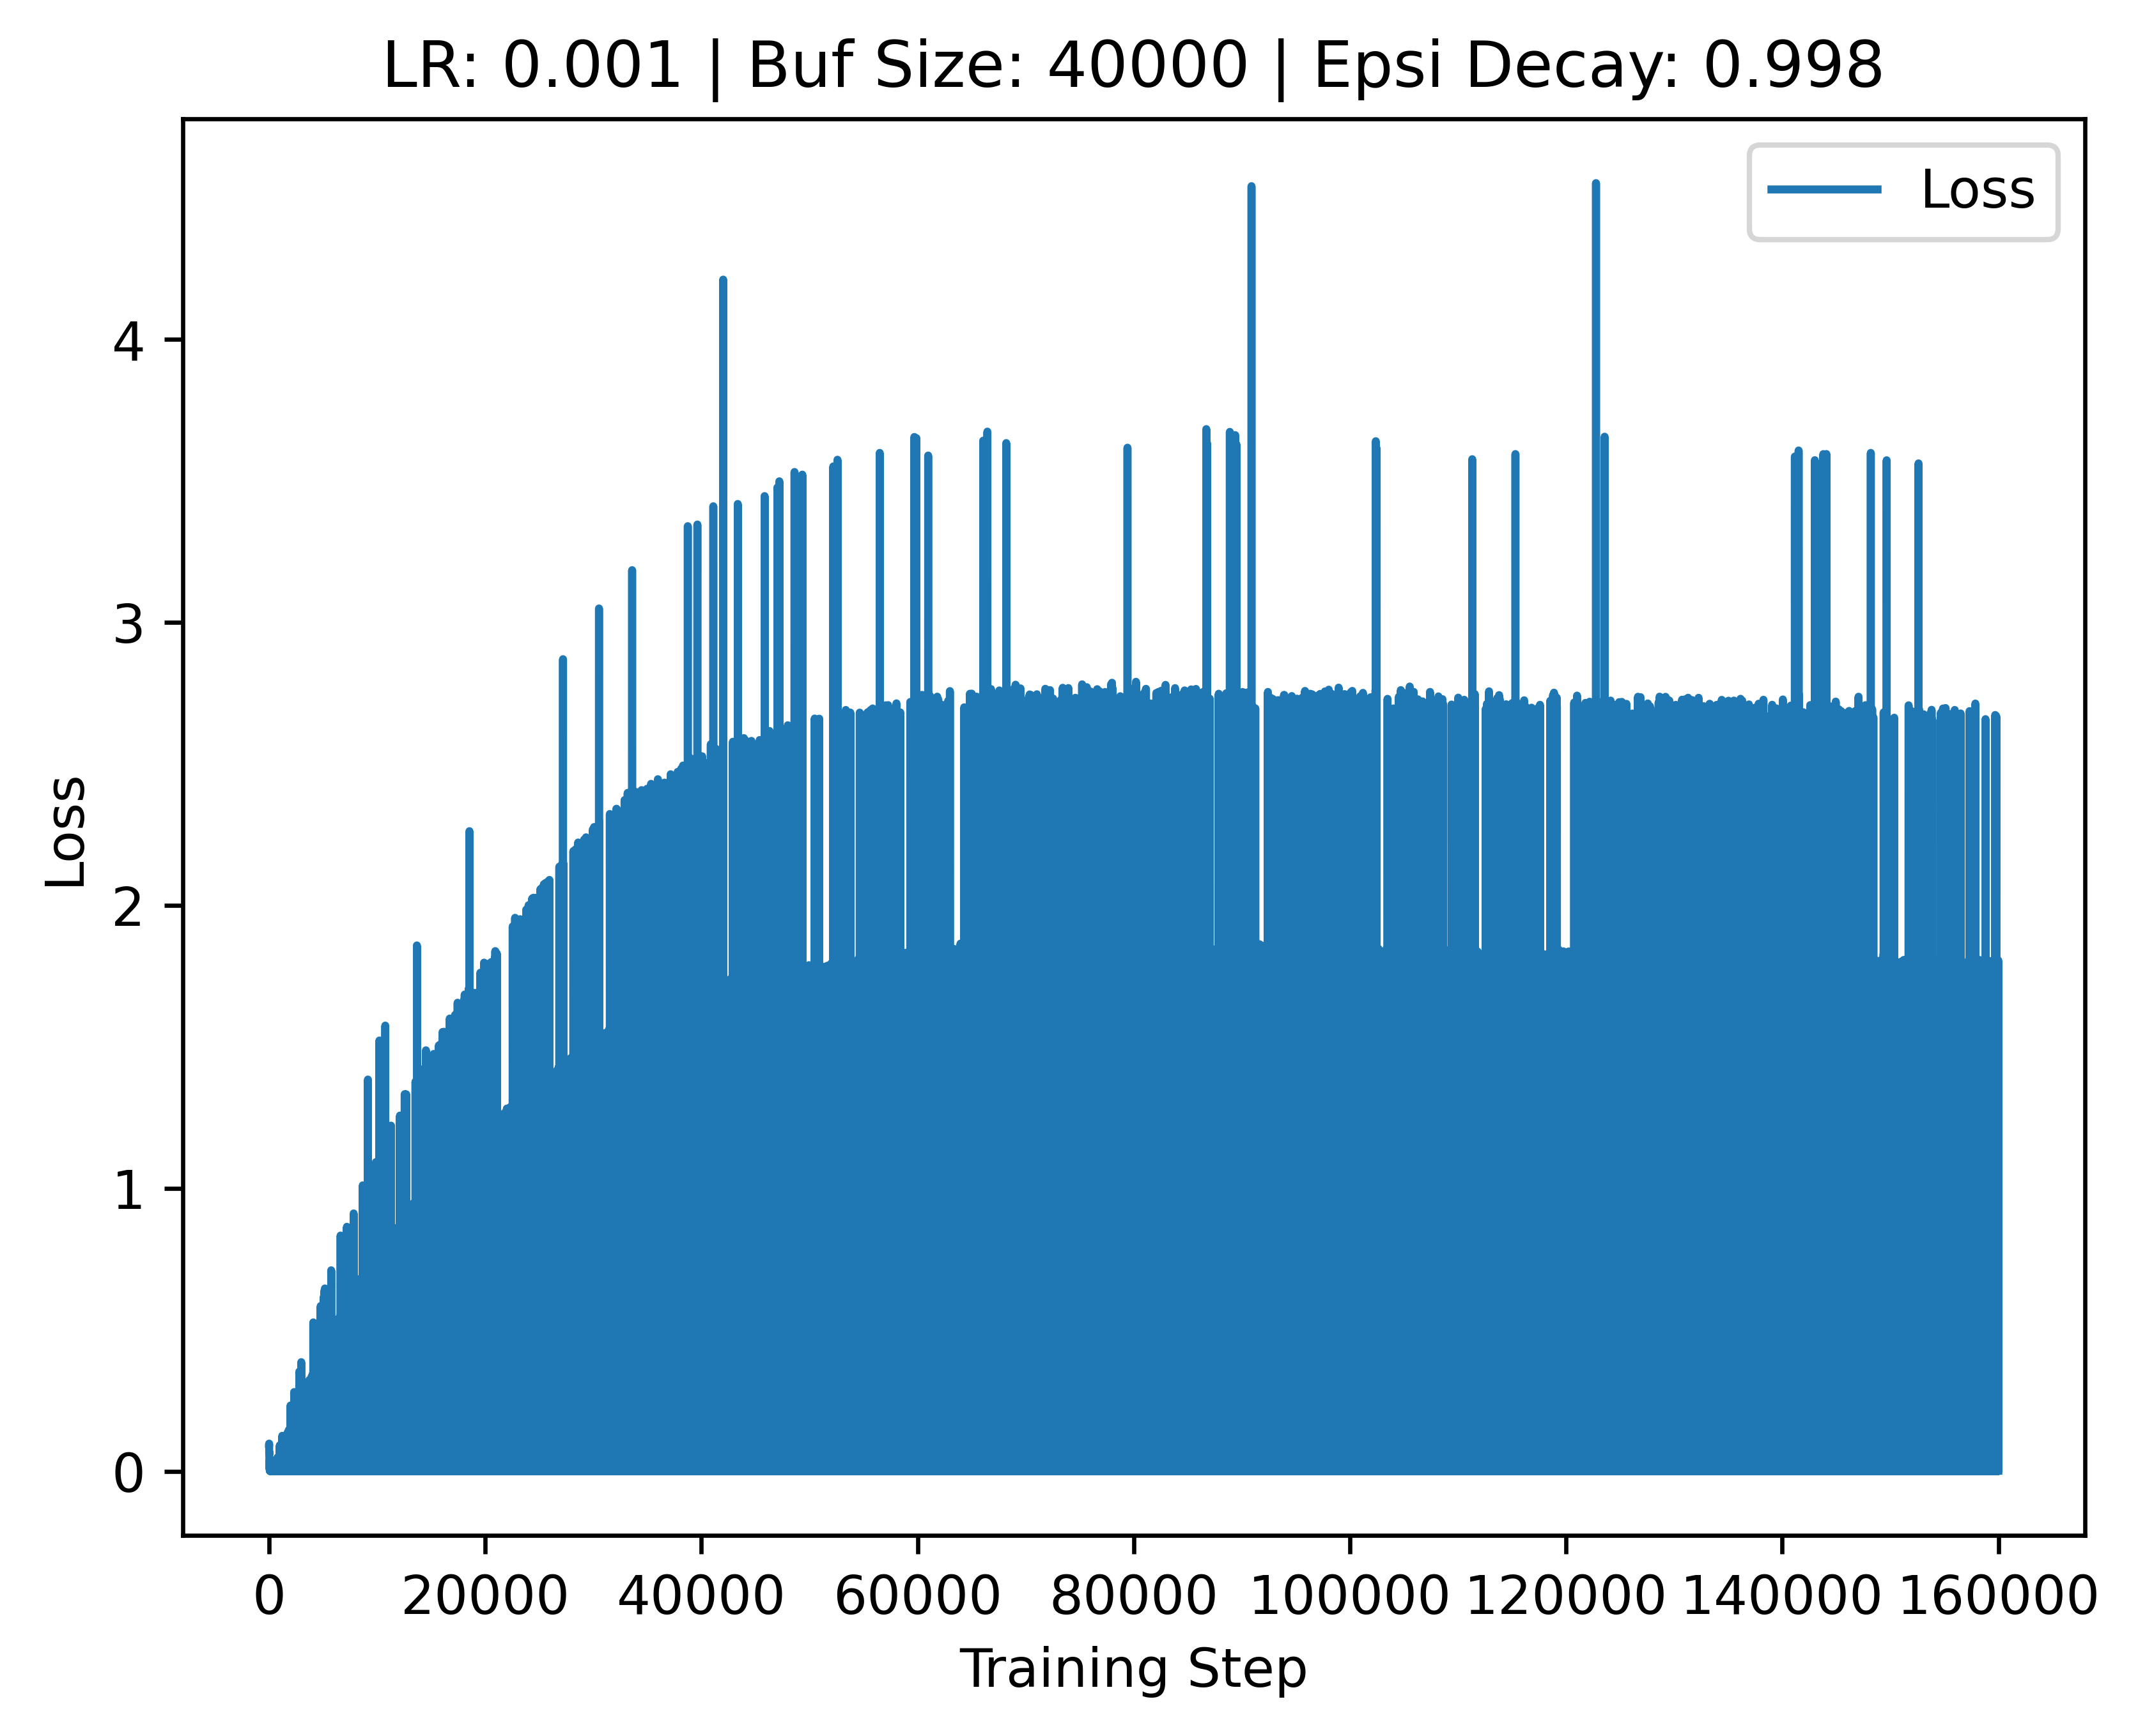
Net: V1
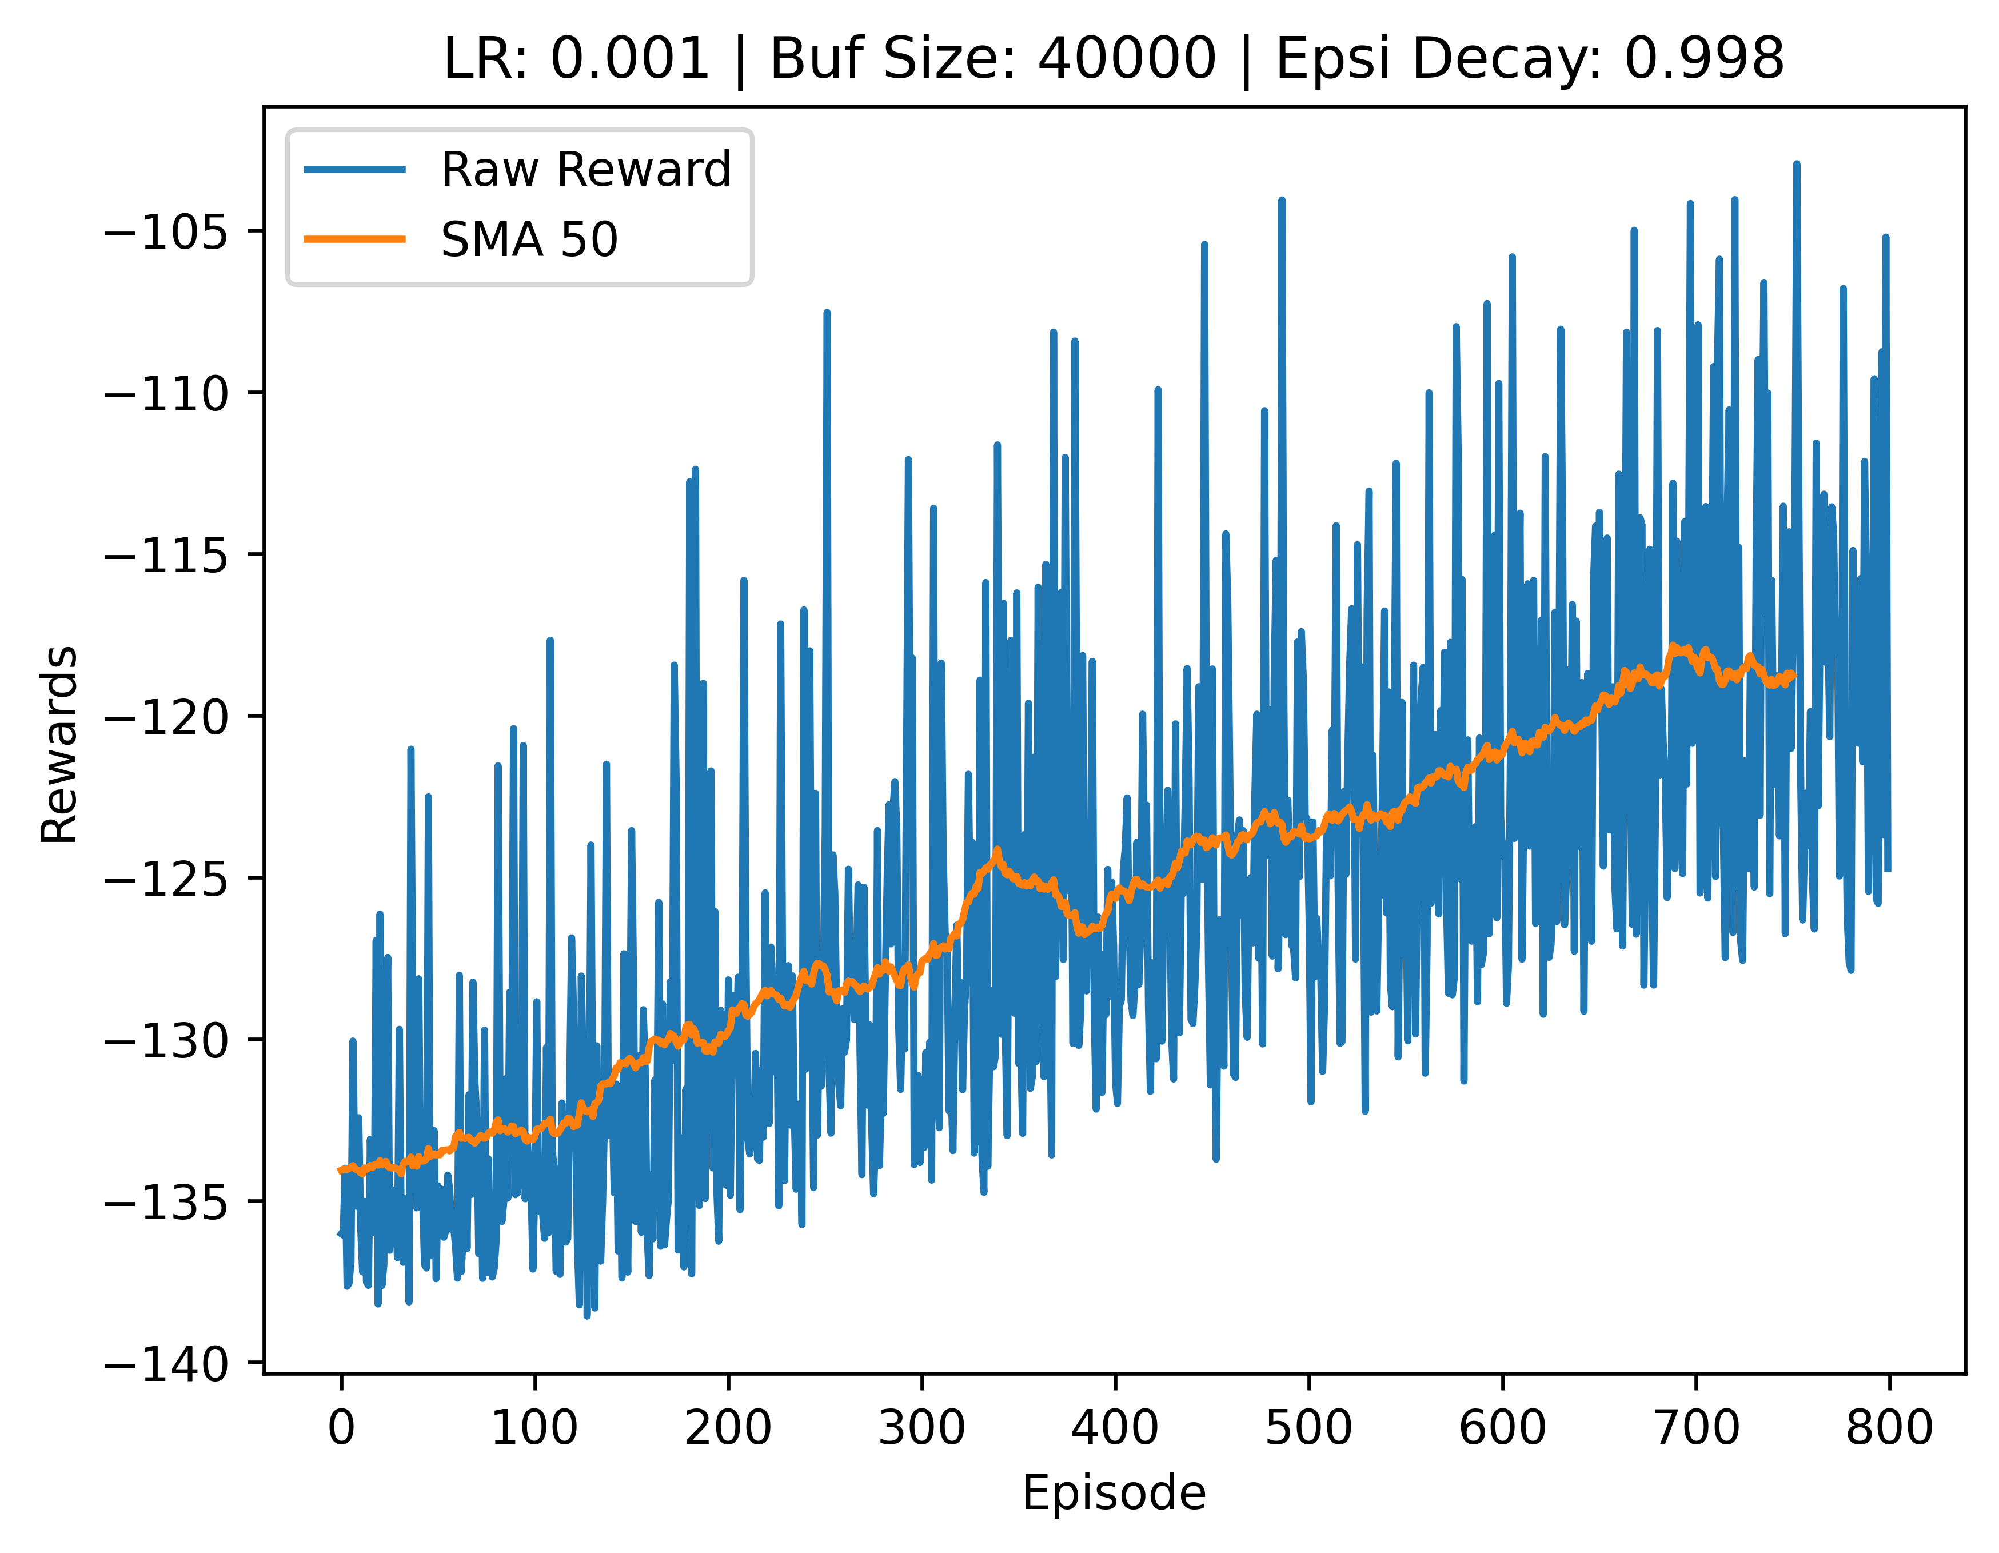

V3:
Reward: V1
Net: V1
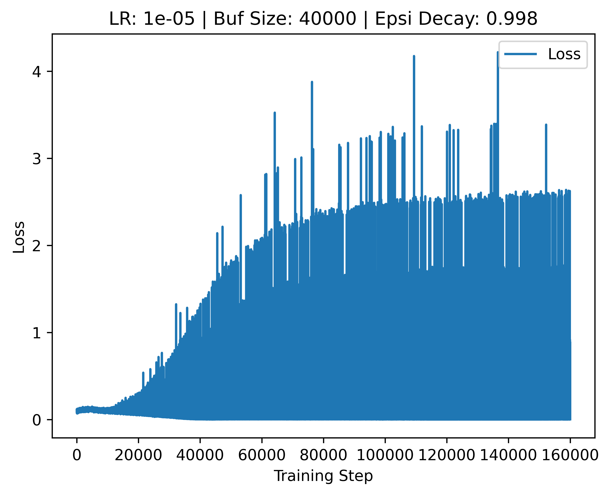
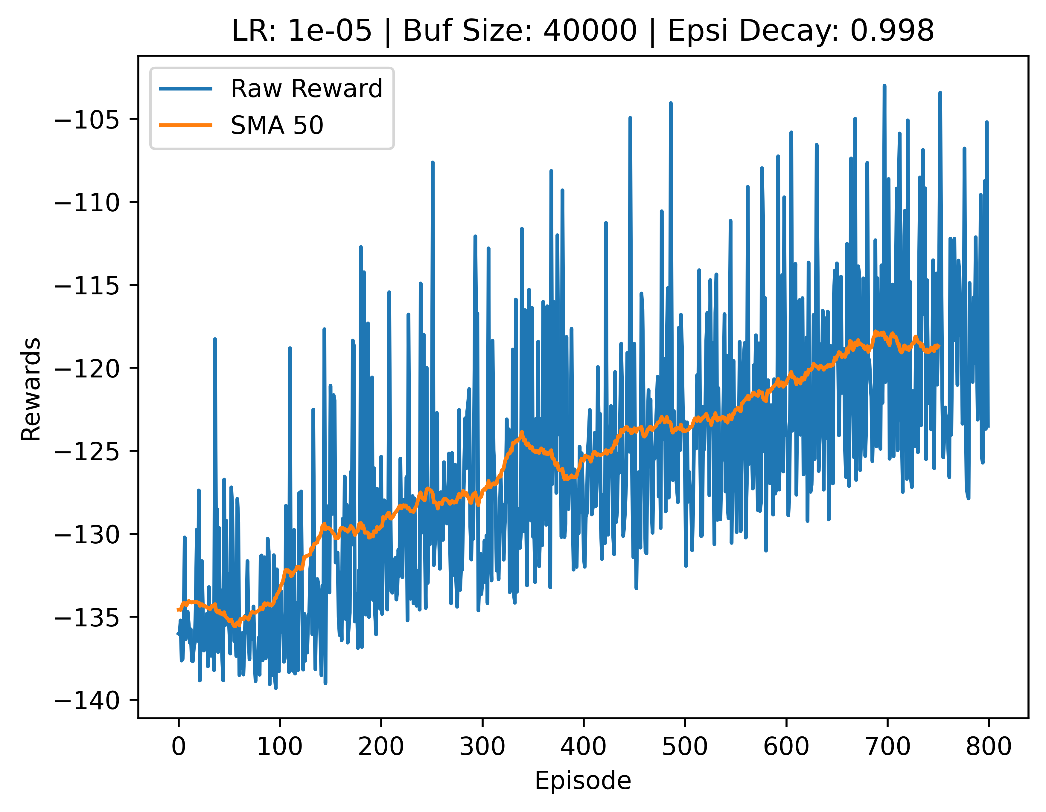
Learning rate:
- 1e-3 = under
- 1e-4 = almost
- 1e-5 = over

V4:
Reward: V1
Net: V1
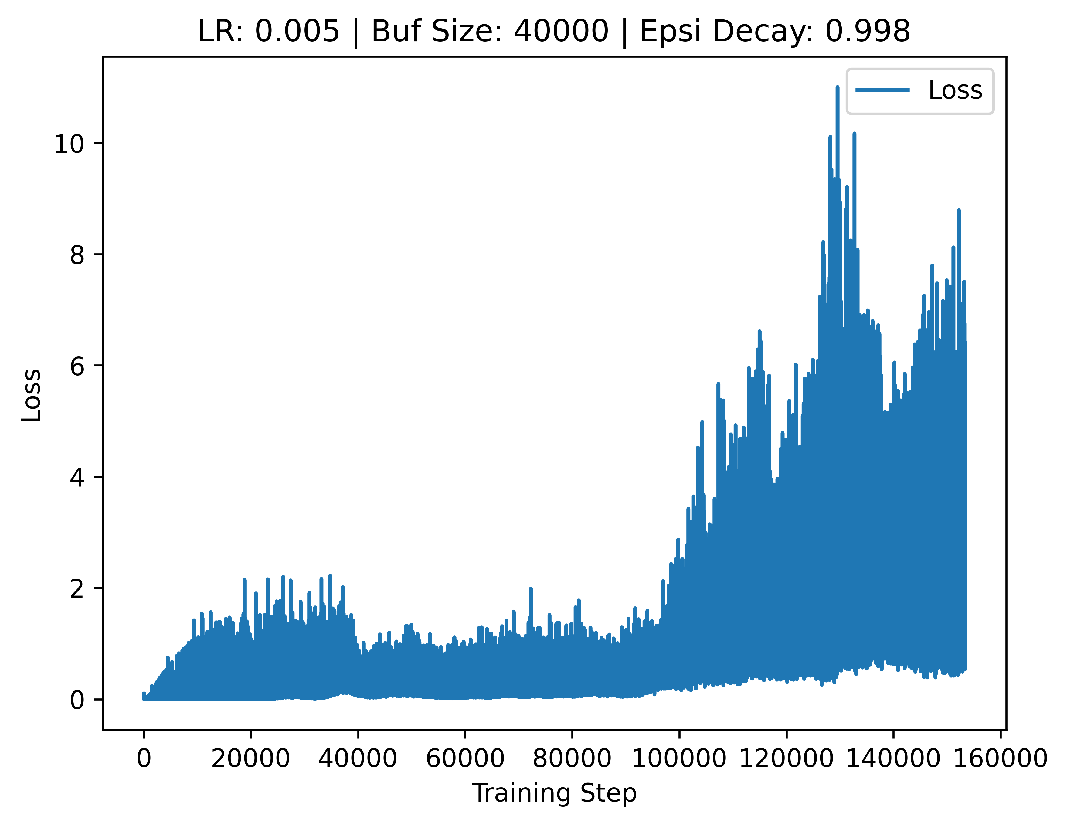
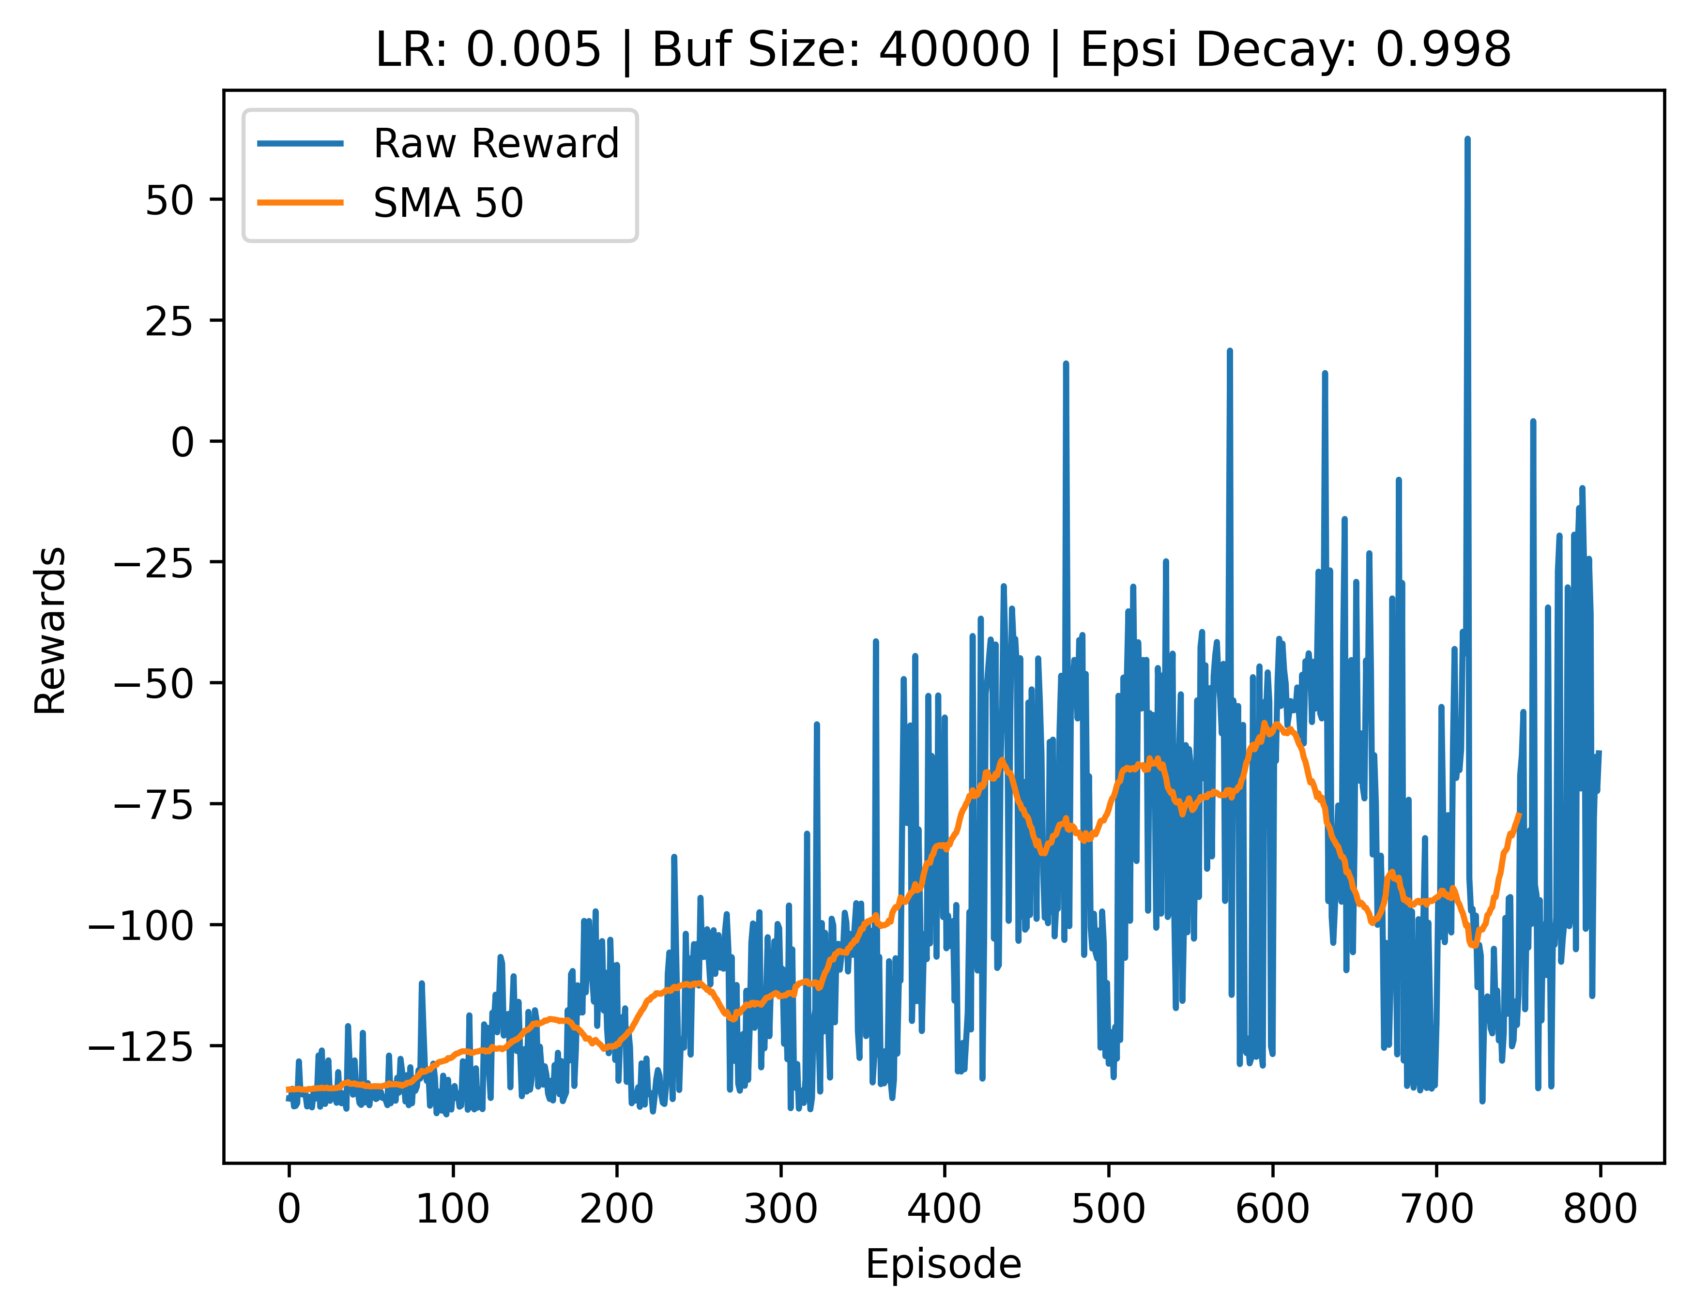

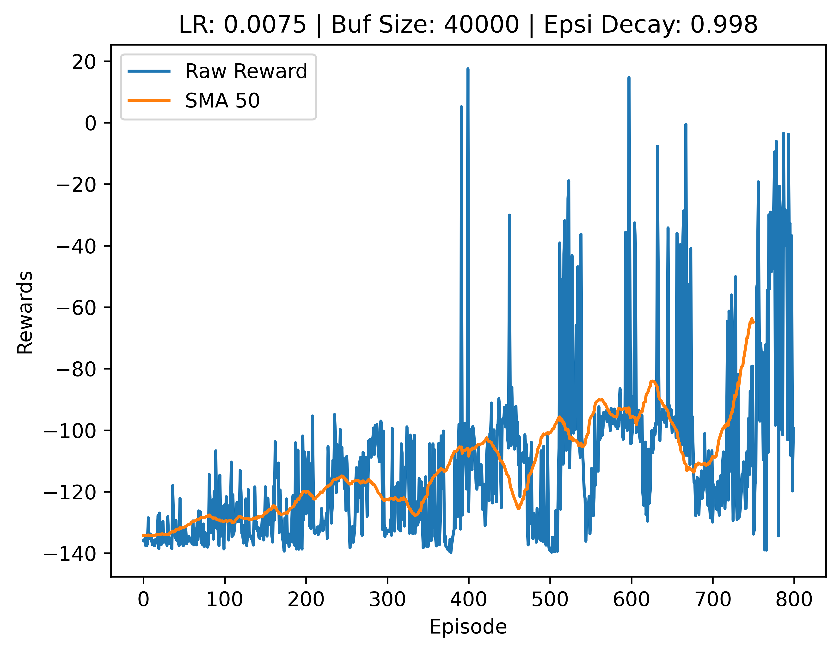
V5:
Reward: V1
Net: V1
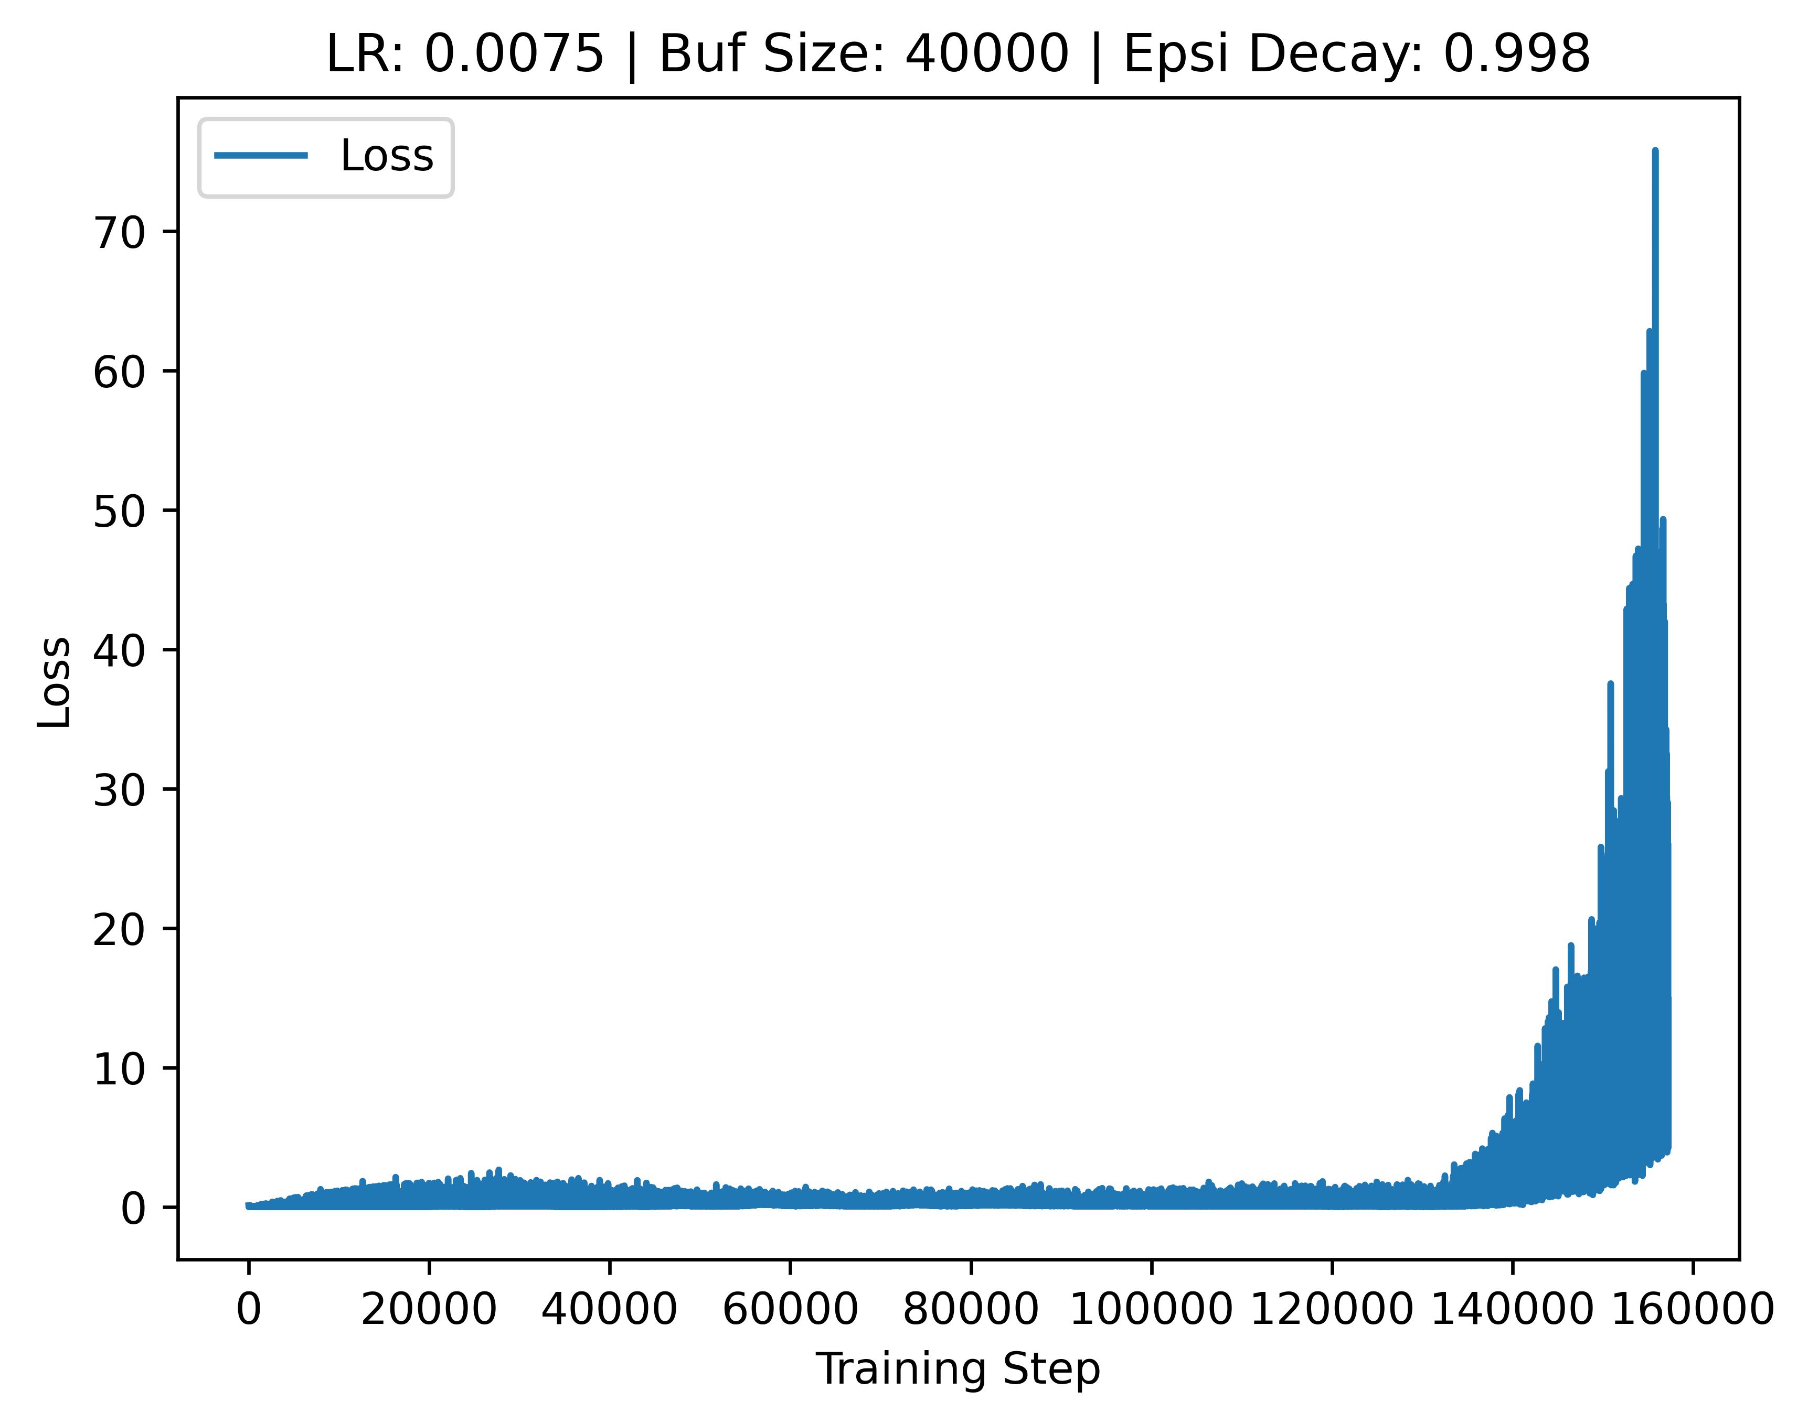

V6:
Reward: V1
Net: V1

