Roulette

Brain storming

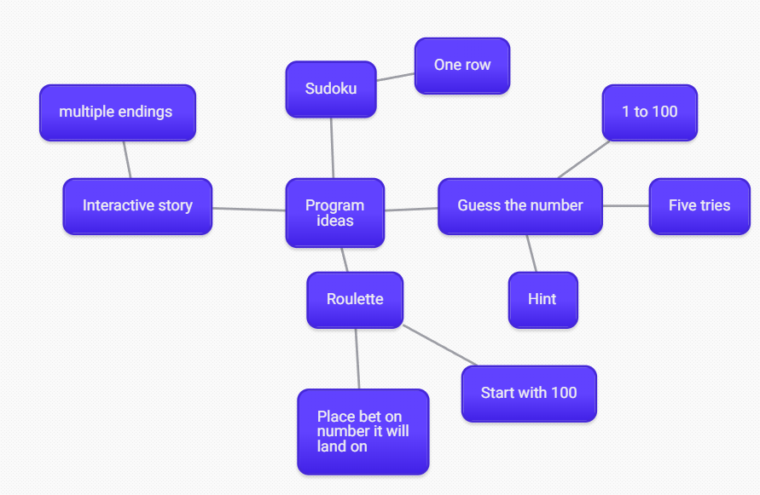

I came up with a few ideas I was going to go for the guess the number I did start it but I thought it was too easy and after looking at Jacobs black jack I wanted to do a roulette.

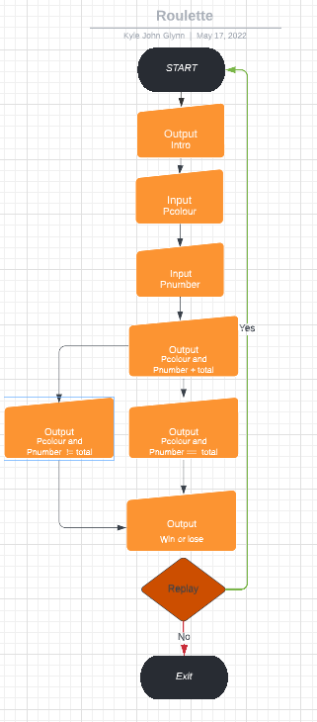Flow chart

Testing

|  |  |  |  |
| --- | --- | --- | --- |
| Test name | What should happen | What did happen | Fix |
| Intro text | I should run it and the intro text should come up | Worked like it should text came up | n/a |
| Time delay | After the intro text there should be a 1 second delay | After the intro there was a one second delay | n/a |
| Input bet | You should be able to input a bet and have it output | You were able to input then have it output | n/a |
| Random colour and number arrays | It should be able to output a random colour  And number | Had an issue where it wasn’t outputting the string colour  And wasn’t outputting the correct line on the number | I sorted the string by not giving a number in the array itself and using the for loop for that and the number I did 13 instead 12 one for 0 to 12 |
| Player colour and number input | The player should able to input colour and number | No issues the player could input their own colour and number | n/a |
| Input credits | The player should be able to input the amount of credits they want to bet | The player is able to input the amount they wanted | n/a |
| Credit limit | There should be a credit limit so the player can only bet what they have | There is a credit limit now | n/a |
| Add or take away  credits | Depending on the results the credits should be added or taken away | It was able to add or take away credits | n/a |
| Output total credits | After it added or taken away it should be able do a total output | Having issue where it was outputting it correct then when it looped  It reset to 100 | I was adding or taking away to total when the credits held the value so I got rid of total so it was just credits += bet or the other way |
| player guess same as total | It should do if player guess same as total, they get credits if not they lose credits | It won’t total them every time I try to total them its like it just ignores them | NOT FIXED  I now know why because it has its values in the function other than in the main, I will have to try something else |
| player guess same as total moved in the class | I am hoping this fixes my issue from before by moving it in the class where the values have been set | It was able to output == for the player colour  and total colour | n/a |
| Bet and credits still working | I don’t think they will work because I can’t move them into the class | I was right I had issues with the bet and credits | NOT FIXED  I tried putting them both into a class it worked for the credits but had issues with the bet need to see if I can get it working |
| Player guess same as total to void game(); | Since both of them won’t work I tried adding player guess and total vaule into the void game(); hoping this will save the values | It didn’t work as I thought it would it would have the same issue as before where it won’t get the values | NOT FIXED  Just like with the other one it didn’t work |
| Getting rid of bet | Since I am able to get credits working I am going to get rid of bet and see if I can get something with credits | I was able to make it more simple by getting rid of bed so now it feels more like a game then before | n/a |
| Adding credits | I am hoping now I can just add and take away credits when the values == like += 25 or -= 25 | I was able to add credits to the values | n/a |
| Play again | It will use the switch statement and if 1 return main(); if 0 ends it | It worked like I wanted it restarts and ends depending on your answer | n/a |
| Colour limit | It should make so the player can’t eneter more 1 since there are only two colours | There was a limit to how many colours you could eneter | n/a |
| Number limit | It should work the same as the colour | There was a limit to how many numbers you could eneter | n/a |

Roulette overview

<https://youtu.be/sEZ05gOqY-U>

References

*Card deck with C++ for beginners part 1*

<https://www.youtube.com/watch?v=4bQdVyjvJig>

*Card deck with C++ for beginners part 2*

<https://www.youtube.com/watch?v=py7nc1Pjgto>

*Looked into operators*

<https://www.cplusplus.com/doc/tutorial/operators/>

*Looked into pick randomly with array*

<https://www.cplusplus.com/forum/beginner/26611/>

*Looked at goto statement*

<https://en.cppreference.com/w/cpp/language/goto>