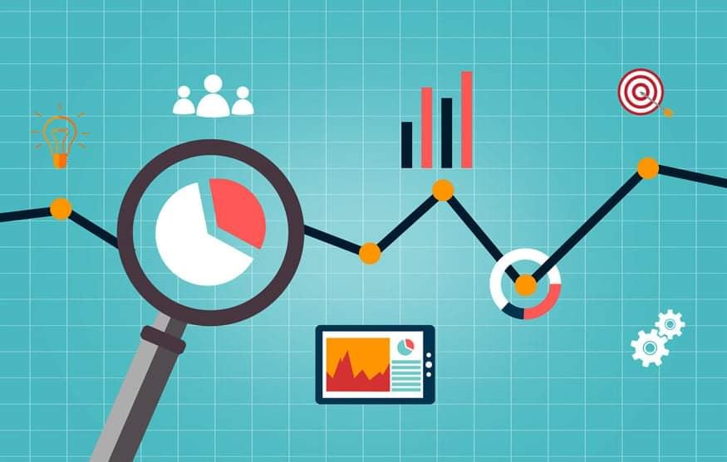

Course Code: SYSADMIN
Course Title: Configurtaion and Maintenance
Course/Program: BS Information Technology 4
Major: Programming
Year Level: 4th year
Semester: 1st
Group Number: 10

Leader: Shellamae B. Cagas
Members:

Reymark B. Belbider
Mark Aldream Cagoco
Jerome E. Escasinas
Allysa Coleen Morella
Mark Jay T. Ochavillo
John Kyle R. Razon
Rhea Angielyn Cordero

Professor
Sir. Rowee M. Marfil

Course Description
This course teaches students understand deployment and maintenance of modern computer systems, with particular emphasis on the administration of user accounts. The course includes an overview of basic administrative tasks associated with network operating systems such as Windows and Linux. The course cover the installation and configuration of mainstream operating systems, important network services, disaster recovery procedures, and techniques for ensuring the security of the system.
Introduction
General-purpose computer systems as supplied are not designed to be connected to hostile networks. The Internet outside the organization should certainly be regarded as hostile and for some purposes parts of the internal organization should also be viewed in this light. This means that many of the computers in the organization need additional configuration and maintenance to reduce the likelihood of them falling victim to an attack across the network. Most computers are configured to provide far more services than are required to perform their intended function. The software that is needed should then itself be configured to remove any unnecessary options that present an unacceptable risk. New threats are being discovered continually, so systems must also be maintained to take account of them.
Secure configuration and maintenance must be included in the organization's security policy and procedures. Without guidance from these documents, this vital work will not happen. The first priority should be those computers that are intended to provide a service to an external network. In time the aim should be to have all computers on the network significantly better protected than when they came out of their packing cases.
Target Learning Outcome
• Explain the used of system policy
• Discuss the controlling causes and symptoms
• Discuss the policy configuration and ethical usage
• Design configuration management is the administration of state in hosts or network hardware. Host state is configured by a variety of methods.

Topics to be discussed.
• System configuration policy
• Controlling causes and symptoms
• Change management
• Policy configuration and its Ethical Usage
• Clock Synchronization
• Human - Computer Job Scheduling
• Prevention Host Maintenance

Learning Management Tools
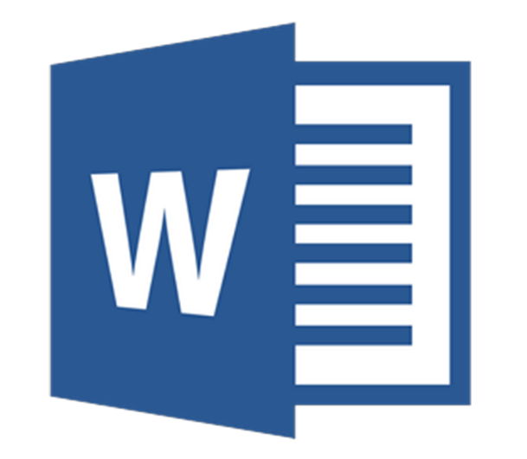

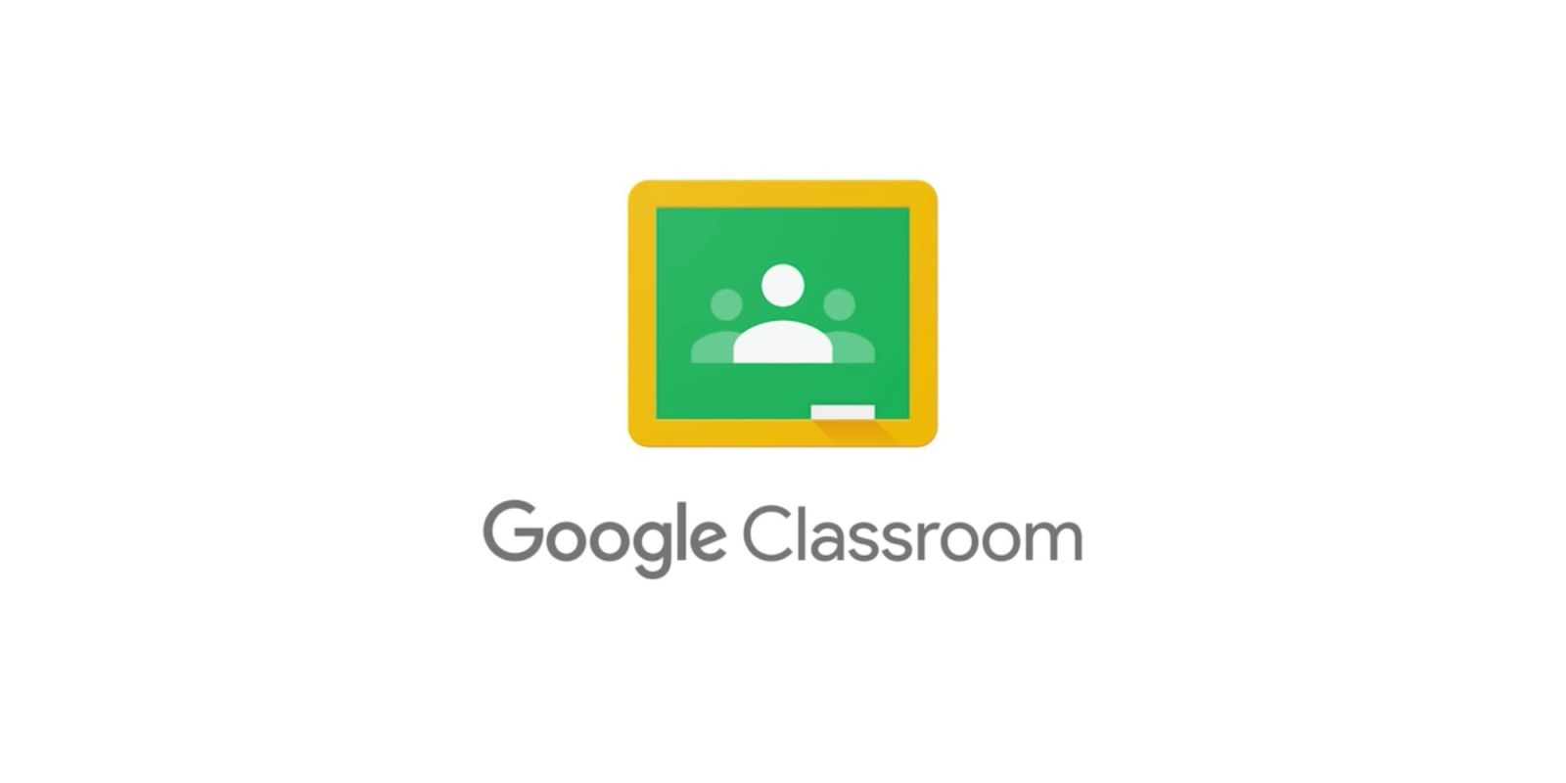


• SYSTEM CONFIGURATION POLICY
The System Configuration/Security Policies page allows user to. configure password policies: complexity, expiry, history and security questions.
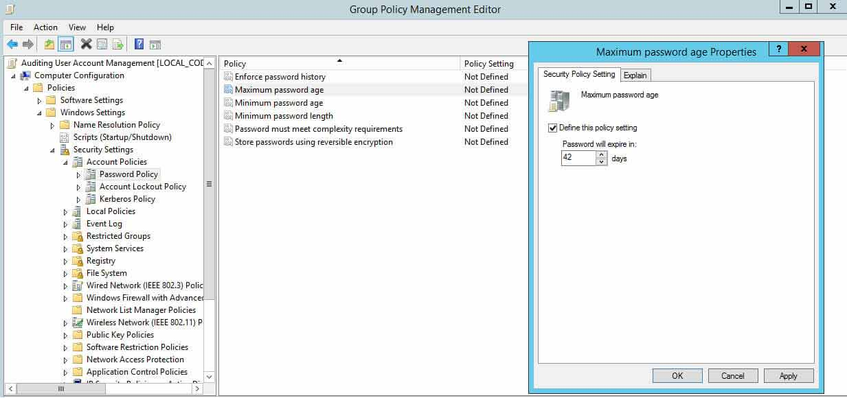
Configuration is what makes your systems (servers, networks, operating systems, data centers, configuration files, IT assets and all other configuration items) work.
The definition of configuration is the way parts are arranged to work together. ... When you try to set up your computer hardware and software to work the way you want such as adding a wireless mouse and keyboard, this is an example of configuration.
• The Role of Information Systems Controls
To ensure secure operations of information systems and thus safeguard assets and the data stored in these systems, and to ensure that applications achieve their objectives in an efficient manner, an organization needs to institute a set of policies, procedures, and technological measures, collectively called controls.
IS controls may be designed to:
1. Prevent an error or an attack from taking effect
2. Detect a violation
3. Detect and correct an exceptional situation.
Reference:
https://kirkpatrickprice.com/video/pci-requirement-2-2-develop-configuration-standards-system-components
https://technology.ky.gov/policy/Pages/CIO-104.aspx
• Information Systems Security and Threats to It
The security of information systems is maintained by measures taken to prevent threats to these systems or to detect and correct the effects of any damage. Information system security aims to protect corporate assets or, at least, to limit their loss. Security measures limit access to information to authorized individuals; there can be no privacy or confidentiality of data records without adequate security.
Security threats have four principal sources which include:
1. Human error
2. Computer abuse or crime
3. Natural and political disasters
4. Failures of hardware or software
Reference:
Managing and Controlling Information Systems (umsl.edu)

• Change Management
Change management is defined as the methods and manners in which a company describes and implements change within both its internal and external processes. This includes preparing and supporting employees, establishing the necessary steps for change, and monitoring pre- and post-change activities to ensure successful implementation.
How to Implement Change Management
Define the change.
Select the change management team.
Identify management sponsorship and secure commitment.
Develop implementation plan including metrics.
Implement the change—in stages, if possible.
Collect and analyze data.
Quantify gaps and understand resistance.
Modify the plan as needed and loop back to the implementation step.
Change management is a systematic approach to dealing with the transition or transformation of an organization's goals, processes or technologies. The purpose of change management is to implement strategies for effecting change, controlling change and helping people to adapt to change. Such strategies include having a structured procedure for requesting a change, as well as mechanisms for responding to requests and following them up.

References:
https://searchcio.techtarget.com/definition/change-management
https://asq.org/quality-resources/change-management

• Policy Configuration and Ethical Usage
More and more of our activities generate data which is collected and used in ways we don’t see and can’t control. While the data is used for analytics and targeted advertising that can potentially improve services enhance our experience as consumers or public service users, its use can also undermine privacy, autonomy, and trust in the digital economy as a whole.
Privacy and data protection rules aim to protect individuals’ interests, but data-handlers can still do things that are legal but unfair, manipulative or even exploitative. Trust is vital to citizens’ willingness to use government services and to engage with the Internet economy as a whole. It is much harder to restore than it was to build in the first place. Responsible data handling goes beyond the legal baseline to embed ethically-based best practices that protect people’s interests and build their trust.
Responsible data handling means applying ethical principles of transparency, fairness and respect to how we treat the data that affects people’s lives. It can protect our privacy and autonomy and build the trust needed for digital innovation to flourish in ways that benefit everyone.

• Clock Synchronization
A synchronized clock system provides the exact same time to all clocks in the system. The synchronized clock system typically consists of a “master clock” and multiple “secondary clocks” also known as “slave clocks”. The master clock communicates with all the secondary clocks in the system to provide them with an accurate time source. The purpose is to make sure that all clocks in the system will show the exact same time. No matter which part of the building you are in, the time shown by the clocks will be uniform and accurate.
Why is clock synchronization important?
The Importance of Time Synchronization for Your Network
In modern computer networks, time synchronization is critical because every aspect of managing, securing, planning, and debugging a network involves determining when events happen. Time also provides the only frame of reference between all devices on the network.
There are many benefits to using a synchronized clock system. The main benefit is that everyone in the building is following the same time source. This eliminates confusion and disorder in different facilities because with a synchronized clock system, everyone is utilizing the same time source. Another feature that synchronized clocks provide is the elimination of correcting the time on all the clocks when Daylight Saving Time occurs. In the event of a power failure, the system will automatically adjust to the correct time as soon as the power returns. The master clock (depending on the model) may also include scheduling capabilities, which enables the user to program the ringing of bells, turning on heating and air conditioning at predetermined times, and control many other devices as needed. Another popular feature is the Count Up and Count Down function, which allows the user to show elapsed time between breaks, between shifts, for “Code Blue” situations in operating rooms, and for many other applications.
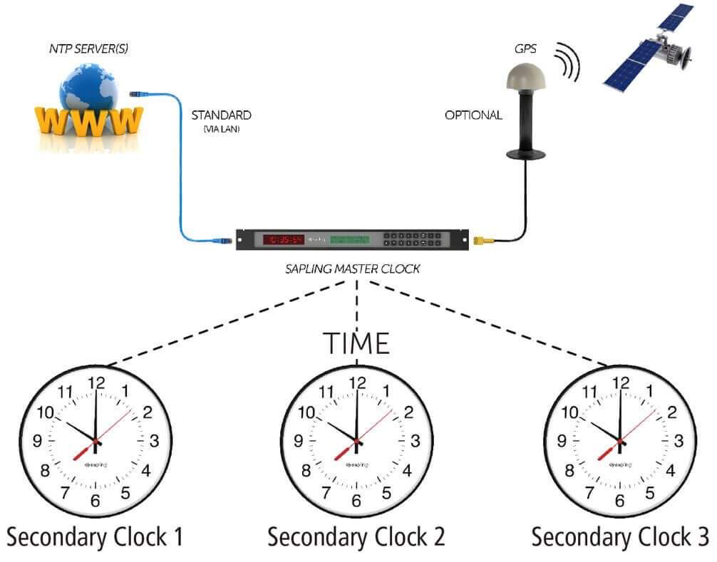

Reference:
https://www.sciencedirect.com/topics/computer-science/clock-synchronization

HUMAN-COMPUTER JOB SCHEDULING
Job scheduling is the process of allocating system resources to many different tasks by an operating system (OS). The system handles prioritized job queues that are awaiting CPU time and it should determine which job to be taken from which queue and the amount of time to be allocated for the job.

Job scheduling is performed using job schedulers. Job schedulers are programs that enable scheduling and, at times, track computer "batch" jobs, or units of work like the operation of a payroll program. Job schedulers have the ability to start and control jobs automatically by running prepared job-control-language statements or by means of similar communication with a human operator. Generally, the present-day job schedulers include a graphical user interface (GUI) along with a single point of control.
Organizations wishing to automate unrelated IT workload could also use more sophisticated attributes from a job scheduler, for example:
Real-time scheduling in accordance with external, unforeseen events
Automated restart and recovery in case of failures
Notifying the operations personnel
Generating reports of incidents
Audit trails meant for regulation compliance purposes

Reference:
https://www.techopedia.com/definition/7882/job-scheduling

Prevention Host Maintenance
Before the computer and networking environment can be managed effectively an organization and its IT group must first define how the task will be assigned and managed. The job of delegating responsibility for the network defines the organization’s administrative model. If there is no administrative model, the environment is managed chaotically, and the bulk of work is usually made up of firefighting. Server updates and modifications must more frequently be performed on the spot without proper testing. Also, when administrative or maintenance tasks are not performed correctly or consistently, securing the environment and auditing administrative events are nearly impossible.
We want a maintenance that is regularly performed on a piece of equipment to lessen the likelihood of it failing. It is routine maintenance that is scheduled based on data insights. A preventive maintenance task is performed while the equipment is still working so it does not break down unexpectedly and create unplanned downtime. In terms of the complexity of this maintenance strategy, it falls between reactive maintenance (or run-to-failure ) and predictive maintenance.

To choose or define the correct administrative model the organization must discover what services are needed in each location and where the administrators with the skill to manage these services are located.
The Centralized Model
The centralized administration model is simple in concept: All the IT-related administration is controlled by one group, usually located at one physical location. In the centralized model, all the critical servers are housed in one or a few locations instead of distributed at each location. This arrangement allows for a central backup and always having the correct IT staff member available when a server fails.
The Distributed Administration Model
The distributed administration model is the opposite of the centralized model in that tasks can be divided among IT and non-IT staff members in various locations. The rights to perform administrative tasks can be granted based on geography, department, or job function. Also, administrative control can be granted for a specific network service such as From the Library of Robert Ryan ptg domain name system (DNS) or Dynamic Host Configuration Protocol (DHCP). This allows separation of server and workstation administration without giving unqualified adminis-rators the rights to modify network settings or security.
The Mixed Administration Model
The mixed administration model is a mix of administrative responsibilities, using both centralized and distributed administration. One example could be that all security policies and standard server configurations are defined from a central site or headquarters, but the implementation and management of servers are defined by physical location, limiting administrators from changing configurations on servers in other locations.

References
https://www.fiixsoftware.com/maintenance-strategies/preventative-maintenance/
https://drive.google.com/file/d/13JGYmXREsyQd-vpc1acAdGyCnD4l1oT2/view

