**Published and Further Research:**

**Previous Published Research:**

***Arrival and departure windows of Atlantic sturgeon in the Chesapeake Bay, United States*:**

**Atlantic sturgeon that are a part of the Chesapeake Bay distinct population segment occupy the Chesapeake Bay before their spawning runs upriver. Determining when Atlantic sturgeon are in the Chesapeake Bay is important for managers to make informed decisions, because collisions with ships and fishing bycatch are of particular concern. Knowing exactly when Atlantic sturgeon are in the bay is vital for their conservation. This paper was accepted in the Fishery Bulletin [in press].**

***Spatiotemporal Distributions of Species Detected within Virginia’s Offshore Lease Areas, Volume 1: Sandbridge Shoal Borrow and Volume 2: The Virginia Wind Energy Lease Area A-0483***

**This project was contracted by the Department of the Interior to assess how the development of offshore windfarms may potentially impact different marine species. Using acoustic telemetry data, we assessed occupancy times of species of commercial, recreational, or conservation importance within the potential windfarm development area.**

**Current Research:**

**Master’s Thesis: In the works…**

**About Me:**

I am a dedicated ecologist with a passion for the natural world and a strong background in wildlife conservation and marine biology. I graduated from Edinboro University in May 2021, and had lots of amazing opportunities, such as doing ecotourism in the Florida Keys, learning about ecology at the Pymatuning lab of ecology, and a summer Research Experience for Undergraduates at Harvard University. After graduating from Edinboro, my journey has taken me from the depths of the ocean, rolling mountains of the west, to the vibrant terrains of tropical islands, contributing to significant research and conservation efforts. Through my journey, I have had the wonder of meeting many fantastic people who have taught me much about the world, culture, and science. I am excited to be now continuing my scientific journey through graduate school at the University of Alabama, and I look forward to what I will get to learn next!

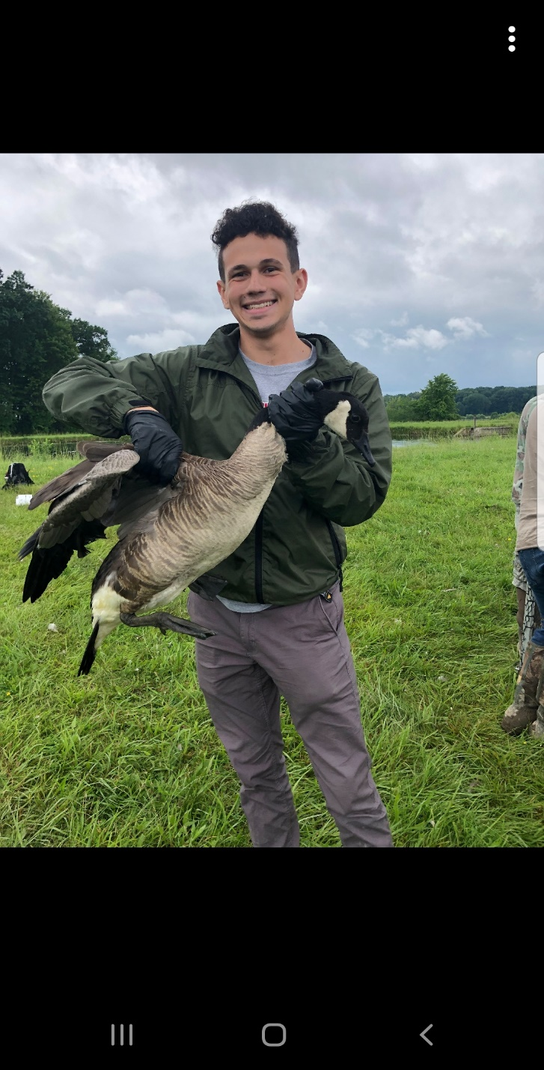

**Primate Field Technician at New York University, Puerto Rico (March 2023 - July 2023)**

While sturgeon is fascinating, it was also a welcome change to "get my feet dry" and return to terrestrial work. I had the opportunity to travel to Puerto Rico to study rhesus monkeys at Cayo Santiago, the Caribbean Primate Research Center. During this project, I was affiliated with the James Highman lab at New York University, collecting noninvasive data such as urine, fecal, and wound analysis for use in aging studies.

In Puerto Rico, my role offered a new and exciting challenge: learning to identify individual monkeys. On Cayo Santiago, there are approximately 1,500 monkeys, and my task involved identifying and tracking a specific group of 50. I needed to know each of my individual monkeys, and learning them in a sea of so many monkeys was difficult. Identifying monkeys required meticulous attention to detail, recording every aspect of each monkey, including their unique behaviors (one monkey I could initially only remember by the way he licked his wrist every 10 seconds), intriguing social patterns (like that one mating pair that got mad when I was around), and discerning their physical features (you would be surprised that a "crooked tail" is a pervasive, often unhelpful feature). This experience undoubtedly taught me patience and honed my skills in maintaining organized and detailed field notes.

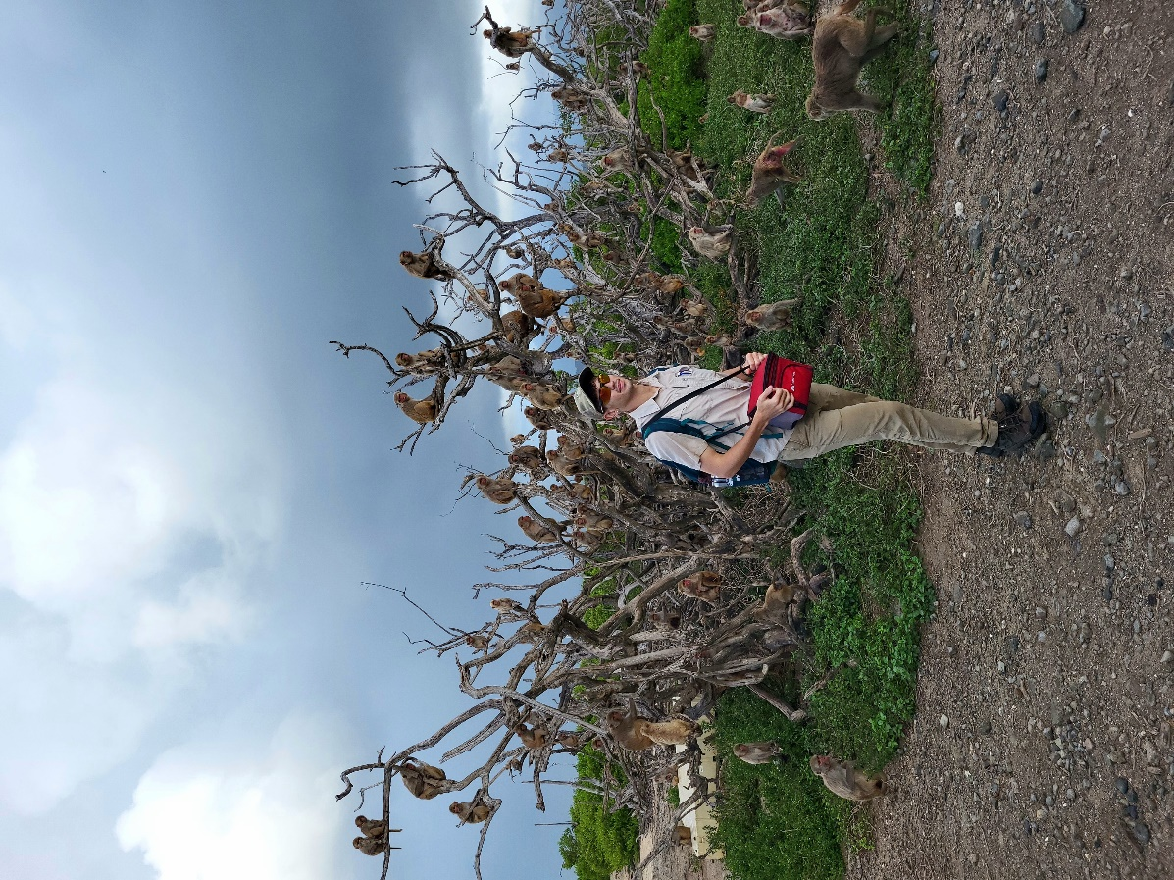

**Sturgeon Technician and Research Assistant at Chesapeake Scientific, Virginia (August 2022 - October 2022 and October 2022- Present)**

At the end of my observer contract, I traveled to Richmond, Virginia, to work with Atlantic Sturgeon under Dr. Jason Kahn, the National Training Coordinator for Section 7 of the Endangered Species Act, and Dr. Christian Hager, CEO of Chesapeake Scientific. We embarked on a challenging fieldwork expedition, often enduring 14-hour days, wrestling with massive, powerful fish that had the potential to inflict severe harm with one powerful tail strike. While I thankfully escaped with nothing more than a mild concussion, this experience deepened my appreciation for the dedication required in scientific research.

During our work, we collected crucial ecological data, including DNA samples, length, weight, sex, egg, and sperm samples, and fitted the sturgeon with tracking devices. My involvement continued in the field; I continued to collaborate with Dr. Kahn and Dr. Chris Hager in a remote capacity, helping with data analysis and paper writing. Working alongside Dr. Kahn, I contributed to a peer-reviewed scientific paper. With Dr. Hager, we produced two government technical reports commissioned by the Department of the Interior to assess the potential impacts of wind farm development on marine life. This experience introduced me to the world of technical writing as a government contractor. It also highlighted the importance of scientist's advocation, even when their findings contradict established practices.

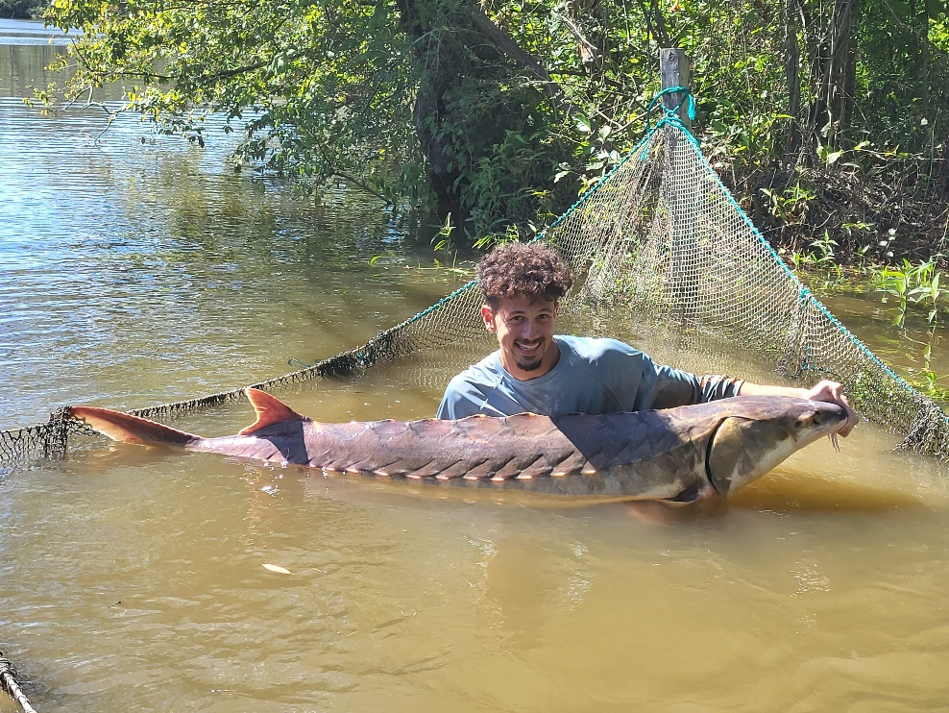

**Marine Biologist - Fisheries Observer at Lynker Technologies, Hawaii (March 2022 - August 2022)**

After working in pest control, I was eager to return to the scientific realm, which led me to my most challenging and rewarding job to date as a fisheries observer in Hawaii. Here, I worked on a fishing vessel out at sea for a month. I collected species identification data, size, sex, and recorded protected species interactions with working hours extending beyond 100 hours per week. The vessels I worked on were small, often only 50 to 70 feet long, lacking amenities like a bathroom or air conditioning, and frequently dealing with bed bugs and cockroach infestations. The crew came from Asian countries such as the Philippines, Vietnam, and Indonesia, providing a phenomenal cultural exchange. However, this meant I was often the only English speaker on the boat, which made communicating with the crew about sustainable fishing practices a challenging yet exciting task. In this unique setting, I not only collected crucial biological data but also played a vital role in instructing the crew on proper fishing practices. This educational aspect of my work was instrumental in ensuring sustainable fishing practices and preserving marine ecosystems. This experience further expanded my scientific knowledge and enhanced my appreciation for the intricate workings of marine ecosystems.

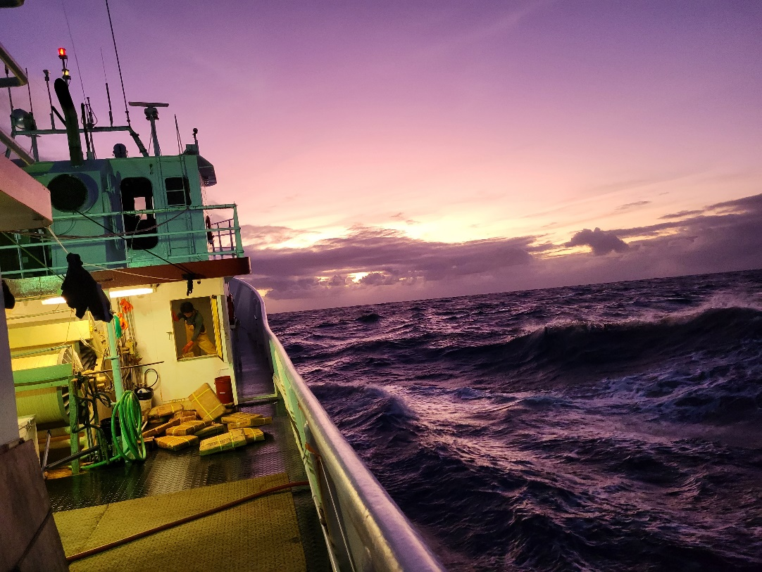

**Wildlife Technician at Budget Pest Control, Pennsylvania (October 2021 - January 2022)**

 Taking on this role presented a unique challenge for me as I am deathly afraid of heights, so this job pushed me out of my comfort zone. Often, animals would break into homes through roofs, and to exclude or remove animals often involved significant ladder work. Despite it not being a "scientific" role in the traditional sense, it was fundamental in cultivating my knowledge of wildlife.

In this position, I learned the intricacies of nuisance wildlife management, how to determine entry points into a home, how to exclude animal entry, and, when necessary, correctly trap and euthanize wildlife. I also did general pest control and got acquainted with pesticide and insect behavior. The most rewarding aspect of this position was the problem-solving it demanded. I had to visit homes and apply my understanding of animal biology to determine how and why animals might be gaining entry and how to exclude or remove them. Here, I got to use my wildlife knowledge in a business setting, which expanded my expertise.

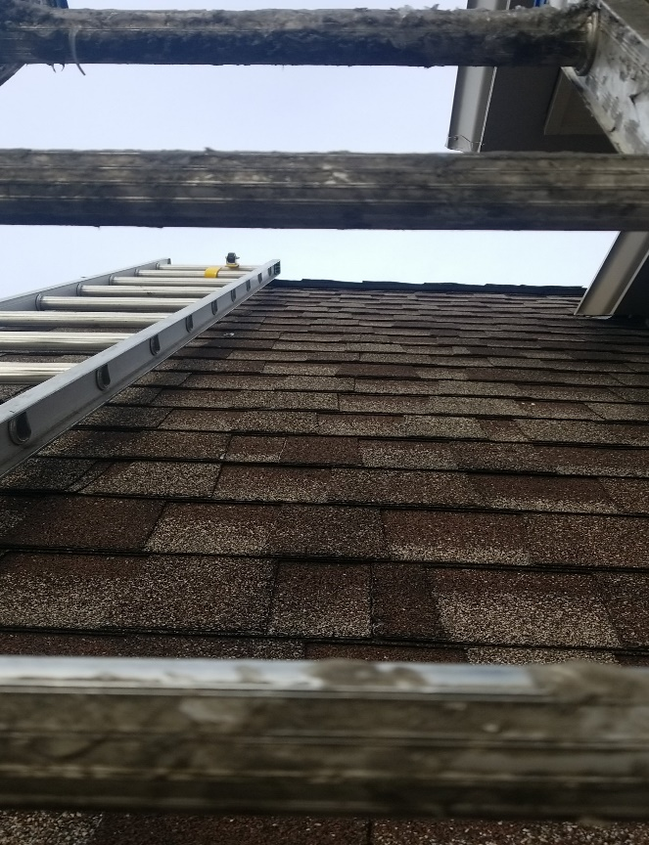

**Natural Resource Technician at Philmont Scout Ranch, New Mexico (May 2021 - August 2021)**

My first job out of college was working as a Natural Resource Technician in Cimarron, New Mexico. I gained various exciting and helpful skills, such as habitat restoration, herbicide treatment, and end-of-season field report writing. As a budding wildlife biologist, one of the most unique parts of my job was nuisance bear control, where I was a first responder to bear incidents on the ranch.

I worked directly under wildlife biologist Casey Myers, who taught me my first significant lesson related to wildlife management: "Wildlife management is land management." To this extent, this job presented numerous challenges that required me to collaborate with fellow scientists to solve complex tasks as a team. Many of these tasks included various land management activities to preserve wildlife. My experiences in New Mexico broadened my understanding of land management, wildlife conservation, and ecological research.

