MODULE 6
Advanced Algorithms
BSCS-3B
Presented by: Group 6
Covers: Recap · Maximum Flow · String Matching
Contents
Recap
Maximum Flow
String Matching
(Headings are styled with Word's built-in Heading 1 / Heading 2 styles — right-click and choose "Update Field" on an inserted TOC, or use References → Table of Contents to generate a page-numbered version automatically.)

Recap
A quick review of last module's topics before diving into this one:
Breadth-First Search (BFS) — A graph traversal algorithm that starts from a source node and explores level by level, visiting all direct neighbors before moving further out. Time complexity: O(V + E).
Depth-First Search (DFS) — A traversal algorithm that explores as far as possible along each branch before backtracking to try the next unvisited neighbor.
Topological Sorting — Arranges the vertices of a directed acyclic graph (DAG) so that for every edge A to B, A comes before B in the ordering.
Dijkstra's Algorithm — Finds the shortest path from a starting node to every other node in a weighted graph by greedily expanding the closest unvisited node, using a priority queue. Requires non-negative edge weights.
Bellman-Ford Algorithm — Finds the shortest path from a source vertex to all others in a weighted graph, and unlike Dijkstra's, it can handle negative edge weights and detect negative weight cycles.
Floyd-Warshall Algorithm — A dynamic programming algorithm that finds the shortest paths between every pair of vertices by repeatedly checking whether routing through another vertex gives a shorter path.
Prim's Algorithm — A greedy algorithm for finding a Minimum Spanning Tree (MST): starting from one vertex, it repeatedly adds the cheapest edge that connects to an unvisited vertex.
Kruskal's Algorithm — Also finds a Minimum Spanning Tree, but by sorting all edges by weight and adding the smallest edge at each step as long as it doesn't create a cycle.

Maximum Flow

What Is Maximum Flow?
Maximum flow is an algorithmic problem that calculates the greatest possible total amount of traffic, data, or liquid that can move from a starting Source to a final Sink through a network of connected pathways, where every pathway has a strict capacity limit.

The Two Core Rules
Capacity Constraint — The flow on any edge cannot exceed that edge's defined capacity.
Flow Conservation — For every intermediate node (any node that is not the Source or the Sink), the total flow entering the node must equal the total flow leaving it. Matter or data cannot magically appear or disappear at internal points.

Core Concepts & Key Rules
Source (S) — Starting node where flow originates.
Sink (T) — Final destination node where all flow must arrive.
Capacity — The maximum physical limit an edge can carry.
Flow — The actual amount currently moving through an edge.
Example: in the path S → A → T, where S → A has capacity 10 and A → T has capacity 7, the flow along that path is 7 — the narrowest ('bottleneck') link limits how much can get through.
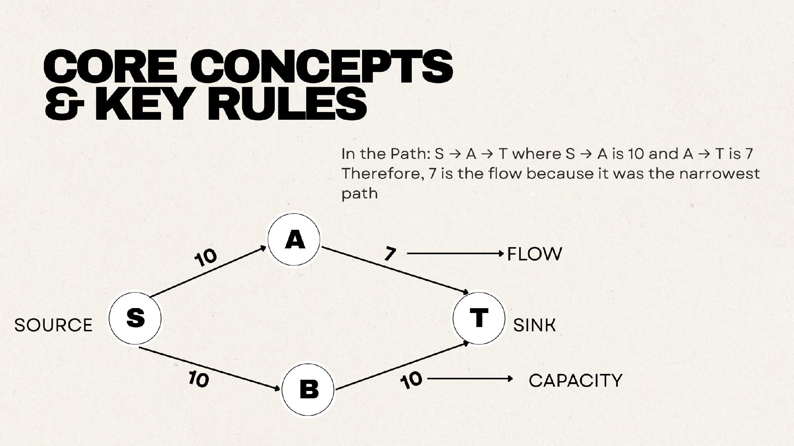
Source, sink, capacity, and flow along a simple path.

The Ford-Fulkerson Algorithm
The Ford-Fulkerson algorithm is a greedy strategy used to calculate the maximum flow in a network graph from a Source (S) to a Sink (T). Instead of guessing all paths at once, it uses an iterative greedy approach powered by residual graphs:
- Augmenting Path: search for any valid path from Source to Sink with remaining capacity.
- Bottleneck: identify the smallest capacity link on that path and push that amount of flow through.
- Add Reverse Edges (undo mechanism): create backward residual edges so future iterations can cancel or reroute sub-optimal flow choices.

Walking through the example graph below (S, A, B, C, T):
- Path S → A → T: bottleneck = min(10, 7) = 7. S→A residual becomes 3, A→T becomes saturated (0). Running total: 7.
- Path S → B → T: bottleneck = min(10, 10) = 10. Both S→B and B→T become saturated. Running total: 7 + 10 = 17.
- No paths remain: both A→T and B→T have 0 forward capacity left, so no further augmenting paths exist.
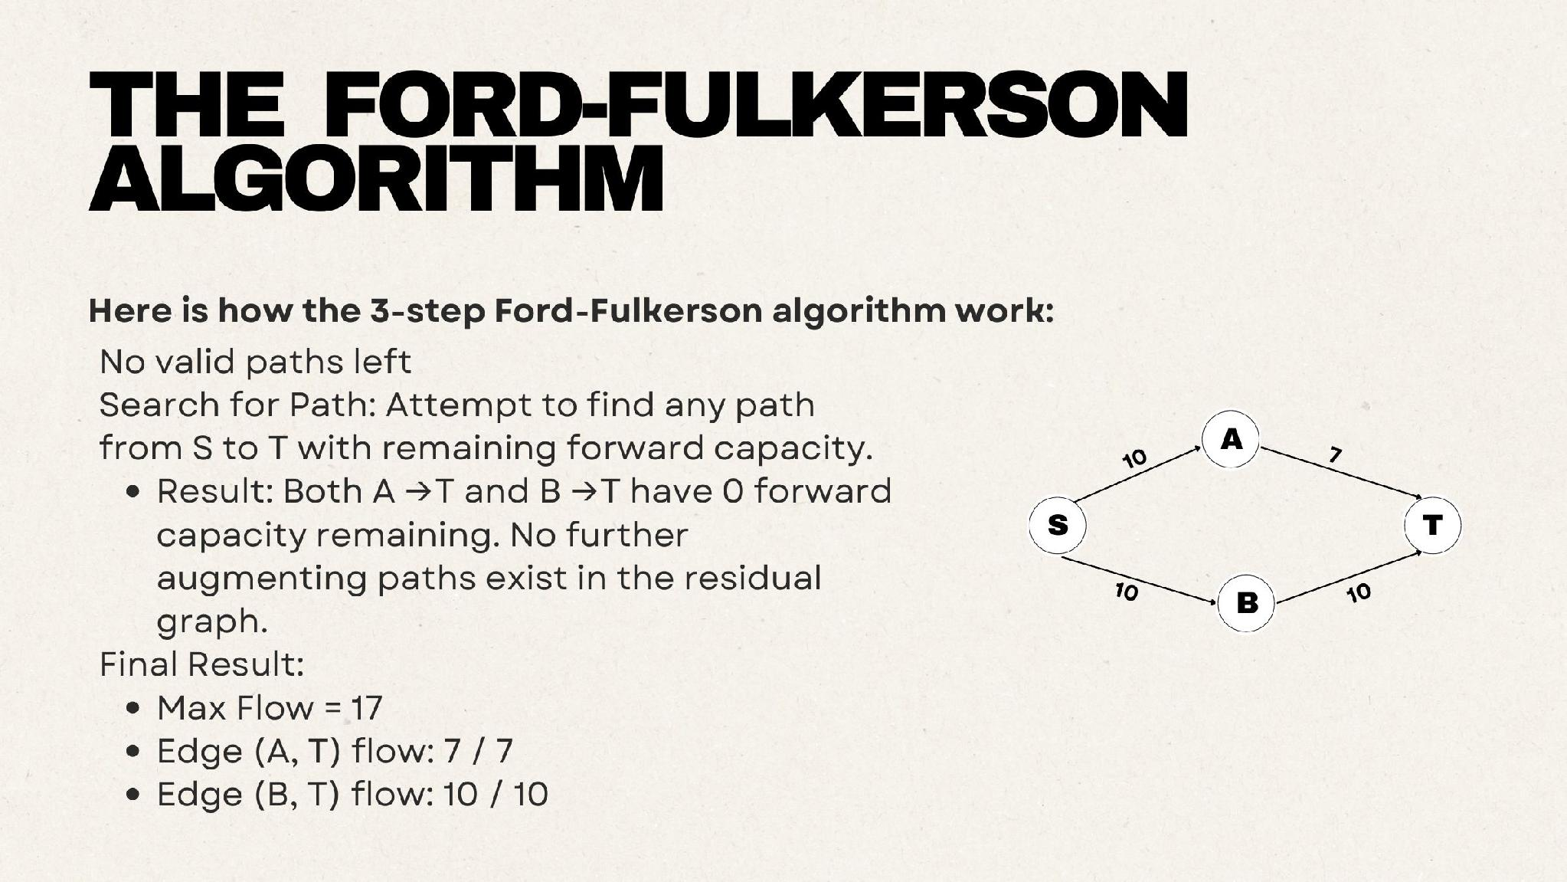
Final state: Max Flow = 17 (edge A→T carries 7/7, edge B→T carries 10/10).

Calculating Max Flow — Example
A larger network to practice on, with source S, sink T, and intermediate nodes A, B, and C:
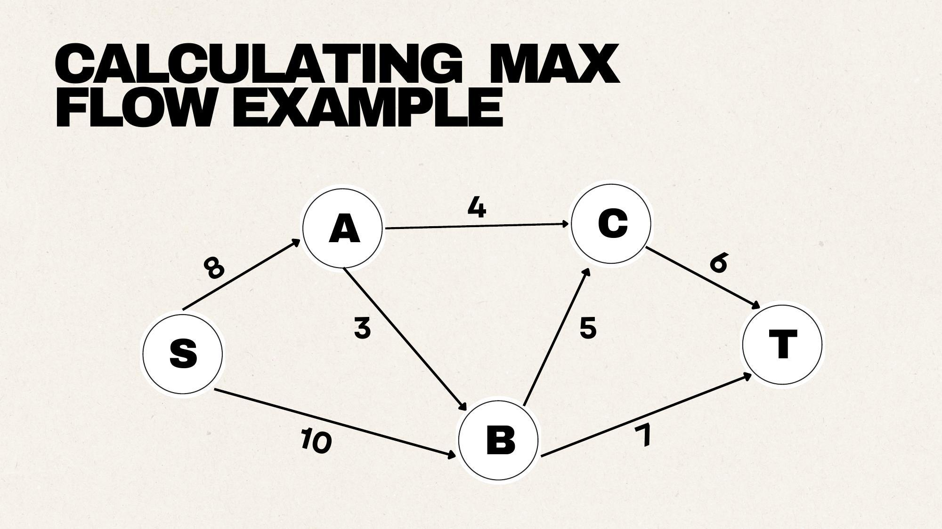
Practice network: S→A (8), S→B (10), A→C (4), A→B (3), B→C (5), B→T (7), C→T (6).

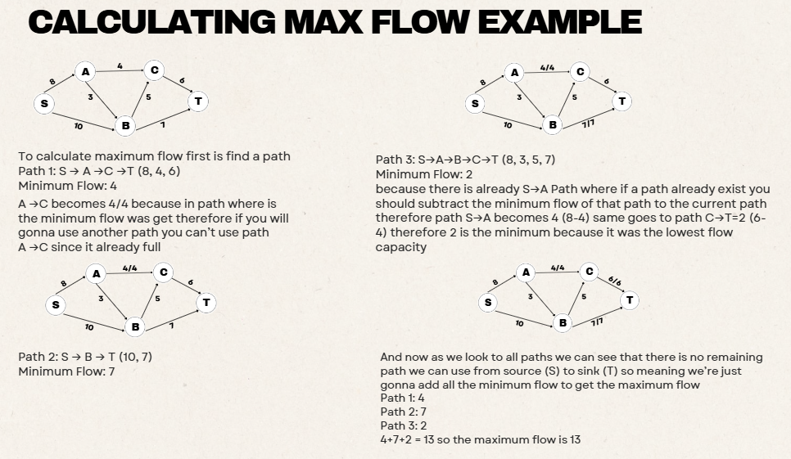

Takeaways
- Maximum Flow — the highest total volume of flow that can move from source to sink.
- Two Core Rules — Capacity Constraint and Flow Conservation.
- Ford-Fulkerson Algorithm — the standard method for calculating maximum flow.
- 3-Step Loop — the algorithm repeatedly finds an augmenting path, pushes the bottleneck flow, and updates residual capacities.
- Path Choice Flexibility — different valid path choices can still arrive at the same correct maximum flow.

String Matching
String matching is the process of comparing a string of characters with another string or a specified pattern to determine whether they are identical, or whether one occurs within the other. For example, searching for "cat" in "The cat is sleeping" is string matching, because the pattern "cat" occurs within the larger text.
Three classic algorithms accomplish this, each with different trade-offs:
- Naive (Brute-Force) Search
- Rabin-Karp Algorithm (Rolling Hash)
- Boyer-Moore Algorithm

The Running Example
Throughout this section, the same running example is used: searching for the pattern "CONT" (4 characters) inside the text "FLOODCONTROL" (12 characters).

1. Naive (Brute-Force) Search
The naive search slides the pattern across the main text one position at a time, comparing each letter until it finds a full match or runs out of positions to try.
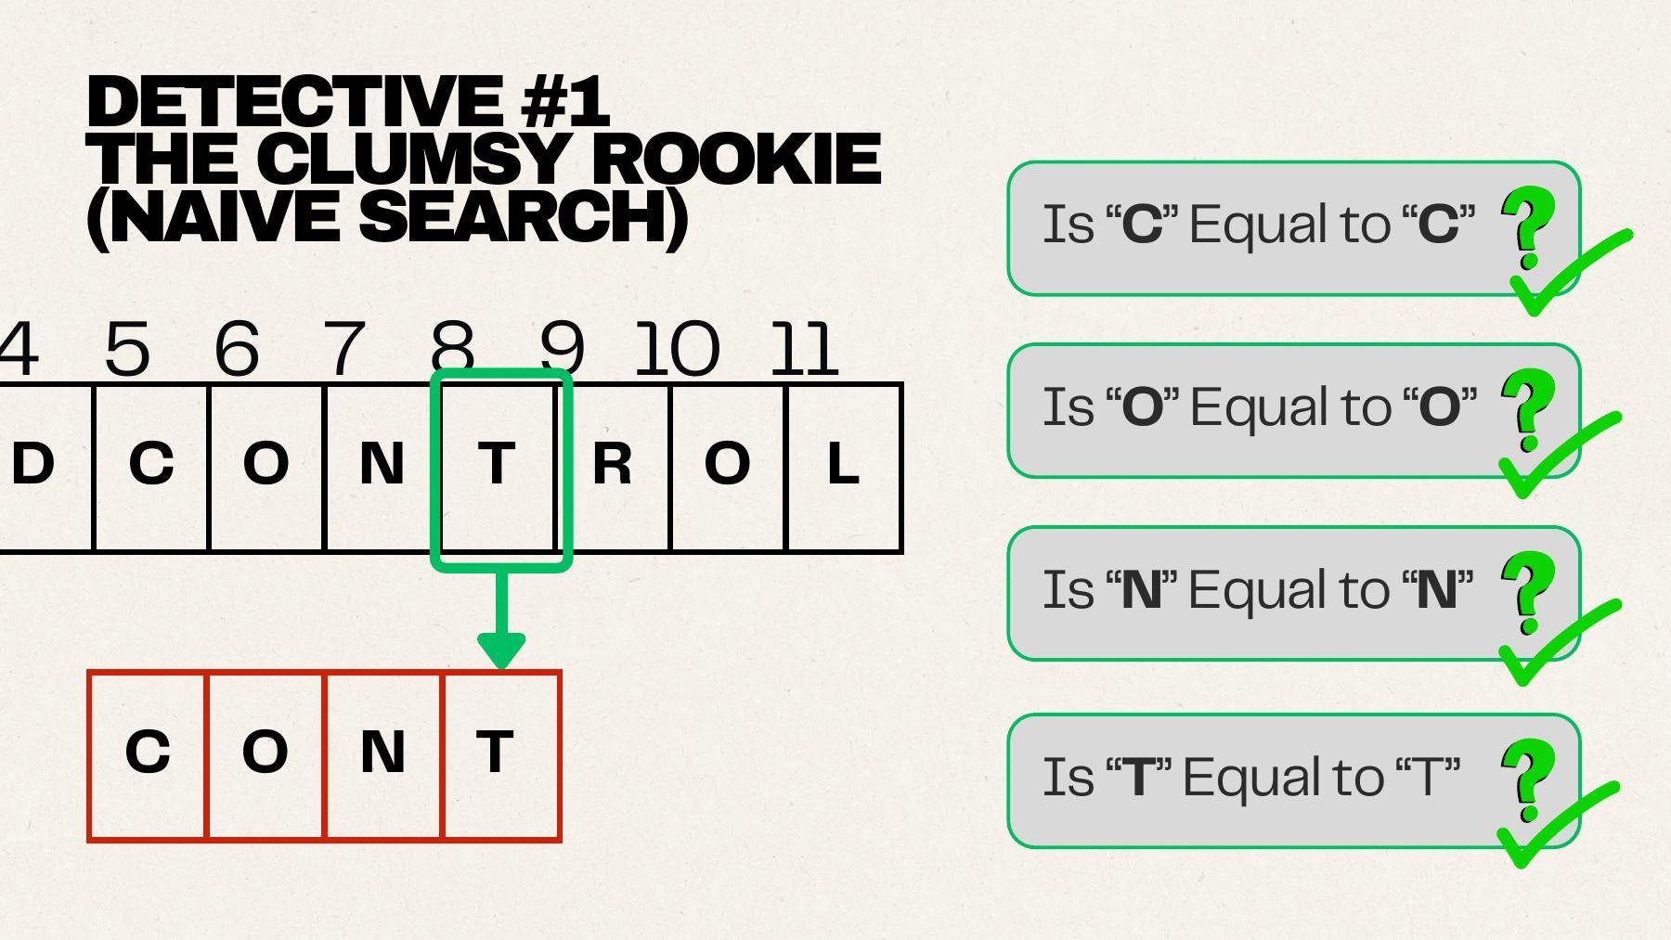
Naive search sliding window: comparing "CONT" against the text at the matching position — every character checks out.
Complexity:
- Mechanism: at every text shift i (0 to n−m), compare the pattern P against the substring T[i...i+m−1].
- Time complexity: O((n − m + 1) × m), which simplifies to O(n × m) in the worst case.
- Best case: O(n), when mismatches are found immediately at each position.
- Worst case: O(n × m), which happens with highly repetitive text and patterns.
- Limitations: it discards all information gathered during partial matches, so each new position starts comparisons completely from scratch.

2. Rabin-Karp Algorithm (Rolling Hash)
Rabin-Karp converts string comparison into numerical comparison using modular arithmetic:
- Map characters to numbers using base d, where d represents the alphabet size.
- Compute the hash value h(P) for the pattern and h(T) for the current text window, both modulo a prime number q.
- Slide the window one position at a time, updating the hash value in constant time using a rolling hash formula instead of recomputing it from scratch.
- Only when the hash values match does the algorithm perform a direct character-by-character check, to rule out hash collisions.
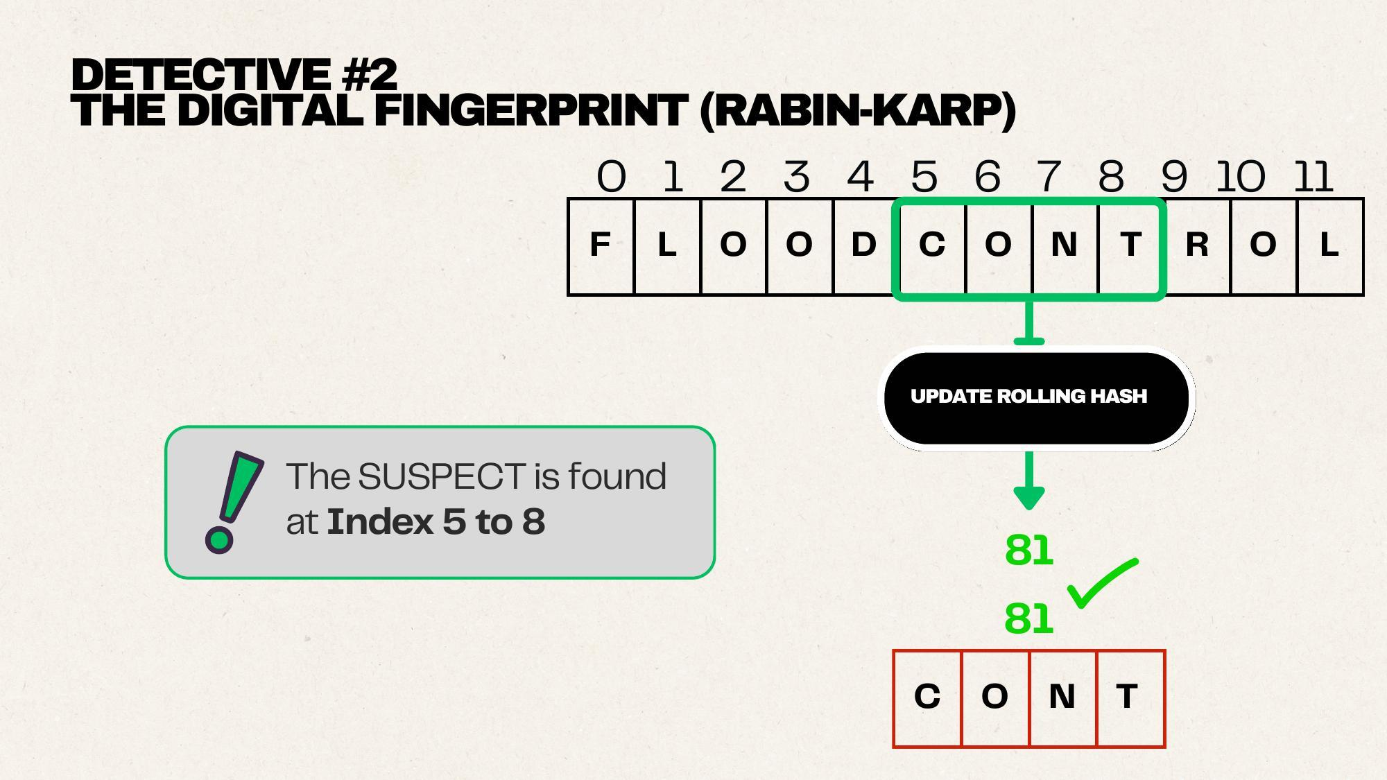
Rolling hash values matching (81 = 81) confirm the suspect pattern is found at index 5 to 8.
Complexity:
- Average case: O(n + m).
- Worst case: O(n × m), due to frequent hash collisions.
- Best used for: searching for multiple patterns simultaneously, such as in plagiarism detection.

3. Boyer-Moore Algorithm
Boyer-Moore compares characters from right to left, starting from position m−1 down to 0 within the current search window, and uses mismatches as clues to skip large sections of text at once — rather than sliding one space at a time.
Two heuristics drive the skipping:
- Bad Character Rule: when a mismatch occurs at T[i] = c, the pattern is shifted right so that the rightmost occurrence of c in the pattern realigns with position i.
- Good Suffix Shift: uses previously-matched suffixes to skip ahead even further.
The algorithm shifts by whichever of the two rules suggests the larger jump. A precomputed Bad Match Table stores the shift distance for each character.
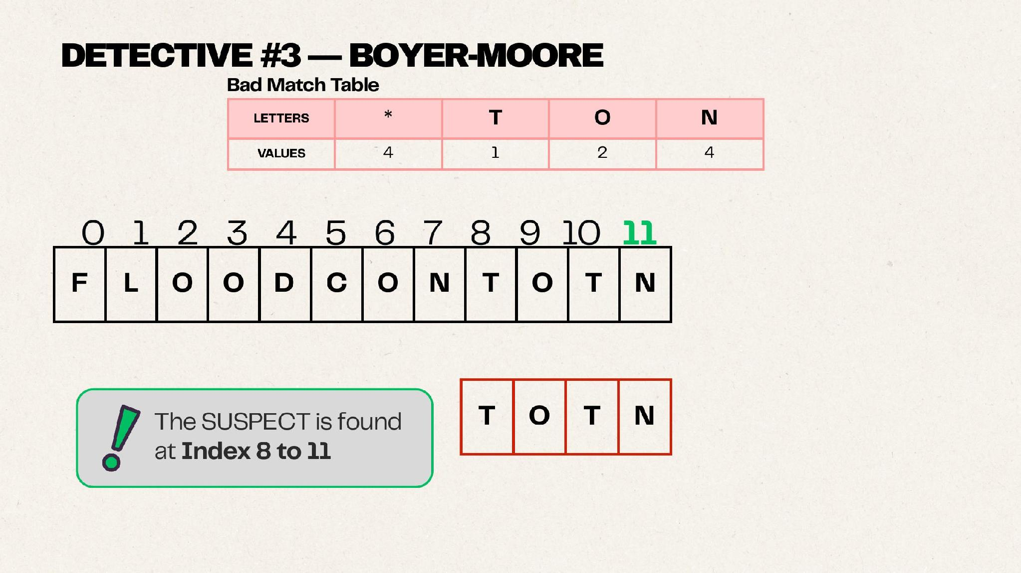
Bad Match Table and the final located match — the suspect pattern "TOTN" found at index 8 to 11.
Complexity:
- Best case: O(n / m), sub-linear, because the algorithm can skip large sections of the text.
- Worst case: O(n × m), though this is rare in practice with a well-built bad match table.

