The objective of this report is to identify potential locations where SeriousMD service coverage can be expanded. Specifically, this report aimed

1. to determine if there is a significant amount of appointments per region,
2. to identify the potential market using SeriousMD services, and
3. to determine the priority locations in expanding SeriousMD services.

To create substantial analysis and recommendations, the primary data used are based on the internal appointments made to SeriousMD and external data from the Philippine Statistics Authority. Furthermore, the following assumptions are made in the analysis:

* The clinic or hospital locations in SeriousMD cater to clients within its area.
* The Philippines contains the following super regions:
  + North Luzon Agribusiness Quadrangle,
  + Metro Luzon Urban Beltway,
  + Central Philippines Region, and
  + Mindanao Super Region.
* Households with any mode of connection to the Internet may access SeriousMD.
* One appointment means that SeriousMD is catered at the location of the appointment.

**Current SeriousMD Coverage per Region**

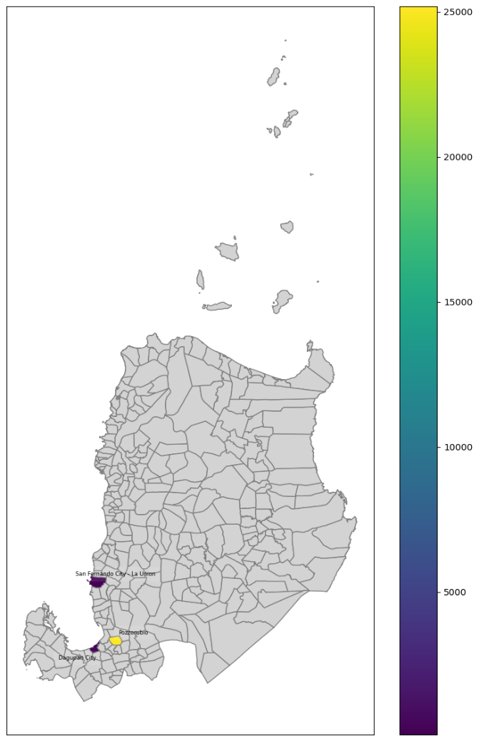

**Figure 1. Appointments in Northern Luzon Agribusiness Quadrangle**

In Northern Luzon, the appointments are concentrated in Pozorrubio (Pangasinan), San Fernando City (La Union), and Dagupan City (Ilocos). Pozorrubio specifically stands out with a significant number of appointments, exceeding 20,000, which is the highest in the super region.

**Figure 2. Appointments in Metro Luzon Urban Beltway**

In Metro Luzon Urban Beltway, the appointments are concentrated in NCR, Olongapo City (Zambales), Malolos City (Bulacan), Dasmariñas City (Cavite), and Laguna. Quezon City in NCR had the highest number of appointments in the super region and in the entire country, exceeding 140,000 appointments.

**Figure 3. Appointments in the Central Philippines Region**

In Central Philippines Region, the appointments are concentrated in Manito (Bicol), Legazpi City (Bicol), Iloilo City (Iloilo), Kananga (Leyte), Cebu City, Liloan (Cebu), Valencia (Negros Oriental), and Dumaguete City (Negros Oriental). Iloilo City specifically stands out and has the highest number of appointments in the super region, exceeding 16,000 appointments.

**Figure 4. Appointments in Mindanao Super Region**

In the Central Philippines Region, the appointments are concentrated in Iligan City (Lanao del Norte), Makilala (Cotabato), and General Santos City (SOCCSKSARGEN). General Santos City had the highest number of appointments, exceeding 16,000 appointments.

**Figure 5. Summary of Appointments in the Philippines per City**

**Figure 6. Summary of Appointments in the Philippines per Region**

Quezon City in NCR had the highest amount of appointments. It is noticeable that there is a large difference between the next city with the largest appointments, Makati. The top 1, 2, and 4 cities on the list came from the Metro Luzon Urban Beltway, while the top 3 came from Northern Luzon. Then, the top 5, 7, and 8 came from Central Philippines, while the top 6 came from the Mindanao Super Region. This distribution of appointments in the country implies that even though the appointments are concentrated in Metro Luzon, there is still a considerable number of appointments in other regions, which means that expanding the service in different regions shows great potential.

**Expanding Services to Potential Users**

**Figure 7. Internet Users in Philippines Per Region and SeriousMD Service Locations [1]**

In Figure 7, the choropleth map shows the distribution of households that have at least one modality of internet access, while the red points are the locations already catered by SeriousMD.

In NCR, more than 2.5 million households have internet access. Still, there are only 200,000 appointments in SeriousMD, as seen in Figure 6. This means that only 8% of internet users use SeriousMD online services. Since there are already enough service locations in NCR, it is recommended that there should be at least an awareness campaign that can be implemented at different partner hospitals in NCR to promote these services.

It is also worth noting that Region 4A has the largest number of households with internet access. It has about 2.8 million households with an internet connection, while there are only approximately 3000 appointments. Less than 1% of internet users do not use any of SeriousMD's online services. Expanding the services in highly urbanized provinces such as Laguna and Cavite is recommended in this case.

In Northern Luzon, it appears that there is also a large amount of households that access the Internet. Specifically, Region 3 had about 1.5 million households with internet access. It is recommended that service expansion be prioritized in areas near NCR, such as Bulacan and Pampanga. Bulacan and Pampanga are also part of the Metro Luzon Urban Beltway, which means that they are considered as urbanized areas.

After the expansion in Luzon, Visayas can be considered. In Region 6, the expansion can start in Iloilo City as it shows a significant amount of appointments in the area while it has a lot of internet users, approximately 900,000. In Region 7, which is almost similar to Region 6, Cebu had many appointments with approximately 1,000,000 internet users. Cebu and Iloilo are highly urbanized areas, and people are starting to use digital technology. In line with this development, SeriousMD can start promoting within Cebu and Iloilo in Visayas and encourage adjacent areas to use online appointments.

On the other hand, Mindanao had the least number of internet users. Although General Santos City already had 16,000 appointments, this is a potential area of interest as users showed interest in using SeriousMD. Further development within this area can be an advantage in expanding these services.

**Figure 8: Hospital Locations in Luzon [2]**

Figure 8 shows the locations of hospitals in the Luzon region and the distribution of internet users per region. Since Luzon has good internet access, prioritizing urban areas in Luzon will create a significant impact. Locations with many hospitals (vivid red spots) are all potential locations for expansion.

In conclusion, start expanding awareness in areas with a large number of appointments but a larger proportion of internet users because this indicates that users are already familiar with the service but lack awareness. Then, areas with fewer appointments mean that these are good areas for expanding the service. Still, we need to consider internet accessibility, the number of internet users, and the current development status in the area.

**External Data:**

[1] <https://www.psa.gov.ph/statistics/population-and-housing/node/1684059979>

[2] <https://data.humdata.org/dataset/hotosm_phl_north_health_facilities>