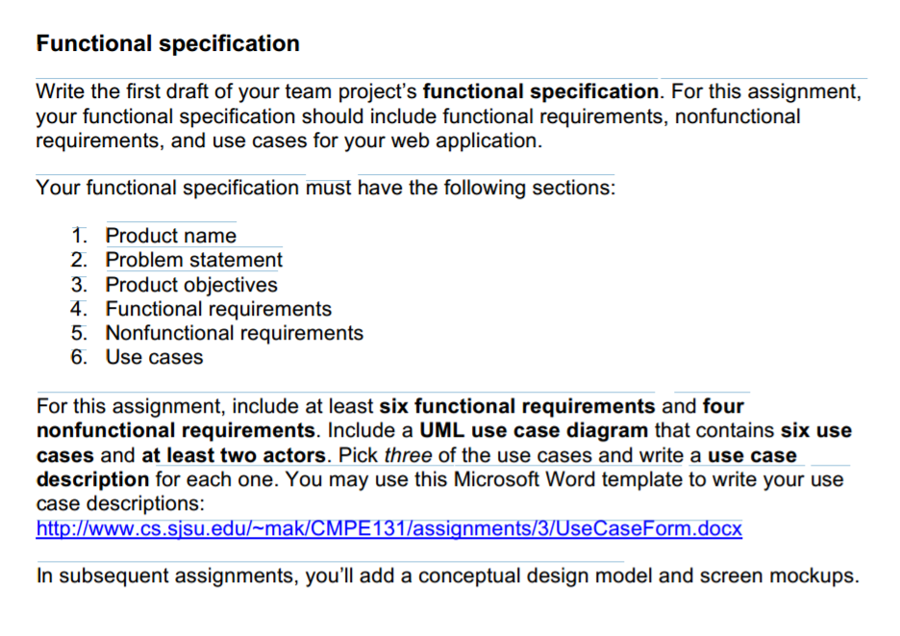

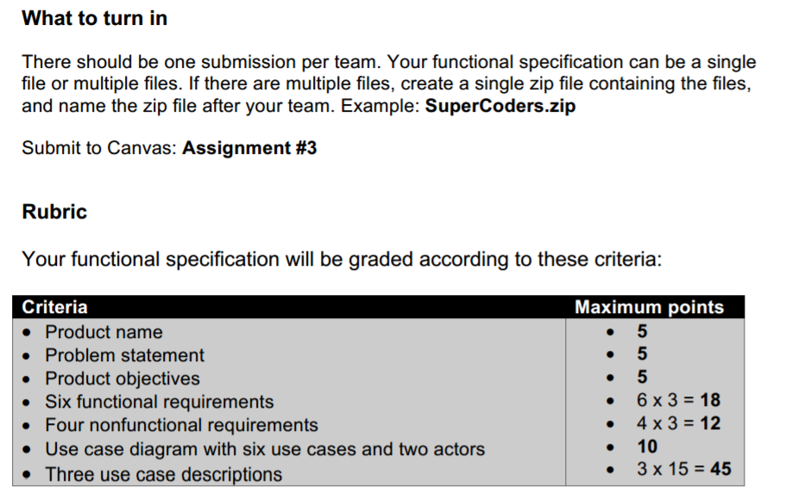

**Frontier Rental Car Service**

Every year car rental companies handle over millions of reservations. A large number of customers are not local, so looking for a good deal on a car rental can be difficult if the customer does not know where to start. The high cost and time to find a rental in some areas also affects the user’s ability to find a suitable car that he or she needs. The car rental services usually fill up fast and are quite expensive. It is easy to find a round-trip rental, but looking for a one-way or long-term car rental can be hard. Once summer and/or holiday season begins, they are in high demand and it is a challenge to find the right car. As of now, customers have to rely on big car rental companies to find a suitable and affordable accommodation for what they need. Therefore, this web application’s goal is to create an online platform for locals and foreigners to share cars where ever they are. This application aims to let users manage their account easily, and with an ease of use, save time and money.

Frontier Car Rental Service will be for all and user-friendly, that is why we have made a few functional requirements to assist the user:

1. User accounts (customer)
   1. To rent a car, the app shall require users to create an account using their name, phone number, address, email and driver license number.
2. Sorting Algorithm
   1. The application must have a functionality to sort searching based on the user’s criteria such as car type, model, number of doors, etc.
3. Matching Algorithm
   1. This functionality shall identify the right vehicle that matches the user’s search
4. Queuing System (FCFS-first come first serve)
   1. The application shall be using the queuing system to prioritize users who have reserved a car first, in the order that the reservations were placed
5. Interactive Map View
   1. The search view must have the option to switch between a listview and an interactive map, which places pins at the location of the cars.
6. User accounts (host)
   1. Additionally to the customer account the app shall allow an account to be switched to a host, with which one can offer their own car for rent

Additionally, to the six functional requirements mentioned above, the application also required to have four nonfunctional requirements to supports the users.

1. GUI
   1. The application’s look must be streamlined with one or more accent colors throughout all pages
2. Load times
   1. Load times of search results shall be kept to a minimum, this is achieved through dynamical loading and limiting to ~20 cars
3. Navigation
   1. There must be a navigation bar on the top which lets the user switch between different views
4. Responsive Design
   1. The app shall offer all functions no matter what platform (Desktop, Mobile or Tablet) it is used from

The functional specification also includes a UML (use case diagram) that contains six use cases with a minimum of two actors and use case forms with three descriptions for each case.

The goal of this web application is to enable the users’ rental experience as easy, safe, efficient and affordable as possible. With the successful implementation of the Frontier Car Rental web application, users will have the ability to find a suitable and right car to rent that he or she needs including car availability, price range, and location.

Platform

Host

Customer