**TUP | Data Filter User Manual**

**Introduction**

The TUP Data Filter is a web application that allows you to upload and filter Excel data. You can apply search filters to the data, visualize it with bar graphs, and download the filtered data as a CSV file. This user manual provides an overview of the application's features and guides you on how to use them effectively.

**System Requirements**

To use the TUP Data Filter, make sure you have the following requirements:

* Python 3.x installed on your system
* Required packages installed: streamlit, pandas, matplotlib, seaborn, PIL, base64, sqlite3

**Getting Started**

1. Clone or download the TUP Data Filter source code.
2. Install the required packages by running the following command:
3. Open a command prompt or terminal and navigate to the directory containing the source code.

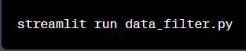

1. Run the following command to start the application:
2. The application will open in your default web browser.

**Login**

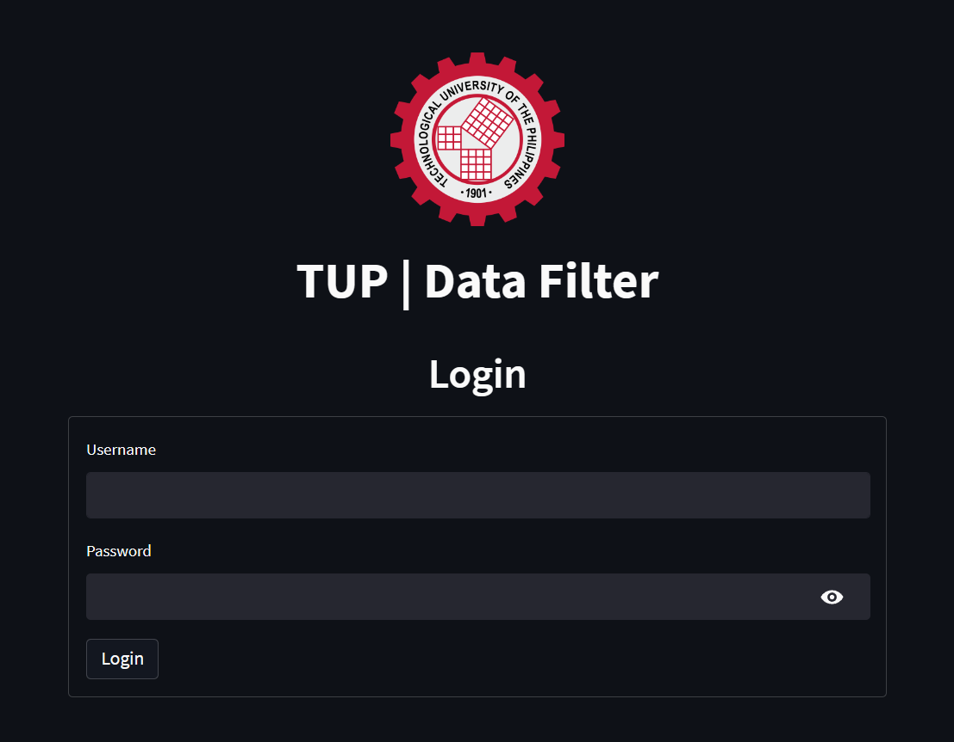

1. When you launch the TUP Data Filter, you will be prompted to log in.
2. Enter your username and password in the login form.
3. Click the "Login" button to proceed.
4. If the login credentials are correct, you will be logged in successfully.
5. If the login fails, an error message will be displayed. Please try again with valid credentials.

**Uploading and Filtering Data**

1. Once you are logged in, you will see the main application interface.

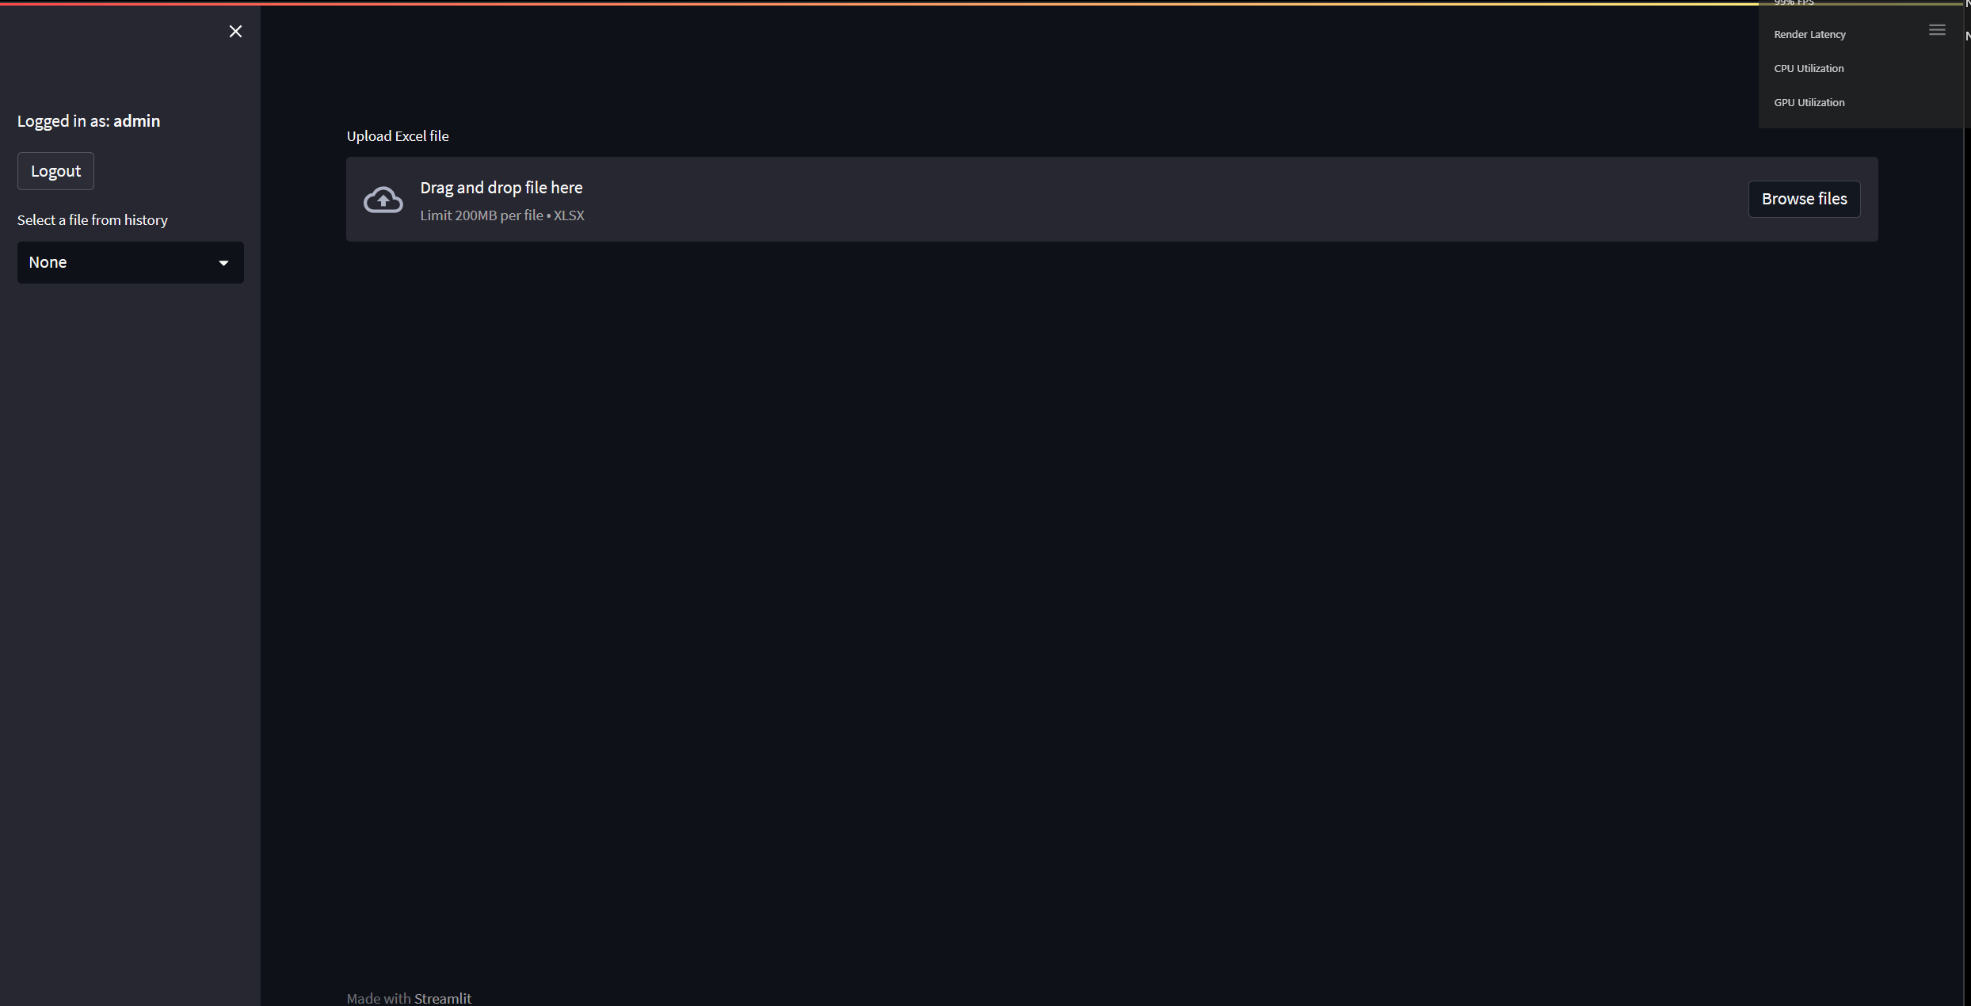

1. To upload an Excel file, click the "Upload Excel file" button.
2. Select the Excel file from your local system and click "Open".

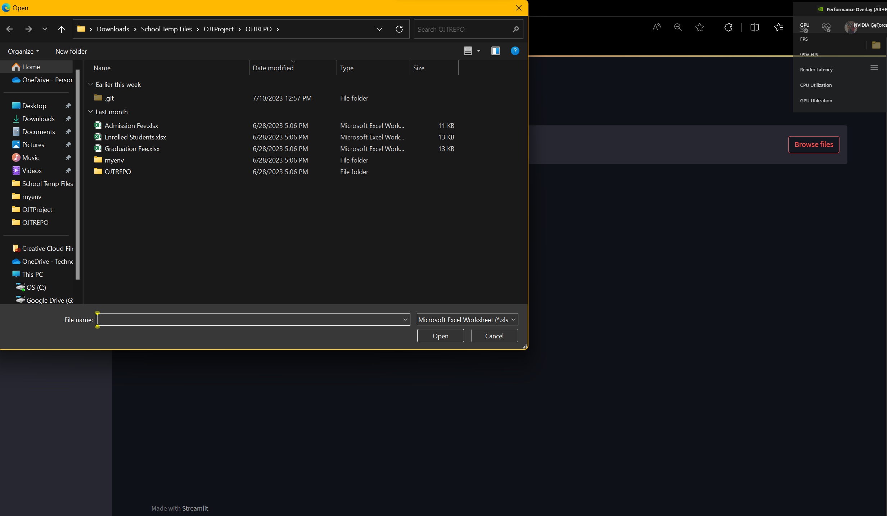

1. The uploaded file will be displayed in the main area of the application.

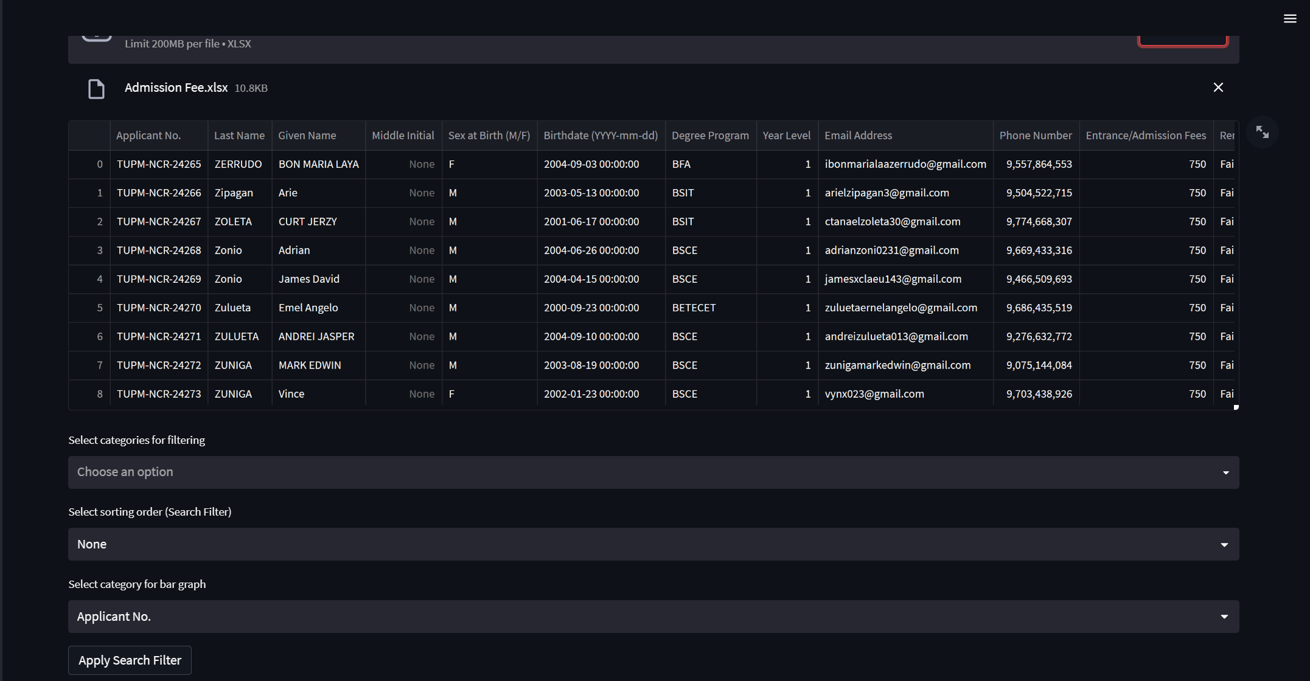

1. 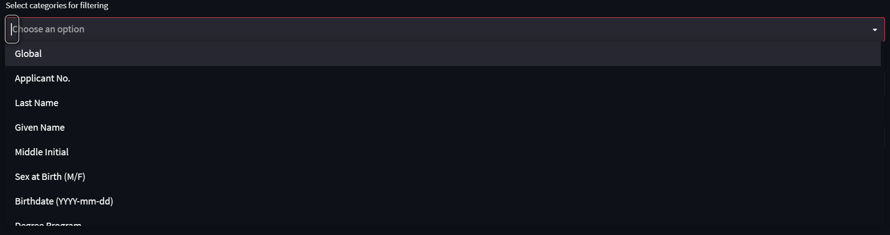To filter the data, select the categories for filtering from the dropdown list. You can select multiple categories.
2. 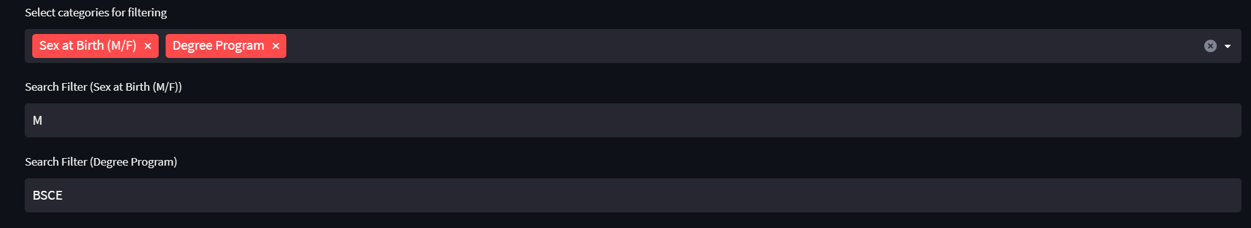Enter the search filters for each category in the corresponding text inputs.
3. Choose the sorting order for the search results from the "Select sorting order" dropdown.

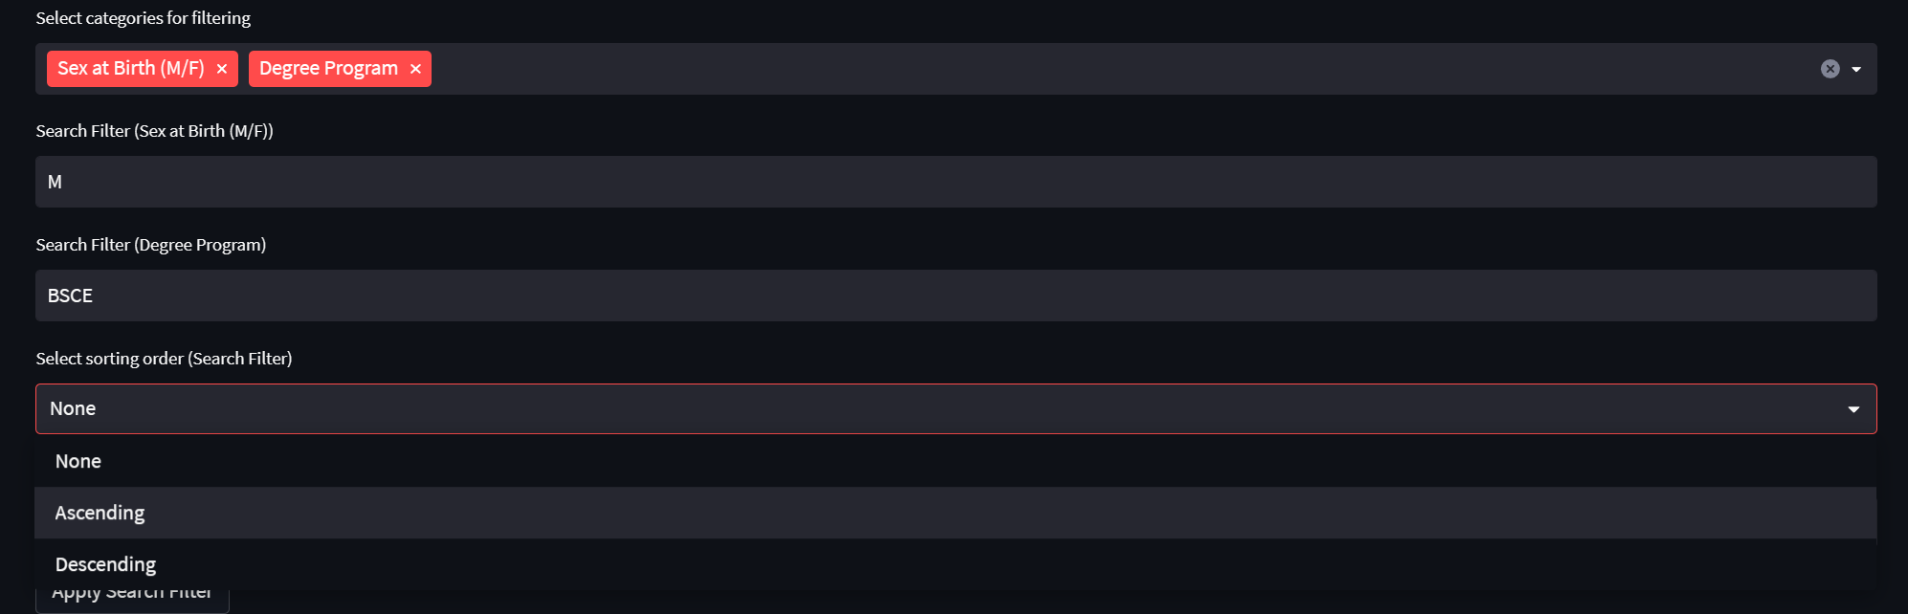

1. 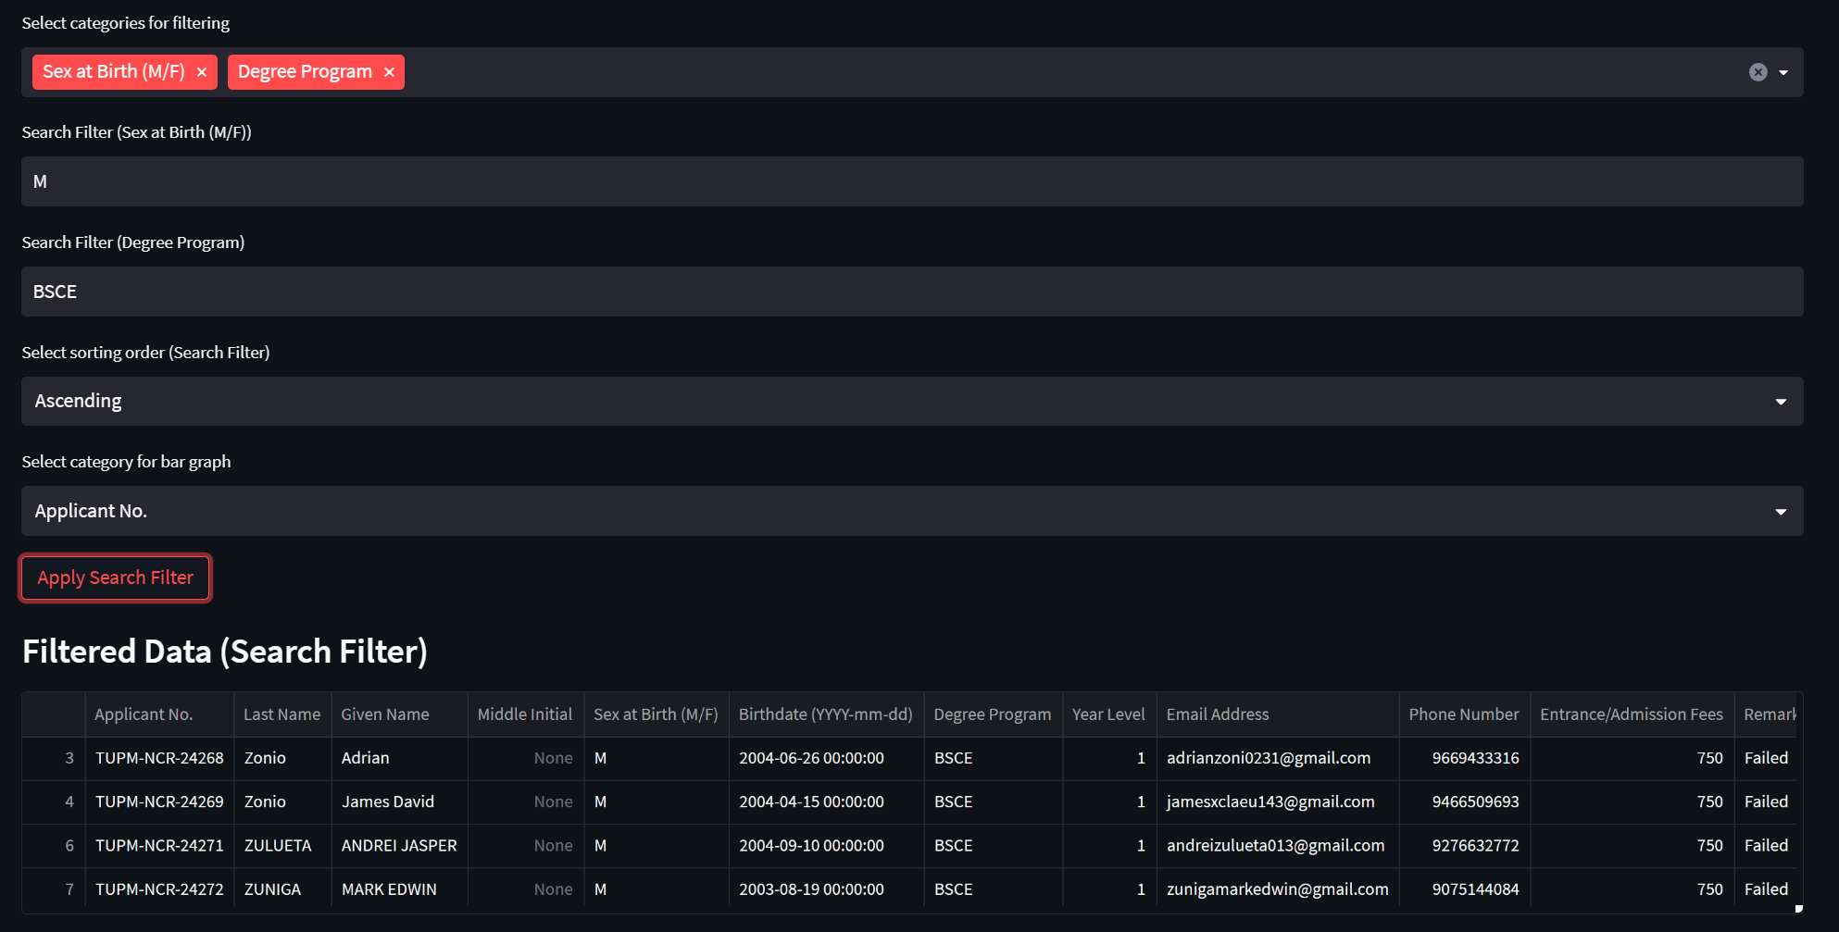Click the "Apply Search Filter" button to apply the filters to the data.
2. The filtered data will be displayed in a table format below the search filters.
3. If no results are found, a message will be displayed.
4. Additionally, a bar graph based on the filtered data will be shown.
5. To change the category for the bar graph, select a different category from the "Select category for bar graph" dropdown.

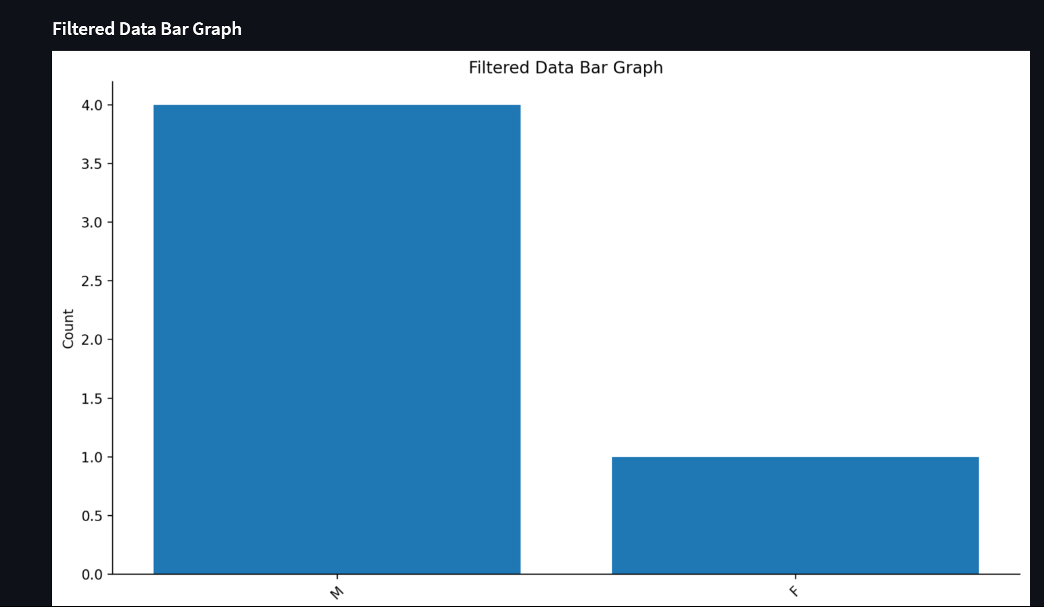

1. To download the filtered data as a CSV file, click the "Download CSV" button.

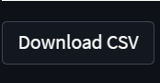

**Viewing File History**

1. On the left sidebar, you will find the file history section.

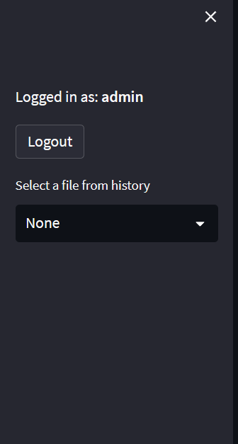

1. The file history displays the previously uploaded files.

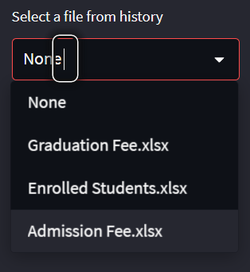

1. To view the contents of a previously uploaded file, select it from the "Select a file from history" dropdown.
2. The selected file will be displayed in the main area of the application, and you can apply filters to it as described earlier.

**Logging Out**

1. To log out of the TUP Data Filter, click the "Logout" button in the sidebar.
2. You will be logged out, and the login page will be displayed again.

**Database**

The TUP Data Filter uses an SQLite database to store the file history.

* The database file is named "file_history.db" and is located in the same directory as the source code.
* The "file_history" table stores the uploaded file names and timestamps.
* You do not need to interact with the database manually. The application handles all necessary operations.

**Troubleshooting**

If you encounter any issues or have questions regarding the TUP Data Filter, please refer to the following resources:

* Check the application's command prompt or terminal for any error messages.
* Make sure you have installed the required packages correctly.
* Ensure your Python version meets the system requirements.
* Refer to the official documentation or contact the application developer for further assistance.