Grazioso Salvare Animal Rescue Dashboard
CS-340 Client/Server Development | Project Two
Author: Kyle Dauk
Southern New Hampshire University | June 2026

1. Project Overview
This project delivers a full-stack web application dashboard for Grazioso Salvare, an international rescue animal training company that identifies dogs suitable for search-and-rescue (SAR) training from five Austin, Texas area shelters. The application enables staff to interactively filter, sort, and visualize the Austin Animal Center Outcomes dataset to identify dogs matching specific SAR profiles defined by breed, sex, and age criteria.

The system follows a Model-View-Controller (MVC) architecture implemented entirely in Python:
- Model: MongoDB database (AAC/animals collection) containing 10,000 animal shelter outcome records imported from the Austin Animal Center Outcomes dataset.
- View: Plotly Dash web components rendered in JupyterLab via JupyterDash, comprising an interactive data table, a breed distribution pie chart, and a Leaflet geolocation map.
- Controller: A reusable Python CRUD module (AnimalShelter class) that issues MongoDB queries and returns results to view components through Dash reactive callbacks.

2. Required Functionality and Screenshots
The dashboard satisfies all specifications from the CS-340 Dashboard Specifications Document. Each of the following subsections demonstrates a functional state of the deployed application. All screenshots include the Grazioso Salvare logo and the unique author identifier.

2.1 Starting State — Reset (All Animals)
On load, the Reset radio button is selected by default. The data table displays all 10,000 records across 1,000 pages (10 rows per page). The pie chart reflects the top breed distribution across the full dataset, and the geolocation map pins the first selected row in Austin, TX.
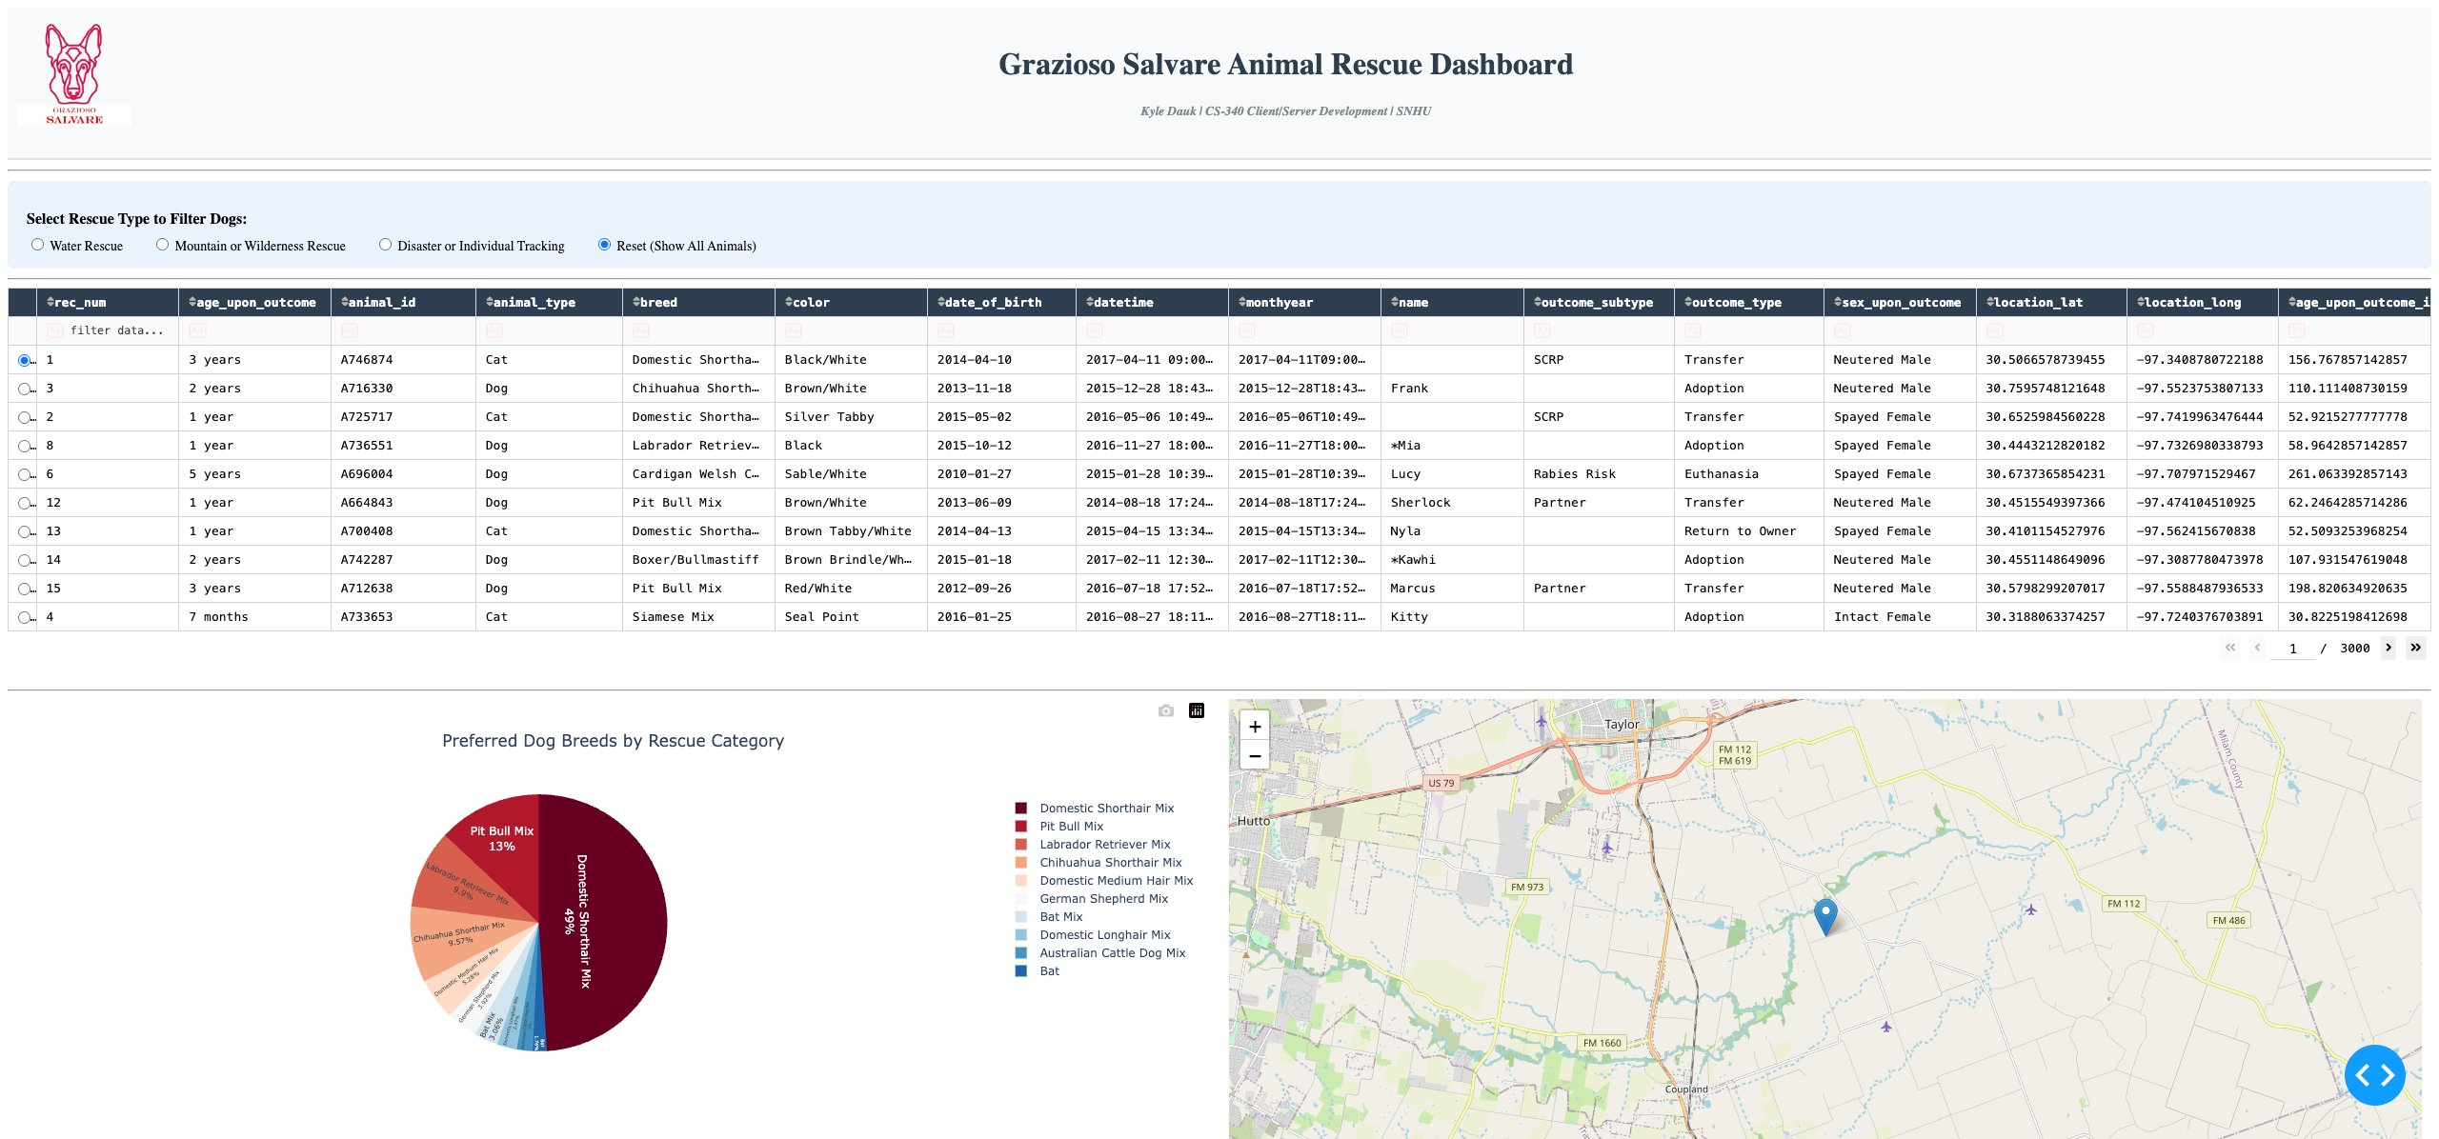
Figure 1: Dashboard starting state with Reset filter selected, displaying all 10,000 records across all animal types. No filters applied.

2.2 Water Rescue Filter
Selecting Water Rescue queries MongoDB for Intact Female dogs aged 26-156 weeks of breeds: Labrador Retriever Mix, Chesapeake Bay Retriever, Newfoundland, and Portuguese Water Dog. The table, pie chart, and map update simultaneously. The pie chart shows 100% Labrador Retriever Mix, confirming the query returns only matching records from the dataset.

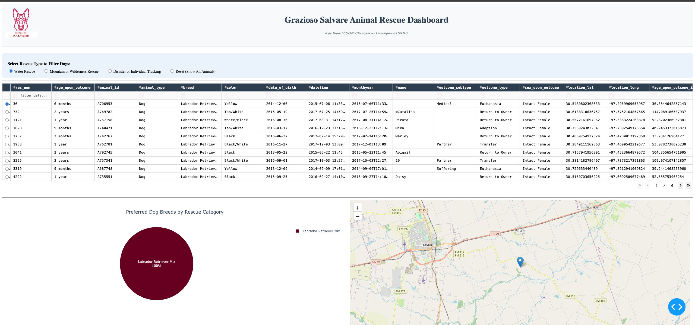
Figure 2: Water Rescue filter applied. Data table shows qualifying Intact Female Labrador Retriever Mix dogs aged 26–156 weeks. Pie chart and geolocation map update dynamically.

2.3 Mountain or Wilderness Rescue Filter
Selecting Mountain or Wilderness Rescue queries for Intact Male dogs aged 26-156 weeks of breeds: German Shepherd, Alaskan Malamute, Old English Sheepdog, Siberian Husky, and Rottweiler. The pie chart shows the distribution across Siberian Husky (40%), Alaskan Malamute (20%), German Shepherd, and Rottweiler, and the map relocates to the selected animal's recorded shelter coordinates.
Figure 3: Mountain or Wilderness Rescue filter applied. Data table shows qualifying Intact Male dogs of the five specified breeds aged 26–156 weeks. Pie chart and map respond accordingly.
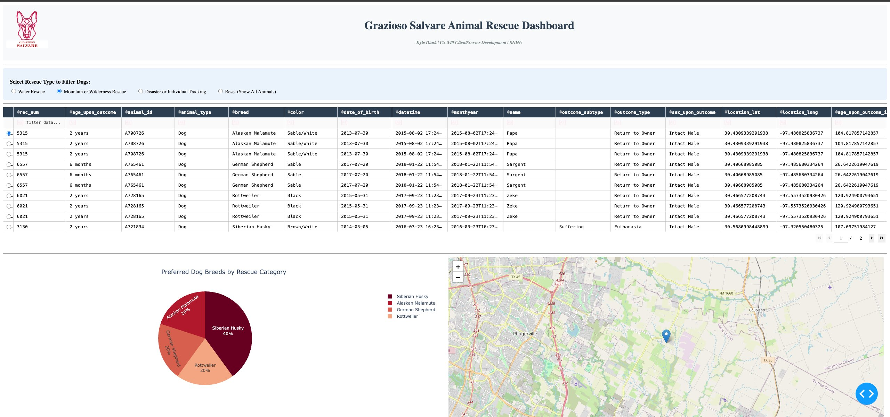

2.4 Disaster or Individual Tracking Filter
Selecting Disaster or Individual Tracking queries for Intact Male dogs aged 20-300 weeks of breeds: Doberman Pinsch, German Shepherd, Golden Retriever, Bloodhound, and Rottweiler. The pie chart reflects Doberman Pinsch (42.9%), Rottweiler (28.6%), Bloodhound (14.3%), and German Shepherd (14.3%). The map updates to the selected animal's location in the Austin metro area.

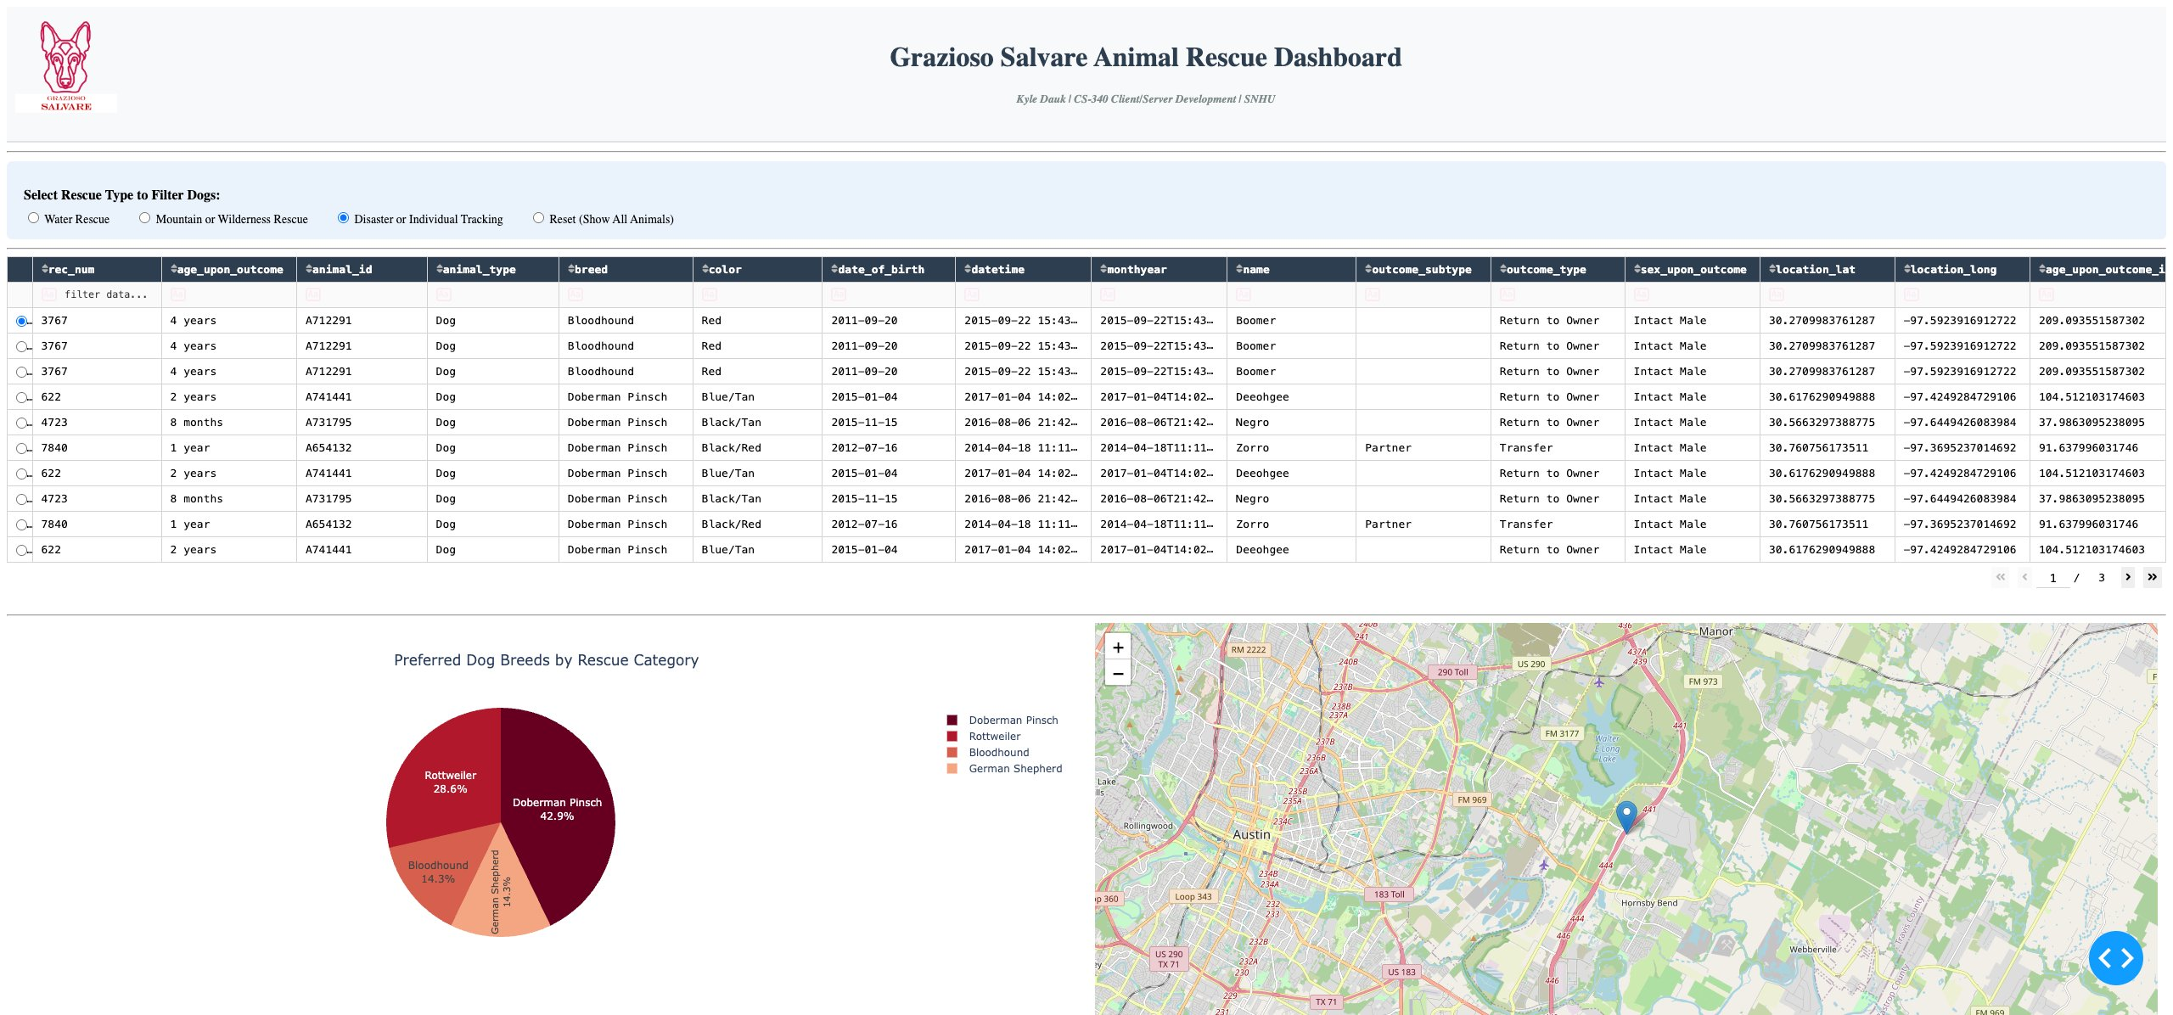
Figure 4: Disaster or Individual Tracking filter applied. Data table shows qualifying Intact Male dogs of the five specified breeds aged 20–300 weeks. All three dashboard components update in response to the filter selection.

3. Rescue Type Filter Specifications
The following table defines the MongoDB query parameters applied for each rescue type, sourced from the CS-340 Dashboard Specifications Document:

Rescue Type | Breeds | Sex | Age (Weeks)
Water Rescue | Labrador Retriever Mix, Chesapeake Bay Retriever, Newfoundland, Portuguese Water Dog | Intact Female | 26 – 156
Mountain or Wilderness Rescue | German Shepherd, Alaskan Malamute, Old English Sheepdog, Siberian Husky, Rottweiler | Intact Male | 26 – 156
Disaster or Individual Tracking | Doberman Pinsch, German Shepherd, Golden Retriever, Bloodhound, Rottweiler | Intact Male | 20 – 300
Reset | All animals, no filter | Any | Any

4. Tools Used and Technical Rationale

4.1 MongoDB — Model Component
MongoDB was selected as the model component for the following reasons:
- Document model alignment: Animal shelter records are naturally document-shaped with variable and nested fields. MongoDB stores each record as a BSON document without requiring a rigid schema, accommodating the 16-column Austin Animal Center dataset without transformation or normalization.
- Python integration via PyMongo: The PyMongo driver provides a Pythonic API mapping directly to MongoDB query syntax. Query filters are expressed as plain Python dictionaries, making multi-field SAR queries such as compound breed lists ($in), sex filters, and numeric range conditions ($gte, $lte) straightforward to compose and maintain.
- Flexible querying without ORM overhead: For this read-intensive dashboard application, direct PyMongo queries without an ORM layer minimize latency and simplify the codebase. All four CRUD operations (create, read, update, delete) are encapsulated in the AnimalShelter module.
- Scalability: MongoDB scales horizontally to accommodate additional shelter data beyond the current 10,000-record dataset without schema migration.

4.2 Plotly Dash — View and Controller Components
Plotly Dash was selected as the full-stack web framework because:
- Python-native full-stack development: Dash allows the complete application — database interaction, data transformation, and UI rendering — to be written in Python without JavaScript, HTML, or CSS authoring. This is appropriate for data-science environments where Python expertise is the primary skill set.
- Reactive callback architecture: Dash's @app.callback decorator system maps input component values to output component properties, implementing the controller layer. The rescue-type radio buttons drive the data table; the data table drives both the pie chart and the geolocation map — all expressed as Python functions.
- Built-in interactive DataTable: dash.dash_table.DataTable provides column sorting, per-column text filtering, pagination, and row selection natively, satisfying the interactive table requirements without custom implementation.
- Plotly Express charts: px.pie() generates publication-quality interactive charts from a Pandas DataFrame in a single call, with automatic color schemes, hover labels, and legend generation.
- JupyterDash: The jupyter_dash package renders the Dash server inline within JupyterLab. The JupyterDash.infer_jupyter_proxy_config() call automatically configures the Codio proxy URL, enabling browser access without manual port configuration.

4.3 Dash Leaflet — Geolocation Map
dash_leaflet wraps the Leaflet.js tile-mapping library as native Dash components (dl.Map, dl.TileLayer, dl.Marker, dl.Tooltip, dl.Popup). It renders interactive, zoomable street maps within the Dash layout without requiring JavaScript configuration. Map markers update reactively with each row selection, centering on the animal's recorded GPS coordinates from the Austin Animal Center dataset.

4.4 Pandas
Pandas DataFrames serve as the data-transformation intermediary between PyMongo query results (Python lists of dictionaries) and Dash DataTable inputs (also lists of dictionaries). Key methods used: pd.DataFrame.from_records() to construct DataFrames from MongoDB results, df.drop() to remove the ObjectID _id column before serialization, value_counts() for breed aggregation in the pie chart, and to_dict('records') to serialize for DataTable consumption.

4.5 Resource References
- MongoDB PyMongo Documentation: https://pymongo.readthedocs.io/en/stable/
- Plotly Dash Documentation: https://dash.plotly.com/
- Dash DataTable Reference: https://dash.plotly.com/datatable
- Dash Leaflet Documentation: https://www.dash-leaflet.com/
- Plotly Express Pie Charts: https://plotly.com/python/pie-charts/
- JupyterDash: https://github.com/plotly/jupyter-dash
- Austin Animal Center Outcomes Dataset: https://data.austintexas.gov/Health-and-Community-Services/Austin-Animal-Center-Outcomes/9t4d-g238/about_data

5. Steps to Reproduce the Project

5.1 Prerequisites
- Python 3.9 or later (project developed and tested on Python 3.11.2)
- MongoDB running on localhost:27017 with user aacuser / SNHU1234 authorized on the AAC database
- Python packages: pymongo, pandas, numpy, matplotlib, plotly, dash, jupyter_dash, dash_leaflet
- JupyterLab with the Codio virtual lab environment (or equivalent JupyterLab installation)

5.2 Database Setup
If the AAC database has not been populated, import the CSV dataset and create the application user:
# Import dataset into MongoDB
mongoimport --db AAC --collection animals --type=csv \
--headerline --file aac_shelter_outcomes.csv

# Create authenticated user (run in mongo shell)
use admin
db.createUser({
user: 'aacuser', pwd: 'SNHU1234',
roles: [{ role: 'readWrite', db: 'AAC' }]
})

5.3 File Placement
Place all files in the same working directory (Codio: /home/user/code_files/):
- CRUD_Python_Module.py — AnimalShelter CRUD class
- ProjectTwoDashboard.ipynb — Dashboard notebook
- Grazioso Salvare Logo.png — Application logo

5.4 Running the Application
# Open ProjectTwoDashboard.ipynb in JupyterLab
# Click inside the code cell and press Shift+Enter
# Click the URL that appears in the output to open the dashboard

5.5 Using the Dashboard
- Select a rescue type from the radio buttons to filter the data table, pie chart, and map.
- Use the sort arrows on column headers and the filter row to refine results further.
- Click any row to move the geolocation map marker to that animal's recorded location.
- Hover the map marker to see the breed; click it to see the animal's name.
- Select Reset to return to the unfiltered view of all records.

6. Challenges Encountered and Solutions
Challenge 1: MongoDB ObjectID serialization crash in DataTable
MongoDB v5+ returns an _id field of type ObjectID in every query result. This type cannot be JSON-serialized by Dash, causing the DataTable to crash on initial render. Solution: The AnimalShelter.read() method was designed to return raw cursor results, so the dashboard code explicitly drops the _id column from every DataFrame before calling to_dict('records'), preventing the crash at the serialization boundary.
Challenge 2: JupyterDash proxy configuration in Codio
Running Dash inside Codio's JupyterLab environment requires proxy configuration so the browser can route requests to the Dash server. Solution: JupyterDash.infer_jupyter_proxy_config() was added immediately after the JupyterDash import. This call auto-detects Codio's proxy settings and configures the application URL, producing a working clickable link in the cell output.
Challenge 3: CRUD module file corruption during development
During initial setup, README documentation text was accidentally written into CRUD_Python_Module.py, producing a SyntaxError on import. The error message identified the affected line number. Solution: The file was cleared and the clean CRUD class was re-pasted, restoring the correct Python syntax. This highlighted the importance of verifying file contents before execution.
Challenge 4: Logo file not found — filename mismatch
The dashboard code referenced Grazioso_Salvare_Logo.png (underscores) while the Codio file was named Grazioso Salvare Logo.png (spaces). This produced a FileNotFoundError at runtime. Solution: The image_filename variable was updated to match the exact filename in the working directory.
Challenge 5: Breed name mismatch between specification and dataset
The Dashboard Specifications Document lists Doberman Pinscher as a Disaster Tracking breed, but the Austin Animal Center dataset records this breed as Doberman Pinsch. Solution: The dataset was queried directly to verify exact breed spellings before writing the MongoDB $in filter queries, ensuring all breed strings match the actual collection values.

Challenge 6: Map not rendering on initial dashboard load
The geolocation map callback receives derived_virtual_selected_rows, which is None until the user explicitly clicks a row. This left the map empty on initial load. Solution: selected_rows=[0] was added to the DataTable configuration to pre-select the first row on render, providing the map callback with a valid row index and ensuring the map displays immediately on dashboard load.

Kyle Dauk | CS-340 Client/Server Development | SNHU | June 2026

