CAN Decode Application Readme
To run application:
Open main.py and edit the video and CAN data files to the correct file and path. Then run the file.
NOTE: The CAN data file needs to be in the correct format with the correct column names as shown in the example for the code to work.

Variables of Interest:

CAN_details:
This variable shows the CAN Id, and the number of bytes in each can ID. It also shows the number of times each byte has changed. This is a Pandas dataframe with fields:
- ID : CAN ID
- Msg_Length: Message length in bytes
- No : Number of times this CAN ID was published
- 0…(Msg_Length-1): This field shows how many times each of the bytes in the message changed.
Use this dataframe to check which CAN Id/Byte combo is of interest depending on how many times it changed.
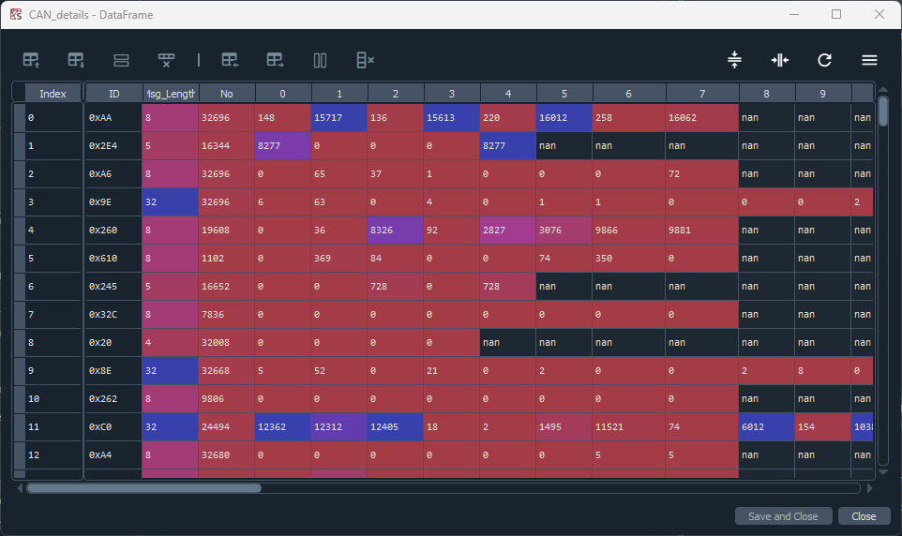

Candidates:
This analyzes the bytes that changed in CAN_details bit by bit to show how many times each bit in the byte has changed. This is a Pandas Dataframe with fields:
- Index, index: ignore this field
- ID : CAN ID
- Msg_Length: Length of the message in bytes
- No : number of times this CAN Id was published
- Byte No: The byte that has been analyzed in this row
- No. of changes: The number of times this byte has a whole has changed
- 0…7: Each column here denotes the number of times that particular bit has changed.
  - NOTE: the columns are numbered wrong, it should be 7 to 0 instead of 0 to 7 as that is the convention in CAN data. This needs to be fixed in future edits to the code.
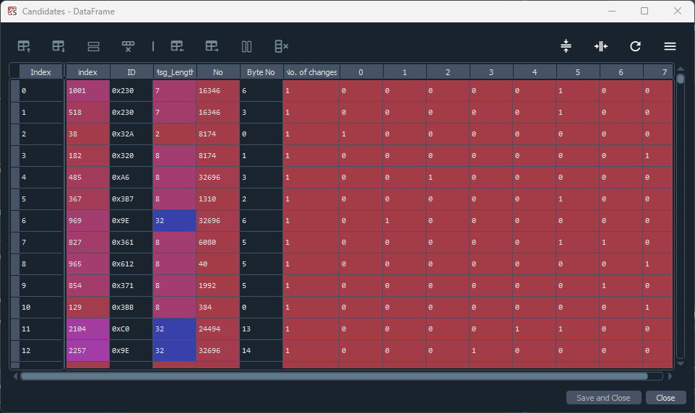

Using the GUI:
To run the GUI, run the last block of code:
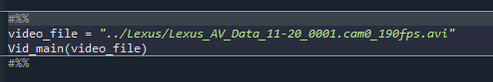

GUI:
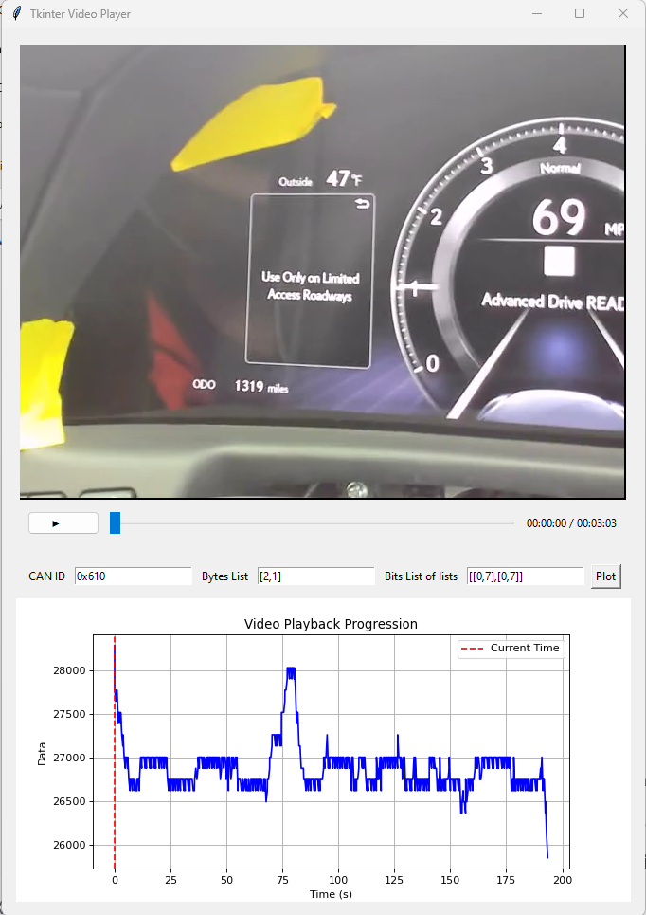
- CAN ID: enter CAN Id to be plotted.
- Bytes List: enter the bytes to be plotted in a list format, in the order to be concatenated.
- Bits list of list: enter the bits for each byte to be concatenated.
Example:
In the example in the figure:
- Bytes list = [2,1],
- Bits list of list = [[0,7],[0,7]]
This will concatenate byte 2 and byte 1 in that order, and all 8 bits ([0,7]) of byte 2 will be concatenated with all 8 bits ([0,7]) of byte 1 and plotted.

