Introduction
Welcome to the Stockpocalypse! Stockpocalypse is a paper stock trading program that allows you to trade fake stock at real market prices using money that does not, and will not exist. The program relys upon using an Internet connection to ask a server for the prices on the market. The user is able to deposit Cash that can be used to buy imaginary stock in a real company. That stock can then be sold at either a profit or a loss depending on how the actual stock market performs throughout time.

Installation Instructions
Before any software is installed, the user is required to go to a location in the computer’s files to create a .txt that is used to store the amount of Cash the user has. There is a funciton that is supposed to have this feature built-in, but it has given kick-back and not done as the language documentation advertised.
Inside the Stockpocalypse Folder:
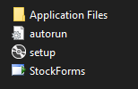

There are four items in the Stockpocalypse folder. To install the program, double-click the setup item. This brings up the installer window:
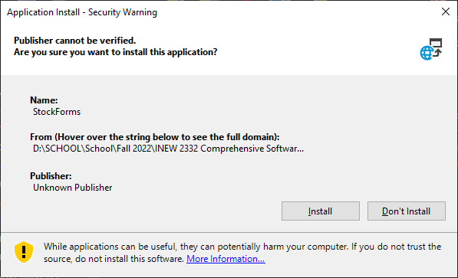

This rudimentary window is all that is given when the in-house installer in Visual Studio is used. There are two options to Install or Don’t Install. Click Install.

The program is now installed and will attempt to run on the current machine.

To run the software on the machine, use the StockForms Program Manifest in the Stockpocalypse folder. Shortcuts can be made so they can be placed elsewhere.

Uninstallation
To uninstall the program, visit the path C:\Users\[USER]\AppData\Local\Apps\2.0 and delete the folder that is NOT “Data”
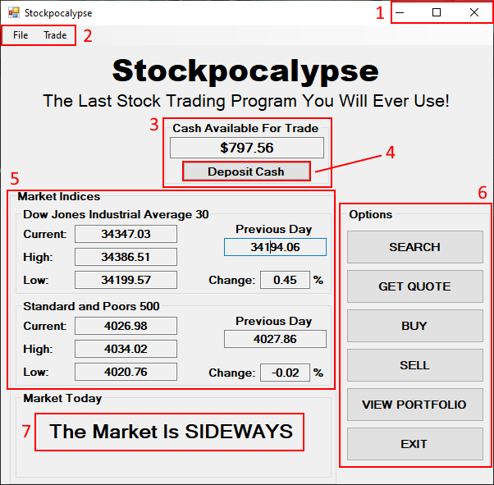
Dashboard

- Window Control (This is the same for every window in the program)
- Toolbar (This is the same for every window in the program)
- Cash Center – Displays the cash that is available for the user to trade with. Contains the Deposit Cash Button. (This is the same for every appearance of this container in the program.
- Deposit Cash Button – Opens the deposit window, which allows the user to insert cash into their account.
- Market Daily Indices – Displays information relating to market indices that provide somewhat of an aggregate of overall market activity for the day. (DJI and S&P500 only)
- Options Panel – The entire program extends from here. The user is allowed to:
  - Search for stocks
  - Get a quote on the stock of the user’s choice
  - Purchase stocks
  - Sell stocks
  - View the user’s portfolio
  - Exit the program
- Daily Market Outlook – A simple display that shows “UP” if an index is up over 0.9% for the day, “DOWN” if under -0.9% for the day, or “SIDEWAYS” if either is true.

Deposit Box
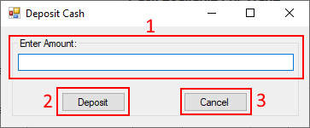

- Deposit Amount – The area for the user to enter their deposit. There is no limit and the money does not really exist.
- Deposit Button – Initiates the deposit. The data is entered into a text file that stores only a single decimal amount that is rewritten every time it is changed.
- Cancel Button – Closes the window.

Toolbar
The toolbar has only two options: File, and Trade.

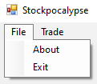
The File option breaks down into two more options:
- About – Brings up a window that displays information about the publisher.
- Exit – Closes the window.
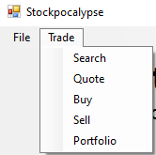
The Trade option brings up all the same options of the Dashboard, making them available on any window that has the toolbar.

Search Form
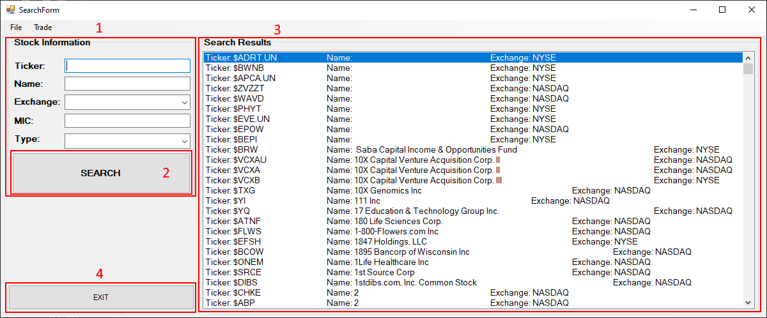
- Stock Information – For the user to insert information related to the stock that they wish to search for.
- Search Button – This is to initiate the search based on the stock information that is provided.
- Search Results – The list of stocks that relate to the information provided. It lists stocks from the NYSE and NASDAQ by default. Provided are:
  - The stock Ticker that the exchange uses to identify stocks.
  - The name of the company.
  - The exchange the stock is listed on.
- Exit Button – Closes the window, then opens the Dashboard.
NOTE: This window is under heavy construction.

Quote Form
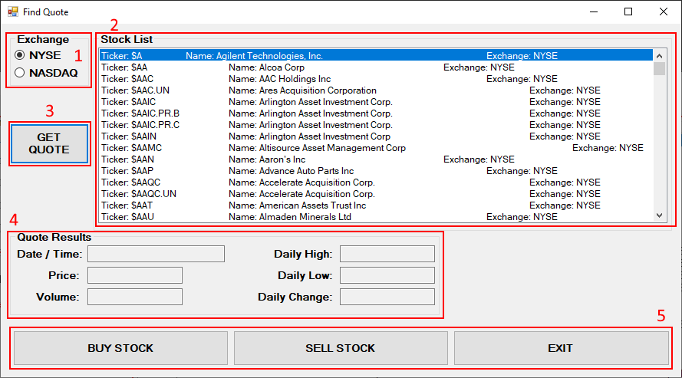
- Exchange Radio Buttons – Choose the exchange to be displayed in the list. This is a rudimentary search feature that allows the user to scroll down an entire exchange and get quotes for company stock. (NYSE is selected and displayed by default)
- Stock List – The display list of the chosen exchange. The information displayed are the Stock Ticker, Company Name, and Listed Exchange. The user will select a stock with the mouse cursor.
- Get Quote Button – Uses the API to initiate a quote on the selected stock.
- Quote Results – Displays various aspects of the quote:
  - Date / Time – The date and time that the quote was taken.
  - Price – The price of the stock at the time of the quote.
  - Volume – The daily volume of trading in the market. Represents the number of shares traded throughout the whole day.
  - Daily High – The highest price that the stock has reached throughout the day.
  - Daily Low – The lowest price that the stock has reached throughout the day.
  - Daily Change – The percentage change of the current price versus the price at the beginning of the day.
- Options – There are three options to choose from for this window:
  - Buy Stock Button – Closes the quote window, and opens a buy window using the information from the quote, if available.
  - Sell Stock Button – Because selling a stock implies owning it first, this button opens a sell stock window without using any information from a quote.
  - Exit – Closes the quote window and opens the Dashboard.

Purchase Stock Form
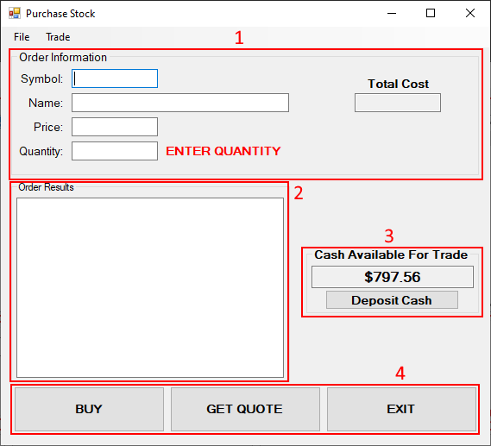
- Order Information – Allows the user to enter information about their order. The user MUST enter a quantity because there is no sale without buying something first. As the quantity is entered, the total cost of the order will calculate.
- Order Results – Displays the results of the order. If the order is executed, then the results of the most recent order from the database are displayed, including:
  - Order ID – The identifying number of the order that is used in the database.
  - Date / Time – The date and time that the order took place.
  - Ticker – The symbol that is used to represent the stock on the exchange.
  - Name – The name of the company that the stock belongs to.
  - Price – The price of the stock that the order was executed at.
  - Quantity – The amount of stock in the order.
  - Total Price – The total value of the order. (Price x Quantity)
- Cash Center
- Options
  - Buy Button – Executes the order
  - Get Quote – Opens a fresh Quote Window, using no information from the Buy Window. This is used when the user realizes they have no idea how much their stock costs.
  - Exit – Closes the Buy Window, and opens the Dashboard.

Sell Stock Form
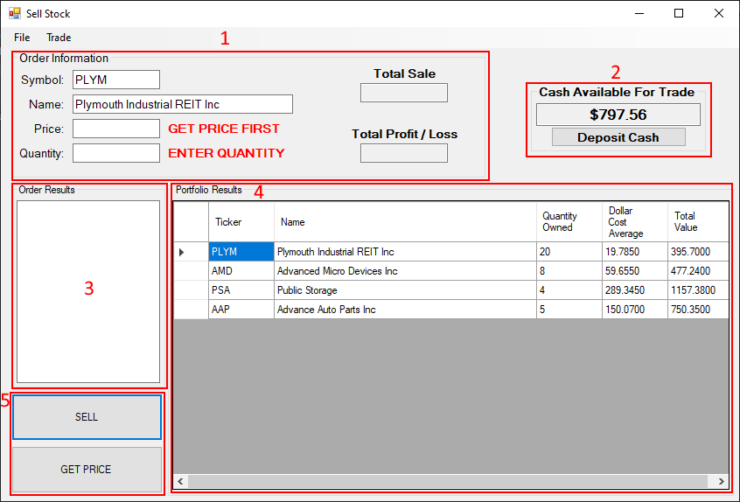
- Order Information – Similar to the panel used on the Buy Form, with two differences:
  - The information can be filled in using the selected row from the user’s portfolio.
  - There is an extra display for the profit or loss on the trade. This is calculated by subtracting the purchase cost of the stock from the total value of the sale. This number can be either positive or negative.
- Cash Center
- Order Results – The same as the Order Result panel from the Buy Form.
- Portfolio Results – This panel displays the results from the portfolio table in the database. The displayed columns are:
  - Ticker - The symbol that is used to represent the stock on the exchange.
  - Name – The name of the company that the stock belongs to.
  - Quantity Owned – Amount of the stock that is owned by the user.
  - Dollar Cost Average – This number represents the average cost of ALL the shares owned, regardless of when they were purchased. This is calculated by adding up the total cost of all the orders, and then dividing it by total amount of shares owned.
  - Total Value – This is the total value of all the shares owned. Calculated by multiplying the dollar cost average by the quantity owned.
- Options – This section has two buttons:
  - Sell Button – Executes the sell order.
  - Get Price – This button asks the API for a price to use, and then enters that price in the appropriate box.

View Portfolio Window
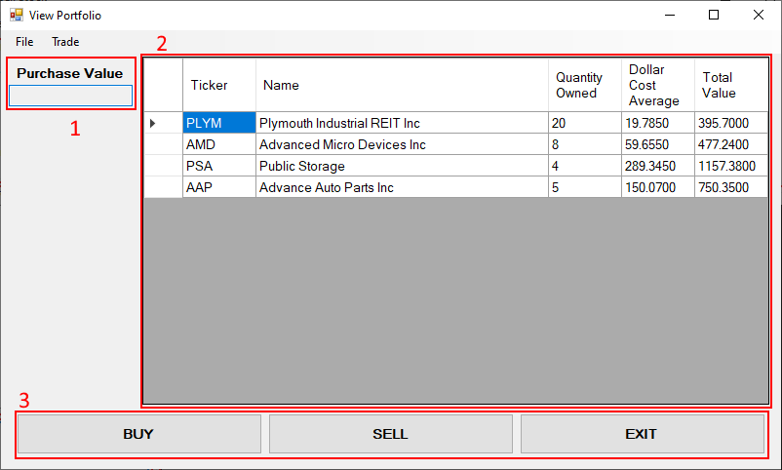
- Purchase Value – This section would be used to calculate the total value of the stocks owned at the time of the purchases. This is calculated by adding up all the total values of all the stocks in the portfolio. It is an incomplete feature.
- Portfolio Panel – The same as the one seen in the Sell Form Portfolio Results panel. All of the attributes are the same.
- Options Panel – Three buttons that give the user the option to:
  - Buy Button – Opens a Buy Window based on the information from the selected row.
  - Sell Button – Opens a Sell Window. This function does not use information from the row because there is a portfolio panel within the sell window already.
  - Exit Button – Closes the Portfolio Window and opens the Dashboard.

