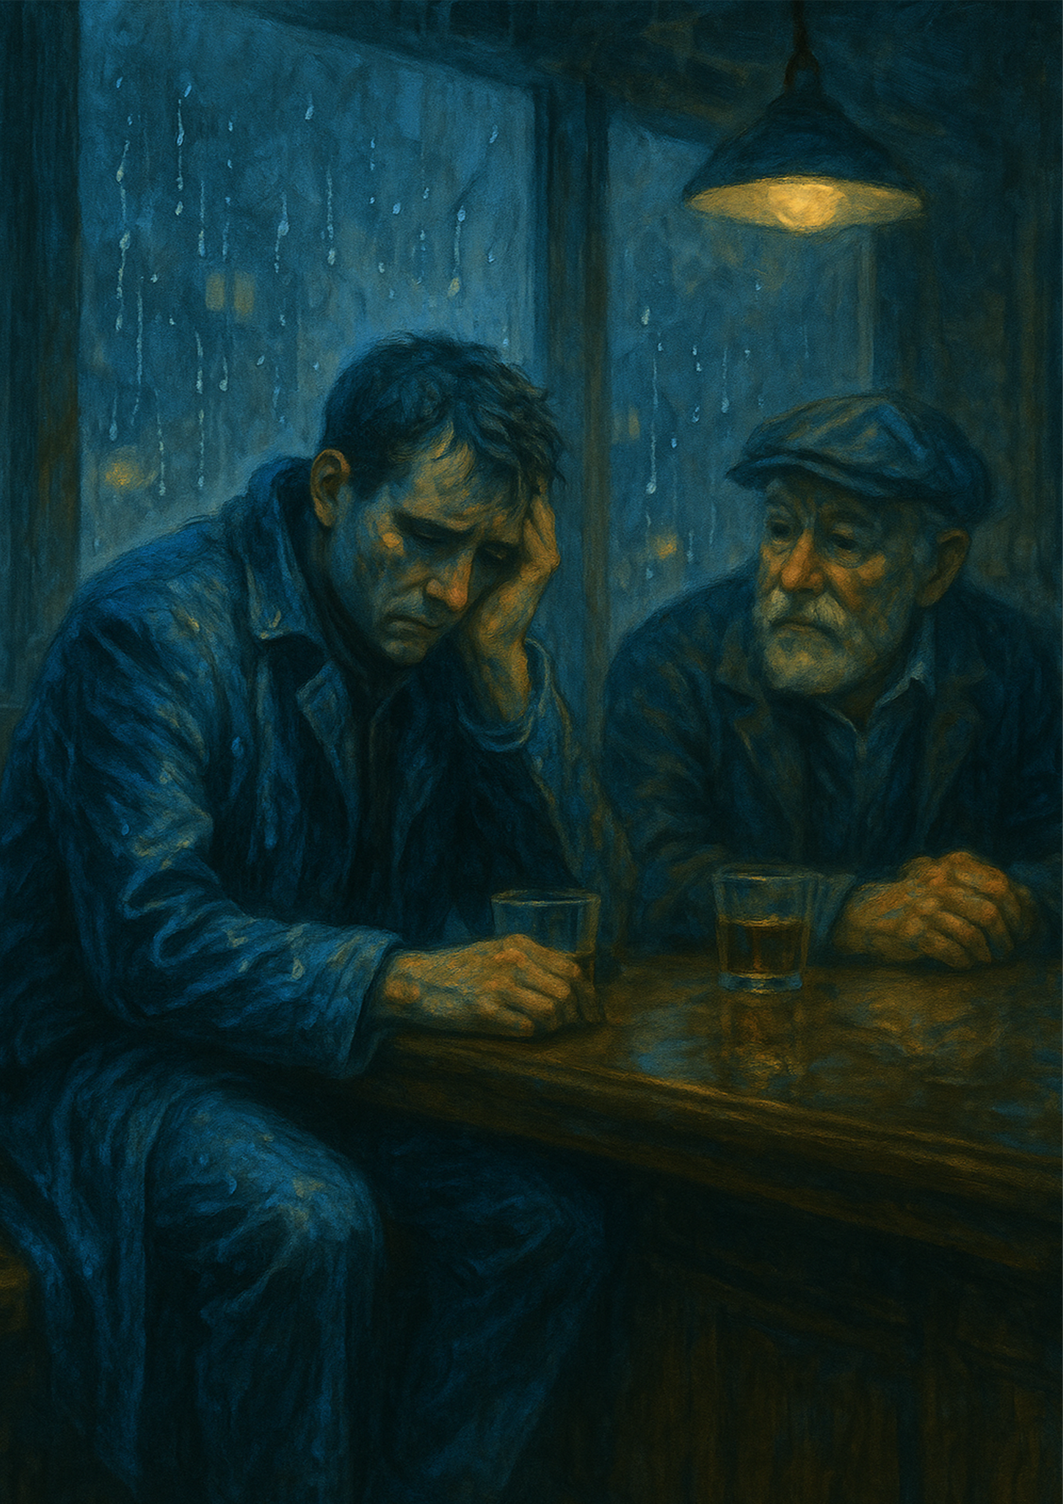



By Kyle Young

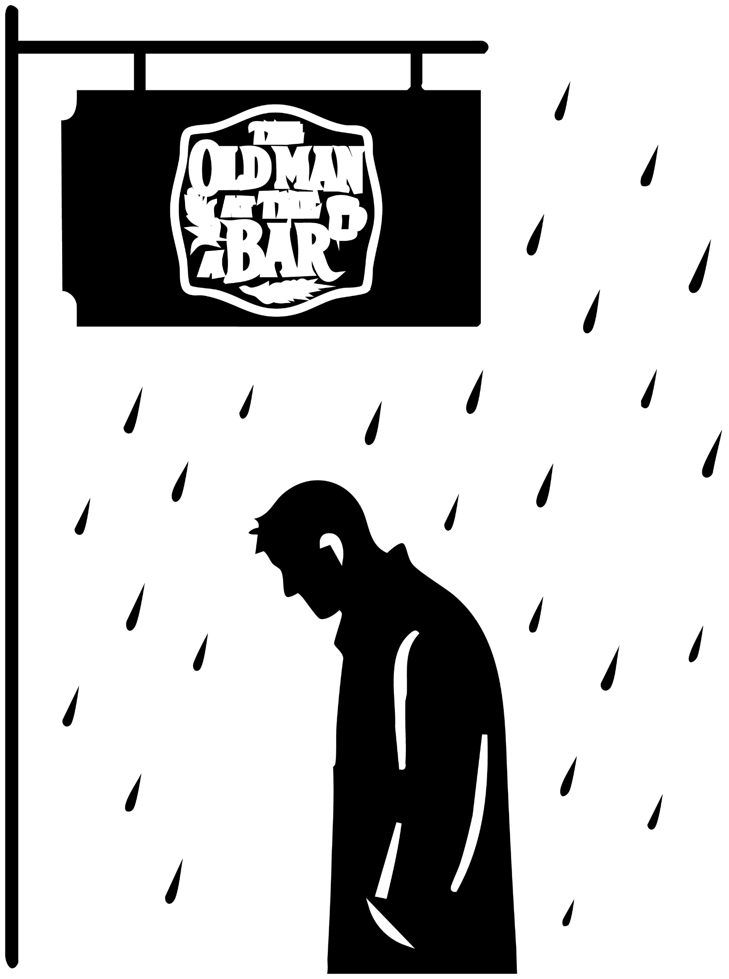

The Sadness Of A Man
Rain drummed softly against James’s coat, each drop clinging to the fabric like it didn’t want to let go. He stood beneath the flickering neon sign that buzzed above him — The Old Man at the Bar. The letters shimmered through the mist, pale yellow bleeding into the wet pavement.

He hesitated at the door, glancing down the empty street as if expecting someone to appear — or perhaps wishing they would. But the only response was the hum of passing cars and the sigh of the wind.

Inside, the bar was a world apart — warm, alive, and loud. Laughter swelled like a tide as fans in yellow and black raised their glasses, sloshing beer and joy in equal measure. The smell of spilled ale and damp jackets filled the air.

“James! The usual?” called the barman, grinning through the noise.

James swallowed, his throat dry. “Yeah… thanks. Who’s playing?”

“Motherwell versus Aberdeen,” the barman said, polishing a glass. “Looks like Motherwell’s taken it.”

A cheer erupted from the corner. James forced a smile, but it stopped somewhere short of his eyes. “Great. A loss on a day like this.”

The barman’s grin softened. “Aye… I heard. I’m sorry, mate. But shouldn’t you be on a plane right now? Hawaii with the family, wasn’t it?”

James rubbed his face, the motion slow and weary. “Yeah. I was. But something came up. Work thing.”

The barman gave a small nod, a look that said he didn’t quite believe it — or didn’t want to press.

From across the room, a group of fans shouted for another round. “Barman! More!”

“Right you are,” the barman said, backing away. “I’ll get your drink in a minute, James.”

James nodded, eyes drifting toward the laughter. The warmth didn’t reach him. Outside, the rain kept falling.

Left alone, the man unlocked his phone. A photo of a woman filled the screen. A picture of the woman standing in paris hold her hand up with an engagement ring onb her hand as her smiles fills her face, The man trys to turn the phone face down as face as possible as closed his eyes putting his hands on them as tears fall threw soaking his hands.

“You alright, son?” a voice asked—soft, worn with years.

The man looked left. An old man sat a seat away, concern in his eyes.

“Yeah,” the younger man said, wiping his face. “Just… rough night.”

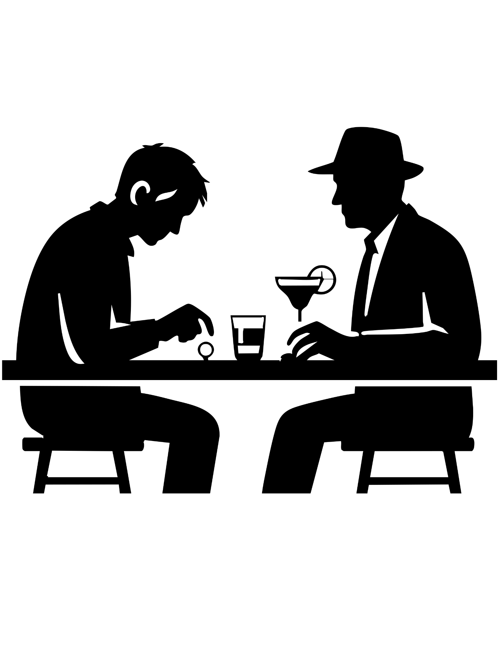

The Drinks
The barman set a Margarita and a whiskey in front of him. James stared at them, as the barman says, “I’ll just put them on your tab.” and then walks around as more of the people want him.

The old man watched Jame, seeing him frozen, as he was trying to understand. “Is that Margarita for me?”

James snapped out of it, as he turned to look at the old man as he says, “Sure,” said hoarsely. “You can have it.”

The old man reached for the glass and noticed the wedding ring. He lifted the drink, smiled. “Well, no self-respecting man should drink a Margarita anyway. Especially one who is married.”

The Jame looked down as his hand as he see the ring on his hand as he says, “Was married.” as he takes the wedding ring off almost slamming it on top the bar, as he took a drink of whiskey.

“Are you ok?,” the old man said.

The Jame took a long swallow, set the glass down. “I’m fine, I only have one thing planned tonight.”

The old man studied him. “Do you want a friend tonight, or just a drinking partner?”

“What’s the difference?”

The old man lifted a hand to the barman. “Open a tab for me and this man, would you?”

“Of course,” the barman said.

“The difference,” the old man told him, eyes kind, “is free drinks.”

The younger man stared at his glass. “It doesn’t matter anymore. None of it does. Its all going to be gone soon”

“Son,” the old man said gently, “of course it does. I’ve lived a long life. Life’s funny that way—full of lows, sometimes so low you think you’ll never stand up again. The night I lost my wife changed me. It changed how I saw the world. But there was still a light at the end of the tunnel, even if it took time to see it.”

James’s face hardened, his jaw tightening as if to hold the words in. “I’m sorry for your loss,” he said quietly, voice trembling at the edges, “but it doesn’t come close to mine. My friends, my wife, my kids... they were on that plane.” He paused, a long breath scraping through his chest. “It crashed. No survivors.” His voice cracked, softening into something raw. “So don’t tell me you understand.”

The old man looked at him for a long moment — eyes dim, but not unkind. He could see it, the hollow left behind where love once lived. “Tell me about her,” he said gently.

James frowned, confused, almost offended. “Why? She’s gone. It doesn’t matter anymore.”

The old man smiled sadly. “In some Mesoamerican traditions,” he said, “they celebrate the Day of the Dead. They believe that when you die, your soul goes to a place more beautiful than words can hold. But you only stay there as long as someone remembers you. When you’re forgotten… you fade away completely.” He leaned closer, his voice barely above the whisper of the bar’s dying music. “So yes, it matters. Memory is how we keep them alive. If you run from it, you send them into the dark. So I’ll ask again—tell me about her.”

James looked down into his drink, the amber catching the low light. Silence stretched between them, thick and slow. Finally, he exhaled. “Her name was Margaret. She always made me order her favorite—Margarita, of course.” A ghost of a smile tugged at his lips. “She’d vanish off to the restroom and come back laughing, like she’d just heard the world’s best secret. We’d sit here for hours, watching the game she cared about and I didn’t. She had this bright yellow and black jersey — loud as the sun. God, I used to tease her for it.”

He chuckled weakly, then shook his head. “Our little girl was just like her — same smart mouth, same grin. She’d repeat things she didn’t even understand, and somehow make us laugh every time.” His eyes glimmered now, the weight of memory pulling them down. “I think we met right here, actually. She told me she used to move from house to house as a kid. Said she had a twin sister she wished she’d known better.” His voice faltered. “She was always chasing connection, you know?”

The words hung there for a moment — fragile, trembling. Then James looked away, eyes wet. “No,” he whispered. “I just… can’t.”

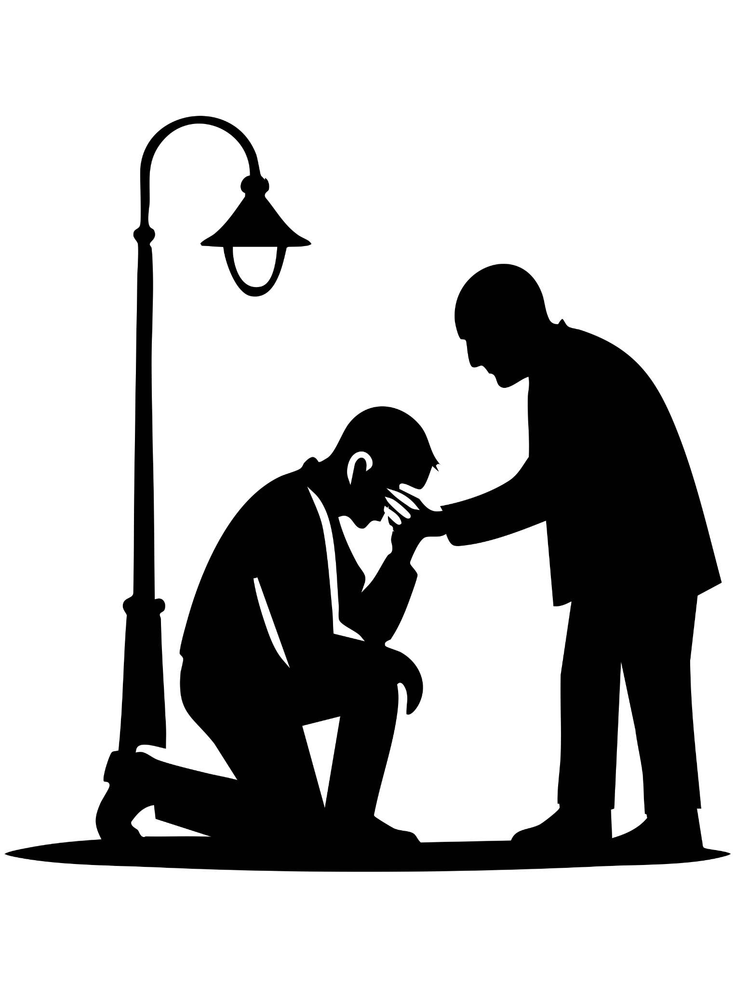

The Weight Of Memories
The barman slid a fresh whiskey toward him. James downed it in one motion and stood. The old man followed him out into the cool night, their shadows stretching long beneath the streetlight — two silhouettes fading into the quiet hum of loss.

“I think I can,” the old man said softly.

The Jame turned, anger and grief burning together. “No, you can’t. You lost one person. I lost everyone.”

“She was my everything,” the old man said. “I grew up without parents, bounced from home to home, until I met her—Gabrielle. She became my family. Then a drunk driver took her. And I had nothing.”

The Jame met the old man’s eyes and, for the first time, saw the same hollow ache staring back.

The old man’s voice was low, roughened by years and loss.
“With time,” he said, “the pain won’t disappear—it only changes shape. It moves from the center of your chest to the corners of your days. The grief that once crushes you begins to linger instead—in the silence after laughter, in the echo of two footsteps where now there’s only one. You’ll find it when you order her drink out of habit, or when your hand reaches for your phone to send a message to someone who can’t answer.

Time doesn’t fix the loss. It only teaches you how to live with the empty space it leaves behind. But if you let others in—if you trust them to see the cracks—it gets lighter. You’ll never forget. You’re not supposed to.”

James looked past him, eyes unfocused. For an instant, the street shimmered—he saw himself and his wife walking hand in hand, laughing softly, their song spilling out from a bar doorway, carried on the wind. His chest ached, splitting open under the weight of it. The tears came like rain breaking a long drought.

The old man stepped forward and held him, steady and unshaking.
“Son,” he murmured, “we never truly leave those we love.”

James looked up—and for a heartbeat, the old man’s face wasn’t his own. It was his father’s, faintly smiling through the blur of tears.

“It’s not time to give up,” the man said gently. “You’ll find your second wind.”

James blinked—and the old man was gone. Only the wind remained, whispering through the street. He remembered, then, his father’s last words: You’ll find your path. And I’ll always be watching over you.

His hands were slick with tears. He fell to his knees on the cold pavement, sobs breaking from somewhere deep, raw, and long-buried.

A touch came—a hand, light on his shoulder. He looked up.

A woman stood before him, her eyes soft, uncertain.

“Are you James Connor?” she asked.

He froze. She looked like his wife—a mirror with a different life behind the eyes.

“Yes,” he said. “How… how are you here?”

She gently stepped back as he stood, instinctively reaching for her. “I’m not your wife,” she said softly. “When I was a kid, my twin sister and I were split up in foster care. I saw her photo on the news.”

He staggered a step. She continued, voice trembling. “I know this is a terrible time, but… could you tell me about her? I want to know what kind of person my sister was.”

James drew a shaking breath. A fragile smile crossed his face.

“Your sister,” he said, “was the most amazing person I’ve ever met. Stubborn, too.” He let out a small, watery laugh. “But every second I spent with her, I loved her with all I had.”

As the two walked through the memory-filled streets, the Jame began to breathe again—just a little.

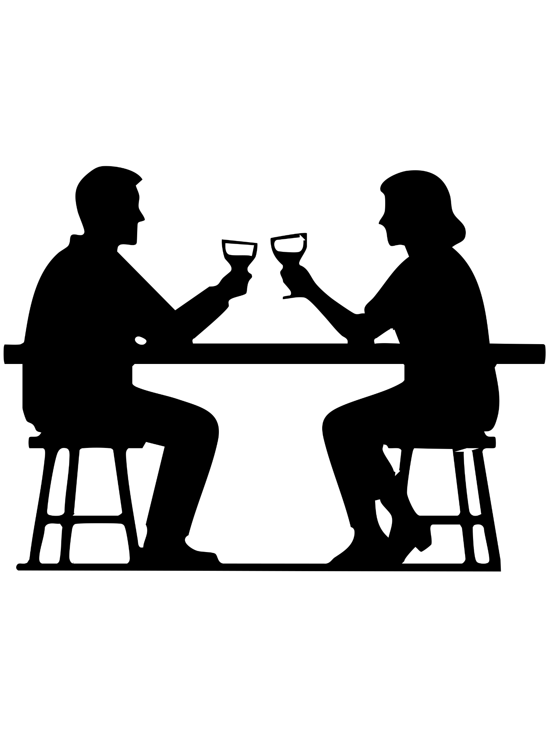

The Second Wind

Time moved on, as it always does—quietly, cruelly, without pause.
James found himself growing close to his wife’s twin. Not in the way that love once bound him to her sister, but in the way two souls cling to one another when the world has taken too much. They became lifelines—pulling each other forward when grief tried to drag them under.

They laughed again, sometimes. They rebuilt small corners of their broken lives together. And then, as if guided by unseen hands, they each met someone new.

The twin met a kind-eyed salesman one rainy afternoon, while she was searching for car parts James needed to fix her old sedan. Their conversation started with bolts and oil filters and ended with shared coffee and laughter that felt almost like sunlight.

James met someone, too—an art consultant who adored the same painter his wife once loved. It felt strange at first, like stepping into a memory he wasn’t ready to touch. But there was warmth there, gentle and patient. Sometimes, he swore his wife had sent her—one last nudge toward living again.

Every Sunday, James and the twin still went to the old bar. They sat in their usual seats, shouting at the television like before, pretending for a little while that time hadn’t stolen everything. Then one day, the owner passed away.

The place fell silent for weeks.

So James bought it. He couldn’t let it die too.

Now, every Friday night, the lights burn warm again, laughter fills the air, and they raise their glasses—not just to the future, but to the ghosts that still linger in the corners.

And sometimes, when the night grows quiet and the street outside hums with distant music, James swears he sees the old man standing across the road. Hands in his pockets. Watching over them.
Making sure everything is, somehow, just as it should be.

