
By Kyle E Young and Zack

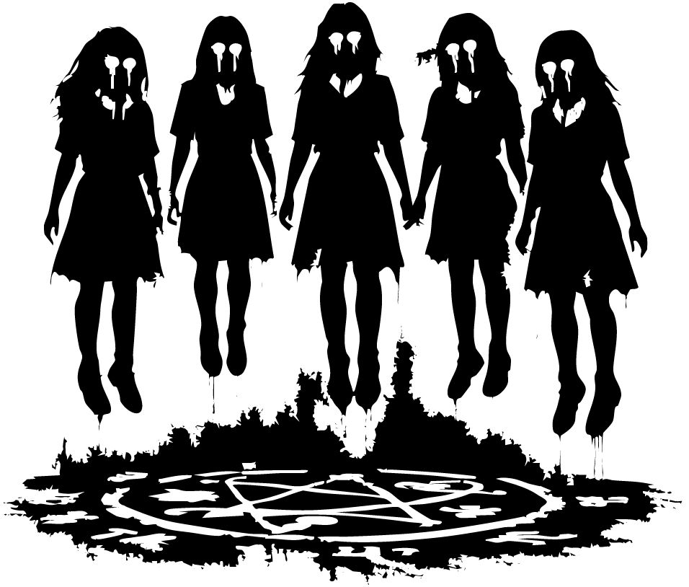

The First Time It Happened
Cole adjusted the pistol at his hip as he walked, the taser knocking lightly against his other side with every step. The school halls stretched empty around him, too still, too quiet.

Not the kind of quiet that meant peace.

The kind that felt aware.

His boots struck the floor in hard, echoing beats, each step ricocheting down the corridor ahead of him as though the building were carrying the sound forward, warning whatever waited in the dark that he was coming. Through the long row of windows, the last of the evening sun bled in streaks of dull orange, its light muddied by dust and old glass. Everything looked dimmer than it should have. Thicker. Off.

He reached the admin office and pushed the door open.

Lucy stood behind the front desk, arms crossed loosely, a red pen tapping against her palm in a lazy rhythm. Tap. Tap. Tap. The fluorescent lights hummed overhead, and somehow the sound of that pen slipping against her skin made the room feel even quieter.

She glanced up and smiled when she saw him.

“What’s with the face?” she asked. “You look like the building just threatened you.”

Cole huffed out something that almost passed for a laugh. “Wouldn’t surprise me.” He stepped inside, scanning the room out of habit before looking back at her. “Just finished my round. Place is empty.”

Lucy arched a brow, amusement flickering in her expression. “Empty, huh?” She tilted her head. “So what you’re saying is it’s just you and me, all alone in this massive school.”

The way she said it was teasing, light, but something in Cole still tensed. A cold unease crept up the back of his neck, though he told himself it was just the silence, just the strange weight in the air.

He shoved a hand in his pocket and shrugged. “I’m saying I need the keys so I can lock up.”

Lucy smiled like she knew he was dodging her and came around the desk, the key ring swinging from her fingers. “You always know how to ruin a moment.”

Cole gave her a sideways glance. “Was that a moment?”

“It could’ve been,” she said.

There was a softness under the joke, easy to miss if you didn’t know her.

Or maybe easy to miss if you didn’t want to know.

She stopped in front of him, still holding the keys just out of reach. “What’s the rush? You heading out to Sophia?”

He let out a quiet laugh, but it faded almost as soon as it left him. “Yeah. Date night.” His voice flattened on the last two words. He looked past her, toward the darkened hall. “Besides, being here too long just reminds me I’m not a cop anymore.”

Lucy’s expression changed, just for a second. Not fully sadness, not fully concern, but something close to both. As if she heard the part he hadn’t meant to say aloud.

“You miss it that much?” she asked more gently.

Cole hesitated. “I miss who I was when I did it.”

For a moment, neither of them moved.

Then Lucy placed the keys into his hand.

The metal was cold against his skin. Colder than it should have been.

“You make it sound like being here is some kind of punishment,” she said.

Cole curled his fingers around the keys and offered a crooked smile. “Not a punishment. Just… not where I thought I’d end up.”

Lucy studied him for a second, and when she spoke again, her voice had lost most of its teasing.

“Funny,” she said. “I think a lot of life is that.”

Cole looked at her then, really looked at her. The tiredness in her eyes. The half-smile she wore like armor. The things neither of them ever said.

There were some people you met too early.

Some too late.

And some you met exactly when you were meant to, only for life to line up wrong anyway.

Lucy gave a small shrug, like she could brush off the weight of what neither of them would name. “Maybe in another life, you and I would’ve had better timing.”

His breath caught before he could hide it.

She smiled then, but it was a sadder smile than before, one that seemed to know exactly what it was admitting. “You know,” she added lightly, trying to save them both from the honesty of it, “one where you weren’t dating Sophia and I wasn’t pretending Michael makes any sense for me.”

Cole let out a quiet laugh, though it hurt somewhere in his chest. “Yeah,” he said. “Maybe in another life.”

And in some impossible version of the world, maybe it would have worked. Maybe if the years had bent differently, if they meet earlier.

But this life had never quite lined them up.

Lucy stepped back first, as if she understood they’d already said too much.

“Well,” she said, heading for the door, “for this life, I guess I should let you get to date night.”

When she pulled the door open, outside air slipped in for the briefest second cut grass, warm pavement, the fading breath of summer evening before the hallway swallowed it whole. The stale air closed in again the moment she moved.

At the doorway, she glanced back over her shoulder, her smile returning in a smaller, safer form.

“For what it’s worth,” she said, “I still think you like hanging out with me more than you admit.”

Cole leaned against the desk, holding onto the normalness of that tone like it was something solid. “You might be right.”

A faint blush touched her cheeks. She rolled her eyes, but he could see the pleased little flicker in her expression.

“Have fun with Sophia, Cole.”

He nodded once. “You too. With Michael.”

Something unreadable passed through her face at that, but it vanished quickly.

“Yeah,” she said softly. “Sure.”

Then she stepped out.

The door swung shut behind her with a muted click.

Final.

Cole stood there for a long moment without moving.

The silence rushed back in, heavier now, pressing against the walls like the school itself was listening again, waiting again.

He turned the keys over in his hand just to make some kind of noise.

The jingle was thin and brittle in the dark.

It did nothing to make him feel less alone.

He starts locking up, door by door. The halls feel longer than they should. The lights seem dimmer than they were a minute ago, as if the school is slowly eating its own brightness.

Room 13.

Lucy’s classroom.

The door is cracked open.

Cole stops. He didn’t leave it that way. He’s sure he didn’t.

From inside comes a faint murmur like a radio whispering from the wrong station.

He pushes the door.

The room is darker than it should be. The blinds are half down. The air smells… damp. Old.

Five girls sit on the floor in a circle, hands linked, heads bowed.

Around them, symbols have been painted in rough, dark strokes shapes that twist the longer he looks, like his eyes can’t hold onto them. Like his mind keeps sliding away from what they are.

“Girls,” Cole says, stepping in, voice firm out of habit. “It’s time to go home.”

No one moves.

The murmur sharpens as he walks closer. It isn’t English. It isn’t anything he recognizes. The sound scrapes inside his ears, like it’s reaching for something behind them.

“Hey. Come on. Is this some sort of prank, because its friday october the 13? Its 2006, we don’t do this sort of shit anymore.” He puts a hand on the nearest girl’s shoulder.

Her skin is cold.

Not “cold classroom” cold.

Cold like the inside of a freezer.

“It’s Friday,” he says, trying again. “Go home. Enjoy the weekend.”

No response. No flinch.

Their bodies sway, barely, in a slow rhythm that doesn’t match breathing. It looks like something is rocking them from the inside.

“Come on,” he mutters, irritation rising to cover the unease.

He shakes the girl gently.

Nothing.

Harder.

Her lips keep moving, forming those wrong sounds. The others answer with her, voices weaving together into one low hum that makes the air vibrate in his chest.

Cole moves to the next girl and grips her shoulders. “Snap out of it,” he says. “This isn’t funny.”

They don’t react.

It’s like he isn’t there.

The murmuring grows louder. The room feels warmer, thick and wet, like someone turned the air into breath. The painted symbols seem to throb at the edges of his vision.

Then

All five girls speak at once.

Perfectly together.

The sound hits the room like a door slamming shut inside his skull. His teeth ache. His eyes water.

Cole staggers back. “Enough!”

He yanks the taser free, arm shaking despite himself. “Stop. Get up. Now or I’ll tase you. I’m not kidding.”

The chant doesn’t break.

It doesn’t even pause.

It swells.

Then everything stops.

All five girls go quiet at once.

Their heads lift.

Their eyes snap open.

Red. Not just red lit from inside, like coals.

“Shit,” Cole breathes.

He fires the taser into the closest one. It crackles. The wires jump.

She doesn’t even blink.

None of them do.

Blood starts to run from their eyes, thick and black red, slow as syrup. It drips down their cheeks like tears. Then it pours from their noses heavy drops hitting the floor and darkening the symbols.

Cole’s hand jerks to his phone. His fingers slip on sweat. He hits 9… 1…

He freezes.

What do you even say?

Five kids. Floating. Bleeding. Something in the room that shouldn’t exist.

His thumb hovers.

Something moves at the edge of his vision.

The girls rise.

Not standing lifting.

Shoes leave the tiles. An inch. A foot. Higher.

Their arms hang loose. Heads tip back like strings were cut. Their mouths open wide and a sound comes out that doesn’t fit in a child’s throat.

It’s too deep.

Too many voices at once.

The lights flicker. Once. Twice.

The symbols flare bright red. The “paint” crawls, tightening into sharper lines, like it’s fixing itself.

The air reeks of iron and burnt hair.

Cole yanks the taser free and shoves it away. His hand goes for the gun.

In the center of the circle, the air… thickens.

It bends like heat.

Then it splits.

A tear opens above the floor dark and wet looking, like the world has been cut.

Something pushes through.

Two horns.

Black, curved, slick.

The girls scream louder. Their bodies bend backward in midair. Fingers stretch, stiffening, curling like claws.

“Stop!” Cole yells, gun up, aiming at the nearest girl. “Stop it now!”

They don’t.

The horns keep coming.

Inch by inch.

Whatever drips off them steams when it hits the tiles.

The rip widens like skin being pulled apart. The sound in the room becomes unbearable girls screaming in layered voices, lights whining overhead, and under it a low rumble, like something huge shifting under the building.

The air turns cold.

Not “AC” cold.

Grave cold.

Then Cole feels it.

A breath at his ear.

No closer than breath.

Inside his head.

A voice slides through him, soft like a secret.

"Give me your life… and I spare theirs."

His arms shake. The gun feels slick in his grip.

"One life for five."

Behind the tear, something moves. A shape pressing forward. The hint of a forehead. The curve of a skull that isn’t fully here yet.

Claws scrape the edge of the rip too long, jointed wrong.

The voice again, sharper.

“Only one has to die. Let it be you… and they live."

Cole’s breath breaks. His hands jerk.

The gun turns slow, forced toward his own head.

He’s crying.

The tears burn.

He tastes metal.

A drop hits the floor.

Red.

He’s crying blood.

The girls float higher, backs arched like invisible hooks are pulling them up. The horns push farther through. Between them, something starts to form an outline of eyes pressing against thin air.

Cole squeezes his eyes shut.

“No,” he chokes. “Whatever you are no. You’re not taking them.”

The pressure in his skull tightens like a fist.

The gun snaps harder toward his temple.

His finger starts to squeeze.

Then

With a ragged, animal sound, Cole rips control back.

The barrel swings away from his head.

He opens his eyes and fires.

The shot punches through the room.

For a split second he sees it horns nearly joined to a forming skull, claws forcing through

The bullet hits one of the girls.

Everything drops.

The horns vanish like smoke dragged backward. The tear slams shut with a sound like bone cracking. The lights cut out for half a heartbeat then slam back on.

All five girls hit the floor hard.

Cole falls with them, landing on his knees. The gun slips from his hand and skitters across the tiles.

Silence.

Not peace.

Just empty ringing.

Four girls groan. They move. They breathe.

One doesn’t.

The one he shot.

The one he chose.

The circle starts to fade paint, blood, whatever it was sinking into the tiles like it was never there.

A voice behind him slices through the quiet.

“I heard a gunshot what happened?”

Cole turns.

Lucy stands in the doorway, frozen.

Her eyes flick past him.

The stains are disappearing. The air almost smells normal again.

Almost.

The four surviving girls start to stir, weak and shaking, trying to sit up.

Cole’s hands tremble as he looks down at the gun on the floor.

He knows deep, certain, sick with it

Something heard him tonight.

And then he hears the voice again, ringing in his ears, “You chose wrong”

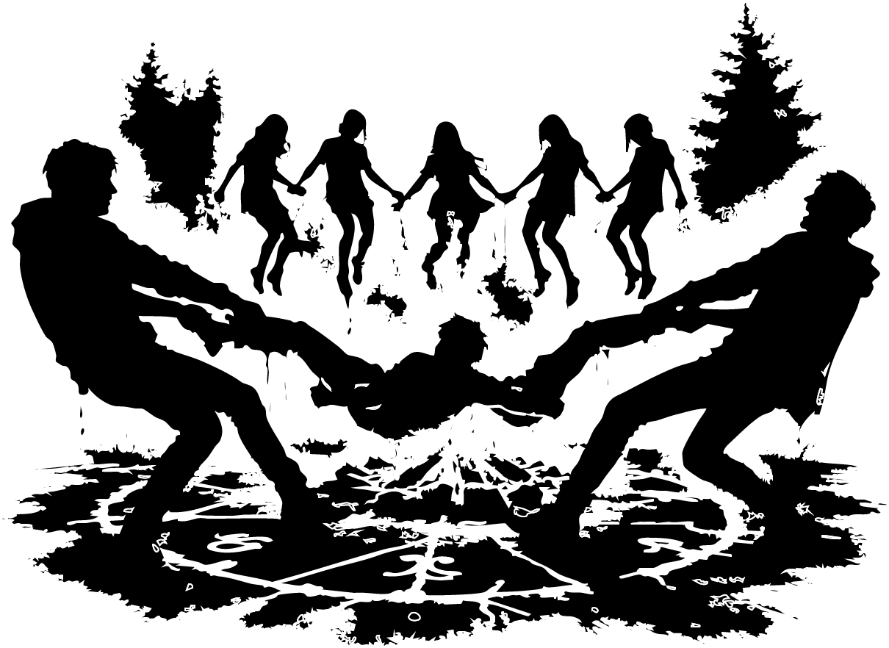

A Camp Fire Story
Marcus walks toward Cabin 13 with his phone light on, a thin white beam cutting through the dark.

The campfire smell rides the air smoke and pine and something greasy while the trees stand too still around the cabins, like they’re leaning in to listen.

He knocks.

A few seconds pass. Then the door opens a crack.

Jason fills the gap, rubbing his eyes, hair flattened, face pale in the phone-glow like he hasn’t slept right in days.

“What’s up?” he mutters.

Marcus forces a grin. “We’ve got five more. They were still up after hours.”

Jason sighs like he expected it. “Of course. By the fire?”

“Yep. Got them around the fire.”

Jason nods. “Alright. I’ll grab my jacket.”

He turns and walks back into the cabin, leaving the door open just enough.

Marcus’s phone light drifts inside by accident just a sweep of brightness over a bed.

Hanna is there.

Not sitting up. Just lying still in the sheets, eyes open, watching.

Marcus freezes.

He lifts the beam a little higher, and her eyes catch it like glass.

“Hi, Hanna,” he says, trying to sound normal.

Her smile is small. Too smooth. “Hi back.”

Jason returns, pauses, looks at Hanna, and says like it’s a joke, like it’s nothing, “My cabin is your cabin.”

Then he steps outside and pulls the door shut behind him.

Marcus stares at him. “Really? You can’t control yourself?”

Jason grins. “She approached me.”

Marcus gives him a look.

Jason’s grin falters. “Fine. I approached her.”

Marcus snorts and starts walking. “You couldn’t control yourself for five days?”

Jason bumps him with his shoulder. “Shut up.”

They laugh quiet, tired laughter while the campfire glow pulses between the trees ahead.

Marcus tries to change the subject. “What’s your plan after this? Class of 2017. I’ve got big plans tourism and hospitality. You, marketing. Work toward a bachelor’s, then postgrad.”

Jason looks up at the sky, at the smoke climbing into the dark. The firelight makes his face flicker like it’s not fully there.

“I don’t know,” he says.

Marcus nods. “No matter what, we keep in touch.”

Jason smiles. “Of course.”

They reach the clearing.

Five kids sit too close to the fire three boys, maybe fourteen or fifteen, two girls and Billy stands near the edge, half in shadow. He straightens when he sees them.

“You guys took your time,” Billy says, then walks off toward the cabins without waiting for an answer. His footsteps crunch the dirt and then vanish.

Jason drops onto a log across from the kids. Marcus sits beside him.

Jason leans forward. “So. You all think you can stay up all night, then?”

The kids glance at each other, restless.

Marcus rubs his hands together. “Well… night + campfire. You know what that means.”

One of the girls swallows. “Story time.”

Jason’s smile shows teeth. “Scary story time.”

Marcus turns his phone light off. The darkness rushes in around them, thicker without it.

Jason lowers his voice. “There was a boy. Awake at midnight, scrolling on his phone. Home alone. Watching other people’s lives.”

A log pops in the fire. Sparks lift like insects.

“And then he heard it,” Jason continues. “Drip… drip… drip. Like a tap left running.”

One of the boys rolls his eyes. “That’s not scary.”

Jason doesn’t look at him. “Then he hears a blender turn on.”

The kids go quiet.

“The boy uses his phone as a torch and goes for the light switch. Nothing. Power’s out. So he follows the dripping sound.”

Jason stares straight into the fire as if he can see something inside it.

“He ends up in the basement. He feels something wet land on his face. He wipes it. It’s warm.”

One of the girls whispers, “Ew…”

“He looks up.”

Jason pauses long enough for the night to fill the space.

“His parents are pinned to the ceiling,” he says softly. “Wrists cut. The dripping… is their blood.”

The boy who rolled his eyes forces a laugh. “Still not scary. Just a kid walking around an empty house.”

Jason’s mouth curls. “What you’re missing is the blender.”

The fire crackles louder.

“Because the story doesn’t end there,” Jason says. “His phone light starts to flicker. The blender stops. And then right behind him someone whispers one word.”

He leans in.

“RUN.”

The kids shift. Shoulders tuck in. Hands pull closer to laps.

Marcus glances down at his phone in the dark. His thumb taps.

A low, distant whirrrrr seeps into the clearing, like a motor starting far away in the woods.

The kids stiffen.

“Do you hear that?” one of the boys asks, voice thin.

Jason stands up slowly, smiling. “No.”

He walks over to Marcus, still smiling, like this is all part of the act.

Marcus takes a few steps away from the fire with him. “Think that’ll scare them into bed?”

“I think so,” Marcus whispers back.

They turn around.

The kids are holding hands.

All five.

Heads bowed.

Mouths moving.

Not giggling. Not whispering.

Chanting.

And the sound coming from them isn’t English. It isn’t even a language it’s like a pattern of noise that makes Marcus’s stomach twist.

He looks down at his phone.

The date reads: Friday, October 13 .

His smile fades.

Jason steps toward the kids. “Alright, that’s enough ”

Then Marcus sees it.

Red lines on the ground.

Not drawn forming.

Thin at first, like scratches in dirt… then brighter, glowing, carving a path around the circle. Symbols bloom along the lines, curling into shapes his eyes don’t want to focus on.

“Jason…” Marcus says, throat tight. “Stop this.”

Jason turns, confusion wiping the grin off his face. “I’m not doing anything.”

The chanting deepens. The fire bends sideways, like the heat is being pulled.

Marcus grabs one of the boys by the arm and yanks.

The boy doesn’t move.

It’s like trying to pull a statue.

Jason grabs another kid and hauls.

Nothing.

Then all five kids speak in perfect sync.

The words slam into the air like a pressure wave. Marcus’s ears ring. His vision swims.

Above the fire something bulges into shape.

Two dark curves rise, slow and wet-looking.

Horns.

Jason steps back, staring up. “No… no, no.”

And then the voice arrives.

Not from the woods.

Not from the fire.

Inside Marcus’s head, intimate as a thought that isn’t his:

Kill Jason… or you will die.

At the same time, Jason flinches hard, face twisting like he’s been hit.

Marcus can see it in his eyes he heard it too.

Kill Marcus… or you will die.

They stare at each other, both breathing too fast, both trying to move and finding their bodies heavy, slow, like the air turned thick.

The voice purrs inside Marcus’s skull.

Let me in… and I’ll save you from him.

The kids lift off the ground.

Not standing.

Floating.

Their hands stay linked as their feet leave the dirt. Blood leaks from their eyes and drops onto the glowing lines, sizzling like rain on a hot pan.

Jason’s mouth spreads into a smile that isn’t his.

Marcus feels his own lips twitch in answer.

Wrong. Wrong. Wrong.

They both move at the same time not toward each other, but toward the same kid, the nearest one, the smallest.

They grab the kid’s legs one each and pull.

The kid’s body jerks like a puppet. The chanting warps, higher, angrier. The horns above the fire thicken, a head beginning to form between them in the dark.

Marcus grits his teeth and yanks again.

Jason roars half human, half something else and pulls with him.

The circle flares bright.

Then it breaks.

The kid rips free like a thread snapping.

The glowing lines gutter out. The symbols collapse into ordinary dirt. The horns shudder and vanish as if sucked backward through a crack in the world.

All five kids slam to the ground at once.

The fire steadies.

The night rushes back in.

Marcus and Jason fall backward with the kid sprawled across them.

For a second, there’s only breathing. Panicked. Shaking.

Then the other kids start to move, groaning, waking like they’ve been dragged up from underwater.

Marcus presses his fingers to the kid’s neck.

Nothing.

He checks again, harder, desperate.

Still nothing.

He looks up at Jason, face gray in the firelight.

“I think…” Marcus whispers. “I think he’s dead.”

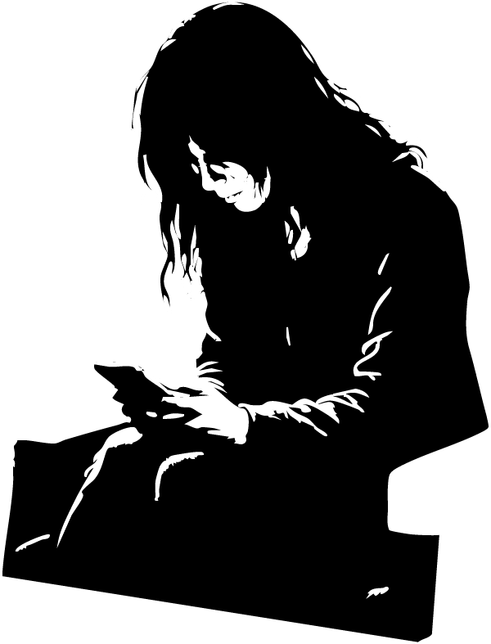

The Ones Lift Behind
Chloe sits in her seat with her knees bouncing so hard the tray table trembles.

The cabin smells like recycled air and stale coffee. Somewhere behind her, an overhead bin slams shut with a hollow thunk that makes her flinch.

She looks down at her phone again.

Friday, October 13 2028.

The date sits on the screen like a bruise.

Outside the window, baggage handlers feed suitcases onto a conveyor. The machine lifts them into the belly of the plane one by one dark shapes swallowed by a dark mouth. Chloe watches too long, as if waiting for something else to come up the belt.

She drags her gaze back to her phone.

A photo fills the screen: Chloe in high school, arm around another girl, both of them smiling like the world couldn’t touch them yet.

Her throat tightens.

A tear slips down her cheek before she can stop it. She wipes it fast and tucks her face into the collar of her jacket, trying to hide trying to disappear in plain sight.

Footsteps stop beside her.

A shadow falls over the aisle.

“Hi,” a man says, calm and bright in the way flight attendants practice. “My name is Marcus. This flight’s smaller than we expected, so I’m going to move everyone up to first class.”

Chloe looks up.

Marcus smiles like nothing is wrong. Like the date on her screen isn’t screaming at her.

Anger sparks through her sharp, sudden. She paid extra for this seat. She wants to tell him that. She wants to tell him no. She wants to tell him anything that makes her feel in control again.

But when she opens her mouth, her mind blanks.

What the hell? Am I going to get a refund? she thinks.

What she says is small and obedient.

“Oh… okay.”

Marcus’s smile widens, satisfied. He nods and steps away.

Chloe stares after him, heat rising in her face. She wants to slap herself. She wants to rewind the last ten seconds and force the right words out.

She looks back down at her phone.

The photo is gone.

The screen shows her reflection instead faint, ghosted by the cabin light.

Except it isn’t her.

A face stares back from the black glass.

Ash-red skin.

Two horns rising from the forehead like broken crowns.

Eyes like hot coals, steady and patient, as if it has been waiting for her to look.

Chloe’s breath catches. Her whole body locks.

She squeezes her eyes shut so hard it hurts.

It’s the light. It’s stress. It’s

A sound crawls into her ears.

A murmuring.

That broken language wrong syllables, wrong rhythm like words trying to form in a mouth not built for them.

The whisper isn’t coming from the cabin.

It’s coming from inside her head.

Her hands curl into fists on their own. Fingernails bite into her palms. She can’t make them stop.

Chloe forces her eyes open.

The phone screen is black.

Just glass.

Just reflection.

Her own face stares back, pale and shaken.

But behind her reflection over her shoulder something dark shifts in the aisle.

Not a person.

Not a shadow from the overhead lights.

Something taller.

Too still.

Watching.

Chloe swallows hard and takes a slow breath through her nose.

The murmuring fades, like it’s sinking under water.

Down the aisle, Marcus continues letting passengers in, guiding them forward with easy gestures. Smiling. Polite. Normal.

Chloe keeps her phone face-down on her thigh like it might bite.

Her legs won’t stop shaking.

And even with her eyes open, even with the cabin bright, she can’t shake the feeling that the plane has already left the ground

and whatever she saw on the screen is already up here with her.

Marcus steps back into the cabin just as Lucy walks in.

She looks older twenty two extra years carved into her face like something dragged its fingers down it. A worn handbag hangs off one shoulder, and a little girl slips in behind her, half-hidden by Lucy’s coat.

“Come on, Max,” Lucy murmurs.

Max finally looks up from her phone. Her eyes flick around the cabin, wide. “Whoa. This is amazing.”

Marcus forces a professional smile. “Your seats are right here.”

Lucy steps forward, shoving her bag into the overhead compartment. The metal door rattles like it might not stay shut. She nudges Max toward the window seat.

“Sit there, honey,” she says.

Marcus turns away, heading back up the aisle to bring in the next passengers.

Lucy settles into her own seat and glances to her side.

Chloe is there, hunched in her hoodie, staring at her own hands like she doesn’t trust them.

“You okay?” Lucy asks quietly.

Chloe turns her head. Her eyes look too bright, like she’s been awake all night. “Yeah,” she says. “I’m okay.”

It sounds like she’s lying.

Up front, Marcus starts toward the stairs to the jet bridge and stops.

Something is standing there.

The demon fills the narrow space, horned head almost scraping the ceiling. Red, ash-dusted skin. Eyes like burning pits, fixed on him.

Marcus goes cold. He wipes a shaking hand down his face, trying to scrub the image away. He squeezes his eyes shut and drags in a breath.

A voice breathes right into his ear.

You chose wrong.

The words crawl beneath his skin.

He snaps his eyes open.

The stairs are empty.

Only the echo of boarding announcements and the distant rumble of the terminal.

Marcus looks down at his wrist. A black rubber band sits there, tight against his skin. He grabs it and snaps it hard.

A sharp sting. A thin line of red.

“It’s not real,” he whispers. “You’re okay.”

He doesn’t sound convinced, but he walks toward the stairs anyway.

Back at the seats, Chloe shifts, pulling her hood down a little.

“So,” she asks, forcing her voice to sound casual, “why are you going to New York?”

In her head: Just leave me alone.

Out loud: “I’m going to see family.”

Lucy smiles, the lines at the corners of her mouth deepening. “Family is so important,” she says.

She looks at Max at the little girl now pressed against the window, watching the wing and then back at Chloe. “Is it for something special? An event? Or just… hanging out?”

Chloe exhales, slow. There’s no way out of the conversation without making it weird. She pushes her hood back fully, like she’s stepping into a spotlight.

“I’m just going home for the holidays,” she says.

Lucy brightens. “Nice. So where and what are you studying?”

Something shifts in Chloe’s expression. Her eyes catch the overhead light, and for a second, there’s a hint of who she used to be before the date on the phone started haunting her.

“Well… back in high school, I was good at chemistry, biology, physics,” she says. “So I’m doing my MBChB. On the track to becoming a doctor. Like my dad. I haven’t decided what kind yet.”

“A doctor?” Lucy says, impressed. “That’s really something. Why a doctor, then? What makes you want to help people?”

The question hangs between them.

The engine outside the window whines to life, a low, building roar that vibrates through the floor. The lights overhead give a brief, almost imperceptible flicker.

Chloe’s jaw tightens.

She turns her head slowly to look at Lucy.

Her hands, resting on her knees, curl into fists so hard her knuckles go white.

For a heartbeat, she doesn’t look like someone who wants to help anyone at all.

Marcus moves through the economy cabin, one hand brushing the tops of the seats as the plane hums around him.

Most of the rows are empty.

Too empty.

The overhead lights cast a flat, pale glow over everything, making the few passengers look cut out and pasted into place. Somewhere deeper in the cabin, someone’s headphones leak a faint hiss of music.

Marcus stops beside a man sitting alone by the aisle.

Headphones on. Head tilted back. Eyes closed.

Marcus reaches out and touches his shoulder.

The man turns.

Marcus jerks back so hard he nearly stumbles.

Jason.

Older now. Face leaner. Eyes harder. But Jason.

For a second, neither of them moves. They just stare, each looking like the other crawled out of a grave.

Then Jason stands.

They both take a half step back at the same time.

Then Jason starts to smile.

“Marcus?”

“Jason.”

Marcus reaches out automatically for a handshake, something safe, something normal.

Jason slaps his hand aside and pulls him into a hug.

“What’s it been?” Jason says. “Eight years?”

Marcus lets out a breath that almost becomes a laugh. “Eleven since the kids.”

That lands between them like something heavy.

Jason steps back, hands settling on Marcus’s shoulders. His grip is firm, almost urgent.

“That wasn’t our fault,” Jason says. “There was nothing we could’ve done. Don’t let it torture you anymore.”

Marcus starts to answer, but Jason’s expression changes.

The color drains from his face.

He’s staring past Marcus.

Marcus turns.

At the far end of the aisle, between the rows, something stands in the cabin.

Too tall for the ceiling.

Horns curled like black bone.

Skin the color of red ash.

Its smile is slow. Delighted.

A voice slips into Jason’s head Marcus can see it happen in the way his eyes lose focus, in the way his jaw tightens.

You should have chosen him.

Marcus turns back fast. “Are you okay?”

Jason blinks, the spell breaking. He looks at Marcus and forces a smile onto his face like he’s dragging it into place with hooks.

“Yeah,” he says. “Always.”

Marcus lowers his voice. “Do you still see him?”

Jason’s smile twitches.

Marcus leans closer. “Because I do. He’s in my dreams. He’s there when I wake up. Just standing there. Watching me like he’s waiting.”

Jason’s eyes flick for half a second toward the aisle behind Marcus, then back.

“No,” he says too quickly. “Of course not. You’re probably overworked. Stressed. Messed-up sleep from shifts like this can do things to your head.”

Marcus steps back a little. The words don’t help. They sound rehearsed. “Yeah,” he says. “Maybe.”

Jason glances around at the empty cabin. “Where is everyone?”

Marcus seizes the safer subject. “That’s actually why I came down here.”

Jason raises an eyebrow. “So you only deal with first-class snobs now?”

Marcus manages a weak smile. “I’m moving everyone up there. Only nine passengers on this flight.”

Jason looks around again, slower this time, like he’s counting shadows between the seats. “Big plane for eight people.”

Marcus nods. “This route’s usually full of connecting passengers. But the storm knocked everything around delays, cancellations. This aircraft is meant to operate a full flight tomorrow from New York to Texas, so it’s still going.”

Jason gives a low whistle. “Sweet as.”

He opens the overhead locker and pulls his bag down. The compartment door slams shut with a sound that makes both of them flinch.

“You know where first class is?” Marcus asks.

Jason gives him a look. “Yes.”

Marcus nods and moves on.

The further down the cabin he goes, the colder it seems to get.

He tells himself it’s the air system.

A few rows later, he spots another passenger a man by the window, earbuds in, staring out into the dark glass like he’s expecting to see something looking back.

Marcus taps his shoulder.

The man pulls one earbud free. “What’s up?”

Marcus puts on the smile again, the one that feels more fake every minute. “I’m moving everyone to first class. So if you could grab your things and head up there.”

The man stands.

They look at each other.

Then Marcus hears it.

Laughing.

Low at first. Then louder.

Not from any seat.

Not from any speaker.

From everywhere.

Marcus turns.

At the far end of the aisle, the demon stands again horns scraping the ceiling, red ash skin glowing under lights that suddenly shift to a deep, blood-colored red.

The whole plane changes.

The aisle stretches longer than it should.

The windows go black.

The laughter echoes inside Marcus’s skull.

The passenger steps forward, staring straight past Marcus at the thing in the aisle.

“Fuck off, Horns,” he shouts. “I’ve stopped you once. I’ll stop you again.”

The red light vanishes.

The cabin snaps back to normal.

White overhead lights. Empty seats. Quiet air. Just the hum of the engines and Marcus’s pulse hammering in his ears.

The man turns back to him, breathing hard, like he didn’t just shout at something impossible.

He sticks out a hand.

“My name’s Cole,” he says.

Cole steps into first class, bag slung over his shoulder, the carpet muffling his footsteps.

The cabin is too quiet. Too bright. The kind of clean, white light that makes everything feel unreal.

He lifts his bag into the overhead compartment. The latch clicks shut.

“Cole?”

The voice freezes him.

He turns.

Lucy is staring at him from her seat, eyes wide, face pale. For a second, neither of them looks entirely alive just two ghosts recognizing each other.

She stands up slowly.

Then she’s hugging him, arms tight around his shoulders, her breath warm against his ear. “How have you been?” she whispers.

He doesn’t answer.

She leans back, hands still on his shoulders, searching his face. “I can’t remember the last time we talked.”

Cole’s expression twists. He tries to hold it steady and fails.

“I can’t forget it,” he says.

He drops his gaze

and the cabin is gone.

A gun sits in his hand.

Room 13 presses in around him: the stink of hot dust and old paint, the hum of lights, the wrong chanting that crawls under his skin.

The girls float in front of him, hair hanging down, fingers curled, blood dripping from their eyes. The symbols on the floor pulse like open wounds.

His breathing spikes. His hand shakes around the grip of the gun.

He can’t move. He can’t blink. The scene won’t let him go.

A hand lands on his shoulder.

Hard.

The classroom rips away.

He’s back in the plane. First class. The engine’s low rumble presses against his chest. Lucy is sitting again, watching him with a worried crease between her brows.

Marcus stands in the aisle, one hand still on Cole’s shoulder.

“Cole,” Marcus says gently, like he’s approaching something fragile. “We’re going to take off soon. Can you sit down, please?”

Cole nods, though his neck feels stiff, like it doesn’t belong to him.

He drops into the seat. His hands won’t stop shaking. He presses them flat on his thighs, tries to slow his breathing.

In.

Out.

The overhead lights buzz faintly.

Marcus steps back, turning to face the cabin. He scans the rows Lucy, Max, Chloe, Jason, the others all strapped in, all pretending this is just another flight.

“We’re going to take off shortly,” Marcus says, voice carrying down the aisle. “Please keep your seatbelts fastened. I’ll let you know when it’s safe to move around the cabin.”

His words sound normal.

Cole’s heart doesn’t believe him.

He can still feel the weight of the gun in his empty hand.

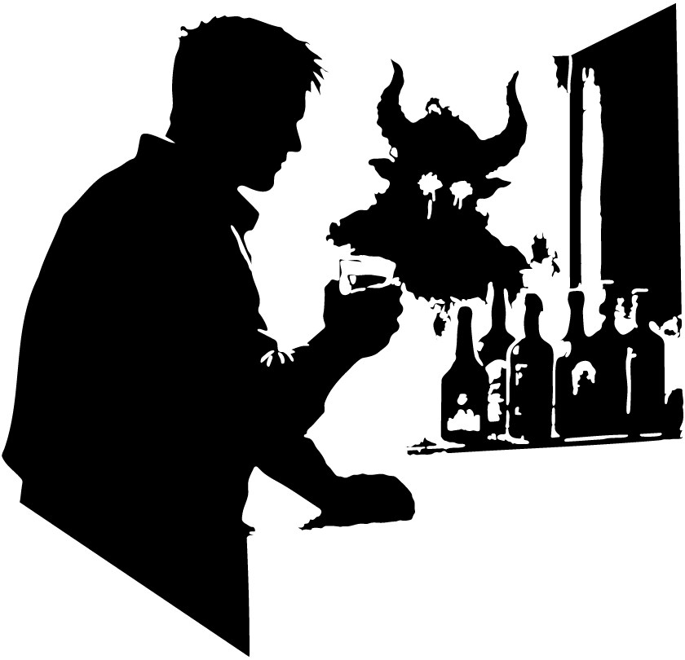

The Reunion
The plane claws its way into the sky.

The engines roar beneath the floor, a long violent shudder that rattles the seats and makes the windows hum. For a while, no one speaks. The cabin is all pressure and noise and the strange helplessness of being carried higher than a body was meant to go.

Then the climb eases.

The plane levels out.

Marcus unfastens his seatbelt. The click sounds too loud in the hush.

He stands in the aisle and forces on his practiced smile. “You’re free to move around the cabin now.”

His voice is calm. Almost cheerful.

But the cabin feels wrong.

Too still in some places. Too alive in others.

He looks around.

Two fourteen-year-old girls unbuckle and drift toward the other two girls across the cabin. They gather close, laughing too loudly, too suddenly, their voices thin and sharp under the drone of the engines.

Jason slips his headphones on, shutting the world out.

Max drops her eyes to her phone, the blue-white light washing her face pale.

Chloe opens her laptop, and the glow from the screen cuts across her features, turning her reflection faint and ghostlike in the darkened window beside her.

Cole stands.

He doesn’t say anything. He just rises and walks out of the cabin, shoulders tense, moving like he needs air the plane cannot give him.

Lucy watches him for half a second, then unbuckles and follows.

Marcus turns away from the passengers and reaches for a sheet of paper tucked near the service area.

It’s the dinner list.

Meal options. Seat numbers. Names.

Normal. Ordinary. Safe.

He stares at it anyway, grounding himself in the printed words.

Chicken.

Pasta.

Vegetarian.

The engines drone on.

Behind him, the girls laugh again.

Here’s a darker, more active rewrite starting at the bar:

Cole reaches the bar first.

He snatches a bottle from the rack, twists the cap off, and pours with a hand that won’t stay steady. The amber liquid jumps against the glass. He grips the counter until the shaking eases.

Lucy comes in right behind him.

Twenty-two years have carved themselves into both of them. The old brightness in her face has thinned into fine lines around the eyes and mouth. His own face looks harder, dragged down by sleepless years and things he never learned to bury. Time has not made either of them gentle. It has only made them tired.

For a second they just stand there, the low hum of the plane pressing around them.

Then Lucy shuts the bar door behind her.

“You still run first,” she says.

Cole throws back half the drink. “You still chase.”

“I had to.” She steps closer. “You vanished.”

Cole sets the glass down hard. “Don’t start.”

“No.” Lucy plants both hands on the counter. “I am starting. Because you left me in the wreckage of that classroom and disappeared.”

Cole looks away.

The glass mirror behind the bottles catches his reflection.

Except it isn’t only his reflection.

Something stands over his shoulder.

Tall. Red ash skin. Horns curled like black bone up toward the ceiling.

Cole whips around.

Nothing.

Just the narrow bar. Bottles. Metal shelves. The distant throb of engines.

He turns back to the mirror.

Only himself now older, hollow-eyed, sweating.

Lucy sees the change in his face. “What?”

“Nothing.”

“That’s a lie.”

Cole grabs the glass again. “Lucy ”

“No.” She cuts over him. “You don’t get to shut this down again. Not after twenty-two years.”

He clenches his jaw.

She keeps going.

“You quit. You vanished. You left me to answer questions I couldn’t answer. You left me with that room.” Her voice roughens. “With that girl.”

Cole’s hand tightens around the glass.

“I know,” he says.

Lucy studies him. “Do you?”

He laughs once, bitter and dead. “Every day.”

The words land. Hard.

Lucy folds her arms, but it doesn’t hide the tremor in them. “Then tell me.”

Cole stares into the drink.

The demon appears again in the curve of the glass.

Horns first. Then the smile.

Cole jerks the glass away from his face and slams it on the counter.

Lucy flinches. “Cole.”

“I shot her,” he says.

Silence.

He forces the words out before he can stop them.

“I pulled the trigger in your classroom. Room 13. I aimed at one of the girls, and I fired.”

Lucy goes still.

Cole presses on, voice low and flat, like he’s cutting the memory out of himself with a blunt knife.

“She was floating. All of them were. Their eyes were wrong. Their voices were wrong. Something had come into that room, Lucy. I saw it. I heard it.” He swallows. “And I fired.”

Lucy shakes her head once. Not denial yet. Just disbelief trying to become shape.

Cole leans in, relentless now. “The bullet should’ve torn through her. I know what I fired. I know what that gun does. But when the shot hit there was nothing. No wound. No exit. No blood from the bullet. It just… disappeared.”

Lucy’s face tightens.

“One girl died anyway,” Cole says. “One girl dropped and never came back. The others woke up. She didn’t.”

He drags a hand down his face.

“I shot at her, Lucy. I made that choice. Whether the bullet vanished or not, I made it.”

Lucy stares at him. “The hospital said there was no gunshot wound.”

“I know.”

“The police said the same thing.”

“I know.”

“They said her organs failed. That her blood ” Lucy stops, breath catching. “That her blood basically cooked inside her body.”

Cole nods once. “I know what they said.”

Lucy slams a hand against the counter. “Then why did you let everyone think the worst of you?”

“Because I was the worst of it.”

He says it so fast she almost misses it.

Cole lifts his head and meets her eyes.

“I walked into your classroom with a gun and pulled the trigger at a child. I don’t care what the police found or didn’t find. I did that.”

Lucy opens her mouth, then closes it.

Cole pushes off the counter and starts pacing the cramped space, all restless motion and old damage.

“They were chanting before I touched them. The symbols were already there. The air changed. The room changed. Then that thing came through.” He points at the mirror without meaning to. “Horns curled like black bone. A voice in my skull. It told me to choose.”

Lucy’s gaze flicks to the mirror, then back to him.

Cole sees it again in the glass.

The demon stands behind Lucy now, smiling down at her like it already knows her.

Cole strides to the mirror and turns.

Nothing.

His breath starts to go.

Lucy steps toward him. “Cole ”

He backs away from the mirror like it might open. “It’s here.”

“What is?”

“That thing.” He scrubs at his face. “It never left. It’s in dreams, reflections, windows, dark screens. I see it in the shine of a bottle, in the black of a turned-off TV, in an airport bathroom mirror. Twenty-two years, Lucy. Twenty-two years and it still looks at me like I owe it something.”

Lucy says nothing.

Cole laughs again, softer this time. More broken than bitter.

“You want the truth? Fine. Here.” He points at himself. “I’m divorced. Twenty-one years ago. She said I was there without ever being there. Said I slept with one eye open and drank with both hands. She was right.”

Lucy’s face shifts.

Cole sees it and gives a tired nod. “You too?”

“Ten years,” she says quietly. “Michael left.”

Cole looks at her properly then.

Not the teacher from before. Not the woman from memory. Lucy, now. Lined face. Tired eyes. Strength worn thin but not gone. A mother. A survivor.

“And Max?” he asks.

Lucy’s expression softens at once. “My daughter.”

Cole nods slowly. “She seems good.”

“She is.” Lucy glances toward the door, toward the cabin beyond it. “She’s the best thing that ever happened to me.”

Cole looks down. “Good.”

The silence that follows is different. Less like a fight. More like standing in the ruins after one.

Lucy moves closer, slower this time.

“We were close once,” she says.

Cole gives a hollow smile. “Once.”

She doesn’t let him dodge it. “Closer than anyone at that school knew.”

He says nothing.

She studies his face, and when she speaks again, her voice loses its edge.

“You were my first good morning every day.”

Cole shuts his eyes for a beat.

“You were the person I could look at across a room and know exactly what you were thinking,” she says. “You were the one who could make me laugh when the whole place felt like a prison.” She exhales. “And then that classroom happened, and you vanished, and I hated you for leaving me alone with it.”

Cole opens his eyes.

“I hated myself first,” he says.

Lucy nods. “I know.”

He looks surprised.

She steps in until there’s barely space between them and the counter.

“You think I don’t see what’s left of that day sitting in your face?” she asks. “You think I can’t tell you’ve been bleeding from it ever since?”

Cole tries to answer, but nothing comes.

Lucy keeps her eyes on his.

“We’re older now,” she says. “We’ve both been wrecked by people who promised to stay. We’ve both raised ourselves through things we didn’t deserve.” Her voice softens. “Maybe we can still be something good for each other. Not what we were. But maybe something.”

Cole stares at her.

Hope is more frightening than the demon.

He glances at the mirror again.

For once, he sees only himself and Lucy reflected there two worn people standing too close in a bar at thirty thousand feet.

Then the horns begin to rise behind his own reflection.

Cole inhales sharply.

Lucy catches it. “What?”

He steps back at once, retreating from both her and the mirror. “Don’t.”

Her face falls. “Cole ”

“I can’t do this if it’s here.”

“What do you mean, here?”

The demon’s smile widens in the glass.

Cole grabs the drink and empties it.

The burn hits fast and hard.

He sets the glass down with a crack.

“It’s here,” he says again, voice gone thin. “And every time I start to think there might be anything left of me worth saving, it shows up.”

Lucy takes one step toward him. “Then stop facing it alone.”

He almost breaks at that.

Almost.

Instead he looks at the empty glass, then at the bottle, then at Lucy.

His hand closes around the bottle.

When he speaks, his voice comes out rough.

“Maybe,” he says. “But not tonight.”
Lucy takes a step back.
The space between them opens, small but final.
Cole drops his eyes to the drink in his hand as she turns and starts to walk away.
He stays at the bar, unmoving, staring into the glass like it might give him a different ending.
His fingers tighten around it.
“One more won’t hurt,” he whispers.
Then he lifts it and drinks.
Marcus catches Jason rising in the corner of his eye.
Jason moves fast, head down, slipping out of the cabin without a word.
Marcus pushes after him at once.
“Jason!”
The name cracks through the low drone of the plane.
Jason keeps going a few more steps, then turns at the top of the stairs leading down to the lower level. The light from the cabin washes him pale.
“Sorry, mate,” Jason says. “I think I dropped my headphones.”
Marcus hurries toward him, breath tight, pulse hammering. “We’re not the only ones who’ve seen it.”
Jason frowns. “Seen what?”
Marcus reaches him and drags his phone out with shaking hands. The screen glow makes his face look sick. “The demon. The thing with the horns.”
Jason’s expression hardens, but Marcus keeps going before he can shut him down.
“I searched Cole Michael,” Marcus says. “The man on this flight. Twenty-two years ago, on Friday, October 13, he was accused of killing a girl. There were five girls in a circle. Lucy was there too she taught at that school.” He swipes the screen, words blurring under his thumb. “Then what happened to us eleven years ago, same date. And Chloe five years ago. She was found alone in a circle of five girls. The others were dead.”
Jason says nothing.
Marcus steps closer, voice dropping, growing sharper, faster.
“It’s always the same. Friday the thirteenth. Five girls. Blood. Symbols. Someone forced to choose.” He swallows hard. “What if it’s not random? What if something is doing this? What if it’s dragging us together?”
Jason stares at him for a beat, then gives a small, uneasy laugh that dies almost instantly.
“Mate,” he says, “I think you need sleep.”
Marcus just looks at him.
Then they hear it.
Footsteps.
Slow.
Measured.
Coming up the stairs from below.
Neither of them moves.
The sound keeps coming one step at a time, heavy enough to feel through the metal floor.
Marcus’s breath catches.
At the bottom of the stairwell, something shifts in the dark.
Then it steps into view.
The demon unfolds upward from the shadows, too tall for the space, horns curving black against the cabin lights. Its skin looks burned and flaking, red ash stretched over something that was never human. Its mouth splits into a grin.
It laughs.
The sound rolls through the plane like rot through wood, echoing down the aisle, crawling into the walls, getting inside Marcus’s teeth.
Jason goes rigid beside him.
The lights flicker once.
Twice.
For one choking second, everything turns red.
The demon stops laughing.
Its head tilts.
Its eyes lock onto Jason.
Marcus can’t breathe.
The thing leans forward just a fraction, like it’s sharing a secret meant only for them.
“It’s happening again,” Marcus whispers.
Jason blinks.
The red light snaps out.
The stairwell is empty.
No demon.
No horns.
Just the dim metal steps and the endless hum of the aircraft.
Jason’s face drains white.
He looks at Marcus really looks at him now and all the easy disbelief is gone.
His mouth parts. His voice comes out thin and scraped raw.
“It’s back,” he says.
He glances down the stairs, then back up, as if afraid it might be standing in both places at once.
“And this time,” he whispers, “it’s going to finish it.”
Lucy steps into first class and stops dead.
The cabin is empty.
Not “quiet” empty abandoned. Seats unbuckled. Blankets half-folded. A laptop left open on a seat, screen glowing to no one. A phone face-up on the carpet, buzzing softly like an insect trapped under glass.
Lucy’s heart kicks hard enough to hurt.
“Max?” she calls, but her voice sounds wrong in here thin, swallowed by the hush.
She moves down the aisle fast, scanning rows, checking seats, checking under them like a parent searching a playground. Her bag thumps against her hip. Her hands won’t stop trembling.
No Max.
No girls.
No footsteps.
No answers.
Only the low, steady drone of the engines too calm, too steady, like the plane doesn’t care who disappears inside it.
She spins toward the front.
Cole steps into first class from the aisle, face tight, eyes wild like he’s been running without moving. He looks older than he did an hour ago.
Lucy grabs the edge of a seat to steady herself. “Where has Max gone?” Her voice cracks. “Where are the other girls?”
Cole doesn’t answer right away.
He stands near the toilet door.
The door is open.
That’s wrong. It should be shut.
Lucy’s gaze locks on the dark gap inside.
A cold breath of air slips out of it damp, metallic, like a basement that’s been sealed for years.
Then Chloe appears from the restroom, stepping out slow, like she’s walking through water.
Her face is drained of color. Her eyes flick left and right, hunting.
“Where is everyone?” Chloe asks.
Lucy’s anger snaps up to cover the fear. “I don’t know,” she says, sharp and shaking. “But I’m finding them.”
Chloe’s attention shifts to Cole. Her voice drops. “How many girls were there?”
Cole’s jaw tightens like the question hits bone.
“A group of four,” he says. “And Max.”
He swallows once.
“Five.”
Chloe’s breath stutters. Her eyes go unfocused for a second, like her mind is yanked backward in time.
“No,” she whispers.
Not pleading.
Certain.
“Not again.”
Lucy turns toward the seats, following Chloe’s gaze.
Chloe is staring at her own chair.
Lucy looks
and sees it.
At first, it’s just the glossy curve of the headrest catching the cabin light.
Then the shape resolves.
Two black horns rising behind the seat like they’ve always been there.
The air thickens. The overhead lights dim by degrees, as if the plane is slowly blinking.
A figure lifts from the seat with smooth, impossible calm.
Red ash skin. A grin that doesn’t belong on anything living. Eyes like embers that never cool.
The demon stands fully upright, too tall for the cabin, shoulders nearly brushing the ceiling panels.
It smiles wider.
Lucy’s mouth goes dry. Her legs lock.
Chloe looks down at her hands.
They’re shaking so badly her fingers blur.
And in the hush, beneath the engine’s hum, the broken language returns soft at first, like a whisper through vents
then louder, crawling up the aisle like it’s coming back to claim what it started.

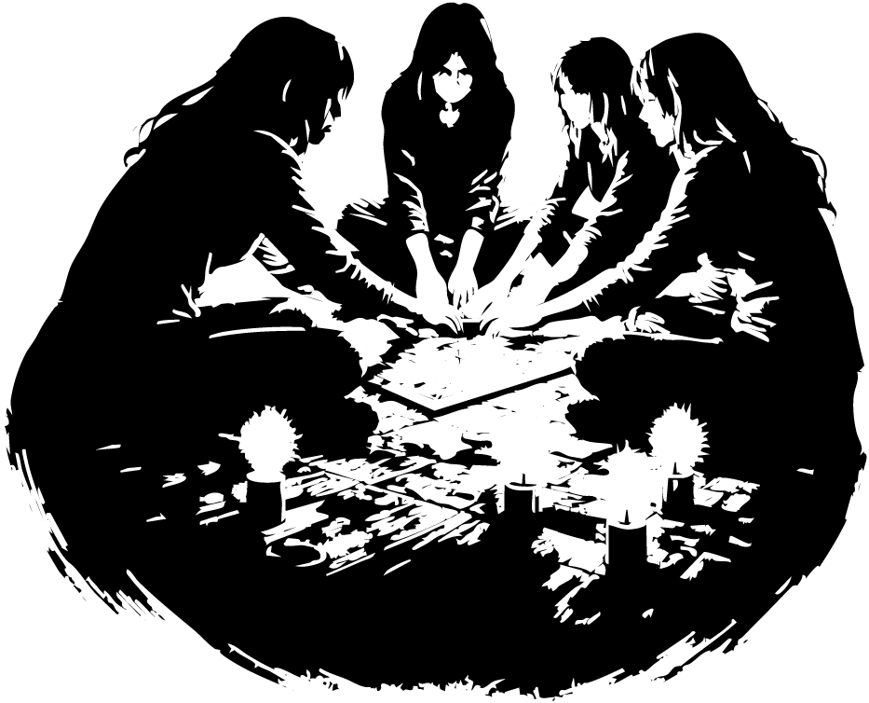

One Night That Will Never Leave You
Chloe looks down at her phone.

Friday, October 13, 2023 9:30 p.m.

The screen glow paints her face pale.

When she lifts her head, the house is waiting for her.

It squats at the end of the dead grass like something rotting upright old wood sagging, windows black, the roofline broken like a spine. No lights. No movement. Just the shape of it against the night, huge and wrong.

A hand lands on her shoulder.

Chloe jumps and whirls.

It’s Sam the same girl from the photo on her phone, only younger now, alive with that reckless grin.

“Chloe, come on,” Sam says.

She heads toward the house with three other girls, laughing too loud, their voices brittle in the cold air.

Chloe doesn’t move at first.

Every part of her body screams at her to run.

Don’t go in. Don’t follow them. Don’t step across that threshold.

But there’s that smaller voice too that stupid, human voice that wants to fit in, wants to look fearless, wants to be cool for five more minutes.

So she runs after them.

The front door hangs open.

Inside, the house smells of mold, dust, and something sour underneath something animal, something old.

The floor groans under every step.

Moonlight leaks through broken boards and shattered windows, striping the walls in pale, corpse-colored bands. Above them, parts of the second floor have rotted through, leaving holes that open into darkness below like missing pieces in a skull.

Chloe stares up at them too long.

It feels like something could lean over those edges and look down at her at any second.

“Come on, Chloe,” Sam calls from the next room. “We’re going to talk to a demon.”

She says it like a joke.

That’s the worst part.

Chloe follows the sound of their voices into a room littered with beer cans, glass bottles, and candle stubs burned low into puddles of wax.

In the middle of the floor sits a Ouija board.

The wood around it is stained dark.

One of the girls drops to her knees. “Everyone put your fingers on the pointer.”

Sam kneels too. The others crowd in around the board, giggling, nervous now.

Chloe stays back.

Sam looks up at her. “Come on, Chloe. Put your hand on it.”

Chloe hesitates.

Then she kneels and reaches out.

The moment her fingertip touches the pointer, the world tears.

The room jerks.

Flickers.

For one blink, she’s staring at the board.

For the next, she’s somewhere else.

She’s in the air.

Her hands are locked with the other girls’ hands. Their bodies float above the floor in a circle, legs hanging limp, heads thrown back. Blood streams from their eyes in black-red lines, running over their cheeks, dripping into a glowing ring of symbols beneath them.

Then the vision snaps

back to the board.

Then back again

floating, choking, the air hot as an oven.

Above them, something rises through fire.

Horns first.

Then shoulders.

Then the upper half of something massive and red-skinned, wreathed in flames that don’t light the room so much as stain it.

Its face is still half-hidden, but Chloe can feel it smiling at her.

The world keeps stuttering between moments board, blood, board, fire, board, horns, board, screaming until she can’t tell which one is real anymore.

Then it stops.

All at once.

Chloe blinks.

She is standing.

No

not standing.

Holding hands.

The girls are in a circle around her.

Their fingers are locked together so tightly it hurts.

For one frozen second, none of them moves.

Then they all drop.

The circle breaks and bodies slam into the floor.

Chloe lands badly, feet hitting first before she crashes onto her back hard enough to drive the breath out of her.

The room goes black around the edges.

When she wakes, the house is silent.

Not quiet.

Silent.

Like sound itself has stepped back.

Chloe lifts a shaking hand to her face.

Wet.

She pulls it away and sees blood black in the dark, slick across her fingers.

It’s all over her cheeks.

As if she’s been crying it.

Panic rips through her. She scrambles to her knees and crawls to Sam.

“Sam?”

She grabs her shoulder and shakes.

Nothing.

Sam’s head lolls to one side.

Blood streaks her face from both eyes.

Chloe turns to the others.

All four girls lie scattered around the room, twisted where they fell, each one marked with the same bloody tracks down their cheeks.

None of them move.

None of them breathe.

Chloe stumbles backward, choking on air.

Her phone lies near the wall. She lunges for it, nearly dropping it when she unlocks the screen.

1:01 a.m. October 14

Chloe stares.

“No,” she whispers. “No where the hell did the hours go?”

Her voice shakes apart in the empty room.

Then she notices the floor.

A ring has appeared around them.

Red.

Fresh.

A perfect circle of symbols crawls across the boards, glowing faintly like heat under skin.

Chloe rises slowly, phone trembling in her hand, and looks around the dark house.

It no longer feels abandoned.

It feels occupied.

Like something opened its eyes the moment she touched that board

and never looked away.



The Final Stand
Everyone runs through the plane calling the girls’ names, voices bouncing off metal walls and dying fast in the engine-hum.

Cole, Jason, and Chloe hit the stairs first and race down toward the cargo level.

The air changes before they even reach it.

Colder.

Damp.

Wrong.

Then they see them.

All five girls stand in a circle near the cargo hold, hands locked together, heads bowed. A red ring burns beneath their feet, drawn in symbols that seem to move when you look at them too long. The light from it stains the walls and ceiling like the inside of a wound.

Chloe stops so suddenly she nearly falls.

Jason slams his fist into the wall.

The crack of bone against metal echoes through the hold.

“No,” he snarls. “Not again.”

Cole turns on him at once. “What do you mean, again ?”

Jason drags a hand across his mouth, eyes fixed on the circle. “Marcus was right,” he says, voice shaking now. “We’ve all seen this before. You in 2006. Chloe in 2023. Me and Marcus in 2017.”

Cole stares at the girls.

“At every one of these ” He swallows. “Did someone die?”

Chloe answers without looking at him.

“Four girls died the last time I saw it.”

Jason and Cole both turn to her.

The horror on their faces is raw and immediate.

Before either of them can speak, the girls begin to chant.

The sound crawls through the cargo hold like smoke. The words don’t belong to any language; they grind and twist, too deep in some mouths, too sharp in others. The metal walls seem to hum with it. The floor trembles faintly under their feet.

Cole moves first.

He walks straight toward Max.

Lucy’s daughter.

The smallest in the circle.

He reaches her and puts a hand on her shoulder. “We have to save them.”

Jason steps closer, but not too close. Fear holds him just outside the red ring.

“Last time I pulled someone out,” he says, voice low and wrecked, “he died.”

Chloe turns to him, stunned. “Wait you weren’t part of the circle?”

Cole answers for him, eyes still on Max. “No. This happened to kids around us. Not to us.”

Chloe takes another step toward the girls.

“I was a kid,” she says. “I was in the circle.” Her breathing quickens. “I blacked out. I only remember waking up inside it. I’ve never seen it from the outside.”

She reaches toward one of the girls.

The instant her fingers touch skin, Chloe freezes.

Her body goes rigid.

Her head jerks up.

Her eyes burn red.

Cole sees it happen and lunges for her. “Chloe!”

He grabs both her shoulders.

Too late.

The change hits him like a current.

His whole body locks.

His breath catches in his throat.

Then his eyes turn red too.

Jason stumbles back.

Cole and Chloe stand there inside the edge of the circle now, bodies stiff, faces empty, the red light climbing up their skin like it’s taking them over from the inside. The chanting swells, folding their voices into it.

The circle is getting bigger.

The symbols are spreading across the cargo floor.

Jason backs up another step, heart smashing against his ribs.

“Fuck this,” he says, voice cracking. “I’m getting the others.”

But as he turns, something moves in the darkness beyond the cargo crates.

Tall.

Horned.

Waiting.

If you want, I can keep going and rewrite the next section so the demon fully manifests in the cargo hold.

Cole opens his eyes

and falls backward into memory.

Room 13.

The last day. The last time he saw Lucy before everything broke.

The classroom is soaked in grief. It hangs in the air like damp rot. The blood circle still stains the floor, dark and wet-looking, though it should have dried years ago. The girls lie around it in broken shapes, and the symbols painted around them crawl across the tiles in clotted red lines, as if the blood itself tried to write its way out.

Cole turns toward the blackboard.

LET ME IN

The words are gouged deep, chalk snapped and dragged so hard it cut grooves into the slate.

He looks down.

His gun lies on the floor beside the circle.

For a moment he just stares at it.

Then he bends, slow, like the weight of the years is on his back.

“All of it,” he says softly. “Every ruined year. Every piece of joy this thing took from me.” His voice tightens. “All because of ten seconds.”

The classroom door opens behind him.

Cole spins.

“Lucy?”

But it isn’t Lucy.

A figure in a black hood stands in the doorway, still as a coffin propped upright.

Cole turns back to the gun and reaches for it.

The instant his fingers brush the grip, the room explodes with screaming.

The girls scream all at once.

Not fear.

Pain.

Raw, tearing pain, as if something is still happening to them, over and over, trapped in the room like sound pinned to a wall.

Cole jerks his hand back.

The screaming cuts off.

He turns again.

The hooded figure steps inside and pulls back the hood.

A man’s face. Pale. Calm. Wrong in the way a grave is wrong when it’s open.

“What are you doing here?” Cole asks.

The man studies him, then the room, then the blackboard.

A faint smile touches his mouth.

“Your name is Cole James Michaels.”

Cole takes a step back. “How do you know that?”

The man ignores the question.

“Have you ever heard the story of Truett and the Great Anchor?”

Cole frowns. “No.”

The man folds his hands behind his back.

“Then listen.”

He steps past the blood circle like it means nothing.

“There was a man named Truett,” he says, “lost at sea in a wooden boat. He looked up and saw storm clouds closing over him. He looked down and saw water spilling through a hole in the hull.”

As he speaks, the classroom seems to change around them. The air smells faintly of salt. The floor groans like timber beneath waves.

“Truett prayed,” the man says. “He asked the gods to save his boat or show him land. And the gods answered only this: Follow the path shown to you. ”

Cole says nothing.

The man continues.

“Then the sea took a breath. The waves turned and pushed south. But in the north, Truett saw light breaking through the clouds.” He glances at Cole. “And when he looked down, he saw a rope tied from his boat to something beneath the water.”

The room creaks again.

“Now he had a choice,” the man says. “Stay with the boat and let the sea drag him. Or cut himself free and swim for the light.”

He stops.

“What would you do, Cole?”

Cole looks at the blood circle. At the girls. At the gun.

Then back at the man.

“What’s the point of the story?”

“If you answer,” the man says, “you may find out.”

Cole drags a breath into his lungs. “I’d cut myself free. I’d swim for the light.”

The man smiles.

“So Truett did. He leapt into the sea and tried to pull the boat with him, but he wasn’t strong enough. In the end, he cut the rope and left it behind. He swam for hours until he found land.”

The classroom feels colder now.

“On that island,” the man says, “he found his boat again. Broken on the shore. Because the anchor had never been the boat.”

Cole narrows his eyes. “What was it, then?”

The man looks straight at him.

“The weight of needing answers.”

Silence.

The girls seem to shift on the floor.

Not moving.

Just settling.

The man goes on.

“Truett broke the boat apart and burned it to keep warm. Had he stayed with it, he would have reached the same island anyway but he would have spent twelve nights freezing beside a broken hull, trying to save what could not be saved.” He tilts his head. “Sometimes the choice is not where the path leads. Only how much it hurts to walk it.”

Cole stares at him.

“Who are you?”

The man’s smile deepens, but only a little.

“Many names exist for me,” he says. “Most call me Death.”

The word seems to darken the room.

Cole glances at the blackboard again.

LET ME IN

Then he looks back.

“What path?”

Death steps closer to the circle.

“Yours is already chosen,” he says. “The question is whether you will choose the version of it that saves them.”

Cole’s throat tightens.

“Where’s Chloe?”

Death’s expression doesn’t change.

“You are using her as a bridge to reach this place.”

Cole goes still.

“What?”

“This realm is not meant for living minds,” Death says. “You crossed anyway. Through her.”

Cole’s face drains.

“And if the bridge breaks?” he asks.

Death looks at him with the patience of something that has answered this question too many times.

“Then you die here.”

The screaming starts again.

Soft this time.

Not from the girls.

From inside the walls.

Jason half-drags Lucy and Marcus down the narrow stairs toward the cargo level.

The air gets colder with every step, like the plane is descending into something that isn’t part of the flight plan. The engine hum fades into a distant throb. Down here, the sound feels muffled smothered like the walls are swallowing it.

Then they reach the cargo door.

And the red light hits them.

A circle glows on the metal floor, bright as fresh blood. Symbols crawl around it in looping shapes that hurt to look at for too long. The light doesn’t sit still it pulses, slow and hungry, like a heartbeat.

Inside the circle, the five girls stand hand-in-hand, heads bowed. Their mouths move in perfect rhythm.

Not singing.

Not praying.

Chanting.

The sound is wrong too old, too layered like something speaking through them instead of from them.

Chloe clings to one of the girls, fingers dug into her arm so hard they should break skin. Her eyes burn red, and blood slides down her cheeks in thick tears, dripping onto the glowing line with faint sizzling sounds.

Cole grips Chloe’s shoulder, trying to hold her back.

His eyes are the same.

Red-lit.

Bleeding.

His blood-tears fall in slow drops, leaving dark spots on the floor that vanish as soon as they touch the symbols.

Marcus and Jason stop dead.

They look at each other wide-eyed, breathless because they both recognize this shape of horror. The circle. The chanting. The way the air feels like it’s waiting for something to arrive.

Lucy pushes past them.

She goes straight for Max.

Her daughter stands in the circle with the others, small hands locked tight, lips moving around words she shouldn’t know.

“Max,” Lucy says, voice breaking as she kneels at the edge of the red line. “Max, look at me. Come back to me. This isn’t you.”

Max doesn’t blink.

Doesn’t flinch.

She doesn’t even seem to hear her.

Lucy’s hands shake as she reaches out, but she stops short of the glowing line like it’s a fence that might bite.

She whips around on Jason and Marcus, panic turning sharp. “What the hell is happening to them?”

Marcus swallows hard. “I don’t know.” His eyes flick to the ceiling, to the walls, like he expects something to step out of them. “But they should be floating by now. That’s what happened before.” He stares at Cole and Chloe. “Whatever they’re doing it’s slowing it down. Holding it back.”

Lucy turns back to the circle.

Her gaze lands on Cole.

The blood on his cheeks makes him look like he’s been crying for years without stopping.

Lucy steps forward.

She steps into the red light without meaning to, one foot crossing the edge of the circle.

The symbols flare brighter under her shoe.

Lucy doesn’t notice.

She only looks at Cole.

“I believe you,” she says, voice raw. “I believe you now. I’m sorry. I’m so sorry I didn’t before.” She takes another step, eyes shining. “Please… please come back to me.”

Cole’s head jerks toward her like he’s fighting something inside his skull.

“Lucy don’t ” he tries to say, but the words come out broken, swallowed by the chant.

Lucy reaches him.

She puts her hand on his shoulder.

The moment her fingers make contact

Lucy’s eyes flash red.

Like someone lit a match behind them.

Her body locks.

Her mouth opens, but no sound comes out at first just a sharp inhale like she’s drowning.

Then she drops to her knees, hard, as if the floor yanked her down.

Blood spills from her eyes in slow, heavy tears.

Marcus makes a strangled sound.

Jason grabs for Lucy, but stops short too afraid to touch her, too afraid the circle will take him too.

They stare at each other in horror.

Because now Lucy is part of it.

And the chanting is getting louder.

Cole steps toward Death, rage shaking through him.

“Stop speaking in riddles,” he snaps. “Just tell me what you want me to do!”

Death’s mouth curves, not kind.

“I’ll see you soon,” he says.

He lifts one hand as if ticking off a second on an invisible clock

and he’s gone.

The cold doesn’t leave with him.

Room 13 creaks like it’s settling into a grave.

Then

a knock at the door.

Soft. Close. Wrong in a place that shouldn’t have doors anymore.

Cole turns.

The door swings inward.

Lucy steps through.

Older Lucy at first lined face, tired eyes then she runs, and something shifts as she moves, like the memory can’t decide what year she belongs to.

“Lucy?” Cole breathes. “What are you doing here?”

She doesn’t answer with words.

She launches into him.

Cole catches her on instinct, arms wrapping around her like his body remembers before his mind does. He lifts her and spins once twice and as he turns, the years peel away from both of them.

Wrinkles smooth. Shoulders straighten. Hair darkens. Their faces slide backward toward the people they used to be back when “good morning” meant something, back when the world hadn’t split open in front of them.

Cole stops spinning, breathless.

Lucy grips his collar like she’s afraid he’ll vanish.

“How are you here?” he whispers.

Lucy smiles through wet eyes. “I’m holding on to you.”

Above them, the ceiling groans.

A crack creeps outward like a vein.

Dust sifts down in a thin, steady fall.

Cole’s eyes flick up, then back to Lucy, panic rising. “You should go. I’ll save Max.”

Lucy shakes her head. “I know you will.”

“Then why did you come?” Cole demands, voice breaking. “Why would you follow me into this?”

Lucy cups his face with both hands.

Her palms are warm. Real.

“Your face,” she whispers. “This is what you looked like when you were last happy. Truly happy.”

Cole blinks.

A tear slips free and runs down his cheek.

“How did you ”

Lucy closes her eyes and presses her forehead to his chest.

“Because before Max,” she says softly, “I was the same. I needed something to hold onto too.”

The room shudders.

Behind Cole, the blood circle on the floor brightens, the symbols crawling like living ink. In its center, the air thickens and starts to split like flesh tearing forming a dark mouth that breathes heat and iron.

Cole turns his head, staring at it.

Then back to Lucy.

“Lucy… you have to go,” he says, urgent now. “Max still needs her mother.”

Lucy’s voice trembles, but she doesn’t move. “You never asked me her full name.”

Cole freezes. “What?”

Lucy lifts her head. Her eyes shine.

“Max’s name is Max Cole Andrew.”

Cole stares like she struck him.

Lucy smiles small, aching. “I named her after you,” she says. “After the man who saved me every day just by being there. After the man who would throw himself in front of anything to protect someone else.”

The ceiling groans again, louder.

The crack spreads.

Something scratches once from inside the walls slow, deliberate like a nail dragged along tile.

Jason’s voice echoes faintly through the room, distant and warped, like sound traveling through water.

“WE’RE GOING TO PULL LUCY FREE!”

Cole’s jaw tightens. He looks into Lucy’s eyes, and there’s too much in his chest to fit into one breath.

“Maybe in another life,” he whispers.

Lucy’s smile wavers. “We were close once,” she whispers back. “Maybe we can be again.”

The room trembles hard enough to rattle the desks.

Lucy pulls him into one last fierce hug.

“I’ll see you in the next one,” she says into his shoulder.

Then she steps back.

Cole catches her wrist. “Lucy ”

She squeezes his hand once, like a promise.

Then she turns and runs to the door.

The blood portal finishes forming with a wet ripping sound.

Something begins to climb out.

Red ash skin rises from the split. Horns follow. The demon’s grin comes last.

Lucy looks back from the doorway.

“I’ll see you again,” she calls, voice breaking.

Cole forces a smile, even as fear claws at his ribs.

“What’s a demon,” he says, “to a man who’s lived with his demons his whole life?”

Jason’s voice shouts again, louder now.

“PULLING NOW!”

Lucy steps through the door.

It slams shut.

Cole stands alone.

He stares at the empty doorway for half a second

then lets his face fall.

Because he knows what he just did.

He lied to her.

Not to hurt her.

To save her.

To get her out.

His eyes drop to the gun on the floor.

He reaches for it.

As soon as his fingers close around the grip, the screams come back dozens of girls, layered and endless, ripping through his skull like hooks.

Cole grits his teeth and holds on anyway. He forces one breath in. One out.

The screaming thins, becoming a distant roar behind his thoughts.

He lifts the gun.

The demon steps fully into the classroom.

Its horns nearly scrape the ceiling. Its skin flakes like burnt paper. Its eyes glow hot, amused.

It laughs.

“You think that little gun can kill me?”

Cole’s hands shake. He keeps the barrel up.

The demon tilts its head. “You’re the guardian,” it purrs. “The block in the doorway. The thing stopping me from reaching the girl Chloe.”

Cole tightens his grip. “This place is a bridge,” he says. “Between the living and the dead.”

The demon smiles wider. “And I’m from the land of the dead.”

Cole’s gaze snaps to the symbols on the floor.

Then to the demon.

“And you were summoned,” Cole says, voice sharpening. “By chanting your name. That’s why the words didn’t sound like English.”

The demon’s grin falters

just for a blink.

Then it moves.

Too fast.

A hand like a claw closes around Cole’s throat and lifts him off the ground. His feet kick uselessly as the demon slams him into the wall hard enough to crack plaster.

Cole’s vision flashes white.

But through the ringing in his head, he hears something else.

Voices.

Not screaming.

Speaking.

Names.

Lucy’s voice faint, distant, but clear pushing through whatever barrier separates them.

“EMMA…”

“JESSICA…”

Marcus and Jason join in, voices overlapping, throwing names into the air like anchors.

“BILLY…”

“SAM…”

The symbols on the floor flare.

The names burn into the blackboard in chalk that writes itself, each one appearing with a sharp scratch like fingernails on slate.

The demon jerks its head toward the board.

For the first time, it looks… wary.

Cole sucks in a ragged breath.

“Your name is the spell,” he croaks. “But so are theirs.”

The demon snarls and tightens its grip.

Cole’s vision tunnels.

He raises the gun with shaking hands and fires.

The shot punches into the demon’s chest.

The demon howls not pain, not exactly more like rage at being touched by something that remembers.

From the blood portal, pale shapes begin to crawl out.

Children.

Not living.

Not fully dead.

Faces gray with sorrow. Eyes hollow and shining. Their hands reach for the demon like drowning hands reaching for a throat.

They grab it.

Hold it.

Cling to it.

The demon thrashes, horns scraping the ceiling, laughter turning to a furious scream.

Cole fires again.

And again.

And again.

Each shot drives the demon backward inch by inch, but it fights, planting itself like a stake driven into the floor. The dead kids strain and pull, but the demon is too heavy too anchored.

Cole sees it.

Sees the truth.

It won’t go unless something takes it .

He drops the gun.

He launches himself forward.

Wraps both arms around the demon like he’s tackling a wildfire.

The demon’s eyes widen.

“No”

Cole drives them both straight into the portal.

The blood-dark split swallows them.

The room flashes white.

And the doorway between worlds snaps shut behind him like a jaw.

Lucy comes back to herself on the cold cargo floor.

Her cheek is wet. Not water—blood, thin and warm, smeared where it ran from her eyes. The air tastes like pennies and smoke.

Above her, the chanting fills the space like a swarm.

Jason and Marcus grip her under the arms and haul her upright. Their hands shake. Their faces are gray with terror.

In front of them, Cole is still locked to Chloe—his arms clamped around her as if he can hold her soul in place with sheer force. Chloe’s eyes burn red. Blood tears slide down her cheeks in slow, heavy lines.

The five girls stand in a circle around them, hands joined, floating inches off the floor. Their mouths move in perfect sync. The red ring beneath them pulses brighter with every word, symbols crawling like living things along the metal.

Marcus squeezes his eyes shut and listens—really listens—past the noise, past the fear.

The sound loops.

The same pattern again.

And again.

Not a sentence.

Not a prayer.

A repeated thing .

Marcus’s eyes snap open.

He turns to Jason, voice sharp. “What if it’s not a spell?”

Jason stares at him.

Marcus points at the girls’ mouths. “What if it’s a name ?”

Lucy pushes herself fully to her feet. Her knees wobble, but she stands. She looks from the glowing circle to Cole and Chloe, then up—like she can feel something pressing down from the ceiling.

“I saw it,” she says, breath ragged. “The demon was trying to open a portal. But it came because they said its name.” Her voice steadies, just a little. “So… if names can summon—maybe names can pull back .”

Jason swallows hard. “You mean… call the dead?”

Lucy nods once. “There are only two we know for sure.”

Marcus and Jason exchange a look—pure dread, and something else underneath it: hope so small it hurts.

They lean in together, facing the circle like it’s a cliff edge.

Marcus shouts the first name, voice cracking. “SAM!”

Jason follows, louder, desperate. “BILLY!”

The chanting stutters.

Just for a heartbeat.

The red ring flickers like a candle in wind.

Lucy steps closer, ignoring the heat coming off the symbols. She screams the names again, forcing them into the air like weapons. “SAM! BILLY!”

The girls’ voices waver.

Their floating bodies twitch, as if invisible strings have been yanked.

The blood tears fall faster now, dripping onto the circle with faint sizzling pops.

Marcus points, wild-eyed. “It’s working—keep going!”

They shout again, together.

“SAM!”

“BILLY!”

The sound slams through the cargo hold.

The red light surges—then falters.

The girls’ hands tremble.

One girl’s head jerks up like she’s waking from drowning.

Lucy’s gaze snaps to Max.

Her daughter’s eyes are still red, still wrong, but her lips hesitate between words.

Lucy surges forward, voice breaking. “MAX!”

Max’s eyelids flutter.

Lucy shouts her name again, louder, as if volume can cut through whatever’s inside her. “MAX!”

Max’s eyes open.

For a second they’re still glowing—

then the red drains away like ink in water.

Her mouth opens, and her voice comes out small and human.

“Mother.”

Lucy makes a sound that is half sob, half laugh. She reaches for Max’s face, gentle, terrified to touch her too hard, like she might shatter.

Around them, the other girls begin to drop.

Not all at once—one, then another—falling from the air like puppets with their strings cut. They hit the floor with dull thuds, gasping, coughing, blinking like they’ve been pulled out of a nightmare.

Jason and Marcus turn sharply.

Cole’s knees buckle.

He still holds Chloe as he falls, like letting go is worse than dying.

They hit the floor together.

Chloe’s eyes flutter—then open.

She sucks in a broken breath.

Alive.

But Cole doesn’t move.

His head lolls to one side. His face is too still. The blood on his cheeks has dried dark.

Lucy freezes, Max’s small hand gripping her sleeve.

The chanting is gone.

The red circle dims, symbols fading like embers cooling.

For a moment, there’s only the engine hum and the sound of terrified breathing.

Jason looks at Marcus, then Lucy, then the girls on the floor.

His voice comes out rough.

“Is that it?” he asks. “Is it… over?”



Another Life
“After that night, we made a promise,” Lucy says. “Every Friday the 13th of October, we’d check in. Just to prove we were still here. Still okay.”

Cole nods, listening like he’s afraid the words might disappear.

“The next one was 2034,” Lucy continues, “and we showed up. All of us. A little older. A little steadier. Still us.”

She smiles softly.

“Max and Chloe stayed close. It started as keeping in touch… then it turned into something real. Like sisters. They didn’t just survive the same nightmare—they built a life around it.”

Lucy’s eyes shine as she speaks.

“Max got married. Chloe stood beside her as her best woman. And when Chloe got married, Max stood beside her too. They gave each other what that night tried to steal.”

Cole’s throat tightens.

“And Jason,” Lucy says, “he actually became a doctor. Properly. Like he always talked about. I think he finally found the kind of peace he’d been chasing.”

She glances away for a second, smiling at the thought.

“Marcus kept flying,” she adds. “He kept seeing the world. Not running this time—just living. Collecting sunsets and cities like proof that life kept going.”

Cole exhales, something warm breaking through his face.

Then he looks at Lucy, quieter.

“But you?” he asks. “Did you ever… become happy?”

Lucy’s smile grows gentle. Not perfect. Real.

“I spent years thinking happiness had to be a person,” she says. “Like if I found the right one, everything would finally make sense.”

She shakes her head, almost laughing at herself.

“But it wasn’t like that.”

She reaches for his hand, just briefly, like she’s testing whether this moment is allowed.

“I found it in small things,” Lucy says. “In Max’s laugh. In mornings that weren’t haunted. In learning how to breathe again.” Her eyes meet his. “And in knowing… someday, I’d see you again.”

Cole looks around, as if the universe might be listening.

“Well,” he says softly, “we did say… in another life.”

Lucy smiles, and this time it reaches her eyes.

“In another life,” she repeats.

And for the first time in a long time, it doesn’t sound like a goodbye. It sounds like a hello

