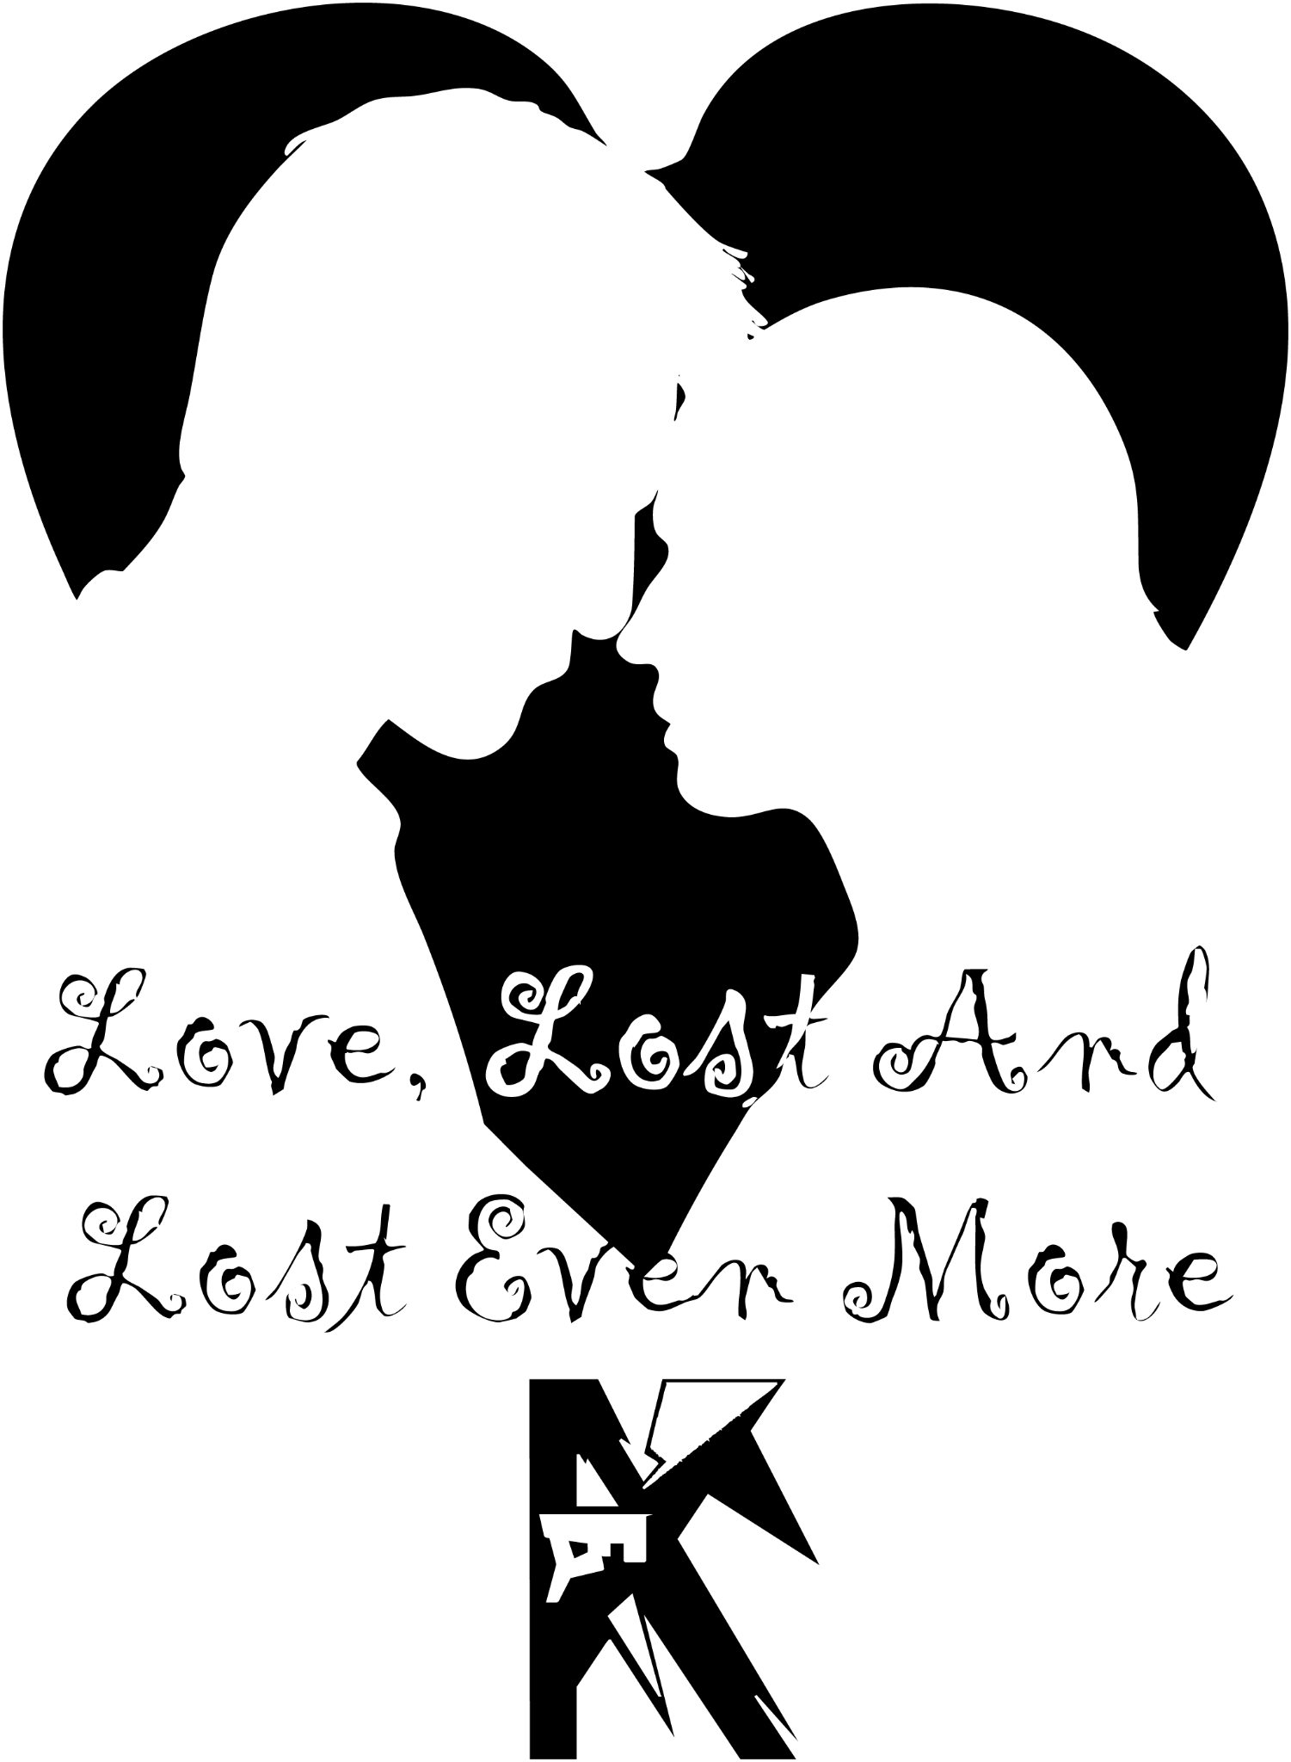

By Kyle Young



The Party
Liam rode the elevator in silence, phone glowing in his hand. A message blinked: The construction deal is moving forward. Need your approval.

He typed back quickly—I’ll look after the anniversary party—and slipped the phone away. As the doors opened, his eyes caught on the painting in the hall: a lone man in a boat, swallowed by waves. For a moment, Liam lingered, whispering, “That’s me,” before heading to his door.

The lock clicked. Laughter spilled out as he stepped into the apartment. “Sorry I’m late,” he called.

Controllers paused; a few friends looked up with grins. Liam moved through the crowd toward Sonia, pouring wine in the kitchen. He kissed her cheek. “Happy anniversary.”

She arched a brow. “Late again?”

He smiled, guilty. “I’ll make it up to you.”

“Always excuses,” she teased, but her smile softened.

Nearby, Hannah nudged her. “Two years, two kids, this apartment—you chose well.”

Sonia laughed faintly, though her eyes shimmered. “Not all sunshine. He’s always working. Sometimes I barely see him.”

Clare slipped an arm around her. “Ups and downs. That’s marriage.”

A knock at the door broke the moment. Sonia brightened. “Pizza’s here.”

The group gathered at the table, laughter mixing with the clatter of plates. Hannah leaned close to James, asking about his work. He grinned—“Car mechanic”—and she laughed, brushing his arm.

Liam tapped his glass. The chatter quieted. He looked at Sonia, his voice soft. “Twenty years ago, I married the most beautiful woman I’d ever seen. But the first time I saw her? I was flat on my back with a black eye from a light pole.”

Sonia chuckled. “Who runs into a pole?”

“Someone distracted by an angel,” he said, eyes locked on hers. “It took me two years to find the courage, but thank you—for saying yes. For staying through it all.” He lifted his glass. “To us.”

Later, after the crowd dwindled and the door shut behind James and Hannah, Liam pulled Sonia close. “Who knew, James and Hanah?”

“I did,” she said with a smile.

He kissed her hair. “God, I love you.”

They laughed, light in their voices, as they disappeared into the bedroom.
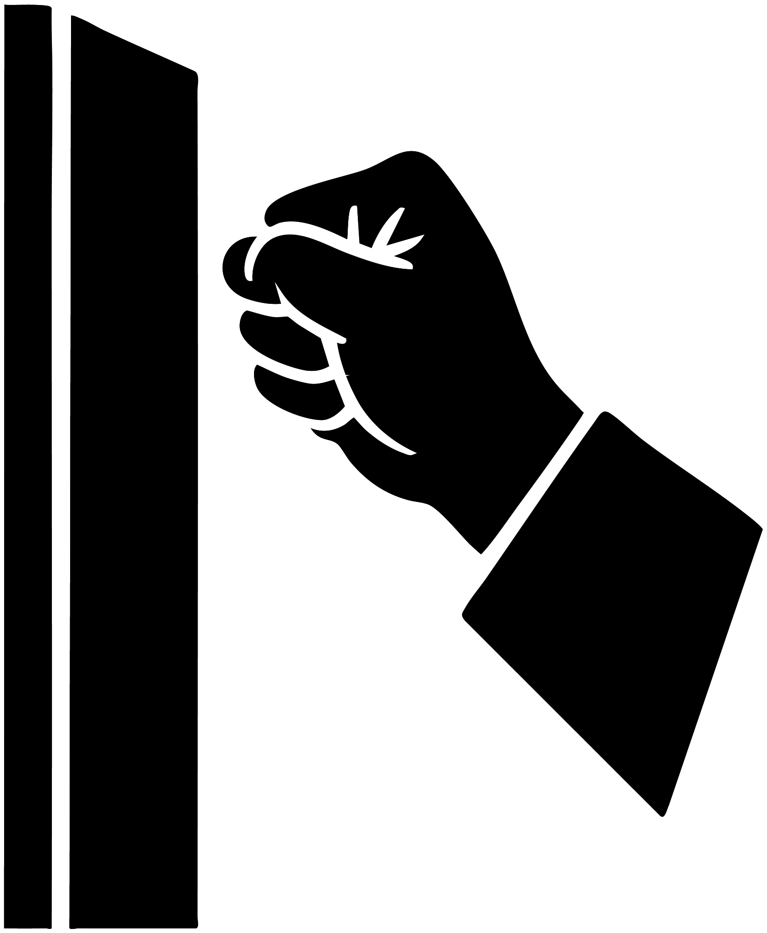

The Knock
At 4 a.m., the pounding came.
It rattled the door like fists desperate to break through. Liam jolted awake, heart racing, the dark still clinging to his eyes. His phone glared back at him—4:00 on the dot.

He tugged on his pants with clumsy hands, the glow of the screen his only light as he followed the sound down the hall. The knocking grew sharper, frantic, as though whoever stood outside was clawing for life itself.

Through the peephole, he froze.
Hannah.
Her dress was shredded and bloodied, her face streaked with tears and smeared makeup, a grotesque mask that made her look less like herself and more like a ghost who had crawled out of the night.

His hands shook as he fumbled with the lock, swinging the door wide. She collapsed against him with the weight of someone who’d carried too much horror to stand.

“Hannah—” He caught her shoulders, but the instant his skin touched hers, she recoiled like his touch was fire. She staggered back, eyes darting wild and glassy, shrinking away every time he tried to step closer.

“Hannah,” Liam whispered, voice trembling, “are you hurt? Please—tell me what happened. Let me help you.”

But her silence was louder than screams.

A soft voice cut the air behind him. Sonia.
She padded down the hallway in her nightgown, rubbing the sleep from her eyes. “What’s going on?”

The switch flipped, flooding the hall with light. Hannah flinched, her arms flying up like the brightness itself had struck her. Then she bolted forward, shoving past Liam, clutching at Sonia’s nightdress like a drowning woman clings to driftwood.

Sonia froze, staring from Hannah’s trembling form to Liam’s bewildered face. “What happened?”

“I don’t know,” he stammered, shutting the door behind them as if that could keep the nightmare out. “I just opened it—she was outside—then she kept pulling away from me.”

Sonia crouched low, her voice tender and steady, the way you’d speak to a wounded child. “Hannah… do you want to come with me? Into the bedroom?”

Hannah gave a shaky nod. “Yes.”

“Alright. Come on.” Sonia guided her gently down the hall. Before closing the door, she glanced back at Liam, her eyes soft but heavy. “I’m sorry, baby.”

Liam forced a shrug that felt like it might break him. “Yeah. I’ll just… wait here.”

The door clicked shut. The silence that followed was suffocating. He sank onto the couch, his chest hollow, his breath uneven. He stared at the glow of his laptop, papers spread before him, trying to lose himself in numbers and words that suddenly meant nothing.

Morning came too quickly. Sunlight poured through the blinds, cruel in its brightness. Liam stirred awake on the couch, phone still clutched in his hand. 9:00 a.m.

And then—voices. Movement. Uniforms. Police officers filled the apartment. His stomach dropped as though the floor had disappeared beneath him. Sonia stood nearby, her face drained of all color, carved with sorrow.

“What’s happening?” he demanded, his throat raw.

Sonia’s eyes met his, hollow and breaking. “Hannah was raped… by James.”

The words slammed into him like iron hammers. “No. No—James would never… that’s impossible. What are you saying?”

“Look at her, Liam!” Sonia’s voice cracked sharp, almost desperate. “Why would she lie?”

His eyes turned, unwilling but unable to resist. Hannah sat slumped in a chair, her face streaked with dried tears, her dress torn like it had been ripped from her body. Her hands shook uncontrollably, her entire frame curling inward. He remembered her recoil at his touch—her terror of any man near her.

His stomach churned. His chest screamed. But still he shook his head. “No. Not James. Not him.”

The denial hardened into something immovable. He stormed into the bedroom, snatched a shirt over his head, grabbed his keys and his phone.

“I have to talk to him,” Liam muttered, his voice a jagged edge, and before Sonia could stop him, he slammed the door behind him, charging into the daylight as though it held answers.


The Friend
Liam stood in the elevator, tapping his leg nervously as he scrolled through his messages:
“Are the contracts good?”
“Are they bad?”
“We need an answer NOW!”
He started typing, but his phone screen went black. The red battery icon blinked once, then died completely.
“Fuck!” he shouted, pacing back and forth in the elevator. His thoughts spiraled. “James would never… but all the evidence points to her. Damn it—I have work, but… fuck.”
He stopped, breath heavy. “James’s place is on the way to the office. I’ll talk to him first.”
The elevator doors slid open. Liam stormed out and headed straight for the garage.
Moments later, he pulled up outside James’s house. Police cars lined the street. Liam’s chest tightened; each step toward the front door felt heavier than the last.
Through the doorway, he heard James’s voice rising: “So you’re saying I can’t even be within ten feet of Hannah—for something I didn’t do?”
A cop replied coolly, “Where were you and Hannah last night?”
Before James could answer, Liam cut in. “Don’t say anything. You know whatever you say can and will be used against you.”
The officers turned, irritated. “Are you his lawyer?” one asked.
“No,” Liam shot back, “but he should wait for one before speaking to you.”
James seized on it immediately. “You heard him. I’m not saying another word without a lawyer.”
The cops exchanged frustrated glances but eventually backed off. As Liam followed James inside, one officer stopped him.
“Don’t leave the state—or the country—until after the trial.”
James gave a thin smile. “Of course.” He shut the door and spun toward Liam, his face red with anger.
“What the fuck was that? I wake up to find cops at my door, accusing me of rape.”
Liam squared his shoulders. “Do you know who accused you?”
James stepped closer, his voice low and sharp. “No. Do you?”
Liam’s eyes hardened. “I’m going to ask you once. Have you ever raped anyone?”
James froze, staring straight into Liam’s eyes. His voice broke with emotion but stayed firm. “No. Never. I would never touch a woman without her consent. I can’t believe you even asked me that.”
Liam studied him—searching for hesitation, for a flicker of a lie. Nothing. Just pain and defiance.
Finally, Liam exhaled. “I believe you. But now you need to tell me exactly what happened after the party last night.”

Liam stepped into his office, greeted by towering stacks of paperwork. His assistant looked up, exasperated.
“Where have you been? I’ve been texting you every minute!”

He sifted through the files without looking at her. “It’s been a bad morning.”

She smirked. “Partied too hard at your anniversary last night?”

Liam glanced up, weary. “No. I wish that was the reason.”

Before she could reply, the door swung open. Sonia stormed in.
“You’re representing James?!” she shouted.

The assistant froze, eyes darting between them. Liam handed her the paperwork. “These are fine. You can go.”

She nodded quickly and slipped out. Liam shut the door, activated the frosted glass, and turned to Sonia.

“Yes,” he said evenly. “Because I don’t think he did it.”

Sonia stared at him, horrified. “So you think Hannah’s lying?”

He guided her to a seat and sat beside her. “I never said that.”

“That’s what you’re implying,” she snapped, standing again. “You’re taking his side.”

Liam rose too, meeting her gaze. “How long have you even known Hannah?”

“Why does that matter?” she shot back, annoyed.

“Because I’ve known James for more than half my life. I know when he lies through his teeth, and I know when he’s telling the truth. And right now—he’s telling the truth. You’ve known Hannah for what? A year? Maybe four conversations total. Forgive me if I trust someone I’ve known twenty years over someone I barely know.”

Sonia’s eyes burned. “She described things no stranger could invent, Liam. The scar on his thigh from that ski trip. How powerless she felt trying to push him off. The exact way his face feels, the crooked T-shaped patch of hair on his chest—you and I have seen it a thousand times when he swam shirtless. She knew it all. And the pain in her voice… Liam, he did it.”

Liam looked down, then back into her eyes. His voice was heavy. “No matter what happened, if she keeps down this path, it’ll destroy them both. And there may never be justice.”

Sonia stepped back. The look in his eyes was unshakable—steel determination. No matter what she said, he wouldn’t bend.
“It’s not about justice,” she whispered. “It’s about making sure it doesn’t happen to someone else.”

“But what if he didn’t do it?” Liam countered. “His name will be dragged through the mud for nothing.”

Sonia cupped his face, searching his eyes. Her voice softened, but it cut like glass.
“I’m picking up the kids tonight. If you don’t come home… I’ll know which side you chose.”

She turned and walked out, leaving him staring at the floor, her words pounding in his chest.

That night, Sonia sat by the front door, waiting. Hours passed. Liam never came home.



The Cost
At 8:30 a.m., Liam stood at his own front door, hand raised to knock. Before he could, it opened. Two little faces appeared—his children.

“Dad!” they cried, rushing forward.

Liam crouched down, forcing a smile. “Kids.”

One of them frowned, tilting their head. “Where were you last night?”

The words stung. He swallowed, masking his guilt. “I’m sorry, guys. I was working late.”

Across the hall, the neighbor’s door opened. She stepped out with her child, pausing when Sonia appeared behind the kids. Sonia’s tone was clipped, polite, but strained.

“Hi—could you take Tim and May to school today?”

The neighbor read the tension instantly. “Of course,” she said softly, leading the children toward the elevator. The doors slid shut, leaving Liam and Sonia alone in the hall.

Sonia’s eyes locked on him. “Where were you last night?”

Liam brushed past her into the bedroom without answering. He unplugged his phone charger, opened drawers, and began packing clothes into a suitcase.

“Why aren’t you answering me?” Sonia demanded, her voice trembling. “Fine. If you won’t talk, then you can listen.”

Her words spilled out like fire. “This isn’t fair. My friend was raped by your friend. And you—” her voice broke—“you choose him over me. I’ve spent years raising your children, putting my life on hold so you could build yours. I’ve cooked, cleaned, sacrificed everything for this family. And the one time I ask you to stand with me, to trust me—you don’t.”

Liam stopped, his hand frozen on the suitcase. His head dropped, eyes closed. When he turned, a tear slid down his cheek.

“Why are you throwing words like landmines?” His voice was quiet but heavy. “Every morning I wake at four to work so the bills get paid, so you and the kids are safe. I don’t always say it, but I show you I love you—when I cook breakfast, when I lock every door at night, when I make sure the heat is on so you never wake up cold. Maybe I don’t have the right words, Sonia, but I’ve shown you. Every day.”

He stepped closer, hands trembling as he set them on her arms.

“James has been my friend for over twenty years. I know when he’s lying, and I know when he isn’t. I believe him. And I can’t turn my back on him for someone I’ve only spoken to a handful of times—even if she’s your friend. I’m sorry. I hate that it puts us on opposite sides. But please, don’t mistake this—I do love you.”

His forehead pressed against hers, the weight of his words hanging between them. He lingered, desperate for her to understand. But Sonia stood stiff, her eyes filled with a pain he couldn’t erase.

Finally, he pulled away, zipped the suitcase shut, and lifted it. Without another word, he walked out.

Sonia remained frozen in the doorway, watching him leave—his charger and clothes in hand, his love declared but his choice made.



The Court
Liam glanced around the courtroom. Sonia sat stiffly in the gallery, directly behind Hannah. On the opposite side, James leaned toward him.
“You’ve got this,” James whispered.
Liam gave a small nod just as the judge cleared his throat.
“Alright,” the judge said. “State the charges.”
Hannah’s lawyer rose, straightening his papers.
“Rape in the First Degree, Penal Law 130.35(1): that the defendant, James, engaged in sexual intercourse with my client by forcible compulsion.
Rape in the Third Degree, Penal Law 130.25(3): that the defendant engaged in sexual intercourse without consent.
And Sexual Abuse in the First Degree, Penal Law 130.65(1): that the defendant subjected Hannah to sexual contact by forcible compulsion.”
He sat down.
“Opening statements,” the judge said. “Prosecution first.”
The lawyer stood again, walking before the jury.
“On Thursday, June 5th, 2025, at Liam and Sonia’s twentieth anniversary party, my client met James. Later that night, the two of them went to a nightclub. On the way, they were attacked. And in that chaos, James raped Hannah.”
Liam was on his feet instantly. “Objection! Leading the jury.”
The judge frowned. “Counsel, mind your wording.”
“Apologies, Your Honor.” The lawyer looked back at his notes. “During the attack, Hannah was raped.” He turned to the jury, his voice firm.
“My client thought she had found a friend that night—a man she felt safe with. But instead, he betrayed her. And I ask you this: why would she step forward? Why would she drag her own name, and his, through the mud unless it was true? She came here for justice. Nothing else.”
He sat down.
Liam rose, walking slowly toward the jury. His tone was measured.
“My client, James, recently sold his construction company—for eight billion dollars. We discussed it at that very anniversary party. Now, the prosecution wants you to believe Hannah has no motive to lie. But with eight billion on the line, I say she has the biggest motive of all.”
Murmurs rippled through the courtroom as Liam returned to his seat.
“We have evidence,” Hannah’s lawyer shot back. His assistant wheeled out a television and set it before the jury.
The screen flickered to life. Grainy security footage showed James and Hannah, visibly drunk, staggering down a street. Suddenly, two masked men rushed them, tackling them off-screen into an alley. The video fast-forwarded. When the pair reappeared, Hannah’s dress was ripped, her face frantic. She bolted from the alley. Seconds later, James stumbled into view—shirtless, pants torn, clutching his stomach. Minutes later, the masked attackers staggered out as well, bruised and battered.
The lawyer stood, gesturing at the screen.
“This footage shows James chasing after Hannah. His pants ripped, as if pulled down while she struggled to escape. It’s clear evidence of what happened.”
Liam shot to his feet. “Objection. Speculation. That’s not what the video shows—that’s your narrative.”
The judge raised a brow. “Then tell us, counselor—what does it show?”
Liam stepped forward. “It shows that James and Hannah were attacked. James was knocked unconscious for thirteen minutes. When he woke, he saw the two men assaulting Hannah. He tore off his belt and fought them, despite his pants being pulled apart in the struggle. He helped her escape and chased after her to make sure she was safe.”
“No,” Hannah’s lawyer countered, rising to his feet. “What really happened was different. They fought off the attackers together. Afterward, in the aftermath, James’s mood shifted. He turned on Hannah. She backed away, but he grabbed her and assaulted her. It took her ten minutes to break free and run, with James chasing her down.”
The courtroom fell into tense silence, the weight of two opposing stories pressing down on every juror.
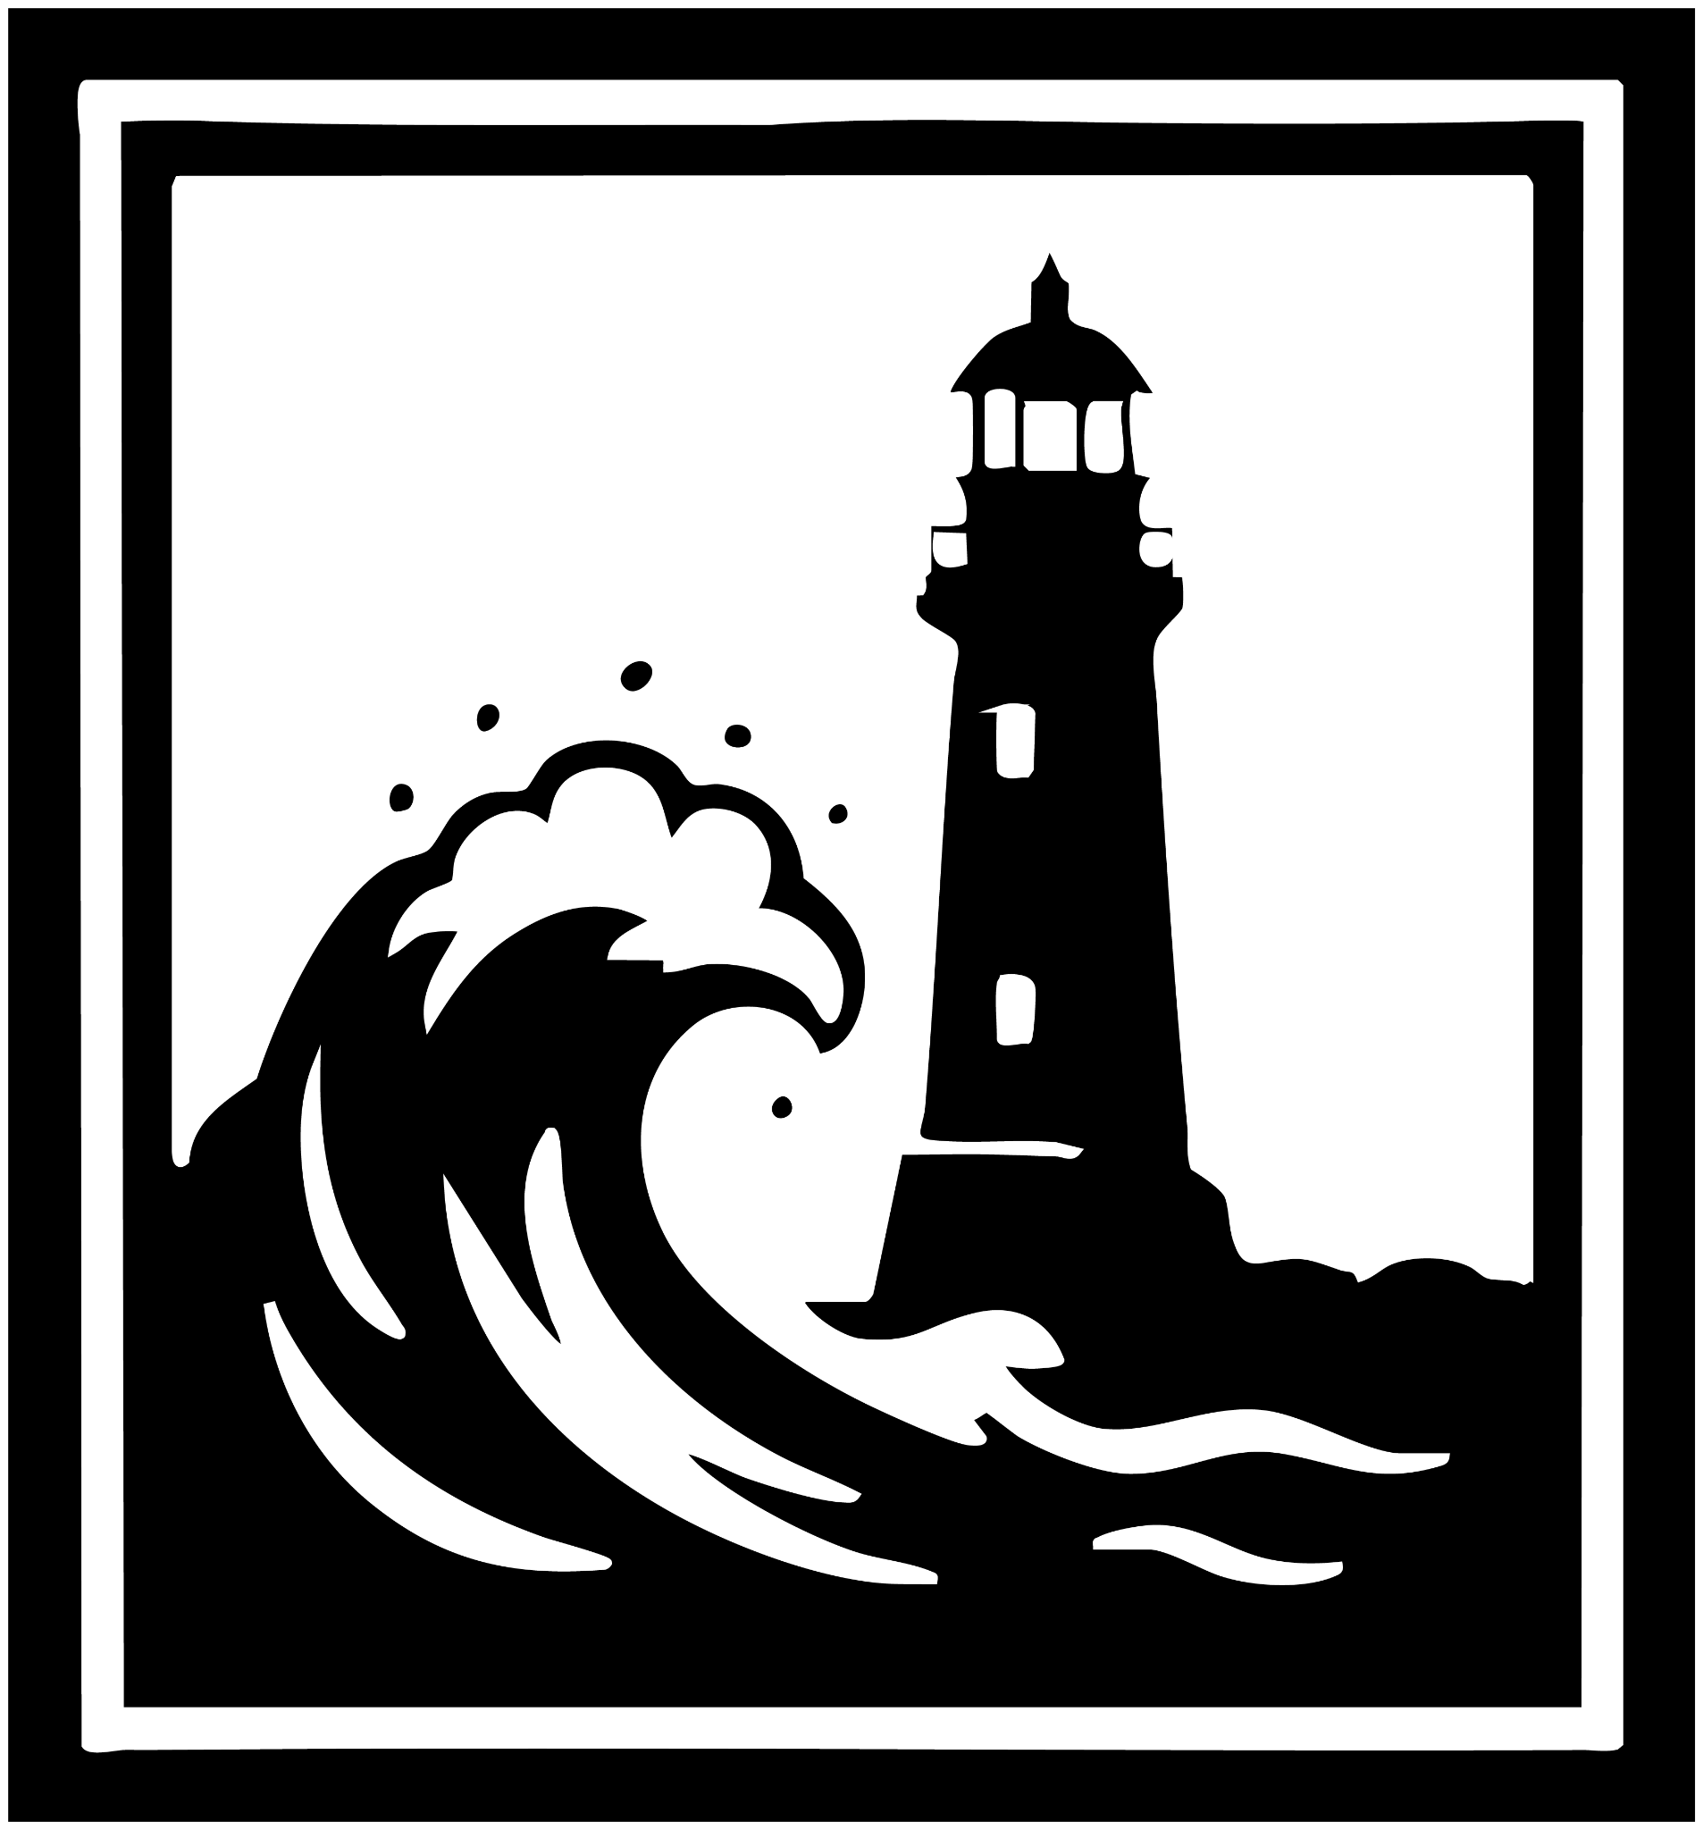

The Fallout
Days turned into weeks, weeks into months. The courtroom debates dragged on, twisting back and forth until the jury was hopelessly deadlocked. No unanimous story could be agreed upon. Finally, the judge sighed, declared a mistrial, and brought the proceedings to a close.

Four weeks later

Liam’s knee keeps time against his palm, a nervous metronome he can’t switch off. The elevator dings; the doors slide open onto the same bright hallway, the same soft hum of lights. He turns, almost by instinct, to the painting behind the elevator—one man in a small boat, disappearing into a cathedral of waves.

He studies it a beat longer than usual. “A man staring at the future,” he murmurs, “knowing that whatever he does, the sea is going to take him. And nothing will be the same.”

He tries on a smile that doesn’t fit, then walks to the apartment. The keycard trembles a little between his fingers before the lock clicks. Inside, the air is familiar but the room is not. The frames that once held his grin, the kids’ gap-toothed summers—gone. Bare hooks glint like tiny moons.

“Liam,” Sonia’s voice comes from the kitchen, steady but thin. “Your box is over here.”

He turns. “I see you redecorated.”

A quick, apologetic smile. “Yeah. Sometimes looking at the past… it just, destroys me inside.”

He tries for lightness. “I thought my famous lasagne did that.”

“By now,” she says, almost laughing, “you should know the difference between cooked and undercooked.”

“Honestly? It’s a miracle I got this far,” he answers, and the two of them share a small island of a smile before the tide pulls again.

He sets his hands on the cardboard box. Sonia’s fingers find his wrist. “Can you take the kids this weekend?”

He meets her eyes. “Of course.”

She nods and starts for the door. It’s now or never. “Is there any chance,” he asks, voice catching, “we find our way back to where we were?”

Sonia pauses. A single tear escapes; she wipes it away with the back of her hand. “Do you have a memory-wipe device for the last three months?”

“I wish I did,” he says, swallowing the hurt. “We could go back.”

She steps close, palm against his cheek, thumb tracing the tired line under his eye. “I wish it didn’t cost us.”

“Me too,” he whispers.

Her hand slips away. She passes him, and the room feels colder without the warmth of her touch. Liam lifts the box. Tears blur the doorway into a smear of light as he steps out. Each footfall stretches into an eternity, and between them grows a distance so wide they can no longer recognize the people they once promised to be.

