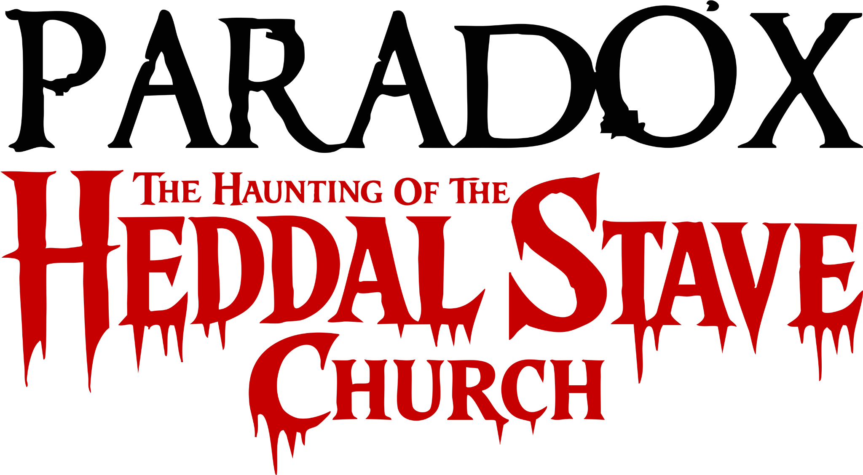
By Kyle E Young

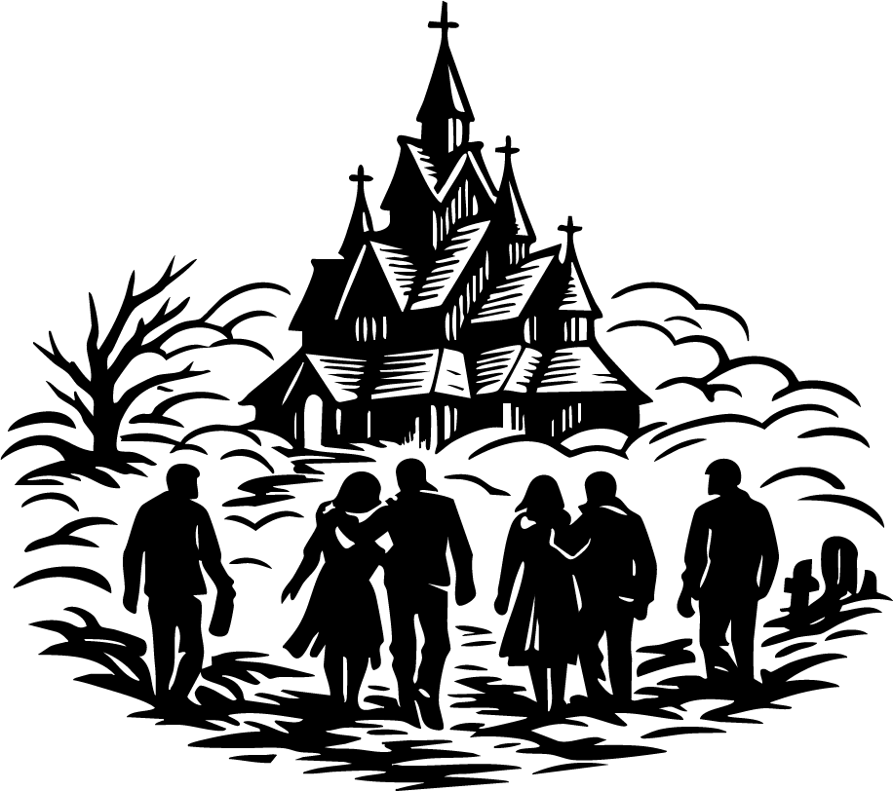

The Party Aftermath
The year was 1909, and the bitter Norwegian morning clung to us like a curse.

Fog pressed in from every side, thick and pale, winding around our bodies like ghostly fingers that refused to let go.

The cold was so sharp it stole the breath from my lungs and left it hanging in the air before me in trembling white clouds. My steps wandered crookedly along the lonely road, a bottle hanging loose in my hand, while ahead of me my older brother, Adolf, and his friend. Behind me came my sister Elsie, her sweetheart at her side, and next to me, ever watchful, was Frederick.

A hand settled upon my shoulder.

I turned, and through the veil of mist Frederick’s face appeared, pale and solemn.

“Mary,” he said softly, “I know it is your eighteenth birthday, but I think you have drunk too much.”

I gave a lazy smile and waved him off. “Shhhh,” I murmured. “It’s my big eighteenth.”

Then a sour burp rose from my throat, and the world tipped beneath my feet.

Adolf and Friend Ernest stopped walking ahead of us as I lurched forward, then backward, before sinking ungracefully onto the frozen road. Frederick knelt with me, steadying me as I mumbled, “Sitting down.”

Ahead, Adolf had rounded on Ernest, his voice cutting through the silence like a blade.

“You sent us down the wrong street! We’ve walked past Hollavegen!”

“No, we haven’t,” Ernest snapped, his voice rising. “It’s just around the corner.”

Adolf stepped closer, his green eyes glinting with anger. “Mate, I walk this road drunk every week after work. I’m telling you we’ve passed it.”

Before the quarrel could grow uglier, Elsie stepped forward, peering into the white abyss around us.

“Shut up, all of you,” she said. “I can see a road over there.”

She pointed into the fog, though to me it looked like nothing more than a darker wound in the whiteness. Ernest squinted, then muttered, “I’ll go and look.”

And with that, he vanished.

The mist swallowed him whole within seconds, as though it had been waiting for him.

I looked up at Frederick and smiled foolishly, only for my stomach to wrench again. I bent and retched onto the roadside, the taste of bile burning my throat. Somewhere beyond me, I heard Adolf’s boots crunching over the frost as he followed after Ernest.

Then Adolf’s voice came, low and dangerous.

“I don’t trust you, boy. I know what sort you are. If you break Mary’s heart, or hurt her in any way, I will destroy you.”

At last the sickness passed, and I pushed myself shakily upright, stumbling forward. I shoved at Adolf’s arm with all the weak force I had left.

“Leave him alone!” I cried.

But the earth seemed to slide away beneath me. My legs folded, and for one terrible instant I thought I was falling into the frozen road. Yet I did not strike it. Instead, I hung there, suspended, the world spinning sickly around me.

I turned my head and saw Frederick holding me, his arms firm around me, his face close to mine.

He smiled, but there was something strange in it something too still, too certain.

“I will never let go,” he whispered.

A chill moved through me then, colder than the morning air.

From somewhere in the fog came Ernest’s voice, distant and thin, as if the mist itself were speaking through him.

“It’s Rindevegen. We’ve walked too far.”

Adolf cursed under his breath. Then, after a long silence, he said, “Mary won’t make it home like this. We’ll have to go to Heddal Stave Church.”

At those words, the air seemed to change.

Even through my drunken haze, I felt it that terrible heaviness settling over us all. No one argued. No one laughed. The very name of the church seemed to fall into the fog like a stone into black water.

Then, slowly, Ernest emerged again from the mist, his face pale as bone. He said nothing, only pointed ahead.

And there it stood.

Through the shifting white veil rose the dark shape of Heddal Stave Church, its steep timbered roofs clawing upward like the backs of slumbering beasts, its blackened spires piercing the dim morning sky. The wood was slick with frost, and every carved beam and jutting cross seemed alive with watching shadows.

The church doors stood open.

No bell rang.
No voice called.
Yet it seemed to wait for us.

Frederick tightened his hold around me. Adolf glanced once at Elsie, then at William, and though none of them spoke, I saw the unease in all their faces. Ernest crossed himself. Even the fog itself seemed to gather at our backs, pressing us onward.

Step by step, we made our way across the frozen ground.

And together, without a word, we walked into the church.
I stumbled into the church half-blind with weariness, my boots slipping against the ancient wooden floor. The world swayed around me. Before I could steady myself, my knees gave way and I collapsed onto one of the narrow pews, the old timber creaking beneath my weight. Frederick sank down beside me at once, and, too tired to protest, I let my head fall against his shoulder.
The church was colder inside than it had any right to be.
A damp, unnatural chill clung to the air, Strange faces had been carved into the beams saints, beasts, and twisted things I could not name and in the uncertain light they seemed less like decoration and more like watchers, patient and unsleeping. The faint smell of old smoke, wet pine, and something older still earth, perhaps, or rot hung over the sanctuary.
Adolf stood a few paces away, his expression tight as he looked toward the great entrance doors.
“Why is the church open?” he asked.
Elsie looked about the dark church as though the answer should have been plain to everyone.
Elsie looked around the dark church as if the answer should have been obvious.
“Isn’t a church supposed to be open?” she asked.
Frederick gave a faint smile, but there was sadness in it.
“It used to be,” he said. “Once, churches stayed open for anyone who needed shelter, prayer, or comfort. But too many children came in to play, carve their names into the wood, and break old things just because they were there. So places like this were closed.”
His voice faded, and the silence that followed felt heavy.
Then, to my embarrassment, everyone looked at me.
Elsie tilted her head, a spark of mischief still in her face even in that grim place.
“Mary,” she said, “are you in love with a churchgoer?”
I smiled despite myself and looked at Frederick.
“Yes,” I said quietly. “We met in church. We actually met here.”
Adolf and Elsie exchanged a look, both confused and doubtful.
At the same time, William Elsie’s boyfriend had wandered toward the altar, drawn by the same careless curiosity that always seemed to get him into trouble. He climbed the steps without much respect and peered through the shadows until he found an old wooden figure near the altar. It was tall and dark with age. He reached out and touched it. When he pushed it slightly, it moved, as if something had been hidden behind it.
He frowned at once.
“There’s something carved here,” he muttered, running his fingers over the wood. “Some kind of pattern.”
But no one was paying attention to him anymore.
They were all looking at Frederick and me.
The weight of their attention felt like judgment. I took a breath, though it shook as I let it out.
“I started going to church after Father died,” I said.
My voice sounded too loud in that empty place. It rose into the rafters and seemed to come back to me changed.
“I needed someone to talk to. Someone who would listen. But all of you…” I looked from Elsie to Adolf, feeling the old hurt open again. “You acted as if he had never really been there. As if his death was just an inconvenience. Something to clean up and move past.”
The church seemed to grow even stiller.
I stood slowly from the pew, holding onto the carved wood for balance.
“He was my favourite person,” I said, and now my voice was breaking. “He understood me. He never laughed at my dreams. He wanted me to follow what I loved.”
Elsie stepped closer, her expression softening.
“We only wanted you to be realistic,” she said. “It wasn’t sudden. He had been getting worse for a long time. You just didn’t want to see it.”
Adolf’s face was shadowed, but there was pain in it.
“I didn’t want to see your heart broken again,” he said quietly. “Not by chasing something that felt impossible. Not so soon.”
Before I could answer, Frederick spoke.
There was something gentle in the way he looked at me, as though even the old church had gone quiet to hear him.
“But heartbreak is part of living,” he said. “So is failure. We often learn more from falling than from succeeding, because failure teaches us what we can survive, how far we are willing to go, and what truly matters to us. That is why it is called a dream. It is not something we hold all at once. It is something we move toward. Something ancient inside us reaches for it long before we understand what it is.”
His words hung in the air like candle smoke.
Then Ernest stepped forward.
“I’ve known you most of your life,” he said carefully, “and I think you do many things well. But to be an actress…” He hesitated, as if he realised too late how cruel he sounded. “That takes everything. More than most people have to give. And I don’t think that’s you.”
His words hit me harder than I expected.
I swayed where I stood, gripping the pew tighter.
“This,” I said, my voice suddenly sharp, “this is exactly what I mean. This constant need to tell me what I cannot be.”
Adolf looked at me, troubled.
“I wasn’t trying to bring you down because I thought you would fail,” he said. “This family was already falling apart. After Mother died, Father made me promise that I would keep us together, no matter what.”
Elsie turned to him in shock.
“Is that why you didn’t want me to go to university?” she asked.
Adolf stepped back.
“No,” he said. “Well… not completely.”
At that moment, the room seemed to tilt. I felt myself starting to fall backward, but Frederick caught me before I hit the ground.
Elsie shoved Adolf, and he stumbled back. Ernest turned toward Adolf, then toward Elsie. Frederick moved in front of her just as Ernest stepped forward with his fist raised, ready to strike.
Before he could hit her, Frederick caught his arm.
“I know everyone here has had too much to drink except me,” he said coldly, “but that is no excuse to lose control.”
Adolf straightened and looked at Ernest.
“Put your fist down,” he said.
Ernest lowered his hand.
Adolf looked back at us, his voice strained.
“I will do whatever I can to protect both of you,” he said. “But we still have to stay together.”
I stood upright again, though my head felt as though cold water was pouring through it.
“So you just want to keep us trapped here?” I said. “Why? Because you’re too afraid to move on?”
Elsie stepped toward me, as if she had finally chosen my side.
Adolf looked at Ernest, almost as if asking for support, then spoke in a low voice.
“Here, we are safe. Here is where we grew up. Here is the first place we saw our parents, and the last. Here is where I promised Father I would not let us drift apart.”
I looked at him, anger burning through my dizziness.
“Did you ever think,” I said, “that trying to keep us together might be the very thing tearing us apart?”
Adolf said nothing.
Elsie lowered her eyes, then spoke softly.
“Why don’t we choose one day every year,” she said, “when we all meet in the same place? A place that will always belong to us.”
A faint smile touched Adolf’s face.
“The old oak tree,” he said. “Where we used to play as children. The place where we said goodbye to Father.”
Elsie nodded.
“Deal.”
I lost my balance again, and Frederick caught me once more.
“Deal,” I whispered.
And then something moved.
A groan rose through the church not from any one of us, but from the wood itself.
We all turned.
William stepped back from the statue, his face gone pale. Beneath his hand, the ancient figure had begun to shift. At first it was only a tremor, so slight it might have been mistaken for failing light. Then came the slow, dreadful sound of timber dragging against timber. Dust drifted from the altar steps. The carved figure tilted, split, and folded inward as though some hidden mechanism, silent for centuries, had been woken at last.
A black opening yawned behind it.
A passage.
A stairway descending into the earth.
No one spoke.
The darkness below seemed thicker than ordinary shadow, as if it possessed depth and appetite. A breath of cold air rose from it, damp and stale, carrying the smell of stone, old earth, and something faintly briny as though the sea itself had somehow found its way beneath the church.
Elsie stared at the opening, then turned to William with wide eyes.
“Baby,” she whispered, “what did you find?”
William’s fear had already begun to twist into wonder. He smiled, though uneasily.
“I don’t know,” he said. “But I want to see more.”
And with that, he stepped toward the hidden stair.
One by one, the others followed, drawn as though by a hand none of us could see. Frederick came to my side and offered me his arm. I took it, and together we descended into the dark beneath the church, while behind us the old wooden figure stood open like a mouth that had at last remembered how to feed.

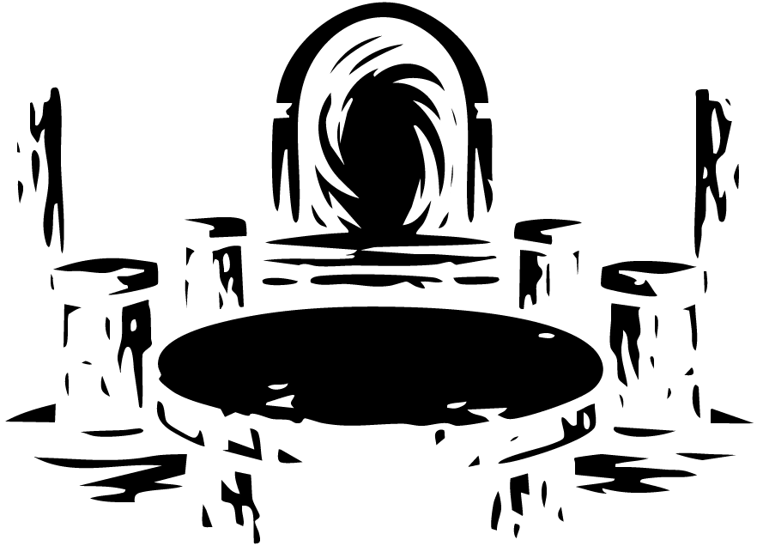

The Secrets of The Church
Frederick kept one steady hand beneath my arm as we descended the winding wooden stair, the steps groaning softly beneath our weight as though protesting our intrusion.
The passage twisted down into the earth like the inside of some ancient spine, close and airless, with walls of old timber that sweated cold damp into the dark. Above us, the hidden church had already begun to feel far away, as though we had not merely gone beneath it, but passed out of the world of ordinary things altogether.
When at last we reached the bottom, the space opened suddenly around us.
It was a round chamber of stone, older than the church above, and so still that even our breathing seemed an offence. Four pillars stood about a table at the room’s centre, black with age and damp, each one carved with faint patterns that the uncertain golden light could not fully reveal. The table itself was of pale stone, worn smooth in places by time and touch, and marked with five symbols. Four were set around the edges, each before one of the pillars, while a fifth lay in the very centre.
Beyond it, on the far side of the chamber, stood a great golden arch.
It rose from the floor without support, gleaming in the half-light like something holy at first glance, yet the longer I looked at it, the less sacred it seemed. There was no door within it, no wood, no iron, no barrier of any kind only an empty space that shimmered strangely, as if the air itself were thinner there. It did not belong beneath a church. It did not belong beneath the earth.
My knees weakened, and I stumbled forward until my hands struck the edge of the table. The stone was colder than ice.
I looked down.
The markings had not been painted on, nor scratched carelessly into the surface. They had been carved deep into the stone itself, deliberate and exact, then filled with colour so faded it looked as though the table had bled it long ago. The symbol in the centre was white and shaped like some growing thing a stem, perhaps, with leaves unfurling from it, though there was something strange and unnatural even in that. The symbol nearest me resembled an hourglass, narrow in the middle, its lines severe and ancient.
Adolf’s voice broke the silence, low and uneasy.
“Who hides a place like this beneath a church?”
Frederick turned to him, his face grave in the dimness. “Who better than a church?” he said. “In war, churches are rebuilt. In ruin, they are remembered. Men may abandon houses, halls, even whole cities but a church is rarely left to vanish entirely.”
His words settled heavily over us.
I lifted my head and looked beyond the stair, and only then did I notice the dark mouths of other passageways opening out from the chamber walls. They were narrow and lightless, their depths unreadable, as though they led not merely through stone but into places where no light had ever reached.
A chill passed through me.
Then we heard it.
Footsteps.
Faint at first, from somewhere above us.
Every soul in the chamber went still.
Then came a man’s voice, sharp with anger, muffled by the floorboards overhead.
“James, why is the passage open? You were meant to prepare it and lock up!”
For one awful moment, none of us moved.
We stared at one another in horror.
Then panic seized us all at once.
Frederick pulled me behind one of the pillars, pressing me back into the strip of shadow it cast. Adolf vanished behind another. Ernest, William, and Elsie slipped beneath the stairs, crouching low in the dark like hunted creatures. My breath came too fast, too loud, and I was certain the pounding of my heart must be echoing through the whole chamber.
Frederick glanced at the narrow space behind the pillar and realised what I already had: there was not room enough to conceal us both.
The footsteps above were growing louder.
Without a word, he caught hold of the carved stone, found purchase where I could not see it, and pulled himself upward. I watched, stunned, as he climbed the pillar with desperate silence, then stretched himself against the ceiling’s shadowed curve, clinging there like some hunted thing carved into the architecture itself.
I scarcely had time to comprehend it before they entered.
Five figures descended into the chamber, each cloaked and hooded, their steps measured and solemn. They did not speak. They moved with the calm of those who knew this place well, as though they had walked these hidden stones many times before.
Their robes were dark, but each hood bore a colour that caught the low light.
Blue.
Red.
Black.
Green.
And white.
They spread themselves around the central table and halted, each one taking position before a symbol, as though answering some ritual older than memory. No face showed beneath the hoods. Only darkness.
I scarcely dared breathe.
My eyes lifted once only once and there above me, half-lost in shadow, I saw Frederick clinging to the ceiling with white-knuckled hands, holding himself still by sheer force of will, like a man suspended over the mouth of hell.
And in that moment the chamber no longer felt hidden.
It felt waiting.
As I turned my eyes toward the figure in the red hood, the five strangers raised their hands as one and drew back their cowls.

Their faces, half-shadowed by the low and uncertain light, seemed at once ordinary and dreadful for that very reason, as though evil had chosen not to cloak itself in monstrous form, but to walk the earth in the likeness of men. One of them, a pale man with sharp features and a mouth too ready to smile, looked about the chamber and said:

“Thank you for meeting me here tonight.”

The man in red gave a grim smile, though there was little warmth in it.

“Mate, we all took the same vow for Patrons. The time has come for this portal, and for whatever waits on the other side, we shall put an end to it.”

Another, if I heard rightly gave a weary nod. “Thank you, Sean. Let us hope this business is finished tonight. God knows it has gone on long enough.”

Above me, Frederick still clung to the ceiling’s shadow like a hunted creature, his hands locked so tightly upon the stone that his knuckles had gone white. His face was darkening now with the strain, his breath shallow, his whole body trembling with the effort of holding himself aloft.

I dared not look at him for long.

A strange light began to gather in the golden archway.

At first it was no more than a shimmer in the empty frame, like moonlight caught upon disturbed water. Then it brightened, deepening into a white radiance that whirled and folded in upon itself, until the arch no longer framed emptiness but something living and luminous, a doorway made not of stone or timber but of light itself.

The chamber changed beneath that glow.

The pillars seemed taller. The shadows withdrew,

The carved symbols on the table gleamed faintly, as though answering some ancient summons. The air itself felt wrong thin and cold and humming with a force that made my skin prickle.

One by one, the men drew up their hoods again, hiding their faces.

Without another word, they turned and began to walk toward the shining portal.

And then, impossibly, they passed through it.

Not around it. Not beyond it. Through it.

Each vanished into the white whirl as though swallowed by some holy or infernal mouth.

The last of them the one in the green hood paused before crossing. He turned his head slightly, and though I could not see his face, I felt with sudden certainty that he was listening.

Searching.

My whole body locked.

Above me, Frederick’s grip failed.

It happened in one dreadful instant. His hand slipped. His body dropped. He struck the stone floor with a force that seemed thunderous in the silence.

The man in green looked back.

My blood stopped in my veins.

But after one long moment, he stepped through the portal and disappeared.

The chamber fell still again.

Frederick pushed himself up with a low gasp of pain and looked at me, his face pale and drawn.

“We need to get the hell out of here,” he muttered.

I could scarcely breathe. My legs felt weak as water as I dragged myself upright from the pillar. Frederick rose beside me, unsteady but standing.

Then I saw Adolf.

My brother had already left his hiding place and was moving toward the portal, drawn to it with that terrible mixture of caution and curiosity that always led us toward ruin. Elsie’s fear was gone as quickly as it had come. Her eyes shone with reckless excitement as she hurried after him.

“This is like some secret society sort of madness,” she said, almost laughing, her voice far too bright in that dreadful chamber.

William had gone to the table. He bent over its carved surface, studying the glowing marks with a fascination that made me uneasy.

“There,” he said, pointing to the white-lit symbol at the centre. “It says this portal.”

He looked up at us, his expression sharpened by wonder.

“If it says this portal, then that means there must be more than one.”

Ernest stepped nearer, peering at the ancient markings. “Then maybe at another table, different symbols would answer. Different places. Different worlds. Perhaps this one means… here. This place. Whatever lies beyond that doorway.”

Frederick turned on him sharply. “Or perhaps it means death, and we should leave before we learn the difference.”

“I agree,” I said at once, my voice thin and unsteady. “We need to go. Now.”

But William only smiled, waving a hand toward the portal as if all of it were some marvellous stage trick.

“They didn’t know we were here before,” he said. “Why would they know now?”

The words had scarcely left his mouth when something came hurtling out of the portal.

It happened so fast that for one sick second I did not understand what I was seeing.

A figure in a blue cloak burst through the white light like a body cast out by violence itself. He struck William full force. The impact drove them both backward across the chamber.

William crashed against the stone table.

I heard the sound before I understood it a wet, terrible sound, followed by the crack of bone.

The edge of the table had split him open.

For one frozen moment he was still there, half-sprawled against the carved stone, his eyes wide with a horror too great for speech. Then the blood came, dark and sudden, pouring down his chest in dreadful abundance.

The man in blue collapsed at his feet, his back bent at an impossible angle, with his eyes changing from red eyes shone to green eyes as broken by whatever force had thrown him through the portal.

Elsie screamed.

The sound rang through the chamber, shrill and piercing, until it seemed the pillars themselves must remember it.

I could not move.

I stood staring at William as the blood spread across the ancient symbols, running into the grooves as though the stone had thirsted for it.

Then Frederick stepped before me, swift and silent, blocking the sight with his body so that I would not have to look any longer.

But it was too late.

I had seen enough.

And the portal behind the dead man still burned white, as though whatever had cast him out had not yet finished with us.

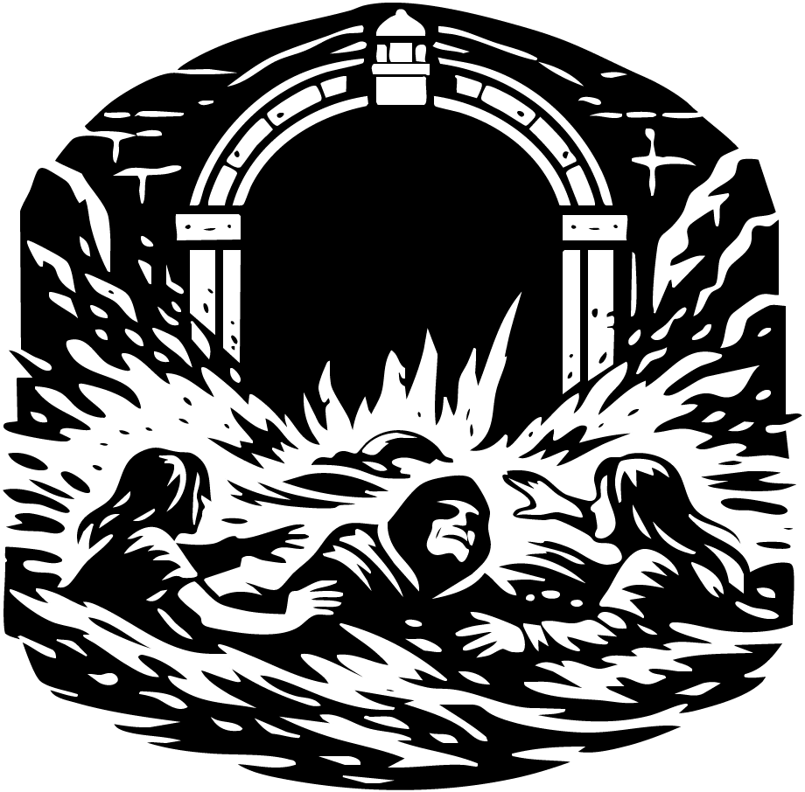

The Horrors Of The Portal
Elsie’s scream went shuddering through the chamber and seemed to cling to the stone long after her voice had broken. For one terrible moment no one moved. Then Ernest turned and fled for the stairs by which we had entered, driven by that blind animal terror which at last strips all reason from the mind.

Frederick seized my shoulders and looked straight into my face.

“Close your eyes,” he said, his voice low but urgent. “And I will get you out of here.”

There was something in his expression that left no room for argument. Trembling, I obeyed. I shut my eyes, and at once his hand closed firmly around mine as he began to guide me toward the stairs.

But before we had gone more than a few steps, we heard the words no soul ever wishes to hear when hunted underground.

“The door is locked!” Ernest cried.

I opened my eyes at once.

The terror in his voice seemed to tear through the chamber more sharply than Elsie’s scream had done. He stood at the foot of the stair, beating his hands against the hidden door above, his face wild with disbelief. The way of escape had been sealed.

Then I heard another sound.

Not footsteps. Not the rush of water.

Something else.

Something swift and dreadful, cutting through the air behind us.

I turned just as a body came flying out of the radiant archway with appalling force. Instinct overcame sense; I thrust Frederick away from me with both hands, and in doing so lost my balance and fell heavily to the flooded stone.

The figure in the green cloak shot past where we had stood and struck the staircase with a sickening crack. His body crumpled against the steps. Blood ran from the corner of his mouth, black in the ghastly light.

He lifted his head only once.

“Run,” he whispered.

Then his eyes closed, and whether he died or merely fell insensible, I could not tell.

I pushed myself upright at once, my heart pounding so violently it seemed it must burst. My first thought was Frederick. I turned in terror, and there he was staggered, shaken, but alive.

Relief had scarcely touched me when I became aware of a coldness spreading over my hands.

Water.

I looked down. It was rising across the floor, dark and swift, pouring around the table legs and over the ancient carvings as though the chamber itself had sprung a wound.

“Water!” Elsie cried. “It’s flooding out of the portal!”

I looked up.

The golden arch no longer shone with cold beauty, but with a violent and unnatural radiance, and from it came not only light but a great surging torrent. The sea itself seemed to have forced a way through that infernal threshold. Water burst from it in a roaring flood, and with it came bodies.

The men in the red and black cloaks were hurled out next, thrown upon the current like broken things. They struck the chamber floor hard, then were seized at once by the black rush of water.

The force of it swept across the room with monstrous strength.

It caught me before I could reach Frederick and tore me away from him.

“No!” I cried.

My voice was swallowed at once by the roar.

The green-cloaked man’s body drifted toward Frederick, while the one in black was swept against me and Elsie as the chamber filled. I felt cloth, limbs, stone, and cold water all colliding at once in the dark confusion. The current dragged at my skirts and pulled my legs from beneath me until I was lifted entirely from the ground.

Yet what terrified me most was not the water.

It was the weight upon my chest.

It felt as though some invisible hand had closed over my heart and lungs together, pressing the breath from me, not drowning me but crushing me from within. My mouth opened, yet the air came thin and sharp, as though the chamber itself had forgotten how to breathe.

Around us, bodies and fragments of light and shadow spun through the flood. The pillars vanished behind sheets of black water. The table, the blood upon it, the dead or dying men, the dreadful portal itself all grew strange and distant, distorted beneath the chaos.

Then the current dragged us beyond the golden light.

Not back toward the stairs. Not toward the church above.

But through a narrow archway at the far side of the chamber, into another room still deeper below the earth

and into a darkness that felt older than the sea.

I fought for breath as the flood hurled me onward.

The water had no mercy in it. It struck me like a living thing, dragging me through the blackness, smashing me against unseen stone, filling my ears with its roar until I could no longer tell whether the sound was outside me or within. Each time I forced my head above the surface, I snatched only the thinnest scrap of air before the current seized me again.

And with every choking breath came memory.

Not this chamber. Not the church. Not the dreadful portal.

But the river.

That terrible night when I had fallen in half-drunk, the dark water closing over me while the world spun above like some mocking dream. I remembered the helplessness of it the cold in my lungs, the blind panic, the certainty that the river had opened its black mouth to swallow me whole. That same terror rose now with such force that I could scarcely think. My limbs moved, but my mind had become a child’s, full only of one desperate plea:

Not again. Dear God, not again.

The torrent flung me through a narrow opening and cast me at last into another chamber. I struck the far wall hard enough to drive the breath from me, then slid half beneath the surface as the water surged around me. The room was small horribly small and close-walled, the stone pressing in on every side like the inside of a tomb. There was no sky, no open air, no sense of escape. Only rising black water and walls slick with age and damp.

For one sickening instant, surrender seemed almost a kindness.

Then another body came crashing into the room with the flood a man in a black cloak, limp as the dead.

Elsie followed close behind him, thrown in by the same savage current. She surfaced with a gasp, her hair plastered to her face, her eyes wild.

I had seen fear in my sister before, but never like this.

Elsie looked about the little chamber, and I watched the horror overtake her as she understood the size of it. The walls were too near. The ceiling too low. The flood still rising. Her breath came short and ragged, quick as if she were already choking.

“No,” she whispered, though whether to me, to the room, or to herself, I could not tell. “No, no ”

“Elsie!” I cried.

She forced her eyes toward me, but they were wide with that trapped, hunted look I knew too well. Claustrophobia had her by the throat now as surely as the water had me. The chamber was becoming a coffin around us.

The black-cloaked man floated face-down between us.

Together we lunged for him, stumbling and swimming through the freezing water. We caught hold of his shoulders and turned him over. His head lolled. His skin was ghost-pale.

“Wake up!” Elsie cried, shaking him.

The water was at our shoulders now.

“Wake up!” I shouted too, though my own voice broke with terror.

At last the man’s eyes flew open.

I recoiled.

They were black.

Not dark blue. Not shadowed.

Black as pitch, black as drowned wells, black as the spaces beneath graves.

He drew in one long, shuddering breath, and as he blinked, the darkness passed from them. Their colour returned slowly, revealing an ordinary blue that somehow seemed no comfort at all.

“What in God’s name is happening?” I gasped.

He looked at us in confusion, as though he had expected some other place entirely.

“Did we win?” he asked.

Elsie gave a sharp, breathless laugh that had no mirth in it.

“If by winning you mean two of your companions dead, one missing, and one still on the other side of that nightmare, then yes,” she said. “You won splendidly.”

The man smiled faintly, a strange crooked smile even now.

“You know,” he said, “you might simply have said no.”

Then, to my astonishment, he pushed himself upright and began wading toward the torrent still pouring into the room.

“Who are you?” he asked over his shoulder. “And what are you doing here?”

“We were only passing through,” I said, still fighting to keep my voice steady. “We came from the pub. We did not mean to find any of this.”

He lifted a hand toward the water.

At once a red light burned to life around his fingers.

I stared.

The flood rushing through the opening shuddered, slowed, and then before my very eyes began to harden. Water became stone. The torrent sealed over with a grinding sound, as though the room itself were closing its own wound.

Elsie and I both stared in disbelief.

“How did you do that?” Elsie asked, her voice still strained and too quick. She kept glancing at the walls, at the low ceiling, at the black water pressing around us, as though the chamber might shrink yet smaller.

The man turned from the sealed passage and gave us a look I could not quite read.

“This world is more than ordinary people have ever been allowed to know,” he said. “This world this multiverse was shaped by beings who wielded five great powers. Red, blue, green, black, and white. Reality, time, soul, death, and life.”

His voice echoed strangely in that little room.

Elsie frowned, trying to force her breathing slower, forcing thought through panic. “The symbols on the table,” she said. “That’s what they meant. Different kinds of magic.”

I heard her, but my mind had fastened upon nothing except the water.

It was up to my neck now.

Every movement made it lap cold against my mouth. Every breath felt stolen. I could not stop imagining the room filling completely, the last pocket of air vanishing, the ceiling pressing down while the dark water closed over my head.

I could not bear it.

“How do I get out of here?” I cried, my voice rising almost to a scream. “How the hell do I get out of here?”

The man looked at me then with sudden understanding, though whether he saw my fear or merely my desperation, I could not tell.

“This chamber is connected to the others,” he said. “If I can open the way, the flood should carry us through.”

I turned toward him, trembling.

At the far side of the room stood another archway, though unlike the golden portal beneath the church, this one was fashioned of metal, old and salt-stained, with the shape of a lighthouse worked into its crown. It stood there like some relic dragged up from the floor of the sea, heavy and strange and waiting.

The man laid his hand upon it.

The metal gate groaned.

Then it opened.

At once the water lurched toward it as if drawn by a vast unseen mouth. The force of it seized us all. Elsie cried out. I barely had time to snatch one desperate breath before the current tore us off our feet and dragged us toward the yawning threshold.

And together we were pulled through.



The Lighthouse

Multiverse Of Time, Earth, New Zealand, Kahurangi Point Lighthouse 1909, 12 February, 5:45 PM
The flood drew us through the iron threshold and cast us into a cavern beyond.

For one bewildered instant I could make sense of nothing. There was only the crash of water, the bitter sting of salt in my nose and throat, and the bruising force of the current as it dragged me across the stone. Then I was thrown hard against the cavern wall, and pain burst through my side so sharply that I thought I had cracked a rib.

I cried out and clutched at the rock, fighting to keep my senses.

Before me stood yet another gate of the same grim design as the last metal-bound, severe, and ancient, its arched frame marked with an emblem that bore an uncanny likeness to the church above, as though this whole hidden world had been built in mocking reflection of holy things. The ironwork was black with age and wet with spray, and in the dim light of the cave it seemed less a doorway than a snare set for the unwary.

The man in the black cloak regained his feet far more easily than I did. He gave the faintest of smiles as if such terrors were ordinary to him then turned and began to walk toward a dark opening farther within the cavern.

Elsie and I stared after him.

“Where are you going?” Elsie called.

I tried to rise, but the moment I pushed myself upright, sickness overtook me. I bent double and was violently ill upon the stone, my whole body shaking with exhaustion and shock. Elsie hesitated only a second before following the man a few paces, then looked back at me with alarm.

Behind us, the water struck the cave floor and broke apart, scattering over the rock before rushing away through narrow channels and cracks, pouring downward with a dreadful ceaseless murmur until it vanished into the sea below. The cavern seemed alive with the sound of draining water, as though the earth itself were swallowing the flood.

I sank to my knees, one hand braced against the stone, trying to steady my breath and clear my sight. The world swam before me.

When at last I lifted my head, I saw the black-cloaked man returning.

In one hand he carried a scroll, old and tightly bound. About his wrist there gleamed a strange bracelet that seemed not forged of gold, but made of liquid sunlight something bright and molten held unnaturally in shape. Its light shivered over the wet stone and made the cavern walls gleam like the insides of a tomb.

He passed me without explanation and went back toward the iron gate.

Elsie hurried to my side and slipped an arm beneath mine, helping me struggle unsteadily to my feet.

“What are you doing?” she asked him.

This time he answered without turning.

“Stay here.”

His voice rang sharply through the cave.

Then he stepped through the gate once more and raised his hand. Red light sprang from his fingers fierce, unnatural, and alive and somewhere beyond the threshold we heard the grinding crack of stone shifting against stone.

He was opening the sealed passage.

A moment later the trapped water came surging back.

It thundered through the reopened way, rushing past the gate and flooding out beneath the lighthouse, where it spilled at last into the waiting sea. The sound of it was immense and hollow, like the breathing of some great beast buried beneath the earth.

Elsie tightened her hold on me.

Together we began to move against the pull of the water, step by step, each foot placed with care upon the treacherous stone. The current fought us, cold and insistent, dragging at our skirts and boots as though it wished to claim us again.

Still we pressed on, one step before the next, deeper into that dreadful cavern where the air smelled of salt, old iron, and secrets too long hidden from the sun.

Multiverse Of Time, Earth, Norway, Inside Secret Room Stave Church, 1909, 12 February, 5:55 am
With Elsie’s arm about me, I let her guide me back through the iron threshold, my steps weak and unsteady upon the flooded stone. Every limb ached. My lungs still burned from salt and panic, and the chill of that black water seemed to have sunk into my very bones. Behind us, the cavern groaned softly with the retreat of the sea, as though the earth itself were troubled by what had been loosed beneath it.

The man in the black cloak glanced back over his shoulder.

“You should return,” he said. “It would be safer for you there.”

His tone was calm, almost careless, as though safety were still a thing that could be promised in such a place.

I looked at him through the dimness, struggling to master my breath. “Then why did you open the portal in the first place?”

That drew from him the faintest smile.

“It is curious that you think we opened it,” he said. “We did no such thing. The portals open of their own accord. Once, we were forced to keep men constantly watching them. But Toby LivingHood found a means to give us warning twenty-four hours before one stirs.”

As he spoke, he turned and began to walk again toward the black portal. Elsie and I followed, though not without dread, the wet stone cold beneath our feet and the shadows about us seeming to gather closer with every step.

“Have you ever heard of ley lines?” he asked.

“No,” Elsie answered.

He inclined his head slightly, as though he had expected as much.

“They are unseen lines said to run across the world, binding certain places to one another. Some believe them ancient paths of trade or travel. Others say they are the roads by which souls journey into the next life. Whatever their true nature, we know this much: vast currents of power move through them. If that force gathers unchecked, it strains the fabric of all worlds. The founders of Patrons made these portals to receive the overflow to prevent the multiverse from splitting under its own burden.”

His voice echoed strangely in those hidden chambers.

“But there is another way to close them,” he continued. “A manual way. A spell. It is written upon the scroll.”

By then we had returned to the chamber of pillars and carved stone, the dreadful room beneath the church where so much blood had already been shed. The ancient table still stood at its centre, marked with its five symbols, and the golden portal yet burned upon the far side like a wound in the dark. Water glimmered in shallow pools across the floor. The dead lay where they had fallen.

The black-cloaked man turned to Elsie and me.

“I am going to try to save this,” he said. “But if I fail, you must use the spell.”

Then he looked to the bodies strewn across the chamber floor.

What happened next I shall remember with horror until my own grave takes me.

A darkness began to rise from him not shadow, but something thicker, fouler, more intimate. It poured from his hands and from the folds of his cloak like black smoke steeped in malice. It crept over the stones and around the dead, and where it touched them, they stirred.

Elsie gasped.

William’s body twitched.

Then, slowly, impossibly, he began to rise.

“William?” Elsie cried, her voice breaking with sudden hope. “William, you’re alive?”

I caught hold of her at once.

“No,” I whispered, though whether I spoke to her or to myself, I do not know.

The man in black did not turn as he answered.

“They are still dead,” he said. “But that does not mean they are useless.”

His voice was cold as the grave.

One by one, the corpses lurched upright. Their movements were wrong too stiff, too delayed, like marionettes whose strings were pulled by an unseen hand. William stood among them, blood still staining his chest, his face pale and emptied of all that had made him human. The others rose likewise, their dead limbs obeying that dreadful summons.

Then they began to walk.

Not toward us.

Toward the golden portal.

Elsie broke into tears against me, and I wrapped my arms around her, holding her back as though I might shield her from the sight, from the truth, from the terrible desecration of what had once been our friend.

Then, over the sound of her sobbing, I heard voices I knew.

“Thank God you’re alive.”

I turned at once.

Adolf and Frederick were coming toward us from the shadows, soaked, pale, and battered, but living. Relief struck me so sharply it was almost pain. Elsie tore free of my arms and ran to them, and I followed a moment later, all three of us clinging to one another with that desperate gratitude only terror can draw from the heart.

For one blessed instant, the chamber, the dead, the portal, the whole nightmare beneath the church fell away.

Then a movement behind them made me lift my head.

The man in the green cloak had entered silently after them.

He looked from Adolf and Frederick to the black-cloaked man and said, “What is the plan, Black?”

The man in black smiled, though there was no comfort in the expression.

“To kill this monster,” he said, “and close this blood-portal.”

The words seemed to darken the air themselves.

Then, without another word, the men in green and black turned together and passed through the golden light.

And once again the portal swallowed the living as easily as it had the dead.



Impossible Choices
We drew apart at last from our embrace, though the comfort of it had scarcely touched the terror pressing in upon us. My hands were trembling as I looked down and saw the scroll still clutched within them. With numb fingers I broke the binding and unrolled it.

Within were not words alone, but diagrams.

They had been drawn in a careful hand, precise and ancient-looking, the ink faded with age. I saw at once the image of the portal, and on either side of it, small markings that appeared to be levers or switches. Beneath that was another drawing the stone table, its symbols set out in some deliberate arrangement, as though the whole chamber were less a room than a mechanism waiting to be understood.

I lifted my head to call Frederick’s attention to it.

And then I saw his eyes.

At first I thought the dimness deceived me. But no the green of them was changing. The pupils narrowed and twisted, lengthening into shapes too sharp and unnatural for any human face. They became like diamonds, hard and inhuman, and then the colour bled out of them altogether until they glowed a dreadful red.

My breath caught in my throat.

“Frederick,” I whispered. “Are you all right?”

He turned to me.

There was no warning.

He struck me with such force that the world vanished into a storm of pain and motion. I was flung backward, the scroll torn from my hands as I hit the stone floor and slid across it. For a moment I could neither think nor breathe.

Adolf shouted and hurled himself at Frederick, driving his fist into his face.

Elsie cried out, “What is wrong with you?”

Frederick only smiled.

It was not his smile.

He lifted his head slowly, and those red eyes shone with a malice so cold it seemed not born of anger, but of contempt. He rose and struck Adolf in turn, sending him crashing to the ground.

“Stop!” I screamed. “Stop, for God’s sake!”

At the sound of my voice, Frederick went still.

He turned and looked at me.

When he spoke, the voice that came from him was not the voice I knew. It was deeper, rougher, as though another thing altogether had forced its way into his throat and borrowed his flesh to make itself heard.

“This world is mine for the taking,” it said. “I am done with you crawling ants. Leave now, or be slaughtered.”

Elsie and I stared at one another in horror.

“That is not him,” I said, though my voice shook.

Then the portal convulsed.

A great tentacle came lashing through the golden light, black and glistening, its monstrous bulk striking the air with a sound like wet canvas snapping in a gale. It writhed into the chamber, scattering water and shadow.

Frederick turned toward it and said with a terrible grin, “You are right. That is me.”

Before he could say more, Adolf launched himself at him again and drove him to the ground.

“Shut the bloody portal!” he shouted.

Elsie did not hesitate. She ran at once toward the glowing arch.

I scrambled across the stones, snatched up the fallen scroll, and forced my eyes over its frantic diagrams. “There’s a switch!” I cried. “At the bottom of the portal on both sides!”

Then I ran to the table.

The carved symbols upon it no longer seemed merely decorative; I saw now that parts of the design could move. The pattern had been disturbed broken, incomplete, like the pieces of some ancient lock thrown out of place. With shaking hands I began to shift the carved sections, turning them inch by inch, trying to make the symbols align with the drawing on the scroll.

Behind me I heard the sickening sounds of the struggle.

Adolf and Frederick crashed against pillars and stone, each blow landing with a force that made me flinch. I could hear their breath, their curses, the brutal rhythm of fists striking flesh. Somewhere in that nightmare of movement and noise, blood was beginning to spill painting the chamber in dreadful streaks of red.

The tentacle swung wildly through the room, thrashing from side to side as though it sensed what Elsie meant to do. She ducked beneath it, but only narrowly; the thing smashed against the pillar beside her with enough force to crack the stone.

Then the man in the black cloak came flying back out of the portal.

He struck the table with a violent crash, hard enough to make the whole mechanism shudder beneath my hands. I nearly lost my grip, but I saw then at last the pattern beginning to resolve itself. The lines were connecting. The design was almost complete.

Almost.

And then Frederick broke free.

He drove Adolf backward with such force that my brother slammed into me, and the three of us went down in a tangle upon the cold stone. The scroll flew from my hand once more. I hit the floor hard, and as I looked up through pain and confusion, I saw that we had fallen directly before the black-cloaked man

I lifted my eyes to the man in the black cloak.

Blood ran from the corner of his mouth in a dark and glistening thread, staining his chin and falling in slow drops upon the ancient stone. There was something dreadful in the calm of his face then something almost tender, and therefore more terrible still, as though he had already passed beyond fear and grief and entered that last solemn country where a man belongs more to death than to life.

He looked at me.

“Forgive me,” he said.

The words were scarcely louder than a sigh.

Then, with a final and desperate gathering of strength, he cast himself against the table and forced the last broken piece into its rightful place.

At once the chamber was transfigured.

The carved lines upon the stone blazed with white fire, each symbol kindling in turn until the whole table shone like some altar awakened for sacrifice. Light flooded the grooves and markings as though the rock itself had begun to bleed radiance. It spread outward in trembling veins, climbed the pillars, and threw great wavering shadows up against the walls, until the room seemed no longer hidden beneath a church, but suspended somewhere between heaven and perdition.

Elsie, who had drawn back in terror, raised one arm before her face as the portal answered. A white seam of light split across its golden frame.

Then the tentacle came.

It struck with the swiftness of judgment.

I saw it sweep across the chamber like a black scourge, saw Elsie turn too late, saw her slight body taken by that monstrous force and dashed against the wall with a violence so savage that the cry died on my lips before it was born. The sound of her striking stone was worse than any scream. It was the sound of something fragile and beloved meeting ruin.

“Elsie!”

I think I called her name. I think I did. But whether it was my voice or only the voice in my own soul breaking apart, I cannot say.

I turned then and beheld the end.

The portal was collapsing in upon itself. Its golden circumference warped and bent like metal thrust into a furnace, while the white light within it deepened into a terrible brightness no mortal eye was meant to endure. The great limb of the beast writhed and lashed, caught fast between one world and another, and in that convulsion Adolf and Frederick were taken.

They were too near.

God help me, they were too near.

The tentacle swept about them both in its death-agony, and then the portal, as though possessed of hunger, began to draw all things toward itself. I saw Adolf struggle. I saw Frederick caught in that dreadful pull. For one single instant one cruel, eternal instant their bodies were outlined against the devouring light.

Then they were torn from me.

Swallowed.

Taken whole into that collapsing abyss, together with the black and glistening horror that had hunted us from the sea.

I screamed then. I know I screamed, because I felt my whole body tear with it. It was not a sound I had ever made before. It was not human grief alone, but something older and more desolate the cry of a soul forced to witness the destruction of all it loves and still be left alive to remember it.

Then the light folded inward.

The chamber gave one long shudder.

And all was still.

No thunder followed. No crash. No mercy.

Only silence.

A silence so absolute and unnatural that it seemed the world itself had stopped in horror at what had just been done.

I could not think. I could scarcely breathe. Yet some remnant of love, stronger than terror, drove me to move. I stumbled across the stones and fell beside Elsie.

My sister lay where she had fallen, broken against the foot of the wall like some abandoned doll. Her face was white so white it seemed already claimed by death. I touched her cheek, her throat, her hand. For one sickening moment I found nothing.

Then at last the faintest breath.

So small. So fragile. A thread.

She lived.

Barely.

I bent over her, shaking, one hand upon her breast as if I might hold her soul inside by force of love alone. Then I lifted my head and looked across the chamber.

The man in black was rising.

He did not seem altogether a living thing any longer, but some dim and failing figure dragged upright by duty alone. Blood marked his mouth. His face had taken on that dreadful stillness I had seen only once before, at my father’s bedside in the hour before the end.

“What have you done?” I cried to him. “What have you done to them?”

My voice rang out through the chamber and came back to me hollow, thin, and useless.

He swayed where he stood.

But he did not look away.

“I stopped it,” he said.

No triumph lived in those words. No pride. Only exhaustion. Only finality.

Then, with hands that could scarcely obey him, he drew from within his cloak a small device of metal and glass, curious in shape and coldly mechanical, as if made for purposes beyond the understanding of ordinary men. He pressed his thumb to it.

A single click sounded.

Small. Precise. Irrevocable.

It was the slightest sound in all that cavern of death, and yet I felt in it the shutting of a thousand doors.

The last strength went out of him.

He fell.

Not dramatically, not with struggle, but simply as a candle goes out when there is no wax left to burn. One moment he stood among the dead, and the next he lay upon the stone as one of them.

And then there was no one left.

No Adolf.

No Frederick.

Only Elsie, broken and breathing faintly in my arms. The bodies. The blood. The extinguished portal. The dreadful table still gleaming with the after-memory of its light. And I, kneeling in that buried chamber beneath the church, with grief so immense it seemed to hollow out the whole of creation.

It is a strange thing, the instant in which the heart understands it has been abandoned by hope.

I felt it then.

Not as a cry, nor even as despair, but as a vast and inward collapse like the falling of great stone vaults in some ruined cathedral of the soul. Everything within me that had reached toward comfort, rescue, providence, or return was crushed beneath that weight.

I was alone.

Truly alone.

Trapped in a sepulchral room full of silent portals, each one dark as a sealed grave, and without the power to open even one.

I gathered Elsie to me as best I could and bowed over her, while the dead looked on and the cold stones kept their counsel.

And in that hour it seemed to me that God had turned His face away, and left only darkness enough to remember the shape of those He had taken.



The Good Bye

Multiverse Of Time, Earth, Norway, Hollagruvene, 1912, 18 March, 6:00 pm
The old oak stood upon the mountainside like some ancient mourner, its great branches stretched wide against the dim and whitening fog. Beneath it I sat in silence, with only the cold earth beneath me and the weight of memory for company. A faint smile, sad and unwilling, touched my lips as I recalled another time, when Adolf, Elsie, and I had run laughing about that very tree, our voices carrying into the mountain air as though sorrow were a thing that could never find us there.

How little we had known.

Now the mist crept low across the ground, pale and shifting as a burial veil, and the mountain seemed emptier than any place I had ever known. Since that dreadful morning, loneliness had settled upon me with a heaviness almost mortal. Adolf and Elsie had been torn from my side, and I had believed myself abandoned at last to the vast and merciless silence of Norway, with none left to call my own.

Yet grief, when it does not kill, alters the soul into something strange.

I lowered my eyes to the pale symbol marked upon my hand the white sign of Life, stark against my flesh, its faint radiance seeming almost unnatural in the gloom. For a long while I regarded it without speaking, as though within that small mark there lay the whole terrible history of what I had become.

“I do not repent it,” I said at last, and my own voice sounded distant to me, scarcely more than a murmur in the mist. “Not truly.”

The words were carried off at once by the wind, yet I spoke them again, more firmly.

“I do not repent joining the Cloaks.”

There had been a time when even the thought would have filled me with bitterness. They had stood too near the ruin of my life; their shadow had fallen across the deaths of those I had loved best. And still, when all was ended and I had been left among the ashes of myself, it had been they who gathered me from that desolation. They had not restored what had been taken from me no earthly power could have done so but they had given shape to my suffering. They had taught me that grief need not be an empty chamber forever echoing with the dead. Even sorrow, in their hands, might be turned toward purpose.

It was a fearful comfort, and yet a comfort all the same.

“They were the reason I lost everything,” I whispered, with a bitterness that had not altogether died. “And yet… they did not leave me to perish in it.”

I rose then and went to the tree, laying my hand upon its rough and ancient bark. It was cold to the touch, and so familiar that for one unguarded moment my heart faltered within me. The mountain, the fog, the silence all of it seemed thick with the presence of those who had once stood beside me and would do so no more.

“May you rest in peace,” I said softly, though whether I spoke to the dead beneath the earth, or to the children we had once been, I could not have said.

For a little while there was no sound but the wind moving through the branches overhead.

Then I heard footsteps.

They came faintly at first, muffled by the fog, but drawing steadily nearer. I turned at once, every nerve within me sharpened by old fear. Through the mist I saw two figures approaching only dark shapes at first, uncertain and half-formed, like spirits wandering out of some borderland between this world and the next.

My hand closed into a fist before I had thought to move.

Then, from within that whiteness, a voice reached me dear and impossible, remembered with too much pain to be mistaken.

“Sister.”

The word seemed to pass through me like a blade.

I stood motionless. My hand slackened. For one dreadful instant I believed myself the victim of some cruel fantasy born of longing and grief. My breath caught in my throat, and my heart beat with such violence that I thought it must surely break.

But the figures came nearer, and the mist no longer concealed them.

Then all at once they were running toward me.

A great and terrible joy rose in me, so sudden that it was almost anguish. I ran to meet them without thought, as though drawn forward by some force stronger than reason, stronger than fear, stronger even than death itself. The fog rushed past me, the cold air burned in my lungs, and for the first time since that black morning, the loneliness which had haunted me so cruelly seemed to loosen its grasp.

In that moment, I no longer felt forsaken.

I no longer felt alone.

