

By Kyle E Young

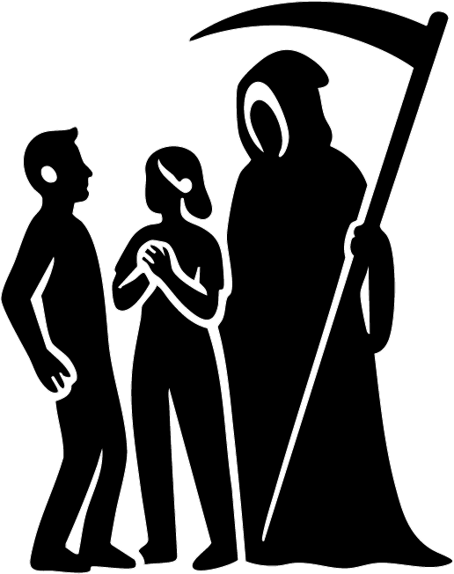

Let's Dance In Style
Michael gripped the steering wheel so hard his knuckles paled.

The road was a narrow ribbon cutting through thick fog, the kind that swallowed headlights instead of reflecting them. Trees slid past on either side like dark fence posts. Every so often a branch snapped somewhere deeper in the mist—sharp, close, then gone again.

Then the car speakers crackled, and Alphaville came on.

Forever Young.

Michael’s mouth twitched into a smile. For a moment, the fog didn’t matter. He tapped the wheel to the beat, nodding along as if the song could keep the night away.

“Let’s dance in style, let’s dance for a while…”

He sang louder, trying to match the timing, watching the trees streak by.

“Forever young…”

The blue glow from the console painted his face. The words felt strangely perfect out here, like the song had been waiting for him.

“Do you really want to live forever…”

He glanced up—then froze.

The trees weren’t moving.

They hung in place like a paused video, sharp and still. The fog didn’t drift. Even the dust in the beam of his headlights looked pinned in midair.

Michael blinked hard. Once. Twice.

The speedometer read 50 km/h.

His stomach dropped. “What the hell…?”

He lifted his foot off the accelerator.

Nothing changed.

He tried the brake. The pedal didn’t budge, as if it was welded to the floor. The steering wheel felt locked in place. The air inside the car suddenly seemed too quiet—too thick—like the fog had seeped through the windows.

Michael snatched up his phone. The screen was on… but the time didn’t tick forward. The icons didn’t respond. Even the tiny loading circle was frozen halfway through a spin.

A cold prickling crawled up his neck.

He shoved the door open and stepped out.

The night hit him like a wall.

Outside the car, the world was wrong. The fog hung perfectly still. The gravel road looked like it had been glued together. Michael waved a hand in front of his face. His breath didn’t even show.

“Okay,” he whispered. “Okay… what is this?”

He walked around the front of his car, heart hammering, trying to find anything moving.

And that was when he heard a woman’s voice cut through the fog.

“Oh come on! I can’t be dealing with this right now!”

Michael turned toward it. Through the white haze, headlights glowed—another car, stopped at an angle as if it had skidded to a halt.

A blonde woman stepped out, slamming her door hard enough that it should have echoed… but the sound died instantly, swallowed by the fog.

Michael raised a hand. “Hey! Are you okay?”

She squinted at him, tense, shoulders tight. “Yeah, I’m fine. But my car’s acting insane. It says I’m going fifty, but I’m not moving. And my music just—” She gestured, frustrated. “It stopped.”

Michael’s blood ran colder. “That’s exactly what happened to me.”

The woman swallowed, forcing a shaky smile like she could joke her way out of fear. “Okay. Great. Love that for us.” She stepped closer. “I’m Janet.”

“Michael,” he said, and they shook hands—her palm cold, damp with panic.

The fog thickened behind them.

Not just thicker—darker.

Michael noticed it first, a slow bruise spreading across the white, rolling forward like something had weight. Like something was pushing through it.

He stepped in front of Janet without thinking.

The darkness moved closer, and the shape inside it began to form—shoulders, arms, a head—like a man being poured out of ink.

Michael’s voice came out rough. “Who the hell are you?”

The fog peeled back.

A man stood in the road as if he’d always been there.

He wore black pants, a black shirt, black shoes polished to a mirror shine. Over it, a white blazer that almost glowed in the headlights—except the bottom edge was stained with spreading black, like paint crawling upward.

He smiled like someone greeting old friends.

A deep voice rolled from him, calm and heavy. “I am Death.”

Janet laughed once, sharp and disbelieving. “No. No, you’re not.”

Death’s smile widened. “Didn’t you hear me?”

Michael’s throat tightened. He forced himself to speak. “Death isn’t a name. It’s… it’s a thing that happens.”

Death tilted his head, as if enjoying the argument. “Like my brothers and sisters,” he said softly. “Hope and Despair. Dream and Nightmare. Peace and Chaos.” His eyes flicked between them. “I am the beginning and the end.”

The air seemed colder with every word.

Michael swallowed. “Why are you here?”

Death glanced past them—at Michael’s car.

The speakers in Michael’s vehicle hissed. The song returned, but warped, slow, like a tape being dragged through mud.

“Forever and ever…”

Michael turned.

His car was moving.

Not fast. Not loudly. Just creeping forward on its own, tires rolling without sound, aimed straight toward Janet’s stopped vehicle.

Janet stumbled back, eyes wide. “Stop it! Stop—!”

The song cut out again like someone snapped a wire. The cars froze mid-roll.

Janet’s voice trembled, but she tried to sound brave. “You’re here to collect something, aren’t you? Like… a postman.” Her laugh cracked. “Only it’s not about what you drop off. It’s what you take.”

Death looked down at the gravel road, almost thoughtful. “It isn’t about what I’m here to collect,” he murmured.

Michael’s chest tightened, panic clawing up his throat. “Are we dead?” he demanded. “Because I can’t be. I have kids. I’m the one keeping everything together. I—” His voice broke. “I can’t.”

Janet slid down the side of her car, suddenly weak, pressing her hands over her face. “My baby,” she whispered. “Danielle… she’ll grow up and never know me.” Her shoulders shook. “My parents… losing their child…”

Death watched them like a judge who’d heard these speeches a thousand times.

“You are not dead,” he said.

Janet snapped her head up, mascara wet at the corners. “Then why are you here?”

Death’s gaze shifted back to the cars. “Because where there is death,” he said, “there is always death.” His voice lowered. “But sometimes… not everyone has to die.”

The song jolted back on, loud and sudden:

“I want to be forever young…”

Michael’s car lurched forward again. Janet’s car shuddered as if yanked by an invisible hand.

Janet screamed and grabbed her door handle, but the metal didn’t move. The world was still holding them.

Then—silence.

Everything froze again.

Death stepped closer. The fog curled around him, swirling now, finally moving—only around him, like he was the only thing in the universe allowed to breathe.

“A choice must be made,” he said.

His outline flickered.

For a blink, he was still a man.

Then—something else.

A taller silhouette. A hood. A long, thin shape in his hand that glinted like a blade.

Janet’s breath hitched. Michael couldn’t move at all.

“I can save one of you,” Death said, voice layered now—two tones speaking at once. “But not both.”

The fog surged and whispered, and the song returned one last time, distant, like it was coming from underwater.

“Do you really want to live forever?”

Death’s smile was the last thing Michael saw clearly.

Then the fog snapped shut.

He was gone.

Michael and Janet stared at the empty road, the still trees, the frozen world.

Janet’s voice came out small. “Michael…”

He turned to her, throat dry, hands shaking.

In the dead quiet, with the cars poised like weapons behind them, they understood the worst part.

It wasn’t whether Death was real.

It was that the choice was, too.



Forever young
Michael turned to Janet.

Her eyes were flat now, like she’d already made peace with what was coming.

“So,” she said quietly, “you have to be the one to die.”

Michael recoiled like she’d slapped him. “Fuck off. I’ve got a family to take care of.”

Janet started toward his car, boots crunching on gravel that still didn’t sound right in the dead air. “And I have a baby,” she snapped. “She’s at my mum’s place. My mum is seventy and she’s barely holding on as it is. I can’t leave Danielle with her.”

Michael’s anger faltered. “What about the father?”

Janet’s jaw tightened. “He vanished the second she was born. Don’t know if he’s dead or just running. Either way, he’s gone. So yeah.” She pointed at him. “It has to be you.”

Michael gave a humorless smile. “One kid? I’ve got five.”

Janet’s mouth twitched. “Dude, learn how to use a condom.”

“By your logic,” Michael shot back, stepping closer, “it should be you. I’ve got more mouths waiting for me.”

Janet didn’t blink. “How old are they?”

Michael hesitated, then forced it out. “Oldest is seventeen. Youngest is three.”

Something shifted in Janet’s face—pain, envy, something sharper.

“At least,” she said, voice cracking, “at least some of your kids know you. My Danielle won’t remember me for a second. I’ll be a photo. A voice on a video. An echo.”

Michael leaned in, breath shaking. “No. I’m not choosing based on who will hurt more. Our lives aren’t the same. What about your job?”

Janet exhaled, bitter. “I’m a lawyer. Firm work. Long hours. Days, nights—whatever it takes.”

Michael scoffed. “So you keep rich people out of jail. You sound like a real saint.”

Janet’s eyes flashed. “You don’t know what I do. I’ve helped push projects through. I’ve helped people get into film, get stories told—stories that never would’ve seen daylight otherwise.”

Michael’s hands curled into fists. He stared at the road like it might open up and swallow him. “And did you ever think about who you pushed out?”

Janet’s voice hardened. “Only the scum.”

Michael looked up slowly. “You pushed out scum,” he said, “and you crushed a lot of good people as collateral.”

Janet frowned. “What are you talking about?”

Michael’s laugh was small and ugly. “I used to write for a TV show. Mystic Knights.”

Janet’s eyes widened. “I loved that show.” Her voice softened, surprised. “But then it… stopped making sense.”

Michael nodded once. “You stopped watching halfway through season four.”

Janet stared. “Yeah. How did you—”

“Because that’s when I got fired.” Michael’s smile didn’t reach his eyes. “Didn’t fit their new boxes. Same year I went unemployed. Had to switch industries. Painting. For less than half the pay. Not because I was bad—because people like you changed all the rules and pretended it was progress.”

Janet took a step toward him. “That wasn’t the goal.”

Michael’s voice rose, shaking with something close to grief. “And people wonder why everything turned to shit. Skilled people got tossed aside and replaced with amateurs. And now I’m struggling to feed my family because of choices you call ‘necessary.’”

The fog behind them thickened, pressing in like a crowd.

Then the cars moved again.

Slow—silent—unstoppable.

Michael’s car crept forward, drawn toward Janet’s like magnets. The speakers crackled alive, the song distorted and too loud in the dead air:

“Forever young… Some are like water, some are like the heat…”

Janet stumbled back, bracing on her door. Michael’s chest seized.

And then—

Everything froze again.

The music cut mid-word.

Michael reached into his pocket with shaking hands and pulled out a coin. “We flip,” he said, swallowing hard. “Heads for me.”

Janet stared at him like he’d lost his mind. “Are you serious?”

“I know,” he said quickly. “It’s stupid. It’s not fair. But we need a choice that isn’t—” He gestured between them. “This. There’s no reason two families should be destroyed because we can’t—”

Janet’s chin trembled. Then she nodded once.

Michael flicked the coin up.

It spun, catching the headlight glow—silver, perfect—turning end over end.

Black fog wrapped around it midair.

The coin stopped spinning like it hit invisible glass.

Death appeared beside them, close enough that Michael could smell cold rain and old dust.

“No,” Death said, voice calm as a closing coffin. “That’s cheating.”

The coin floated into Death’s hand as if it belonged there.

Michael’s mouth went dry. “How is that cheating?”

Death lifted the coin, studying it. His white blazer was nearly swallowed now—black paint creeping higher, veins of darkness reaching for his collar.

“Because you are not choosing,” Death said. “The coin is.”

Janet’s voice came out thin. “So what? It’s random.”

Death’s smile was gentle in the worst way. “Random is not peace.”

He looked at Michael. Then at Janet.

“When you return to your car,” Death said, “everything you’ve said tonight will be gone. Like breath in fog.” He tapped the coin once. “The one who dies must indicate into the crash. They must feel… settled.”

Michael’s stomach rolled. “Indicate?”

“Yes,” Death whispered. “A decision made with intent. A final step taken with certainty.”

Janet’s eyes filled again. “And if we don’t?”

Death’s gaze sharpened. “If the coin decides, you will not be at peace.” His voice dropped, heavy. “And both of you will die.”

Michael’s blood turned to ice.

“And if either of you refuses to choose,” Death continued, “both of you will die.”

Silence swallowed them.

Then the cars lurched forward again as if the universe was impatient.

The speakers groaned back to life:

“Some are a melody and some are the beat… Sooner or later, they all will be gone…”

Janet clutched the roof of her car, knuckles white. Michael could barely breathe.

The cars froze again.

Death leaned closer, and for a split second his outline flickered—man, then something hooded and vast, a hint of a curved blade catching no light at all.

“When the song reaches,” Death said softly, “‘Youth’s like diamonds in the sun, and diamonds are forever,’ your time will be up.”

Janet made a broken sound. Michael stared at the ground, fighting the urge to run even though there was nowhere to go.

Death straightened.

“But,” he said, almost kindly, “there is one thing I will show you.” The fog coiled around him like fingers. “Something that may help.”

His voice turned into a whisper in their bones.

“Your loved ones’ lives… without you.”

The fog swallowed Death.

And in the distance, two lights appeared—faint at first, then brighter—glowing through the mist like open doors.

Michael and Janet stepped forward without meaning to, drawn toward the lights as if the road itself was pulling them in.

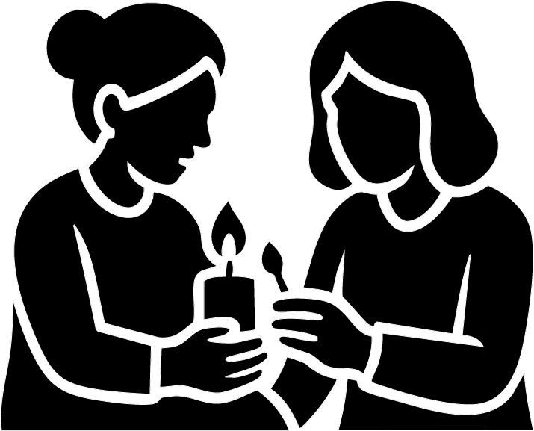

Diamonds Are Forever, Janet
Janet woke to the slow beep of a heart monitor and the sharp sting of disinfectant.

For a second she didn’t remember her own name.

Then she blinked, and the ceiling tiles swam into focus. Her throat was dry. Her body felt heavy, like she’d been poured into the mattress.

Beside her bed, her mother sat with Danielle curled in her arms, asleep and warm, tiny fingers wrapped around a lock of hair.

Janet tried to speak. Only air came out.

Her mother noticed. Her face broke into a shaky smile—relief so strong it looked like pain. “Oh thank God,” she whispered, standing quickly. “You’re awake. You’re here.”

Janet’s voice scraped out, small. “Where… am I?”

“In hospital,” her mother said, brushing tears off her cheek like she was annoyed with them. “You were in a car crash. They—” She swallowed. “They said you shouldn’t have made it the way you did.”

Janet’s mind snagged on one word. Crash.

Fog. Frozen trees. A song dragging like it was drowning.

And a man turning his car toward hers.

Janet’s eyes darted to the window. Outside, in the grey light, a woman stood in the carpark with children clustered around her. She was crying so hard she seemed to fold in on herself.

Janet sat up too fast. Pain flared in her ribs. “Who…?”

Her mother’s expression softened. “The man in the other car,” she said gently. “I heard his wife say his name was Michael.”

Janet’s stomach dropped.

“He—” her mother continued, voice trembling with disbelief, “he turned into your lane. Like he chose it. Like he was trying to take the impact. It’s… it’s amazing you’re here without major injuries.”

Janet stared at Danielle’s sleeping face, and the room tilted.

Michael.

The name felt like a weight around her throat. She could still hear the song. She could still see the fog closing over him.

And the last thing Death promised:

I’ll show you their lives without you.

Weeks later, the rain came down in thin cold sheets over the graveyard.

Janet stood under a borrowed umbrella, the ground squelching beneath her shoes. A small crowd surrounded an open grave. The air smelled like wet dirt and flowers dying too fast.

Michael’s wife stood at the edge, still as stone, a black veil clinging to her hair. Children pressed in close—five of them—eyes red, faces too young to look that tired.

Janet watched dirt hit the coffin.

Not loud. Not dramatic.

Just final.

When people began to drift away, the wife didn’t move. She stayed, staring down like she could will him back with stubbornness alone.

Janet walked over carefully, like approaching a wild animal.

“I’m so sorry,” Janet said. Her voice shook. “For your loss.”

The woman turned, eyes glossy but sharp. “How did you know him?”

Janet’s heart stuttered. She looked at the gravestone instead—MICHAEL carved into wet granite like the world was rubbing it in.

“I didn’t,” Janet admitted. “Not really.” Her fingers tightened around what she’d brought. “But he saved my life.”

She pulled out a cheque—$5,000—and held it out with both hands as if it might burn her.

“I know he was the main income,” Janet said quietly. “I just… I want to help. Even if it’s only for a little while.”

The woman looked down at the cheque, then back up at Janet. Something in her expression shifted—pain making room for pride.

“No,” she said softly. “I can’t take this.”

Janet’s face fell. “I understand. I just—”

“But,” the woman continued, voice steadier now, “if you truly want to help… you can fill his seat at the table tonight.”

Janet blinked. “What?”

The woman’s mouth trembled into the smallest smile. “My name is Isabella.” She touched her chest as she spoke, a habit of grounding herself. “In my culture, death isn’t the end. It’s a beginning. We remember. We keep them close.”

Isabella glanced back at the grave. “I will miss Michael every day I breathe.” Her eyes glistened. “And I’ll speak his name until I can’t anymore. But tonight…” She looked at Janet again. “Tonight my children will eat. And they will laugh if they can. And someone will sit where he should be.”

Janet’s throat tightened. “I can do that.”

Isabella nodded, as if the decision was already part of a larger story. “Then come.”

That night, Janet stood on a small porch with peeling paint and a warm light spilling through the window.

She knocked.

The door opened, and Isabella’s face appeared—tired, careful, kind.

Janet shifted Danielle higher on her hip. “Is it okay,” she asked, nervous, “if I brought one more?”

Isabella’s eyes softened immediately. “It’s always okay,” she said. “Come inside.”

The house smelled like cooked onions and rice and something sweet. Janet stepped in and saw it: a cabinet filled with candles and framed photographs—faces watching from different years, different smiles. In the middle was Michael, caught mid-laugh, like someone had told him a joke he didn’t want to admit was funny.

Janet stared, chest aching.

She looked down at Danielle. Whispered, so only her baby could hear: “This is a second chance. We don’t waste it.”

Isabella’s voice called from the hallway, gentle. “Kitchen’s through there. Bathroom’s that way.”

Janet hesitated. “Sorry—what did you say your name was again?”

Isabella smiled properly this time. “Isabella.”

Janet followed her into the dining room and stopped short.

A big table. Too big to ever feel empty—yet tonight it did. Five children sat around it, watching Janet with guarded curiosity and the kind of sadness kids think they’re hiding.

Isabella set plates down with steady hands. She moved like someone who had learned to keep going even when her chest was breaking.

Janet took the empty chair.

Michael’s chair.

The room didn’t get lighter.

But it got warmer.

One dinner became another. Once a month. Then twice. Then—without anyone naming it—once a week.

Janet worked brutal hours at the firm. She started sending money for groceries, for school shoes, for power bills. Isabella never asked, never begged—only accepted help the way you accept a hand when you’re drowning: with pride swallowed and eyes down.

And slowly, something new formed between them.

Not romance.

Something more.

Family.

Janet and Isabella grew close like sisters do: arguing over nothing, laughing too loud, sharing quiet looks across the room when a memory hit at the same time. Danielle grew up in that house as if it had always been hers too. Michael’s kids stopped flinching when Janet walked in. They started saving her a seat before she even arrived.

Years passed.

When Danielle turned twenty, Janet finally let herself live again—really live. She met a man named Connor, kind-eyed and patient, the sort of person who didn’t try to “fix” grief, just sat beside it. He loved Danielle like she was his own. He brought flowers to Isabella on the Day of the Dead without being asked.

And every year, Isabella lit candles.

Every year she said Michael’s name.

Every year she set out his photo, his favourite food, and sat at the table surrounded by the living—because that was how she fought the darkness.

Until one year, she couldn’t.

One year her hands shook too much to strike the match.

Janet sat beside her, took the candle, and lit it for her.

Isabella leaned her head on Janet’s shoulder the way you lean on someone you trust to hold you up.

“Thank you,” Isabella whispered.

Janet squeezed her hand. “Always.”

And when Isabella finally took her last breath—quiet, at home, with candles flickering nearby—Janet liked to believe Michael was waiting at the beginning of whatever came next.

Not as an ending.

But a new beginning.

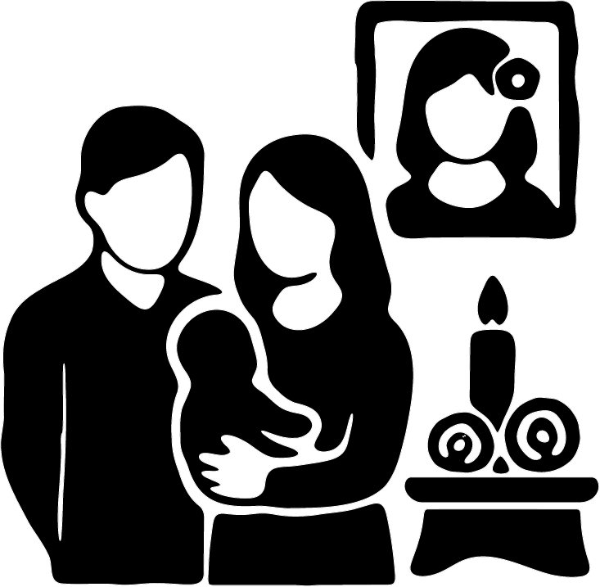

Diamonds Are Forever, Michael
Michael woke to the steady beep… beep… beep of a hospital monitor and the sound of someone crying like they were trying not to.

An old woman’s sobs.

He tried to move, but his body felt stitched together with pain. His eyelids dragged open and the ceiling lights stabbed his eyes.

Then Isabella was there—right beside him—grabbing his face with both hands like she had to prove he was real.

“Thank God,” she whispered, and hugged him so tight it knocked the air out of him. Her shoulders shook. “Thank God you’re okay.”

She pulled back just enough to scold him, her voice trembling into Spanish. “¿Qué estabas pensando? No me hagas eso.”

Michael managed a weak smile. “I’m sorry,” he rasped. “I didn’t… I didn’t mean to.”

He sat up slowly, wincing, and the room came into view—his kids piled near the door like they’d been waiting for permission to breathe. The second they saw his eyes open, they ran in, climbing onto the bed, hugging him hard, crying into his gown.

And across the room—

The old woman.

She held a baby wrapped in a blanket—Danielle—while tears ran down her face like she’d been leaking grief for days.

Michael looked at Isabella. “What happened?”

Isabella’s expression turned careful, the way it did when she didn’t want to break him again.

“There was a crash,” she said softly. “You got lucky.”

She glanced toward the old woman, then lowered her voice.

“Her daughter didn’t.”

Michael stared at the baby in the old woman’s arms.

A cold wave rolled through him, deep and slow, like fog creeping under a door.

Because he remembered.

The frozen road.

The swallowed sound.

Death’s voice: A choice must be made.

And then—nothing.

Like the world had cut the tape and left him with only the bruises.

A few weeks later, Michael found her sitting alone on a bench by the sea.

The wind off the water was sharp. Grey waves slapped the rocks like they were angry at the shore for existing. The old woman sat hunched, holding Danielle close and staring at the horizon as if she expected someone to walk out of it.

Beside her on the bench was a traditional urn.

Janet.

Michael stopped a few steps away, unsure if he was allowed to enter someone else’s grief.

But she looked up, and there was nothing left in her eyes to protect.

“Are you okay?” Michael asked quietly.

She gave a short, broken laugh. “No.”

He sat at the far end of the bench, respectful. Close enough to help, far enough not to steal her air.

“I don’t know how I’m going to do this,” she whispered, barely audible over the wind. “No mother should have to say goodbye to her daughter.” Her fingers tightened around the urn like if she let go, Janet would vanish all over again.

The baby made a tiny sound, and the old woman rocked her automatically, tears dripping onto Danielle’s blanket.

“I don’t have the strength for what’s in front of me,” she said.

Michael’s gaze went to Danielle—small, innocent, unaware she was the only thing left.

He hesitated. Then asked the question that tasted like rust. “Are you going to put her up for adoption?”

The old woman’s mouth trembled. “I’m going to have to. I’m seventy. My body’s failing. I don’t—” She closed her eyes. “I don’t have time.”

The wind screamed between them.

Michael swallowed. His hands shook, but his voice held.

“Then let me adopt her.”

The old woman turned slowly, as if she hadn’t heard correctly. “Why would you…?” Her brow furrowed. “Did you know Janet?”

Michael’s throat tightened. He chose his words carefully.

“Kind of,” he said. “Enough to know she’d want Danielle to know where she came from. Enough to know she wouldn’t want her to grow up alone in the system, not if there was another way.”

The old woman stared at him, suspicious and desperate at the same time—the expression of someone who’s been offered a rope but doesn’t trust the hand holding it.

Michael continued, gentler now. “You can visit whenever you want. You can be part of her life. And you can meet my family first—my wife, my kids. If it doesn’t feel right, we won’t do it. I’m not asking you to hand her to a stranger. I’m asking… for a chance.”

The old woman looked down at the urn.

Then at Danielle.

Then back at Michael.

Her voice cracked. “It… sounds good.”

A week later, she stood on Michael’s porch with Danielle bundled against her chest and the urn held like a fragile heart.

Michael opened the door and immediately stepped aside. “Come in,” he said softly.

Isabella appeared behind him, cautious at first—then she saw the baby and her whole face softened, like something in her had been waiting.

The old woman walked in slowly, taking in the house: the shoes by the door, the family photos, the scent of food, the noise of children somewhere deeper inside.

And then she stopped.

Against one wall stood a small cabinet—candles, marigolds, framed pictures. A shrine.

A place for names that still mattered.

Her eyes locked on one photo.

Janet.

Her breath caught. “Why do you have a picture of my daughter?”

Michael stepped beside her, careful. “It’s our altar,” he said. “We believe the dead stay close when they’re remembered—especially on the Day of the Dead.” He nodded toward Janet’s photo. “And I thought… maybe through Danielle, Janet can still be here. In our home. In our stories.”

The old woman’s face crumpled. She covered her mouth with her hand and began to cry—not the sharp, angry crying from the hospital.

This was quieter.

This sounded like relief.

“Thank you,” she whispered.

Isabella reached out and touched her elbow. Not pushing. Not taking. Just… present.

And the old woman leaned into that touch like she’d been standing alone for too long.

Trial days turned into weeks.

Weeks turned into something neither side had expected.

Family.

Danielle grew into the house like she’d always belonged there. The other kids complained about her toys and then defended her like she was their blood. Isabella learned Danielle’s cries, Danielle learned Isabella’s lullabies.

And Janet’s mother came every week for dinner.

At first she sat stiff, guarded, afraid to love too hard. Afraid the world would punish her for it again.

But Michael’s home didn’t ask her to pretend it didn’t hurt.

They talked about Janet. They said her name out loud. They let Danielle grow up hearing, “Your mum was brave. Your mum mattered.”

When Danielle was eight, Michael took them to the sea.

The sky was pale, the waves calmer than that first day. Janet’s mother held the urn with both hands. Danielle stood between Michael and Isabella, small fingers threaded through theirs.

Janet’s mother whispered something into the wind—words meant only for Janet—then tipped the ashes into the water.

The sea took them gently.

Danielle didn’t fully understand, not yet. But she watched the waves carefully, as if memorizing the way the ocean carried people.

The next year, Janet’s mother died.

Danielle cried like she’d lost a second mother—because she had.

But she didn’t say goodbye alone.

Michael and Isabella were there. The kids were there. Arms around her shoulders. Hands in her hair. Plates of food left beside her door when she couldn’t eat in front of people.

And every year, the altar grew.

Janet’s photo. Candles. Marigolds.

And beside her, a new picture—Janet’s mother—lit by the same warm flame.

When Danielle was twenty-five, she met someone who treated her like she was not a leftover piece of tragedy.

Someone steady. Someone kind.

She married him at twenty-eight, and when they started their own family, she built a small altar in her own home—because love, she learned, was a kind of haunting too.

Janet’s face hung there, surrounded by candles.

And next to it: her grandmother.

Not ghosts meant to scare.

Ghosts meant to guide.

And on the nights when the wind sounded like distant fog moving through trees, Danielle would sit with her hand on her child’s back, stare at the candlelight, and whisper into the warmth:

“I’m still here. Because you were.”

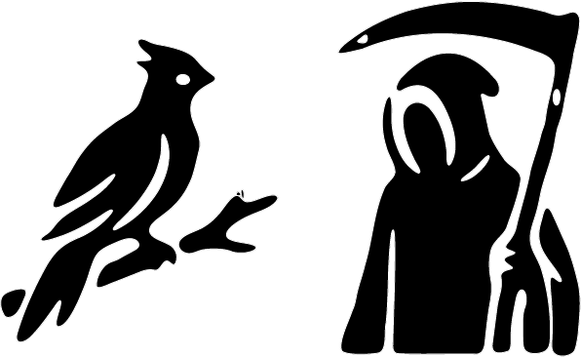

So Many Adventures Couldn't Happen Today
The cars started moving again.

Slow. Silent. Like they were being pushed by invisible hands.

Michael’s speakers crackled, and the song slithered back in—too clear, too loud in the dead fog:

“Sooner or later, they all will be gone…
Why don’t they stay young?
It’s so hard to get old without a cause…”

Then everything stopped.

The road, the fog, the world—frozen mid-breath.

Janet and Michael stood between the two cars, staring at each other. Now they could see them properly: Michael’s car lined up like a weapon… Janet’s car waiting like a target.

Michael swallowed, voice shaking. “You’d stay with my family,” he said. “You’d help them live.”

Janet’s eyes widened, like she’d just understood the shape of the future. “And you’d adopt Danielle.”

Michael didn’t hesitate. “In a heartbeat.”

Janet ran forward and jumped into his arms. For one second, it wasn’t fear—it was relief so strong it hurt. Michael spun her around, laughing once, breathless and terrified, like the laugh might keep Death away.

He set her down.

And Death was already there.

Right in front of them.

Black suit. Black eyes. A white slash still clinging to his blazer like the last piece of light refusing to die.

His voice rolled through the fog like thunder heard underwater. “So. I’ve shown you your futures.”

He leaned in slightly, smiling.

“Now choose. Which path will you take?”

Fog gathered around him, thick and hungry. His outline flickered—man to something taller, hooded, wrong. A scythe-shadow flashed for a heartbeat.

Then he vanished like he’d never existed.

Michael exhaled hard. He looked at Janet, and his face went still—resigned.

“I’ll do it,” he said quietly. “You helping my family when I’m gone… that’s enough.”

He turned toward his car.

Janet grabbed his hand.

“No.” Her grip was tight, desperate. “I’ll do it.”

Michael stared at her. “Janet—”

She shook her head, eyes wet but fierce. “I was scared of being forgotten. That’s what I couldn’t stand. But you—you proved I won’t be.” Her voice broke. “You’ll make sure Danielle knows my name. You’ll give her a home.”

Janet stepped closer, still holding his hand like she could anchor him to her choice.

“If I live,” she whispered, “your kids lose their father. If I’m gone… Danielle gets brothers and sisters. A whole family.” She swallowed. “Something I never had.”

They stood there, locked together, trapped between two futures—each one a knife.

Then the song started again, like a timer clicking down.

“I don’t want to perish like a fading horse…
Youth’s like diamonds in the sun…”

The fog seemed to press inward, breathing against their faces.

Michael’s eyes flicked to his car. Janet’s eyes flicked to hers.

Their hands slipped apart.

And they ran.

They dove into their cars at the same time, slamming doors that made no sound. Their hands shook as they grabbed the steering wheels—cold as bone.

Somewhere in the nearby trees, a darker shape watched.

Death stood at the forest’s edge, half-hidden in mist.

Beside him, a phoenix perched on a low branch—embers glowing under its feathers, eyes bright as a warning. It didn’t burn the fog away. It only lit it from within, making it look like smoke from a funeral pyre.

Death spoke softly, as if to the night itself. “Thank you, sister.” His gaze followed the cars. “Thank you, Future… and Past.”

The phoenix tilted its head, voice quiet but sure. “If there’s a chance to save a life,” it said, “I always take it.”

Death listened.

And then he heard it.

A human voice—thin, exhausted, almost a whisper through glass.

“I’m so tired.”

A click.

A faint ticking sound—too loud in the frozen world.

An indicator.

Blink… blink… blink…

The song reached its final line, dragging like a blade across stone:

“…And diamonds are forever.”

The world released its breath.

The cars surged.

Metal met metal with a sound that finally existed—violent, wet, final. Glass burst like ice. The fog shuddered from the impact, rippling outward as if it had been struck too.

Death looked down at his hand.

A scythe formed there, appearing the way darkness appears when you turn off a light—sudden and absolute. His blazer blackened completely, the last white line drowning, and a hood rose over his head like a closing curtain.

He began to walk toward the wrecks.

Behind him, the phoenix spread its wings, heat blooming in the cold air.

“I think,” the phoenix said softly, “they made the right choice.”

Then it launched upward, beating through the fog and into the dark sky—leaving Death alone with the twisted cars, the settling silence, and whatever soul had turned on the indicator at the very end.

