
By Kyle E Young



Happy Beginnings

As Alexander and Kayla walked through the park, they laughed softly together, their hands woven tight as if they had been made to fit. Evening light spilled across the path in warm ribbons of gold, and wherever Kayla stepped, it seemed the whole world shone brighter. With her beside him, everything felt touched by sunlight, as though the day itself loved her.

Then they noticed a homeless man sitting on the curb, wrapped in old layers, his face worn by hardship. He looked up at them and asked quietly, “Do you have any food to spare?”

Alexander and Kayla glanced at each other. Kayla gave him one of her gentle smiles, the kind that could make even sorrow feel less heavy. Alexander opened his bag and found it full of food. He reached inside and pulled out a bundle of bananas, then handed it to the man.

“What’s your name?” Alexander asked.

The man’s tired face softened. “Jake,” he said.

Alexander smiled. “Well, here you go, Jake.”

Then Kayla opened her purse and placed several hundred dollars into his hand. “Find somewhere warm to sleep tonight,” she said kindly.

Jake stared at the money in one hand and the bananas in the other. His eyes filled with tears. “Thank you,” he whispered. “Thank you. I won’t forget this. I won’t forget either of you.”

Kayla stepped in front of Alexander then, walking backward with a playful grin as she pulled him along by the hand.

“You just gave him a few hundred dollars,” Alexander said, half shocked and half amused.

Kayla laughed. “Don’t worry about it, billionaire. Mr. I just sold my startup for 2.8 billion dollars. To you, it’s a drop of water in a lake. To him, it could be the whole river.”

Alexander looked at her like she was made of starlight. Then he pulled her close and spun her into his arms.

“You really are the best part of me,” he said.

Kayla kissed him, smiling against his lips. “Husband, I know. Now tell me, what should we do on the third anniversary of the day we said yes?”

Alexander grinned. “Why don’t we stay in tonight? I’ll cook dinner.”

Kayla drew back and looked at him suspiciously. “Cook dinner? Something’s wrong. You never cook.”

A smirk spread across her face as she started walking away.

“That’s not fair,” Alexander called after her. “I do cook.”

“Oh really?” she teased. “What about that one time you burned pasta?”

Kayla broke into a run, laughter trailing behind her like music. Alexander ran after her, protesting.

“That’s not fair! We agreed never to talk about that again!”

“Just because we don’t talk about it,” Kayla called over her shoulder, “doesn’t mean it didn’t happen!”

And so they ran together into the golden light, as if the whole evening had become a storybook just for them.

But not far away, beside the tree near where Jake had been sitting, Compassion appeared and watched them with a warm smile. She turned as Jake walked away toward a hotel, clutching his gifts.

“Did you know,” Compassion said softly, “that this moment, this one small act of kindness, will change Jake’s life forever? Past told me that tonight he will get a room, wash himself clean, and buy a suit. In a few days, he will go to a job interview—and he will get the job. One act of compassion, and his life bends toward the light.”

From the lengthening shadows, Death appeared.

“Time is a funny thing,” he said.

Compassion looked at him sharply. “Why are you here?”

Death’s gaze drifted toward Alexander and Kayla, still laughing as they ran. “I appear when it is time,” he said. “And tonight, it is time for one of them.”

Compassion’s face fell. “Please,” she whispered. “Not this time.”

“You know it does not work that way,” Death replied.

He began to walk toward them, and Compassion caught his arm.

“When?” she asked.

Death looked at her, and his answer came like a winter wind.

“Tonight.”

By the time Alexander and Kayla reached their apartment door, both of them were breathless and laughing. Their door, marked E18, stood at the end of the hallway.

Kayla dug through her purse for the keys while Alexander leaned against the wall, still trying to catch his breath.

“I swear this used to be easier,” he said.

Kayla smiled. “Yeah. Well, we used to be younger.”

She opened the door.

“Surprise!”

The apartment burst into sound and light. Friends and family filled the room, smiling and cheering. Kayla jumped back, startled, while Alexander stood there grinning.

“Surprise,” he said proudly.

Kayla turned to him with a look that was equal parts annoyance and joy. Then she saw her brother Mike coming toward her with open arms.

“Sister,” he said, wrapping her in a hug, “it feels like forever.”

“That’s because it has been years,” Kayla said, hugging him tightly. “Too many years.”

As Kayla greeted her family, Alexander slipped into the kitchen. The sink was already piled high with dishes. He looked at them with mild horror.

Kayla’s mother noticed and laughed. “Alexander, you are allowed to walk away from that and enjoy the party.”

He smiled. “See, that’s where you’re wrong. I can’t enjoy myself while I know the kitchen looks like this.”

Kayla came up behind him and tapped him on the back. “Then let me help.”

Outside the window, Compassion watched from a distance, her expression troubled.

“I can’t bear to watch them lose one another,” she whispered.

Death’s voice rose from the dark beside her. “Then leave.”

Compassion turned toward him. “You truly mean to take one of them?”

Death’s face was unreadable. “Death is not always a single choice. It is like a storm, or the sea, or the turning of the earth. Sometimes it can be bent. But not tonight. Tonight is fixed. One of them will die.”

One week later, Alexander sat in the dark silence of his apartment. The world around him felt drained of color. Without Kayla, everything had turned blue—cold, dim, and endless. It was as if the gold had gone out of the world the moment she had.

In front of him stood a wooden casket.

His hands were clenched so tightly that his knuckles had gone white. Tears slipped down his face, and no matter how hard he tried, he could not stop them. In his palm lay Kayla’s wedding ring.

Mike sat beside him, his own grief heavy in his eyes.

“She was taken too early,” Mike said quietly.

Alexander turned toward him, pain hollowing his voice. “I’m sorry for your loss.”

Mike gave a sad, broken smile. “I knew her longer. But no one made her happier than you did.”

Alexander swallowed hard. “And I don’t think she could have asked for a better brother.”

The apartment was full of distant relatives and low voices, but Alexander felt alone inside the sorrow. Outside, on the rooftop of the next building, Compassion watched him through the window.

“There must be something I can do,” she whispered. “Something to ease his pain.”

Beside her stood Hope, radiant and strange, like a phoenix born from dawn.

“Compassion,” Hope said gently, “is not the absence of pain. It is what helps someone survive it.”

Compassion lowered her eyes. “Do you ever think the world would be better without Despair? Wouldn’t it be kinder if humans only felt the better parts of us?”

Hope turned to her with ancient calm. “You cannot know hope without despair. To feel yourself moving forward, you must first know what it is to feel lost. Only then can hope become a flame again.”

Compassion looked back through the window at Alexander. “I just wish I could ease his pain.”

Hope’s expression softened. “Do not lose faith. I can still see the smallest spark of hope in him.”

The days passed, and Alexander’s apartment fell into ruin around him. Clothes covered the floor. Dishes overflowed in the sink. The television flickered without meaning. Dark circles hung beneath his eyes like bruises from too many sleepless nights.

Then one day, there came a knock at the door.

Slowly, Alexander rose from the couch and opened it.

No one was there.

But on the floor beyond the doorway, a glowing path had appeared.

He stared at it in silence.

It shone soft green, like leaves lit by moonlight, and it curled upward toward the staircase. With nothing else to guide him, Alexander followed it.

Up one floor.

Then another.

The glowing trail led him down a quiet hallway and stopped before a door marked F19.

Alexander frowned. “There is no apartment nineteen in this building.”

He hesitated, then knocked.

The moment his hand touched the door, the blue light around him began to change. Slowly, impossibly, it turned to gold.

The hallway brightened. Warmth bloomed through the air. For the first time since Kayla had died, the world no longer felt cold.

The door opened.

And there she stood.

Kayla.

Golden, radiant, and lovely as a dream. The sight of her stole the breath from his chest. It felt like the very first moment he had ever seen her, like finding sunlight after endless winter.

His voice broke on her name.

“Kayla?”



The Feelings Of Lost Love

Alexander stood frozen in the doorway, staring at Kayla as if he were looking at a miracle.

Kayla tilted her head, confused by the expression on his face. “What are you doing out there?” she asked softly. “Come inside. It’s cold.”

Alexander stepped into the apartment, still unable to take his eyes off her. His heart pounded in his chest. As he looked around, he realized the apartment was exactly as it had once been—before he lost her. Everything was neat and in its place. The air felt warm, safe, and full of life. It was as though he had stepped out of the cold blue world of grief and into a hidden golden place where sorrow could not enter.

Kayla studied him for a moment, her brow furrowing. “Are you okay? You look like you’ve seen a ghost.”

Alexander swallowed hard, then smiled through the ache in his chest. “No, I’m alright,” he said. “I just wanted to tell you that you’re beautiful.”

Kayla smiled, soft and bright, and closed the door behind him. At once, the room seemed even warmer, as if her very presence painted the world in gold.

She walked into the kitchen and called back, “So, what do you want for dinner—lasagna or steak and salad?”

Still in shock, Alexander answered almost automatically. “Lasagna.”

Kayla moved around the kitchen, beginning to prepare dinner. As she did, she noticed a clock decorated with photographs of her and Alexander. She picked it up, frowning.

“I don’t remember where this came from,” she murmured.

The moment her fingers touched it, a strange vision flashed through her mind.

She saw herself running after a woman, clutching a purse in one hand and shouting, “You forgot this!” She raced into the street without looking, and then—

A loud bang.

Kayla gasped and dropped the clock onto the table.

Alexander was at her side in an instant. “Are you okay?”

Kayla turned to him, shaken, but gave a small nod. “Yeah,” she said quietly. “I’m okay.”

She went back to cooking, though something in her expression had changed.

After a moment, Alexander asked gently, “What’s the last thing you remember?”

Kayla kept layering the lasagna as she answered. “I remember coming home and finding all my family here—because of you. Then after everyone left, we went to bed, and you stayed up cleaning the apartment.”

A tear slipped from Alexander’s eye before he could stop it. He quickly wiped it away.

“Yeah,” he said softly. “That’s what happened last night.”

And so Alexander spent the evening with Kayla, holding onto every golden second as though it were spun from magic. From far away, Compassion watched them and smiled.

The Next Morning

Alexander woke suddenly in his own bed.

At once, he turned to the empty space beside him, but Kayla was gone.

He shot upright and looked around in panic.

The room was dark and messy. Clothes were scattered across the floor. Dirty dishes overflowed from the sink. The air felt heavy and still. The warmth was gone. The gold was gone.

Everything had turned blue again.

“No,” Alexander whispered. Then louder, more desperate: “No, no, no. It had to be real. It had to be.”

He rushed out of his apartment and ran upstairs to the level above, racing through the hallway until he found the door marked F19.

When he saw it, relief washed over him. His hands trembled as he reached for the handle.

He opened the door.

Inside was a clean apartment, glowing with soft morning light. Hope burst alive inside him. He hurried to the bedroom and found Kayla lying peacefully in bed.

A smile spread across his face. He climbed into bed beside her, as if he had crossed back into a kingdom of gold.

From then on, the pattern began.

Day after day, Alexander woke in his own blue, broken apartment—alone, grieving, surrounded by the ruins of the life he had stopped living. And day after day, he ran upstairs to Kayla’s apartment, where the world was golden again. There, she was alive. There, she smiled at him. There, he could pretend that death had made a mistake.

And each day, he fell for her. Once again.

One evening, Alexander stood outside the door marked F19 and knocked.

Kayla opened the door, and at once his face lit up. He leaned in, kissed her on the cheek, and stepped inside carrying bags full of groceries.

“I got all our favorite food,” he said, setting the bags on the table.

Kayla smiled. “Did you get the sausages?”

“Of course,” Alexander replied with a grin.

As Kayla began making dinner, Alexander held up two DVDs. “I picked out two movies. Want to know what they are, or should I surprise you?”

Kayla laughed. “Surprise me.”

Alexander slipped one of the DVDs into the player, then looked back at her. “So, how was your day?”

Kayla stirred the sausages in the pan and smiled faintly. “It was pretty good. I mostly just looked outside—watched the trees sway and people pass by.”

Alexander sat down at the table, his gaze falling on the salt and pepper shakers. They were cracked and broken.

“Damn,” he muttered. “I meant to buy new ones. I’ll go get some now.”

He left the apartment and went downstairs to his real one. The moment he stepped inside, the golden warmth faded. The blue silence of his true life wrapped around him again. Nothing had changed. Clothes still covered the floor. The sink was still full of dishes. His home looked like a place abandoned by joy.

He walked to the pantry, found the salt and pepper, and emptied them into the sink. Just as he turned back toward the door, he found Mike standing there with a pregnant woman beside him.

Mike looked at him carefully. “Are you okay?”

Alexander immediately tried to block the doorway, but Mike pushed past him and stepped inside. He looked around at the apartment, seeing that it was just as bad as the last time he had visited.

Mike turned back to him, sadness in his face. “You know it’s been five years since my sister died. Are you okay?”

Alexander forced a laugh. “Yeah, I know. I’m fine. Great, even. Just living off the billions from my startup.”

Mike looked at him for a long moment. He could tell Alexander was hiding something, but he also knew he would not get the truth from him.

“Okay,” Mike said quietly. “But I think you should get some help. Whether it’s for this”—he tapped his temple—“or for this apartment. No one should be living like this.”

Something angry and wounded flashed across Alexander’s face.

“I said I’m fine,” he snapped. “Now get out.”

Mike looked at the pregnant woman and sighed. “Come on, fiancée.”

They turned to leave, but before the door could close, Mike stopped and held out an envelope.

“Alexander,” he said, “we came to invite you to our wedding. Here.”

He handed over the letter, but Alexander only stared at it before slamming the door in his face.

Outside, Mike stood there for a moment, then bent down and slipped the invitation under the door.

Putting an arm around his fiancée, he said softly, “He’s never been the same since my sister died.”

The woman looked up at him with kind eyes. “You haven’t been either,” she said. “But that’s okay, as long as you keep moving forward.”

Inside, Alexander stood in the silence of his apartment. He looked around at the mess, at the proof of years wasted in grief, at the life that had stopped while time marched on for everyone else.

Then he looked down at his hands.

And for the first time, he truly saw it.

Nothing had changed.

He had not moved forward at all.

Slowly, he sank to the ground beneath the weight of that truth.

But after a while, he stood again.

Without thinking, or perhaps thinking too much, he left his apartment and walked upstairs toward the door that had become his refuge, his dream, his curse.

The door waited for him.

His hand trembled as he lifted it to knock.

He closed his eyes and took a shaky breath, trying to decide if he could walk away from this beautiful illusion. Trying to decide if he could let go of the golden world and return to the blue one. Trying to decide if he was strong enough to leave behind the ghost of happiness and step back into real life.

But in the end, his hand moved forward.

He knocked.

The door opened, and there stood Kayla.

At once, relief flooded through him like sunlight after a storm. He buried his pain beneath the comfort of her smile and stepped inside. The world turned golden once more.

As the apartment door closed behind him, a unicorn walked quietly down the hallway.

Love had come.

She paused outside the door, sensing the deep bond between Alexander and Kayla. It was there, powerful and shining—but something was wrong. Something was broken beneath the beauty.

Love stepped closer and closed her eyes.

When she opened them again, she saw Alexander and Kayla dancing together inside, both of them glowing purple with love.

But Kayla’s purple light began to flicker.

It glitched.

It wavered.

And then, slowly, it changed into green.

Love blinked in alarm and whispered one word:

“Compassion.”

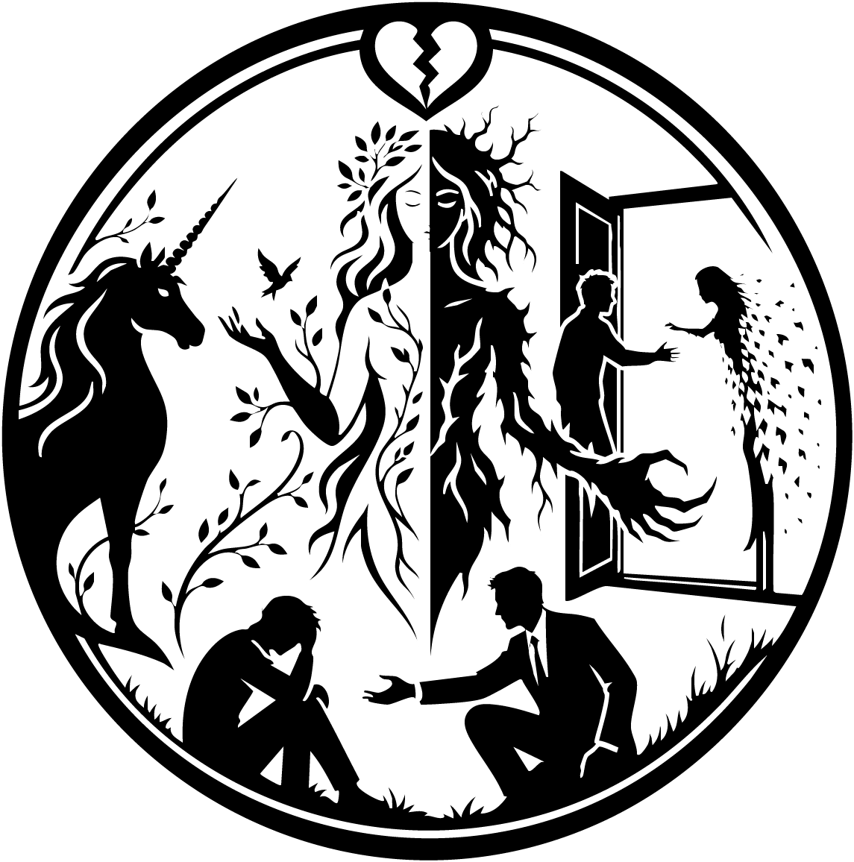

Compassion Or Cruelty
Compassion sat high in the branches of a great old tree, hidden among the leaves like a dryad of the woods. From there, she watched a young man gently help an old woman cross the street, and a soft smile touched her face.

Then, beside the tree, a unicorn appeared.

“Hello, sister,” Compassion said lightly. “What brings you here?”

The unicorn lifted her head, her eyes searching the branches until they found Compassion hidden among the leaves. Her gaze sharpened.

“What did you do?” she asked.

Compassion rose slowly from the tree, her leafy form shifting in the light. “I don’t know what you mean.”

At once, the unicorn changed.

Her white form melted away, and in its place stood Love in her fiercer shape—an Erinyes, a warrior woman with dark horns, crimson wings, shining armor, and a sword in her hand. Her beauty was terrible now, like a storm wrapped in fire.

“What did you do to Alexander and Kayla?” Love demanded. “What have you done?”

Compassion stepped back, shaken by the fury in her sister’s voice.

“I was showing him compassion,” she said. “I was giving him time. Giving him space to learn how to live without Kayla. To move on.”

Love stared at her with deep disappointment. “What you gave him was not compassion,” she said. “It was cruelty.”

At that word, something inside Compassion cracked.

Her eyes darkened. Her face hollowed. Horns twisted from her head. Her body grew taller, monstrous, her spine bending with awful creaks. Fur burst across her skin, and her hands became huge and clawed. She became a wendigo, terrible and starved, the shadow hidden inside kindness when kindness loses its way.

“I am not cruel!” she roared. “Cruelty is not part of me! I am Compassion alone! You and the others would not understand with your double natures—Love and Hate, Dream and Nightmare, Hope and Despair, Trust and Fear. But I am only one thing. Only kindness. Only compassion. I will never be cruel!”

Then, just as suddenly, the monster faded.

The fur became leaves again. The claws softened into hands. The great beast shrank down until Compassion stood there once more, trembling and frightened, tears in her eyes.

“I’m not cruel,” she whispered. “I never wanted to be cruel. I am only kind. Only compassion.”

Love’s fierceness softened. She returned to the shape of the unicorn, gentle and bright once more.

Then she said quietly, “People cannot truly know one side of life without the other. Love means something because hate exists. Hope matters because despair exists. Trust matters because betrayal is possible. We all have two faces, sister. But we do not let our darkness rule us.”

Compassion began to cry.

Love lowered her head and rested it gently against Compassion’s back.

“We need to fix this,” she said.

Compassion walked to the apartment door and knocked.

Almost at once, the door swung open, revealing Alexander and Kayla together. Warm light poured from inside, soft and golden, like the glow of a storybook hearth. Wherever Kayla stood, the world shimmered with gold. But beyond that golden doorway, Compassion could already feel the cold blue grief waiting beneath it all.

Alexander looked at her sharply. “Who are you?”

Without answering, Compassion stepped into the apartment.

“Hey—stop!” Alexander said. “You can’t just walk in here!”

Compassion looked around. Popcorn sat ready on the table. Blankets and rugs were spread out for a movie night. It was a small, lovely scene, made of longing and illusion.

Kayla looked at Compassion curiously. “Do I know you?”

Compassion rubbed her hands together nervously, then stretched them out.

At once, the world around them began to tremble.

The golden room flickered.

Alexander looked at Kayla just as she looked down at her own hands. They had begun to glitch, breaking apart like light on shattered glass.

Alexander turned in horror toward Compassion. “What have you done?”

Compassion’s eyes filled with tears. “I’m here to set things right.”

Kayla looked at her sadly, and though her voice was calm, there was pain in it. “I’m not really here, am I?”

Compassion lowered her head. “No.”

Then Alexander’s expression changed. Something terrible clicked into place.

“That’s where I’ve seen you before,” he said. “You were there that night.”

Compassion began to cry openly. “I’m so sorry.”

Alexander rushed forward and grabbed her by the throat. His other hand drew back, ready to strike.

“Stop!” Kayla cried.

Alexander turned toward her, his face twisted with grief and rage. “You don’t know what happened.”

Kayla stood, even as her form trembled and flickered at the edges. “But I do,” she said softly. “You dropped that clock, didn’t you, Compassion? And I found a purse you left behind, so I ran after you into the street.”

Compassion shook her head, struggling through tears. “The purse wasn’t mine. It was Death’s. He left it there to draw one of you in. You chased after me… and followed it into the road.”

Alexander’s voice broke. “You were hit by a car. There was so much blood. I was only steps behind you. One moment you were there, lighting up the whole world around you—and the next…” He could not finish.

Kayla’s arms flickered harder now, pieces of her fading into light.

“Let her go,” she whispered.

Slowly, Alexander released Compassion. She fell to the floor.

He turned back to Kayla, shaking. “No.”

Kayla looked at him with all the love she had ever carried for him. “Let me go,” she said. “Stop letting my death define who you are.”

Alexander began to cry. “But I don’t want to. The plan was to sell my startup, have all the time in the world, and grow old with you. I was always too busy before… and then when I finally had time, you were gone.”

Kayla sank to her knees as she continued to fade, like a golden light disappearing into dusk.

“But the time we had,” she said, “was beautiful. I would not trade a second of it for anything. Now you have to live.”

Then, in Alexander’s arms, she faded away completely.

The gold went with her.

At once, the room felt blue again—deep, aching, endless blue.

Alexander held the empty air where she had been and turned toward Compassion, tears streaming down his face.

“How is this right?” he asked. “How is taking away the one I love supposed to be right?”

Compassion looked at him with sorrow. “She was already gone. She died a long time ago.”

“She’s not dead to me!” Alexander shouted.

He looked at Compassion with raw anger.

“I was only trying to be kind,” she whispered.

Alexander rose slowly and stepped toward her. “What kind of demon are you?”

Around them, the apartment faded. The walls darkened. The warm, golden illusion fell away into shadow.

“I am no demon,” Compassion said. “I am Compassion.”

Alexander stood directly before her. His face was streaked with tears, but his voice was steady now.

“This wasn’t compassion,” he said. “This was cruelty.”

Compassion took a step back. Her grief deepened.

“I see that now,” she said.

With a snap of her fingers, she vanished.

Alexander found himself back in the hallway.

He turned toward where the apartment door had been—but there was nothing there. No golden doorway. No hidden room. No Kayla.

Only an empty wall.

He fell to his knees and wept.

From far away, Compassion watched him and looked down at her hands. Once more, they had become the claws of a wendigo.

“One half darkness,” she whispered. “One half light.”

Alexander walked slowly down the stairs, remembering the first time he had followed the glowing path. Back then, the world had turned gold whenever it led him to Kayla. Now that gold was gone. The world was blue again, and this time it seemed it might remain that way forever.

He reached his apartment door and pulled out his keys.

“Alexander!”

He looked up.

Standing there was Jake—the homeless man he and Kayla had once helped in the park. But he was not the same man anymore. He wore a black suit now, neat and proud, and there was strength in his eyes.

“I’ve been looking for you for months,” Jake said.

Alexander gave a tired shrug. “Yeah. Sorry. I’ve been busy.”

He opened the apartment door, revealing the mess inside.

Jake’s face softened. “I heard about your wife,” he said quietly. “I’m so sorry. And I know what that feels like.”

Alexander walked inside and began absentmindedly picking things up. “How would you know?”

Jake stepped in after him and gave him a small, sad smile.

“How do you think I became homeless in the first place?” he asked. “I let the darkness consume me. I let my wife’s death swallow me whole. I stopped living. I stopped moving. I let grief turn my world cold.”

He looked around the ruined apartment, then back at Alexander.

“Then you and Kayla came into my life like light,” he said. “You gave me a chance to move forward. And that’s why I’m here now. I’m not going to let you fall into the darkness alone.”

Alexander looked at him, silent.

“But first,” Jake said gently, “you have to take one step forward.”

Alexander’s eyes drifted to the clock Compassion had dropped—the one filled with pictures of him and Kayla.

And then, soft as a memory and warm as sunlight, he heard Kayla’s voice one last time:

Don’t let this define you.

Alexander closed his eyes.

When he opened them again, there were still tears there—but for the first time in a long while, there was something else too.

A small, fragile spark.

Not gold.

Not yet.

But perhaps the first pale color of dawn after a long blue night.

And slowly, Alexander smiled.

