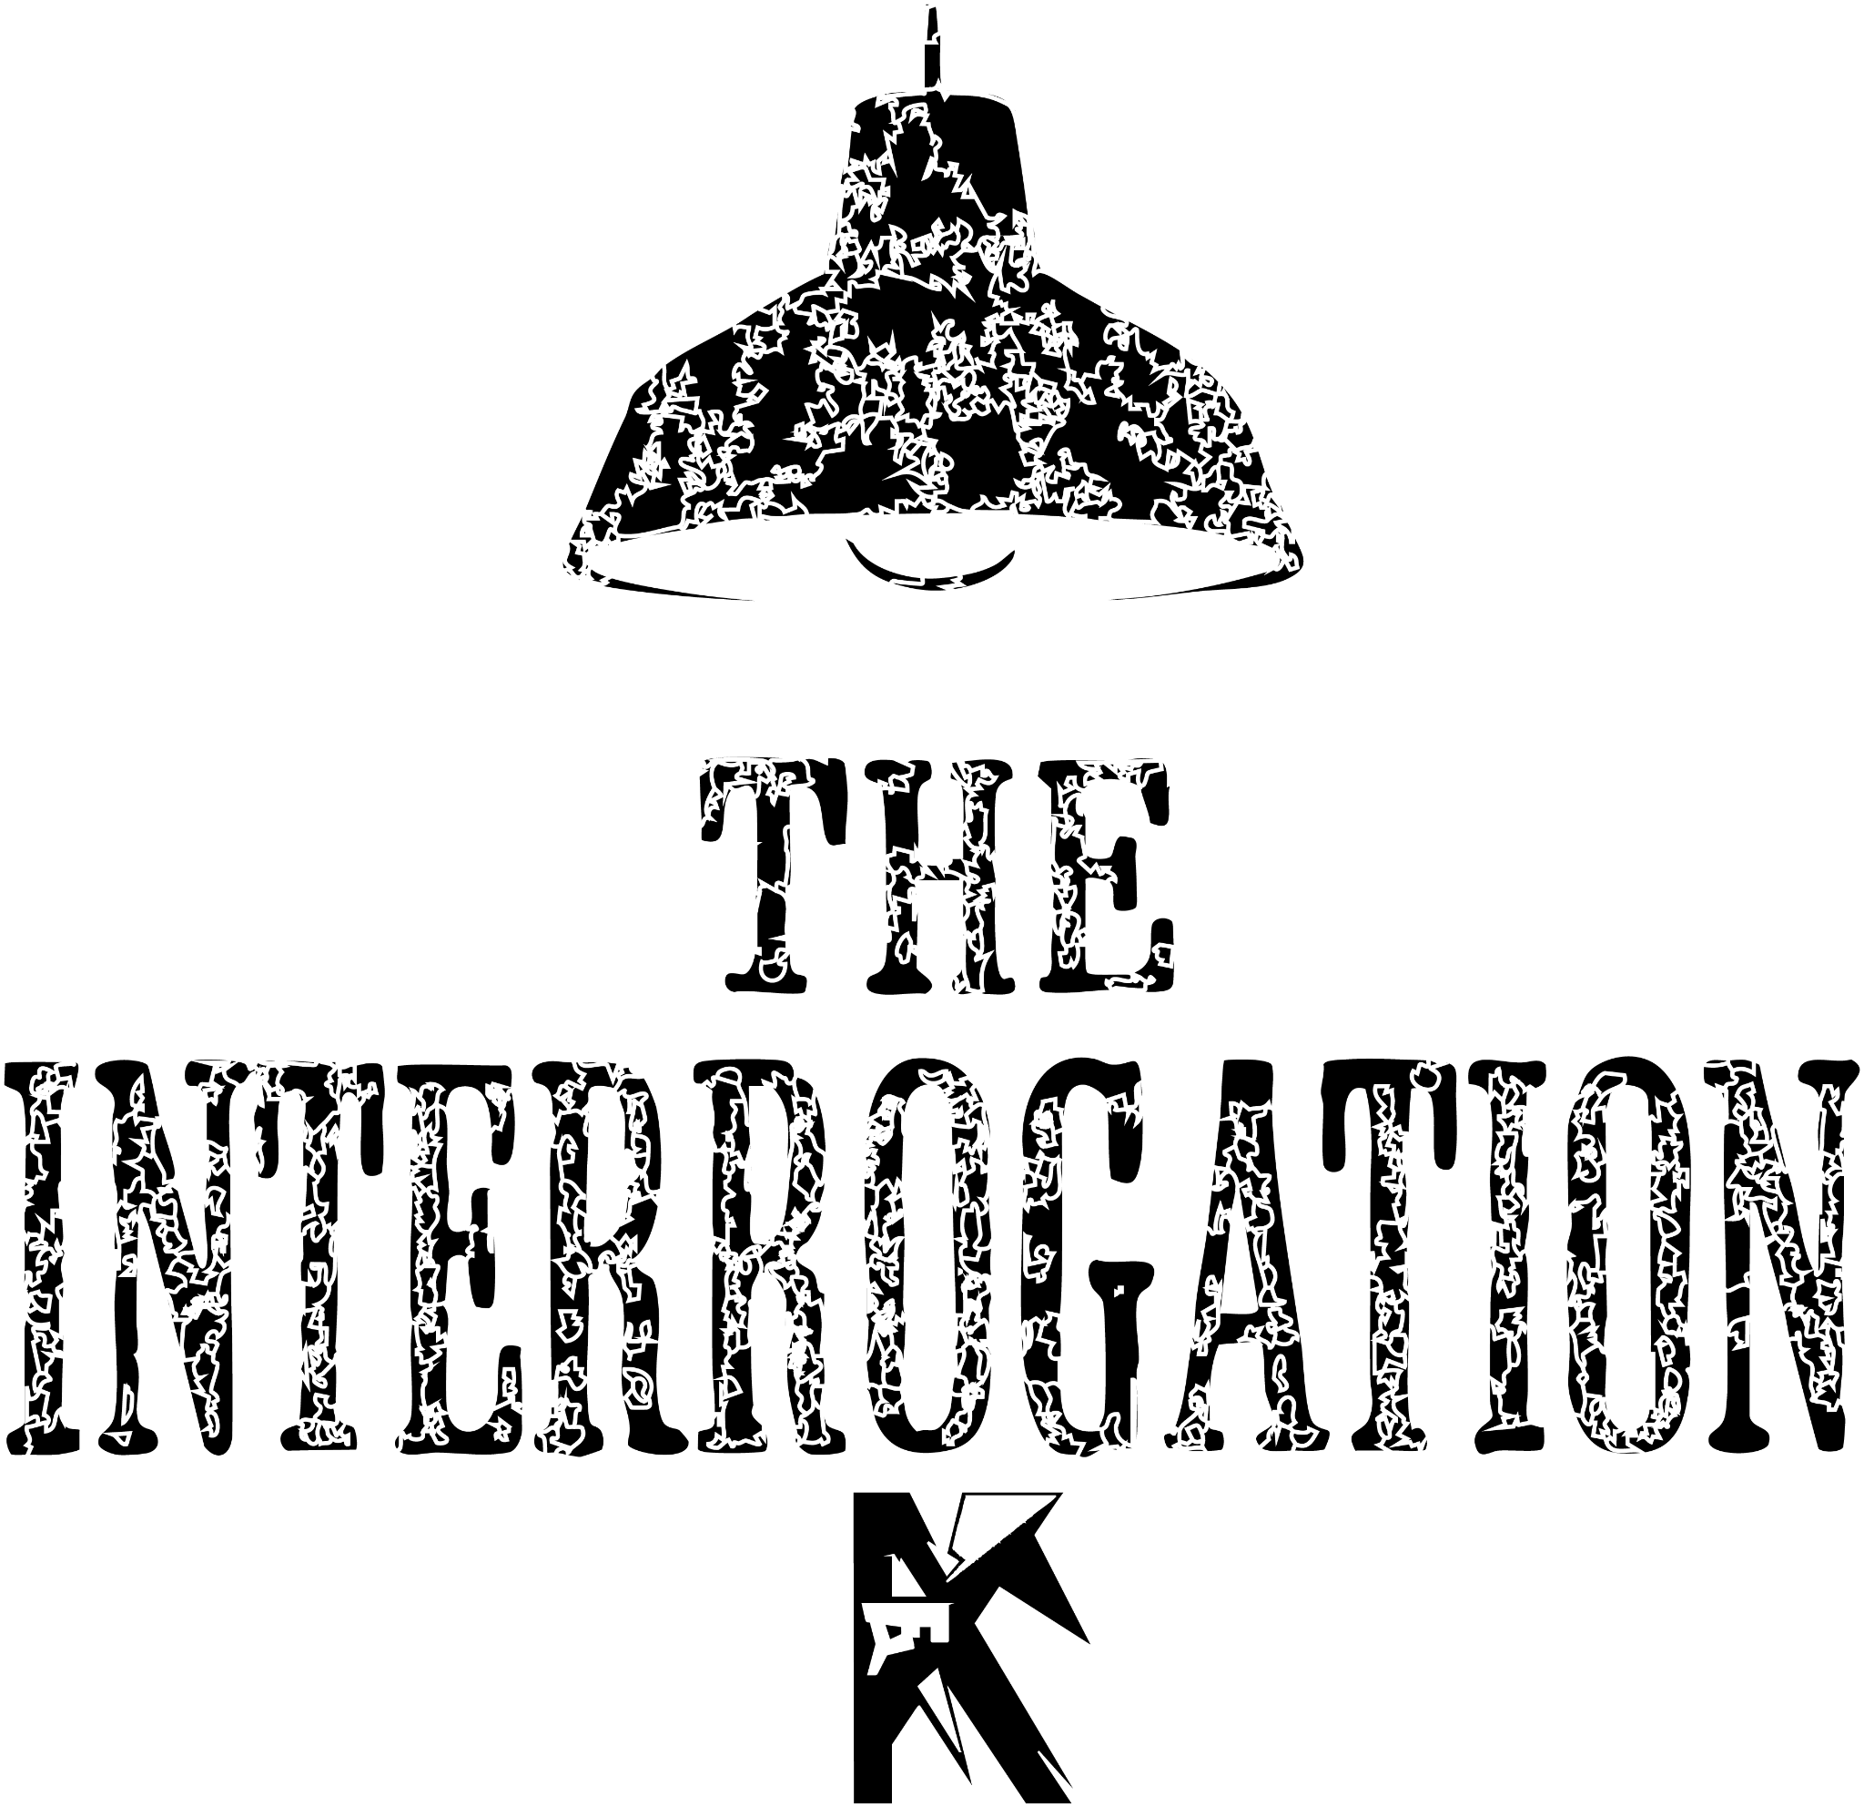

By Kyle Young

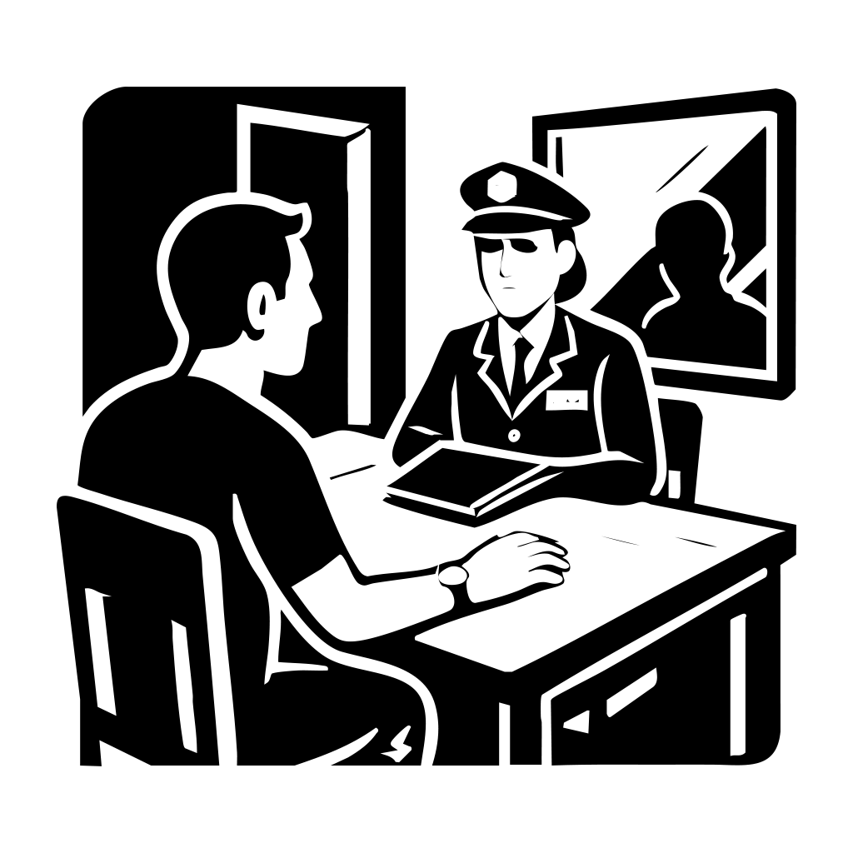

The Silent Hello
The mirror stares back at me, cold and silent. My hand, inexplicably, is stuck to the wooden table. It’s the kind of table I remember from high school—uncomfortable, splintered, too small for grown hands. And somehow, the chair beneath me is the exact same. I shift, but it offers no relief. I look up to see nothing but darkness.
Across from me, an empty chair waits. It’s not just empty—it feels... aware. Like it’s watching me. Judging. Tearing me apart molecule by molecule, without a single word spoken.
My wrist itches. I glance down. My watch ticks, impossibly slow—each second stretching longer than it should. A giant mirror looms to my right, and something about it gnaws at me. It's double-sided. I know it. I feel it. Someone is behind it, watching.
But I don’t know who. Or why.
The door creaks open, and a woman steps inside. Her dark blue police uniform is crisp, hat angled with care, the name tag “Lois." She doesn’t smile as she sits across from me. Her file lands on the table with a quiet thud. My leg begins to tap involuntarily. Her gaze pierces through me.


The Cop
She speaks first.
“Do you know why you’re here?”
I meet her eyes. They're searching, dissecting. I respond, dryly:
“I was hoping you knew.”
She removes her hat, sets it beside the file, and opens it. As she flips through the pages, photographs spill across the table—grainy shots of me and women. Dinners. Sidewalk strolls. Drops at front doors.
“What is this?” I mutter.
“You tell me,” she replies, coolly.
I scoff.
“Surveillance? You’ve been following my dating life now?”
She leans back, folds her arms.
“So you agree these are photos of you.”
I lean forward. The images blur, the faces pixelated—but I know I’m in them. The edges of my confidence begin to fray.
“What’s this about?” I ask.
Her tone sharpens.
“You tell me. These women—you were the last person seen with all of them.”
A chill runs through the room. The air tightens. Something shifts.
“You think that means I did something to them?”
She doesn’t blink.
“I can see it in your eyes. You know something.”
I glance again at the photos. The angles—they’re from far off, like from inside a car. Someone watching.
“I met them all on an app,” I murmur.
“Why would I hurt them?”
Suddenly, her hands slam the desk. I flinch.
“Because you're lying!” she snaps.
“Everything points to you!”
I ignore her. I pull the photos closer. Something is off. The light. The framing. The intent.
Then I ask, coldly:
“Who took these pictures?”
She hesitates. Her face stiffens.
“What do you think this is?” she says, scooping up papers and slamming them down again.
The sheets scatter.
They're blank.
No reports. No case numbers. No evidence.
Just paper.

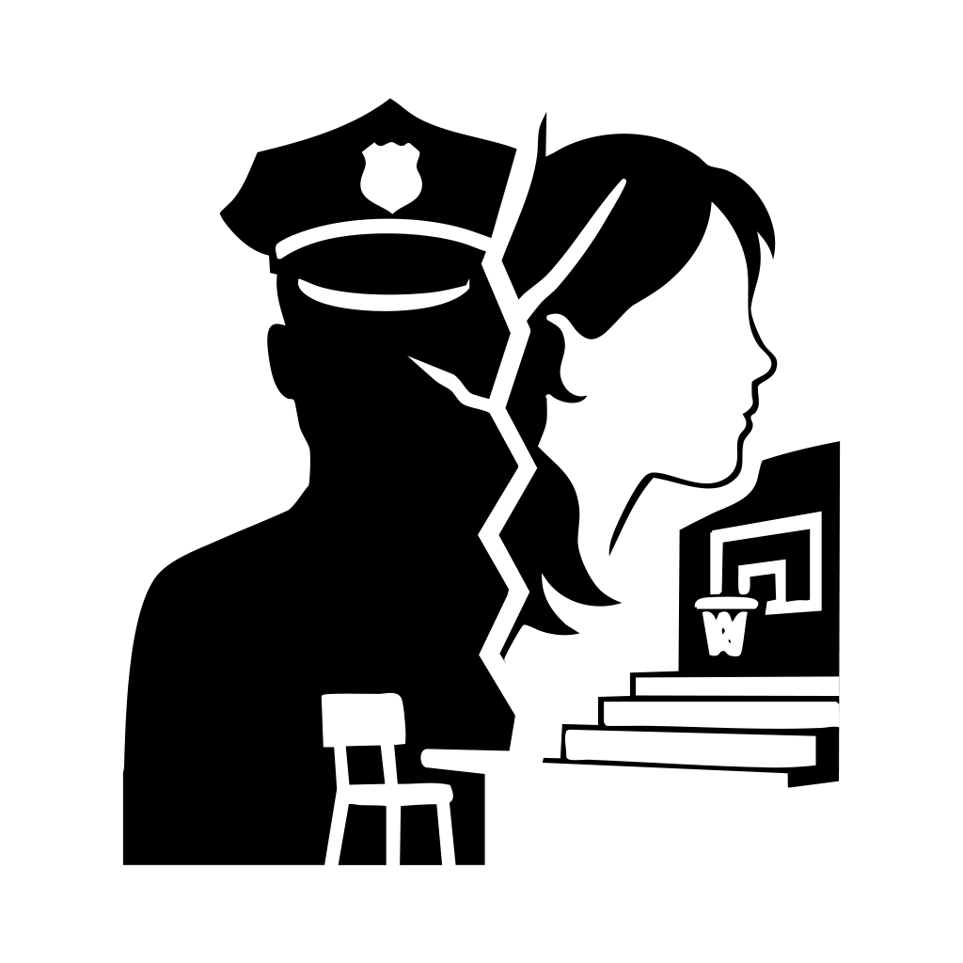

The Lies
I watch her unravel. Her tough facade buckles, her shoulders slump. And then—tears. Slow, deliberate.
I ask again, softly this time:
“Who took the pictures?”
She chokes on her words.
“I did.”
The room goes still.
As I look back at the mirror to see it shift.
I stand to push it, the room around shifts, moves, like it was made out paper, falls around us,
Revealing my high school’s gym.
Then, it hits me. Her face, younger. Glasses. A timid girl in the back of my high school science class. Always staring, always silent. The memory detonates in my mind.
“I remember you,” I say.
“We had class together. You... you never spoke to me.”
She nods slowly.
“I was protecting you.”
“Protecting me? From what?”
Her voice becomes honeyed, delusional.
“From them. They were pulling you away. You belonged to me. You just didn’t realise it yet.”
My feet are heavy, as I slowly walk away from her.
“How are we in the high school?”
Then, a terrifying smile took over her face
“A few years after we left high school, there was a series of murders. I made it so it would just be you and me, back in the place where we fell in love.”
Then it hit me, her name wasn’t Lois, it was Hannah, how did she get the police officer outfit, badge, gun. I hit the gym wall.
“I don’t even remember coming here,” I whisper.
She walks closer. Calm now. Terrifyingly calm.
“That’s because you didn’t.”
I reach for the gym door handle. It doesn't budge.
Locked.
Her hand moves—from her taser to her gun.
“Did you kill them?” I ask, my voice barely my own.
She smiles. Eyes gleaming.
“They were distractions. I took them off the board.”
My pulse pounds. She's reaching for her weapon. Time fractures.
I charge.
A single shot shatters the silence.
Then, only ringing.
Then... nothing.

Draft 2
The mirror stares back at me, cold and silent. My hand, inexplicably, is stuck to the wooden table. It’s the kind of table I remember from high school—uncomfortable, splintered, too small for grown hands. And somehow, the chair beneath me is the exact same. I shift, but it offers no relief.
Across from me, an empty chair waits. It’s not just empty—it feels... aware. Like it’s watching me. Judging. Tearing me apart molecule by molecule, without a single word spoken.
My wrist itches. I glance down. My watch ticks, impossibly slow—each second stretching longer than it should. A giant mirror looms to my right, and something about it gnaws at me. It's double-sided. I know it. I feel it. Someone is behind it, watching.
But I don’t know who. Or why.
The door creaks open, and a woman steps inside. Her dark blue police uniform is crisp, hat angled with care. She doesn’t smile as she sits across from me. Her file lands on the table with a quiet thud. My leg begins to tap involuntarily. Her gaze pierces through me.
She speaks first.
“Do you know why you’re here?”
I meet her eyes. They're searching, dissecting. I respond, dryly:
“I was hoping you knew.”
She removes her hat, sets it beside the file, and opens it. As she flips through the pages, photographs spill across the table—grainy shots of me and women. Dinners. Sidewalk strolls. Drops at front doors.
“What is this?” I mutter.
“You tell me,” she replies, coolly.
I scoff.
“Surveillance? You’ve been following my dating life now?”
She leans back, folds her arms.
“So you agree these are photos of you.”
I lean forward. The images blur, the faces pixelated—but I know I’m in them. The edges of my confidence begin to fray.
“What’s this about?” I ask.
Her tone sharpens.
“You tell me. These women—you were the last person seen with all of them.”
A chill runs through the room. The air tightens. Something shifts.
“You think that means I did something to them?”
She doesn’t blink.
“I can see it in your eyes. You know something.”
I glance again at the photos. The angles—they’re from far off, like from inside a car. Someone watching.
“I met them all on an app,” I murmur.
“Why would I hurt them?”
Suddenly, her hands slam the desk. I flinch.
“Because you're lying!” she snaps.
“Everything points to you!”
I ignore her. I pull the photos closer. Something is off. The light. The framing. The intent.
Then I ask, coldly:
“Who took these pictures?”
She hesitates. Her face stiffens.
“What do you think this is?” she says, scooping up papers and slamming them down again.
The sheets scatter.
They're blank.
No reports. No case numbers. No evidence.
Just paper.
I watch her unravel. Her tough facade buckles, her shoulders slump. And then—tears. Slow, deliberate.
I ask again, softly this time:
“Who took the pictures?”
She chokes on her words.
“I did.”
The room goes still.
Then, it hits me. Her face, younger. Glasses. A timid girl in the back of my high school science class. Always staring, always silent. The memory detonates in my mind.
“I remember you,” I say.
“We had class together. You... you never spoke to me.”
She nods slowly.
“I was protecting you.”
“Protecting me? From what?”
Her voice becomes honeyed, delusional.
“From them. They were pulling you away. You belonged to me. You just didn’t realize it yet.”
I stand. My feet are heavy, but I walk toward the door.
“I don’t even remember coming here,” I whisper.
She stands too. Calm now. Terrifyingly calm.
“That’s because you didn’t.”
I reach for the door handle. It doesn't budge.
Locked.
Her hand moves—from her taser to her gun.
“Did you kill them?” I ask, my voice barely my own.
She smiles. Eyes gleaming.
“They were distractions. I took them off the board.”
My pulse pounds. She's reaching for her weapon. Time fractures.
I charge.
A single shot shatters the silence.
Then, only ringing.
Then... nothing.

