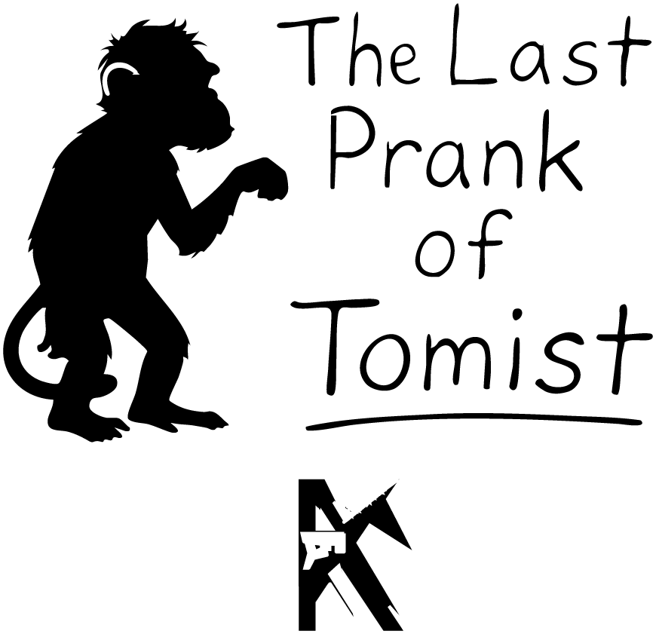

BY Kyle Young



The Crash
Leo presses his forehead to the cool window. The road curls like a black ribbon through trees, and the trees keep whooshing by like the world’s longest car wash.

“Thanks for picking me up, Dad,” Leo says, twisting around in the front seat to grin at him.

“Are you kidding?” Dad—Logan—glances over and smiles. He’s got that soft-dad smile that makes his eyes crinkle. “You’re twelve. Of course I’m picking you up. Also, your mom is in full-on kitchen battle mode. Pumpkin pot pie. The kitchen smells like Halloween married Thanksgiving.”

Leo snorts. “So… how was work?”

“Eh,” Dad says, rolling his wrist like he’s stirring soup. “Work was work. How was school?”

Leo brightens. “We started Harry Potter! Again! But this time I get to see it through everyone else’s eyes in class. Also, lunch debates. Ron vs. Hermione on literally everything.”

Dad chuckles. “Do you remember the parts I read to you when you were little? You used to fall asleep right when things got exciting.”

“I remember!” Leo says. “Now I don’t fall asleep. I just… vibrate.”

Outside, dusk decides to skip the polite part and go straight to night. Dad flicks on the headlights. The beams carve two bright tunnels through the trees.

“Huh,” Dad murmurs. “Does it always get this dark this fast?”

“Pretty much,” Leo says. “Mom and I usually talk about school and work. By the time we get home, it’s night-night-town.”

“Well,” Dad says, “then I’m glad I get this talk time too.”

He reaches over and squeezes Leo’s shoulder. It’s quick, but warm, like a high-five turned into a hug.

That’s when the sky gets weird.

At first it’s just a glow, like someone turned on a giant flashlight behind the clouds. Then it brightens. And brightens. And then—hello, daytime—but only right in front of them.

“Dad?” Leo says. “What is that?”

Dad eases off the gas. His voice stays calm, the way dads on TV talk when the kitchen is on fire. “No idea, champ. But we’re slowing down.”

The light floods the road. The car hums, like a bee swallowed a lawnmower. Leo’s seat belt hugs him tighter, tighter. There’s a pop—glass spiderwebs across the windshield. Airbags explode.

Everything yanks, tilts, stops.

And then: black.

Leo wakes up to the taste of dust and the smell of hot metal. The stars look wrong. Oh. Not stars. Sparkly bits of windshield in the grass.

He pushes up slowly. “Dad?”

A shape glows in the ditch—half a metal disc jammed in the ground, like a UFO tried to do a handstand and gave up. Their car is upside down on its roof, crumpled like a sad soda can.

“Dad!” Leo shouts, louder.

No answer.

He staggers toward the glowing disc. Something silver-green drips from a seam and splats on a rock. It gleams like slime at a science fair.

Curiosity defeats common sense in a wrestling match that lasts roughly one second. Leo sticks a hand under the drip. It’s warm. “Feels like honey,” he mutters. He sniffs it. Smells like… carrots?

Because he is a scientist (and twelve), he touches it to his tongue.

“Blegh!” He stumbles back onto his butt. “Tastes like carrot syrup! Why would anyone invent carrot syrup?”

Clonk.

A panel on the disc flops open and a blue—yep, blue—person tumbles out. The person has a square-ish head, shiny dark eyes, and hands like… plungers?

They blink at Leo and fumblingly poke a metal wand. The wand crackles and a canned voice blurts, “Hello, fellow human.”

Leo blinks back. “You don’t look like any human I’ve seen.”

The blue person looks at their plunger-hands. “I am very human. My name is Nexa. A totally normal human name. Why would an alien have a human name if he wasn’t human?” The wand squeaks like it disagrees.

Another blue somebody rolls out of the ship and smacks into Nexa. They both go down like bowling pins.

“Um,” Leo says, pointing. “There’s more than one of you?”

The new one sits up, fixes an imaginary tie, and says, “I am Korr. We are—how do you say—just passing by.”

Nexa scrambles upright. “Dude, our holograms are not working!”

“They are obviously working,” Korr says, glancing at his bright-blue arm. He lowers his voice. “What are we going to tell the human about the crashes?”

“Do not put this on us!” Nexa yelps. “You left the person who literally said, ‘I cannot fly the ship,’ to fly the ship!”

Korr waves that away. “It is fine. If we get the photon engine to fifty percent, we can clean this up in a few hours, tops. Then we gently mind-wipe the boy and—”

They both turn toward where Leo was.

Leo is not there.

Because Leo is now inside the ship.

He didn’t mean to become a stealth ninja, but when two blue maybe-aliens argue about mind-wiping you, your feet learn to tiptoe very fast. He squeezes through the open panel, scoots down a narrow hallway, and lands in a room full of humming boxes.

In the middle sits a thing that looks suspiciously like a watch. Not just any watch. A cartoon-famous, world-saving, monsters-are-friends-now kind of watch.

Leo picks it up. It’s heavier than it looks and warmer, too. “If this turns me into a giant talking iguana,” he whispers, “I will not complain.”

Outside: “Little Human Boy!” Nexa calls. “Please return for your—uh—prize!”

Korr adds, “We have definitely not mentioned mind-wiping!”

Leo slips the watch onto his wrist. It clicks like it was waiting for him.

“Leo!” A voice booms from outside. Not alien. Dad.

Leo’s chest hops. “Dad! I’m in here!”

There’s a scraping scream as metal bends. A rectangular hole peels open like a can lid, and Dad’s face appears, streaked with dirt and worry. He looks at Leo like he’s a miracle and a missing sock found at the same time.

“There you are,” Dad says, voice gentle but tight underneath. He reaches in, muscles straining, and drags the panel wider. “You okay? Anything hurt? Fingers, toes, brain?”

“I’m okay,” Leo says. “Kind of. There are aliens.”

“Yup,” Dad says, breathing hard. “I met the concept.”

He hauls Leo out and tucks him into a quick, fierce hug. Leo can feel Dad’s heart thudding like it’s trying to drum a hole through his shirt. When Dad pulls back, his smile is steady and brave. His hands, though, shake just a little.

“Game plan,” Dad says, like he’s explaining how to win at laundry. “My phone is toast.” He shows the spider-cracked screen. “We’re ten minutes from home on foot. If we cut through the trees, we’ll get there faster. We’ll use the landline in the shed. We’ll call the cops and ask for backup. Sound good?”

Leo nods. “Yes. Very yes.”

“Okay.” Dad takes Leo’s hand. “We’re going to walk fast and quiet. I will be exactly one dad-length away the whole time. And Leo?”

“Yeah?”

“I’m not scared,” Dad says, very calmly. Then he winks. “I’m… super alert.”

Leaves whisper as they slip under the trees. Behind them, Nexa and Korr argue about whether “mind-wipe” sounds rude.

They reach home without getting mind-wiped, abducted, or asked to fill out any alien customer-satisfaction surveys.

“I’ll hit the shed phone and call the cops,” Dad says, steering Leo toward the porch. “You tell Mom we’re okay-ish.”

The front door opens before Leo can knock. Mom—Grace—takes one look at him: dirt-smudged, leaf-decorated, eyes too wide. She drops to her knees and cups his cheeks.

“Sweetie?”

“There was a spaceship,” Leo blurts. “It crashed in front of us and aliens chased me and—”

A strange, soft blue shimmer washes across the yard, like someone ran a giant highlighter through the night and colored everything “Huh?”

Mom’s eyes flick to the empty street. No car. No crash. Just… normal.

“Where’s your dad?” she asks, her voice suddenly very level.

But then a blue wave of energy passed threw Leo and his mother.

“In the shed,” Leo says. “He’s calling the cops.”

“Okay.” Mom kisses his forehead. “Go inside. There’s pie. Eat, shower, bed. Orders, not suggestions. We’ll talk in the morning.”

Leo recognizes Mom’s Command Voice and obeys. Pie is a strong motivator.

Mom heads for the shed. Dad steps out as the door slides open, still breathing fast, phone in one hand and his jaw set to Serious. They trade a look that says a thousand married-people sentences.

“I’m going back to the site,” Dad says.

“Fine,” Mom says, grabbing the car keys. “We go together.” She squeezes his hand. “Backup, remember?”

They drive. The blue shimmer hums in the distance like a secret.

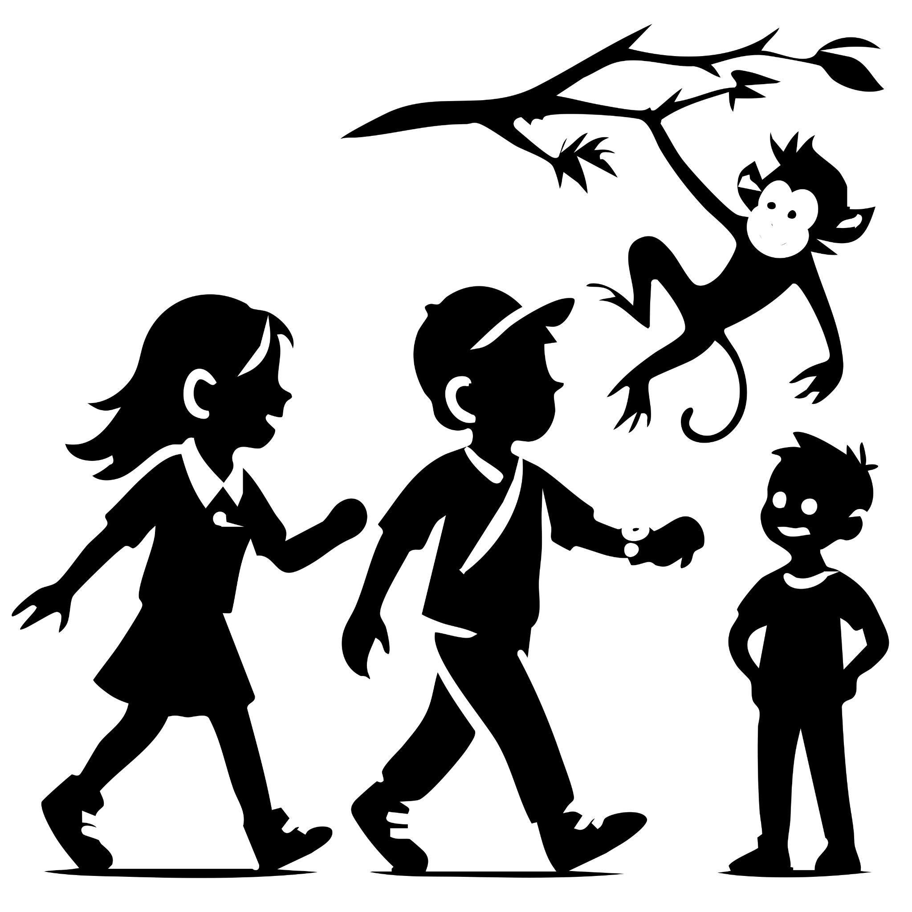

Next Morning
The next morning, Leo hops into his mom’s car, still buzzing like a shaken soda can.

“You’re gonna see,” he insists as Mom buckles up. “No way we’re getting to school. A spaceship crashed. Right there. Boom. Aliens.”

Grace sighs the sigh of every mom who has ever been handed a science-fiction story before coffee. “Leo, there was no spaceship. You and your father just… misplaced a perfectly good car.”

Leo throws his hands up. “Cars don’t just disappear, Mom! That’s not how physics works!”

But as they drive, the road is spotless. No UFO crater, no carrot-flavored slime, no upside-down family sedan. Just boring pavement. Leo’s heart sinks.

“See?” Grace says gently. “No crash. No aliens. Just a story your dad cooked up. I don’t know why, but…”

“He’s not lying!” Leo blurts. “I saw them.”

“Enough, Leo.” Her voice turns sharp, like the end of a pencil. “We’re not talking about this anymore.”

The rest of the ride is silent. Once, their car rides had been filled with jokes and chatter. Now it’s all zip. Zero. Nada.

At school, Leo can’t focus. The teacher’s voice drones like an airplane engine, but Leo’s brain is replaying the crash on loop. He doodles the spaceship in the margins of his notebook.

Max leans over. “Whatcha drawing?”

“Something I saw last night,” Leo mumbles.

Milo perks up from the next desk. “Wait. I saw something too. After that blue wave hit? Michael Longfoot showed up.”

Leo and Max stare. “Your imaginary friend?”

“Yes.” Milo folds his arms like a detective revealing his best clue.

Max frowns. “That’s weird… because I swear I saw Jack last night too. Thought it was a dream.”

Leo pushes up his sleeve. “I didn’t see Tomist yet… but I did find this.” He flashes the alien Ben 10-style watch.

The bell rings. Lunch.

Milo slaps the desk. “Guys. Follow me.”

They sneak out back, where no teachers lurk. Max whispers, “Why are we back here?”

“You’ll see.” Milo taps on the brick wall like it’s a secret button. The wall ripples… and then poof.

Standing there is Michael Longfoot: round orange body like a bouncy ball, tiny legs, comically huge feet, arms like cranes, hands like catcher’s mitts, and a head too small for the rest of him.

Max and Leo stagger back. “Whoa.”

“See?” Milo grins proudly. “He’s real. I even brought him to school.”

Flashback: Milo’s Morning Disaster

Milo’s mom had been at the wheel, keys jangling. “Got everything?”

“Um… forgot my lunch,” Milo said, too fast.

Mom sighed, hopped out, and went inside.

That’s when Milo yanked open the back door. “Michael, get in!”

Michael Longfoot came charging across the yard like an orange wrecking ball. He tried to climb in but—thunk. Too round. Didn’t fit.

“Breathe in!” Milo hissed, shoving from behind.

“I am breathing in!” Michael wheezed, wedged in the doorway like a beach ball in a mail slot.

“You have to meet my friends today!” Milo shoved harder. The car groaned. Finally, Michael popped inside like a cork. The whole back end sank down.

Mom’s footsteps grew louder. Milo panicked, slammed the door, and dove into the front seat.

“Don’t slam the doors, Milo!” Mom called, returning with his lunch. She tossed the bag into the back. It smacked something invisible.

“Ow,” Michael whispered.

Back in the present, Milo shrugs at Max and Leo. “You don’t even want to know how hard it was to get him out of the car.”

Max grins. “Okay, my turn. Watch this.” He rubs his hands together, blows into them, and whispers, “Come on, Jack.”

A glow sparks. Out floats a tiny seahorse wearing a top hat and puffing a fake cigar. “Afternoon, Max,” it says in the voice of a retired British butler.

Max beams.

Leo gapes. “Why is this happening to you guys?”

A voice behind them says, “It’s not just you.” Ava steps up, all black clothes and cool goth attitude. Behind her, a unicorn with glowing eyes prances out like it’s auditioning for a music video.

“Your imaginary friend is a unicorn?” Leo blurts.

Ava smirks. “Obviously.”

Ava folds her arms. “I heard you whispering in class about imaginary friends turning real. Mine did too. So… what’s going on?”

Leo looks around at Max, Milo, Ava, the unicorn, the seahorse, and Michael Longfoot (who is currently poking the wall like it might be edible). “Okay… if everyone’s imaginary friends are showing up, then…” He hesitates. “…where’s Tomist?”

At that exact moment, a shadow falls over Leo’s head. A soft plop.

A hat lands perfectly on his hair.

Leo freezes. Slowly, he looks up.

Dangling upside-down from nothing at all is a monkey-man with wild blue-white hair and a grin so wide it could power a city.

“Miss me?” Tomist says, flipping right-side-up with a showy twirl. “I’m always with you, Leo. All you have to do is think about me.”

Leo bursts into laughter, relief spilling out like soda fizz. “You guys see him too, right?”

“Oh, we see him,” Max says, eyes bugging out. “Your friend is… a monkey?”

“Correction,” Leo says proudly, straightening the hat Tomist just gave him. “A prank master monkey. You know… to balance out all your boring unicorns and butler seahorses.”

“Excuse me,” Jack the seahorse says, adjusting his top hat. “I am not boring.”

“Yeah, he’s distinguished,” Max adds.

Michael Longfoot claps his giant mitts together, almost knocking himself over. “This is the best day ever!”

“Guys,” Ava cuts in, suddenly serious. Her unicorn’s ears twitch. “Do you hear that?”

They all fall quiet.

A low rumble drifts over the playground. Not thunder. Not a bus. Something… stranger.

They creep around the corner of the school building—

—and freeze.

The yard is packed. Swarming. Overflowing.

Imaginary friends everywhere.

A dragon is using the hopscotch squares. A robot politely asks a vending machine if it accepts hugs as payment. A cloud shaped like a dog is floating on a string leash. A giant made entirely of Legos is trying to sit on the swings, which is going badly for both the swing and the giant.

Every kid’s imagination is out walking around, real as the cafeteria pizza smell wafting through the air.

Leo glances at his new watch. It clicks softly, like it just cleared its throat.

He takes a deep breath. “Okay,” he says. “This is officially bigger than last night.”

Tomist hangs upside-down from a tree branch, grinning. “Bigger… and way more fun.”

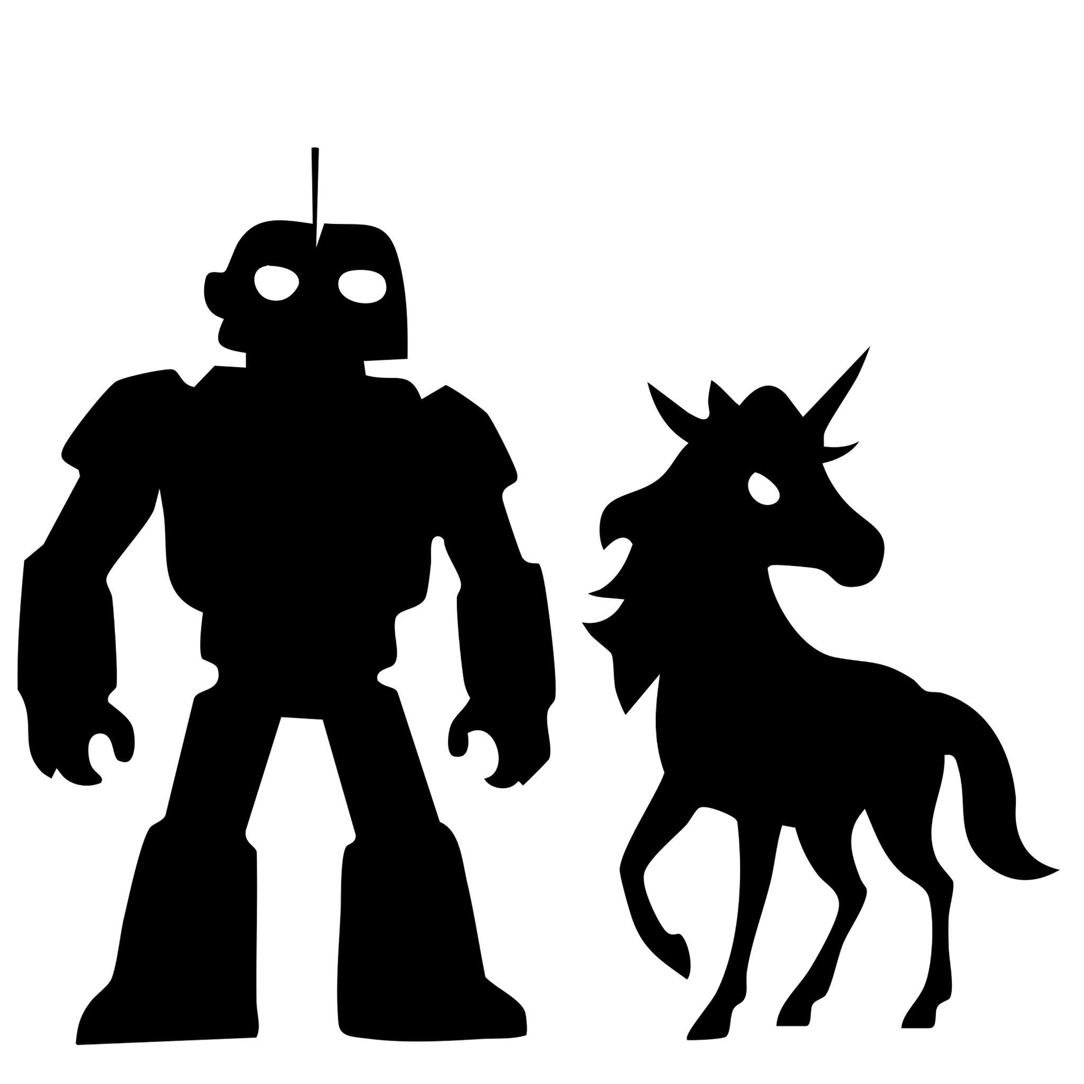

All The Friends
Grace gripped the steering wheel like it had personally wronged her. The car hummed along, but the air inside was thick with the kind of silence that usually comes right before a storm—or right after a dad insists aliens stole his car.

“I’m telling you,” Logan said, hands waving for emphasis. “Aliens took the car!”

Grace shot him a look sharp enough to cut seatbelts. “Right. And I suppose Bigfoot borrowed the minivan last week, too?”

Logan frowned. “Don’t be ridiculous. Bigfoot doesn’t drive.”

Grace slapped the steering wheel. “That’s your response?!”

“Yes!” Logan said, leaning in, dead serious. “A spaceship crashed, Leo and I ran, the car got sucked into alien tech. That’s the truth.”

Grace’s laugh was half snort, half scream. “Do you hear yourself? You’re saying aliens swooped in, crashed your car, and then—what? Shoved it under an invisibility blanket like a magician hiding a rabbit?”

Logan’s eyes lit up. “Yes, exactly! Finally, you get it!”

Grace blinked at him. “Logan, I was being sarcastic.”

“Well, sarcastic or not, you’re still correct,” he said, folding his arms smugly.

Grace muttered under her breath, “I married a man who thinks ‘Independence Day’ was a documentary.”

Logan sat back, trying very hard to look brave and not like a little kid who just got grounded. The silence crept back in—awkward, stubborn, married-people silence—filling the car as they sped toward the school.

Leo spun in a slow circle, jaw dropping. The schoolyard was absolute madness: dragons hopping through hopscotch squares, robots arguing with vending machines, clouds shaped like dogs floating on leashes. Imaginary friends everywhere.

He turned back to his crew: Tomist the prank-monkey hanging upside-down from a tree, Ava coolly stroking her goth unicorn, Max proudly standing beside his seahorse butler (complete with top hat and fake cigarette), and Milo grinning next to Michael Longfoot, who was currently trying to eat a soccer ball.

“What if…” Leo said slowly, “it’s not just our imaginary friends?”

Ava tilted her head. “What do you mean?”

Jack the seahorse puffed a little smoke ring and said, “Sir, I’m quite curious what nonsense you’re on about.”

Leo pointed at the chaos around them. “What if it’s anything we imagine? Our friends only showed up first because they’re the closest things in our heads.”

Max’s eyes went wide. “Anything?” He immediately shut his eyes, scrunched his face, and shouted, “I WANT TO BE SURROUNDED BY CANDY!”

Pop! Pop! Pop! Candy rained down like sugary hailstones. Gumdrops bounced off backpacks. Chocolate bars smacked the pavement. A lollipop the size of a frisbee landed on Michael Longfoot’s head.

“Best. Day. Ever,” Michael mumbled through a mouthful of caramel.

Milo’s jaw dropped. “So if it’s whatever we imagine…” He rubbed his hands together. “What if I picture… A GIANT ROBOT DINOSAUR?”

“WAIT—” Leo started.

Too late. The ground shook as a thirty-foot T-Rex made of chrome stomped onto the football field, its tail smashing the bleachers. Kids screamed, half in terror, half in excitement.

Ava groaned, facepalming. “Okay, but question: is this just kids, or everyone?”

Leo swallowed. “I… don’t know.”

Tomist flipped down onto Leo’s shoulders, whispering in his ear. “Wanna bet what happens if a teacher sneezes and imagines summer vacation?”

In the teacher’s lounge, Miss Lucy sat slouched in a chair, nursing her third coffee like it was life support. The TV buzzed in the background with some boring news story about traffic cones.

Outside, the noise of pure chaos grew louder: kids screaming, dragons roaring, candy raining, soccer balls exploding into glitter. Miss Lucy pinched the bridge of her nose.

“Unbelievable,” she muttered. “Every day. Every single day. I just want some peace and quiet.” She shut her eyes, coffee steaming in her hand. “I wish all the kids would just… go to the Silent Place.”

And just like that—poof.

Silence.

Glorious, eerie silence. Another teacher, Ms. Harper, shuffled in with a sandwich. She blinked at the sudden hush. “Uh… Lucy? Why does it sound like the apocalypse just… stopped?”

Miss Lucy took a long, slow sip, then let out a relieved breath. “No idea. Fire drill? Assembly? Whatever it is… blessed silence.”

Ms. Harper frowned, listening. “Weird. It’s never this quiet.”

Lucy gave a tired half-smile. “Around here we call it the Silent Place—those rare five minutes when nobody’s yelling and my coffee’s actually hot.” She shrugged. “I’m not asking questions.”

Ms. Harper paused, sandwich halfway to her mouth. “Feels almost spooky.”

Lucy leaned back, finally relaxing. “Spooky, sure. But for the first time in twenty years, I’m finishing this coffee while it’s still warm. I’ll take it.”

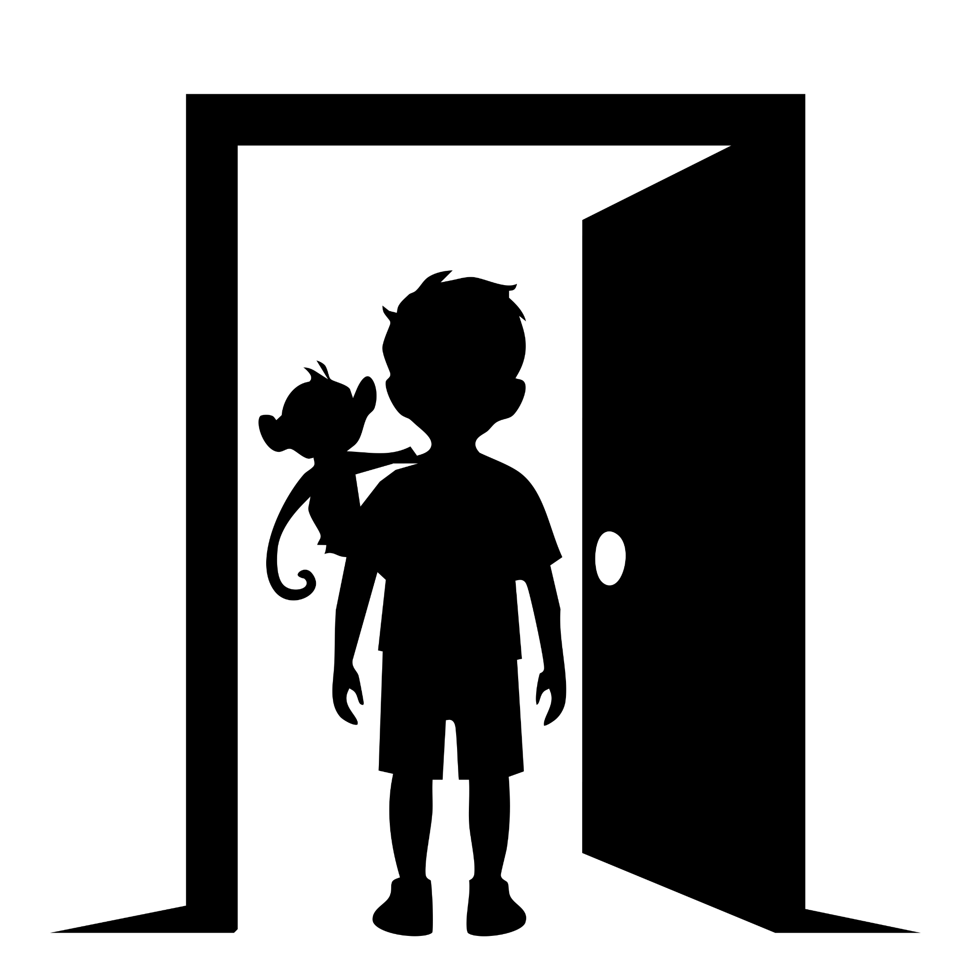

Silent Place
Leo blinked awake and nearly tripped over a stuffed giraffe. The air smelled faintly of baby powder, and the walls were painted a blinding blue with the name “Sam” stenciled across them in bubble letters.

“What the—” Leo muttered.

Beside him, Tomist the monkey-man was already rummaging through a toy chest. He popped a pacifier in his mouth, spat it out immediately, and declared, “Definitely a baby boy’s room. Zero stars. No bananas.”

Leo spun in a slow circle. No windows. No doors. Just endless baby furniture. He swallowed. “Wait. Are we… trapped in here?”

Before Tomist could answer, Leo’s alien watch pulsed a glowing green.

“Ooooh, shiny thing!” Tomist said, grabbing Leo’s wrist like he was about to propose. His furry fingers brushed the light—only for his hand to start fading away.

“Uh, hey!” Tomist yelped, waving the see-through stump. “Bad shiny thing! Return to sender!”

Leo’s eyes widened. “Wait. If it can erase you… maybe it can cut through the imagination stuff keeping us trapped.”

Tomist’s hand flickered back into existence. He grinned. “Ohhh, I like where this is going.”

Leo pressed the glowing watch against the wall. The room flickered, shook, and then peeled away like old wallpaper—revealing the same baby room, but older now. Dusty. Abandoned. Toys slumped in corners.

And this one had a door.

Leo exhaled and stepped through. But when he glanced back, he froze. Ava and her goth unicorn were in another “baby Sam” room, trapped just like his had been. With the Text under it says, “Silent Place”

Tomist waved cheerfully and bolted toward them. “Playdate!”

Leo stayed in the doorway, thinking hard. “Okay. Whoever made this place… they trapped us all in the same room, but split it so each of us sees our own version. Like… shared space, private prisons.”

He closed his eyes, gripping the watch tighter. “If someone imagined us into this place… then maybe I can imagine us out.”

The watch gave another green pulse, brighter this time

Grace pulled into the school parking lot so fast the tires squeaked. Both she and Logan jumped out, marched inside, and stopped cold.

Empty. The halls, the classrooms—everything. No kids, no noise, just eerie silence.

Logan scratched his head. “Uh… where’s Leo? Where’s anybody?”

Grace’s jaw tightened. “I’m finding the teachers,” she snapped, storming down the hall with Logan hustling after.

Before they could reach the office, poof! Leo appeared right in front of them—Tomist dangling from his shoulders like an acrobat who missed the circus. Behind him were Ava and her unicorn, Max with his seahorse butler, and Milo with Michael Longfoot, who was busy chewing on a whiteboard eraser.

Grace froze, stunned. Logan, however, grinned ear to ear. He scooped Leo up and spun him around—only to immediately wince. “Ow, ow, nope. Too old for that. My spine is filing for early retirement.”

“Dad!” Leo laughed, hugging him tight anyway.

Grace folded her arms. “Leo. You weren’t here. Now you are. Explain.”

Leo lifted his glowing alien watch. “It’s from the spaceship. It cuts through illusions. That’s how I got us out of the Silent Place. And maybe it can cut through the alien ship’s disguise too.”

Logan nodded, serious now. “Yeah. Something from that wreck is fueling all this. Shut it down, and the chaos goes with it.”

Leo closed his eyes, holding up the watch. “Okay. Take us to the crash site!”

Nothing.

He tried again, gritting his teeth. Still nothing.

Ava crossed her arms. “Maybe because the Silent Place wasn’t real until someone imagined it. But the spaceship? It’s already real. You can’t teleport to a thing that physically exists.”

Grace groaned. “Fine. Then we go the old-fashioned way.”

Max frowned. “Uh… what’s the old-fashioned way?”

The family car honked outside, twice, like an impatient goose.

Logan jerked his thumb toward it. “Driving. Sorry, kids—we’ve only got four seats.”

Ava, Max, and Milo exchanged looks. Milo puffed his chest. “Then we’ll hold the line here.”

Max smiled, but his seahorse butler, Jack, floated forward, clearing his throat. “Ladies, gentlemen, monkey-men… it has been the utmost honor—”

“Not the time, Jack,” Max cut in.

“—to serve alongside such a—”

“Seriously, Jack.”

“—distinguished band of misfits. I shall remember you all—”

Tomist snatched the top hat right off Jack’s head, plopped it on, and bowed dramatically. “Speech over. Monkey wins.”

The unicorn rolled her eyes, Michael Longfoot waved both massive hands, and Ava gave Leo a smirk. “Nice being part of a group, even if it was a weird one.”

“Don’t talk like you’re quitting,” Leo said firmly. “We’ll see you on the other side.”

Grace’s voice rang from the doorway, sharp with urgency. “Leo—let’s go!”

He turned, heart pounding, and sprinted after his parents. Tomist clung to his shoulders, grinning under Jack’s stolen top hat.

The car door slammed shut. The engine roared. They were off.

Behind them, their friends and their imaginary companions stood like a ragtag army, watching the car disappear down the road.

Max sighed. “Okay. Now that was a proper dramatic farewell.”

Jack sniffed. “It would’ve been better if someone hadn’t stolen my hat.”

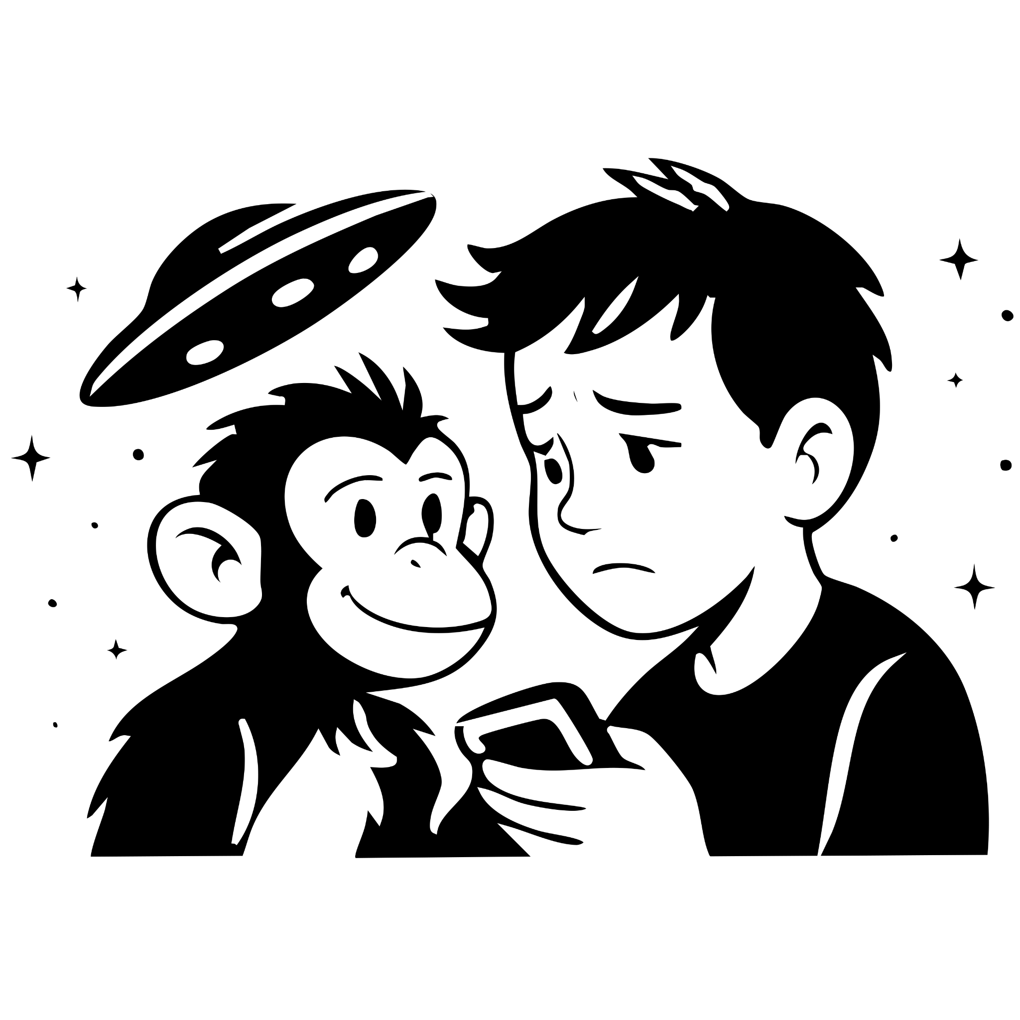

Back To The Beginning
Korr and Nexa trudged through the woods, the tracker in Korr’s hand beeping like a very annoyed alarm clock.

Finally, Nexa flopped onto a log with all the grace of a wet pancake. “What’s the point? We’ve been walking for what feels like forever.”

Korr spun around, glaring. “What’s the point? Did you seriously just say ‘what’s the point’?”

“Yeah,” Nexa said, shrugging. “What’s. The. Point?”

Korr stomped closer, waving the tracker in Nexa’s face. “The point is our mission! You remember the mission, right? The very important mission?”

Nexa scratched his chin. “Uh… observe humans quietly, understand how they think, don’t talk to them, don’t interfere, definitely don’t crash into their cars—”

“Exactly!” Korr snapped. “And now look around. Total mess. Kids summoning monsters, adults panicking, imaginations breaking reality. You think Command is gonna give us a medal for this?”

Nexa sighed. “Maybe a really small one?”

Korr groaned and stuck out his hand. “Get up. We fix this, or we’re toast.”

Nexa grabbed it, hauling himself upright. Korr glanced at the tracker again—and froze. “Wait… we’re closer than I thought. It’s moving… toward us?”

“That can’t be right,” Nexa muttered, peering at the screen. “Unless—”

VROOOM!

A car zoomed past on the road, engine roaring, headlights blazing.

Both aliens whipped their heads around, eyes wide. The tracker beeped like it was laughing at them.

“That’s them!” Korr shouted.

Nexa’s jaw dropped. “The humans took the regulator on a road trip?!”

They stared at each other for one horrified beat. Then, in perfect sync, they bolted after the car, limbs flailing like two very bad marathon runners.

“Run faster!” Korr yelled.

“I’ve got plunger hands!” Nexa wheezed. “This is my top speed!”
Grace’s hands tightened on the wheel as she drove toward the stretch of road where Logan’s car had been smashed the night before. Her heart thumped louder with every mile.

And then—it shimmered into view. The spaceship. Hulking, metallic, glowing like it had just parked from another galaxy.

Grace slowed, pulled over, and killed the engine. Her voice was small. “Oh my god.”

Logan smirked, though his eyes were shining. “Now do you believe me?”

Grace didn’t look away from the ship. “Yes… but from my point of view, this is insane.”

Logan rolled his eyes, already climbing out. “I’ll take it.”

They all got out: Logan, Grace, Leo, and Tomist. The ship loomed over them, smooth and silent, no sign of the broken panel Leo had used before. Sealed tight.

“So what now?” Grace asked.

Tomist puffed up his chest. “Leave it to me! I’ll run around and look for another way in.” He took off, scampering around the spaceship like a caffeinated squirrel.

Leo glanced at his parents. Logan sighed. “Well… at least we know we’re not alone in the universe anymore.”

Grace nodded, watching Tomist leap over a pile of rubble. “I always wondered what your imaginary friend looked like, Leo. And now I know. Monkey-man.”

Leo grinned. “Still mischievous, too.”

Grace smiled knowingly. “When you were little, if Tomist was real, he’d have been stealing my jewelry by now.”

Leo smirked. “Like your necklace?”

Grace froze. Her hand flew to her chest. The necklace was gone.

“Tomist!” she yelled.

On cue, Tomist swung down from the top of the ship, wearing her necklace like a crown. “I found a way in!”

Grace narrowed her eyes. “Or you just broke a way in.”

Tomist shrugged innocently. “Details.”

Logan put a hand on Grace’s shoulder. “I think Leo and I should go in. You stay out here. We need someone ready with a way out.”

Grace looked at him for a long moment, then nodded. “Okay. Protect him.”

Logan smiled, soft but steady. “Always.”

With Grace’s help, they pried open the makeshift entrance. Logan, Leo, and Tomist slipped inside.

The air was colder, metallic, humming with alien power. As they walked, Logan’s voice echoed. “Leo, I’m proud of you. For figuring this out. For standing your ground. For being brave.”

Leo’s chest swelled. He smiled up at his dad. “Well… who do you think I got that strength from?”

Logan’s eyes glistened, but he kept walking.

They reached the engine room. At the center, a glowing socket pulsed—the perfect shape for the alien watch.

Leo turned to Tomist. “You’re my best friend. You’ve been there when I needed you most.”

Tomist’s grin softened. He wrapped Leo in a tight, warm hug. “Of course. Always. I’ll always be with you. Just… don’t forget me this time.”

Leo swallowed hard, his hand trembling as he raised the watch toward the engine. Logan’s hand came down on his shoulder, steadying him. Together, they pushed forward.

But as the watch neared the socket—Tomist began to fade. His laugh, his furry hands, his mischievous eyes, all dissolving into light.

And then—Logan’s outline flickered too. His hand grew translucent on Leo’s shoulder. His voice wavered.

“Dad?” Leo gasped, yanking the watch back. Tears blurred his vision. “No… no, you can’t be. You’re not—you’re not imaginary too, are you?”

The silence of the spaceship hummed around them, heavy and cruel, as Leo’s words hung in the air.

Leo’s breath hitched as the memories snapped together like puzzle pieces.

When his dad picked him up at school earlier, he hadn’t put him down because his back hurt. His hand had flickered—fading. When the spaceship first crashed, the car had been crushed… and Leo only saw his dad again after he licked that disgusting carrot-flavored alien goo. And his mom? She didn’t even see Dad until after the blue wave hit.

Leo stumbled back, shaking his head. “No. No, I can’t lose you and Tomist at the same time. I can’t.”

Logan’s hands—still flickering, but warm—rested firmly on Leo’s shoulders. His eyes were soft, steady, and unbearably sad. “Leo… I died. Back in the crash. Every second since then has been a gift.”

Tears spilled down Leo’s cheeks. “That’s not fair! No! I’m not doing it.” He yanked the watch back from the engine, clutching it tight like it could anchor his whole world.

Logan’s voice was gentle but unshakable. “The world can’t keep going like this, son. Everyone’s imagination running wild—it’ll tear everything apart.”

Leo sobbed. “I can’t keep going without you. You’re my dad. I can’t even imagine a world without you in it.”

Logan smiled sadly. “Leo… the world’s never been fair. But with you, and your mom… nothing can beat you. Nothing.”

Leo shook his head, his shoulders curling inward, shutting down.

Logan leaned closer. “Hey. Remember in Harry Potter? Sirius’s last words to Harry were ‘Good work, James.’” He swallowed, his voice breaking just a little. “So I’m going to change it. Good work, Leo. As much as I want to stay and watch you grow up… time’s already shown its hand.”

Leo loosened his grip on the watch, choking on his words. “We were supposed to… to build Lego Hogwarts together. And stay up all night watching the stars move past.”

Logan pressed a fading hand to his son’s chest. “And I will. From right here.” He tapped Leo’s heart, his touch warm for one last instant.

Leo’s voice cracked. “I don’t want to say goodbye.”

Logan’s eyes sparkled, proud even through the tears. “Then don’t. Just say, ‘See you next time.’”

Leo sobbed, nodding. “I’ll see you next time.”

Tomist padded forward silently, for once not joking. He placed his hand over Logan’s. Father, son, and monkey-man—all together—pressed the watch into the ship’s engine.

A green pulse of light shot through the room.

Logan smiled one last time. Tomist winked with his usual mischief. And then—both of them vanished. Along with every other imagined friend across the world.

Leo collapsed to his knees, covering his face, his cries echoing in the hollow alien ship. For the first time since the crash, he was truly alone.

And then—clink.

On the cold metal floor, Grace’s necklace tumbled out of thin air, rolling to rest at Leo’s knees. Tomist’s final prank, returned.

Through his tears, Leo let out a shaky, broken laugh.

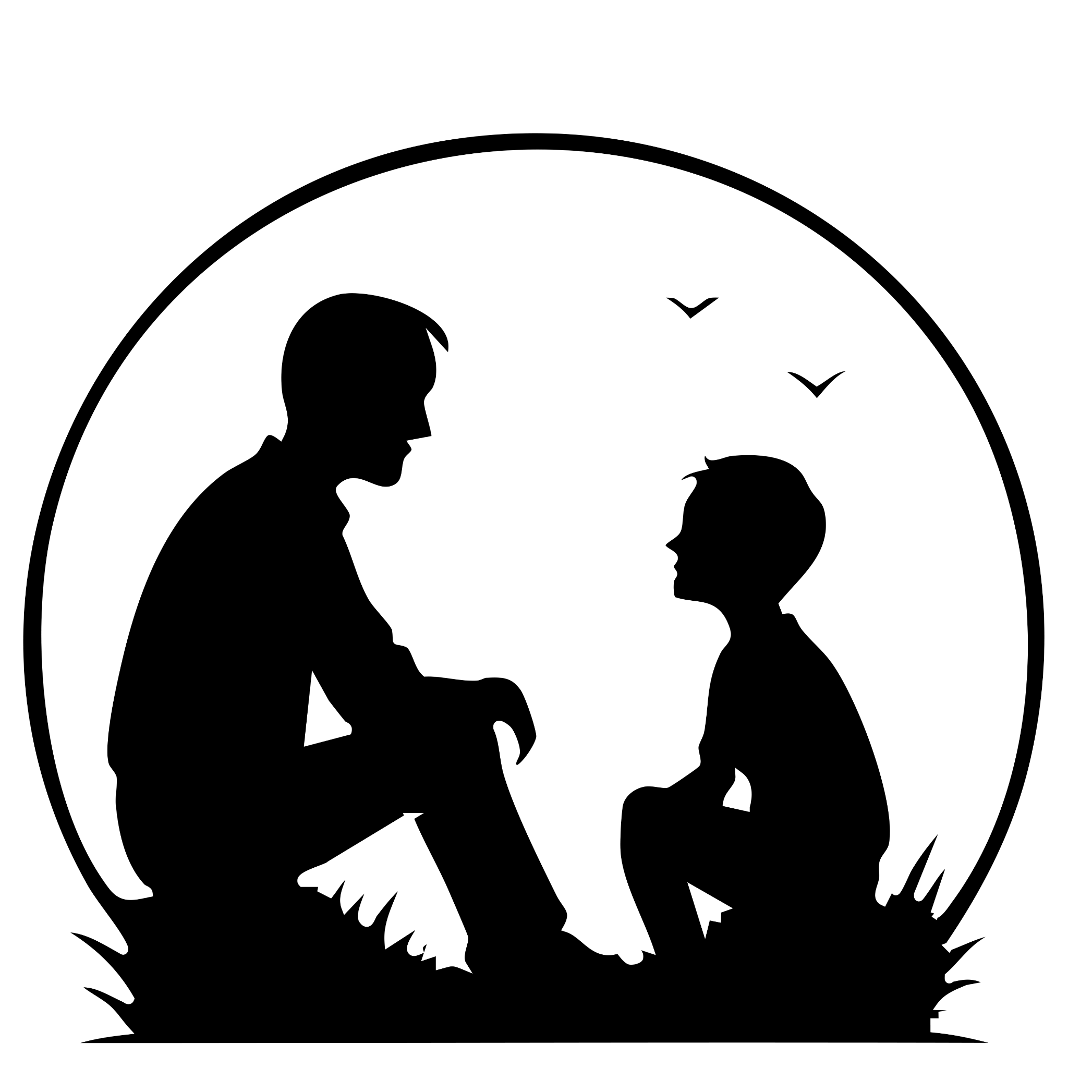

As The World Turn Back To Normal
Grace waited outside, pacing near the busted panel Tomist had smashed in. She clutched the jagged car part like a weapon, every nerve on edge.

That’s when Korr and Nexa finally stumbled onto the crash site, panting like they’d just finished the worst jog of their lives. They froze when they spotted her.

Korr hissed to Nexa, “Okay, let me handle this.”

Nexa nodded. “Good idea. You usually make things slightly worse instead of catastrophically worse.”

Korr squared his shoulders and approached. Grace immediately raised the car part like she was about to knock his head into orbit. “So this is your spaceship then? This is all your doing?”

Korr froze. Then leaned toward Nexa. “Wait… how does she know it’s our spaceship?”

Nexa gasped. “Maybe humans can read minds!”

Grace glared. “No, it’s because you’re ALIENS!”

They looked down—realizing their holograms had fizzled out.

Korr groaned. “Seriously? You had one job: keep the disguises working.”

Nexa sheepishly wiggled his plunger-hands. “Yeah, my bad. I got distracted by… snacks. And gravity. Mostly gravity.”

Grace’s hand shook as she kept the car part raised. Her voice cracked. “My son is inside. He’s putting the watch back. But it’s taking time… he’s saying goodbye to his imaginary friend.”

Korr’s eyes widened. “Wait. His imaginary friend actually appeared?”

Grace lowered the weapon, her shoulders sagging. “Yes. Everything started coming real after your stupid ship crashed.”

Korr checked the tracker, frowning. “Then it’s true. The engine’s field—it’s making every illusion real. Every dream, every nightmare… turned solid.”

Nexa sighed. “Sooo… still my bad?”

Korr shot him a look. “You think?”

Before Nexa could reply, the ship thrummed to life. Lights flickered. Panels realigned. The deep hum of alien machinery filled the air.

Korr glanced at the readings. “The kid must’ve put the watch back.”

The two aliens moved toward another hatch, slipping inside. Grace dropped the car part and ran after them, her heart pounding.

They reached a catwalk overlooking the engine core. Nexa waved vaguely. “Engine’s down there. Your son’s probably…” He trailed off when Grace bolted past without a word.

She raced down the stairs until she saw him.

Leo. Curled into a ball on the cold floor, his shoulders shaking. His jacket was wet with tears.

“Leo?” Her voice cracked. She dropped to her knees. “Where’s Logan?”

Leo looked up, his face blotchy and red. He tried to swallow the sobs but they kept spilling out. “He’s… gone.”

Grace’s stomach dropped. “Gone? What do you mean gone?”

“He died. In the crash. I just… ”

Grace felt her whole chest collapse. Her arms went around him instantly, pulling him close, holding on like she’d never let go. Together, they cried into the belly of the alien ship.

And then—clink.

Grace looked down. In Leo’s lap, something small and shiny rolled to a stop. Her necklace.

Tomist’s final prank—and his way of making sure it got back to her.

Grace let out a wet laugh through her tears, brushing the chain with trembling fingers. “That monkey…”

Leo hiccupped a sob but managed the tiniest smile. “He’d say it wasn’t stealing if he gave it back.”

Mother and son held each other tighter, grief and laughter mixing in the shadows of the spaceship.

Leo sat at his father’s tombstone, lowering himself onto the cool grass beside it. His voice was quiet, almost conversational, as though Logan were still listening.

“The next few minutes after you left were blurred,” he said softly. “Korr and Nexa slipped away, their cloaking tech shimmering the ship out of sight, hidden once again from Earth’s eyes. Mum and I… we called the cops. Tried to explain what happened.”

He gave a faint, rueful smile. “Of course, they didn’t believe a word. They spent months poking at what was left of the car, filing reports, muttering theories. It all turned into a cold case. But at least the insurance came through—life insurance, car insurance. Numbers on paper. Nothing that could ever fill the hole you left behind.”

His gaze drifted across the cemetery, unfocused. “We stayed in that house for a few more weeks, but it was too heavy, too haunted. So we moved closer to school. Funny enough, we ended up next door to Ava. Over the years, the four of us—Ava, Max, Milo, and me—just grew tighter. And eventually, Ava and I weren’t just friends anymore.”

A bittersweet laugh escaped him. “By the time college came around, I went to Harvard for computer science. Ava dove headfirst into biology. Different paths, same bond. Life kept moving—road trips, late nights, laughter. And then, one day, I proposed. Honestly, I think everyone saw it coming before I did. But when Ava said ‘yes’… it still felt like the biggest surprise of my life.”

He paused, blinking hard against the sting in his eyes. “And now here I am. Tomorrow, I’m getting married. I wish you could be there, Dad.”

Leo leaned forward, pressing his palm against the cold stone. A tear slid down his cheek—and just then, the flower he had set carefully at the base of the tombstone tipped over as if nudged by invisible fingers. He let out a shaky laugh, shaking his head. “Still you, huh, Tomist? Can’t resist one last prank.”

Because sometimes, even now, things in his life had a habit of shifting when they shouldn’t. A pen would vanish from his desk only to turn up in his shoe. His car keys would appear in the fridge. His phone would slide from the table when no one was near. Tomist never stayed for long—but every so often, Leo felt the monkey’s grin flicker at the edge of reality. Mischievous. Loyal. Still watching.

Footsteps crunched on the grass. Max and Milo approached, both dressed sharp but wearing the same crooked smiles they’d had since childhood. Max shook his head. “Come on, Leo. We’re thirty. It’s not like we’re getting any younger.”

Milo smirked. “Yeah, mate. Big party waiting. And I’m not letting Max give a toast sober.”

Leo chuckled, standing and brushing his hands against his slacks. He gave the stone one last touch, voice steady now. “I love you, Dad. Always.”

Then he smiled through the ache and jogged after his friends toward the limousine waiting at the edge of the cemetery.

Tomorrow, he would begin a new chapter. But he knew—somewhere, somehow—his father, and maybe even Tomist with one last trick up his sleeve, would still be with him.

