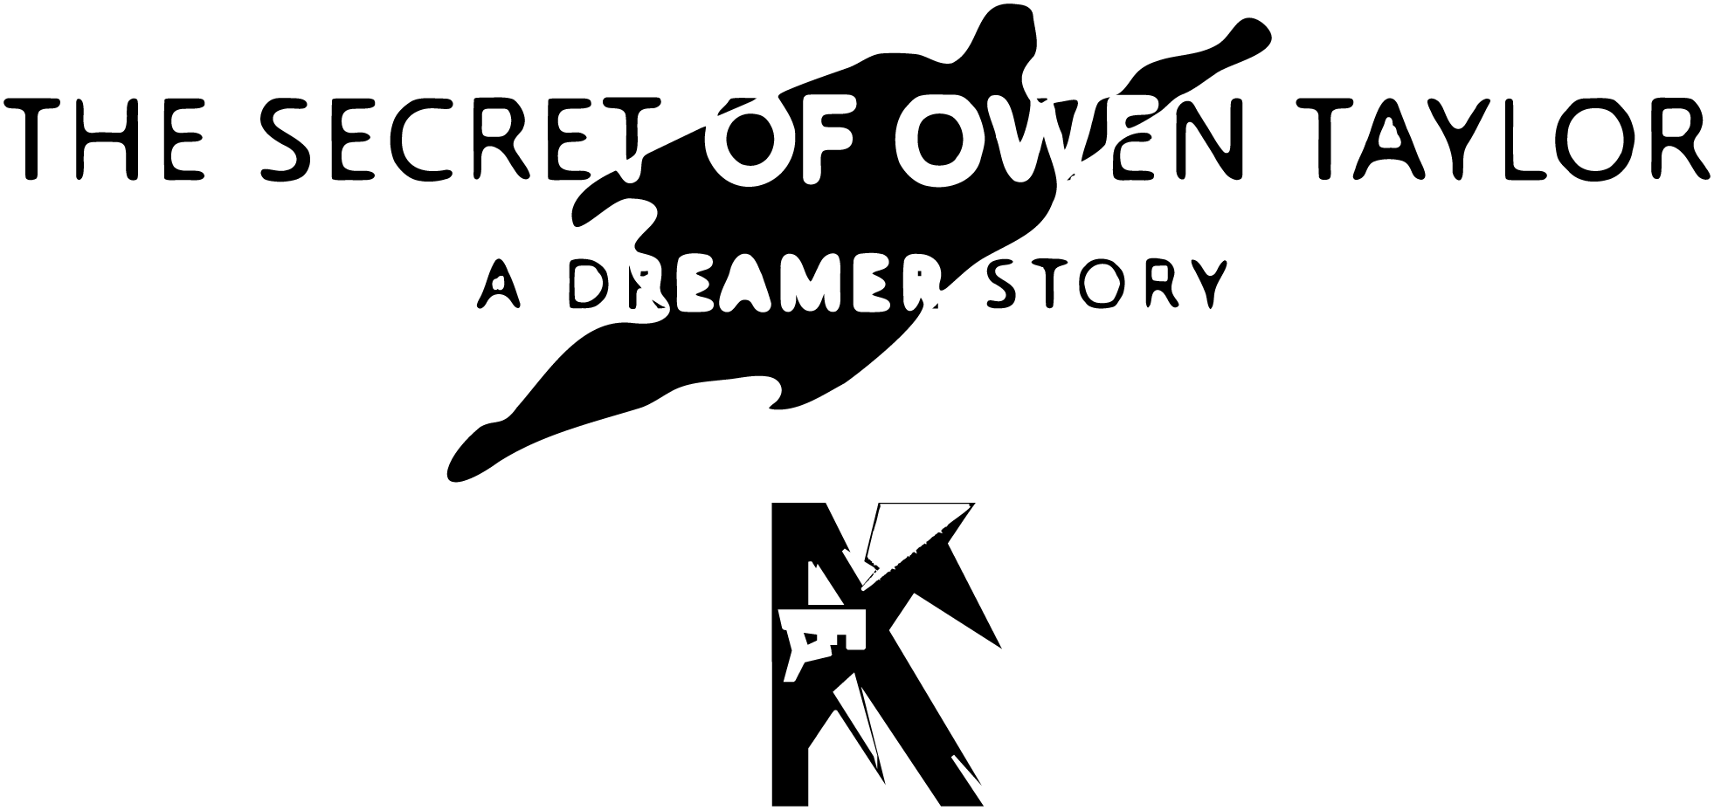

By Kyle Young

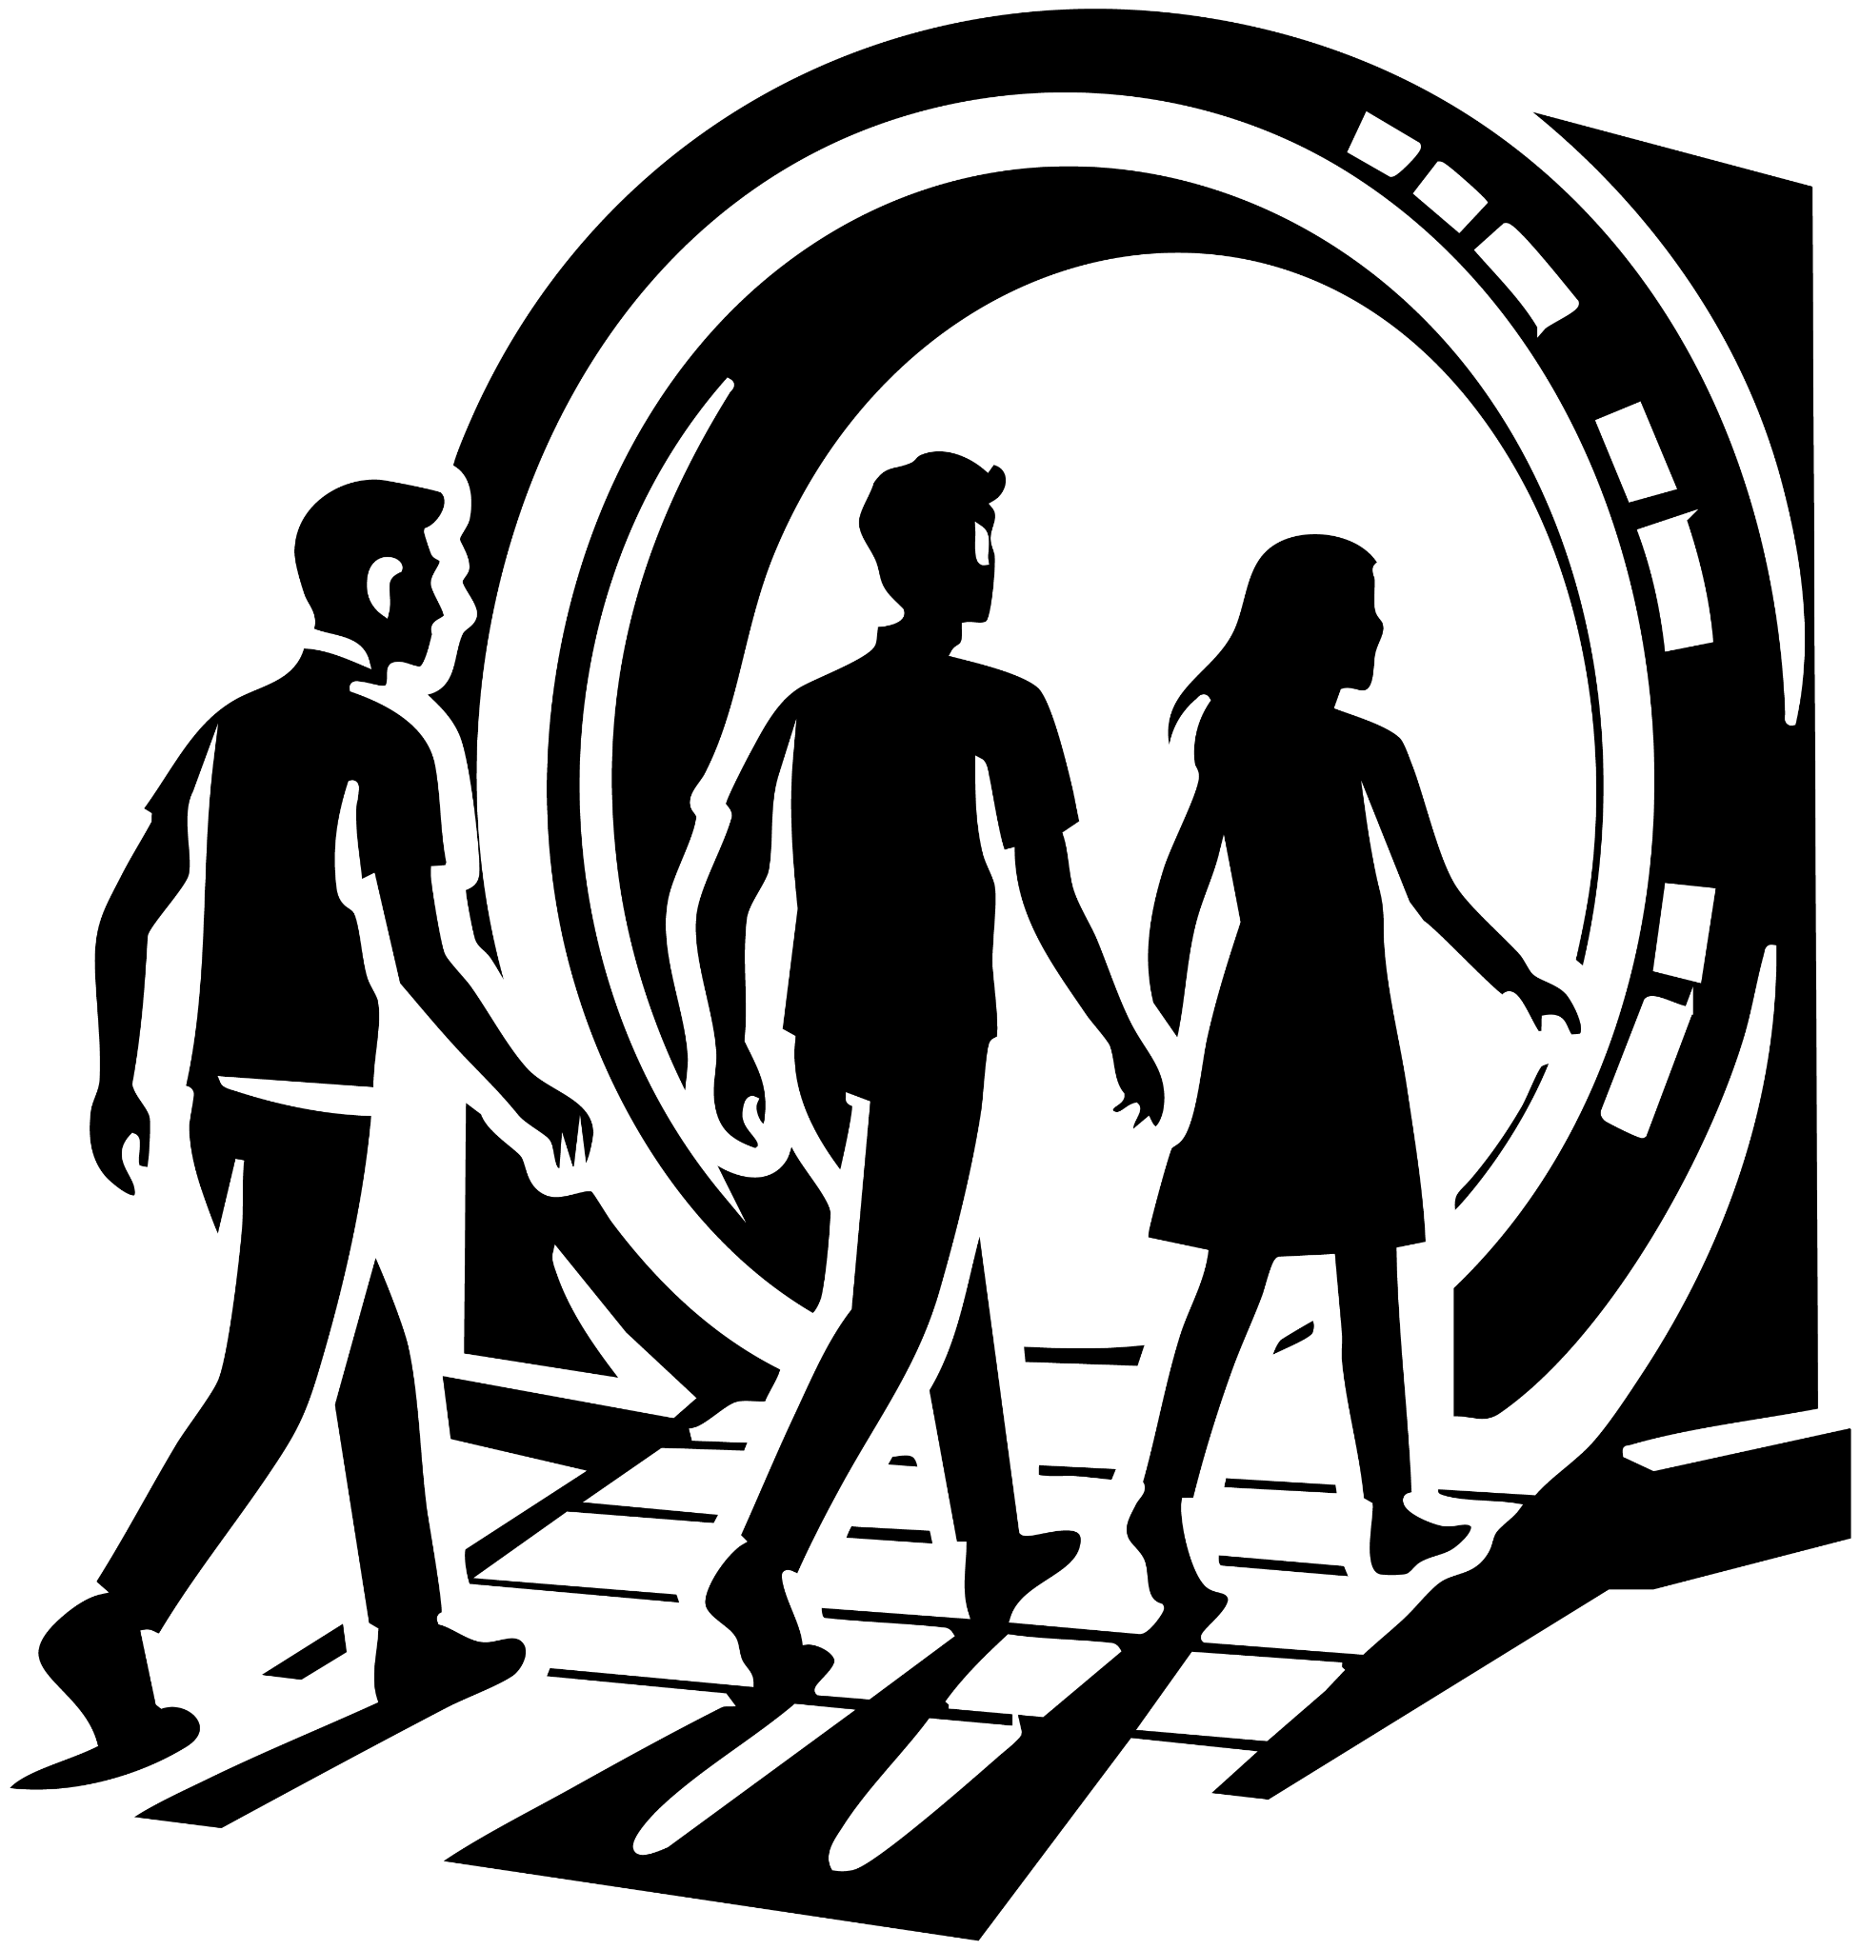

The Day My Heart Stood Still
Owen scanned the crowded hall, searching for Tessa. The place buzzed with anticipation—every eye fixed on the stage, waiting for Elias’ big event to begin.

He lowered his gaze to the glossy pamphlet in his hands. The bold title read:

“Revolutionising Technology Forever.”

“Revolutionising..” Owen muttered under his breath. “Must mean whatever they’re about to unveil will change the world forever.”

A hand clapped onto his shoulder. Owen turned to see Sebastian grinning at him.

“You buying into the sales pitch already?” Sebastian asked.

“Well, it does say it’s going to ‘revolutionize technology forever.’” Owen replied defensively.

Sebastian plucked the pamphlet from Owen’s grip, flipping through it. “This is fluff. Doesn’t even say what they’re showing. Like every so-called tech revolution—game-changing for about five people.”

Owen frowned. “A small step forward is still forward.”

Sebastian smirked, squeezing his friend’s shoulder. “Forever the optimist. Amazing life hasn’t beaten that out of you yet.”

Owen’s phone buzzed in his pocket. Adjusting his glasses, he checked the message.
“Tessa says she’s outside,” he said, confused. “But she was the one who insisted on coming. Why would she miss the show?”

Sebastian shrugged. “She’s your girlfriend. We’re here because of her. Besides, the best parts’ll be online anyway.”

They slipped out of the hall, pushing against the tide of people flowing toward the stage. Outside, they circled the building and spotted Tessa near a side door.

Sebastian raised an eyebrow. “Looks like your girl’s sneaking in the back way.”

Owen shook his head. “She’s a scientist. Maybe she knows someone here. A friend giving us…backdoor access.”

Sebastian gave him a look that said Really? You believe that?

They reached the door, and Sebastian asked, “So, do you know someone on the inside?”

Tessa smirked. “No. But I found something interesting.”

Sebastian shot Owen a knowing glance. Told you.

Owen crossed his arms. “You didn’t just break in, did you?”

“If you call borrowing a keycard from some guy named Johan ‘breaking in,’ then sure,” Tessa said casually.

Owen frowned. “I’m not sure I’m comfortable with this.”

She stepped closer, eyes locking with his. “Come on, Owen. Don’t you feel it? That reporter instinct itching for a scoop on the next revolution? My science brain is screaming to see what’s inside.”

Owen glanced down at the pamphlet, then back at her. After a beat, he nodded. “Fine. Let’s do this.”

Tessa grinned as she pushed open the door. Together, the three of them slipped into the shadows of the unknown.

Owen slipped inside, the air sharp with silence. His eyes flickered red for a moment as his x-ray vision cut through the walls. Shadows moved beyond—security guards, pacing.

He thrust an arm out, holding Sebastian back. His other hand lifted, halting Tessa just as a guard’s silhouette passed by on the other side of the wall.

Tessa smirked. “Well, that was perfect timing.”

Sebastian squinted at him. “Yeah… too perfect. How did you know?”

Owen tilted his head, listening to echoes no one else could hear. “Didn’t you hear them?”

Both Tessa and Sebastian shook their heads. “No.”

Owen frowned. “Then maybe you should trust me. Because everything about this screams we shouldn’t be here.”

Tessa tapped him on the shoulder, eyes glinting with mischief. “Stop being such a boy scout. Live a little.” She slipped past him, scanning left and right before motioning. “Follow me.”

They crept down a long, exposed hallway. No cover. No shadows to hide in.

Owen froze. His super-hearing caught the heavy rhythm of approaching footsteps. “Someone’s coming. Hide!”

Sebastian and Tessa glanced around frantically. “Where?!”

Owen’s eyes flared again, sweeping the walls. Nothing—until he spotted a thick steel pipe overhead.

Without hesitation, he pressed a palm to the wall. His heat vision burned through the metal, sparks hissing as steam roared out in a blinding cloud. The corridor filled with fog, cutting them off from the advancing guards.

Sebastian and Tessa stared in disbelief. Owen turned casually, tilting his head to block the faint glow still smoldering in his eyes. “So where exactly are we headed, Tessa?”

She didn’t miss a beat. “End of the hall. There’s a machine—something I’ve never seen before. That’s why I brought you, Sebastian. Your engineering brain might crack it.”

The two pushed forward, but Owen lingered for a moment. He inhaled, then exhaled a frosty gust. Ice spread across the ruptured pipe, sealing it shut.

“Just in case,” he muttered. “Never know who’s behind us.”

Then he sprinted to rejoin them, the mist still curling in the hall like a ghost.

The three of them stepped into the chamber—and froze.

At first glance, it looked like a room of mirrors. But the reflections weren’t theirs. Instead, the walls shimmered with the vastness of space: galaxies spiraling, stars burning bright. Not just any stars—Owen recognized them. These were his skies. The constellations of his lost homeworld, the last thing he saw before the black hole swallowed it all.

Owen’s voice cracked with awe. “What… what is this?”

Tessa’s eyes danced with excitement. “To me? Looks like a particle generator. But… why use CG projections of space?”

Sebastian wasn’t listening. His gaze locked on the corners of the chamber—scattered with tools. He strode over, pulling open his case and snapping on a screwdriver head. Metal squealed as he began working on a panel.

Owen tensed, his stomach twisting. “Tessa, this doesn’t feel right. Something’s… off.”

Sebastian waved him off. “Relax. Don’t be such a baby. We’re basically there.”

But Owen’s eyes burned red, x-ray vision piercing the walls. What he saw made his breath catch—shapes shifting, matter rewriting itself.

The walls began to bleach to blinding white. A piercing RIIIIING erupted, drilling into his skull. Owen dropped to his knees, clutching his head, eyes squeezed shut.

“Owen!” Tessa knelt beside him, gripping his shoulders. “Hey! Look at me—are you okay?!”

Sebastian turned, panic breaking through his bravado. “Owen!” he shouted, shaking him.

The sound crescendoed, drowning everything out.

And then—

Nothing remained but white.

Only Owen’s vision cut through the void, his x-ray sight still alive in the blindness.

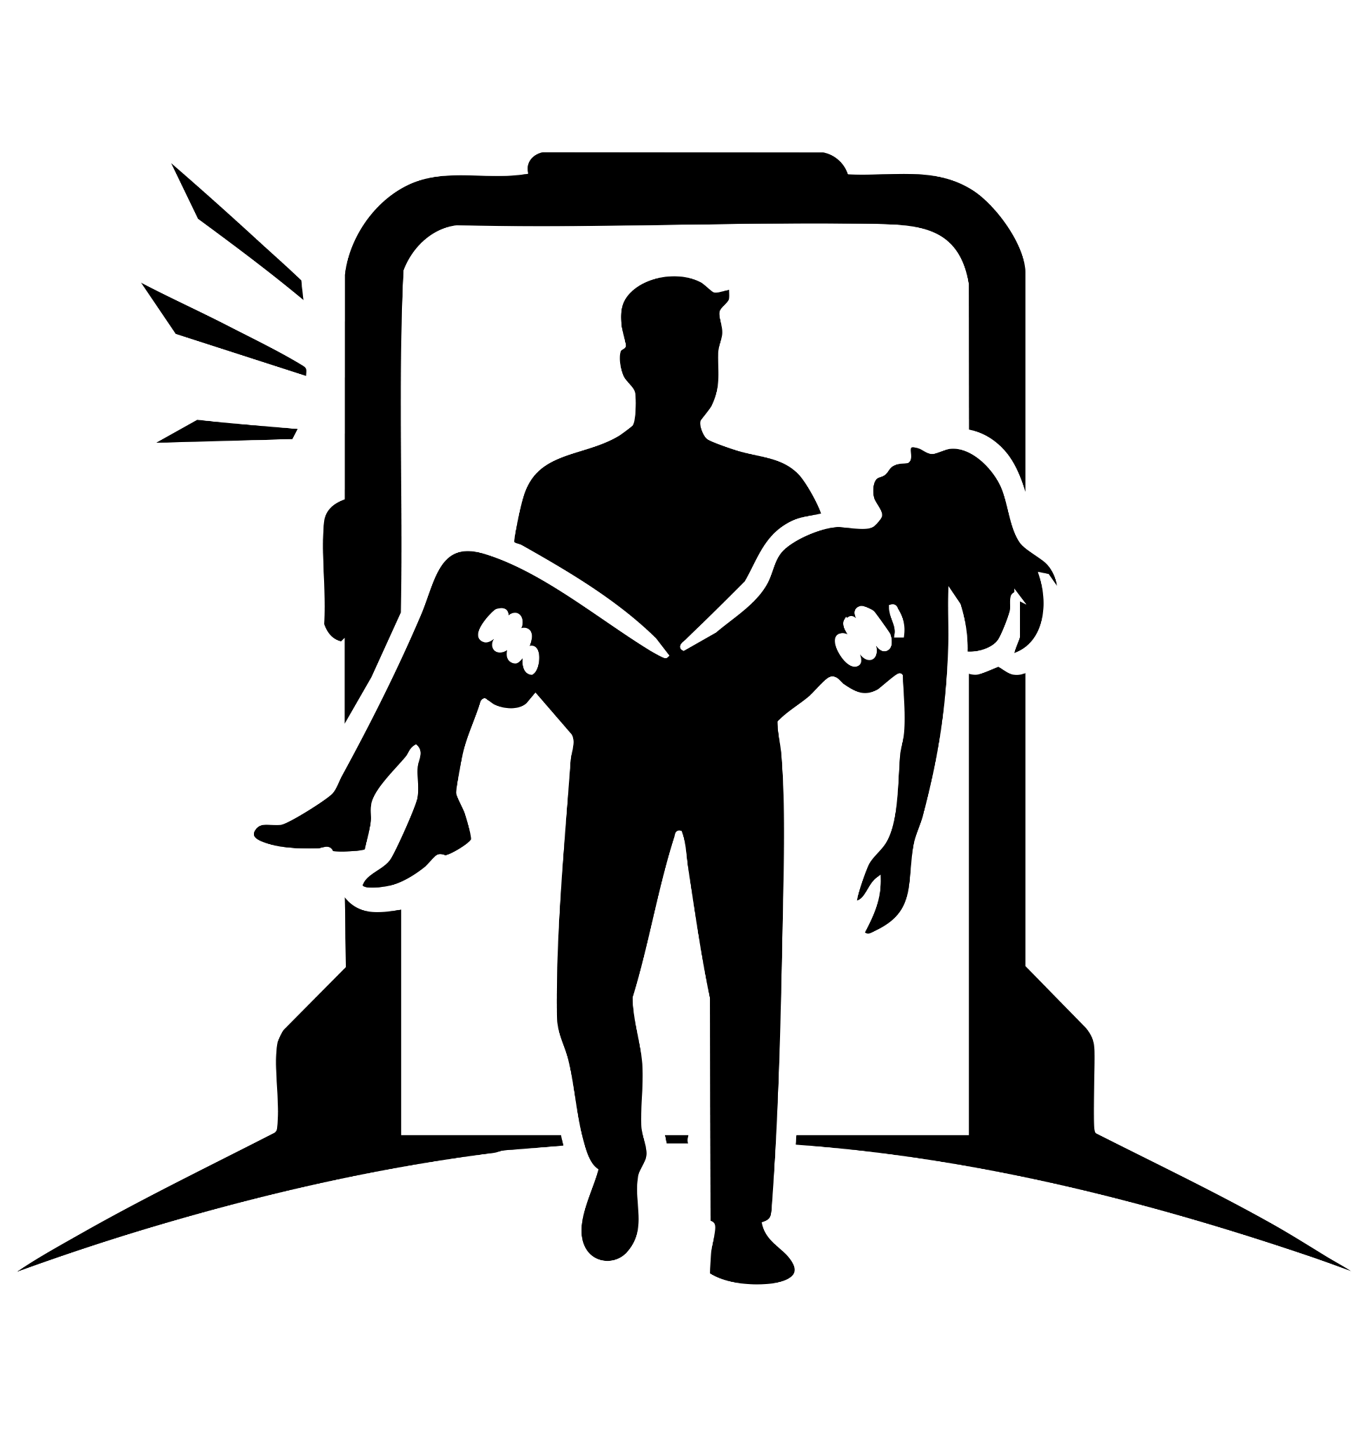

The Minute Everything Changed
A blast of energy ripped through the chamber. Owen slammed into the wall, shards of glass cascading around him like falling stars.

Groaning, he forced his eyes open. Tessa lay beside him—bloodied, her skin laced with fresh scars. But Sebastian… he was gone.

Owen’s gaze drifted across the glittering floor. The shards—dozens of them—were scattered in a perfect circle around him. Not cutting him. Not even scratching. They had bounced off.

The ceiling above split wide, daylight pouring through. From the blinding glow descended a figure in crimson and green, trimmed with radiant blue highlights. Energy swirled around his frame, shaping itself into a massive glowing K.

He landed hard, the floor trembling beneath his boots.

Owen squinted. The man stooped, picked up his glasses, and handed them back with a half-smile.

“Here you go, Owen.”

Tessa staggered to her feet, staring in awe. Owen froze, heart racing, words caught in his throat. “…So. What’s your name again?”

The stranger straightened, the firelight gleaming off his chestplate.

“They call me… the Dreamer.”

Before Owen could reply, Dreamer turned. Flames devoured the far wall, thick smoke choking the room. With a single breath, he exhaled a wave of frost, extinguishing the blaze in seconds.

Owen hauled Tessa up, her arm slung across his shoulders. Dreamer pointed to the side corridor. “I cleared a path. Go!”

Owen nodded, leading Tessa out through the crumbling wreckage.

“Where’s Sebastian?” she asked, her voice trembling.

Owen glanced back, eyes shadowed. “I don’t know. But if he’s alive… Dreamer will find him.”

They staggered into daylight, survivors rushing past them. Sirens wailed in the distance.

Then—Tessa gasped. Her body convulsed, heat radiating from her face.

Her eyes burned red.

“Tessa?” Owen asked, fear slicing his voice.

She screamed, staggering backward—until a sudden surge of searing light tore from her eyes. Twin beams of crimson fire.

Owen reacted instantly, leaping in front of her. He raised his hands into the oncoming blast. The air sizzled. His palms glowed, burning, blackening under the strain. He bit his lip, silent against the pain, forcing himself forward step by step.

“Tessa, look at me!”

Her vision flickered—then blinked out. The beams vanished.

Owen dropped his hands, trembling. Black scorch marks crawled across his skin. He stared at them in shock—until, before his eyes, the wounds began to heal.

Tessa fell to her knees, panting. “When did I get… laser vision?”

Owen met her gaze. “When did you get laser eyes?”

She watched as his ruined hands knitted themselves back together. Then she touched her arms—the scars she’d carried for hours were fading, healing as if they’d never been there.

Her voice was barely a whisper. “When could you… do that?”

Owen swallowed hard, watching her wounds disappear in perfect sync with his own.

“When could you?”

Owen steadied his breath, locking eyes with Tessa.
“I know a place,” he said quietly. “My farm. Out in the country. We can test this… whatever’s happening to us.”

Tessa stared down at her trembling hands, the last glow of power fading from her fingertips. She nodded. “Okay… sounds good.”

Owen pointed past her. “Car’s parked over there.”

Tessa raised an eyebrow, a spark of mischief breaking through her exhaustion. “Race you?”

Owen smirked. “You’re on.”

They broke into a sprint. For a heartbeat, it felt normal—just two friends racing for a car. But then Tessa’s steps grew lighter. Her stride lifted. Her feet no longer touched the ground.

She gasped as her body drifted upward, rising fast. In seconds she was floating above Owen, her momentum carrying her higher—until she hovered dangerously near the roof of the burning building they’d just escaped.

“Tessa!” Owen skidded to a halt, scanning frantically. His eyes fell on a length of twisted pipe. Grabbing it, he raised it toward her.

“Take it!”

She reached out, fear in her voice. “Help me!”

Clutching the metal like a lifeline, she pulled herself down, hand over hand, until she stumbled back to the ground.

No one noticed—everyone else was consumed by the chaos of the fire.

They scrambled into the car, Tessa still hovering inches above the seat until she forced herself down with trembling effort. Owen slid into the driver’s side, slamming the door shut.

He turned to her, voice low, urgent. “What happened to you?”

Tessa met his gaze. Her eyes burned with the same question, but her lips curled into a wry smile. “Don’t you mean… us?”

For a moment, Owen’s expression softened. He gripped the wheel and nodded. “Yeah. Us.”

The engine roared to life, headlights cutting into the night. Without another word, Owen steered them into the darkness—toward the farm, toward answers, toward whatever they were becoming.

The road hummed beneath the tires as Owen drove through the night. Beside him, Tessa’s head rested against the window, her breathing shallow, her body trembling.

The machine hadn’t bent matter; it rewrote it. Had it fused his DNA with hers?

He glanced at her again—her skin flushed, sweat beading on her forehead. The temperature of her body was climbing fast. Panic hit him.

The farmhouse came into view. Owen slammed the brakes, threw open his door, and sprinted around the car. With effortless strength, he lifted Tessa into his arms.

“Hold on,” he whispered.

He burst into the barn. A sharp gust from his lungs blasted the wooden doors wide. The shadows peeled back, revealing the secret within: a spacecraft, hidden in plain sight. Its hull unfolded into a chamber of steel and glowing circuitry, a world apart from the quiet farm outside.

He laid Tessa on the pod’s platform. Instantly, a calm, synthetic voice filled the air.

“How far back are we going this time?”

Owen shook his head. “Not this time. I just need you to scan her. She’s… developing powers. Like mine. Tell me she’s going to be okay.”

“Initiating scan,” the voice replied.

A blue beam swept across Tessa’s body. She convulsed, heat radiating from her in waves.

“Warning: her DNA is unstable.”

Owen’s eyes widened. “Wait—what?”

Needles slid from the pod, injecting her before he could react. Tessa’s trembling slowed.

“What did you just do?!” Owen shouted.

“Stabilized her. The only DNA compatible enough to prevent cellular collapse was Nerathis. If I had her original sequence before alteration, I could have restored it. Otherwise… animal DNA was an option. But the result would have been hybrid—third animal, third human, third Nerathis.”

Owen’s stomach dropped. He stepped closer, voice raw. “Then what is she now?”

The chamber hummed.

“Her sequence is now half human… and half Nerathis.”

Owen staggered back, running a hand through his hair. His voice cracked. “So she’s… one of us. Half of my race.”

He swallowed hard. “What does that mean for her powers?”

“Unknown. When your parents sent you to this world, their knowledge of Earth was limited. They knew it sustained life. They saw that humans resembled Nerathis… and that reproduction was possible. They hoped you might one day find family here. But they never anticipated the power you’d hold beneath this sun. Power… like a god.”

Owen sat down heavily, staring at Tessa’s still form. What have I done to her?

Finally, he stood, lifting her gently from the pod. “We don’t know what’s coming… not yet.”

He carried her upstairs, into the farmhouse. Carefully, he laid her on his bed. Watching her breathing steady, he whispered to himself:

“I’ll take the couch tonight.”



A New Beginning
A hand brushed Owen’s shoulder.

“So this is the famous farmhouse you’re always talking about?” Tessa teased, her voice soft but curious.

Owen sat up from the couch, eyes sharp. “Are you okay?”

She blinked at him, puzzled. “Yeah… why?”

“Last night you didn’t look so good,” Owen said, studying her.

Tessa stretched, flexing her fingers as if rediscovering her own body. “Actually? I feel really good.”

She drifted toward the kitchen. Owen followed, flicking his x-ray vision across her frame—heart steady, lungs full, organs aligned. Perfect. Too perfect.

“What’s the last thing you remember?” he asked.

Tessa frowned, pressing a hand to her temple. “Sneaking into the back of Elias’ event… and then nothing.”

Owen poured a glass of juice, masking his tension. “Let’s see what the news is saying.”

He set the glass down and flicked on the small TV.

A reporter’s face filled the screen.

“Last night, Elias Industries was set to reveal a device capable of creating matter from nothing—revolutionizing, well, everything. But something went wrong. A paradox triggered inside one of the chambers. Eight lives were lost. Here is Elias himself, in his own words.”

The feed cut to Elias at a press podium, grief painted across his features.

“Last night was a tragedy,” Elias said. “Eight souls gone. I mourn with their families. But thanks to the heroes Dreamer, Flame, and Mr. Cool, many more were saved. To them, we owe our thanks.”

He stepped back, removed the microphone, and exited the stage. The cameras stayed behind, cutting back to the newsroom.

But Elias kept walking.

Out of the press lights. Down a corridor. Through a security door.

Moments later, he slid into the back seat of a sleek black car. Inside, waiting in the shadows, was a woman.

His composure cracked. The mask of grief fell away, replaced with cold contempt. “I hate superheroes. Did you see what Flame did? He sucked up the fire and hurled it skyward. Sparks rained down and ignited half the block. They made everything worse.”

The woman smirked. “At least it wasn’t a total loss.”

Elias narrowed his eyes. “What do you mean?”

She handed him a tablet. On the screen—grainy footage of Tessa, floating in the smoke, Owen below her holding up a steel pipe like a lifeline.

Elias’ lips parted. “The machine gave her powers? So you're saying there is a way to give human powers?”

The woman’s smile widened. “Yes.”

He leaned back in the seat, stroking his chin, the wheels in his mind already turning.

“…Unexpected, we can use this machine to get more than just Illuminite,” he muttered.

Outside the tinted window, the city lights blurred past. Elias’ gaze hardened, calculating.

“We may be able to use this.”

The field stretched wide under the stars, hay swaying gently in the night breeze. Owen stood at the center, Tessa across from him.

“Alright,” Owen said, steady and calm. “Let’s see what you can do.”

Tessa smirked. “Don’t you mean… what we can do?”

Owen caught himself and nodded. “You’re right. What we can do.”

He drew a breath, focused downward. The ground seemed to loosen its grip on him as he slowly began to rise, his boots leaving the earth. Hovering now, he glanced at her. “Looks like you can fly too.”

A grin spread across his face. “Now your turn.”

Tessa planted her feet, bent low, and pressed her hand into the grass. She closed her eyes, feeling the world beneath her. Then—with all her strength—she launched upward. For a heartbeat, she soared, eyes wide with wonder… before gravity reclaimed her.

She crashed back into the hay, landing flat on her back.

Owen dropped down beside her. “You okay?”

Tessa burst out laughing, brushing grass from her hair.

Owen knelt, smiling despite himself. “It’ll take time. Mastery doesn’t happen overnight.”

She sat up, catching her breath—and then Owen noticed. Her exhale frosted in the air, the temperature plummeting around them.

“Do you see that?” he asked, adjusting his glasses.

She blinked, staring at her own breath curling like frozen mist. For a moment she smiled, wonder in her eyes… then it faltered.

“I wish Sebastian was here,” she whispered. “He would’ve loved this.”

Owen sank down beside her, quiet.

“He once built these metal gloves,” Tessa said, a sad laugh in her voice. “Could punch straight through concrete. He wore them for days, grinning, pretending he was a superhero.”

“Yeah,” Owen said softly. “For a while, he really was. Called himself the Blue Giant.”

Tessa’s eyes lit. “No way. The Blue Giant? He saved me once. Pulled me out of a burning building.”

Owen chuckled. “That’s him. But he realized if he wanted to make real change… it couldn’t be from the shadows. Not as someone who appeared out of nowhere.”

Tessa leaned against him, the two of them sitting together in the open field.

Then Owen heard it. Distant, faint—but unmistakable. Screams. The earth itself rumbling beneath them. His eyes closed, senses sharpening. An earthquake…

He almost pushed it away. I’ll deal with it later. But then he looked at Tessa.

“I love you,” he said, the words heavy and real.

She turned to him, her eyes soft. “I love you too.” She leaned in, about to kiss him—

Then she froze. Her head tilted. She had heard it too.

“Owen…” Her voice hardened. “There are people out there. They’re screaming. The earth is shaking. We have to help.”

Owen rose with her, his voice measured. “Tessa, you can’t even fly yet. You don’t know what else you can do.”

Her jaw tightened, fire in her eyes. “I can help. We have to help.”

Owen saw the resolve in her face—the stubbornness he knew he couldn’t break. He sighed, then smiled faintly.

“Alright,” he said. “But first… we get you a mask.”

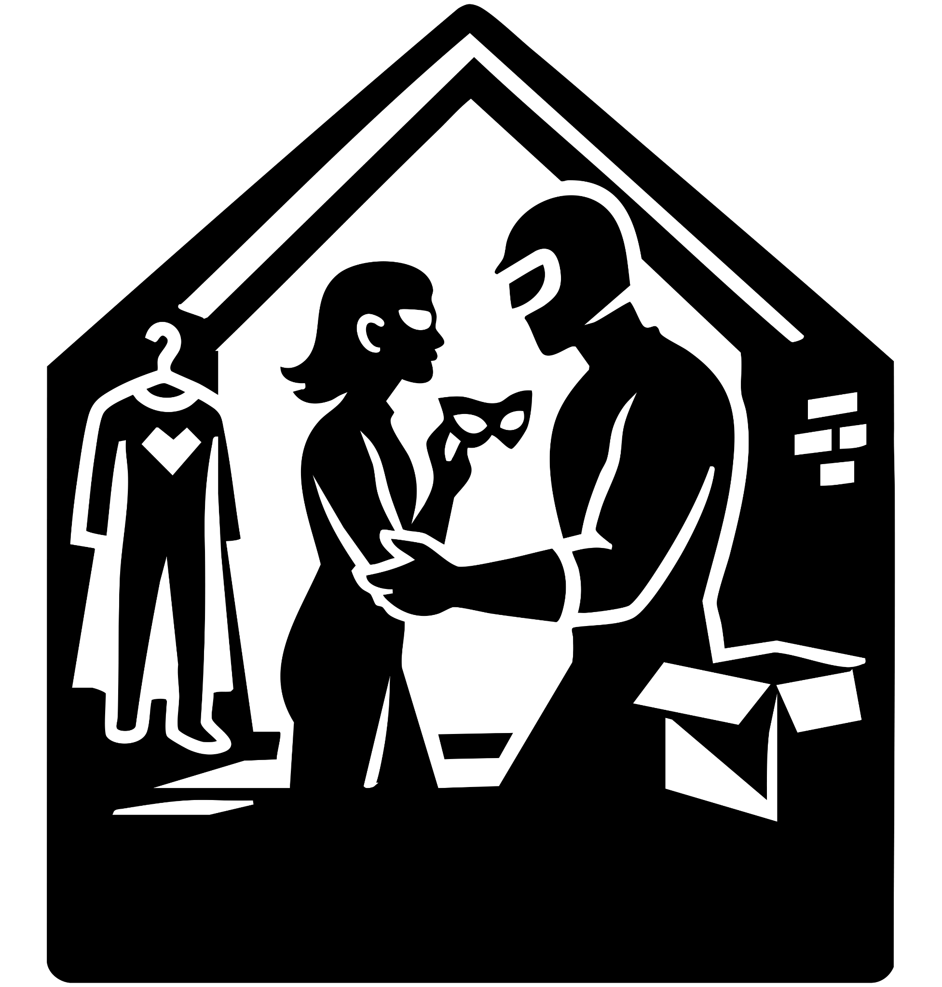

The Blue Giant
Owen and Tessa sprinted back into the farmhouse, the floorboards rattling under their boots. He led her down the narrow stairs into the basement, where old crates and dust-covered boxes lined the walls.

Owen dug through one, pulling free a bundle of dark blue fabric. He shook it out—a full superhero suit, marked with age, its insignia faint but still proud.

Tessa tilted her head. “That’s not gonna fit me.”

Owen smirked, tossing the suit aside. “It’s not for you. I don’t need a full suit right now. Let’s hope you’re not weak to Illuminite like dreamer is, I don’t think there’s any more on Earth, But you—” He rummaged deeper, pulling out a slim black-and-blue eye mask. “You do need this.”

He adjusted his glasses, then handed the mask to her. “It’ll stick once it’s on.”

Tessa pressed it against her face. Instantly, it clung as though made for her. She turned toward a cracked mirror on the wall. For a long moment, she stared at her reflection. “I… I look like a superhero.”

Behind her, Owen pulled something else from the box. Not a suit—but an old, scuffed bike helmet, black with a scratched visor. He flipped it down over his head, then removed his glasses, carefully setting them back into the crate.

When she turned, he stood there in makeshift armor, visor hiding his eyes.

“Let’s do this,” Owen said.

A grin broke across Tessa’s face. “Yeah. Let’s.”

They bounded up the basement stairs and out into the night.

Owen shot into the air with ease, floating high above the field. Tessa crouched, leapt—then immediately face-planted into the dirt.

“Ugh!”

From above, Owen chuckled. “I could just go on ahead while you… figure that out.”

Tessa pushed herself up, glaring. “How are you doing it?!”

“Picture yourself in the air,” Owen called down. “Feel the wind around you—but be like a rock in a river. Steady. Unmovable.”

She closed her eyes, whispering: “Like a rock. I am… floating.”

Slowly, she rose. Her feet left the ground. Her eyes snapped open—she was hovering.

Owen’s voice rang with pride. “Look at you. You’ve done it!”

Her grin returned, fierce and full. “Race you!”

“Sure.”

Tessa blasted forward—straight in the wrong direction. Owen didn’t move.

“Uh… Tess?” he called. “The sound’s the other way.”

She stopped, cheeks flushing, then closed her eyes to listen. The distant cries cut through the wind.

“You’re right,” she admitted. Then she shot past him, laughing. “Still gonna win!”

Owen smiled under the helmet, heart pounding with something bigger than the race. This is the start of everything.

The city trembled on the horizon. Sirens wailed. Windows flickered like stars going out.

Owen and Tessa cut through the sky, streaks over the farmland. Owen flew just beneath her, ready to catch if her newfound lift faltered.

“So, I just fly into collapsing buildings and save people?” Tessa shouted over the wind.

“That actually sounds like a good plan,” Owen said, eyes scanning the chaos ahead.

They crested the last row of rooftops—and the battlefield exploded into view: a skyscraper groaning on its foundations, sand spiraling into a dragon’s silhouette as it hammered a figure in red and black. Across the plaza, Dreamer—barefaced, no mask—traded blows with the same man, each punch cracking the air.

Who survives Dreamer’s punches? Owen thought.

The red-and-black brute shoved Dreamer backward. Owen tucked his arms forward like a spear and slammed into the villain mid-charge, blasting him across the street and into a parked transport. KRANNNG!

Owen landed hard, boots skidding on shattered glass. The sandstorm collapsed into a human form beside him—Sand Dragon reforming with a hiss of grit.

Dreamer—face uncovered, cape scorched—met Owen’s battered gaze.

“What are you doing here?” Owen asked.

Dreamer gave the faintest shrug, a tired half-smile. “Well, you know.”

Owen winced at the blood on his knuckles. “How does this happen to you?”

Dreamer’s eyes narrowed, distant and knowing. “Well, you’ll find out.”

A red-and-black blur tackled Owen skyward. WHOOSH! They rocketed above the rooftops, trading shockwave punches in midair.

Sand Dragon lunged to pursue, but Dreamer’s arm snapped out, stopping him.

“We have to help him.” Sand Dragon’s voice was raw, urgent.

Dreamer didn’t flinch. “No, we have to save everyone else.”

Anger flared across Sand Dragon’s face. “He just looks like a normal dude, if we couldn’t beat him, he won’t be able to.”

Dreamer’s tone turned iron. “There’s more at play than one man versus anyone—we need to save people first.”

A beat. Rubble groaned. People screamed.

Sand Dragon exhaled, resolve hardening. “Fine, I’ll stabilise the buildings, you grab the people.”

Dreamer nodded once and vanished in a thunder of wind, blue and red blurring through smoke as Sand Dragon surged into a roaring column, bracing the tottering high-rise with a tidal wall of sand.

Owen slammed into the pavement, the breath ripped from his chest. The man was on him instantly—fists raining down, blow after blow.

Owen raised his arms, blocking what he could, bones rattling under the barrage. A punch slipped through, splitting his lip. Another rattled his jaw.

Then—an opening. Owen twisted, pushing off the ground, catching the attacker’s arm. In one fluid motion he flipped the man over, slamming him down with a thunderous KRASH!

Owen’s fists came down in return, hammering the mask until it cracked and shattered.

The face beneath froze him cold.

“...Sebastian?”

His best friend stared back at him, eyes wide—then flickering, turning a sickly yellow. His body spasmed, hands clawing at his temples as he screamed.

“What’s happening to you?!” Owen shouted, staggering to his feet.

The scream stopped. Sebastian’s face hardened, twisted into fury. His body coiled like a weapon switched on. Then—he launched.

Owen caught the first strike, then the second. He backpedaled under the third, gritting his teeth. “I won’t hit you, Bas.” He kept his hands open and ate the next punch.

But Sebastian didn’t stop. His fists pummeled like machine-gun fire. Each hit drove Owen lower, knees buckling under the relentless storm.

Through bloody gasps, Owen pleaded, “We shouldn’t have left you. I went back… I searched for you… I know you’re still in there!”

Sebastian froze, just for a moment. His trembling hands lowered.

Owen’s heart sparked with hope—until a slow, mocking clap echoed across the rubble.

He turned.

Elias stepped from the shadows, immaculate in his suit, smiling like a predator.

“What have you done to him?” Owen demanded.

Elias spread his arms. “I made a weapon.”

THUNK!

Something ripped into Owen’s back, a giant metal needle covered in illuminate—hard, sharp, burning. His eyes widened. A barbed cable, humming with energy, had punched into him.

He staggered, choking, the cable vibrating like a live wire. His skin crawled as he felt it pulling—not just his blood, but his very strength.

Elias’ voice was ice. “You’re an alien, Owen. Your DNA is superior. Stronger. Smarter. Why waste it? I’ll take what I need… and make more of him.”

Owen’s vision blurred. His body grew heavy, energy bleeding into the crackling line running back toward Elias’ device.

He dropped to his knees, the world spinning.

Falling.

Fading to black.



The Night Tessa Found Out
The last survivors stumbled into the safety zone as dusk bled across the skyline. Tessa touched down, her boots settling in the dirt, and exhaled.

“I think that’s everyone,” she said, brushing the dust from her arms.

Dreamer floated down beside her. His scars were gone, his strength renewed. He gave her a warm, almost tired smile. “Yeah… I think that’s everyone. Nice to meet you.”

Tessa studied him—his emblem glowing faintly against the fading light. “Why is your name Dreamer… but your logo’s a K?”

Dreamer glanced down at the crest on his chest, running his fingers across it. His eyes softened. “The K… on my world, it means a better tomorrow. A symbol of hope, of striving for something more. That’s the closest translation, anyway. My name is Dreamer… because that’s what I’m working toward. That’s what I fight for. A better tomorrow.”

Tessa blinked, surprised. “I never knew that.”

Dreamer’s smile deepened, a hint of mystery in his tone. “There’s a lot you don’t know about me. But you’ll find out. Soon.”

She raised an eyebrow. “What, did you give an interview or something?”

Dreamer chuckled. “It’s the… something.”

Tessa folded her arms. “Have you seen a guy wearing a bike helmet? Haven’t spotted him anywhere.”

Dreamer shook his head. “I haven’t seen him. But if I were you… I’d start with the last place you saw him.”

With that, he crouched low, then rocketed into the sky, vanishing into the twilight with a streak of blue and red.

Tessa pulled out her phone, thumbs flying as she texted Owen. No response. She frowned, worry etching her features.

“I could just… fly to his farmhouse.”

She looked once more at the horizon, then leapt upward. The air caught her, lifted her, carried her toward Owen’s home as the stars blinked to life overhead.

The world blurred past Owen in a smear of light and color. His head lolled forward, vision flickering in and out—sky, rooftops, highway signs flashing by like streaks of white fire.

Muffled voices cut through the haze.

“So this is the alien?” one man said somewhere above him. “Doesn’t look like much. No ship crash on any of our satellites… so what kind of tech’s he hiding?”

Owen tried to move. His arms felt heavy—dead weights at his sides. He swung once, clumsy and weak, his fist thudding against the man’s chest like a child swatting at steel.

The man just chuckled, unfazed. “Easy, hero. You’re going home. At least, according to your driver’s license.”

He dangled Owen’s wallet in front of him, flipping open the ID. The photo was of Owen with glasses—the ordinary man he pretended to be. The man studied the card, then glanced at Owen’s bruised, alien face.

“Doesn’t look like you,” he sneered.

The vehicle jolted to a stop. Tires screeched.

Owen’s door swung open, and he spilled out onto gravel, coughing, trying to get his bearings.

And then he saw it—his farmhouse.

Another car rolled up behind, black and unmarked. The door opened, and Elias stepped out. Calm. Cold. Calculating.

“Search everything,” Elias ordered, his voice sharp as glass. “Tear it apart. I want that alien ship.”

Men in black gear streamed past him, heading toward the barn.

Owen tried to push himself up. The strength was coming back, faint but real—like fire catching on damp wood. His vision steadied, breath slowing.

Not yet whole. But enough to fight.

His eyes flared red for just a heartbeat.

Tessa soared across the darkening fields, the last light of dusk behind her. As Owen’s farmhouse came into view, her stomach dropped.

Black SUVs ringed the property. Men in tactical gear swarmed like ants, tearing through walls, ripping apart the home.

“What the hell—who are they?” she whispered—then gasped as her vision sharpened unexpectedly. She’d accidentally triggered her x-ray sight, catching glimpses of shattered beams and armed men ripping through Owen’s rooms.

A rush of air—then a voice beside her.

“Have you seen him yet?”

She spun and nearly shouted with relief. “Dreamer! I need your help!”

“Yep,” Dreamer said with a calm smile. “I know. Follow my lead.”

He dove, cape snapping behind him. Tessa followed, landing hard in the dirt.

Dreamer exhaled a gale of freezing wind. Ice swept across the yard, locking the first wave of attackers mid-step.

“Tessa! Pick him up!” Dreamer barked.

She bolted to Owen, lying weak but alive among the wreckage. His face lit with relief when he saw her.

“Thanks for coming,” Owen rasped.

“No worries,” Tessa said, helping him upright.

Dreamer blurred past them, smashing through another squad with a thunderous punch.

“Let’s go!” Tessa shouted.

Owen shook his head. “No—we need the barnhouse.”

“Why?”

“Trust me.”

Tessa didn’t argue; she helped him limp across the yard. Dreamer passed them with long, steady strides. As he went by, he leaned close to Owen and said quietly, “Right. Right. Left.”

Owen’s eyes sharpened.

Tessa frowned. “Where are you going?”

Dreamer flashed a small, knowing smile. “Just trust Owen. I need to distract him.” Then he shot skyward, a streak of red and blue cutting across the night.

“Distract who?” Tessa muttered.

But before Owen could answer, two armed men lunged from the right.

Owen inhaled sharply—then unleashed a burst of icy breath. The men froze in place, sheathed in frost.

Another assailant vaulted from a car on the left—Owen spun and blasted him midair, knocking him cold.

Tessa’s eyes widened. “That’s what ‘right, right, left’ meant?”

Owen gave a grim smile. “Exactly.”

Behind them, a sonic BOOM split the sky. Tessa glanced back just in time to see a blur of motion—Sebastian, armored in red and black, slamming into Dreamer mid-flight. They crashed into the treeline like meteors.

Owen and Tessa reached the barn. He threw the doors wide, revealing the hidden truth: the sleek alien pod nested inside, glowing faintly with strange symbols.

“What… the hell is all this?” Tessa asked, breathless.

“I need you to help me to the pod,” Owen said.

She hesitated, but slipped under his arm, guiding him to the vessel. “When did this get here?”

“This is the pod I landed in… twenty-three years ago.”

Tessa froze. “Landed? You mean—you’re an alien?”

“It’ll all make sense,” Owen said through gritted teeth. “But right now… just trust me.”

He slumped into the pod. Panels lit up, bathing the barn in silver light.

Tessa stumbled back, shielding her eyes as the machine roared to life. Energy arced across the walls.

“Owen!” she shouted—then he vanished. A sudden flash. Gone.

The machine powered down with a hiss, steam curling upward.

Tessa stood frozen, heart hammering. “What the hell is going on?”

A slow clap of footsteps on the barn floor answered.

She turned—and Elias stepped through the doorway, cold smile cutting across his face.

“And there’s the ship,” he said.

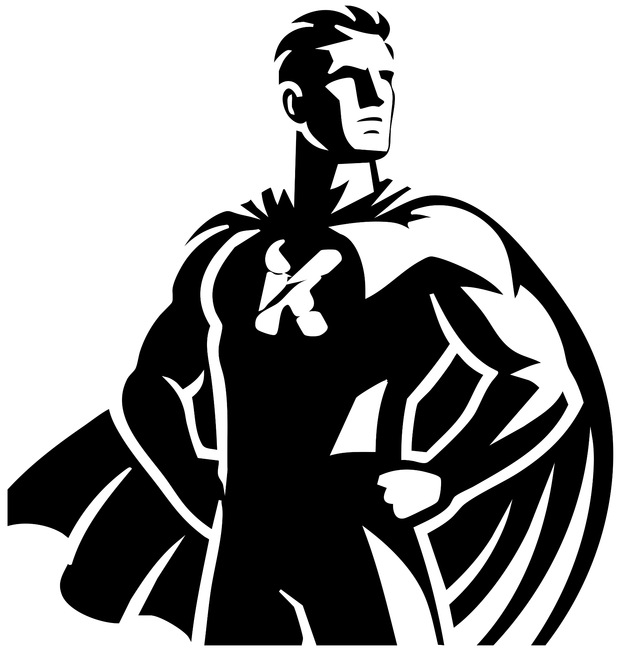

The Day Of Dreamer
White light collapsed. Owen dropped onto cold metal, coughing, the pod’s hum fading to silence.
He pushed himself up—same barn, different moment. On a rack beside the pod hung a suit: crimson and green with blue edging, the K crest gleaming like a promise.
Owen’s fingers trembled as he lifted it. Dreamer.
Tires crunched outside.
Headlights swept the barn doors. Owen slipped into the shadows as his car rolled to a stop—Tessa slumped in the passenger seat. The past Owen leapt out, sprinted around, and scooped her into his arms, rushing toward the barn.
Heart hammering, present Owen hugged the wall, letting his other self thunder past. The loop held.
When the doorway cleared, he cut across the yard. The car sat where past-him had left it—engine ticking, keys still in.
He slid behind the wheel, the suit across the passenger seat, the K crest catching the dashboard glow.
“The quake… Dreamer appears at the quake,” he murmured. “So I need to be in the city.”
Gravel spat from the tires as he shot down the back road, away from the farm, away from Elias’ men. Wind tore through the open window; the suit’s cape fluttered like a living thing.
City lights flickered on the horizon.
Owen tightened his grip on the wheel, eyes hard, jaw set. No mask. No alias to hide behind—just a symbol and a choice.
“Better tomorrow,” he whispered to the emblem.
He pressed the accelerator to the floor and drove toward destiny.
Owen drove into the city under cover of night, neon and glass flashing past the windshield. He parked beside a hotel, hood up, head down. Inside, he booked a room with cash and took the elevator in silence.

In the quiet of the suite, he tossed his bag on the bed and unwrapped the Dreamer suit. The weight of the symbol hit him. His younger self hadn’t worn it yet. This was his first step into the legend he already knew.

Exhaustion crashed over him. He didn’t fight it. Sleep came hard and fast.

Hours later, the world shook.

His eyes snapped open. The bed trembled; the city roared beyond the window. Owen felt stronger—skin flushing back to its healthy color, energy rushing through his veins like fire.

He suited up. The cape settled across his shoulders, the K crest catching the morning light.

He slid the window open, stepped onto the ledge, and launched himself into the sky.

The city was breaking apart. Towers groaned and tilted. Bridges buckled. Screams rose from every street.

Dreamer cut through the shaking skyline, cape snapping, hands already reaching for the first falling body.

He caught falling workers, hauled families from crumbling balconies, moved faster than the eye could track. Again and again, lives pulled from the brink.

Then the air shifted—a roar of sand. Sand Dragon surged up from the ground, shaping highways of living grit, carrying crowds to safety, catching debris with towering dunes.

Relief was short-lived.

A red-and-black blur slammed into Dreamer mid-flight. They tumbled, cracking through a plaza before Dreamer flipped his attacker away and landed hard, cape torn.

Sand Dragon slid in beside him, forming walls of sand, eyes blazing. Together they braced as the villain approached—Sebastian, but changed. Masked. Burning.

Dreamer charged first, fists a blur. The red-suited figure dodged, countered with brutal strikes.

Sand Dragon lashed out, snaring the man’s legs with coils of sand—but the villain’s eyes flared hot. Beams of heat seared the coils into molten glass.

Before the next blow could land, another impact streaked from above—Owen himself, younger, desperate, slamming the red villain into the pavement with all the strength he had left.

The two heroes locked eyes across time—older Dreamer staring at his battered past self.

Present Dreamer’s breath caught.

“What are you doing here?” Owen demanded, chest heaving, confusion and rage on his face.

Future Dreamer—scarred but unmasked—stood frozen for a heartbeat, watching his own past unfold.

Tessa hesitated, still catching her breath. “Have you seen a man wearing a bike helmet? I… haven’t seen him anywhere.”

Dreamer’s eyes softened for a heartbeat, then sharpened with purpose. “I haven’t seen him. But if I were you, I’d go to the last place you saw him.”

Before she could ask more, Dreamer bent his knees and launched upward, disappearing into the clouds in a streak of crimson and green.

He soared across the cityscape, skyscrapers glowing like steel fires beneath him. Elias Industries loomed ahead, black glass catching the last gold rays of day. Dreamer’s vision burned red as he swept the towers, peering through concrete and steel like tissue paper.

“Come on… something, anything that can help Sebastian…” he muttered.

Deep inside the complex, in a vault lined with strange tech, something caught his attention. A helmet—gleaming, heavy with circuitry, cables snaking from its crown.

Dreamer’s breath hitched. “That helmet… could do something. Might be a way to break Elias’ control.”

But then shadows stretched long across the city—the sun slipping below the horizon. His heartbeat stuttered.

Tessa.

His jaw tightened. “I have to get back. She’s not safe.”

He cast one last look toward the helmet, memorizing where it was, then banked hard and streaked away—leaving the city’s lights behind, heading for the only place that still felt like home.

Dreamer dropped from the sky, landing between the swarm of black-clad men and Tessa. She was dragging a half-conscious Owen toward the barnhouse. Dreamer glanced at Owen, their eyes locking for a breath.

“Right, right, and left,” Dreamer said quietly — a coded warning only Owen would understand.

Then Dreamer turned away, stepping between the chaos and his friends. From the treeline, a red-and-black blur shot forward — Sebastian, armored and feral.

Dreamer barely braced before the hit came. WHAM! The two crashed through the field, tearing up earth in a wake of dust and shattered fence.

Dreamer twisted midair, throwing Sebastian to the ground with a heavy slam. He stepped forward, no guard raised, voice breaking past the sound of battle.

“Do you remember the night we stayed up playing Night Image?” Dreamer said, eyes pleading. “Two consoles, side by side. Two TVs. We sat on that old couch trying to figure out the twist… please. Come back to me.”

Sebastian’s breathing hitched. For a flicker, the rage in his yellow eyes dimmed.

“Owen…” His voice cracked. “I can’t stop myself.”

Dreamer knelt, reached out, hand trembling as it landed on Sebastian’s shoulder. “Then we’ll figure this out. We’ll fix you.”

Sebastian looked down at his hands as claws curled from his fingers, sharp and unnatural. His face twisted in grief. “What have I become?”

“In that machine…” Dreamer’s voice was quiet but certain. “It mixed your DNA with mine — but unstable. Elias may have patched it with wolf… or something worse. But we can find a way back. Together.”

Sebastian’s gaze darted past Dreamer, to the black SUVs encircling the house, soldiers spilling out. His breath came faster, panic and fury mingling.

“I’m a liability,” Sebastian said through clenched teeth. “You have to go. Help Tessa.”

“Sebastian—”

“I’ll draw them off. I’ll go to the lighthouse.”

Dreamer hesitated only a second, then nodded once. No fear, just sorrow.

Sebastian’s claws retracted. With a single leap he launched skyward, streaking red and black across the night until he vanished over the tree line.

Dreamer stood alone, cape rippling in the wind, and turned back toward the farmhouse where Tessa disappeared inside.

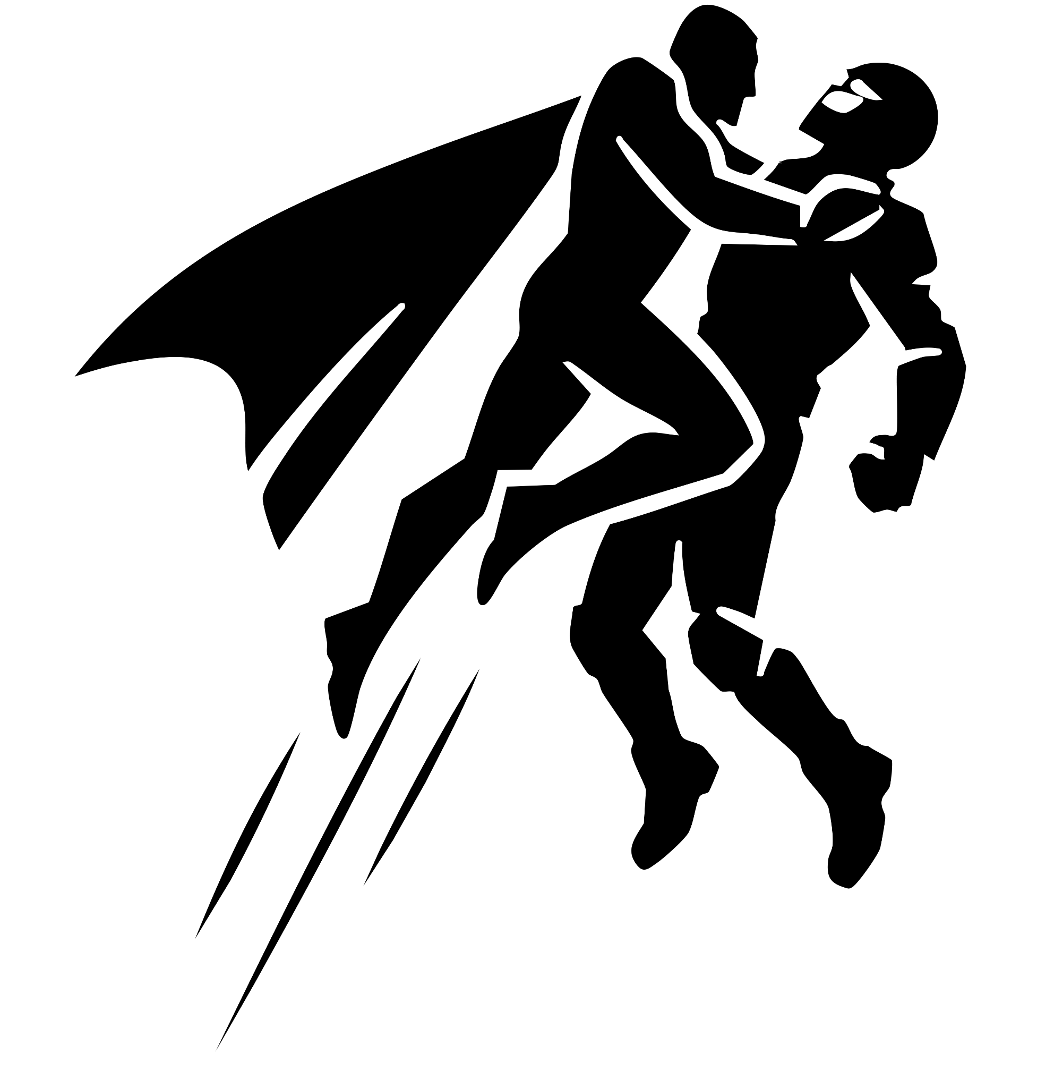

The Day My Heart Couldn’t Stop
Elias stepped into the barnhouse, boots crunching on straw. Tessa was backing away from the alien pod, its cradle lights pulsing.

“So that’s how he’s doing it,” Elias said, eyes glittering. “I wondered if you even knew.”

Tessa squared up. “What do you mean?”

“Owen. Dreamer,” Elias replied, drifting toward the pod. “He’s the reason you have powers. My Atom Stealer pulls matter from one place only; when you got caught in its field, your DNA went unstable. He used this pod to stabilize you—made you more or less… alien.” His mouth curled. “Unlike your friend Sebastian. I finished his sequence with animal DNA.”

Tessa’s breath caught. “So Sebastian’s alive!”

Elias smirked. “That’s what you took from all that?”

Tessa didn’t wait. She lunged, shoulder-first, SLAMMING Elias into the wall. Armor irised over his suit in overlapping plates, red lines waking like embers.

“What the hell is that?” she demanded.

“You thought I’d walk into Dreamer’s house without protection?” Elias purred.

“Your suit is nothing compared to my powers.”

“Oh, I chose that star system for a reason,” Elias said, raising his arms. “The planet was rich in a mineral called Illuminite.” His gauntlets flared. A dull crimson radiance bled from the seams.

The power drained out of Tessa in a heartbeat. Her grip faltered; she dropped, knees hitting the floor. Elias landed lightly, nudged her aside with a contemptuous kick.

“So you really did get the good with the bad,” he mused. “The powers and the weakness.”

He turned to the pod, holding his wrist scanner over its plates. Alien glyphs danced across his display.

“Fascinating,” Elias whispered. “A lovely puzzle to take apart.”

The pod thrummed. Light surged behind the canopy—a silhouette forming, then solidifying.

Elias looked up, too late.

KRAK! Dreamer exploded from the pod, fist first, driving Elias through the barn doors and out into the yard. They skidded a furrow across the dirt.

Dreamer drew a breath, steadying, as Elias staggered to his feet. Veins stood out along the villain’s neck; the Illuminite glow deepened.

No time. No mercy.

Dreamer launched, grabbing Elias by the chestplate and rocketing skyward—through cloud, through thin blue, into black.

Inside the barn, another figure swept in—the younger Owen, the Dreamer Tessa knew. He dropped to her side.

“What happened?” he asked, hand on her shoulder.

“You flew out of the pod,” Tessa breathed, eyes wide. She pointed. “And he has Illuminite.”

Dreamer glanced at the humming cradle, understanding snapping into place. “Okay. I need to complete the loop.”

He stepped into the pod. Panels folded, lights climbed toward white.

Tessa reached out. “He has Illuminite!”

Dreamer managed a quick, wry smile. “Of course he does. Computer—take me back a few minutes.”

The pod flared—and he vanished. The barn fell quiet, save for the soft ticking of cooling metal and Tessa’s racing heartbeat.

High above the clouds, Dreamer’s grip on Elias faltered. The closer they climbed toward the edge of space, the more the Illuminite radiation gnawed at his strength. His skin dulled; each breath felt heavier.

Elias twisted in Dreamer’s grasp, snarling. “You can’t hold me forever!”

Dreamer’s fingers slipped for half a second — enough for Elias to wrench free. They spiraled out of control, plummeting like meteors until they smashed into the Greenland ice shelf with a bone-shaking KRA-KOOOM!

Snow blasted upward in a white storm.

Dreamer skidded across the frozen ground, rolling until he dug his fists into the ice and stopped. Elias rose first, cracking his neck, his armored suit pulsing with that faint red glow.

Dreamer forced himself upright, chest heaving. “Great. Middle of nowhere. Just what I wanted.”

Elias grinned coldly. “You’re fading. That pretty skin of yours can’t stand my mineral.”

Dreamer’s knees trembled, but his voice stayed iron. “You’ve already lost.”

Elias’ eyes narrowed. “What the hell are you talking about?”

Dreamer stood taller, veins glowing faintly beneath his skin as he forced strength back into his limbs. “You know my farm’s wired top to bottom with cameras, right? I’ve got you — and your private army — invading my home, experimenting on Sebastian, hurting Tessa. It’s all recorded.”

Elias laughed, sharp and biting. “Those leaks will burn you too.”

Dreamer’s mouth tugged into a wry smile. “How, Owen and Dreamer are two different people, I’m just a man who got his home invaded by a billionaire who thinks he's above the law. You’re a billionaire breaking into homes and twisting lives. I think I can handle the heat. Can you?”

Elias’s smirk faltered for the first time. He studied Dreamer with something new—respect, or maybe calculation.

“Nice move,” he said, voice low. “But I didn’t grow up with money—I made it. Send me to prison and I’ll plan from a cell. I’ll find a way to steal your gift.”

Dreamer held his gaze. “What was your plan?”

Elias’s smile returned, thinner. “I wanted your power, so I built a machine to look at what’s left of your world, grabbing the left over Illuminite, Trying to understand enough what makes you different. I never expected it to mix the DNA.” He tilted his head. “Not until I found Sebastian flying through my building. He was half the answer. Tessa and Owen—you were the rest. Take my money, take my machines; it doesn’t matter. One way or another, I will stop you.”

Dreamer squared his shoulders, ready for whatever came next.

An hour later…
Moonlight cut across the ocean as Dreamer descended onto the jagged rocks by the lighthouse. His boots crunched against the stone, cape snapping in the salt wind.

He stepped inside, voice echoing through the hollow tower.
“Sebastian! Sebastian!”

The only answer was the crash of waves.

Dreamer’s eyes swept across the walls — deep wolf-like claw marks shredded the paint and wood. The air smelled scorched. His gaze caught on a charred ring burned into the far wall, edges still faintly glowing. A portal scar.

His voice dropped to a whisper.
“Who took you…?”

He touched the blackened circle, jaw tightening.

Days later — the fallout

News headlines flashed across every screen:

TECH TYCOON ELIAS VALE ARRESTED — HOME INVASION & HUMAN EXPERIMENTATION EXPOSED

The footage came from Dreamer’s cameras — Owen’s cameras.

Owen sat at his desk, typing the last lines of his article. Beside him, Tessa knelt over a workbench, sparks flying as she welded pieces of sleek armor and fabric together.

Owen leaned back, exhausted but determined. “That’s it. Story’s out. He’s finished.”

Tessa didn’t look up, still working the seam of a new suit. “Good. But it doesn’t bring Sebastian back.”

Owen glanced at the glowing Dreamer emblem on the chest plate she was building, then met her eyes.

“Exactly,” he said quietly. “Now… we find him.”

The two shared a silent nod — allies, ready for the next hunt.

