**Updated Cancer Data Press Briefing**

**Report**

27/09/2022

This Report is based on present cancer data from 1996 to 2018

(2018 data are provisional).

Notable Changes Over Time

While total cancer registrations and deaths have steadily increased from 1996-2018, as can be expected with population increase. The cancer registration and death rates which are calculated as per 100 K population, have steadily decreased (Figure 1). These rates are much more indicative of the true change of cancer deaths and registrations over time. Cancer registrations have increased by 10,051 and cancer deaths have increased by 2,368 between 1996-2018. Although the rate of cancer registration and death have decreased by 9.4 and 43.1 respectively.

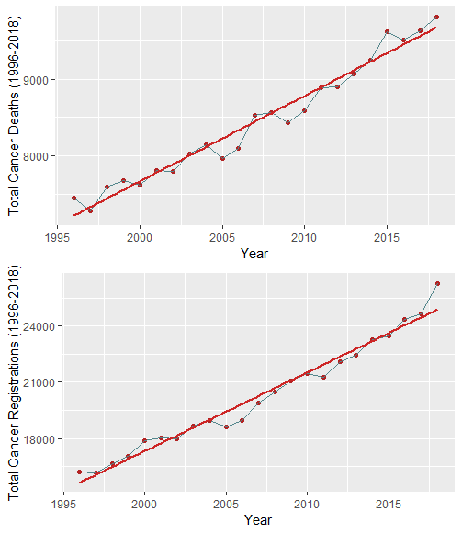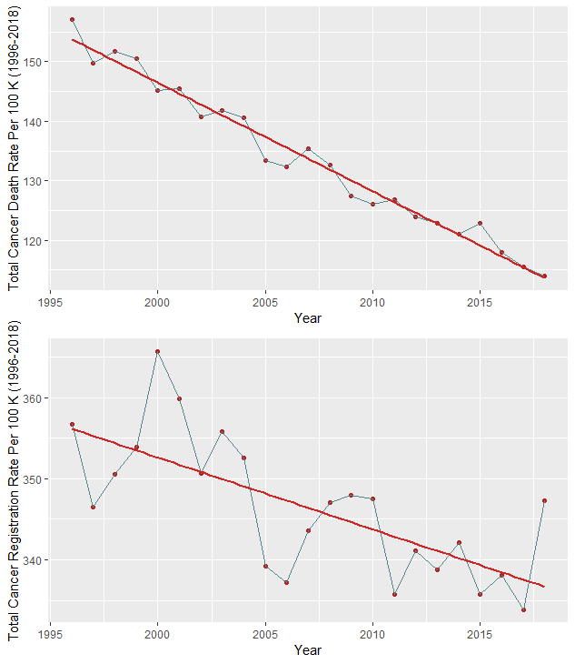

**Figure 1:** LEFT: Line plots of total cancer deaths and registrations, showing positive trendlines. RIGHT: Line plots of cancer death and registration rates, showing negative trendlines.

Variation According to Cancer Type

Lung & Trachea type cancer has the highest death rate of 25.33 (Table 1 & Figure 2) and is also in the top 5 highest registrations, with a registration rate of 30.78 (Table 2).

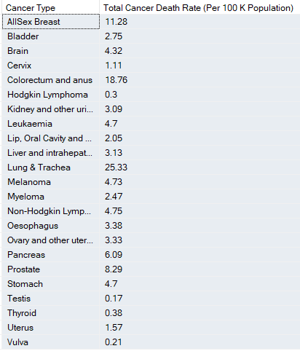

**Table 1:** Death rates for each cancer type.

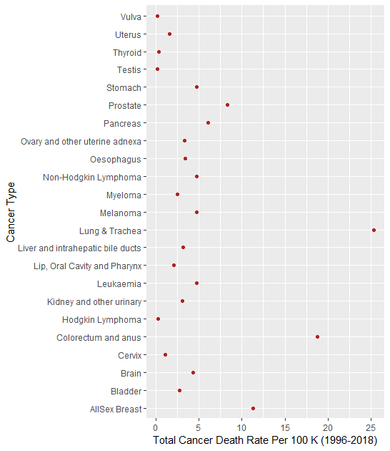

**Figure 2:** Cancer death rate for each cancer type. Showing Lung & Trachea as the deadliest.

Prostate cancer has the relatively low death rate of 8.29, it has the highest rate of registration over the same period (49.59).

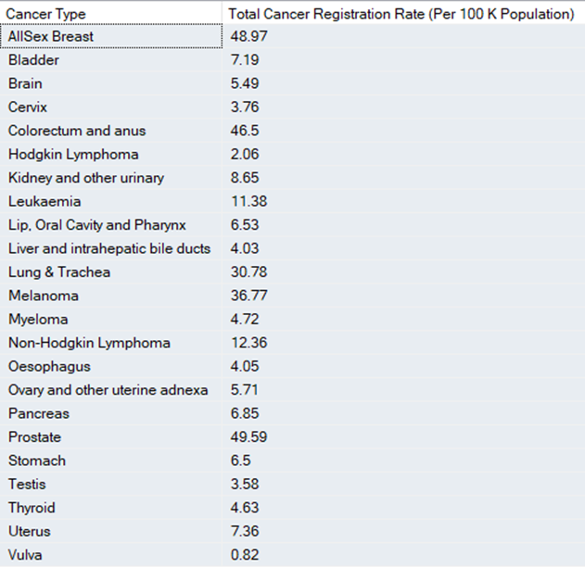

**Table 2:** Registration rates for each cancer type.

Variations Between Sex

Between the period 1996-2018 males had the highest rate of both cancer registrations and deaths, which were 36.95 and 14.61 respectively. The cancer registration rate for females was 27.68 and the death rate was 10.02. Over the time period between 1996-2018, cancer death and registration rates for both males and females declined (Figure 3 & 4).

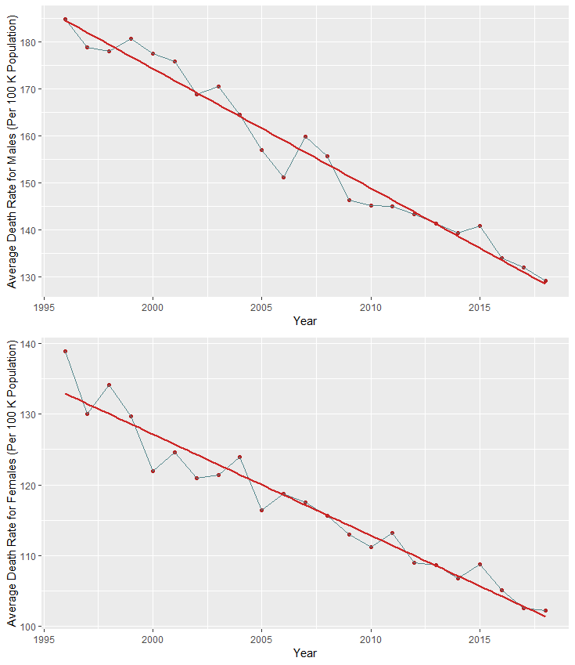

**Figure 3:** TOP: Average cancer death rates for males. BOTTOM: Average cancer death rates for females.

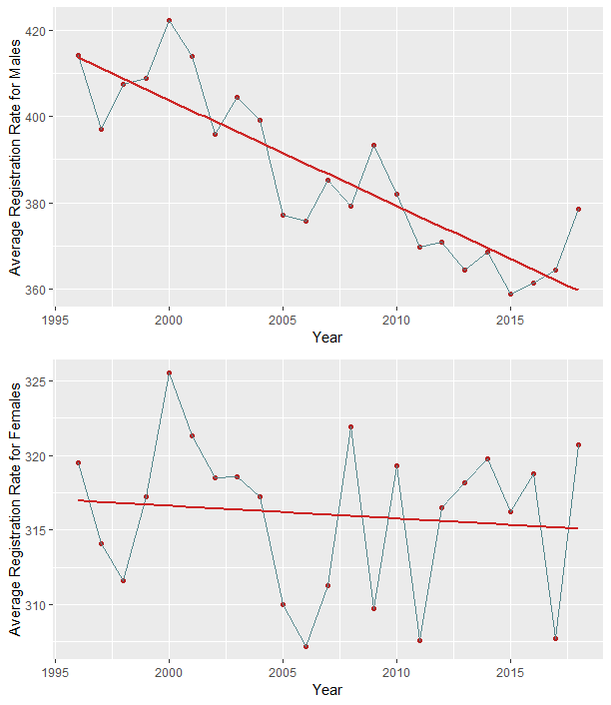

**Figure 4:** TOP: Average cancer registration rate for males. BOTTOM: Average cancer registration rates for females. Registration rate is calculated per 100 K population.

The average cancer registration rates for males decreased from 414.1 to 378.6 from 1996-2018, a drop of 35.5. The registration rate for females had much higher fluctuation but the trend remained negative (Figure 3). Although, the 2018 data has shown a slight increase of 1.2 in the average registration rate when compared to 1996.

Appendix

**Variations in cancer death and registration rates over time:**

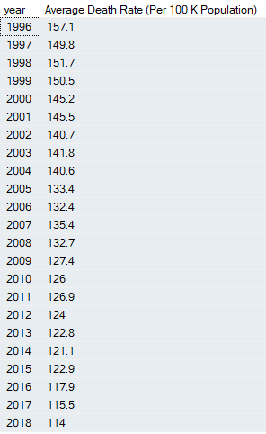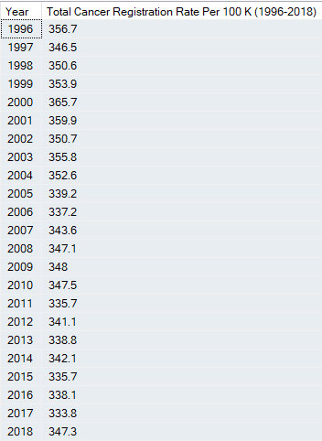

**Death and registration rates of each cancer type:**

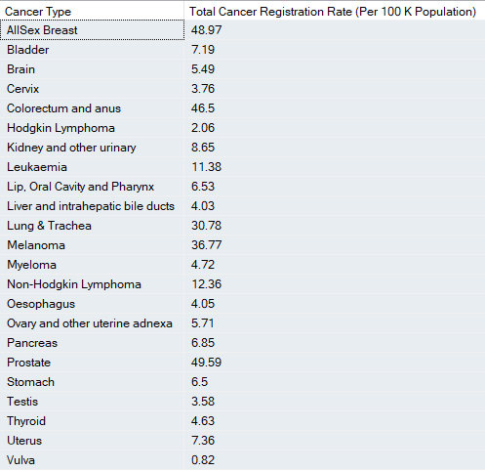

**Variation between sex:**





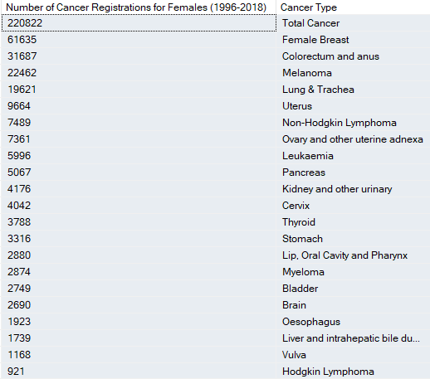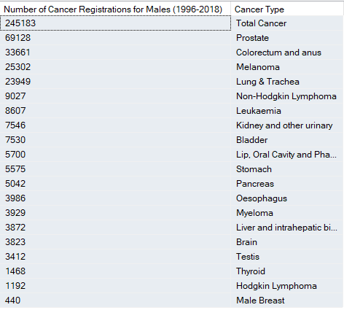

**Notable changes over time**

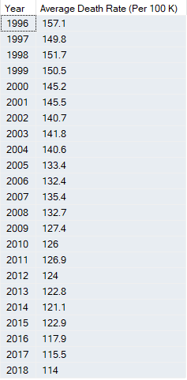

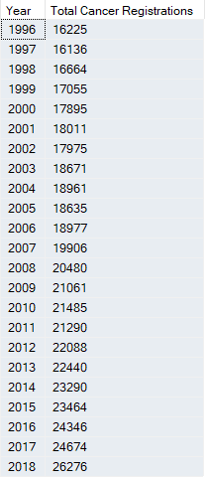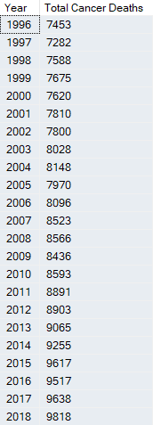

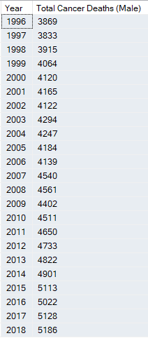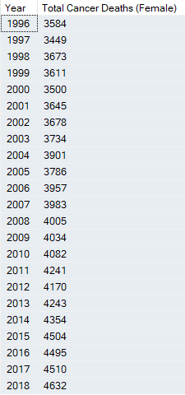

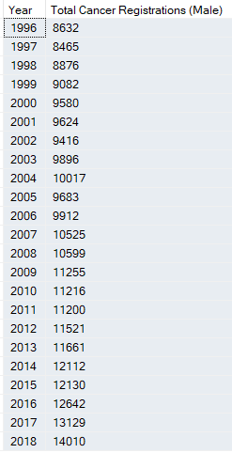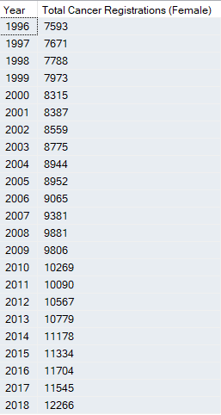

**Variation over time and sex:**

