HQSC_Cancer_Data

Kyle Gibson

25/09/2022

library(readxl)  
library(ggplot2)  
library(gridBase)  
library(gridExtra)  
library(gridGraphics)

## Loading required package: grid

getwd()

## [1] "C:/HQSC"

setwd("C:\\HQSC")  
  
avg_death_rate_male <- read.csv("avg_death_rate_male.csv") # Reading in table from SQL query.  
View(avg_death_rate_male) # Viewing data.  
  
plot(avg_death_rate_male$Year, avg_death_rate_male$Average.Death.Rate.for.Males..Per.100.K., xlab = "Year", ylab = "Average Death Rate for Males (Per 100 K Population)", pch = 19, col = "firebrick")  
lines(avg_death_rate_male, col = "cadetblue4") # Traditional graphics used but I have decided to use ggplot going forward.

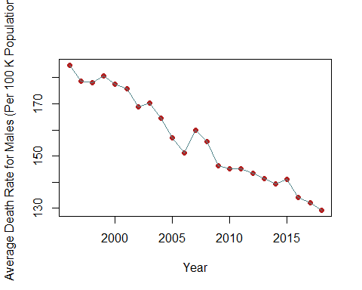

p1 <- ggplot(data = avg_death_rate_male, mapping = aes(x = Year, y = Average.Death.Rate.for.Males..Per.100.K.)) +   
 geom_point(col = "firebrick") +   
 labs(y = "Average Death Rate for Males (Per 100 K Population)", x = "Year") + geom_line(col = "cadetblue4")+  
 stat_smooth(method = "lm", se = FALSE, col = "firebrick3")   
   
  
avg_death_rate_female <- read.csv("avg_death_rate_female.csv")  
  
p2 <- ggplot(data = avg_death_rate_female, mapping = aes(x = Year, y = Average.Death.Rate.for.Females..Per.100.K.)) +   
 geom_point(col = "firebrick") +   
 labs(y = "Average Death Rate for Females (Per 100 K Population)", x = "Year") + geom_line(col = "cadetblue4")+  
 stat_smooth(method = "lm", se = FALSE, col = "firebrick3")  
  
  
grid.arrange(p1, p2, nrow = 2) # Viewing male and female death rate plots.

## `geom_smooth()` using formula 'y ~ x'

## `geom_smooth()` using formula 'y ~ x'

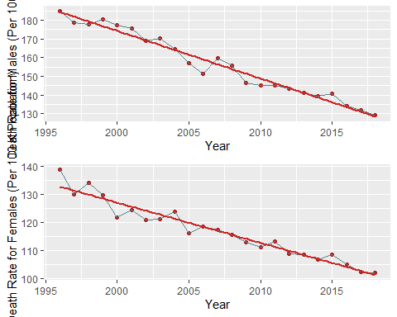

total_cancer_deaths <- read.csv("total_cancer_deaths.csv")  
View(total_cancer_deaths)  
  
  
p3 <- ggplot(data = total_cancer_deaths, mapping = aes(x = Year, y = Total.Cancer.Deaths)) +   
 geom_point(col = "firebrick") +   
 labs(y = "Total Cancer Deaths (1996-2018)", x = "Year") + geom_line(col = "cadetblue4")+  
 stat_smooth(method = "lm", se = FALSE, col = "firebrick3")  
  
total_cancer_regs <- read.csv("total_cancer_regs.csv")  
  
p4 <- ggplot(data = total_cancer_regs, mapping = aes(x = Year, y = Total.Cancer.Registrations)) +   
 geom_point(col = "firebrick") +   
 labs(y = "Total Cancer Registrations (1996-2018)", x = "Year") + geom_line(col = "cadetblue4")+  
 stat_smooth(method = "lm", se = FALSE, col = "firebrick3")  
  
grid.arrange(p3, p4, nrow = 2)

## `geom_smooth()` using formula 'y ~ x'  
## `geom_smooth()` using formula 'y ~ x'

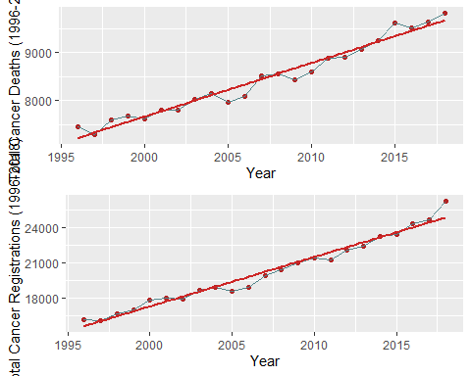

avg_death_rate_over_time <- read.csv("avg_death_rate_over_time.csv")  
View(avg_death_rate_over_time)  
  
p5 <- ggplot(data = total_cancer_regs, mapping = aes(x = Year, y = avg_death_rate_over_time$Total.Cancer.Death.Rate.Per.100.K..1996.2018.)) +   
 geom_point(col = "firebrick") +   
 labs(y = "Total Cancer Death Rate Per 100 K (1996-2018)", x = "Year") + geom_line(col = "cadetblue4")+  
 stat_smooth(method = "lm", se = FALSE, col = "firebrick3")  
  
total_cancer_regs_rate <- read.csv("total_cancer_regs_rate.csv")  
  
p6 <- ggplot(data = total_cancer_regs_rate, mapping = aes(x = Year, y = Total.Cancer.Registration.Rate.Per.100.K..1996.2018.)) +   
 geom_point(col = "firebrick") +   
 labs(y = "Total Cancer Registration Rate Per 100 K (1996-2018)", x = "Year") + geom_line(col = "cadetblue4")+  
 stat_smooth(method = "lm", se = FALSE, col = "firebrick3")  
  
grid.arrange(p5, p6, nrow = 2)

## `geom_smooth()` using formula 'y ~ x'  
## `geom_smooth()` using formula 'y ~ x'

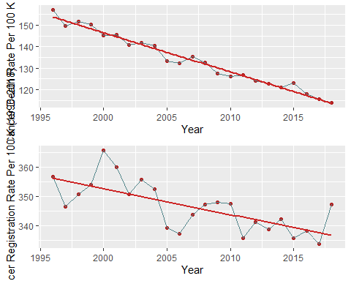

total_death_rate_cancer_type <- read.csv("total_death_rate_cancer_type.csv")  
  
ggplot(total_death_rate_cancer_type, mapping = aes(x = Total.Cancer.Death.Rate..Per.100.K.Population., y = Cancer.Type)) +  
 geom_point(col = "fire brick") +  
 labs(y = "Cancer Type", x = "Total Cancer Death Rate Per 100 K (1996-2018)")+  
 stat_smooth(method = "lm")

## `geom_smooth()` using formula 'y ~ x'

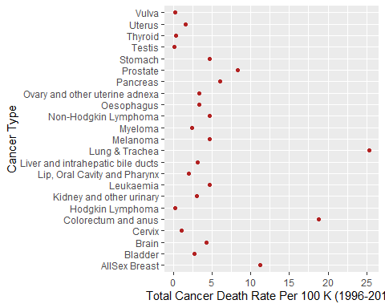

avg_reg_rate_male <- read.csv("avg_reg_rate_male.csv")   
  
p7 <- ggplot(data = avg_reg_rate_male, mapping = aes(x = Year, y = Average.Registration.Rate.for.Males..Per.100.K.)) +   
 geom_point(col = "firebrick") +   
 labs(y = "Average Registration Rate for Males", x = "Year") + geom_line(col = "cadetblue4")+  
 stat_smooth(method = "lm", se = FALSE, col = "firebrick3")   
  
  
avg_reg_rate_female <- read.csv("avg_reg_rate_female.csv")  
  
p8 <- ggplot(data = avg_reg_rate_female, mapping = aes(x = Year, y = Average.Registration.Rate.for.Females..Per.100.K.)) +   
 geom_point(col = "firebrick") +   
 labs(y = "Average Registration Rate for Females", x = "Year") + geom_line(col = "cadetblue4")+  
 stat_smooth(method = "lm", se = FALSE, col = "firebrick3")  
  
grid.arrange(p7, p8, nrow = 2)

## `geom_smooth()` using formula 'y ~ x'  
## `geom_smooth()` using formula 'y ~ x'

