

Research on the Use of a Simulated Environment to Demonstrate the Transmission of COVID-19

Interim Report

DT211C

BSc in Computer Science (Infrastructure)

**Kyle Heffernan**

C17444434

Bryan Duggan

School of Computer Science

Technological University, Dublin

**14/12/2020**

Abstract

As the number of coronavirus infections continue to grow worldwide,

Declaration

I hereby declare that the work described in this dissertation is, except where otherwise stated, entirely my own work and has not been submitted as an exercise for a degree at this or any other university.

Signed:

_________________________

Kyle Heffernan

Date: 14/12/2020

Acknowledgements

I would like to thank my supervisor Bryan Duggan for his constant support and guidance throughout this project.

Table of Contents

1. Introduction 7

1.1 Project Background 7

1.2. Project Description 7

1.3. Project Aims and Objectives 7

1.4. Project Scope 7

1.5. Thesis Roadmap 8

2. Project Background 9

2.1 Introduction 9

2.2. Alternative Existing Solutions 9

2.3. Technologies You’ve Researched 9

2.4. Other Research you’ve done 10

2.5. Existing Final Year Projects 10

2.6. Conclusions 10

3. Prototype Design 11

3. Project Design 11

3.1 Introduction 11

3.2. Software Methodology 11

3.3. Overview of System 12

3.3.1. Technical Architecture 12

3.3.2. System Diagram 13

3.3.3. Requirements Table 14

3.4. Front-End 16

3.4.1. Key Screens 16

3.4.2 Use Cases 19

3.5. Middle-Tier 22

3.6. Back-End 23

3.6.1 Entity Relationship Diagrams 23

3.6.2 Interaction Sequence Diagrams 23

3.6.3 Class Diagrams 23

3.7. Conclusions 25

4. Future Work 26

4.1 Introduction 26

4.2. System Development 26

4.2.1. Prototype Development 26

4.2.1. Production Development 27

4.3. System Testing 27

4.3.1. Prototype Testing 27

4.3.1. Production Testing 28

4.4. Project Plan 28

4.5. Conclusions 30

Bibliography 31

# 1. Introduction

## 1.1 Project Background

The purpose of this project was to design a simulation of the transmission of COVID-19 between people in a populated environment. As Coronavirus became a sizeable factor of everyday life for most people[x], I wanted to make a simulation to assist in visualizing how easily it can be spread in a populated environment.[x] I believe it will be beneficial for greater understanding of the transmission of COVID-19, as observing it spreading in real time will highlight the severity of the virus in everyday conditions.

## 1.2. Project Description

## The Project includes simulated environments of populated buildings, such as a restaurant or office. There are autonomous agents walking around the buildings representing people going about their daily lives. The building has a navigation mesh to aid the agents[x], and they path find through this mesh, doing random tasks and having various interactions based on their role/job. Some agents are infected with coronavirus, so as they walk around, they breath/cough/sneeze intermittently creating a particle system from their mouths dispersing outwards.

## The particles in this particle system[x] have a chance of being infected, and if they are, they expose whatever they come in contact with to the virus. If they encounter a surface, it becomes contaminated with the chance of contaminating other agents. If the particles come in contact with another agent, there is a chance they will be exposed to the virus as well.

## The maths for the chance of particles being infected, how long they stay on surfaces and the chance of another agent getting exposed to the virus are all taken from medical papers[x]

There is a graphical user interface, allowing the user to alter numerous factors that affect the results of the simulation.

Factors the user can change:

## **Viral Load:** The number of particles coming from the particle system that carry the infection.

## **Masks:** Reduce the number of particles coming from each agent.

## **Number of Infected Agents**: The number of agents infected at the start of the simulation.

* **Susceptibility Factors:** Factors such as vaccinations, age, vitamin deficiencies, etc.
* **Time scale:** The rate at which time passes in the simulation.

[photo of GUI design]

## 1.3. Project Aims and Objectives

* **Real Time Simulation**

The user can watch the simulation run in real time and observe the virus spreading between agents.

* **Change Variables**

The user can adjust certain variables that alter the results of the simulation.

* **Utilize Unity’s Navigation Mesh System**

A navigation mesh is a data structure which helps agents path find through complicated spaces by returning a collection of walkable nodes. The autonomous agents in this simulation will be able to path find through the building with the help of the navigation mesh.

* **Autonomous Agents**

The agents follow certain behaviours as they path find throughout the building following various feasible paths.

* **Use Data from Medical Papers**

The methods of transmission and exposure will make use of statistics taken from medical papers/journals

* **Utilize Unity’s Entity Component System**

The entity component system is a new approach to designing Unity projects which entails using data orientate design rather than the usual object orientated approach. It makes use of the C# Job System and multithreading to optimize performance.

* **Display Results**

The user can see statistics about the number of agents exposed to the virus as the simulation runs.

* **Utilize Unity’s Particle System**

The infected agents will be emitting infected particles from their mouths with the use of Unity’s particle system.

## 1.4. Project Scope

This project allows users to view a COVID-19 simulation in real time and alter certain variables to see how they affect the transmission results. The simulation is made using Unity, and the environment in which the simulation takes place in is a populated building with autonomous agents walking around. Navigation Mesh is used to map out the walkable paths for the agents throughout this environment. The agents have simple designs and basic AI allowing them to walk through the building performing appropriate tasks. Infected agents emit particles using Unity’s Particle System that leave a surface infected, or they expose other agents to the virus based on their susceptibility. The user can alter the time scale to speed up the simulation, and they can also adjust variables that affect the result of the simulation such as susceptibility factors.

[photo of design]

## 1.5. Thesis Roadmap

Chapter 2 is the Literature Review Chapter, and covers the main literature researched as part of this project, including academic papers, books, and websites. It also looks at technologies and other projects that have informed this project.

Chapter 3 is the design chapter, it presents a description of the methodology used in this project, as well as a system overview. It also describes in detail the design of both the front-end of the system, and the back-end design of the system.

Chapter 4 is the Future Work Chapter, it describes the development process that has been undertaken so far as well as the plans for future development. It also describes the Software Test planning that has already been undertaken, as well as the Testing that is planned.

# 2. Project Background

## 2.1 Introduction

In this chapter a review of relevant research and other software is presented as it relates to the __________ system. First existing software that performance similar function to this project are presented, and following that, the technologies that might be used in this system (including databases, programming language, scripting languages, device drives, test harnesses, and operating systems). Other research including academic papers, books, web information, and technical standards, are presented following this, and two final year projects are finally discussed.

## 2.2. Alternative Existing Solutions

At least 3 existing software systems, but they don’t have to be exactly like your system, as long as they are similar, or even if they just inspire you on one aspect of your system it’s fine, e.g. if you use this to inspire your UI.

For each one (do at least the following):

* A 2-5 sentence summary of the software
* A picture of the system, e.g. screengrab
* A list of features of the software
* 2-4 sentences saying why this is relevant to your project

## 2.3. Technologies You’ve Researched

This may include, presenting alternatives for:

* Programming languages, e.g. Python, Java, C++
* Databases, e.g. Oracle, PostgreSQL, MySQL
* Operating systems, e.g. Windows, Linux
* Scripting languages, e.g. PHP, Perl, JavaScript
* Device drives
* Testing Software, e.g. Selenium, TestingWhiz, HPE Unified Functional Testing, TestComplete, Ranorex

For each technology:

* 1-2 sentences about the history and development of this technology.
* 4-10 sentences on why this language is popular of useful in general.
* Some sample code (picture?)
* 1-2 sentences on why this language might be useful for this project.

## 2.4. Other Research you’ve done

Other key sources include:

* Academic papers, at least 3 papers
* Books, at least 2 books
* Web information, at least 2 web references
* Technical standards, might be none, but check if ISO has a standard you might look at, e.g.
* ISO 9126, ISO 29119, ISO 23053, also check out ISO 3103.

For papers and books:

* Pop into Google Scholar
* Type in your area of research
* Find a relevant paper
* Click on the double quotes

For other web resources and Standards:

* Pop into Google
* Type in your area of research
* Find a relevant site

## 2.5. Existing Final Year Projects

You’ve already reviewed these projects, so just add in those reviews, and add in a few more sentences.

## 2.6. Conclusions

In this chapter, the literature to the ______ system was presented. First the software systems that are comparable with the ______ system were discussed, following this the technologies (including databases, programming language, scripting languages, device drives, test harnesses, and operating systems) that apply to this project were reviewed. From there a range of academic papers, books, web information, and technical standards were reviewed, and finally two final year projects were discussed.

# 3. Prototype Design

**As least 6 pages, but as many as you like (but lots of diagrams, which count towards the page total).**

# 3. Project Design

## 3.1 Introduction

Following on from the existing software and research papers that we reviewed in the previous chapter, in this chapter the design of the _____ system will be discussed. First the methodology used in this project will be outlined, and following this a discussion of the technical architecture will be presented.

The Front-End of the system is discussed in the following section, with the user journey being presented, followed by paper prototypes and wireframe that depict drafts of the user interface, and some Use Case diagrams. Next the Middle Tier is discussed, followed by the Back-End, when the object design is detailed using Class Diagrams, and the key database tables are presented using Entity Relationship Diagrams.

## 3.2. Software Methodology

**Briefly describe 3-5 methodologies**

**Describe you’re your chosen one**

* **Include a diagram from the original paper**
* **Cite and describe the original paper**
* **Add a few lines on why this makes sense for YOUR project**

## 3.3. Overview of System

### 3.3.1. Technical Architecture

* **Include a diagram – One of these???**

|  |  |
| --- | --- |
| **Stand-Alone**  **(1-Tier)** |  |
| **Client-Server**  **(2-Tier)** |  |
| **3-Tier** |  |
| **N-Tier** |  |

### 3.3.2. System Diagram

**Another Diagram of system, maybe?**

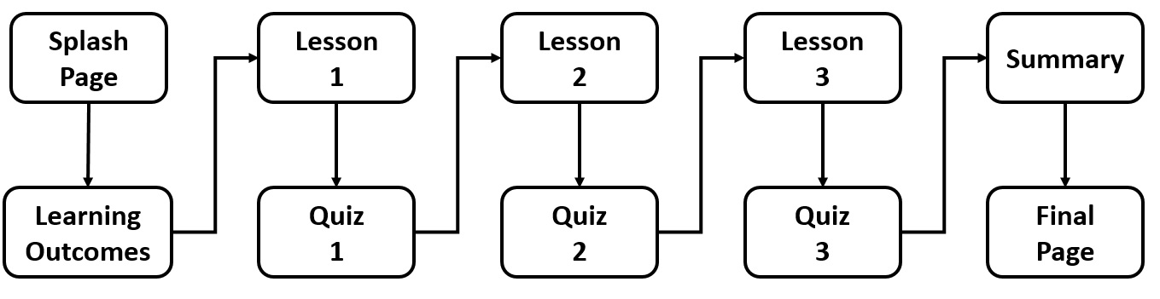

OR:

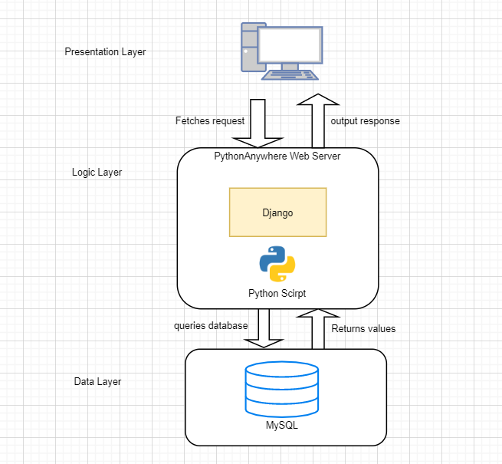

### 3.3.3. Requirements Table

|  |  |  |  |  |
| --- | --- | --- | --- | --- |
| **ID** | **Name** | **Description** | **Priority** | **Version** |
| 1 | Database | Set up database for all stored data | High | 1.0 |
| 2 | Registration | Ability to register user through app | High | 1.0 |
| 3 | Login | Ability for registered user to log in. | High | 1.0 |
| 4 | Location Tracking | App uses user location. | High | 1.1 |
| 5 | Message posting | Users ability to post messages | High | 1.1 |
| 6 | Post visibility by area | To limit posts to be visible to the area they are relevant to. | High | 1.1 |
| 7 | Post access limited by ownership and area | User’s own post should be visible, but other posts access is limited by area. | High | 1.1 |
| 8 | User voting | User’s should be able to promote other posts that they think is important or high quality. | Low | 1.5 |
| 9 | User preference | Content should be limited by the user’s own preference settings. | High | 1.3 |
| 10 | Posts Sorting | Ability to sort posts by different factors, i. e. most popular, most interactions, most important | Low | 1.5 |
| 11 | Post access relevance to area scaling | User’s should be able to see content relevant to for other locations depending on it’s importance e.g. emergencies | Medium | 1.2 |
| 12 | Register as a club or organization | Users should be able to create accounts for clubs or organizations | Low | 1.5 |
| 13 | Users preferences hobbies | Preferences should include hobbies | Low | 1.6+ |
| 14 | Register for clubs or organizations | Users should be able register membership for clubs or organisations | Low | 1.6+ |
| 15 | Editing posts | Users should be able to edit their posts after they have been made. | Medium | 1.3 |
| 16 | Users should be able to see the original post prior to editing | Post history should be available to be viewed. | Medium | 1.2 |
| 16 | User downvoting | Users should be able to downvote content they think isn’t relevant. | Low | 1.6 |
| 17 | Report content | Users should be able to report content they think is inappropriate | Low | 1.6+ |
| 18 | Admin UI | Admin accounts should have it’s own UI | Low | 1.5 |
| 19 | Admin remove | Admins should be able to remove posts | Low | 1.5 |
| 20 | Quick Glance | Users should be able to see the immediate most relevant post in an area without logging in | Medium |  |
| 21 | Home View | Users should see content relevant to their home without being in that location. | Medium |  |
| 22 | Work view | Users should see posts from their work area without being at that location | Medium |  |
| 23 | Private zone | A specific building or location should have it’s own private thread so only people with access can view it | Low |  |
| 24 | Draggable menu | By having a side swap menu for post making users can avoid making accidental posts. | Low |  |
| 25 | Password Reset | Users can reset password | High |  |
| 26 | Menu buttons | Menu buttons bring user to correct pages | High |  |
| 27 | Firebase authentication | Firebase authenticates logins correctly | High |  |
| 28 | Push notification feature | App can send push notifications to user. | Low |  |
| 29 | User preferences simple to manage | Users can set their preferences without a lot of effort | High |  |
| 30 | Users can filter out posts that contain certain words | Users can blacklist words in their preferences, they won’t see posts that contain those words | Medium |  |
| 31 | Scale access | Users should be able to increase and decrease the range of the posts they see | Medium |  |
| 32 | User profiles private | A user’s profile should only be visible by that user | High |  |
| 33 | User post score | Users should be able to see how popular their posts are on their private profile | Low |  |
| 34 |  |  |  |  |

## 3.4. Front-End

### 3.4.1. Key Screens

Including

Paper prototypes were used for the first iteration of the screen layouts. This paper prototypes were useful as they could be shown to potential users and outline the finished product.

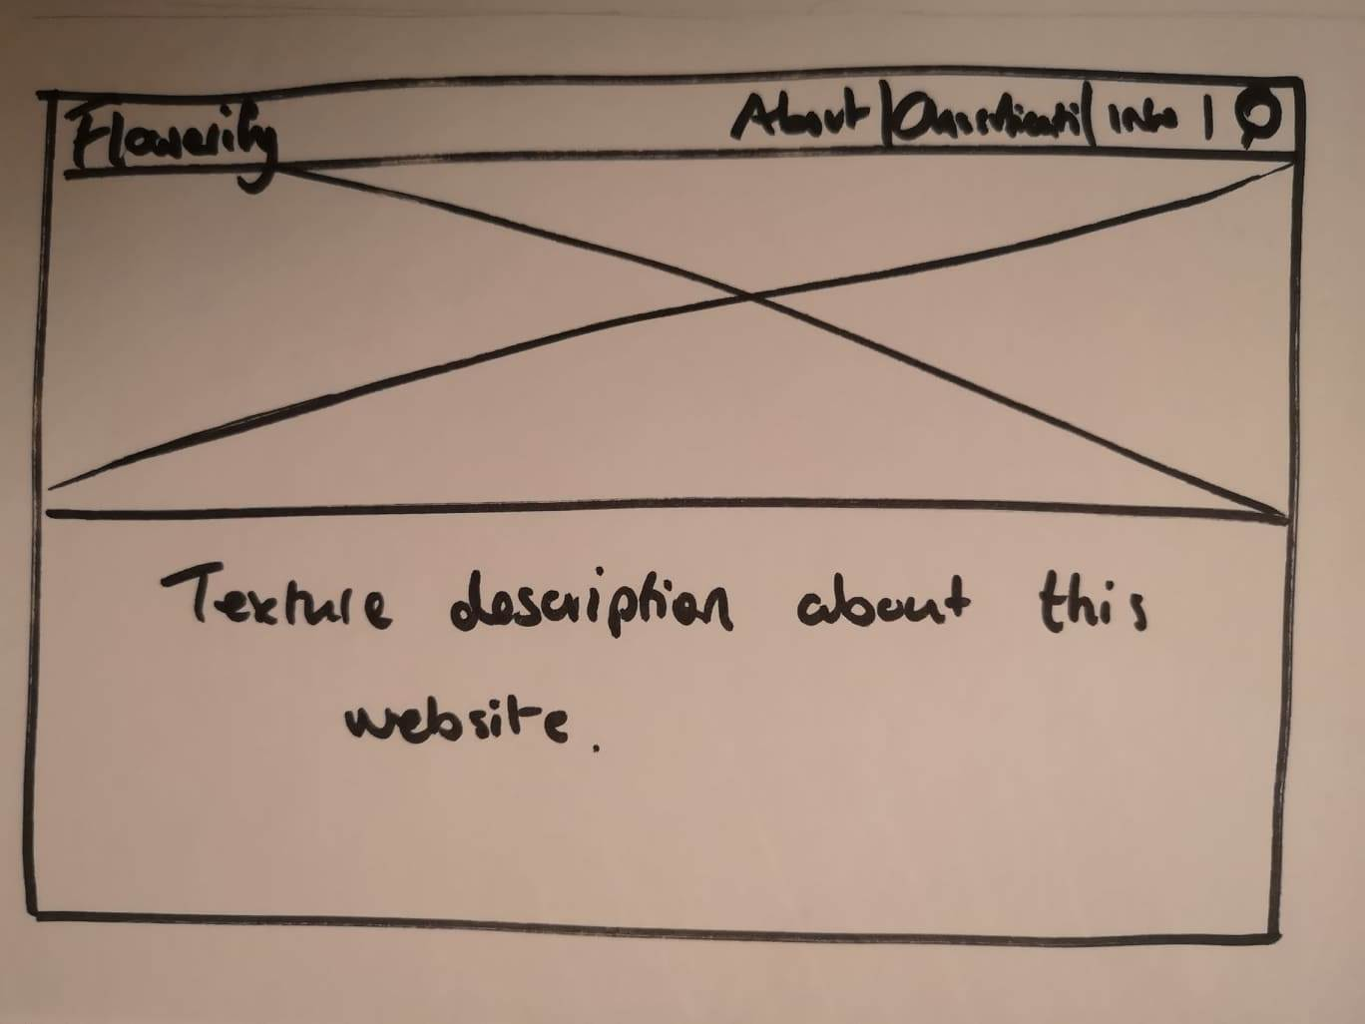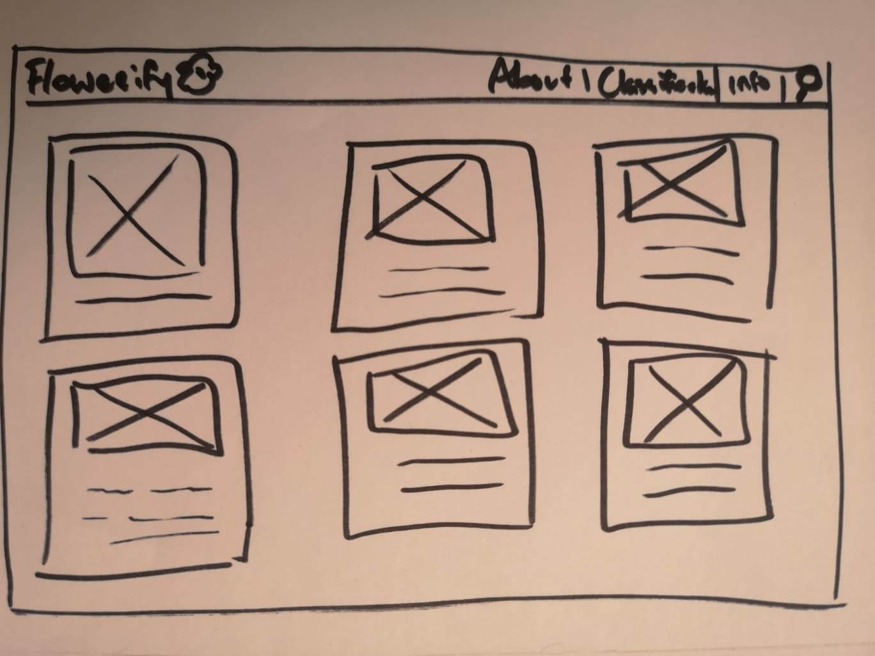

Figure - Index/Home page

Figure - Gallery page

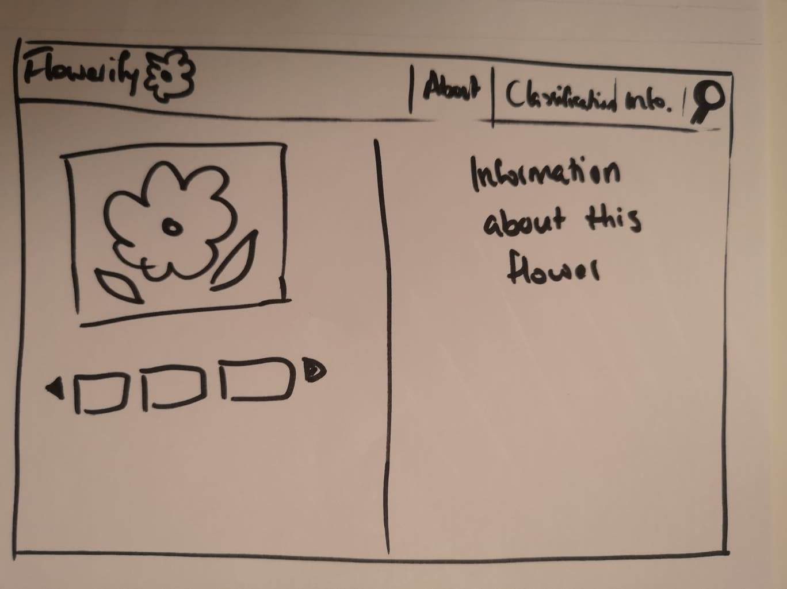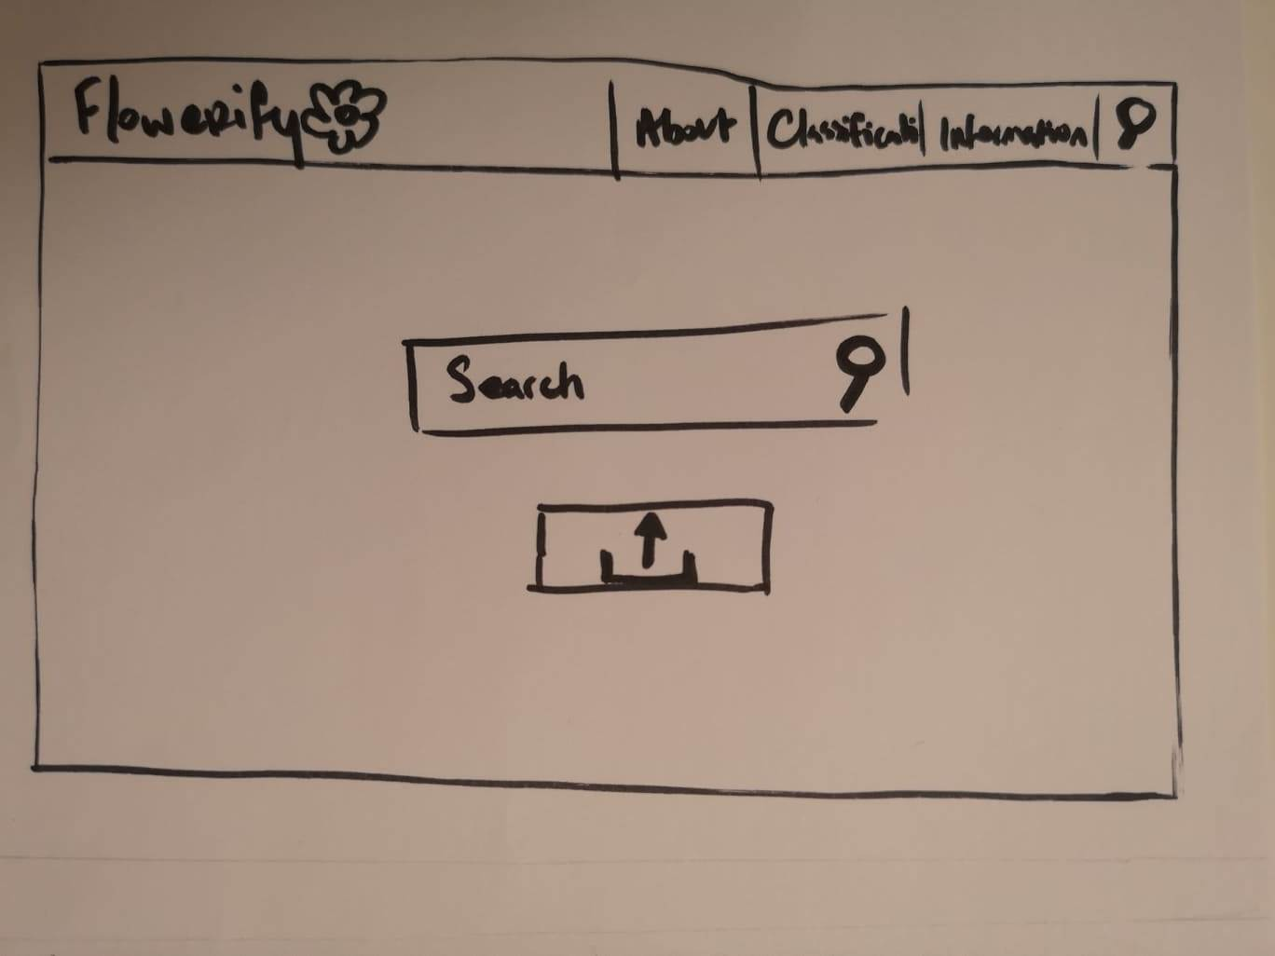The index page will display information about the page and background behind this web application. The information page will be showing different kind of flower with textual description from the database.

Figure - Result page

Figure - Upload page

The classification page will allow user to search, upload and take an image of flower. The result of the classification will be display on the next screen with the information relating to that particular flower as well as recommendation of similar flower underneath the image.

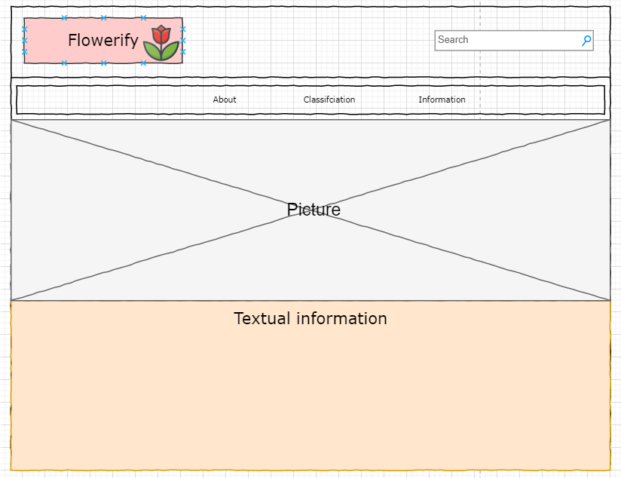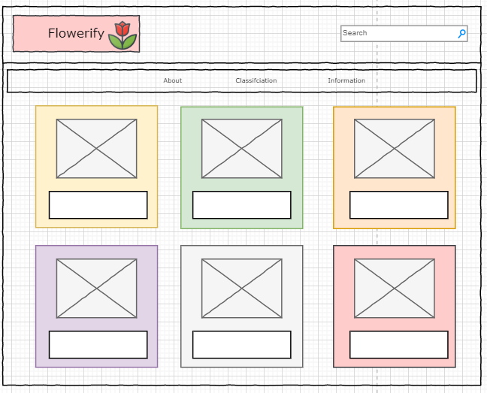From here, the next stage of the screen layout design phase began. For this, a program called drawio was used. This program allowed for a high-level design for the screen layouts and interactions between the screens. This medium fidelity prototype can be seen below.

Figure - Index/Home page

Figure - Gallery page

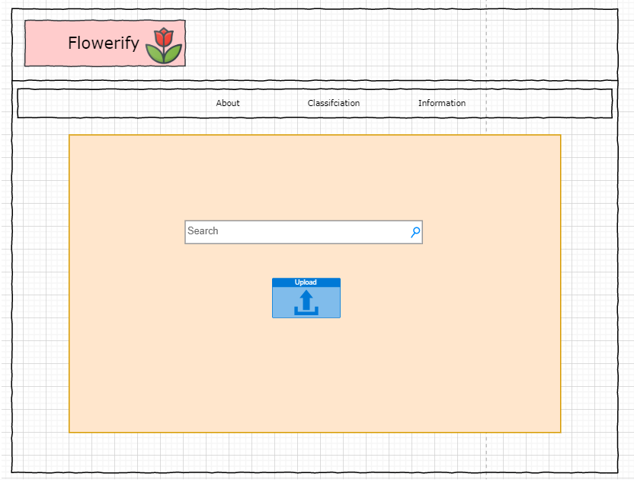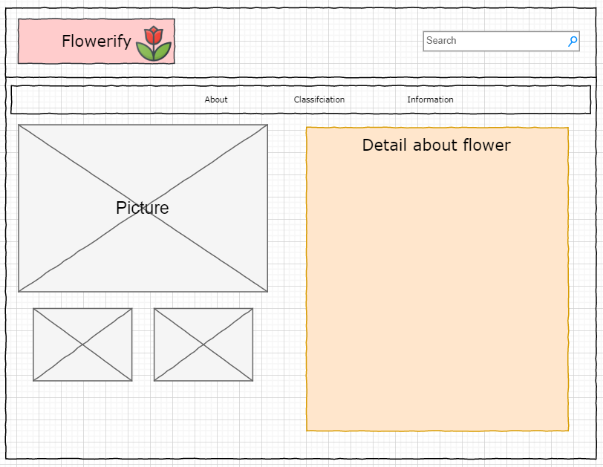

Figure - Upload page

Figure - Result page

All the pages will be linked together with the menu bar, however, the result page will only link to classification page.

The following screens were mocked up to give an idea of what the application might look like further through its development.

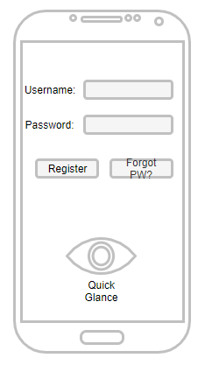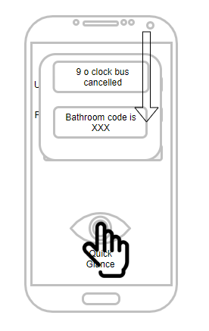

Figure Login page and Quick Glance feature

User can register or login. If a user has forgotten their password, they can request a password reset. Sometimes there are situations where a user does not have time to login or reset a password. They might be in a hurry, or a situation that does not leave them time to request their password. In this scenario I propose a quick glance feature shown in figure 14 where the user who isn’t logged in is shown what is believed to be the most relevant piece of data per their location.

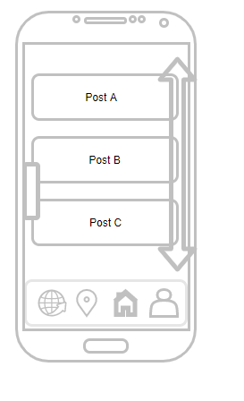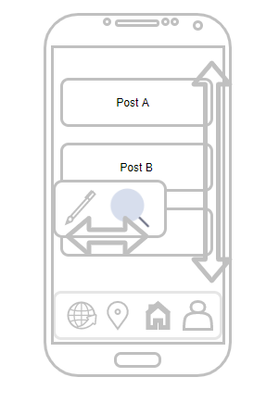

Figure Home Screen menus and edit button

On the home screen after logging in users have multiple options available to them.

### 3.4.2 Use Cases

This section presents the design of the user’s interaction with the __________ system. It shows three key diagrams: an initial design, which provides a simple overview of the system, following this an intermediate design, which adds more detail, and lastly, a final design which shows all of the key features of the system.

The basic functionality of the system is as follows, the user first logs into the _____ system, then they “DO STUFF”, and finally they can log out whenever they wish. <MORE TO SAY>

|  |
| --- |
|  |
| **Initial Design** |

Logging into the system is a two-stage process, the first time a user joins the system they have to create a user profile and that will include: blah, blah and blah. Once the user profile is set-up then the user can login into the main functionality of the system.

The main features of the system are in four main sections, _______________________________________________________________________________________________________________________________________________________________________________________________________________________________________________________________________________________. All of this detail is presented in the intermediate diagram below.

|  |
| --- |
|  |
| **Intermediate Design** |

Logging into the system is a two-stage process, the first time a user joins the system they have to create a user profile and that will include: blah, blah and blah. Once the user profile is set-up then the user can login into the main functionality of the system.

The main features of the system are in four main sections, _______________________________________________________________________________________________________________________________________________________________________________________________________________________________________________________________________________________. All of this detail is presented in the intermediate diagram below.

|  |
| --- |
|  |
| **Final Design** |

## 3.5. Middle-Tier

* JDBC
* ODBC

## 3.6. Back-End

### 3.6.1 Entity Relationship Diagrams

### 3.6.2 Interaction Sequence Diagrams

### 3.6.3 Class Diagrams

* Class Diagram - don’t just create one diagram, show an evolution of diagrams, from:

|  |
| --- |
|  |
| **Initial Design** |

Sdfsdfsdfsd

|  |
| --- |
|  |
| **Intermediate Design** |

Sdfsdfsdfsdfds

|  |
| --- |
|  |
| **Final Design** |

## 3.7. Conclusions

In this chapter, the design of the ______ system was presented. First, the ______ methodology was discussed as the approach to be used in this project. Following this, the technical architecture of the system was presented, and in this case, the ________ _________ is being used as the methodology.

The Front-End design of the system was presented next, with paper prototypes, wireframes and Use Cases to help document the evolution of thinking about the user interface. The middle tier was discussed, focusing on ___________. Finally the Back-End was discussed with Class Diagrams to show the design of the objects, and Entity Relationship Diagrams for the tables.

# 4. Future Work

## 4.1 Introduction

This chapter presents the development and testing process that will be undertaken as part of this project as well as a project plan that highlights the key challenges ahead. The development section comprises of two main sub-sections, the first covers work that has already been done in terms of the development process, describing the extent of the prototype system that has built so far, and what challenges were encountered. The second sub-section explains future development plans, development environment, and estimations of how long the development process will take. The testing section also comprises of two main sub-sections, the first covers the testing work done to date including the development of any test plans, and an exploration of testing tools. The second section will outline any potential software testing libraries that can be used in the development environment, and what functionality it would be important to test. Finally a project plan is presented, and discussed.

## 4.2. System Development

This section outlines plans for the development of the _________ system, as well as all the work done so far. The first section describes the prototype development process that has been undertaken so far, and the second section discusses future development plans.

### 4.2.1. Prototype Development

* What have you done so far?
* What technologies have you tried?
* How did you download and install them?
* What challenges did you encounter?
* How did you overcome them?
* What have you learned from that process?

### 4.2.1. Production Development

* How will the final development differ from the prototype?
* What are the key features of the final system?
* How long will each feature take to implement (you will have to guess)?
* What features will you dump if unexpected challenges occur that delay you.
* Add in any diagrams that make sense.

## 4.3. System Testing

This section outlines plans for the testing of the _________ system. The first section describes the prototype testing process that has been undertaken so far including an initial test plan, and the second section discusses future testing plans, including software testing tools.

### 4.3.1. Prototype Testing

* Develop a test plan.
* Explore some testing tools, and a bit more detail on one of these:
  + Selenium, TestingWhiz, HPE Unified Functional Testing, TestComplete, Ranorex

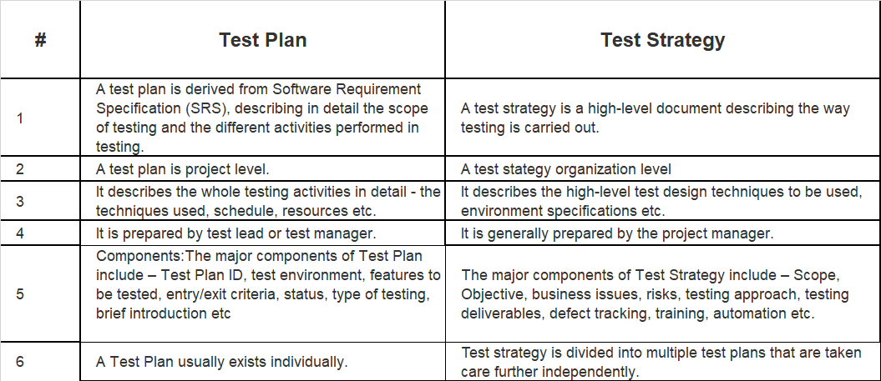

### 4.3.1. Production Testing

* What software tools goes with your system?
  + JUnit, CUnit, TestApe, Unity, JMock, JTest, PowerMock, Unitils, QUnit, Unit.js, Jasmine, PHPUnit
* Also
  + Test with Personas?
  + A/B Testing?

## 4.4. Project Plan

In this section the project plan is presented below, which includes all of the key stages in this project as well as an approximate duration for each stage.

As can be seen the Development phase will take place in [December?] to [Feburary?], followed by the testing phase in [March?]. The documentation process will occur throughout the entire year.

|  |  |  |  |  |  |  |  |  |  |  |  |  |  |  |  |  |  |  |  |  |  |  |  |  |  |  |  |  |  |  |  |  |  |  |  |  |
| --- | --- | --- | --- | --- | --- | --- | --- | --- | --- | --- | --- | --- | --- | --- | --- | --- | --- | --- | --- | --- | --- | --- | --- | --- | --- | --- | --- | --- | --- | --- | --- | --- | --- | --- | --- | --- |
|  | **September** | | | | **October** | | | | **November** | | | | **December** | | | | **January** | | | | **February** | | | | **March** | | | | **April** | | | | **May** | | | |
| **Initial**  **Proposal** |  |  |  |  |  |  |  |  |  |  |  |  |  |  |  |  |  |  |  |  |  |  |  |  |  |  |  |  |  |  |  |  |  |  |  |  |
| **Requirements**  **Gathering** |  |  |  |  |  |  |  |  |  |  |  |  |  |  |  |  |  |  |  |  |  |  |  |  |  |  |  |  |  |  |  |  |  |  |  |  |
| **Initial**  **Design** |  |  |  |  |  |  |  |  |  |  |  |  |  |  |  |  |  |  |  |  |  |  |  |  |  |  |  |  |  |  |  |  |  |  |  |  |
| **Vertical**  **Prototype** |  |  |  |  |  |  |  |  |  |  |  |  |  |  |  |  |  |  |  |  |  |  |  |  |  |  |  |  |  |  |  |  |  |  |  |  |
| **Interim**  **Report** |  |  |  |  |  |  |  |  |  |  |  |  |  |  |  |  |  |  |  |  |  |  |  |  |  |  |  |  |  |  |  |  |  |  |  |  |
| **Interim**  **Demonstration** |  |  |  |  |  |  |  |  |  |  |  |  |  |  |  |  |  |  |  |  |  |  |  |  |  |  |  |  |  |  |  |  |  |  |  |  |
| **Final**  **Design** |  |  |  |  |  |  |  |  |  |  |  |  |  |  |  |  |  |  |  |  |  |  |  |  |  |  |  |  |  |  |  |  |  |  |  |  |
| **Implementation**  **Process** |  |  |  |  |  |  |  |  |  |  |  |  |  |  |  |  |  |  |  |  |  |  |  |  |  |  |  |  |  |  |  |  |  |  |  |  |
| **Software**  **Testing** |  |  |  |  |  |  |  |  |  |  |  |  |  |  |  |  |  |  |  |  |  |  |  |  |  |  |  |  |  |  |  |  |  |  |  |  |
| **Project**  **Evaluation** |  |  |  |  |  |  |  |  |  |  |  |  |  |  |  |  |  |  |  |  |  |  |  |  |  |  |  |  |  |  |  |  |  |  |  |  |
| **Dissertation**  **Document** |  |  |  |  |  |  |  |  |  |  |  |  |  |  |  |  |  |  |  |  |  |  |  |  |  |  |  |  |  |  |  |  |  |  |  |  |
| **Final**  **Demonstration** |  |  |  |  |  |  |  |  |  |  |  |  |  |  |  |  |  |  |  |  |  |  |  |  |  |  |  |  |  |  |  |  |  |  |  |  |

## 4.5. Conclusions

This chapter presented the direction in which the project is heading. It focused on two aspects of the future work, first looking at the development process, and presented what has already been done so far, and the plans going forward. The second aspect that the project presented was the testing aspect of the project, again considering what has been done so far in terms of designing tests, and what will be done subsequently. Finally a project plan is presented, and discussed.

# Bibliography