**Institute of Technology, Carlow**

**Functional Specification Document**

**For**

**Music Record & CD shop**

**Name:** Kyle Hennessy

**Date:** 27/11/18

**Tutor:** Timothy Casey

**Table of Contents**

Introduction…………………………………………………………………………… **3**

Business Overview…………………………………………………………………. **4-5**

System Layout………………………………………………………………………… **6**

Entity-Relationship Diagram…………………………………………………… **7**

Data Base Layouts………………………………………………………………….. **8-9**

Screens…………………………………………………………………………………… **10-38**

Appendices…………………………………………………………………………….. **39**

Introduction

The purpose of this Functional Specification manual is to entail the design, requirements and development of an internal management system of a Music Record & CD Shop. The system should be able to handle all functions that a small business has and be able to process payments and transactions. It is to be an alternative to other Internal Management Systems and should differentiate from other systems available on the market.

The manual is made up of the following sections:

* **Introduction**

This is a short description of what the functional specification document is about. It outlines the different parts of the functional specification, why it was written and who it was commissioned by. It also outlines the whole structure of the functional specification document.

* **Business Overview**

This is an overview of an existing system that has been investigated for comparison with the newly developed system. It is a description of the features of the existing system.

* **System Layout**

This is a diagram that illustrates the major components of the system

* **Entity-Relationship diagram**

This is a diagram that illustrates the entities in the system and the relationships between them.

* **Database Layouts**

This is a layout of the database tables used in the database.

* **Screens**

This is the explanation of each feature in the system and how it is implemented.

* **Appendices**

This contains links or references to any information or documents used in the research for the functional specification

The system for this Music Shop has the following functions:

* Orders
* Reports
* Transactions and sales
* Management of Customer Accounts
* Inventory Management
* Employee Actions
* User Management

Business Overview

For the development of the internal management system for the Music Record & CD shop, an existing system was investigated to base the proposed solution on and recognise any flaws or ways it can be improved.

The system investigated was for the Trax music shop, located in Carlow town.

Upon looking at the system, it was difficult to navigate, the interface was clunky and archaic, and was not clear how the information on screen was being processed. After seeing a system like this, it was clear that the top priority for the new system solution should be ease of use, pleasing aesthetics and clear explanation of what each element on screen is doing.

The way data was stored was then investigated to see how it was stored, what way the data was laid out and how easy it was to access and read.

The database processing was messy and very difficult to search for certain terms and fields. The way the data was stored was unsecure. All of the data was stored in a plain text file, making it cluttered, hard to view, and none of the information was encrypted due to the plain text format. It was clear that for the new proposed system, the data should be stored in separate tables for each entity. Each field in each table should be clearly labelled with a description of the field and how it relates to the entity. Each Entity should have its own table so it is easy to view at a later date.

User Management was another part of the system that was investigated. The way the management of the users was similar to how the database was handled, clunky, archaic and unsecure. The system login details and employee details were stored on a plain text file which could easily be breached. In the new system, the user management side of the system could be incorporated into the data processing aspect of the system and a table could be used to store and process the system log in info and employee details.

In this pre-existing system, it was not easy to edit or delete pre-existing entries. In order to make changes to a system, you would have to search through the cluttered text file and find the entry and only there can you edit or delete an entry. This cumbersome way of editing data highlighted the importance of ease of use and stress free handling of data.

There were some redeeming qualities about the system that were incorporated into the new design.

One of these was, to reduce the number of screens a user must go through by having the menu for the function on top of the window that the user is working on. This makes it so that the user can easily see what part of the function they are using (e.g. New Sale in Transactions) while being able to select a different function without backing out of the screen they were on.

Another feature that benefitted the pre-existing system was the ability to search through the database by different fields (e.g. search by Order ID or Order Date for orders). Although the systems database was cluttered and saved in the same plain text file, this made filtering by a certain field or entry a little bit easier to accomplish. This was incorporated into the new system by adding a search bar at the top of the window when opting to ‘View Details’ of the current function the user is on (e.g. View Order Details in Orders).

The way returns were handled was another stand out feature of the pre-existing system was the way returns were handled. Instead of having a separate table to handle returns, it instead used the Sale ID in the Sales table to calculate the total cost of the transaction and the list of items bought in the transaction that a customer wishes to return. The cost of the item that is being returned is automatically grabbed from the table and displayed on screen by reading the item ID in the sales line and then searching the inventory table and outputting the sale price for the item entry with the same item ID.

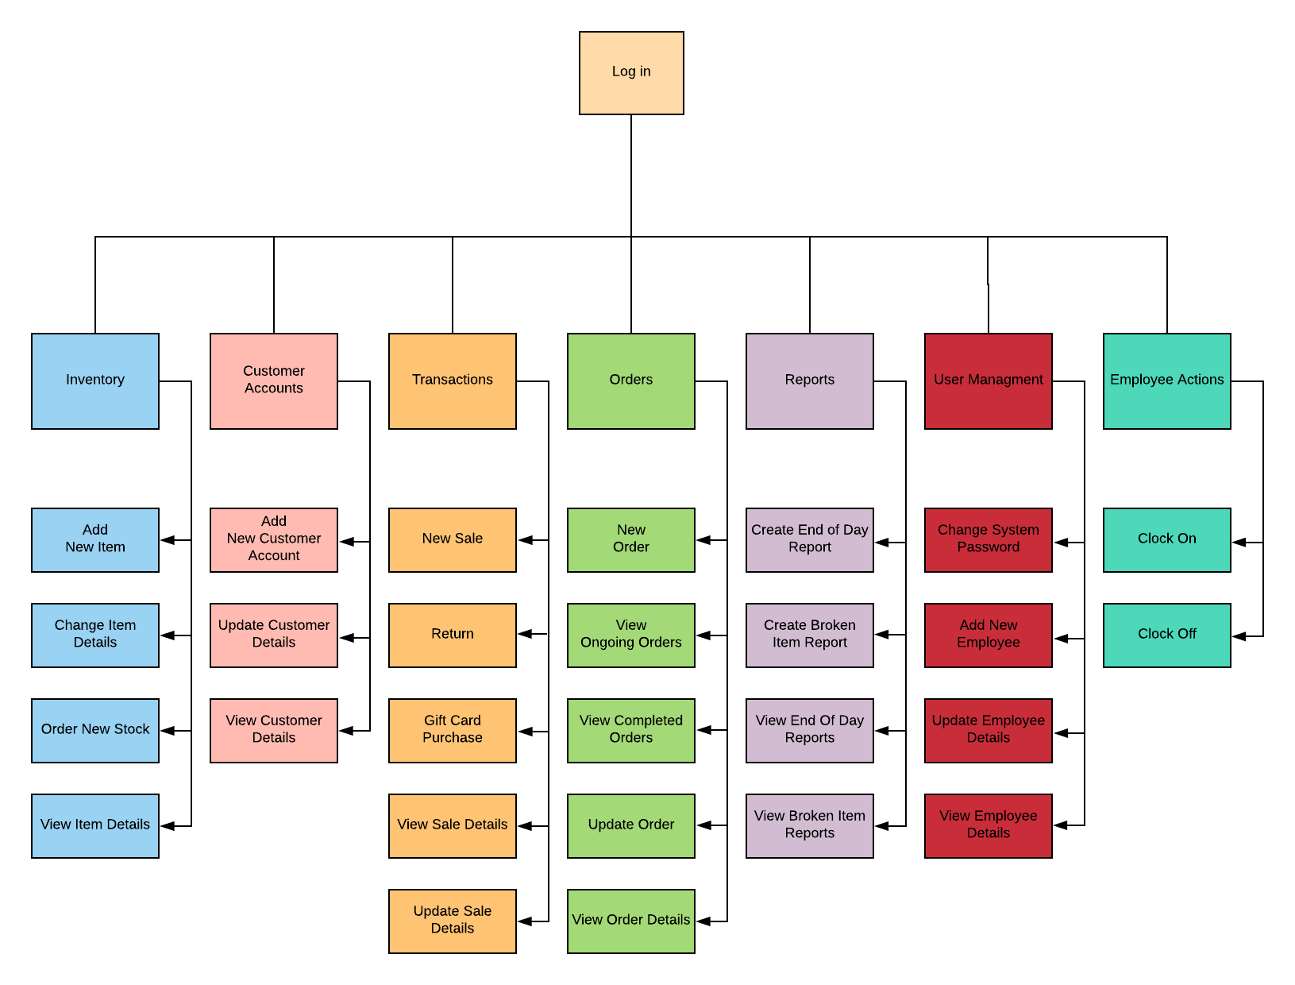

System Layout

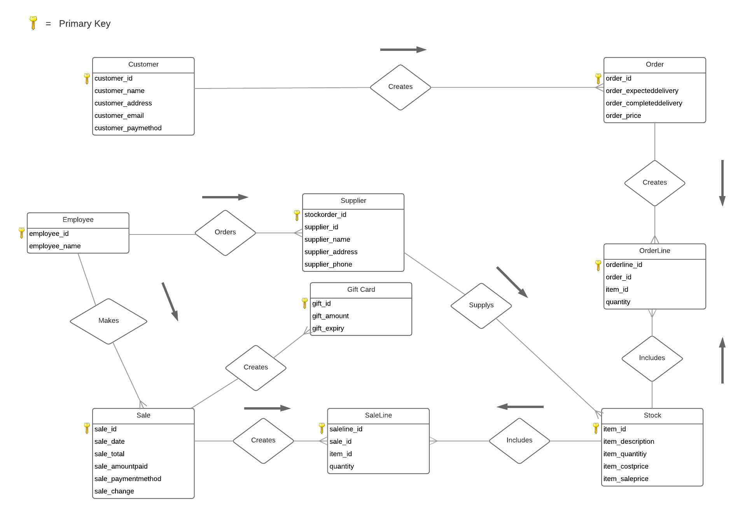

Entity-Relationship Diagram

|  |  |  |
| --- | --- | --- |
| Field Name | Data Type | Description |
| customerID | AutoNumber | ID number of the Customer Account |
| customerName | Short Text | Customers Full Name |
| customerAddress | Short Text | Customers Home Address |
| customerEmail | Short Text | Customers E-mail Address |
| customerPaymentMethod | Short Text | Customers saved payment method(Debit Card, Credit Card or Paypal) |

Database Layout

Foreign Key

Primary Key



Customer

Employee



|  |  |  |
| --- | --- | --- |
| Field Name | Data Type | Description |
| employeeID | AutoNumber | ID number of the employee |
| employeeName | Short Text | employees Full Name |



Inventory

|  |  |  |
| --- | --- | --- |
| Field Name | Data Type | Description |
| orderID | AutoNumber | ID number of the Order |
| customerID | Number | ID number of customer who placed order |
| customerAddress | Short Text | Customers Home Address |

|  |  |  |
| --- | --- | --- |
| Field Name | Data Type | Description |
| itemID | AutoNumber | ID number of the item |
| itemDescription | Short Text | Description of item |
| itemQuantity | Short Text | Quantity of item in stock |
| ItemCost | Number | The cost of the item from the supplier |
| ItemSale | Number | The price the item is selling for |



Order

|  |  |  |
| --- | --- | --- |
| Field Name | Data Type | Description |
| orderlineID | AutoNumber | ID number of the order line |
| orderID | Number | Order number that the order line is fulfilling |
| itemID | Number | Item number that is being ordered |
| quantity | Number | Quantity of item that is being ordered |



Order Line

|  |  |  |
| --- | --- | --- |
| Field Name | Data Type | Description |
| giftCardID | AutoNumber | ID number of the gift card |
| saleID | Number | ID number of the sale where the gift card was purchased |
| giftAmount | Number | Amount of money credited on gift card |
| giftExpiry | Date/Time | Expiry date of the gift card |



Gift Cards

|  |  |  |
| --- | --- | --- |
| Field Name | Data Type | Description |
| saleLineID | AutoNumber | ID number of the sale line |
| saleID | Number | ID number of the sale that the sale line is fulfilling |
| itemID | Number | ID number of the item being purchased in the sale line |
| quantity | Number | Quantity of the item that is being purchased |

|  |  |  |
| --- | --- | --- |
| Field Name | Data Type | Description |
| reportID | AutoNumber | ID number of the report |
| reportType | Short Text | Specifies what type the report is (end of day report, broken item report) |
| reportDate | Date/Time | Date and time of which the report was created |
| reportDetails | Long Text | Details of the report |



Reports

Sale Line

|  |  |  |
| --- | --- | --- |
| Field Name | Data Type | Description |
| saleID | AutoNumber | ID number of the sale |
| saleDate | Date/Time | Date and time that the sale has taken place on |
| saleDetails | Long Text | Details of the transaction (item information, quantity) |
| paymentMethod | Short Text | Payment method used to fulfil transaction |
| paymentAmount | Number | The total cost of the transaction |



Sales

Supplier

|  |  |  |
| --- | --- | --- |
| Field Name | Data Type | Description |
| supplierID | Number | ID number of the supplier that is fulfilling the stock order |
| supplierName | Number | Name of the supplier |
| supplierAddress | Number | Address of the supplier |
| supplierPhone | Number | Suppliers phone number |



Stock Order Line

|  |  |  |
| --- | --- | --- |
| Field Name | Data Type | Description |
| stockOrderID | AutoNumber | ID number of the stock order |
| supplierID | Number | ID number of the supplier being ordered from |
| itemID | Number | Address of the supplier |
| quantity  System | Number | Suppliers phone number |

|  |  |  |
| --- | --- | --- |
| Field Name | Data Type | Description |
| systemName | Short Text | Name of the system for login (can’t be changed by user) |
| systemCurrentPassword | Short Text | Current password of the system |

Shifts

|  |  |  |
| --- | --- | --- |
| Field Name | Data Type | Description |
| shiftClockOn | Date/Time | Date and time employee has clocked on |
| shiftClockOff | Date/Time | Date and time employee has clocked on |
| employeeID | Number | ID number of employee |



Screens

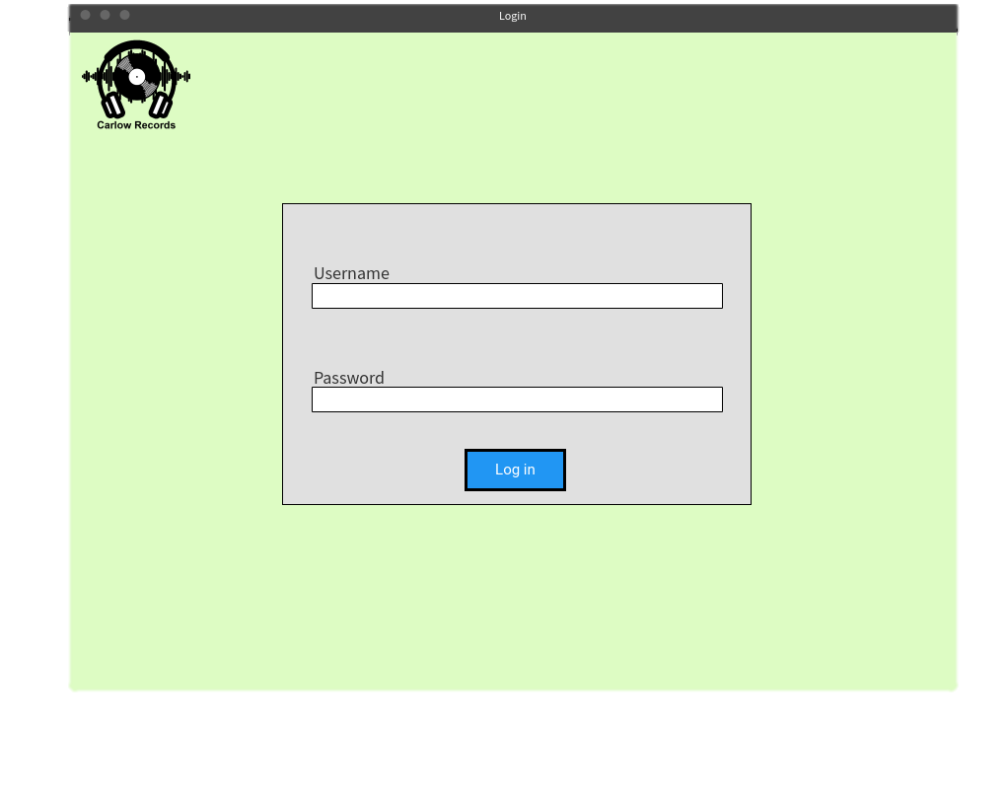Login

**Access to Screen:**

Login

**Purpose of this Screen:**

Prompts the user to enter username and password to access system

**Table Processing Involved:**

Login is only permitted when the username and password entered by user matches the ‘systemName’ and the ‘currentPassword’ in the System Table.

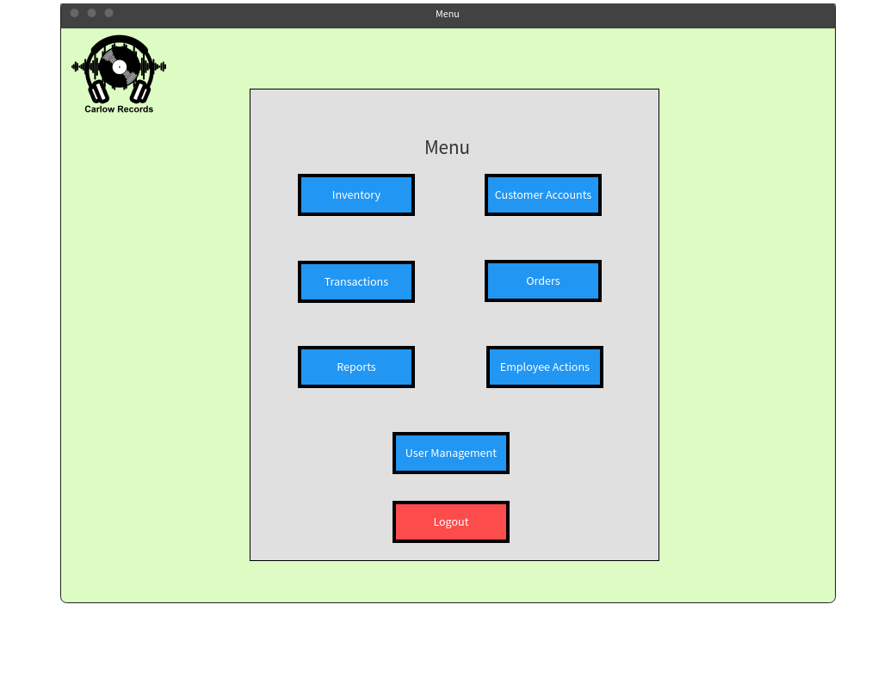Menu

**Access to Screen:** Login > Menu

**Purpose of this screen:** Gives user a list of the functions in the system to choose from

Inventory

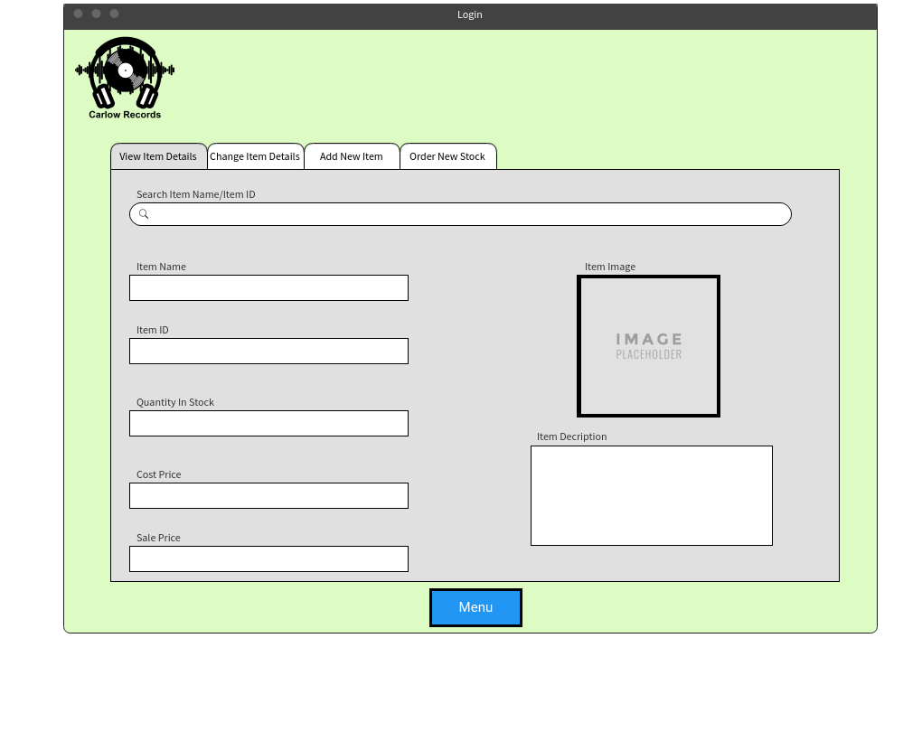View Item Details

**Access to screen:**

Login > Menu > Inventory >View Item Details

**Purpose of this screen:**

To view details of an item the user has searched for.

**Table Processing involved:**

The Inventory table is searched for an entry with same item name or item ID the user has entered and shows all the associated data with the specified item.

Inventory

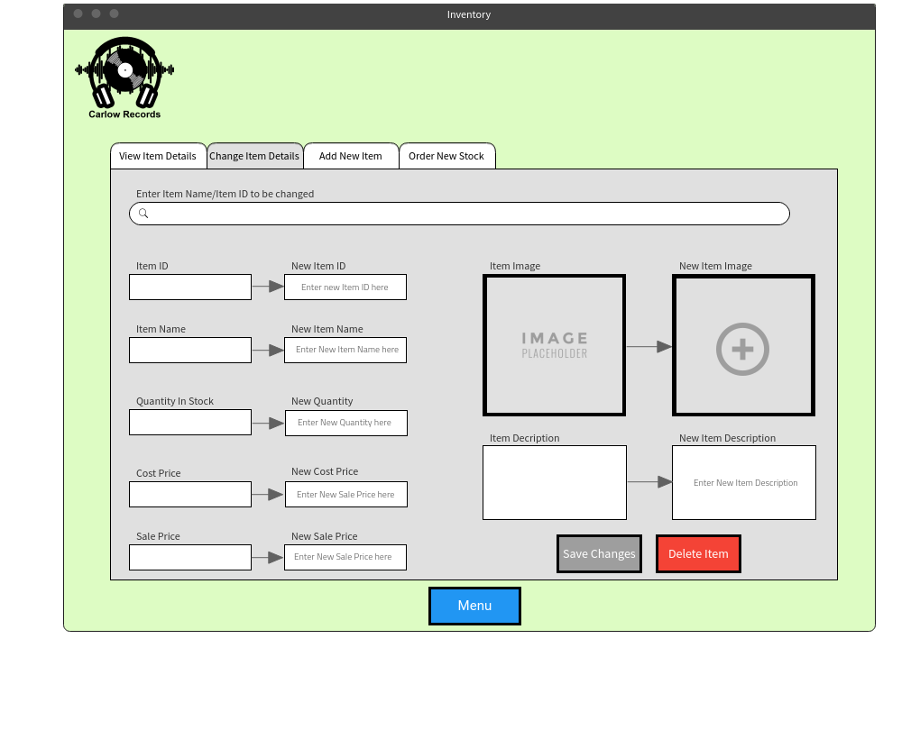Change Item Details

**Access to screen:**

Login > Menu > Inventory > Change Item Details

**Purpose of this screen:**

To update, change or remove an item entry in the system.

**Table Processing involved:**

The Item Name or ID entered by the user is searched for in the system and displays the associated data on the screen. The user is then able to change the data in the table or remove the item entry entirely.

Inventory

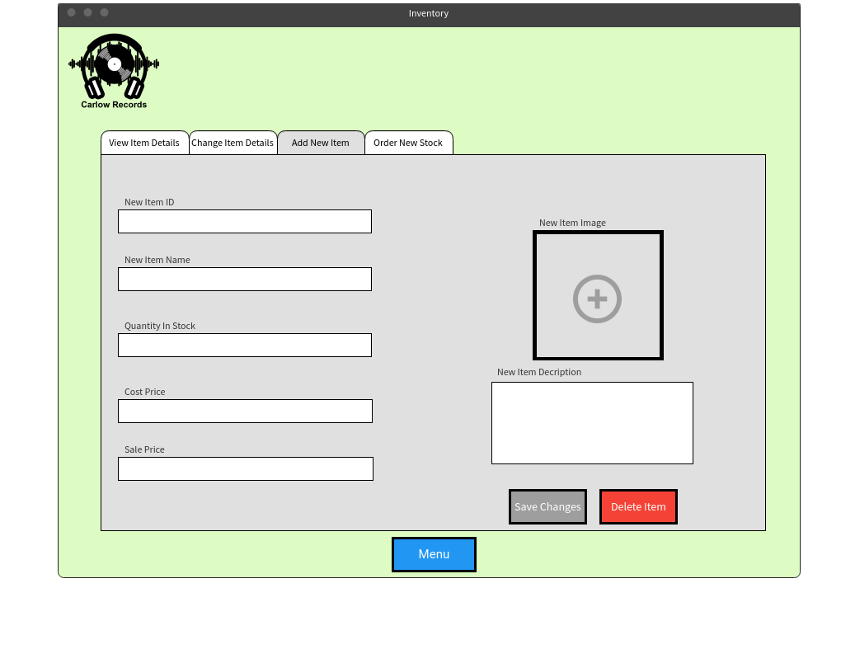Add New Item

**Access to Screen:**

Login > Menu > Inventory > Add New Item

**Purpose of this screen:**

To create a new Item entry in the system

**Table Processing Involved:**

A new entry in the Inventory table is created and saves the information entered by the user into the associated fields.

Inventory

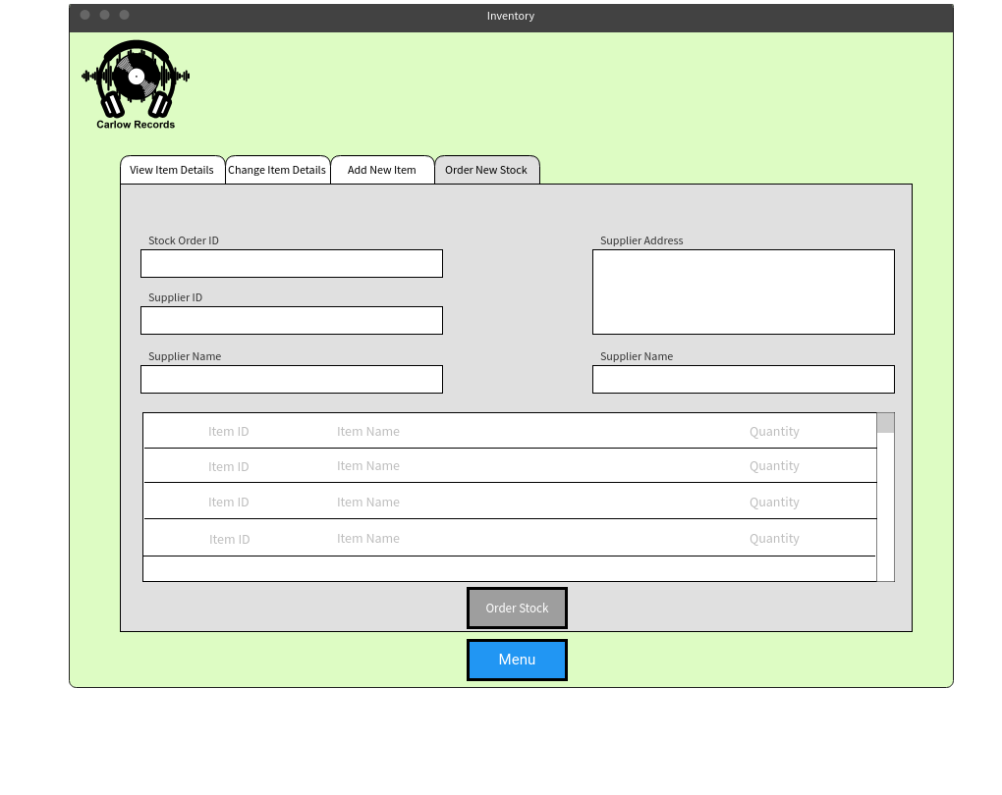Order New stock

**Access to screen:**

Login > Menu > Inventory > Order New Stock

**Purpose of this screen:**

To order new stock from a supplier. The user enters in the Stock Order ID, Supplier ID, Item ID and quantity to be ordered and the rest is filled in automatically.

**Table Processing Involved:**

In the Suppliers table, the supplier ID entered by the user is searched for in the table and the entry with the same supplier ID is displayed on screen. In the Stock Order Line table, a new entry is created. The stock order ID is an auto number and is filled in automatically. The user enters in the Item ID and the quantity to be ordered. The Item name is read from the entry in the Items table with the same Item ID and is filled in automatically.

Customer Accounts

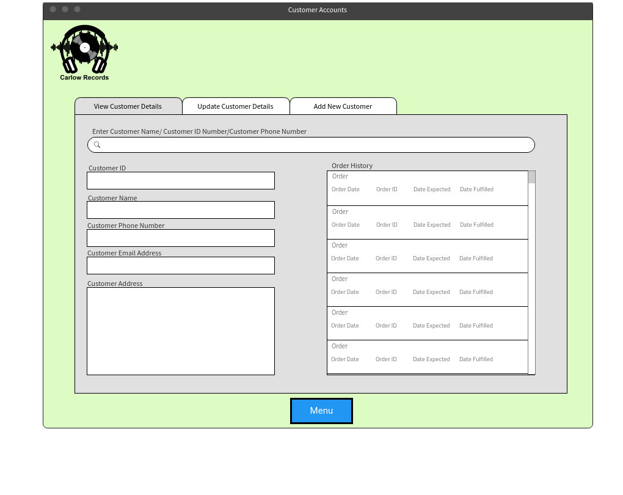View Customer Details

**Access to Screen:**

Login > Menu > Customer Accounts > View Customer Details

**Purpose of this screen:**

Prompts user to search for Customer Name/ID/Phone Number and displays the associated data with the searched data entry

**Table Processing Involved:**

Searches the Customer Accounts table for users input and displays the associated data on the left hand side. The Orders table is then searched for any orders with the same Customer ID and displays the order date, order ID, date expected and data fulfilled on the right hand side under order History.

Customer Accounts

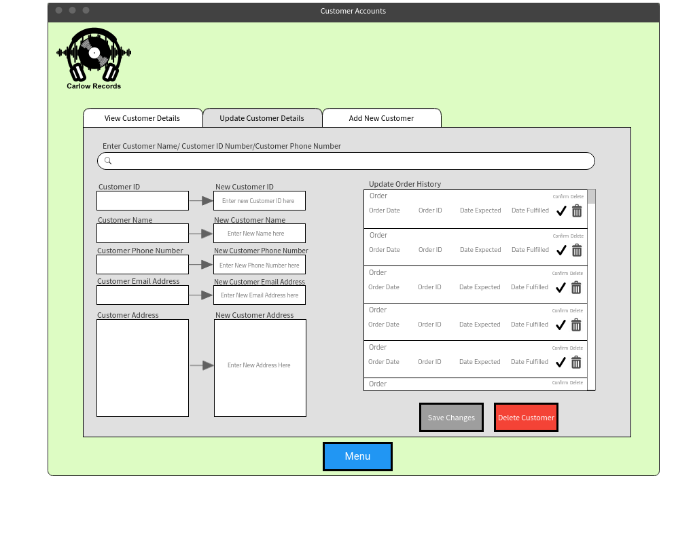Update Customer Details

**Access to screen:**

Login > Menu > Customer Accounts > Update Customer Details

**Purpose of this screen:**

Prompts the user to input either a customer’s name, ID number or phone number to display their account and update the details displayed or remove customer account entirely.

**Table Processing Involved:**

The Customer Accounts Table is searched for any account with the ID number/name/phone number and displays the information on screen. The Orders table is then searched for any orders with the same customer ID and displays the information on screen. The user can then change any of the information on screen which will then be overwritten in the data’s associated table. The user can also delete the Customer Account entirely.

Customer Accounts

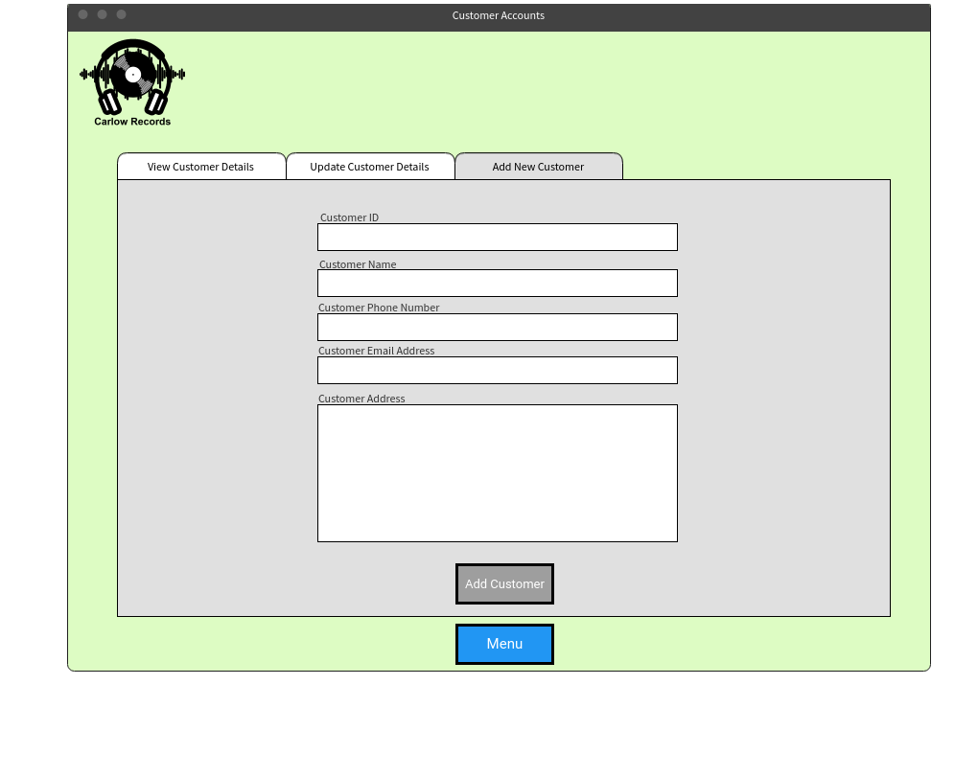Add New Customer

**Access to screen:**

Login > Menu > Customer Accounts > Add New Customer

**Purpose of this screen:**

To add a new customer account to the system

**Table Processing Involved:**

In the Customer Accounts table, a new entry is created and the information entered by the user is saved in to the associated fields

Transactions

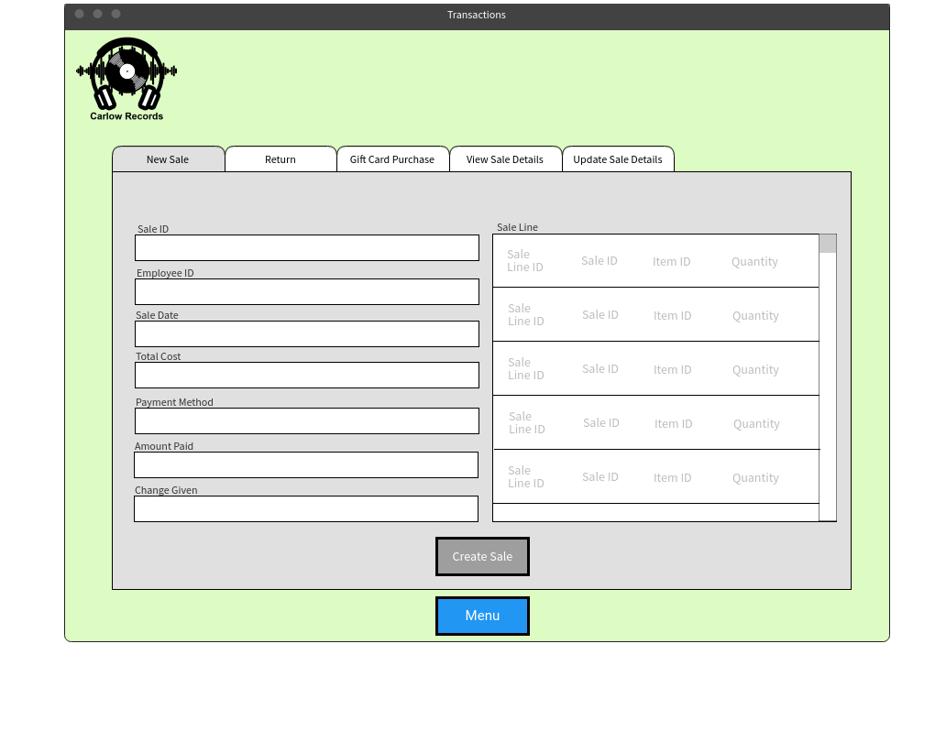New Sale

**Access to screen:**

Login > Menu > Transactions > New Sale

**Purpose of this screen:**

To create a new over the counter sale in the shop

**Table Processing Involved:**

In the Sales table, a new entry is created, and the information entered by the user on the left-hand side of the screen is saved into the associated fields (The Sale ID is an auto number and can’t be inputted by user). In the Sale Line table, the user inputs the item ID and quantity of the item being sold. The Sale Line ID is an auto number and the Sale ID will be the same as the sale that is being created.

Transactions

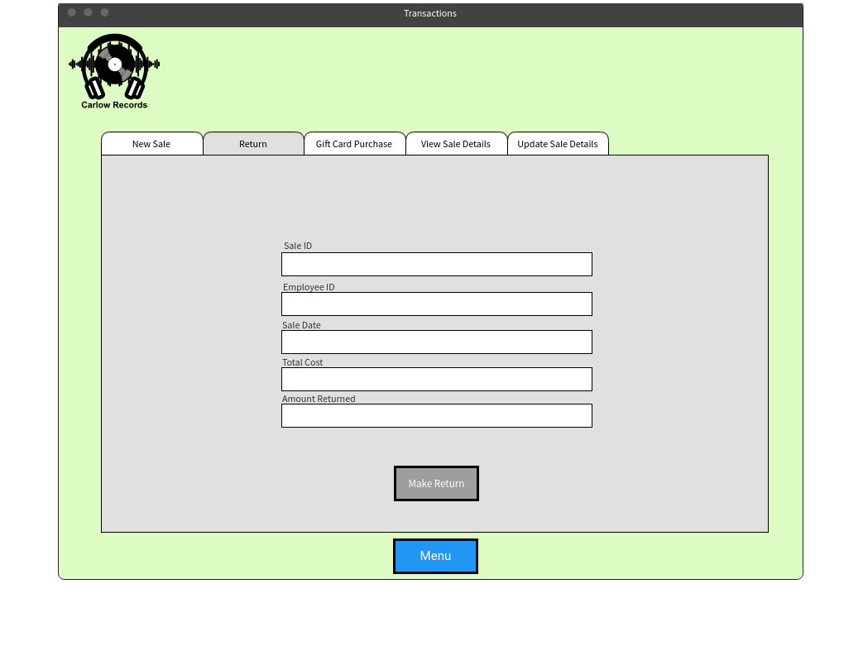Return

**Access to screen:**

Login > Menu > Transactions > Return

**Purpose of this screen:**

To process a return of a customer’s purchased item. The user inputs the ID number of the sale and their employee ID. The details will be then displayed on the screen. The amount being returned is entered by the user.

**Table Processing Involved:**

In the Sales table, an entry is searched for with the same Sale ID entered by the user. When the found, the Sale date and Total Cost is displayed on screen. In the Returns table, a new entry is created and the Sale ID, Employee ID and Amount Returned is saved into this new entry.

Transactions

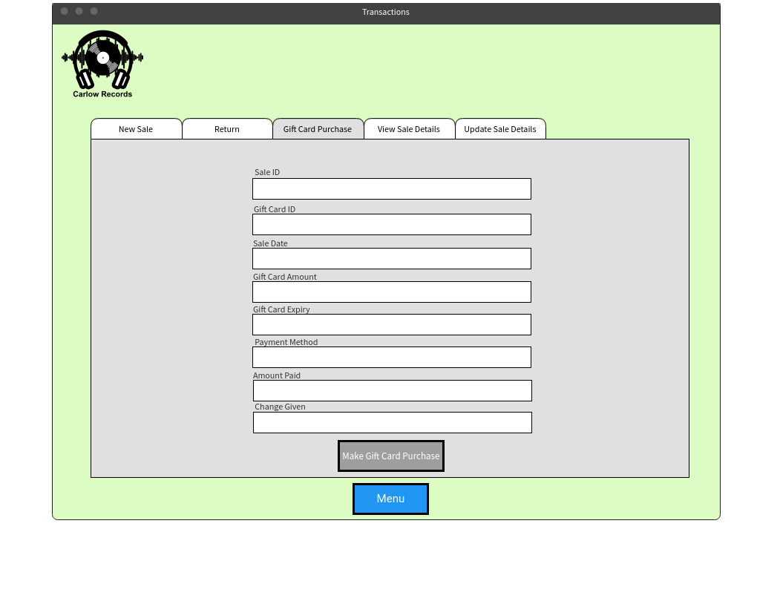Gift Card Purchase

**Access to screen:**

Login > Menu > Transactions > Gift Card Purchase

**Purpose of this screen:**

To create a Gift Card Purchase and assigning the value, expiry date and gift card ID number to gift card being purchased

**Table Processing Involved:**

In the Sales table, a new entry is created. The Sale ID is an auto number and is inputted automatically. The sale date, amount paid and change given is entered by the user and saved in the corresponding fields. In the Gift Card table, a new entry is created. The Gift Card ID is an auto number and is inputted automatically. The Gift Card Amount and Expiry is inputted by the user and saved into the corresponding fields in that new entry.

Transactions

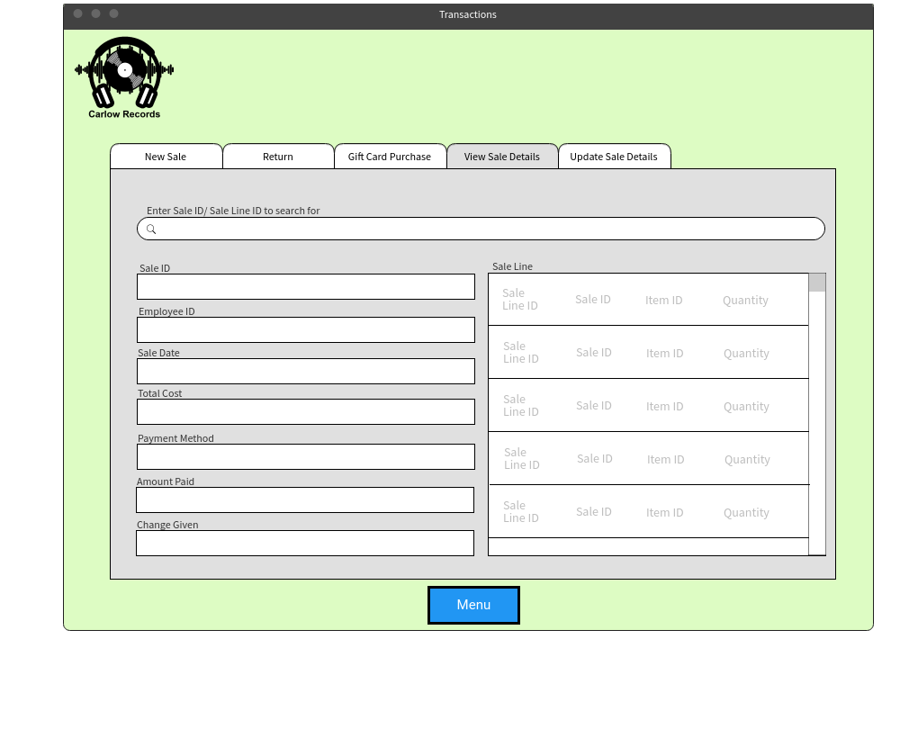View Sale Details

**Access to screen:**

Login > Menu > Transactions > View Sale Details

**Purpose of this screen:**

To view the sale details of the Sale ID or Sale Line ID that the user has searched for

**Table Processing Involved:**

In the Sales/Sale Line table, every entry is searched for the Sale ID/Sale Line ID entered by the user. When found in the table, all its information is displayed on screen for viewing.

Transactions

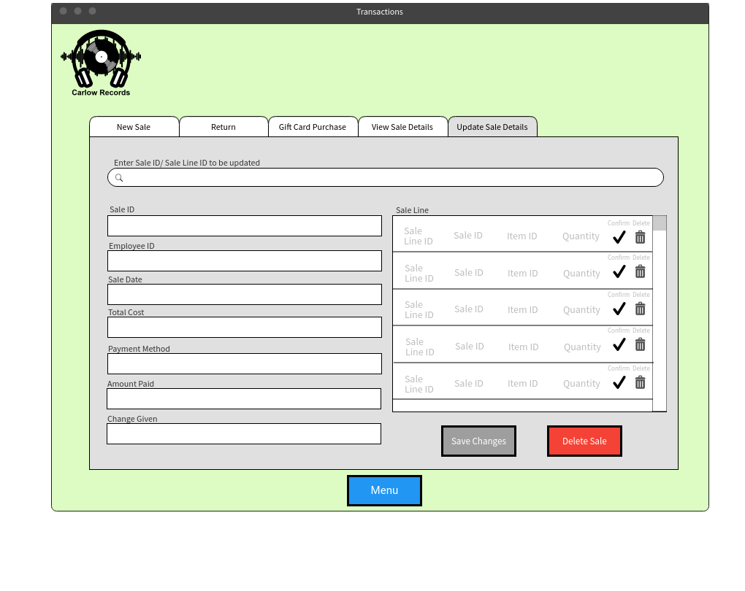Update Sale Details

**Access to screen:**

Login > Menu > Transactions > Update Sale Details

**Purpose of this screen:**

Shows the details of the sale which the user has searched for and allows the user to overwrite any of the fields and change the sale line. The user can also delete this sale entry.

**Table Processing Involved:**

In the Sales/Sale Line table, every entry is searched for the Sale ID/Sale Line ID entered by the user. When found in the table, all of its information is displayed on the screen. The user can then change any of the Sales details, The Sale Line’s details or delete the sale entirely.

Orders

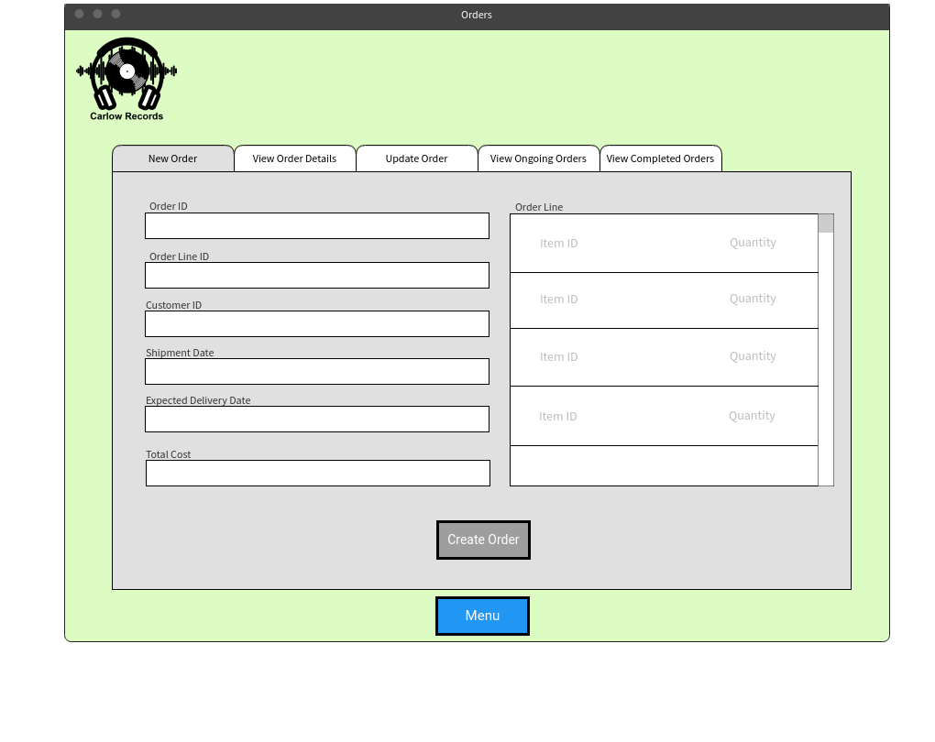New Order

**Access to screen:**

Login > Menu > Orders > New Order

**Purpose of this screen:**

To create a new order that a customer has made online. The order information is on the left hand side of the screen while the order line which contains the items ordered by the customer is on the right hand side.

**Table Processing Involved:**

In the Orders Table, a new entry is created and the information entered by the user on the left hand side of the screen is saved into the associated fields. Order ID is an auto number and is filled in automatically. In the Order Line table

Orders

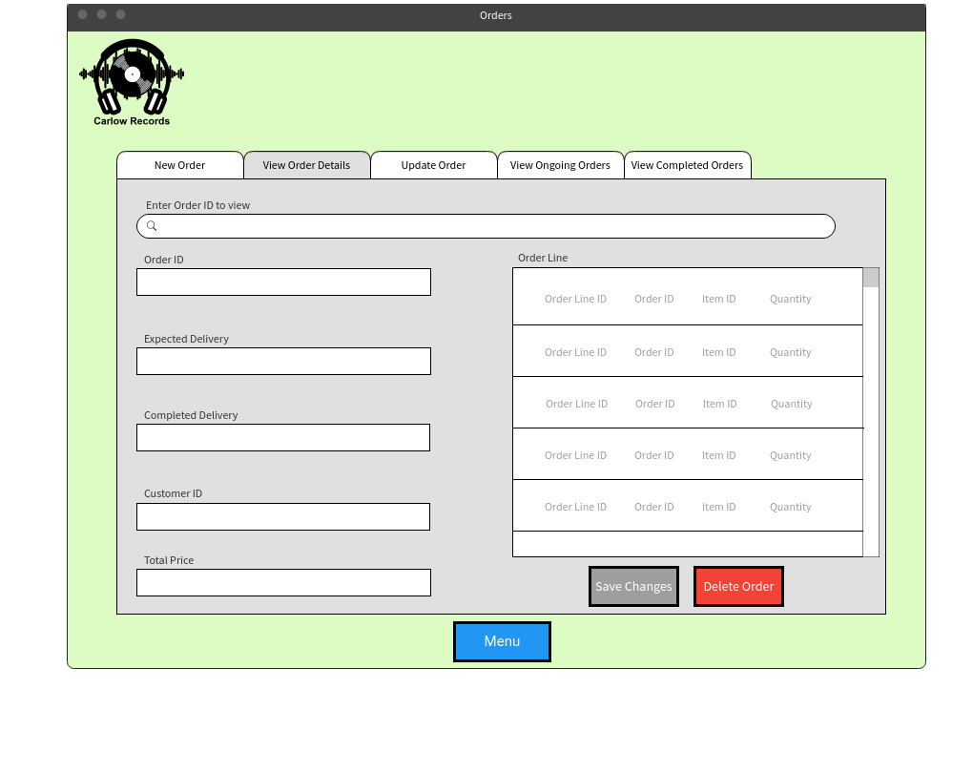View Order Details

**Access to Screen:**

Login > Menu > Orders > View Order Details

**Purpose of this screen:**

To allow user to search for an order ID and shows the details of that order. The Order ID is entered by the user at the top and the order and order line information is displayed on screen.

**Table Processing involved:**

In the Orders table, an entry is searched for with the same Order ID that the user inputted. When an Order with that Order ID is found, its details is displayed on screen.

Orders

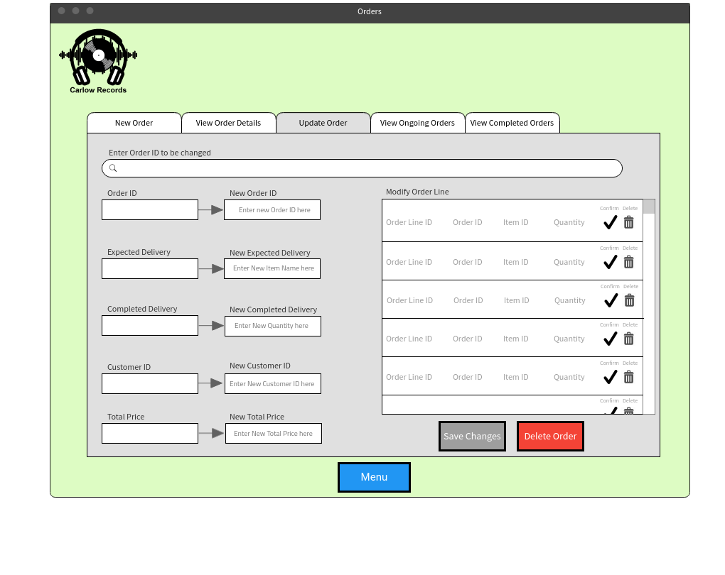Update Order

**Access to screen:**

Login > Menu > Orders > Update Order

**Purpose of this screen:**

To allow user to change any details of an order or delete the order entirely.

**Table Processing involved:**

In the Orders table, an entry is searched for with the same Order ID that the user inputted. When an Order with that Order ID is found, its details is displayed on screen and the user can then change any of the Order or Order Line details or delete the order entirely.

Orders

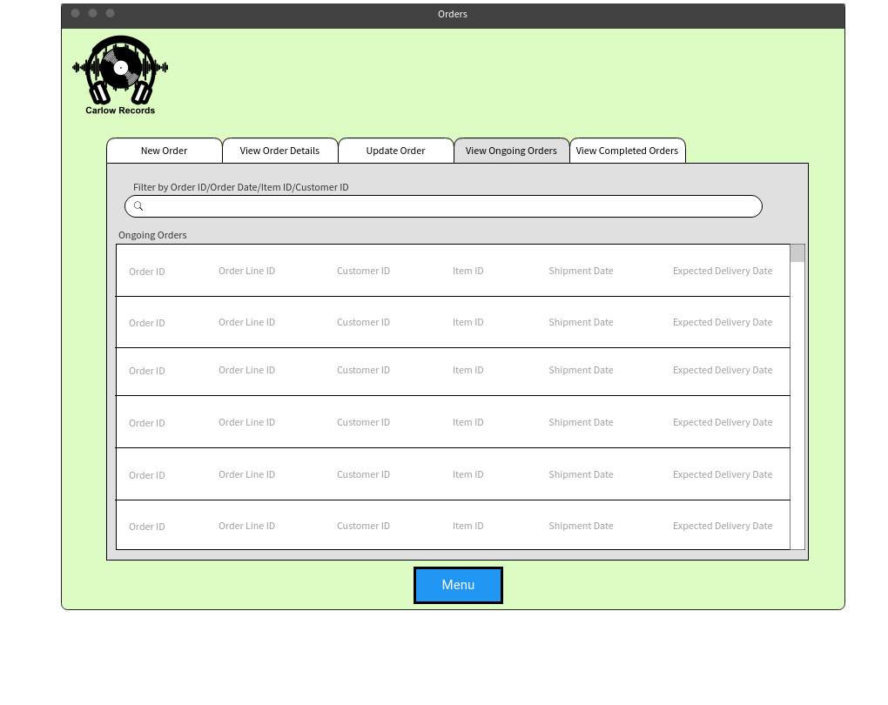View Ongoing Orders

**Access to screen:**

Login > Menu > Orders > View Ongoing Orders

**Purpose of this screen:**

Shows all orders that are still ongoing or haven’t been delivered yet. The user can also filter the results by Order ID, Order Date, Item ID or Customer ID

**Table Processing Involved:**

In the Orders Table, Every Order entry that is still ongoing/has not been delivered yet is displayed on the screen.

Orders

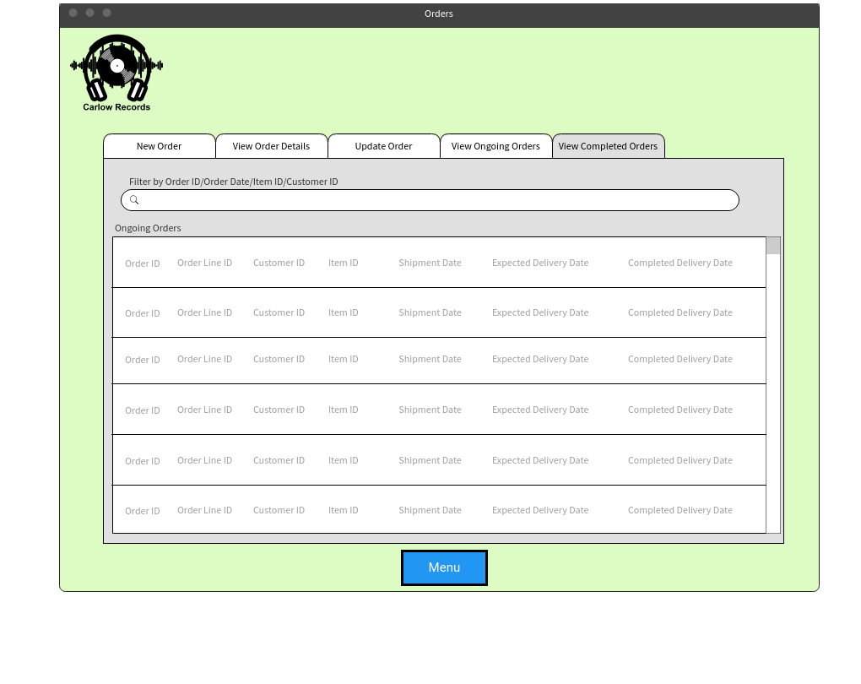View Ongoing Orders

**Access to screen:**

Login > Menu > Orders > View Completed Orders

**Purpose of this screen:**

Shows all orders that have been completed and successfully delivered. The user can also filter the results by Order ID, Order Date, Item ID or Customer ID

**Table Processing Involved:**

In the Orders Table, Every Order entry that been delivered yet is displayed on the screen.

Reports

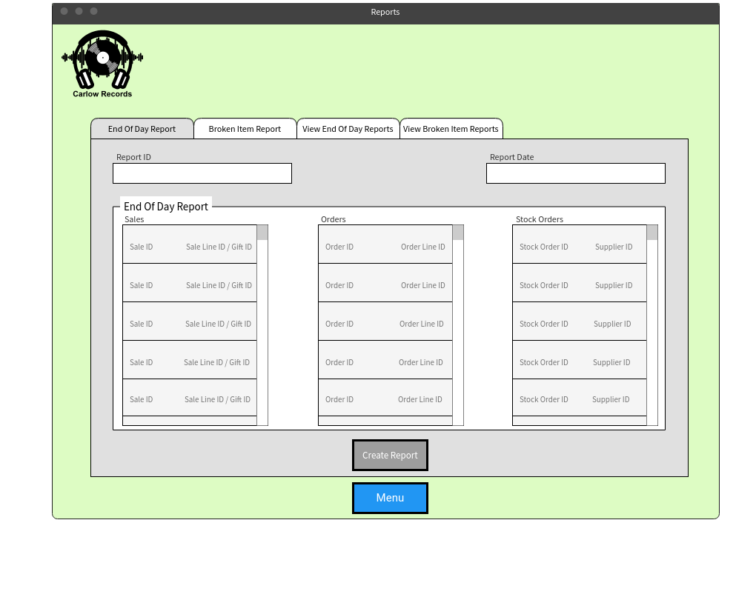End of Day Report

**Access to screen:**

Login > Menu > Reports > End of Day Report

**Purpose of this screen:**

To create an end of day report which records the current day’s Sales, Orders and Stock Orders and saves it into a table for viewing at a later date.

**Table Processing Involved:**

In the Reports table, a new entry with the report type ‘Day’ is created. The report reads every new entry on today’s date in the Sales, Orders and Stock Orders tables and records them into the ‘Report Description’ field. The Report ID is an auto number and is filled in automatically. The report date is the current date.

Reports

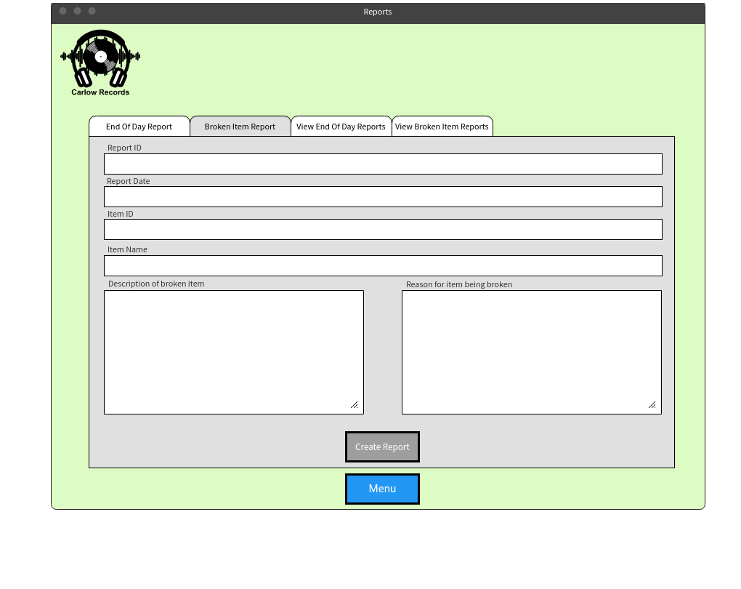Broken Item Report

**Access to screen:**

Login > Menu > Reports > Broken Item Report

**Purpose of this screen:**

To create a broken item report. The user inputs the items information, a description of the damage to the broken item and the reason for the item becoming broken.

**Table Processing Involved:**

In the Reports table, a new entry with the report type ‘Broken’ is created. The user enters in the Item ID, Description of the broken item and the Reason for the item being broken. Both the Description of the broken item and reason for item being broken is saved in the description entry The Report ID is an auto number and is filled in automatically. The report date is the current date.

Reports

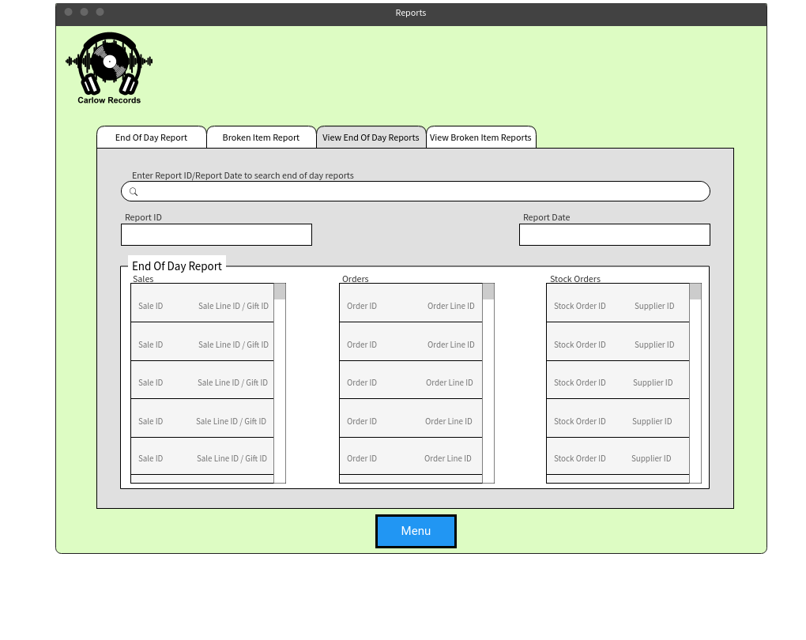View End of Day Reports

**Access to screen:**

Login > Menu > Reports > View End of Day Reports

**Purpose of this screen:**

To view End of Day reports from earlier dates. The user either enters the Report ID or the Report Date and that End Of Day Report’s details are displayed below

**Table Processing Involved:**

In the Reports table, an entry with the same Report Date/Report ID entered by the user is searched for in the table. When found, the information of the report is displayed below.

Reports

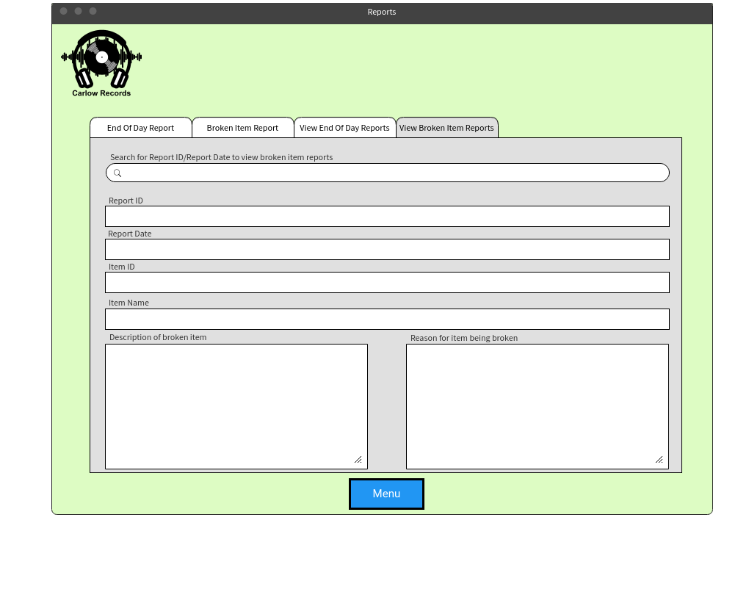View Broken Item Reports

**Access to screen:**

Login > Menu > Reports > View Broken Item Reports

**Purpose of this screen:**

To view Broken Item Reports and the details of that report. The user enters either the Report ID or the Report date to access a broken item report and the details are displayed below.

**Table Processing Involved:**

In the Reports table, an entry with the same Report Date/Report ID entered by the user is searched for in the table. When found, the information of the report is displayed below.

Employee Actions

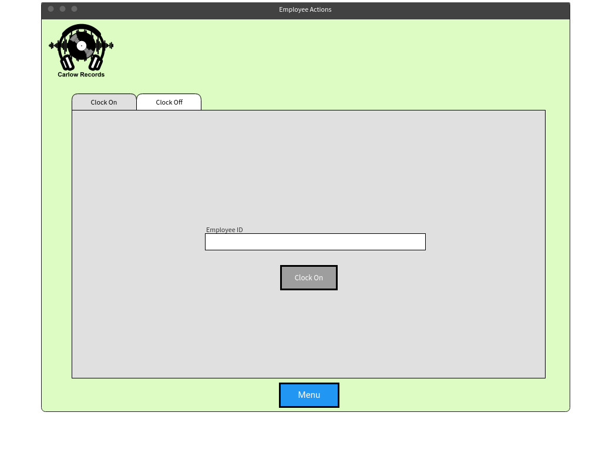Clock On

**Access to screen:**

Login > Menu > Employee Actions > Clock On

**Purpose of this screen:**

To allow employees to clock on for work when they start their shift. The employee enters their Employee ID number and clicks the ‘Clock On’ button to clock on.

**Table Processing involved:**

In the Employee Shifts table, A new entry is created. The employee ID entered by the user is saved in the employee ID field. When the user clocks on, the current date and time is recorded in the ‘shiftClockon’ field.

Employee Actions

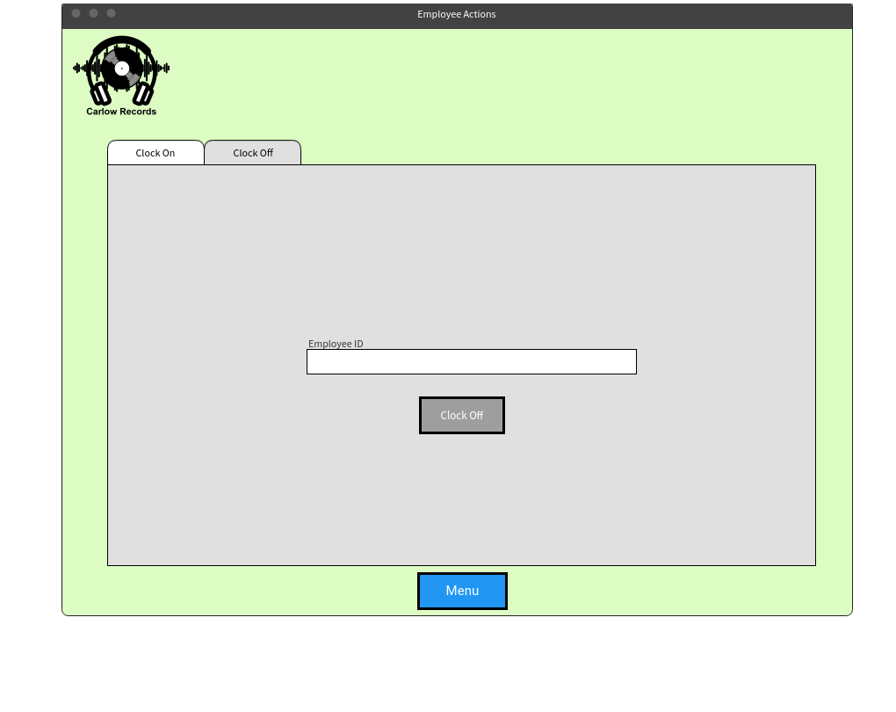Clock Off

**Access to screen:**

Login > Menu > Employee Actions > Clock Off

**Purpose of this screen:**

To allow employees to clock off for when their shift is over. The employee enters their Employee ID number and clicks the ‘Clock Off’ button to clock off.

**Table Processing Involved:**

In the Employee Shifts table, the employee ID entered by the user is searched for in the table. When the user clicks the clock off button, if there is an entry with the same Employee ID and the employee has clocked on at today’s current date, the current date and time is recorded in the ‘shiftClockoff’ field.

User Management

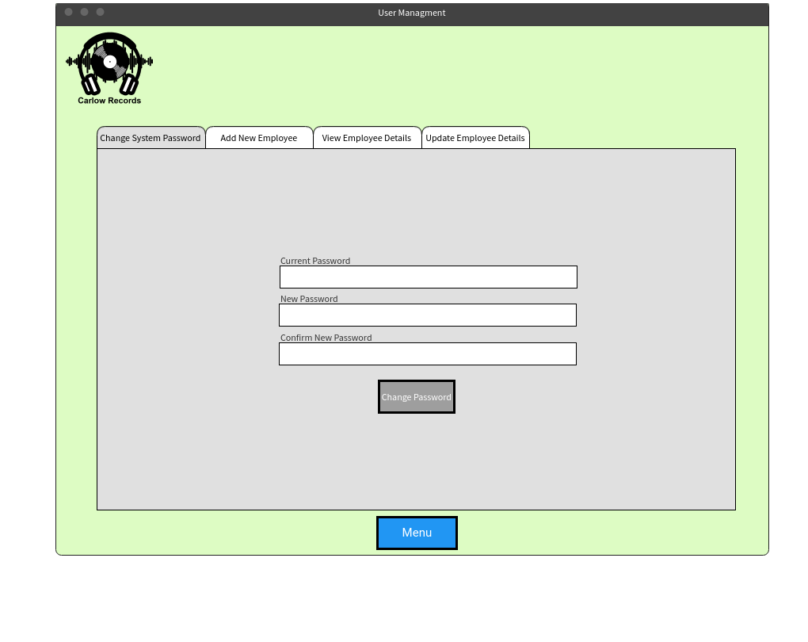Change System Password

**Access to screen:**

Login > Menu > User Management > Change System Password

**Purpose of this screen:**

To change the system password to a new one. The user enters the current password and the new password and clicks the ‘Change Password’ button to change the password.

**Table Processing Involved:**

In the System Table, If the current password entered by the user matches the ‘currentPassword’ entry, then the ‘currentPassword’ entry is overwritten by the new password entered by the user.

User Management

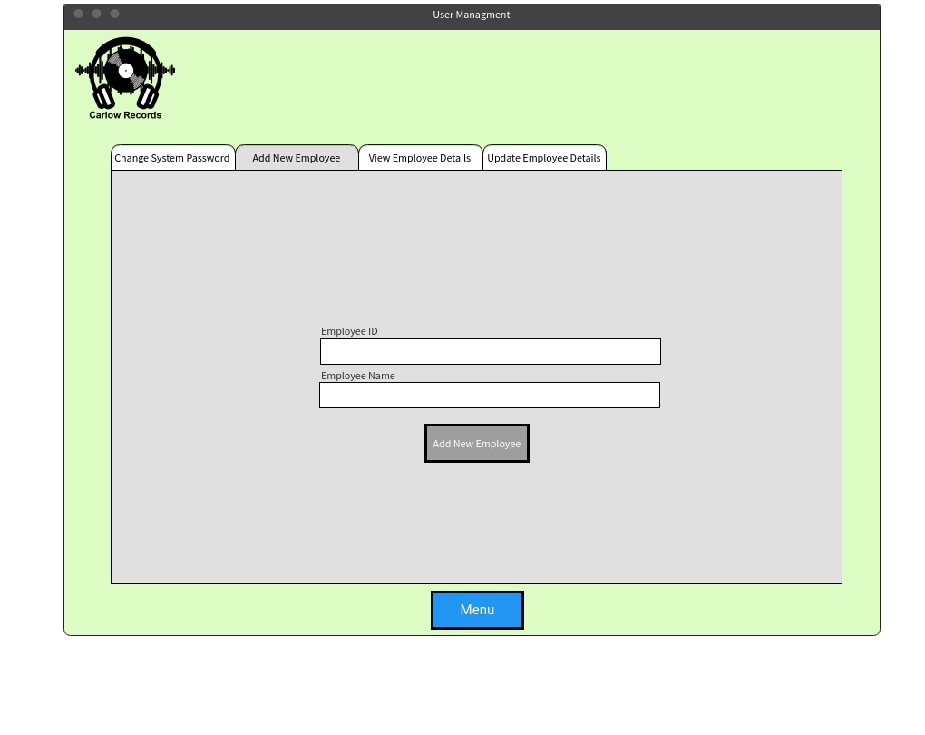Add New Employee

**Access to screen:**

Login > Menu > User Management > Add New Employee

**Purpose of this screen:**

To add a new employee to the system. The user enters their name and Employee ID and clicks the ‘Add New Employee Button’ to add a new employee.

**Table Processing Involved:**

In the Employee table, a new entry is created and the Employee ID and Employee Name entered by the user is saved into the corresponding fields.

User Management

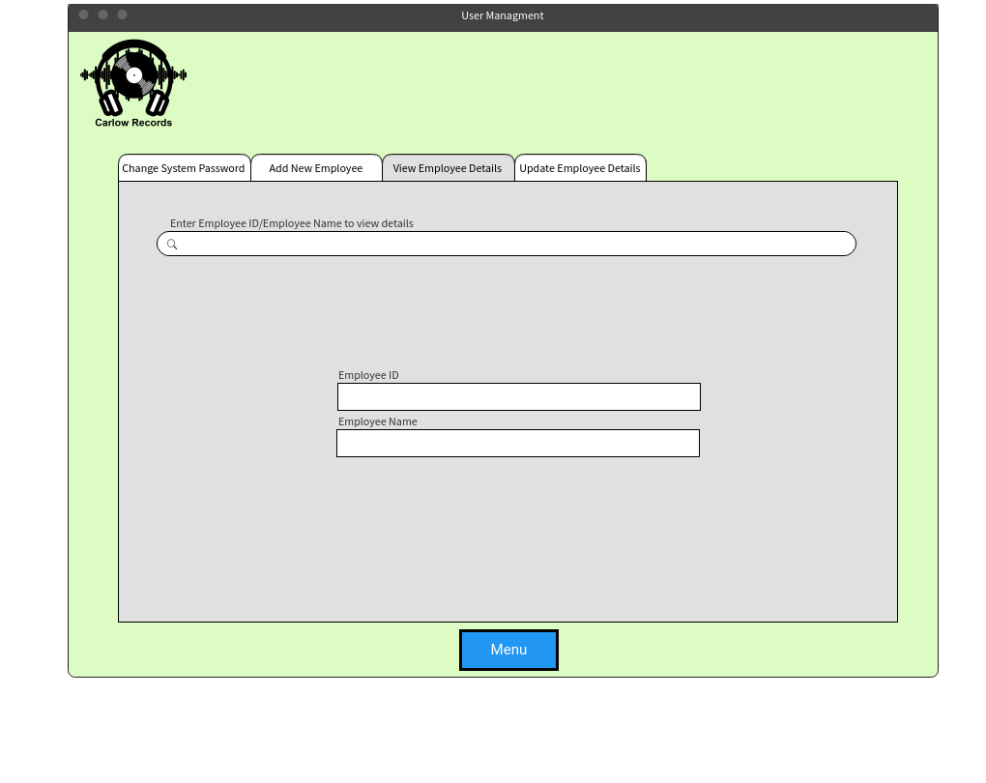View Employee Details

**Access to screen:**

Login > Menu > User Management > View Employee Details

**Purpose of this screen:**

To view the details of an existing employee. The user inputs either the Employee ID number or the employees name to search the system. The Employees details is then displayed on screen.

**Table Processing Involved:**

In the Employee table, an entry is searched for with the same Employee ID or Employee Name entered by the user. The entry is then displayed on screen.

User Management

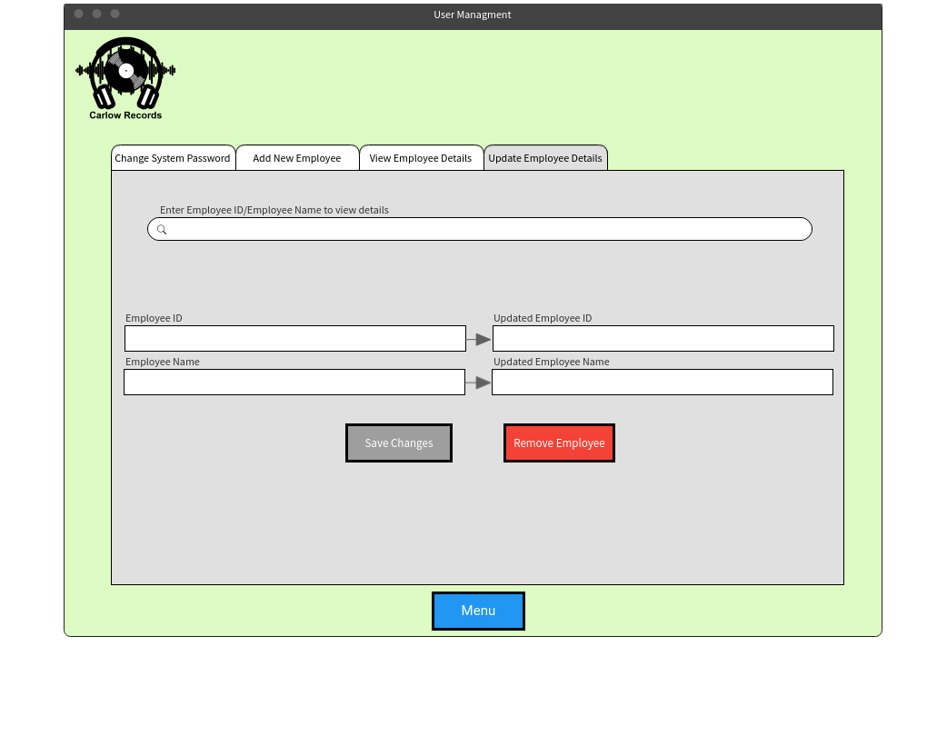Update Employee Details

**Access to screen:**

Login > Menu > User Management > Update Employee Details

**Purpose of this screen:**

To update the details of an employee. The user inputs either the employee’s ID number or name to view their details. The user can then change their details or delete the employee from the system entirely.

**Table Processing Involved:**

In the Employee table, an entry is searched for with the same Employee ID or Employee Name entered by the user. The entry is then displayed on screen and the user can update any of this entrys details or delete the entry entirely.

**Appendices**

* **What differentiates your system from other pre-existing systems on the market?**
  + We believe our system is one of the fastest and most efficient business management systems available. Our system is specifically designed from the ground up with your business in mind which means there are no useless or unwanted features that take up space and clutter the system.
* **Why should a business choose your solution over other pre-existing systems for the management of their business?**
  + Our system is tailored to a business’ needs on and only features functions that you use. In addition to that, we provide support for a business if something where to happen to the system or if they require additional functions to be added on to the system. Unlike other companies who provide systems, we will provide long lasting support.
* **What would your response be if your system ever malfunctioned suddenly and was unresponsive?**
  + If the system were to ever malfunction or become unresponsive, we would work on getting the system back up and running as soon as possible as we know how vital an automated system is to maintain and run a business such as a Music CD & Record shop.
* **What is the strongest selling points of your system?**
  + The strongest selling point of our system is the minimal response time and ease of use. We designed our system to have a user friendly, easily understandable interface which can be easily understood and requires little knowledge of computers. Faster use of the system means customers can be served quicker which in turn leads to more revenue being earned for your business.
* **What would you say is the weakest aspect of the system?**
  + The weakest aspect I would say about the system is the data processing involved is quite intensive on the system when performing searches of databases and updating details of pre-existing entries in the various databases.
* **The data contained in the system is confidential and ensuring the data is secure is vital. How does your system keep all this data secure?**
  + When first brainstorming ideas for the system, the security of the system and the data contained in it was one of our top priorities. The system has a secure user name and encrypted password and every customer’s data is encrypted to ensure its integrity.