CCAppraiser Web scraper Set-up and Tutorial

Set-up

Step 1: Download All content From the google drive link. You will notice that it is 2 files namely “CCAppraiser Scraper.app” and “chromedriver”
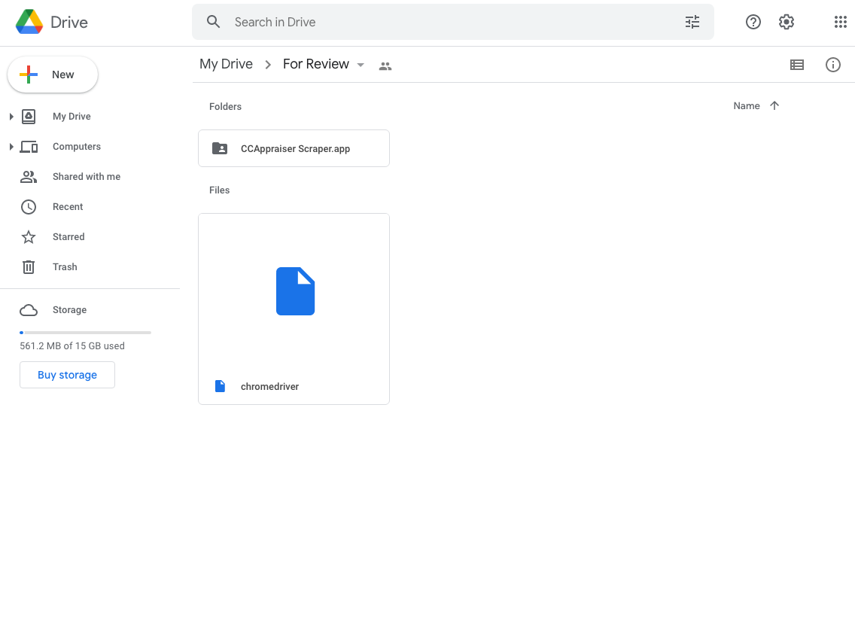

Step 2: Once downloaded, make sure that the two files are located in the “Downloads” folder as indicated below.
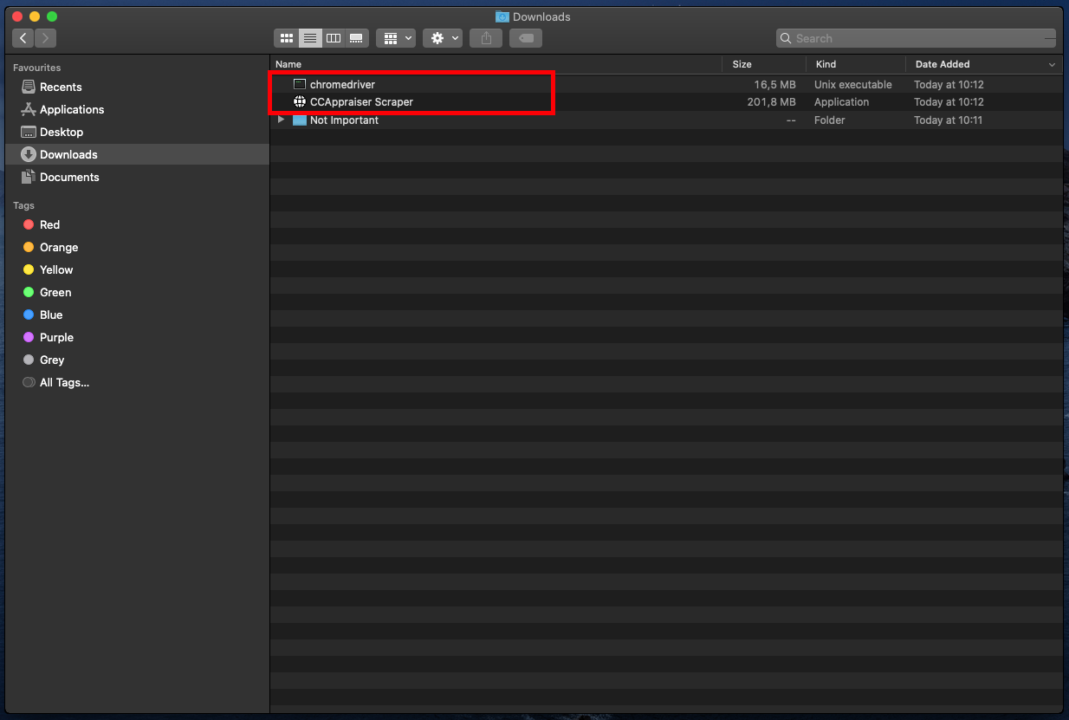

Step 3: Open up terminal, type in “cd Downloads” and hit enter, as per below.
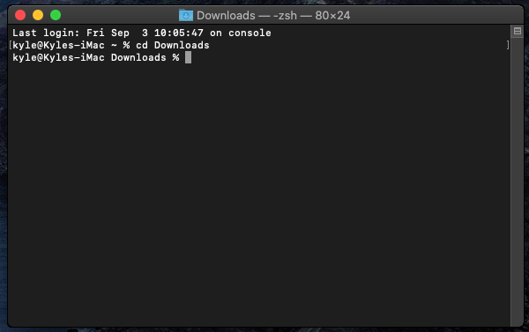
Step 4: Type in the command “sudo mv chromedriver usr/local/bin” and hit enter. You will be prompted for your password. Type it in and hit enter.
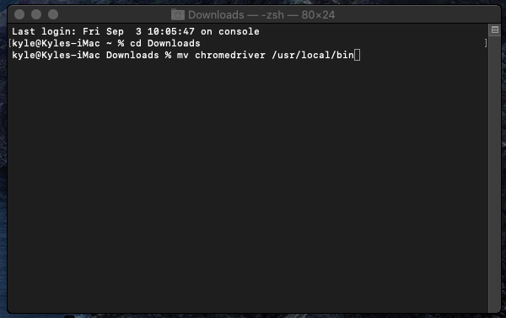
Set-up is now complete!

Tutorial

Step 1: Open up the CCAppraiser Scrapper.app
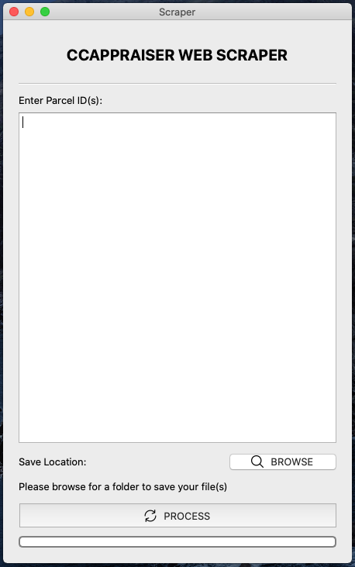

Step 2: Enter Parcel Id / Id’s. (note: separate each ID with a space, new line, or a comma. No other separation will be accepted)

Insert Parcel Id(s) here

Step 3: Browse for a folder that you would like to save the PDF’s to.
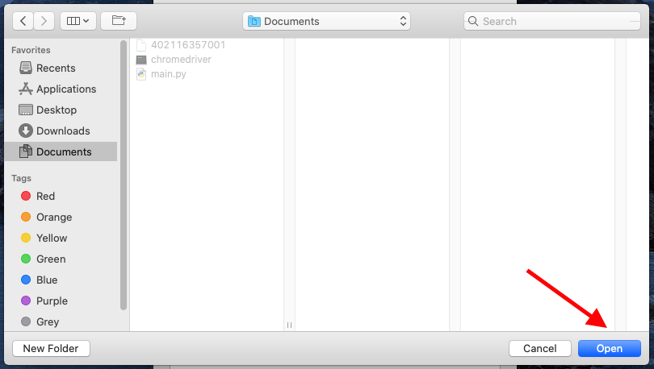

Press Open once navigated to the chosen folder

Press the Browse button

Step 4: Press the Process button, and wait for your pdf’s to load to the folder that you specified.
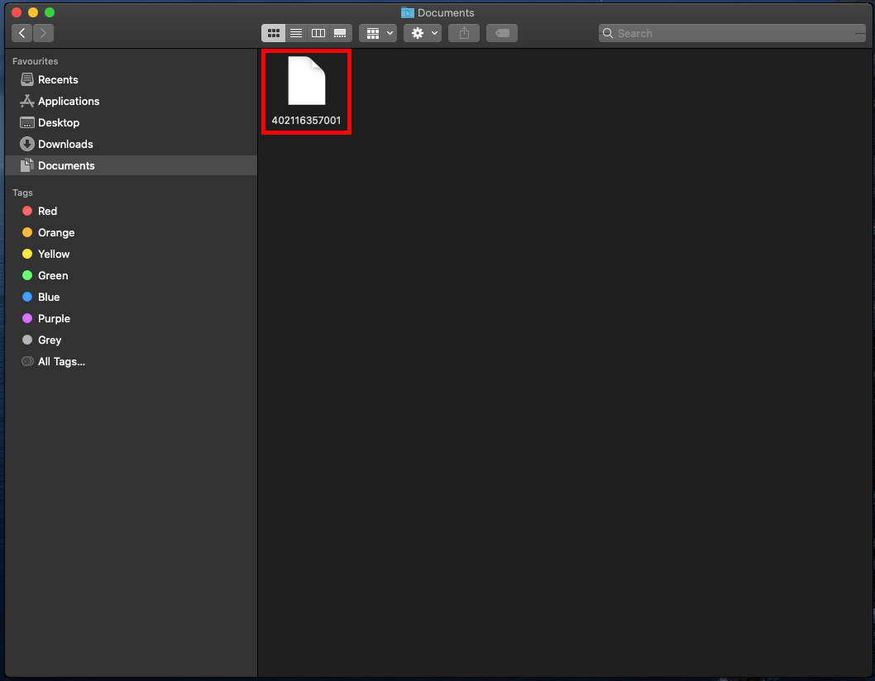

` Press process

I chose the documents folder to save my pdf as indicated above.

Please note: The applications run time varies according to your internet connection and your computers performance.Any Issues can be directed to me and I will assist you as soon as possible.

Thank you for using CCAppraiser Web Scraper.

Best Regards, Kyle.

Tutorial Complete!

