Kyle Klausen

Assignment5_3

CSD-310

06/22/25

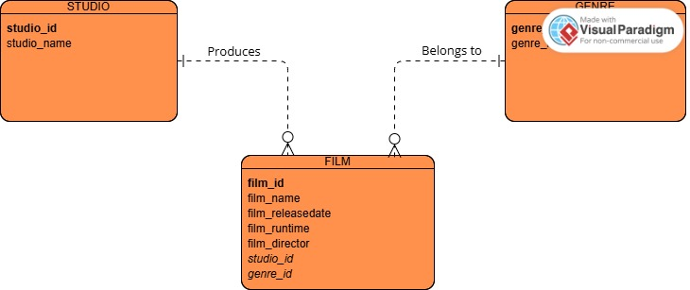

Since the watermark got in the way, I have included a personal screenshot of the ERD:

